Downloaded from

https://www.parents.com/toddlers-preschoolers/starting-preschool/separation-anxiety/overcoming-separation-anxiety/ [Accessed: 14.07.20]

18 Tips for Overcoming Separation Anxiety on the First Day of Preschool
Entering a new environment can be scary for preschoolers. Find out how to overcome separation anxiety for a happier first day of school.
By Karin A. Bilich, Ilisa Cohen, and Ronnie Koenig
Updated February 13, 2020
ADVERTISEMENT
SavePinFBMore
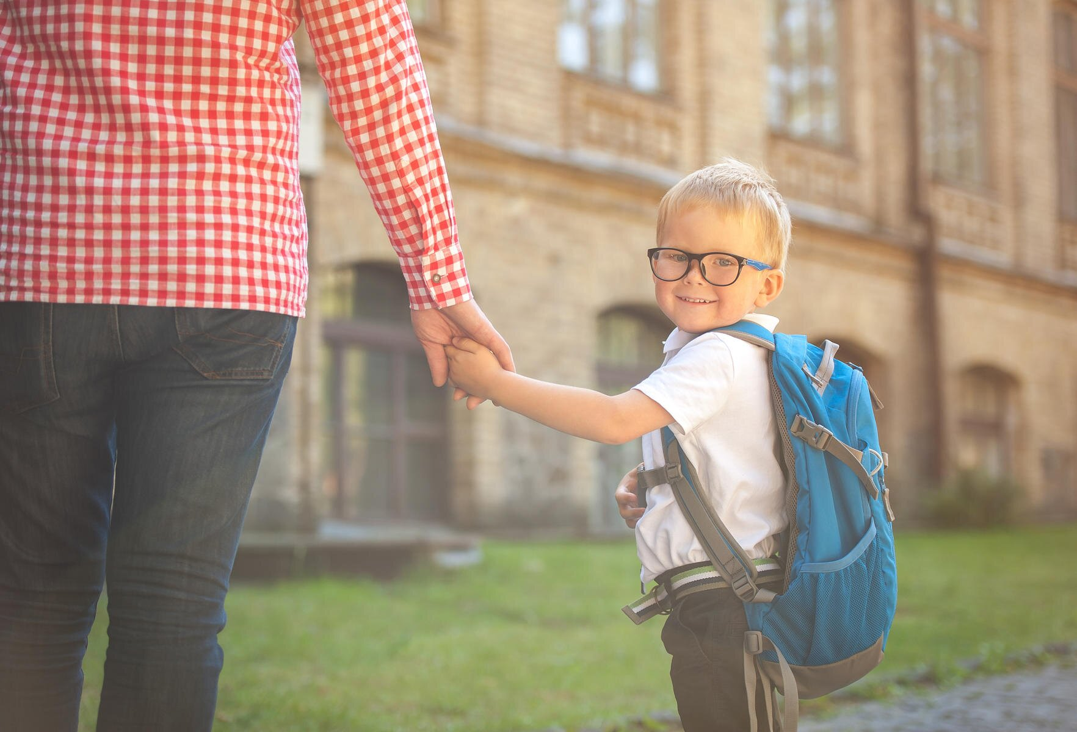
SHAROMKA/SHUTTERSTOCK
Although starting preschool is a major milestone, it often comes with lots of crying, uncertainty, and heel digging. “For children, the main source of anxiety around entering preschool is that they have absolutely no idea what to expect," says Katrina Green, a certified early childhood and early childhood special education teacher at the Just Wee Two program in Brooklyn, New York. "They have spent the first three to four years learning the rules and routines of their family life and they are completely unfamiliar with the new rules and routines they will encounter."
Since starting preschool is such a novel experience, you shouldn’t treat it like any other date on your calendar. "Take several weeks before the first day to ease him into this new adventure,” says Alisa Clark Ackerman, who has taught at several preschools in New York City. Read on to learn the best ways to help a child with “first day of school” separation anxiety.
- RELATED: School Anxiety in Children: Causes, Signs, and What to Do

Preparing Kids for Preschool
Preparing your child for preschool can greatly reduce any separation anxiety he may feel when you leave. Here are some ways to familiarize your youngster with his new environment.
Explain the routines of preschool. Tell her about the games she'll play, the kids she'll meet, and how you'll always be there to pick her up at the end of the day. Don't overhype school, and don’t make promises about things you can’t control (like making new friends). If your child's initial experience doesn't match his expectations, school may already seem scary, not exciting.
Meet the teacher. Many preschools host an open house, where parents, teachers, and children can get to know each other. There will likely be many parents vying for the teacher's attention, but make sure you get a chance to chat with her when your child is within earshot. "If you show your child that the teacher is someone you like and trust, he'll have an easier time forming an attachment to her," says Ackerman.
Visit the school. Before the school year, take your child around the classroom and point out the different activities he'll do each day. Also tell him the name of the school, recommends Ackerman. "Over the first week or so leading up to preschool, prepare him for the first day by saying, 'Next week you'll go to Elm Street Preschool and play with the tambourine,'" she says. What’s more, whenever you're driving by the school, casually point it out to your child, suggests Parents adviser Kathleen McCartney, Ph.D., a professor at Harvard Graduate School of Education.
- RELATED: A Parent's Guide to Separation Anxiety in Toddlers
Set up playdates before the school year. Seeing familiar faces in his class will increase your child's comfort level. You'll get a class list during the summer, "so plan playdates with some other classmates before the big day," says Amy Flynn, director of the Bank Street Family Center at the Bank Street College of Education in New York City, which trains teachers from around the country. "Also, ask about setting up a buddy system; you and another class family have each other as contacts for playdates and support before school begins.
Keep a positive mindset. Your child will take cues from you, so be calm and confident that everything will go well. "You don't want to ask him if he's scared too many times—that might make him even more fearful," says Flynn. "But if he seems anxious in the days preceding school, reassure him that he'll be okay and that you're nearby if he needs you.”
Role play. Pretend play with stuffed animals can help your child adjust to the idea that he'll be leaving you, but you'll come back. (For example, his teddy bear goes to school with some other furry friends, and Mommy Teddy leaves and returns after he's sung a song and had a snack).
Read books. "Books that describe what happens at school, as well as validate a child's feelings, can help quell jitters," says Sally Tannen, director of the Parenting Center at the 92nd Street Y in New York City, which has its own preschool. These books provide your child with a sort of dry run of school in the comfort of home, where he feels safe. Check out our round-up here.
- RELATED: 20 Tips for Parents From Preschool Teachers

How to Handle Preschool Drop-Off
No matter how much you prepare, your preschooler will still be full of nerves on her first day. Here’s how to make drop-off a little easier.
Create a goodbye ritual. Having a goodbye routine provides comfort and familiarity, so your child knows what’s to come. This could be anything you and your child decide on, such as a special hug or handshake followed by a "See you later, alligator!" Once you've said your goodbyes, it's best to skedaddle so that your child doesn't become preoccupied by your presence. A long farewell scene might only serve to reinforce a child's sense that preschool is a bad place.
Don’t sneak away. It might be tempting to bolt from the room, but your little one will feel more afraid if you suddenly disappear. "Moms should never be ripped away abruptly from their child," says Fran Walfish, Psy.D., child and family psychotherapist and the author of The Self-Aware Parent. "It can take up to ten weeks for a child to fully be ready to be left at school without her mother. The best way to handle the separation process is to begin by Mommy going to school with her child and sitting next to her. She should not interact with her in games and toys, but rather be there as a safety net."
Bring a comforting object. Have your child bring a little reminder of home to ease his separation anxiety. If he doesn't have a favorite doll or blankie, even a beloved book or a sippy cup filled with his favorite drink can do the trick. Comfort objects may seem like small stuff to you, but they can provide a real sense of security to kids in an unfamiliar environment.
Never make comparisons. Don't chastise your toddler and say, "Nolan doesn't cry when his mom leaves." Honoring your child's process is the best way to make the transition to preschool as smooth as possible, Green says. "The child who never cries when his parent leaves him may act out the scene over and over again during play to process his feelings. Another child may need to cry at every separation for a while in order to work through his feelings," Green says.
- RELATED: Overcoming Your Baby's Stranger Anxiety
Remind him that you came back. When you pick him up at the end of the day, reinforce the idea that you came back, just like you said you would. This way, each day's drop-off won't feel like you're both starting teary and upsetting goodbyes all over again.
Consider a reward system. Linda Roos, of Scottsdale, Arizona, gave her kindergartner his own calendar. If he went to class without putting up a fuss, she put a smiley face on the calendar (otherwise, he got a sad face). On Friday, if he had five smiley faces, she made him a treasure hunt as a treat.

Tips for Parents Dealing with Separation Anxiety
Don't minimize the importance of easing your fears as well as your child's. If you feel guilty or worried about leaving her at school, your child will probably sense that. The more calm and assured you are, the more confident your child will be.
Get to know the teacher beforehand. Your child can benefit from meeting his teacher before school—but so can you. Ask your child's teacher what her procedure is when children are crying for their parents. Make sure a school staff member is ready to help your child with the transfer from your care to the classroom.
What’s more, "it's helpful for me to know as much as possible about a child's home life in order to ease their transition into preschool," says Green. "Their eating, sleeping, and toileting patterns are just as important as knowing their favorite color, what games they like to play, or what songs they like to sing. It also helps to know what techniques the family uses to calm a child down when she is feeling upset or anxious (so I can) try to replicate those techniques in the classroom." Be sure to let the teacher know about any medical issues, such as food allergies.
Think of preschool as a life lesson. Many moms may see their child have a bad first reaction to preschool and immediately decide to pull him out of the classroom. But that's a bad idea: "It denies the child an opportunity to learn how to work through negative feelings and sets a precedent of not having to face problems," Green says.
- RELATED: Anxiety in Children: When to Worry About Your Child's Worries
Resist surprise visits Once you've left your child, resist the temptation to go back and check on her, and don't phone the school every hour. "If you're always checking up on your child, you risk the reciprocity of your child checking on you constantly,” says Dr. Walfish.
Give yourself a pep talk. Come up with a mantra such as, "This is best place for (your child's name)" or "Bringing (your child's name) here is the right decision" to remind you of why being apart is good for both you and your child. Then, keep repeating it as often as you need it!
Have patience with your preschooler. "It's okay to keep leaving the child if he keeps crying," Green says. "A complete and successful transition into school can take months, especially if there are family vacations or breaks from school, when children often regress, or if there are changes happening at home." But rest assured that in all her years of teaching, Green hasn't encountered one student who couldn't overcome his separation anxiety.
- By Karin A. Bilich, Ilisa Cohen, and Ronnie Koenig

