Jazmine Love (1402067)
Managing internationaly SBUS6115
Evaluation of Cultural variation on the strategy and operations of an international organisation using academic models and theory

Executive Summary

The purpose of this study is to research and evaluate companies that have entered into different environments and cultures. It explores how cultural variation has impacted on the strategies and operations deployed in these countries, and explains the how and the why of the results seen.
Emphasis has been given in the following areas of research:

- Factors that influence negotiation and decision making
- Differences in communication preferences between cultures;
- How culture affects the management of people internationally:
- How culture affects leadership and motivation.

Introduction

This thesis is aimed at exploring the cultural adaption model of McDonald’s and KFC. In today’s world business sis bigger than ever, global culture differences present challenges to any business in emerging markets. Businesses face many challenges when going international that could be new to them, they must learn to adapt to new cultures and ways of doing things. Culture effects everything a business does and how it portrays themselves in different countries has an infectious outcome, communication, management, leadership and motivation. The organisation must be able to meet the requirement of the country for them to believe they are a benefit to them. When approaching the global market some business practices are not acceptable in other countries, Cultural adaption in the way you conduct business is essential when operating in the foreign market. (Markgraf, 2018)
McDonald’s and KFC have adapted to local culture and it shows throughout this paper. However the most important thing to remember is they have different ways of conducting business. To gain a competitive advantage they should gain respect and trust of the country and a way of doing that would be to communicate deeply with their culture.

Main Findings

  - 3.1 Culture
Culture has been heavily researched and theorised, there are two definitions of culture that have gained wide approval, as follows:
“Culture is the collective programming of the mind which distinguishes the members of one group/ category of people from another.”
- (Hofstede, 1994)

“Culture is a fuzzy set of basic assumptions and values, orientations to life, beliefs, policies, procedures and behavioural conventions that are shared by a group of people, and that influence (but do not determine) each member’s behaviour and his/her interpretations of the ‘meaning’ of other people’s behaviour.”
- (Spencer-Oatley, 2008)

Culture is an important aspect of the world, it is not something one inherits, everyone is taught a different culture, that is learned and acquired through others, The shared culture exists all around the world in groups, societies, beliefs of an individuals can be classified as “ideas” but don’t really come through as part of the culture, however the idea will help to further develop culture. (Ali, 2015) It is a code of attitudes, norms and values that are learnt in a social environment. The importance of forming European culture is meeting diversity, being complimentary of ideas, interacting with values such as: religion, mythical thought and humanism. (Deresky, 2016) Hofstede’s five dimensions of culture is the most widely used model they are, identity, Hierarchy, Aggression, Otherness and Gratification of needs, Chia are very recognisable in these. (Hofstede, et al., 2010)

  - Impact of culture on leadership and motivation

When a business expands in to international territories, it should not rely on its current culture, and must consider the culture differences in each country. For example rules and regulation, taxation, different currency, different holiday periods etc. (Ali, 2015) The Chinese culture can be traced further back than any western civilization, therefore it is not surprising to find wealth of tradition and embedded customers in modern Chinese society. (Delios, et al., 2014) The Chinese philosophy is that Confucianism is taught based on their usefulness in self-cultivation. (Berling, 1980) “Confucian values emerged from a time when China was a feudalistic society ruled by dynastic families.” However this has not rigorously been followed by society. (Delios, et al., 2014) Loyalty is a highly valued trait of confusion, its values promote moral guidelines for behaviour and relationships, from individuals to groups and from families to the broadest organisations. The Chinese values differ from that of western, tis values and changes were placed in china meaning industrialization and urbanization are happening faster. (Delios, et al., 2014) It is believed that negotiation within the Chinese culture web is increasingly important to business, the Chinese have developed their own negotiation strategies that are unique to their culture. (Alon, 2003)

McDonald’s and KFC are two well recognised American food brands, both operating in china, that have adapted to the cultural methods. There are three essential layers of culture: (1) Artefacts and attitudes, (2) Norms (rules) and values (3) Basic assumptions. KFC have quite an impressive story of emerging markets, they have achieved success, with a transformed business model after the Chinese government granted foreign companies greater access to markets, they were able to develop a blue print to transform. (Bell, 2011) Both McDonald’s and KFC have a widely recognised standard set of product that are available to purchase. KFC have used a localization strategy. (Singh, 2012) Upon entry to the Chinese market KFC grew faster and so forth became more advanced in terms of localization policies, including localized menus and employing local suppliers. (Zhu & Anagondahalli, 2017) By transforming it to a “Western Brand with Chinese characteristics” (McMahon, 2009) KFC China’s menus typically include 50 items, compared to that of the 29 in the United States, not fast-food, but set out in a restaurant style. Inexpensive western style food and traditional Chinese dishes. KFC adapted their business to fit in with Chinese culture, and pronominally become part of the community, with bigger kitchens and floor space to draw in families and groups. (Bell, 2011) KFC understood in many of their developing countries including China that “food is at the very heart of society, inextricable from national and regional cultures, and that an abundance of flavours and an inviting ambience would be necessary to win over customers.” (Bell, 2011)

“Guanxi behaviour is an important concept in Chinese leadership values and should be employed to develop a model of Chinese leadership behaviour” (Anon., 1998) A large part of KFC’s culture building was investment in training in to developing a good standard of customer service ethics. (Hexter & Woetzel, 2007)

  - 3.3 Culture Analysis

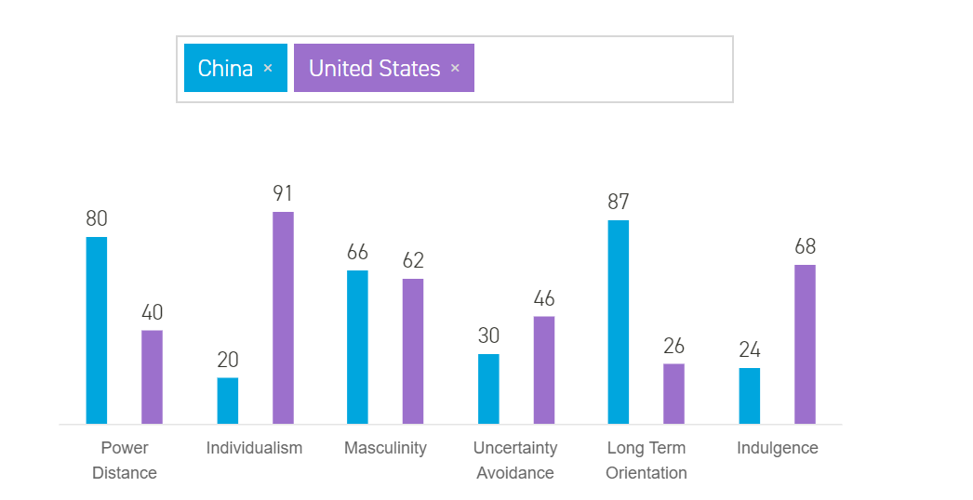
Hofstede insights comparison of countries shows the different organisational values within the United States and China. The scores used for the fifth dimension are based on the research of Michael Minkov as published in the 3rd and the latest edition of Cultures and Organizations, Software of the Mind (2010), pages 255-258.

- (Hofstede, 2018)

The most studied cultural dimension is individualism/ collectivism, they refer to the degree of which individuals are placed in groups. (Hofstede, 1984) China has collectivistic society, there is not any need to join and make friendships, who ones friends are in a collectivistic society is predetermined by ones family. Collectivism is seen a lot more in Chinese society, as a result of this, “Chinese communication style is marked by avoidance of direct confrontation in order to maintain a flow of peace in the country, (Ting-Toomey, 1999) this is influential on how corporations respond and communicate with each other. (Wen, 2003)

  - 3.4 Influential factors in negotiation and decision making

According to Hofstede’s culture dimension model, China have a relatively high position of power. (Hofstede, 1984) Many people in China consider the relationship between the prices of customer places and personal appearance seriously. Strategic preparation and cultural awareness can sharpen the competitiveness There strategies are influenced by internal and external factors, not just stores but organisations online as well. Internal factors like company size and product positioning are main factors that influencing the place strategy, additional to this social-cultural factors like local law and government policies, religion, language, customer buying behaviour also affect this in different ways. (Huang , 2007) Promotion strategies in China marketplace, makes decisions making in international market more complicated than pricing dimensions, because promotion is what the organisations use for communication in the market place. (Halmstad, 2009) Both KFC and McDonald’s have engaged in unethical practices within China, however both organisational leadership team reacted to the crisis differently; McDonald’s were able to recover quite quickly, however KFC faced substantial criticism, not only effecting their reputation but displaying bad ethical level of organisational responsibility and choice of response strategy. (Zhu & Anagondahalli, 2017) (Coombs, 2007) To become and remain competitive within the Chinese environment, corporations may have to enter second or third tier cities, build relationships with regional and niche players, or cultivate deals in China’s interior provinces. (USCBC, 2010)

  - 3.5 Communication
Communication around the world has different values, and is not just an aspect of business but in everyday life. Effective communication is essential to the success of businesses merging into different markets, no matter what langue is spoken , the way they convey their message is very important, Americans are very direct and seen as argumentative, and professionals from India can be more indirect and nuanced in their communication. “Understanding the importance of subtle non-verbal communication between cultures can be crucial in international business. (Hult News , 2017) The Indians communicate in business very different to American’s, he style of Indians tends to be very polite, and they avoid conflict in all areas whereas business culture in the USA is to debate issues directly and leads Americans to be seen as aggressive and even rude. (Warburton, 2017) In Indian communication style comes across as ambiguous and indirect, Americans are perceived more intrusive. In India their topics of conversation include opinions or viewpoints and are often subject to negotiation rather than conflict of argument, even if they feel they are correct. (Cultural Atlas, 2018) McDonald’s took a much localised approach to India, and decided to employee solely from India, “McDonald’s India is running by Indians who know their culture better. McDonald’s chose to take a very persuasive approach communication in India, they included ethos, logos and pathos message appeals, using family and children as spokespeople, their focus is families, and they’ve used emotion to target that market. There restaurants were made family friendly with lower tables, play areas, family seating and toys provided with their meals. Although media, television and radio were there chosen advertising tools, they used advertisements with graphics and audio of kids emotion to display family ties and fun to capture Indian’s psychological emotion. (Tong, 2012) As well as Corporate Social Responsibility (CSR) McDonalds engage in Creating Shared Value (CSV) they have provided job opportunism, especially in young people. (Tong, 2012)

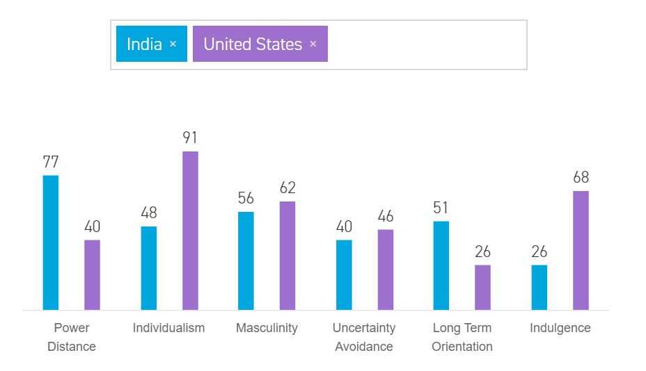
(Hofstede, 2018)

  - Culture effect management of people

While business management styles differ from country to country, ethics and expectations effect all business transactions. There are believed to be many ethical differences between effective management in China and the USA, they have different perspectives and ethics. A management style that works in the European world may not in China. When American’s enter the Chinese market, the potential for ethical conflict increases. It is vital for Western marketers to understand the cultural bases for ethical behaviour in both USA and China. (Pitta, et al., 1999) Over the past decade foreign investment has grown in China, accompanied by an influx of expatriate managers with responsibility for managing joint ventures and subsidiaries. KFC have used an application of knowledge of cultural differences. (Sergeent & Frenkel, 1998) Thus, for many businesses, it is very important for manager and staff to understand cultural diversity. (Bartolome, 2017) The use of a conventional management style is decreasing as globalisation progresses and more and more businesses deal with multiple cultures and countries.

Discussion

The most effective way to adapt to marketing in different culture is to strategies and study them first. McDonald’s adapted very well in the Indian market and understood them. However they did not embrace the Chinese market as well as KFC had done so. America and China have been subject to comparison in many academic fields of research. KFC and McDonald’s had to make a lot of considerations and preparations before ever embarking on business within China. “Although these two countries have similar ambitions to dominate the world economy, their culture and mind-set is like east and west (pun intended).” (Tan, 2015) The collective and individual trait is perhaps the most important dimension of cultural differences across diverse culture, (Triandis, 1988) Americans strongly believe in individuality, they prioritise personal goals and motives over collective ones. They focus on making a difference, unlike the Chinese who make their decisions how hoe they will be preserved by those around them. As discussed family comes first and they avoid confrontational manners at all costs. The finding show American’s to be very upfront and challenging. “They often cause misunderstanding or sometimes, even hurt the feelings of Chinese people. (Tan, 2015) American culture id to be defensive of their ideas, and they often lead a debate in getting the other person to believe what they do. As discussed the Chinse behaviour/ communication towards this would just be to “nod” or agree even if they believe it to be wrong, and always use very indirect ways of voicing their views. “They do this to respect and honour others’ opinions.” (Tan, 2015) Americans openly talk about themselves and are sometimes perceived as rude and they can get personal quite quickly, China on the other hand have a very respective and trusting culture, and do not wish to be involved in discussion about other people. Earlier in this paper the Chinese relationship was referred to as “guaxi”. They strongly believe in this and conduct it in business, they believe in socialising and meeting in large groups, very different to that of America, but both KFC have implemented this within their business by transitioning to more of a restaurant than that of fast food in the USA, they have adapted kitchens and made eating space larger and inviting.

The values of American and Chinese are both interesting, and unique. Because of their cultural difference confrontation may become unavoidable for the Chinese, but throughout long term relationships and consideration these cultural differences could come together.

References

Bibliography

Ali, M., 2015. Impact of culture on international Business. [Online]
Available at: https://www.linkedin.com/pulse/impact-culture-international-business-ali-muhammad-mba-acca-uk-

Alon, I., 2003. Chinese Culture, Organizational Behaviour, and International Business Managment. Westport: Praegar Publishers.

Anon., 1998. Same Kentucky Chicken, Different Taste: Cross-cultural Leadership Studies at KFC in Beijing. [Online]
Available at: https://vtechworks.lib.vt.edu/handle/10919/36848

Bartolome, A., 2017. Abs Cbn. [Online]
Available at: http://news.abs-cbn.com/business/06/30/17/business-mentor-how-cultural-differences-affect-doing-business
[Accessed 2 May 2018].

Bell, D., 2011. Emerging Markets KFC's Radical Approach to China. [Online]
Available at: https://hbr.org/2011/11/kfcs-radical-approach-to-china

Berling, J., 1980. The syncretic Religion of Lin Chao-en.. New York: Columbia University Press.

Coombs, W. T., 2007. Ongoing crisis communincation: Planning, managing, and responsding. 2 ed. Thosand Oaks : Sage.

Cultural Atlas, 2018. Cultural Atlas. [Online]
Available at: https://culturalatlas.sbs.com.au/indian-culture/indian-culture-communication
[Accessed 2 May 2018].

Delios, A., Wu, Z. & Day, P., 2014. China 88 The Real China and How to Deal with it. Upper Saddle River, New Jersey : Pearson .

Deresky, H., 2016. International Management: Managing Across Borders and Cultures: Text and Cases. London: Pearson Publications.

Halmstad, 2009. American fast food in Chinese Market: A cross cultural perspective , Halmstad: University of Halmsted.

Hexter, J. & Woetzel, J., 2007. Operation China: From Strategy to Execution. 1st ed. United States: Harvard Business School Press .

H. H., 2007. Croos-culture marketing: KFC in China.. The international journal of educationa nd managment , Volume 1, pp. 263-265.

Hofstede, 2018. Hofstede Insights. [Online]
Available at: https://www.hofstede-insights.com/product/compare-countries/
[Accessed 2 May 2018].

Hofstede, G., 1984. Cultures Consequences, Internationsl differneces in work-related values. London, UK: Sage.

Hofstede, G., 1994. Uncommon Sense About Organizations: Cases, Studies, and Field Observations. Thosand Oaks: Sage Publications.

Hofstede, G. J., Jonker, C. M. & Verwarrt, T., 2010. The Influence of Culture on ABMP negotiation Parameters. Verlag Berlin Heidelberg: Springer.
Hult News , 2017. Hult INternational Business School. [Online]
Available at: http://www.hult.edu/blog/cultural-differences-impact-international-business/
[Accessed 3 May 2018].

Markgraf, B., 2018. Cultural Adaption in the global market. [Online]
Available at: http://smallbusiness.chron.com/cultural-adaptation-global-marketplace-68239.html
[Accessed 4 May 2018].

McMahon, D., 2009. KFC IN CHINA: SECRET RECIPE FOR SUCCESS. ProQuest, 172(1), pp. 67-68.

Pitta, D. A., Fung, H.-G. & Isberg, S., 1999. Ethical issues across cultures: Managing the differeing perspectives of China and the USA. Journal of Consumer Marketing , 16(3), pp. 240-256.

Sergeent, A. & Frenkel, S., 1998. Managing people in China: Perceptions of expatriate managers. Journal of World Business , 33(1), pp. 17-34.

Singh, N., 2012. Localization Strategies for Global E-Buisness. Cambridge : Cambridge University Press.

Spencer-Oatley, H., 2008. Culturally Speaking, Culture, Communicatin and Politness Theory. London: Continnum International Publishing Group.

Tan, J., 2015. Goldstar. [Online]
Available at: https://goldstarteachers.com/7-differences-between-chinese-and-american-culture/
[Accessed 5 May 2018].

Ting-Toomey, S., 1999. Communicating across cultured. New York: The Guildford Press.

Tong, I., 2012. Slide Share. [Online]
Available at: https://www.slideshare.net/IvyTong/analyzing-mcdonalds-pr-strategies-in-india
[Accessed 2 May 2018].

Triandis, H., 1988. Collectivism v. Individualism: A reconceptualisation of Basic Concept on cross cultural social Psycology. 1st ed. London: Palgrave Mcmillian .

USCBC, 2010. Negotiations, Chinesse Style. [Online]
Available at: https://www.chinabusinessreview.com/negotiations-chinese-style/
[Accessed 1 November 2018].

Warburton, K., 2017. World Business culture. [Online]
Available at: https://www.worldbusinessculture.com/country-profiles/the-usa/culture/business-communication-style/
[Accessed 3 May 2018].

Wen, T. Y. W., 2003. Crisis communication in Chinese culture: a Case Study in Tiwan. Asian Journal of Communication, 13(2), pp. 50-64.

Zhu, L. & Anagondahalli, D., 2017. Social media and culture in crisis communication: McDonald's and KFC crises management in China. Public Relations Review , 43(3), pp. 487-492.

