Benjamin Atkins (1809782)
1809782@student.uwtsd.ac.uk
ACCA5023 – Network Operating Systems and Services
Worksheet 1
264
Table of Contents
- Introduction
- Implementation evidence
- Observational Tasks

- Introduction
The aim of this assignment worksheet was the creation of a small LAN consisting of 2 Windows server 2019 virtual machines and 2 Windows 10 client virtual machines in the Virtualbox software program as well as conducting various observational reflections on the technologies.

- Implementation
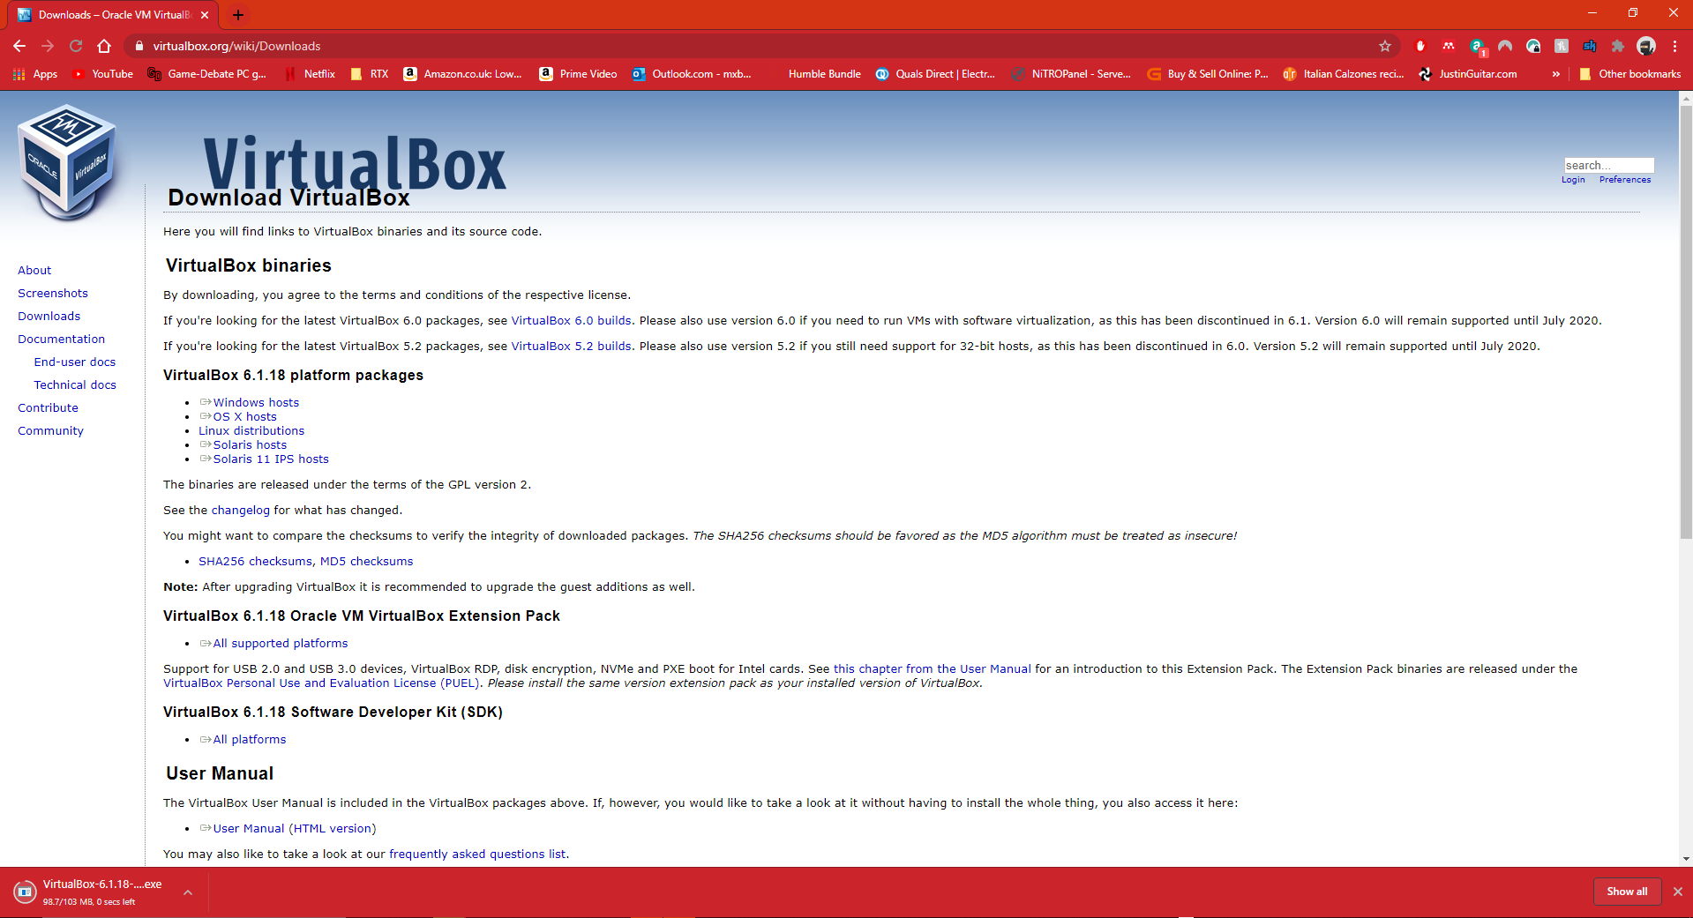
First I navigated to the Virtualbox download page and downloaded the software installer
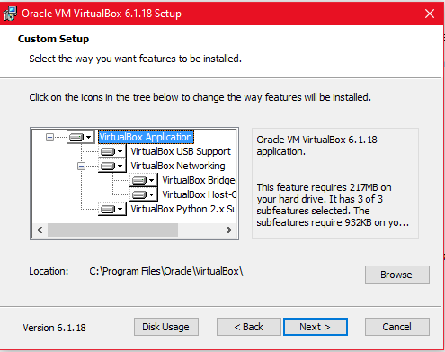
virtualbox was then installed on my desktop PC

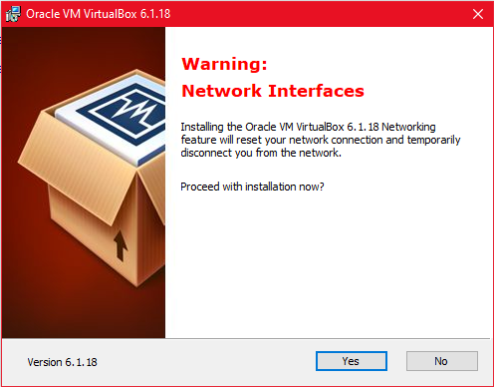
The virtualbox network adapter was also installed within this process

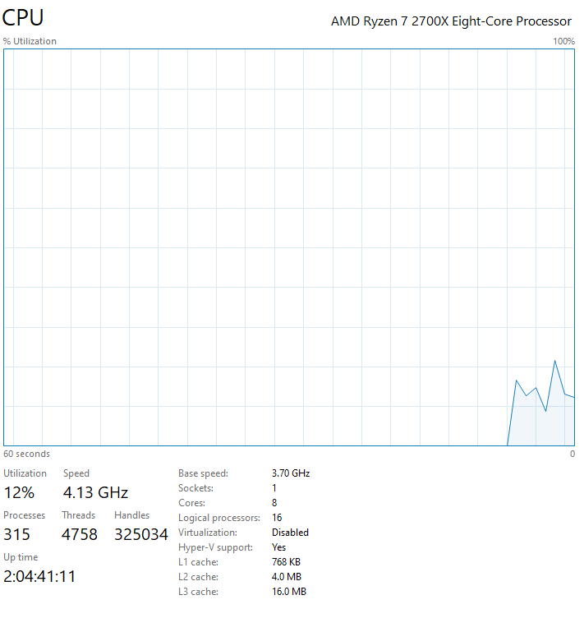
It was at this point I realised that virtualisation was not enabled within the BIOS following a recent BIOS flash update. once I had entered into the BIOS and enabled this however my computer went into startup repair multiple times, following some troubleshooting and eventual startup recovery by entering the PCs recovery partition this was resolved.

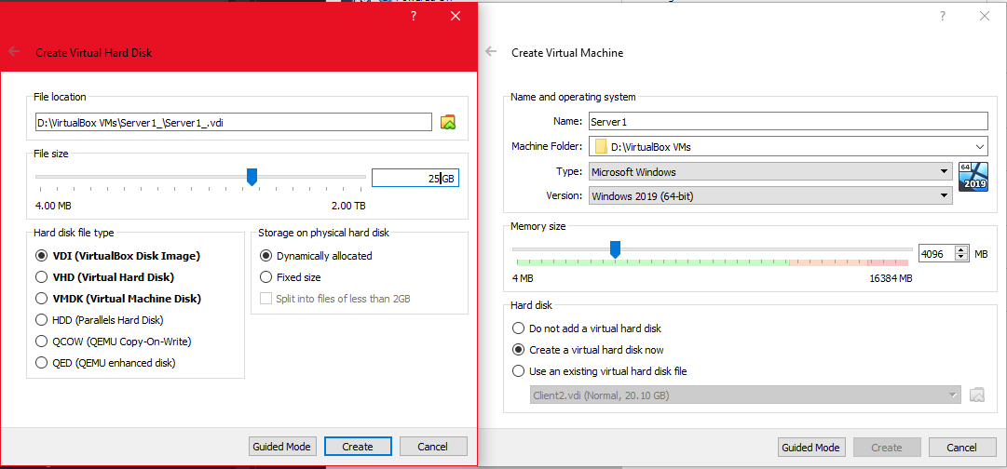
Now that this was enabled and I was able to fully uttilise my processors virtualisation capabilities allowing for functioning 64bit VMs I began to setup the 4 VMs needed

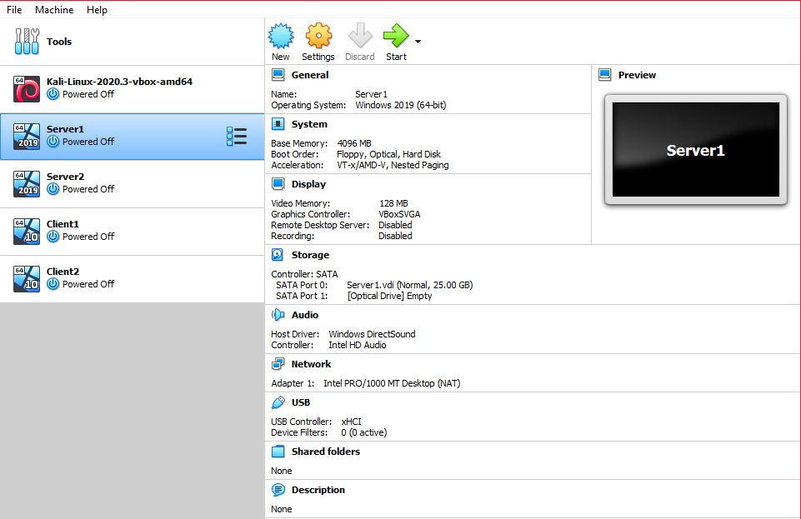
Screenshot of all VMs within Virtualbox

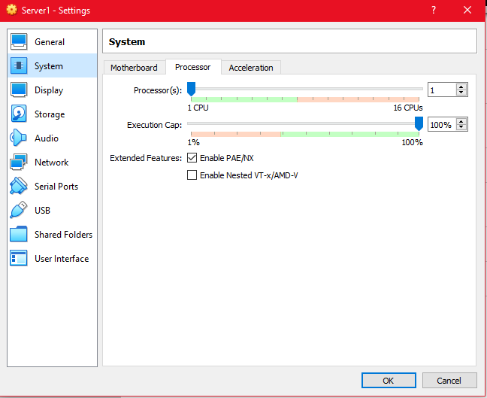

I then enabled PAE/NX for all VMs
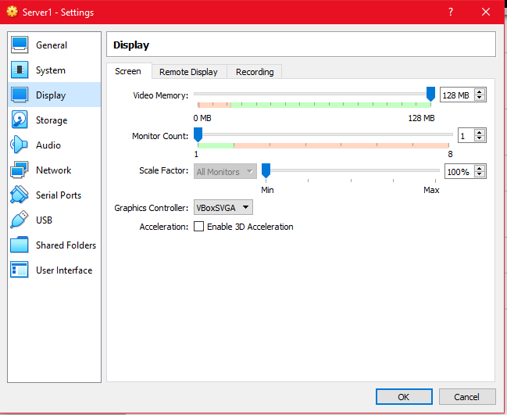
As well as allocating the correct among of video memory

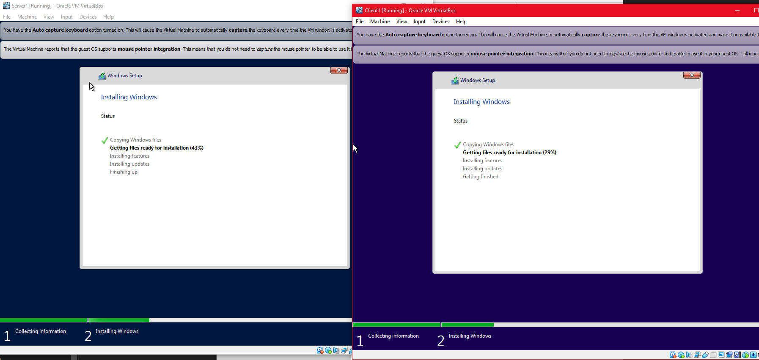
I then installed the relevant operating system for all VMs this began with me mounting the correct ISO to each virtual machine on boot of the VM

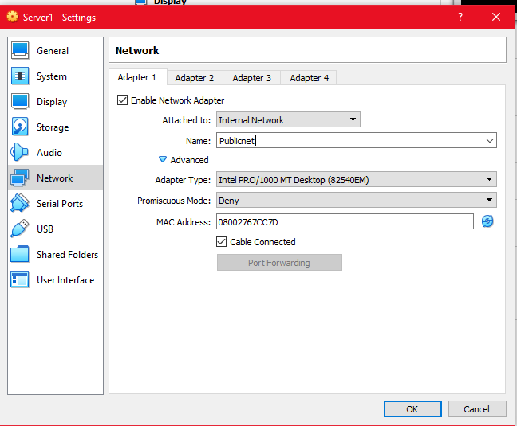
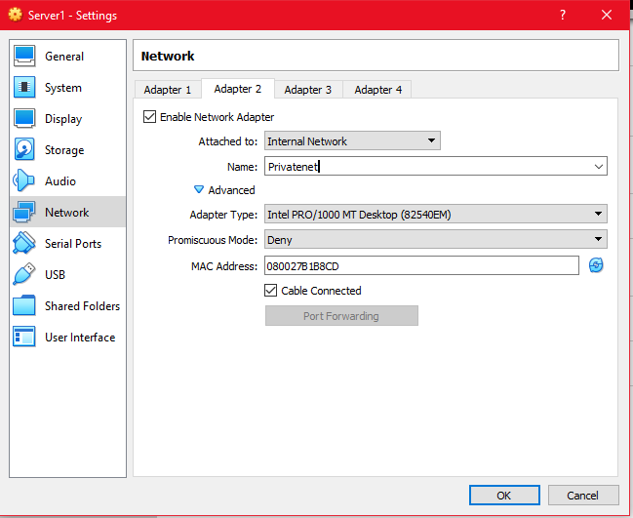

Once the operating systems were installed and configured the virtual machines were closed and I began to enable the network adapters for each of the VMs, this included the publicnet and privatenet1 + 2 network adapters

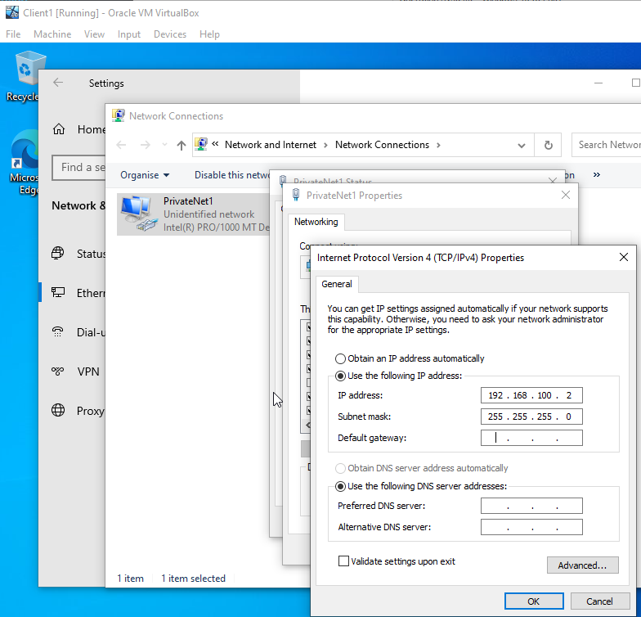
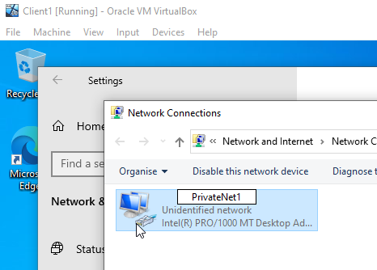

I then booted the virtual machines up again, this time navigating the the network adapter setting within control panel, I renamed each of the network adapters to their respective names in order and assigned them the corresponding IPv4 address and subnet mask

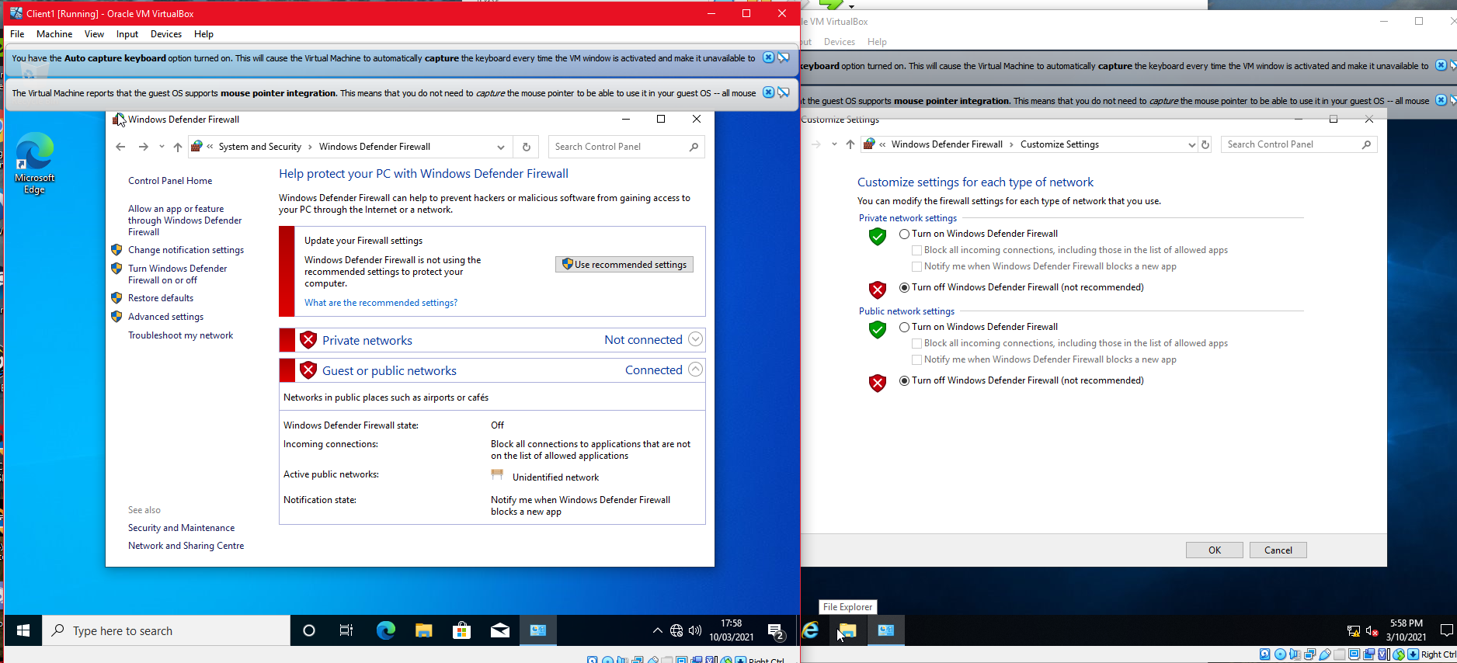

Once all the network adapters were configured and validated I then went into control panel again and disabled the windows firewall for public and private networks on each of the virtual machines

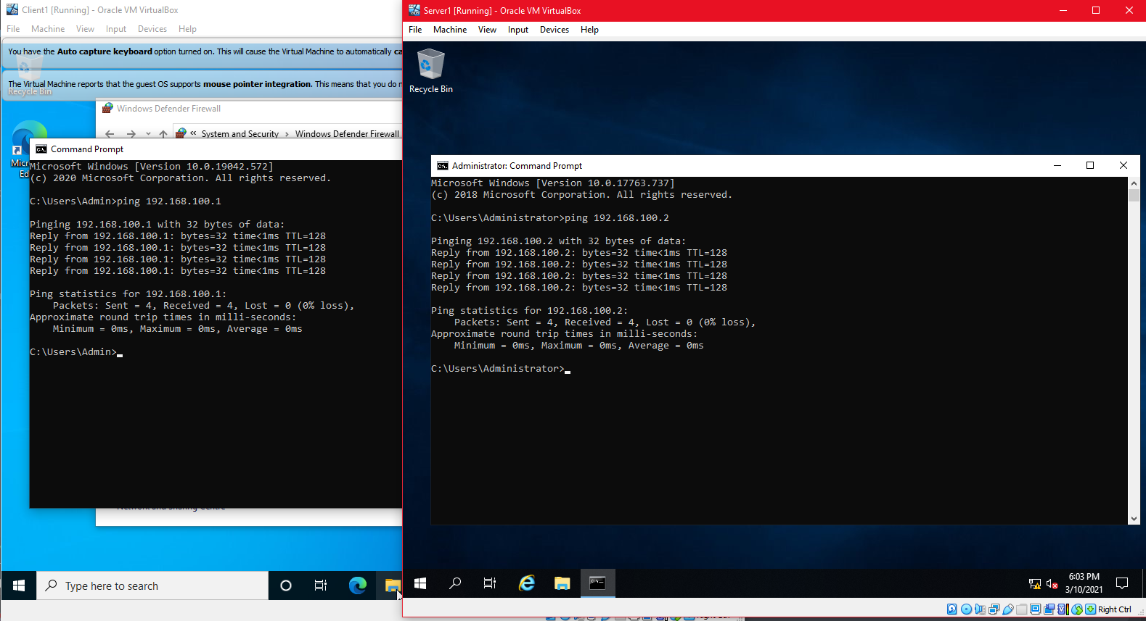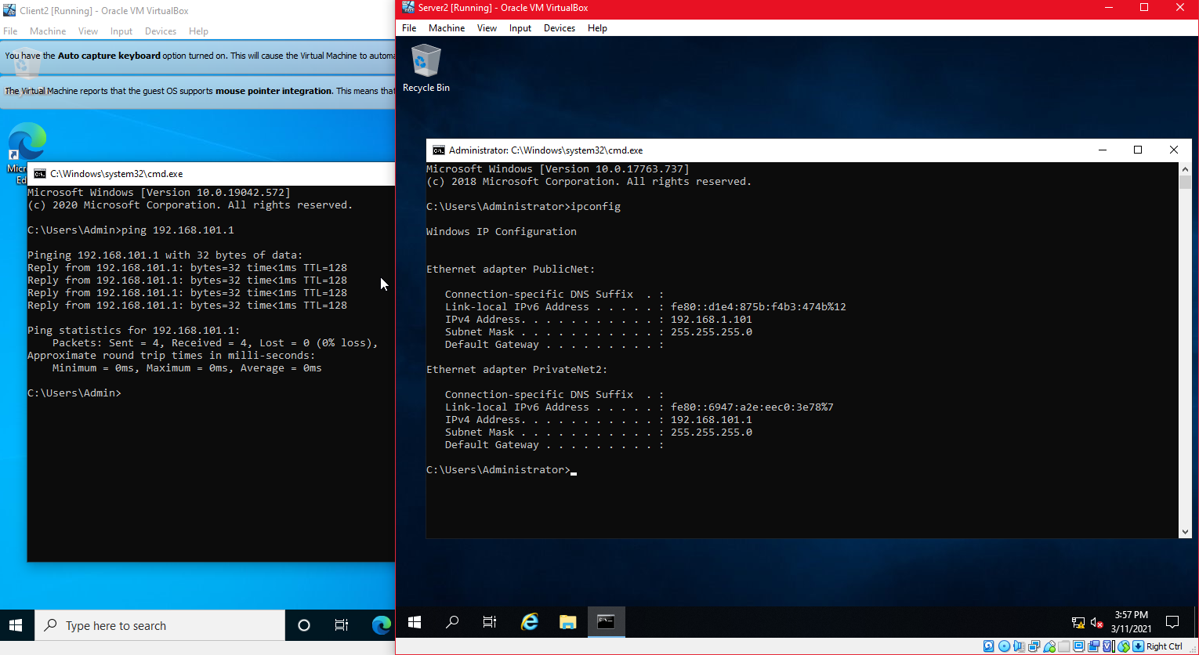

Now that the networks were fully configured I tested the connection of the 2 clients to the 2 respective servers with a ping command, this validated the successful connection and that my configuration was correct.

3. Observational Tasks
a) Describe the main differences between Type 1 and Type 2 Hypervisors. Identify benefits and drawbacks of both and provide some example Vendors.

The primary difference between type 1 and two hypervisors is whether they run on top of another operating system or on the ‘bare-metal’ of the hardware [1].

Type 1 Hypervisors are run on this ‘bare-metal’ which means that it is executed directly onto the machine’s hardware and therefor has access to the direct hardware of the machine, this means that it does not require another operating system to be loaded for them to function on top of or contest for resources against, meaning that they usually have far greater performance over type 2 hypervisors for this reason. [2] As they are not run with an underlying operating system they tend to be very simplistic in nature when configuring the hypervisor itself and most and configured through CLIs (command line interfaces) although configuration can be ousted to a remote management console if required. More features of type 1 hypervisors include the ability to move virtual machines between servers on an automatic or manual basis, this allows for (with correct configuration) the ability to quickly failover software and services to other hosts when an issue arises. They also allow for the over-allocation of server resources to the virtual machines, you may allocate more memory than the server has with the anticipation that one or more virtual machine will not be consuming all of its assigned resources at one given time allowing for far greater performance with proper management. [3]

Some example vendors of type 1 hypervisors include: Windows Hyper-V, Oracle VM, VMWare vSphere & VMWare ESXi.

Type 2 Hypervisors operate conversely to Type 1’s with an additional ‘shell’ around where the virtual machines are actually situated on the host machine. The hypervisor runs from an operating system, and are therefor sometimes referred to as hosted hypervisors and are usually used for setting where a smaller number of servers is necessary.

The hypervisor itself is simply run as an application on the host machine and as this is the case configuration can occur graphically with little to no need for a remote management console. They fall short in the sense that they must compete with the OS for physical resources on the host machine and in this case are more suited for testing of new software.

Some of the available vendors of type 2 hypervisors include: VMWare Workstation, Oracle Virtualbox & Microsoft Virtual PC

This is where the differences come into play as type 1 hypervisors offer a more dynamic approach to hosting virtual machines as any resources assigned to them are not immediately consumed and held for the duration the VM is running, unlike type 2 hypervisors. With this said Type 1 hypervisors are usually more suited for enterprise environments and provide them the necessary redundancy and granular configuration necessary for modern software and services.

b) What is the significance of the subnet mask in IPv4 addressing?
Subnetting was designed and implemented as a solution to the ever increasing scale of modern computer networks. As networks started to switch from hubs to switches the need for this became more apparent as latency would increase, therefore this subnetwork system was devised. It operated mainly like a logical partition and allows the network to be divided up into smaller more manageable segments. This coupled with the ability to use VLSM (variable length subnet masking) allows for a very granular division of the network reducing latency further. This is why it has become a staple of IPv4 addressing in modern technology. [4]

c) Cloud computing has revolutionised the way that enterprise networks are hosted. Describe the use of cloud computing including its benefits and drawbacks and identify example vendors within the industry.

Cloud computing has allowed companies around the world to upload its software and services to instead be hosted by these cloud computing providers. This has allowed business to retain the same level of service and even increase it by outsourcing it to instead be hosted on the cloud provider’s hardware. This creates a number of advantages and disadvantages to instead having these services hosted on premises. Whilst most are dependant on the provider selected for the most part this operates on the assumption that adequate research took place and that the provider selected was reputable and a provided a good level of cloud computing service.

Benefits:
Start-up cost – one of the main benefits come it becoming no longer necessary to purchase hardware for the service infrastructure, this means that businesses can save on having to provide the high capitol necessary for these servers to be set up.
No more geographical boundaries – as cloud providers provide high speed and mostly global access to the infrastructure, geographical border for accessing system usually hosted in one location of the glob is no longer a hinderance on the business.

No management – businesses are no longer required to hire and pay staff to install and manage the hardware to run the services this adds to the financial benefits of utilising cloud providers.

Multiple financial models – as well as having the option to simply pay for the hardware specifications required on the machine, most providers also offer customers the option to pay-per-use and sometimes per execution on the hardware, allowing a more scalable approach that depending on the configuration and service required can further add to the financial savings.

Drawbacks:
Requirement for internet connectivity – should you face loss of internet access you have lost access for the management of your cloud infrastructure unlike with on-premises hosting where physical interfacing is a viable option.

Lack of control – whilst the GUIs provided by the providers are usually very intuitive and provide most of the features necessary, you rely solely on these for the configuration of your software and services, with very little bearing on the hardware and (usually) hypervisor it is hosted upon this may lead to problematic troubleshooting especially when support staff on their side may not be immediately available to help you in what you consider to be business critical.

Security – although still a concern when hosting on-premises you must be aware you are relying on a 3rd party to manage you’re data as well as this relying on their ability to secure it for you and giving you little oversight of this.

Some example vendors of cloud computing include: Amazon web services, Microsoft Azure, Google Cloud & oracle
[5][6]

d) Give an in-detail description about the different terminologies and its purposes (like (not limited to) Ping, Server Management, Firewall, PAE/NX, OOBE etc) you came across during the Task 1 and Task 2. Compare your list of terminologies in the aspect of their operations/functionality with other Network Operating Systems. (For example: If you select Windows Firewall and describe the operations/functionality of Windows Server 2019 Firewall, you have to compare these features with the operations/functionality of other Network Operating Systems like Linux, Mac)

Ping – ping is a bash command and synonymous across many CLIs throughout computing. It operated by sending an ICMP (Internet Control Message Protocol) echo request to a specific target and in order to verify a successful (and if a required test) stable connection can be made. [7] The command allows for various configuration that dependant on the needs of the testing such as increasing the number of pings made, the time to live for each ICMP request and the size of the packet sent (defaults to 32 bytes)

Ping requests have become used very widely in DOS (Denial Of Service) and DDOS (Distributed Denial Of Service) attacks, known as PoD (Ping of Death) as they can be used to flood one host with requests forcing them to respond and subsequently consuming all resources of the machine sometimes to the point where it can crash. [8]

Another synonymous use is to use the ping command to ping the loopback address (127.0.0.1) which validates the function of the network adapter to establish a TCP/IP connection.

PAE/NX – Physical Address Extension (PAE) is a feature that allows a x86 (32-bit) processor access to more than 4GB of physical memory on a machines and are therefore also required to host 64 bit operating systems. When this comes to virtualisation this functions much in the same way.

No-eXecute (NX) is an additional feature to this which provides systems the capacity to mark memory pages if it wishes as non-executable. This is to further security for any malicious attacks that may wish to run these pages or prompt the system to do so. It is utilised by the DEP (Data Execution Protection) feature within Microsoft Windows.

