Introduction to Weka

This tutorial is intended to introduce you to the Weka software by performing a simple classification task.

The data set to be used is the best known database in the field of pattern recognition, the Iris Plants Database. It contains 150 data instances, 50 of each of three species of iris and records
- Sepal length in cm
- Sepal width in cm
- Petal length in cm
- Petal width in cm
- Class - Iris Setosa, Iris Versicolour or Iris Virginica

1. Run Weka
From the Start menu, select the Weka 3.6.14 folder and run the Weka 3.6 shortcut. This will open up the Chooser (figure 1).

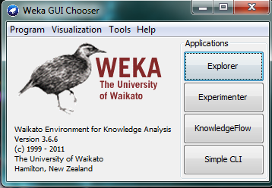
Figure 1 -- Weka Chooser
Click on Explorer to open the main Weka window (figure 2).

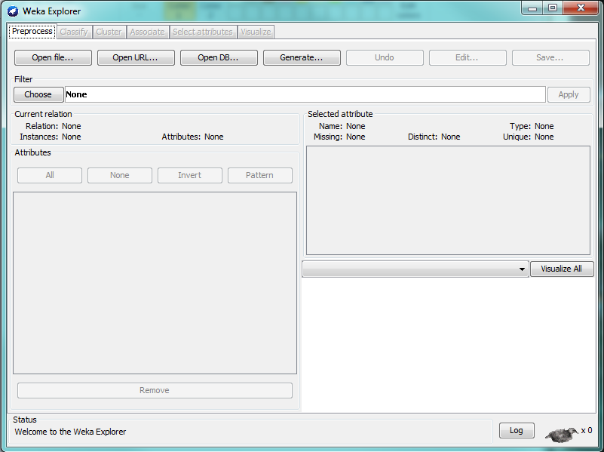
Figure 2 - Weka Explorer
2. Data files for Weka
Weka files are stored in Attribute-Relational FileFormat (.arff) files. These are ASCII text files that describe a list of instances sharing a set of attributes and are split into two sections, the Header, followed by the Data.

The Header contain the name of the relation, a list of the attributes and their types, e.g.

% 1. Title: Iris Plants Database
%
% 2. Sources:
% (a) Creator: R.A. Fisher
% (b) Donor: Michael Marshall (MARSHALL%PLU@io.arc.nasa.gov)
% (c) Date: July, 1988
%
@RELATION iris

@ATTRIBUTE sepallength NUMERIC
@ATTRIBUTE sepalwidth NUMERIC
@ATTRIBUTE petallength NUMERIC
@ATTRIBUTE petalwidth NUMERIC
@ATTRIBUTE class {Iris-setosa,Iris-versicolor,Iris-virginica}

The Data contains the actual values as a comma-separated list, e.g.

@DATA
5.1,3.5,1.4,0.2,Iris-setosa
4.9,3.0,1.4,0.2,Iris-setosa
4.7,3.2,1.3,0.2,Iris-setosa
4.6,3.1,1.5,0.2,Iris-setosa
5.0,3.6,1.4,0.2,Iris-setosa
5.4,3.9,1.7,0.4,Iris-setosa
4.6,3.4,1.4,0.3,Iris-setosa
5.0,3.4,1.5,0.2,Iris-setosa
4.4,2.9,1.4,0.2,Iris-setosa
4.9,3.1,1.5,0.1,Iris-setosa

Lines that begin with % are comments.

3. Loading and exploring data
To load data, click on the Open File... button and select the file iris.arff from the selection window. This will load it into the explorer window (figure 3). On the left of the window are shown the attributes within the data file. In the upper right are shown the basic statistical descriptors of the chosen attributes. Below this is a visualisation of the data set. Selecting different attributes in the left-hand panel will change the related displays in the right-hand panel.
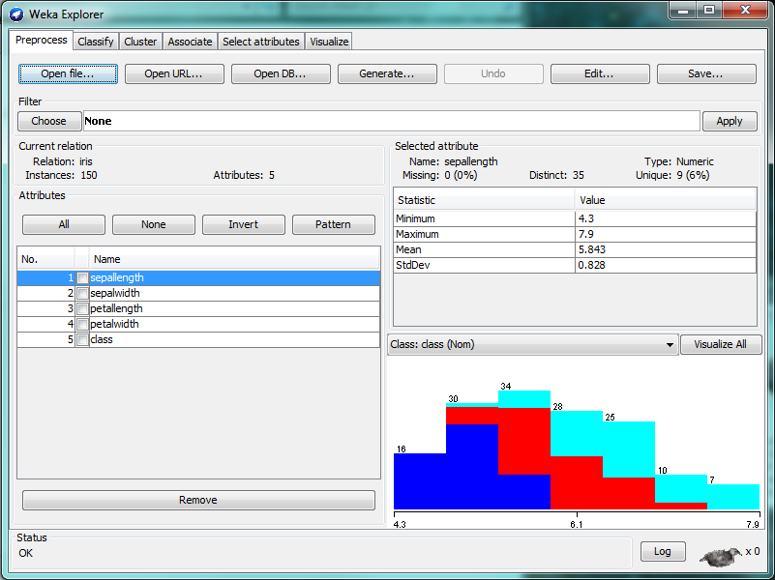
Figure 3 - Explorer with Iris data
Clicking on the Edit... button will open a further window that shows the original data (figure 4).
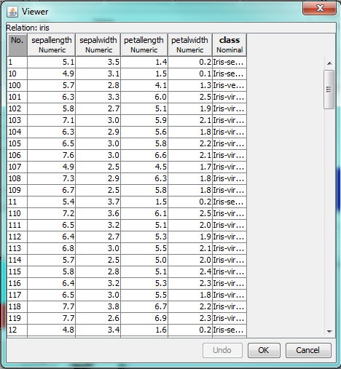
Figure 4 - Data Viewer
The data can also be visualised as a set of histograms by clicking on the Visualise All button to the upper right of the histogram (figure 5).

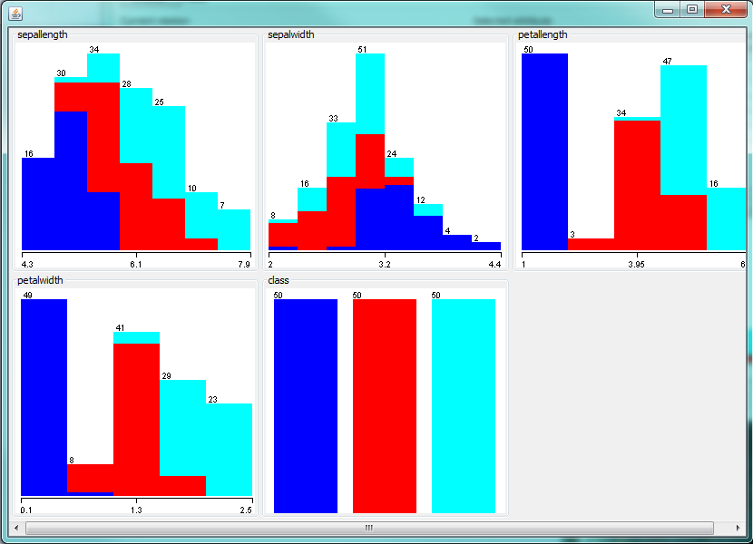
Figure 5 - Visualising all of the data
4. Classifying Data
To perform a classification task, click on the Classify tab then click on the Choose button. This will allow you to select one of a number of different classification methods; select the J48 method from the trees category (figure 6).

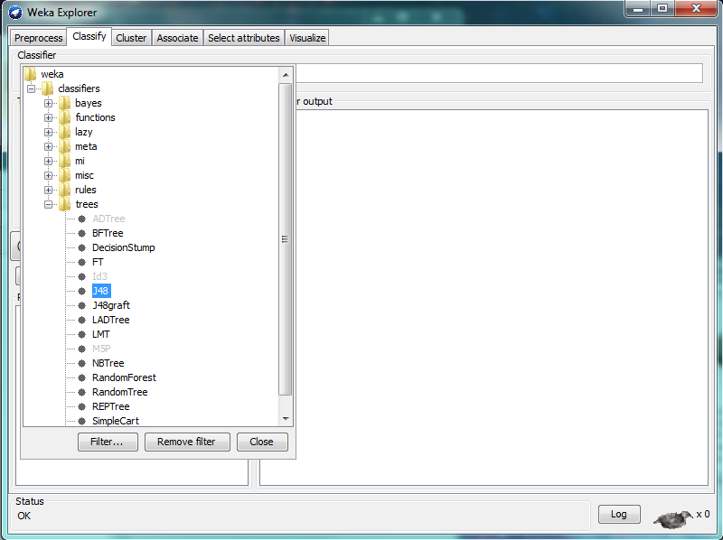
Figure 6 - Selecting a classification method
Once the classification method has been selected, click on the Start button to begin the classification. The result will appear in the right-hand pane of the classification window (figure 7).
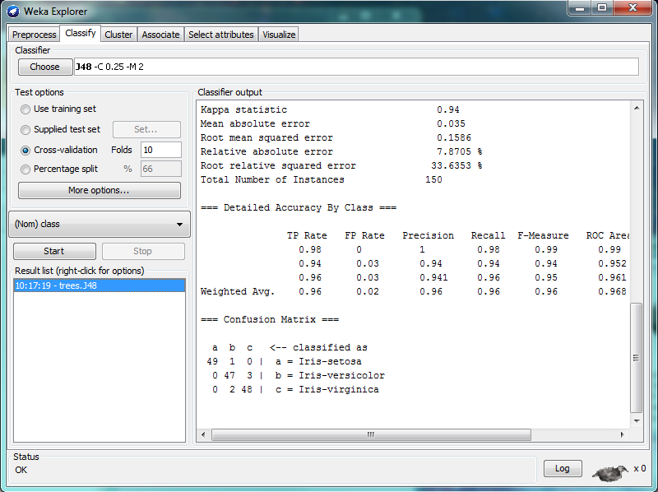
Figure 7 - Output of classification process
The output pane shows information about the input data, a classification tree showing how the data has been classified and statistical information about the accuracy of the classification. The classification tree can be displayed in a more understandable manner by right-clicking on the appropriate operation on the Result list on the left and selecting Visualise tree from the pop-up menu (figure 8).

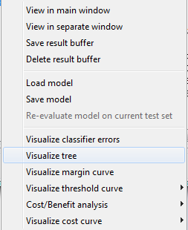
Figure 8 - Visualisation options
The classification process is then displayed as a tree-like structure explaining the rules used for classification of the data (figure 9).

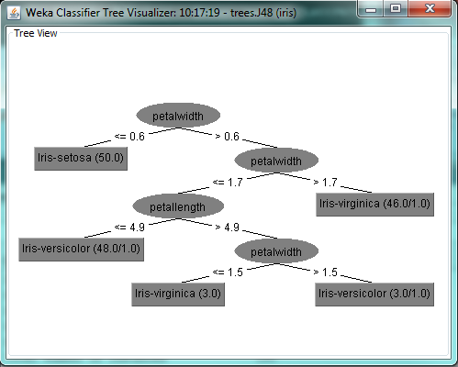
Figure 9 - Classification tree
The results of the classification can be saved by right-clicking on the appropriate operation in the result list and selecting Save Model from the pop-up menu shown in figure 8.

This simple classification task does not include any pre-processing, nor has it looked at different classification techniques or how to decide which is the best technique for a given data set. All of these factors will be addressed later in the course.

