/8/

Gheorghe Trifoi 2030295
Tutor: Hossein Shokri
Problem Solving and decision making
BMSW4004
Problem - The lazy co-worker
Table of Contents
INTRODUCTION 2
PROBLEM ANALYSIS 2
The identified Problem 3
Own research conducted on the construction site 3
Cause and effect analysis of the lazy coworker (Fishbone diagram) 4
Solutions 5
Decision making process 5
CONCLUSION 6
REFERENCES 7

INTRODUCTION
This work is trying to find solutions to a work-related issue from own place of work in the construction industry. The work-related issue concerns passive people that are unhappy with their job and this effects their performance and the companys. Different methods and strategies will be used to assist discover what caused the employees' dissatisfaction with their issue to find a solution to the problem.
The purpose of this report is to identify the issue of “the lazy co-worker” in the workplace, using tools to find what reasons caused the problem and propose appropriate ways to fix the situation. Research on different literature works will help to understand employee job dissatisfaction and how to apply tools to solve a problem in the working environment.
Being a difficult and complicated process, problem-solving can be important for the success of a company and employees wellbeing reason for the leaders and organisation to consider options to identify, analyse and solve a problem. Many organizations are taking different approaches and use tools and strategies to face challenges. One of them is cause and effect analysis, this can help you to find ways to addressing an issue.

PROBLEM ANALYSIS
Straus (2002) defines problem as a “situation that someone wants to change” saying that problem solving is the process of resolving or acting on an issue and it involves many of our daily activities, like communicating, learning, planning, working, and making decisions. An issue can be described as any circumstance where a gap exists between what is and what should be,' according to Proctor (2018). He explains that to solve a problem you need to go through a process of first identifying the problem properly, after the problem must be analysed and a solution or solutions found and evaluate the benefits and disadvantages of each one. In the end a solution can be chosen but if it doesn’t work is good to have an alternative solution.
In an article philosopher Neel Burton (2014) talks about laziness and says that a person is lazy because of the effort that he needs to put in the activity and not that he can’t complete the activity. According to evolutionary theory, nomads was in the past lazy because they had to save energy to fight to survive focusing their efforts only on short-term gain. Today is about long-term gain effort that brings the best results, not about survival. Our natural impulse is to save energy and avoid effort that is unnecessary.

The identified Problem
In any work environment, no matter the company and the type of job people are doing, there is always someone that is running away from work in a way or another. A lazy person in the workplace can create different issues between coleagues and impact on the everyday activities and productivity of the team or company. A good example to describe this type of issue is from my own workplace. Work in construction as a steel erector is a difficult job to do and it involves mostly physical work but like in any job, there are days and days. But this is not a reason for people to run away and hide from work. And it happens a lot and other people work more or cover for the runaways or the lazy workers that find different reasons like smoking, a toilet break or just other unknown reasons. From own experience and what I observed recently it can be stressful and is affecting you physically and mentally. This type of work environment gives me anxiety and decreases my level of productivity It also affecting my personal life as I feel irritated and stressed about small things. What I found is that a difficult worker pulls the team down and is distracting the others plus is damaging the relations with other colleagues. Facing the person in cause might not be a good idea because of their reaction plus is better to avoid conflict. Going to the manager is a good idea but then you will be looked like a gossiper. Sure, there are reasons for a person being lazy or is just their nature to behave like that. Gazioglu et al. (2006) explains that personal or job characteristics are reasons for job dissatisfaction like people are dissatisfied with their job or don’t like their job or their manager, their wellbeing is not taken cared for in the workplace, or maybe he feels even being underpaid and this can all be reasons to avoid work. Help is needed from the managers to solve a situation like this but what they can do will be looked at in the next part of this work.

Own research conducted on the construction site
To help with this study, I asked more people on the construction site some questions to see if they experienced lazy colleagues an how they fell about it. More then 15 people have said their opinion on lazy coworkers and there wasn’t one that did not have or seen someone not doing their work or running away from duties while on site. Some have been affected directly or indirectly and were disappointed saying that have worked more or harder, had more overtime, managers have not been fair and avoided them, others had low self-esteem, were angry and even conflicts happened.
According to a psychological theory people are lazy maybe because the job that they are doing is paying their bills and is not what they want to do. Other reasons that cause people to be lazy is fear and pessimism. Fear is making them be afraid to succeed or maybe don’t trust themselvs enough and this is making them lazy. In the long run, the only way to fight laziness is to understand what is causing it and its nature, to think, and gradually find a better way of life (Burton, 2014).
Analyzing more information on the problem of laziness in the workplace is clear that this is an issue facing every company and is one of many other reasons of job dissatisfaction in employees. Lazy workers do just enough to avoid being fired, they are not engaged employees and take shortcuts whenever possible (Baker, 2012).

Cause and effect analysis of the lazy coworker (Fishbone diagram)
The picture atached shows the main causes found in my workplace that might cause the coworker to be lazy, it was done using a fishbone diagram, it looks like a fish skeleton and is a useful tool to analyze a problem. It helps to find the reasons that problem happened, a cause and effect of the issue (Coccia, 2017).
-*-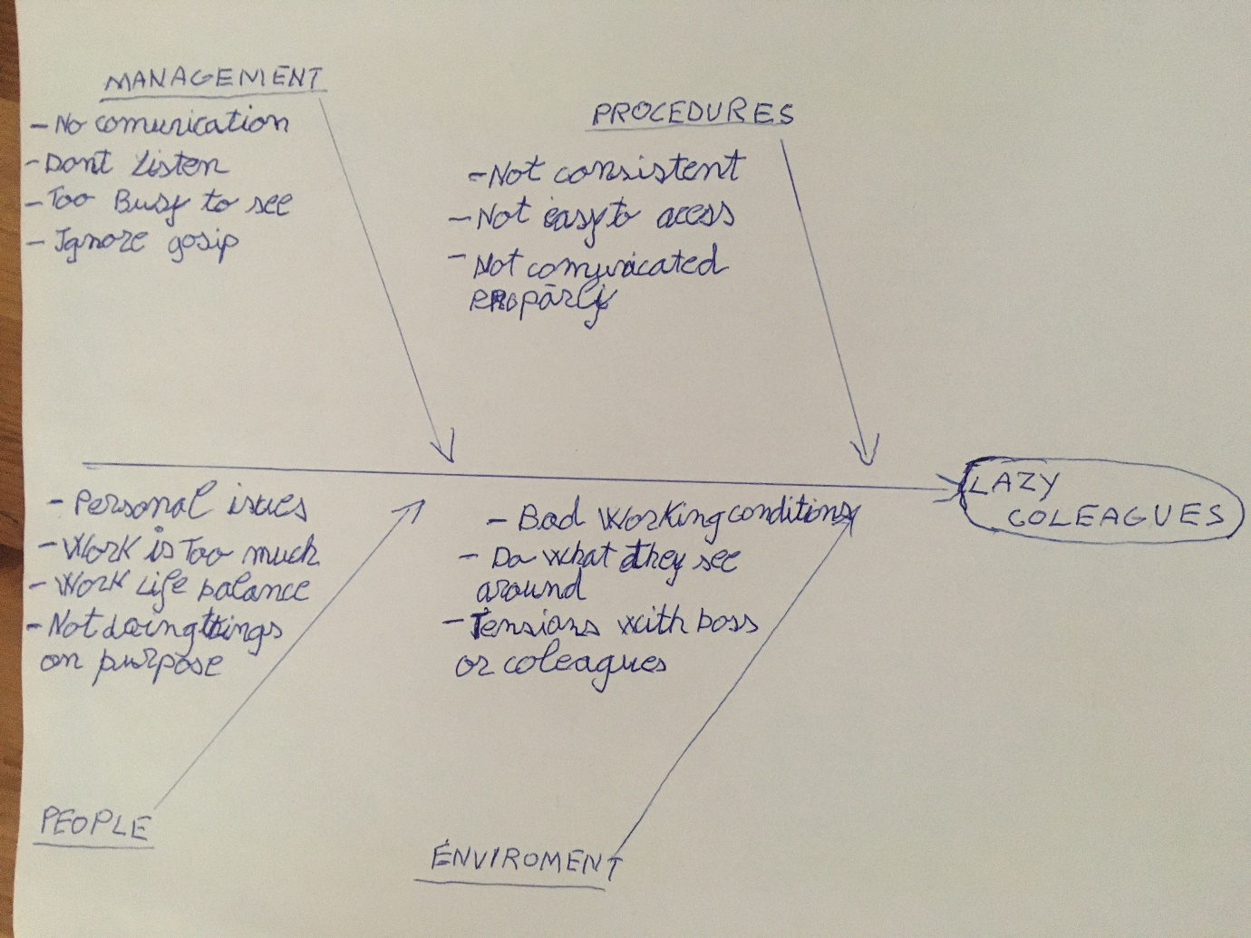
The issue of the lazy coworker on the construction site I work, needs attention from the management as it is starting to affect the other workers, with gossiping and also the performance of everyone is low, work being slow too. There might be too busy to see the specific person because they ignore the gossip and focus more on work. Manager do not communicate with the people much and this affects people’s morale and performance. The procedures are not consistent and not easy to access causing the people to forget what their duties are and how they should do their work. The people intentions might not be intentional, their work life balance is affecting their performance, or the work might be too demanding or personal issues are interfering and this is making my colleague to avoid work. The work environment has a negative impact on my colleague because there is not a very good atmosphere between colleagues, he doesn’t enjoy his work plus he maybe is doing what he sees around.

Solutions
- The management can:
- interact with staff by communicating and listening to them, ask them about issues in the workplace, this will make them feel valued.
- The HR could implement an action plan to train and help them improve as employees. Maybe the lazy colleague is not prepared for the task at hand and need new ways of completing it with training
- Fire them/him if is the right choice but this might affect their self worth
- Review their way of leading a team
- Give clarity to the workers about what they need to do and how to do it and also check their work performance
- Do surveys with employees about work related issues, people might be stressed, they need to be motivated
- As a colleague you can:
- Try and talk with the lazy colleague explaining what is happening and how his behavior affects you and other colleagues
- Listen to him, he might have a problem
- Stand up and tell him you are not doing any work for him
- Don’t do anything as you can look like a gossiper and can ruin the relation
- Talk to the manager, tell him what is happening, and that work is affected by what is happening.

Decision making process
Critical thinking helps decision-making process to identify problems and analyse the best possible solution to a problem. More, when combined with the individual's creativity, it contributes to the analysis and reflection on the circumstances as well as the development of solutions to the situation or problem (William, 2001). He suggests to be rational when making a decision and follow the process of identifying the problem, in this case the lazy coworker; define the criteria that can influence the decision making process, cause and effect analysis; find alternative and evaluate them to find the pros and cons taking into account organizational barriers and external implications, then implement the chosen option and follow with feedback to check if it was helpful or not. Morgan (2016) also agrees that creativity is essential to find solutions to problems as an individual uses his knowledge and experience to think and come up with ideas.
After reviewing some possible solutions, the decision makers can choose the best one and implement in the company. After considering that as a colleague to do something about it can affect that person negatively by making you look bad, have a bad influence on you, and to avoid conflicts, talking to the manager is the best solution because they are the most capable to deal with this situation. By implementing a plan of action to engage with the lazy worker and see what his needs are, they can help him further with training on the job or counsel outside if needed. This way his needs are met, and he can improve his performance at work.
After the solution is implemented and any changes have been made, the managers must consider the impact it had on the lazy coworker and the company. They need to observe the performance of the workers progress and get his feedback. This way it can be seen if the solution helped or not.

CONCLUSION
In conclusion the issue of the lazy co-worker is just one of the many problems that people are facing in their workplaces and is a reason of job dissatisfaction. Other issues of job dissatisfaction like company culture, unsupportive management, low pay, work life balance and many more are as important, for some more than for others but from a personal point of view and experience I found useful to look at the issue of the lazy person that caused me distressed and dissatisfaction over work for a while now.
It was very interesting to see that no matter the workplace or situation, in every person is a “lazy worker“ that has a reason or not to escape from or avoid work. Not liking the work, they do, the colleagues they work with or the boss, a personal issue or the work environment or other reasons, it is possible to overcome this lazy state of mind, but help is necessary. And to achieve success, the management of the company should care to look into situations like this, listen and offer help, guidance or training to workers. Not only for their benefit but also for the well-being of the workers that is important for a company’s success.

REFERENCES
Baker, S. (2012) The Consequences of Lazy Employees (acaciahrsolutions.com) [Accessed 13 April 2022].
Burton, N. (2014) The Psychology of Laziness, The psychology of laziness, procrastination, and idleness The Psychology of Laziness | Psychology Today United Kingdom [Accessed 13 April 2022].
COCCIA, M., 2017. The Fishbone diagram to identify, systematize and analyze the sources of general-purpose technologies. Journal of Social and Administrative Sciences, 4(4), pp. 291-303.
Corporate Chaplains, 2021 Top 6 Factors that Cause Employee Job Dissatisfaction - Corporate Chaplains of America [Accessed 25 March 2022].
Morgan, P. (2016), The Business Student′s Guide to Study and Employability, SAGE Publications, Ltd. (UK), [Insert City of Publication]. Available from: VitalSource Bookshelf.
Proctor, T. (2018) Creative Problem Solving for Managers. [BibliU version] 5th ed. Taylor and Francis.
Straus, DA 2002, How to Make Collaboration Work: Powerful Ways to Build Consensus, Solve Problems, and Make Decisions, Berrett-Koehler Publishers, Incorporated, Oakland. Available from: ProQuest Ebook Central. [18 April 2022].
Tansel, Aysit & Gazioglu, Saziye. (2006). Job Satisfaction in Britain: Individual and Job-Related Factors. Applied Economics. 38. 1163-1171. 10.1080/00036840500392987.Accessed at: https://www.researchgate.net/publication/24075706_Job_Satisfaction_in_Britain_Individual_and_Job_Related_Factors
Williams, SW 2001, Making Better Business Decisions: Understanding and Improving Critical Thinking and Problem-Solving Skills, SAGE Publications, Thousand Oaks. Available from: ProQuest Ebook Central. [22 March 2022].

