DS 1 Template

My Screenshots/Photos
- Please add 4–6 screenshots or photos of your digital life.
- You can use your phone or laptop.
- For each screenshot, write one or two sentences explaining what it shows.

Screenshot/Photo 1
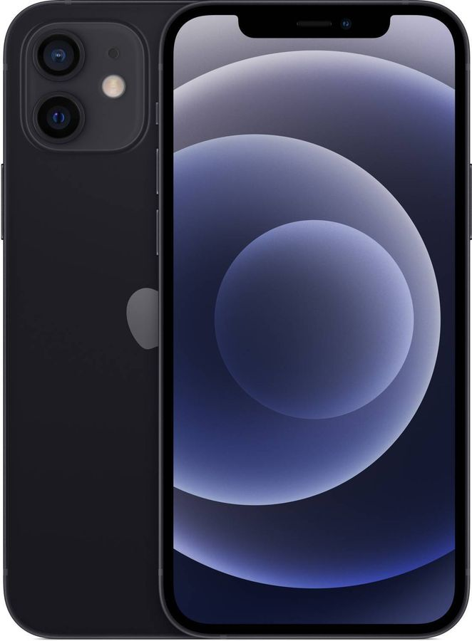
This is my phone. I use it every day to communicate with my friends and family, study English, use different apps, and access the internet. I am good at using my phone to find information and organise my daily tasks. I would like to improve my digital skills by learning how to use more useful apps and online tools. These skills are important because they help me study, stay connected with other people, and manage my daily life.

Screenshot/Photo 2
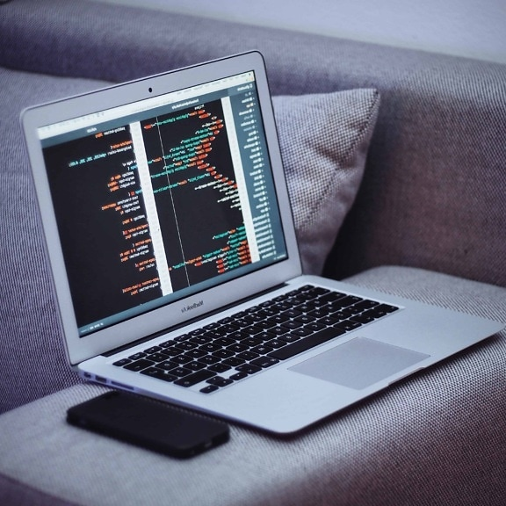
This is my laptop. I use it for studying, doing my assignments, searching for information, watching educational videos, and joining my English classes. I am confident using Microsoft Word and searching for reliable information online. I would like to improve my computer skills and learn how to use more programs for my studies. These skills are important because they will help me at college and in my future career.

Screenshot/Photo 3
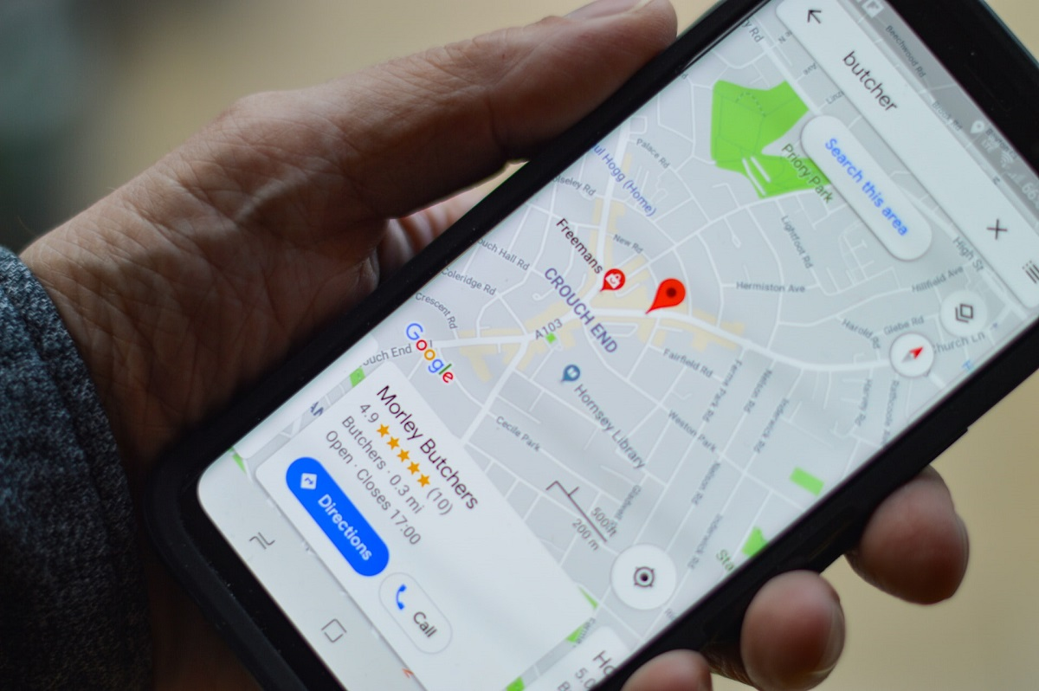
This is Google Maps. I use it to find places, get directions, and plan my journeys. I am good at using it to find the fastest route and discover new places. I would like to learn more about all the features of the app, such as saving favourite places and planning trips more efficiently. These digital skills are important because they help me travel safely, save time, and feel more confident when I visit new places.

Screenshot/Photo 4

This is ChatGPT. I use it to find information, get help with my studies, and learn new things every day. It also helps me improve my English, understand difficult topics, and check my grammar and spelling. I am good at asking clear questions and using the answers to complete my assignments. I would like to improve my English and learn how to use AI tools more effectively. These skills are important because they help me study, solve problems, and prepare for my future career.

Screenshot/Photo 5
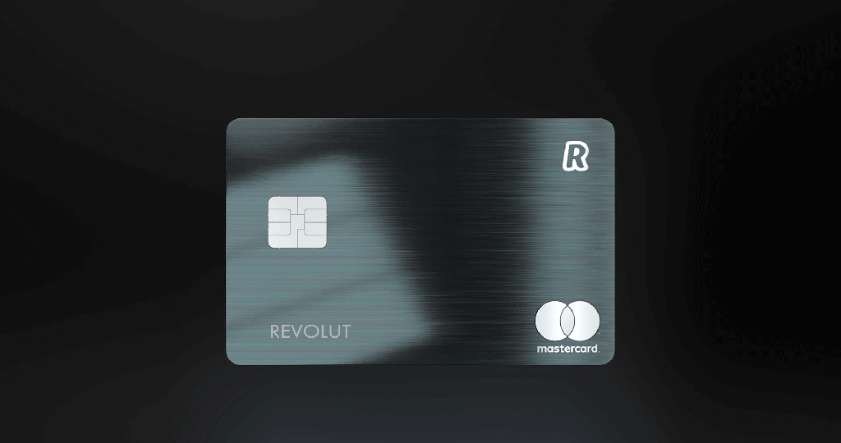
This is my online banking app. I use it to manage my finances, check my balance, make payments, and transfer money. I am confident using online banking safely and keeping track of my spending. I would like to learn more about budgeting and saving money by using the app’s different features. These digital skills are important because they help me manage my money responsibly and make everyday banking quick, safe, and convenient.

Screenshot/Photo 6

These are social media apps. I use them to communicate with my friends and family, share photos, watch videos, and follow people and topics that interest me. I am confident using social media to find information, stay in touch with others, and communicate online. I would like to improve my digital skills by creating better online content and learning how to use social media more safely and responsibly. These skills are important because social media helps people communicate, learn new things, and stay connected with the world.

My Short Reflection
- Write 5–8 simple sentences about your digital life.
- You can use the sentence starters below if helpful.
I use digital tools to communicate, study and find information.
I feel confident when I use my smartphone, laptop and online banking.
I want to improve my digital skills and learn more about technology.
I often use these tools: Google Maps, ChatGPT and social media.
I sometimes feel nervous about online security and protecting my personal information.
I hope this module will help me improve my digital skills.
Digital skills are important for me because they help me in my studies and everyday life.

Sentence starters
- I use digital tools to …
- I feel confident when I …
- I want to improve …
- I often use these tools: …
- I sometimes feel nervous about …
- I hope this module will help me …
- Digital skills are important for me because …
You can write more if you want.

Submission Checklist
Before you submit, please check:
​​​ ☒ I added 4–6 screenshots
☒ I wrote short sentences for each screenshot
☒ I wrote my short reflection
☒ My work is my own
☒ My file opens correctly
​​

