Contemporary Management Approaches
(BMSP4002)

Hannah Kilburn
1805552
Tutor - Davina Evans

Contents
Introduction………………………………………………………………………………..3
Approaches to organisation and management…………………………………………….4
Work motivation and satisfaction…………………………………………………………7
Perception and communication…………………………………………………………...9
Organisation content………………………………………………………………………11
Conclusion……………………………………………………………………………….12
References………………………………………………………………………………..13

Introduction
For this assignment, the main objectives are to include detailed research and analysis to find the contemporary management approaches of a popular and recognised company or organisation. When studying a company, it is important to look for confirmation of how the business shows evidence of their theories, management approaches and models. These should be evident in the subsequent topic areas. These include:
- Approaches to organisation and management
- Work motivation and satisfaction
- Perception and communication
- Organisational content
Tesco is a private company that has many approaches to control each and every store. Tesco is a very large, well-known company that provides for millions of people in various countries across the world. Tesco is a large superstore located in many countries world-wide; they also provide an online service to access a wider population to generate a larger income.
Tesco first began in 1919 when Jack Cohen launched his own stall selling fruit and vegetables in his local area of East London. Mr Cohen progressed dramatically with his small stand, and by the 1930s Tesco developed into a Private Limited Company. Since Tesco became a large superstore, the market has fluctuated from being the most successful superstore in 1995 to having a major decline in profits in 2013 (Clark and Ping-Chan, 2014.)

Approaches to organisation and management
The first area to look at when studying the approaches to business includes the approaches to organisation and management. The main approaches to organisation, structure and management include;
- The classical approach
- Human relations approach
- Contingency approach
The classical approach, according to Mullins is shown to put (L.J.Mullins, Management and Organisational Behaviour, 2010, p. 43) “emphasis on purpose, formal structure, hierarchy of management, technical requirements and common principles of organisation”
The classical approach was introduced in the early 1990s to create better productivity in the workplace and to increase profit for a company. The classical approach was advanced by Frederick Taylor and his aim was to provide workers with the correct tools to get the most efficiency and output from their current job. (Terry, 2017)
The classical theory is shown as a formal system where, in the workplace, workers concentrate on the planning of work, the technical demand of the company and the specific behaviours in the organisation including rational and logical behaviour. Understanding the basic objectives would show the workers the purpose and importance of the organisation. Therefore they produce the most effective way of working and having a clear vision of duties and responsibilities will provide a better work space for the employees. (L.J.Mullins, Management and Organisational Behaviour, 2010)
As Tesco is a large company, having a formal structure is the best way to run the business. Tesco has many departments which need to be controlled in a certain way, therefore employees have to follow specific instructions from an experienced member of the team to gain knowledge and understanding of behaviour and tasks they must follow. As Tesco (Tesco, Our Approach , 2015) says “Wherever we work, we want to help make life a little easier for our customers, colleagues and communities.” It suggests that customers are at the heart of the business and Tesco’s employees must provide the best for them to gain the most profit for the store. The classical approach is the best method for Tesco as it is a large company that has customers at its heart. Following specific rules and behaviours means that Tesco can follow strict employment systems to make sure all staff is given correct instructions and understanding of their given tasks.
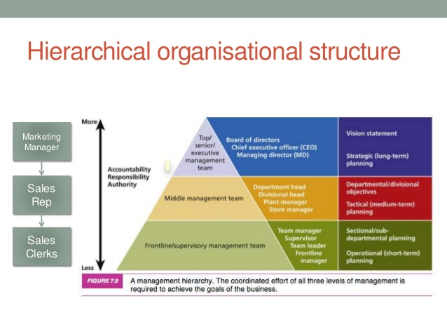
There are many positives and negatives to the idea of the classical management approach. The benefit to having the classical approach in a company is the idea of a hierarchal structure which defines the job roles of the employees. The structure is split into three sections to clearly show the individual roles and responsibilities that the employees must follow for the company to work in the most efficient way possible. The hierarchical structure is best used in larger businesses or companies that are expanding as not all small businesses have a large amount of staff to hold specific job roles and responsibilities. (Russ, 2018)

Classical writers have had negative comments about this approach for not including enough evidence of personality factors and ignoring the fact that workers have very little responsibility over their work environment. Studies have also found that there is doubt in the progression of these issues when applied in the workplace. (Yukl, 2006)
There are two sub-groups of the classical approach which are:
- The scientific approach by F.W. Taylor
- The bureaucratic approach by Max Weber
The scientific approach was presented by Fredrick Taylor who proposed that there was certain and best ways to work and looked at the productivity of employees in different companies. Taylor came up with four principles to provide information about his given theory. The first principle was to use more common sense in the workplace and find out the best possible way for the employees to work. The second principle was to assign workers to a specific task that matched their capability and interests. The third way was to supervise each worker to make sure they are working in the most efficient way and to monitor and evaluate each employee regularly to advise the best instructions. The final principle that Taylor created was to ensure that mangers used their time efficiently to plan and train their workers correctly. (MindToolsContentTeam, 2016)
The bureaucratic approach was developed by Max Weber which looks at the rules and power in a business. He believed that having a good relationship with the boss and having rules in place created the best work environment. Weber believed that workers should have a clear understanding of jobs roles and who was the main power of the business. Weber established main characteristics for this type of organisation. Some of which include a well-defined division of labour and high degree of specialisation, a hierarchical structure, having rules and regulations in place to achieve important decisions and employment is dependent on technical qualifications. The four main features are specialisation, hierarchy of authority, system of rules and impersonality. (L.J.Mullins, 2010, p. 50)
The human relations approach looks at the behaviour of workers in an organisation and analyses the social factors that are involved. This approach was developed when Elton Mayo (1880-1949) conducted an experiment at the Hawthorne plant of the Western Electric Company where he found interesting findings about how workers perform in different environments. The main experiments involved changing the lighting in the workplace, the amount of breaks taken by workers and the temperature. These were all part of the Hawthorne experiments. The workers did improve when conditions changed although the workers may have felt pushed to work better and produce more as they knew they were being observed, therefore leading to the conclusion that changing the physical conditions doesn’t always help. (Nunes, 2016)
The contingency approach to management is the idea of a company or organisation not having a specific or best way to run or work in the business. This management style looks at the situations in the workplace and the managers own technique of working to express the most efficient management style for their company. This form of management is a contrast to the classical approach which believed in having specific systems in the workplace. There are certain internal and external factors which can affect the contingency approach. Internal factors which can change the way of working in this theory include the size of the business, the amount of employees compared to the amount of managers and the leadership style of each manager. External factors that may affect the company include the marketplace and the amount and orientation of the customers. (Leonard, 2018)

Work motivation and satisfaction
When looking into the approaches to management, work motivation and satisfaction is a massive factor in all organisations. The main theorists that studied work motivation and satisfaction are:
- Maslow – hierarchy of needs
- McGregor – theory X and theory Y
Maslow’s created a five tiered model to show the basic needs, the psychological needs and self-fulfilment needs for human beings to work and contribute to the best of their ability in the workplace. On the bottom tier the needs include physiological needs which consist of food, water, warmth and rest. The second tier introduces safety needs including a sense of security and safety in the workplace. The third tier mentions the feeling of love and belongingness which includes intimate relationships and friends. The fourth tier includes esteem needs which consists of prestige and the feeling of accomplishment and the fifth tier, the top tier, relates to self-actualization where someone achieves their full potential. It is believed that to achieve the best, people must have the lower tiers to be successful in reaching the top tier. Maslow concluded that the most important tier from his model was the physiological needs as this is what’s needed for the body to function correctly. The summary of this model shows the real life needs that motivate human beings while being involved in an organisation or company. (McLeod, 2018)


McGregor came up with the idea of theory X and theory Y which are two opposite perceptions of people. Theory X looks at the more traditional thought of work with an autocratic leadership style which also relates to workers following the hierarchal model in the workplace. Theory X is placed on the assumption of people not wanting to work and only working for the money to provide for personal needs, also it suggests that people in this theory have no ambition and do not enjoy working. On the other hand, theory Y enjoys work and wants to reach the top of the hierarchy model to receive the best awards. Theory Y people are full of ambition and thrive off the idea of working which is the polar opposite to theory X. The principles for theory Y include the idea of having responsibility and that individuals can achieve their personal goals by focussing on their given task. (Mulder, 2015)
When looking at Tesco from an employee’s perspective, they are one in 440,000 across all the stores. The way that employees gain satisfaction from this company would be having initial support from other employees and having a manager of their store to go to. Having staff discounts, lots of security systems, staff breaks and gaining a job title provides workers with a name and high motivation for going to work for Tesco. Tesco want to treat their workers with respect and work as a team to gain the motivation and to listen to others. As Tesco mentions they want “colleagues to feel recognised and rewarded for the work they do together.” Having a good salary and a successful and hard-working team, Tesco provides positive worker satisfaction. (Tesco, Core purpose and Values, 2018)
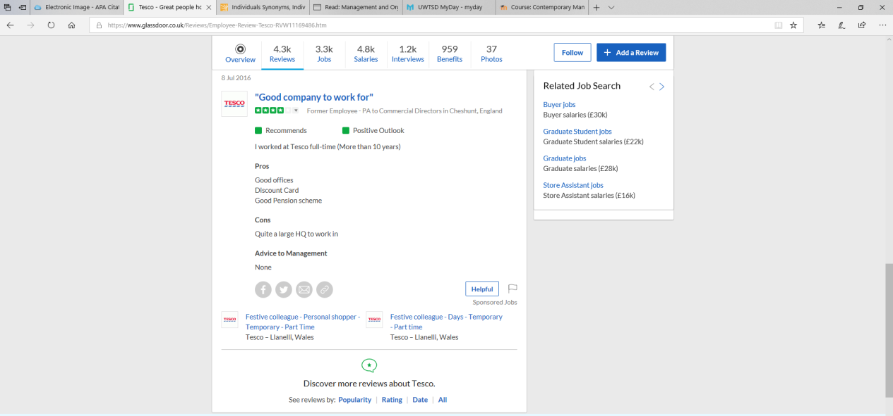

Perception and communication
Perception is the idea of looking at something from a personal point of view through the senses. As individuals we may see or hear things in a different way, which is seen as our perception. The senses are the main things that influence our perspective; these include sight, hearing, touch, smell and taste and as people we all experience these differently. Perception and communication are linked as the way we communicate could lead to the way we perceive something to be. According to Mullins (L.J.Mullins, Management and Organisational behaviour, 2013, p. 205) “Perception is the root of all organisational behaviour”.
As the images show there can be two ways to how we view certain objects in differing situations. As individuals we will always have differing opinions which will impact in our perception on varying situations.



Communication is a vital part of having a successful and efficient work force in an organisation or company. Companies will communicate with each other, managers will communicate with employees and employees will communicate with other employees to get the most information and correct instructions to take part in what the business needs. Having good communication with each people in each hierarchal tier will give the most effect way of working as individuals and as teams. Communication builds productivity in the workplace which leads to a better profit in the business and possibly offering the employees a chance of getting better wages or bonuses. Multinational companies are very reliant on great communication as individuals from other countries may speak a different language which may need to be translated so they understand the goal and objectives of the company. Body language is another factor that is a way of non-verbal communications which is important for managers to look into, especially when taking on new employees and during interviews to examine the candidate’s skills and willingness to work.
Tesco’s main idea is to make sure that customers get the best shopping experience and return to their store time and time again. Tesco communicate with their customers in store, online and through the post. Communicating with customers is important, but making sure managers communicate professionally with their employees is also very important to gain the most profit from the store. Tesco are always asking for feedback from customers but also from employees to make sure they understand a get the best training possible to complete the most efficient work.

Organisational content
Conflict in the workplace is an issue which is inevitable in big, well-established organisations that have a large workforce. Conflict can therefore lead to many issues and the main factor leading to stress which can be a massive issue in a company. Workers taking time off can have an effect on a business however large or small and can lead to companies on a loss of profit. Conflict can occur for many reasons such as other workers underperforming, unequal job responsibility, poor communication, bullying, personality difference and poor management. Conflict can be avoided but it causes issues in most businesses. Making sure good communication and having a clear understanding of everyone’s job roles is a good way of avoiding and preventing any conflict in a business.
Stress is another concern that may affect the efficiency of a worker in a company. Stress can be a result of conflict but also other issue that may arise outside the workplace. Stress can push and motivate a worker to be more efficient but can also have the opposite affect and can be harmful to a person under extreme stress. The cause of stress in the workplace can include working long hours with potential very little break time, an excessive amount of rules and responsibilities on one person, development in technology which some employees may not be aware of how to use them properly without thorough training and loss of staff leading to more work load on other employees. Managers should make sure that they don’t make sudden changes unless needed to avoid stress in the company.
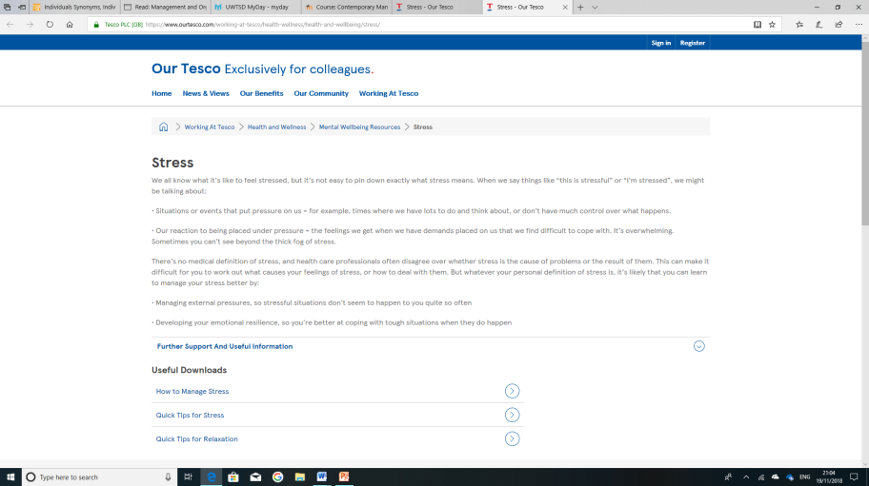
Tesco makes sure that they address the issue of stress and make sure that workers have special help if needed. They have a special web page which is especially made for employees to contact the right person for any enquiries they may have. Tesco like to show their employees that there is help available if needed. They also provide special contact numbers for their colleagues to call if they have any issues that may make them stressed and possible lead to more health related problems. (Tesco, Stress, Updated 2018 )

Conclusion
Overall the research and evidence collected has shown that Tesco is a large company that employs many staff and welcomes thousands of customers through stores doors across the world. From looking on Tesco’s website they motivate and control their staff in an affect way to get the best possible results and profits. They make sure they have help in place for any issues raised by employees or customers, to make sure no one has an unpleasant experience when either working or buying from the store. The workers are motivated through earning a good wage, by having staff discounts and assistants from managers and other staff members if any problems arise. Tesco appear to use the classical approach, as that is the management approach which works well for big organisations and a large workforce. Having this approach in place means that employees know who is in charge and who can help them if in need. Communicating with other members of staff can possibly help with any troubles and stress that may occur in the workplace and giving the correct instructions to new members of staff will lead to a more efficient way of working. Conflict is an issue which can arise in any business, small or large, but Tesco attempt to put in place communication systems and make sure that no staff members under performs the task and responsibility set for them.

References

Gleeson, P. (2018, June). Chron. Retrieved November 2018, from Smallbusiness.com : https://smallbusiness.chron.com/importance-system-approach-principle-81413.html
Heibutzki, R. (2018). Why Is Effective Communication Important in Management? Retrieved November 2018, from work.chron: https://work.chron.com/effective-communication-important-management-27001.html
L.J.Mullins. (2010). Management and Organisational Behaviour. England.
L.J.Mullins. (2010). Management and organisational behaviour .
L.J.Mullins. (2010). The organisational setting. In L.J.Mullins, Management and organisational behaviour (p. 50).
L.J.Mullins. (2013). Management and Organisational behaviour.
Leonard, K. (2018, June). Chron. Retrieved November 2018, from Smallbusiness.com: https://smallbusiness.chron.com/contingency-approach-use-business-33893.html
McLeod, S. (2018). Maslows Hierarchy of needs. Retrieved November 2018, from simply psychology.org: https://www.simplypsychology.org/maslow.html
MindToolsContentTeam. (2016). MindTools. Retrieved November 14th, 2018, from Mindtols.com: https://www.mindtools.com/pages/article/newTMM_Taylor.htm
Mulder, P. (2015). McGregor theory X and theory Y . Retrieved November 2018, from Toolshero: https://www.toolshero.com/leadership/mcgregor-theory/
Nunes, P. (2016, June 26th). Retrieved November 2018, from Knoow.net: http://knoow.net/en/economics-business/management/human-relations-theory/
Ping-Chan, C. a. (2014 , October 4th ). Retrieved Novemeber 7th , 2018, from The Telegraph: https://www.telegraph.co.uk/finance/markets/2788089/A-history-of-Tesco-The-rise-of-Britains-biggest-supermarket.html
Russ, J. (2018, June 29). Chron. Retrieved November 14th, 2018, from SmallBusiness: https://smallbusiness.chron.com/advantages-benefits-classical-management-theory-37990.html
Terry, L. (2017, February 22nd). Retrieved November 7th, 2018, from business.com: https://www.business.com/articles/classical-and-scientific-management-theory/
Tesco. (2015). Our Approach . Retrieved November 2018, from Tesco PLC: https://www.tescoplc.com/media/1069/tesco_cr15_corporateresponsibilityupdate2015.pdf
Tesco. (2018). Core purpose and Values. Retrieved November 2018, from Tesco PLC: https://www.tescoplc.com/about-us/core-purpose-and-values/
Tesco. (2018., November 7th). Retrieved from Tesco PLC: https://www.tescoplc.com/about-us/our-businesses/
Tesco. (Updated 2018 ). Stress. Retrieved November 2018, from Tesco PLC: https://www.ourtesco.com/working-at-tesco/health-wellness/health-and-wellbeing/stress/
Yukl. (2006). Leadership in organisations, Sixth edition.

