

Exploring the Influence of Psychological Branding on Consumer Behaviour: A Study of Samsung Galaxy Smartwatch’s Social Media Marketing Strategies among University Students in the United Kingdom

Subject Code: LCMB7020
Lecturer: Dr Jia Miao
Course: MBA Marketing Management
Term: 3

Student Name: Varun Joseph Sony
Student Number: 2129151

Acknowledgement
I extend my heartfelt gratitude to all those who played a pivotal role in the completion of my dissertation. My sincere thanks go to my dedicated tutors and academic advisors at the University of Wales Trinity Saint David (UWTSD), London, for their unwavering support and scholarly guidance. To my friends and colleagues, I am profoundly grateful for your encouragement, thoughtful discussions, and unwavering support during the challenging phases of this research. I owe a debt of gratitude to my parents, whose boundless love, unwavering faith, and constant encouragement have been the bedrock of my academic pursuits. I extend my heartfelt thanks to all the individuals who participated in my research study, as your willingness to share insights and experiences has been invaluable. I also wish to acknowledge and thank all the organizations that provided access to resources, data, and information necessary for the successful completion of this research. To every individual who contributed, in ways both big and small, to the realization of this dissertation, I offer my sincerest thanks. Completing this dissertation would not have been possible without your support, and I am deeply appreciative of the assistance and encouragement I have received throughout this academic journey. Thank you all for being a part of this significant milestone in my life.

Declaration


Master’s Degrees by Examination and Dissertation
Declaration Form.
1. This work has not previously been accepted in substance for any degree and is not being concurrently submitted in candidature for any degree.
Signed: Varun Joseph Sony
Date: 27/09/2023

2. This dissertation is being submitted in partial fulfilment of the requirements for the degree of Master in Business Administration.
Signed: Varun Joseph Sony
Date: 27/09/2023

3. This dissertation is the result of my own independent work/investigation, except where otherwise stated.
Other sources are acknowledged by footnotes giving explicit references.
A bibliography is appended.
Signed candidate: Varun Joseph Sony
Date: 27/09/2023

4. I hereby give consent for my dissertation, if accepted, to be available for photocopying, inter- library loan, and for deposit in the University’s digital repository
Signed (candidate): Varun Joseph Sony
Date: 27/09/2023
Supervisor’s Declaration.
I am satisfied that this work is the result of the student’s own efforts.
Signed: Dr. Jia Miao
Date: 27/09/2023

Abstract
This study aims to investigate the intricate relationships between psychological branding, social media marketing, and consumer behaviour in the context of Samsung's engagement with university students in the United Kingdom using the Galaxy Smartwatch. It focuses on dissecting the psychological branding elements integrated into Samsung's social media marketing strategies and their subtle effects on the cognitive and affective responses of university students. In addition, it seeks to quantify the extent to which these strategies influence not only students' purchase intentions but also their actual purchase behaviour, enabling a comparative analysis of the efficacy of various branding elements. In addition to contributing to the academic discourse surrounding branding psychology, this study aims to provide marketing professionals with actionable insights for refining their strategies in an ever-changing digital environment. Importantly, the findings of the study have the potential to directly benefit Samsung Galaxy Smartwatch by enhancing its marketing strategy and ensuring its sustained resonance with its target audience.

Table of Contents
Acknowledgement 2
Declaration 3
Abstract 4
1. Introduction 6
1.1 Background and Context 6
1.2 Problem Statement 8
1.3 Research Aim 8
1.3.1 Research Objectives 9
1.3.2 Research Questions 9
1.4 Significance of the Study 10
1.5 Dissertation Structure 11
2. Literature Review 12
2.1 Psychological Branding 12
2.1.1 Psychological Factors in Branding 13
2.2 Consumer Behaviour and Decision-Making Process 16
2.2.1 Influences on Consumer Behaviour 17
2.2.2 Consumer Decision-Making Models 19
2.3 Social Media Marketing and its Impact on Consumer Behaviour 22
2.3.1 Role of social media in Marketing 23
2.3.2 Social Media Advertising Strategies 24
2.4 Theoretical Frameworks 25
2.4.1 Relationship between Psychological Branding and Consumer Behaviour 26
2.4.2 Impact of Social Media Marketing on Consumer Behaviour 27
2.4.3 Theoretical Models and Constructs 28
3. Research Design 33
3.1 Research Onion 33
3.1.1 Research Philosophy 34
3.1.2 Research Approach 35
3.1.3 Research Strategy 35
3.1.4 Time Horizons 36
3.1.5 Data Collection Methods 36
3.1.6 Data Analysis 37
3.2 Ethical Considerations 39
4. Data Analysis and Findings 40
4.1 Descriptive Statistics 40
4.1.1 Perceptions of Samsung Galaxy Smartwatch 40
4.1.2 Influence of Social Media Marketing Strategies 42
4.1.3 Psychological Branding 46
4.1.4 Smartwatch Preferences 50
4.1.5 Brand Loyalty 54
4.1.6 Future Purchase Intentions 57
4.1.7 Open Ended Responses 61
4.2 Discussion of Findings 63
4.2.1 Influence of Psychological Branding on Consumer Behaviour 63
4.2.2 Impact of Social Media Marketing Strategies on Consumer Behaviour 64
4.2.3 Comparison of Findings 66
5. Practical Implications and Recommendations 68
6. Suggestions for Future Research 70
7. Conclusion 72
7.1 Summary of Findings 72
7.2 Contribution to the Field 73
7.3 Conclusion and Final Remarks 75
References 77
Appendices 90
Survey Questionnaire 90
Ethics Form 109
E-Thesis Deposit Agreement 123

1. Introduction

1.1 Background and Context
Psychological branding, also known as emotional branding or experiential branding, transcends conventional marketing strategies by emphasising the establishment of an emotive bond between the brand and its target audience (Evans, 2013; Hartmann and Apaolaza-Ibáñez, 2012). It attempts to tap into consumers' psychological and social identities in order to create associations with a deeper resonance. Psychological branding aims to elicit positive emotions, memories, and perceptions, which can contribute to increased brand recall, customer loyalty, and favourable purchase intentions.
Numerous studies have investigated the influence of psychological branding on consumer behaviour, revealing its capacity to influence brand attitudes, purchasing decisions, and brand loyalty. Literature on branding psychology emphasises the importance of emotional experiences in consumer-brand relationships and the necessity for marketers to go beyond product attributes and functional benefits.
Smartwatches have emerged as one of the most promising product categories within the wearable technology industry, revolutionising how individuals interact with technology daily. These multifunctional devices combine fashion and technology, appealing to both tech enthusiasts and fashion-conscious consumers. Samsung Galaxy Smartwatch has attracted attention for its innovative features, fashionable design, and seamless integration with Samsung's larger ecosystem of products and services.
In order to capitalise on the potential of the wearable technology market, Samsung Galaxy Smartwatch has strategically integrated social media platforms into its marketing initiatives. Social media has become the primary channel for consumer engagement, allowing brands to interact with their target audience in real-time, instigate conversations, and promote their products and values. It has been demonstrated that the use of social media in brand marketing enhances brand-consumer relationships and fosters brand loyalty via frequent interactions, content personalization, and community development.
Understanding the efficacy of Samsung Galaxy Smartwatch's social media marketing strategies is essential for both academics and industry professionals considering the ever-changing landscape of consumer behaviour and technological advancements. There is a paucity of research on the smartwatch industry and its engagement with university students in the United Kingdom, despite the abundance of literature on psychological branding and its effects on consumer behaviour.
This dissertation aims to contribute to the existing body of knowledge in the fields of branding, consumer behaviour, and marketing by examining the impact of psychological branding on consumer behaviour through the lens of Samsung Galaxy Smartwatch's social media marketing strategies among university students in the United Kingdom. Insights gleaned from this study will not only benefit Samsung, but also provide valuable guidance to marketers and businesses seeking to leverage social media and psychological branding to engage their target audience more effectively. In addition, the findings will pave the way for future research into and refinement of psychological branding theories and their practical applications in the ever-changing digital landscape.

1.2 Problem Statement
The marketing literature has extensively investigated psychological branding and social media marketing. Despite this focus, there exists a critical gap in research pertaining to the integrated impact of these factors within the context of the burgeoning wearable technology industry. The examination of Samsung Galaxy Smartwatch's social media marketing methods and their influence on consumer perceptions, attitudes, and purchasing intentions is of utmost importance to academic academics and marketing practitioners, given the increasing popularity of smartwatches. The assessment of the efficacy of psychological branding within this specific market segment can yield useful information for customising marketing strategies to promote brand engagement and loyalty, hence assuring the continued success of the Samsung Galaxy Smartwatch in a fiercely competitive and continuously expanding digital environment.

1.3 Research Aim
The objective of this study is to examine the impact of psychological branding on customer behaviour, specifically focusing on the social media marketing methods employed by Samsung Galaxy Smartwatch, within the demographic of university students in the United Kingdom. This study aims to investigate the various aspects of psychological branding and its influence on university students' views, attitudes, and purchasing intentions towards Samsung Galaxy Smartwatch products. Specifically, it aims to understand how emotional and cognitive connections developed through social media interactions contribute to these outcomes. The primary objective of this research is to provide significant insights into the effectiveness of Samsung's social media marketing techniques. Additionally, it intends to contribute to the larger comprehension of the impact of psychological branding on customer behaviour in the digital era.

1.3.1 Research Objectives
- To analyse the psychological branding elements utilized in Samsung Galaxy Smartwatch's social media marketing strategies, targeted specifically at university students in the United Kingdom.
- To examine the cognitive and emotional responses of university students towards Samsung Galaxy Smartwatch's social media marketing content.
- To assess the impact of Samsung Galaxy Smartwatch's psychological branding on university students' purchase intentions and actual purchase behaviour.
- To compare the effectiveness of different psychological branding elements in Samsung Galaxy Smartwatch's social media marketing on university students' brand loyalty and advocacy.
- To propose practical recommendations for optimizing Samsung Galaxy Smartwatch's social media marketing strategies through the strategic integration of psychological branding elements.

1.3.2 Research Questions
- How do specific psychological branding elements, such as emotional storytelling and aspirational lifestyle portrayal, in Samsung Galaxy Smartwatch's social media marketing influence university students' cognitive responses, emotional engagement, and brand perception?
- To what extent does the integration of social proof, fear of missing out (FOMO) tactics, and personalized content in Samsung Galaxy Smartwatch's social media marketing impact university students' purchase intentions and actual purchase behaviour, and how do these elements compare in their effectiveness?
- How does the alignment of Samsung Galaxy Smartwatch's social media marketing with university students' values and interests contribute to their brand loyalty, advocacy, and overall consumer behaviour, and which specific values and interests have the most significant impact?
- What is the role of community-building strategies, such as interactive discussions and user-generated content, in Samsung Galaxy Smartwatch's social media marketing, and how do these strategies foster a sense of belonging and influence university students' perception of the brand?
- What are the most effective combinations of psychological branding elements in Samsung Galaxy Smartwatch's social media marketing that led to a significant positive shift in university students' purchase intentions, brand loyalty, and advocacy, and how can these findings be practically implemented to optimize marketing strategies?

1.4 Significance of the Study
This dissertation carries substantial significance for several stakeholders, encompassing academic scholars, marketing practitioners, and the Samsung Galaxy Smartwatch brand. The contributions of the study are delineated as follows:
- Academic Contribution: This study seeks to enhance the scholarly comprehension of psychological branding and its impact on consumer behaviour. Through an examination of the correlation within the domain of social media marketing and wearable technology, this investigation aims to enhance the current body of knowledge on branding and consumer decision-making. Consequently, it will offer novel perspectives and potential avenues for future research.
- Marketing Industry: This study's findings can provide marketing professionals with practical insights on how to optimise social media marketing strategies for firms in the wearable technology sector. The comprehension of psychological determinants that impact consumer behaviour would empower marketers to adeptly customise their ads and effectively connect with university students by aligning with their preferences and emotions.
- Strategic Insights for Samsung Galaxy Smartwatch: This research aims to provide valuable insights about the effectiveness of Samsung Galaxy Smartwatch's current social media marketing initiatives among university students in the United Kingdom, thereby benefiting the brand directly. The results of the study might provide valuable insights for the brand to enhance its marketing strategies in order to effectively reach and engage its primary consumer category, hence enhancing brand loyalty and market share.
- Consumer Empowerment: Through acquiring a more profound comprehension of the psychological branding approaches implemented by firms such as Samsung Galaxy Smartwatch, consumers, particularly university students, can enhance their awareness of the marketing strategies that impact their purchasing choices. The acquisition of this knowledge enables consumers to make well-informed decisions and underscores the significance of critical thinking in a marketplace heavily influenced by digital technologies.

1.5 Dissertation Structure
Each chapter of this dissertation is crafted and structured, to play a vital role in advancing our understanding of the complex interplay between psychological branding, social media marketing, and consumer behaviour.
- Chapter 1: Chapter 1 introduces the research by outlining its context, the identified problem, research aim, objectives, and questions. It emphasizes the study's significance and provides an outline of the dissertation's structure.
- Chapter 2: Chapter 2 delves into the existing body of knowledge on psychological branding, consumer behaviour, and social media marketing. It establishes the theoretical framework for the study.
- Chapter 3: Chapter 3 details the research design, including philosophy, approach, strategy, data collection methods, and ethical considerations.
- Chapter 4: Chapter 4 analyses collected data, presenting descriptive statistics and exploring participant perceptions of Samsung Galaxy Smartwatch, social media impact, psychological branding, smartwatch preferences, loyalty, future intentions, and open-ended responses.
- Chapter 5: Chapter 5 provides practical recommendations for enhancing psychological branding and social media advertising effectiveness, along with tailored marketing strategies for engaging UK university students.
- Chapter 6: Chapter 6 suggests potential avenues for future research, identifying areas needing further exploration.
- Chapter 7: Chapter 7 summarizes key findings, highlights contributions to the field, and offers concluding remarks.

2. Literature Review

2.1 Psychological Branding
Carlson et al. (2008) and Gabay (2015) define psychological branding as a strategic methodology that investigates the complexities of customers' emotional responses, cognitive evaluations, and behavioral proclivities in relation to a brand. According to Hsu et al. (2018), the primary objective of psychological branding is to establish brand loyalty, stimulate purchase intentions, and promote positive word-of-mouth. This method is consistent with the growing recognition that consumers frequently base their decisions on emotional rather than purely rational factors, making it an effective and relevant strategy for brand managers in today's competitive marketplace (Pappu et al., 2007).
By comprehending the psychological determinants that influence consumer behaviour, brands could customise their marketing endeavours in order to establish a robust emotional connection with their intended demographic (Vainikka, 2015; Ramya & Ali, 2016). By constructing persuading brand narratives, businesses can connect with the values, goals, and desires of consumers, evoking emotional responses that go beyond merely functional benefits (Smith, 2011). A brand may, for instance, construct a narrative that strategically employs nostalgia to induce positive emotions and a sense of familiarity, thereby forging a connection with the target audience. Similarly, the establishment of a distinct brand personality enables brands to cultivate a deeper and more lasting connection with their target audience.
In the modern digital era, when consumers are inundated with brand messages and options, psychological branding has taken on a greater significance. Psychological branding has the potential to foster emotive bonds, which can effectively set a brand apart from its competitors. When there exists an emotive connection between customers and a brand, it is probable that consumers would demonstrate brand loyalty, engage in favourable word-of-mouth, and maybe defend the brand in times of crisis. In addition, the establishment of emotional resonance through psychological branding has the potential to exert a long-lasting effect on consumers' perceptions of a brand, thereby influencing their purchasing decisions and intentions. Consumers are more likely to choose brands that align with their emotional states, personal beliefs, and self-perception, resulting in increased brand preference and customer loyalty (Dick & Basu, 1994; Grewal et al., 2018).

2.1.1 Psychological Factors in Branding
In contemporary times, scholars and practitioners have increasingly acknowledged the importance of psychological elements in influencing consumers' cognitions, attitudes, and actions in relation to brands. The comprehension of consumers' emotions, motives, and cognitive processes has emerged as a crucial aspect in the development of successful branding strategies that promote brand loyalty, advocacy, and favourable word-of-mouth (Tybout & Artz, 1994; Mullen & Johnson, 2013).
Brand Personality
The marketing community has extensively adopted Aaker's (1997) brand personality framework, which includes characteristics such as honesty, excitement, competence, sophistication, and ruggedness. However, it is crucial to evaluate the framework's applicability in different contexts and industries. This presumption may oversimplify the complexities of branding. Different markets and cultural contexts may necessitate a more nuanced brand personality strategy. In addition, the static nature of the framework may not account for changes in consumer preferences and societal developments over time.
Hosany and Martin (2012) propose that the congruence of brand personality with consumers' self-concepts and beliefs requires a more nuanced examination. While it is true that congruence between a brand's personality and a consumer's self-concept can foster a sense of connection, the assumption that consumers actively pursue this alignment in all brand choices warrants examination. Sometimes, product functionality, affordability, and convenience can trump brand personality. This emphasizes the need to consider the interaction of multiple factors in consumer decision-making, where brand personality is merely one element of a complex web of influences.
Regarding brand personality as a cognitive convenience in decision-making, as proposed by Aaker and Fournier (1995), it is crucial to recognize that consumer behavior is a complex phenomenon. In some contexts, brand personality can simplify decisions, but in others, it can oversimplify them. This heuristic may overlook the subtleties of individual preferences and the dynamic nature of consumer choices if used exclusively.
Brand Identity
According to Keller (1993), the purpose of establishing a well-defined brand identity is to distinguish a brand from its competitors while concurrently fostering consumer familiarity and trust. In 2008, Kapferer presented a comprehensive conceptual framework for brand identity consisting of six distinct dimensions: physicality, personality, culture, relationship, reflection, and self-image. The physical characteristics of a brand, such as its logo, design, and packaging, are crucial in establishing brand recognition. The personality dimension imbues the brand with anthropomorphic characteristics, fostering a personal connection between consumers and the brand. The cultural dimension refers to the brand's alignment with particular values and perspectives that coincide with the preferences and convictions of the target market. The relationship component emphasizes the dynamic interaction and active engagement that occurs between a brand and its consumers in order to foster brand loyalty and establish a profound emotional connection. The reflection component pertains to the way consumers perceive themselves in relation to the use or affiliation with a brand, hence engendering a sense of self-expression and identity. The self-image component refers to how the brand influences the self-concept and personal identity of consumers.
Beyond visual and linguistic signals, brand identity encompasses elements such as the brand's positioning, values, and personality traits (Balmer & Greyser, 2003). Brand communication is crucial for establishing a brand's identity and facilitating effective communication with its target audience across multiple channels. This practice guarantees the consistency and cohesion of the brand's message across all points of interaction with its target audience. Buil, Catalán, and Martnez (2016) emphasize the importance of brand identity in establishing brand equity and fostering brand loyalty. Aaker argues that a strong and effectively communicated brand identity is essential for fostering increased brand recognition, favorable brand evaluations, and increased brand loyalty among customers.
The development of the digital age has intensified the significance of brand recognition. According to Vargo and Lusch (2004), there has been a transition in brand identity in which it is no longer solely controlled by the company, but rather co-created with consumers via a variety of touchpoints and interactions. Modern consumers are actively involved in the process of constructing a brand's identity by contributing user-generated content, writing evaluations, and participating on social media platforms.
Brand Image
A well-defined brand identity distinguishes a brand from its competitors and fosters familiarity and trust, as stated by Keller (1993), is a fundamental premise. However, the notion that uniqueness alone is sufficient for success in today's intensely competitive markets merits close examination. In a globalized world with an abundance of options, attaining true differentiation is a challenging endeavor. Brands must not only stand out, but also provide consumers with meaningful value and relevance. In addition, the relationship between familiarity and trust is not linear; trust is not solely based on recognition, but also on consistent, ethical behavior and meaningful interactions. Trust can be fragile and easily eroded by brand missteps, making its management a challenging aspect of brand identity.
The six-dimensional framework for brand identity developed by Kapferer (2008), which consists of physicality, personality, culture, relationship, reflection, and self-image, provides a structured method for comprehending brand identity. However, the applicability and applicability of such a comprehensive model in practice raises concerns. Frequently constrained by limited resources, brands may find it difficult to effectively manage and measure all these dimensions. In addition, the relative significance of these dimensions may differ across industries and consumer segments.
The expansion of brand identity beyond visual and linguistic signals to include positioning, values, and personality traits (Balmer & Greyser, 2003) demonstrates the importance of authenticity and consistency in brand representation. Brands are under increasing scrutiny for their ethical and social responsibility, and any discrepancy between their professed values and actual practices can result in consumer backlash.
The importance of brand communication in sustaining a consistent and uniform brand message is undeniable (Buil, Catalán, & Martnez, 2016). However, in this age of information overload and fragmented media channels, attaining such consistency is a daunting task. Additionally, the shift toward personalized and targeted communication raises questions regarding privacy and ethical issues in brand messaging.
The notion that brand identity is co-created with consumers (Vargo & Lusch, 2004) is a reflection of the increasing influence of consumers in the digital age. While this presents thrilling engagement opportunities, it also poses significant challenges for brand consistency and reputation management. The potential risks posed by negative user-generated content and the influence of online evaluations on brand identity require a proactive approach to online reputation management.

2.2 Consumer Behaviour and Decision-Making Process
Personality, culture, and socioeconomic background influence individuals' decision-making processes differently. Although models of consumer decision-making, such as those described by Kotler & Armstrong (2020) and Munthiu (2009), provide a structured framework, they may not convey the nuances of individual decisions. Recognizing the variety of consumer behavior and the limitations of one-size-fits-all models would constitute a more critical approach.
As emphasized by Kotler & Armstrong (2020), it is crucial to comprehend the variables that influence consumer behavior and the decision-making process. Marketers are responsible for considering the prospective effects of their strategies on the well-being of consumers. It is essential to question whether certain marketing practices cross the line between persuasive marketing and manipulation, particularly when targeting vulnerable consumer segments.
The consumer decision-making process, which typically includes stages such as problem recognition, information search, evaluation of alternatives, purchase selection, and post-purchase evaluation, is a valuable framework, as outlined by Munthiu (2009). Nonetheless, it is crucial to evaluate the effects of digital technology and information inundation on this procedure. Consumers have access to an overwhelming quantity of information in the digital age, which can result in decision fatigue and information paralysis.

2.2.1 Influences on Consumer Behaviour
In order to develop successful marketing strategies and cultivate customer happiness and loyalty, marketers must possess a comprehensive understanding of the diverse elements that influence consumers' decision-making processes and behaviours. The subsequent sections present a thorough examination of significant elements that shape consumer behaviour, encompassing both internal and external influences that have an impact on consumers' choices and decisions regarding purchases.
Internal Influences
Internal influences on consumer behavior include a variety of psychological variables, such as attitudes, beliefs, motivations, personality characteristics, and way of life. Attitudes, as defined by Shastry & Anupama (2021) and Asiegbu et al. (2012), are consumers' evaluations of products, brands, or services. In today's fast-paced and information-rich environment, consumer attitudes can change promptly in response to a variety of stimuli, including marketing campaigns, social trends, and public opinion. These shifts, which challenge the notion of fixed consumer attitudes, necessitate constant monitoring and adaptation by marketers.
As cognitive representations of a product, beliefs have a substantial impact on brand preferences and behavior (Jervis, 2006). Consumers have a tendency to search out information that confirms their preexisting beliefs, while ignoring evidence to the contrary. This cognitive bias can result in echo chambers and the reinforcement of preconceived notions. It raises ethical concerns regarding the responsibility of marketers to provide consumers with information that challenges their existing beliefs.
As the motivating forces behind consumer behavior (Solomon et al., 2019), motivations are essential to comprehending why consumers make certain decisions. Consumer choices may be influenced by emotional and subconscious factors that conflict with their stated desires and requirements. This raises questions about the adequacy of conventional market research techniques for uncovering consumers' genuine motivations.
Indeed, personality attributes and lifestyle, as internal factors influencing consumer preferences and brand attachments (Aaker, 1997; Veloutsou & Moutinho, 2009), are significant. Nevertheless, personality traits are not always reliable predictors of behavior, and lifestyle classifications may oversimplify the diversity of consumer preferences. Marketing strategies that rely solely on these variables risk overlooking the nuances and complexities of individual preferences.
External Influences
External influences on consumer behavior, including social, cultural, economic, and situational factors, are crucial determinants of consumer decisions. According to Bhukya & Paul (2023) and Ioană & Stoica (2014), social influences include familial, reference group, and social media factors. While it is undeniable that these influences have a significant impact on consumer behavior, it is essential to evaluate the ethical implications of such influence critically. For instance, family can exert both positive and negative influences on consumer decisions. While family traditions and values can influence preferences, they can also contribute to conformity and impede individual autonomy. Reference groups, such as online communities, have the ability to influence opinions through word-of-mouth and social comparison.
According to Hofstede (1980) and Rehman (2017), cultural variables play a crucial role in shaping the attitudes and preferences of consumers. Assuming that all members of a culture or subculture share the same values and beliefs can result in ineffective marketing strategies. To appreciate the diversity within cultural groups, cultural understanding should go beyond surface-level attributes.
According to Solomon et al. (2019), economic factors such as income, price, and economic conditions are undeniably significant. Nevertheless, pricing strategies such as price discrimination and surge pricing, despite being financially advantageous for businesses, may be perceived as unjust or exploitative by consumers. In addition, the influence of economic conditions on consumer behavior, as seen during economic crises, raises concerns about the robustness of marketing strategies in unstable economic environments.
According to Hoyer et al. (2017), situational factors, such as time constraints and tangible surroundings, have a substantial impact on consumer convenience and accessibility. This raises ethical concerns regarding the manipulation of choices based on ephemeral circumstances, which is frequently exploited by marketers.

2.2.2 Consumer Decision-Making Models
The study of consumer decision-making models has been a prominent area of investigation within the fields of marketing and consumer behaviour for an extended period. These models offer significant insights into the cognitive processes and psychological aspects that impact customers' decision-making and purchasing behaviours.
The Information Processing Model
The Information Processing Model, which has its roots in cognitive psychology, has been a cornerstone of research on consumer decision-making for decades. This model provides a structured framework for comprehending how consumers make decisions, but a closer look reveals both its strengths and limitations (Bettman, 1970; Engel, Blackwell, and Miniard, 1990). A fundamental aspect of this paradigm is the concept of problem recognition, in which individuals recognize a need or issue that initiates the decision-making process. This step is crucial because it initiates the complete process. Frequently, consumers may not be completely aware of their needs, and their recognition of a problem can be influenced by a number of factors, such as marketing stimuli and societal pressures. In today's digital age, where advertising and social media continuously expose individuals to new desires, the line between genuine need and manufactured desire becomes increasingly blurry.
Following image illustrates the model:
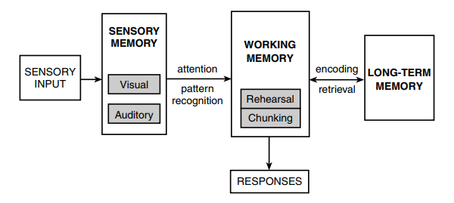Source: https://fredjmr.wordpress.com/2020/08/30/what-is-the-information-processing-theory-the-basics-of-cognitivism/
The Information Processing Model focuses on the methodical retrieval of information and evaluation of alternatives. It suggests that consumers carefully evaluate factors such as price, product quality, and brand reputation. This supposition may not always hold true, especially in situations involving a rushed or emotionally charged purchase. Consumers frequently rely on mental short-cuts or past experiences to simplify difficult decisions. These shortcuts can occasionally result in suboptimal decisions or biased assessments. These cognitive fallacies are frequently utilized by marketers to influence consumer decisions, raising ethical concerns regarding the use of persuasive tactics.
Moreover, the model's post-purchase evaluation emphasizes the significance of consumer satisfaction. Emotional and psychological factors, such as brand loyalty and self-identity, can substantially affect feelings following a purchase. Even if the product or service did not completely meet their expectations, consumers may rationalize their decisions in accordance with their self-concept. This calls into doubt the validity of post-purchase evaluations as indicators of genuine customer satisfaction. In the current environment, where information overload is prevalent, the model's presumption of methodical information retrieval may be questioned. Consumers are inundated with information from multiple sources, such as online reviews, social media, and advertisements. More research should focus on how consumers filter and process this information, as well as the possibility of information paralysis or choice overflow.
The Consumer Decision-Making Process Model
The Consumer Decision-Making Process Model represents a significant advance in the understanding of how consumers make decisions by integrating a broader range of factors than the conventional Information Processing Model. It acknowledges that consumer decisions are influenced not only by rational and systematic factors, but also by emotive, experiential, and environmental factors. Nevertheless, while this expanded perspective enriches our comprehension, it also poses challenges in terms of complexity and practical application.
According to Hoyer and MacInnis (2008), an important aspect of this model is its recognition of the influence of emotive factors and previous experiences on consumer decisions. This acknowledgement is crucial because it correlates with mounting evidence that emotions play a crucial role in consumer decisions. Nevertheless, emotions are extremely subjective and difficult to predict and manage. It may be difficult for marketers to evoke the desired emotional responses from consumers, and the same emotional trigger may have different effects on different individuals.
In addition, the incorporation of social influences, cultural variables, and situational considerations into this model results in a more comprehensive understanding of consumer behavior. It emphasizes the interdependence of these factors and the fluidity of consumer decisions. However, this complexity presents marketers with significant obstacles. Understanding the influence of social and cultural factors is essential, but it can be difficult to implement strategies that effectively leverage these insights. To avoid stereotyping or misinterpretation, cultural nuances must be carefully considered, for instance.
In this paradigm, situational factors such as time constraints and physical surroundings are also essential components. They acknowledge that consumer decisions are context-dependent and can vary depending on the situation. However, accurately anticipating situational variables can be challenging. In different situations, the same consumer may make different decisions, making it difficult to develop consistent marketing strategies.
According to Panwar et al. (2019), the model also emphasizes the significance of understanding consumers' cognitive and emotive responses to marketing stimuli. This insight is priceless, but it also raises ethical issues. It is reprehensible to manipulate emotions or exploit cognitive biases for marketing purposes, especially when it involves vulnerable or impressionable consumer groups. The following image illustrates an ideal consumer decision-making process model:
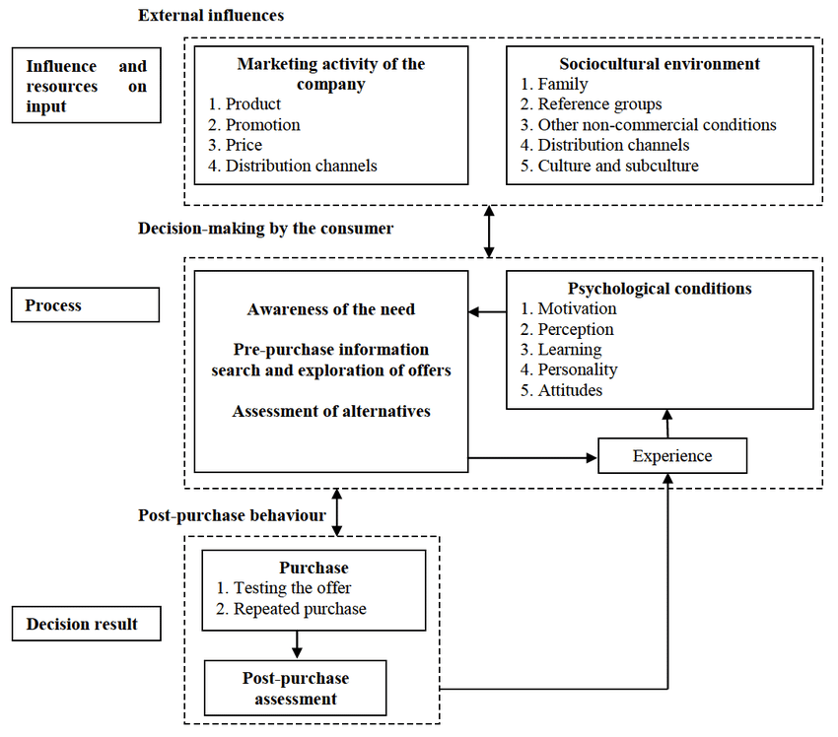Source: https://www.researchgate.net/figure/Model-of-the-consumer-decision-making-process_fig2_321080708

2.3 Social Media Marketing and its Impact on Consumer Behaviour
According to Wirtz et al. (2013) and Gong (2017), higher levels of participation on social media platforms are associated with greater brand loyalty and positive brand attitudes. This finding demonstrates the capacity of social media to strengthen brand-consumer relationships. In an era where influencer marketing and sponsored content are prevalent, however, there is a risk that consumers will perceive these interactions as dishonest or manipulative. The question of whether or not these online connections result in long-lasting brand loyalty remains under investigation.
In addition, as emphasized by Hajli (2014), the establishment of a sense of community and trust among consumers is a crucial aspect of effective social media marketing. Indeed, engaging content, personalized communication, and prompt responses are crucial for establishing trust. However, negative online experiences, such as data breaches or misleading content, can rapidly erode trust. In addition, the question of whether trust in a brand on social media translates to real-world behavior, such as purchasing, requires a more nuanced examination.
According to Yang and Brown (2015), the interchange of information among individuals on social media platforms, which enables them to seek and offer guidance and endorsements, is a significant aspect of consumer behavior in the digital age. However, this poses concerns regarding the dependability and credibility of user-generated content. In addition, the influence of algorithms and content curation on social media platforms on the information consumers receive should not be understated. These platforms exercise significant influence over what consumers see, potentially skewing their decision-making.

2.3.1 Role of social media in Marketing
Hanna et al. (2011) assert that social media enables brands to actively engage with consumers by providing a forum for open and transparent communication. This activity enhances consumers' perceptions of authenticity and trustworthiness. On social media, however, negative comments and public relations crises can rapidly escalate, posing a risk to a brand's reputation. Brands must walk a fine line between authenticity and vulnerability in their interactions, necessitating a delicate balance.
The research conducted by Dwivedi et al. (2021) highlights the positive influence of social media on consumer perceptions, attitudes, and brand loyalty. However, the simplicity of clicking "like" or "follow" does not always translate into authentic loyalty or advocacy. The phenomenon of "slacktivism," in which consumers express support online without taking actual action, raises concerns about the depth of these online relationships.
Moreover, as discussed by Schivinski & Dbrowski (2014) and Chatterjee & Kar (2020), the customization of messaging and targeting of specific consumer segments is a valuable aspect of social media advertising. This customization raises ethical concerns regarding data privacy and the possibility of microtargeting. The fine-grained profiling of individuals for marketing purposes can violate personal boundaries and create filter chambers in which consumers are only exposed to content that confirms their existing beliefs.
Mangold and Faulds (2009) emphasize the positive influence of social media advertising on brand perceptions and purchase intentions. However, the prevalence of influencer marketing and sponsored content raises questions regarding transparency and authenticity. Consumers may doubt whether recommendations are sincere or financially motivated. According to Stephen and Galak (2012), the viral nature of social media platforms provides opportunities to increase brand visibility through user-generated sharing. However, there are hazards associated with the virality. Rapid dissemination of false information and rumors can be detrimental to a brand's reputation. Positive or negative, brands must be prepared to manage and respond to viral content.

2.3.2 Social Media Advertising Strategies
According to Kanaveedu and Kalapurackal (2022), the effectiveness of influencer marketing in shaping consumer perspectives and purchase intentions is evident. However, audiences of influencers may become desensitized to endorsements over time, requiring brands to continuously seek out new influencers. This turnover may increase expenses and dilute brand messages. Social media contests and giveaways, another common strategy, do indeed bolster consumer engagement and brand awareness. Nonetheless, it is essential to analyze consumer participation motivations. These activities frequently employ gamification techniques, which can generate a sense of urgency and enthusiasm. This may increase short-term engagement, but it does not necessarily result in long-term brand loyalty. The objective of a critical analysis should be to determine whether contest participants are loyal customers or predominantly attracted by the possibility of winning prizes.
Thi et al.'s (2021) research on the positive effects of social media contests on consumer engagement and loyalty is insightful. Nonetheless, it is necessary to consider the prospective drawbacks. The overuse of contests may condition consumers to only interact with a brand when incentives are provided. This transactional relationship may inhibit the development of genuine brand loyalty, in which consumers support a brand not solely for rewards but because they believe in it sincerely.
According to Kim & Lee (2019), user-generated content (UGC) is a potent method for social media advertising. While UGC can humanize brands and strengthen brand-consumer relationships, the potential risks should be questioned from a critical standpoint. Encouragement of user-generated content can result in unpredictability. Brands may also receive negative or controversial user-generated content. This raises concerns regarding brand management and reputation management. Moreover, if brands incentivize users to create content, the authenticity of UGC, which is frequently viewed as more genuine and trustworthy, may be compromised. The distinction between genuine endorsement and incentivized promotion can become hazy, potentially undermining credibility. Brands must carefully balance their involvement in UGC campaigns to maintain the integrity of consumer-generated content.

2.4 Theoretical Frameworks
Effective psychological branding requires theoretical frameworks to comprehend and manipulate consumer behavior. The self-congruity theory proposed by Sirgy (2018) is one such framework. This theory suggests that consumers favor brands that align with their self-concept and identity. This alignment appears to be a logical strategy for brands to employ at first glance. However, a deeper analysis reveals potential difficulties and complexities.
Self-congruity theory suggests that brand-consumer alignment results in positive emotions and a sense of belonging. There is a risk of oversimplifying the relationship between consumers and brands, even though this is frequently the case. Individuals' complex and multidimensional self-concepts, for instance, may not neatly align with a singular brand personality. This alignment should not be viewed as a one-size-fits-all strategy, as it may not resonate with all segments of a brand's target audience.
In addition, there is the issue of authenticity regarding brand-personality alignment. Consumers are becoming increasingly astute and able to discern when brands attempt to mimic their values and self-concepts for marketing purposes. This raises questions regarding the authenticity of such brand-consumer relationships. The purpose of research should be to determine whether a brand's stated values are genuine or solely a marketing ploy. Authenticity is essential for establishing long-term consumer trust.
In addition, while self-congruity theory offers insights into the significance of alignment, it does not explore the broader context of consumer-brand relationships. However, brand loyalty and affective connections are contingent on a variety of factors beyond self-congruence. These may include product or service quality, customer service, and the social responsibility initiatives of the brand. Focusing solely on self-consistency can lead to disregarding other crucial aspects of brand loyalty building.

2.4.1 Relationship between Psychological Branding and Consumer Behaviour
Consistently, the research on psychological branding and its effect on consumer behavior has highlighted the importance of emotional connections in influencing purchasing decisions, brand loyalty, and advocacy. This recognition of the predominance of emotive aspects over rational evaluations in consumer decision-making, as emphasized by Pappu et al. (2007), is one of the most important takeaways from these studies.
Despite the effectiveness of psychological branding's emphasis on emotional attachment, there is a danger of manipulation. The skepticism of consumers may be engendered by brands that exploit consumers' emotions without delivering genuine value or authenticity. The skepticism of consumers is growing, and they can rapidly identify insincere attempts to elicit emotional responses. To maintain credibility, brands must ensure that their emotional appeals are consistent with their actions and offerings.
The definition of brand personality provided by Aaker (1997) emphasizes the significance of an authentic and consistent brand image. Despite the importance of aligning with consumers' self-concepts and beliefs, it is essential to evaluate the limitations of this strategy. Brands are faced with the difficulty of remaining pertinent as consumer identities evolve. A brand with an inflexible personality may find it difficult to adapt to shifting consumer preferences and values.
Keller (2013) explains that brand identity is another aspect of psychological branding. A consistent and visually appealing brand identity can indeed elicit positive feelings and enhance brand recognition. However, an excessively rigid brand identity may inhibit innovation and creativity. In a dynamic marketplace, brands must establish a balance between consistency and adaptability to remain relevant.
According to Keller (2008), the concept of brand image emphasizes the significance of consumer trust, credibility, and loyalty. In the era of social media and instant information sharing, however, negative events or controversies can quickly tarnish a brand's image. Companies must be proactive in addressing issues and preserving a positive reputation.

2.4.2 Impact of Social Media Marketing on Consumer Behaviour
The ability of social media platforms to disseminate diverse types of content, such as product information, user-generated content, and promotional incentives, influences consumer attitudes and purchase intentions (Ziyadin et al., 2019). In spite of this, brands must carefully balance their content strategies. A glut of promotional materials can result in audience fatigue and cynicism. Consumers are becoming increasingly adept at distinguishing between authentic, informative content and obvious advertising. Brands that focus solely on promotional content may risk alienating their audience.
Furthermore, according to Tsimonis and Dimitriadis (2014), the interactive nature of social media marketing fosters brand loyalty and advocacy. Nonetheless, it is essential to recognize that not all interactions are positive. Social media also exposes the door to customer complaints and negative feedback, which, if not effectively managed, can escalate quickly. Brands must be prepared to respond to such circumstances with candor and compassion. Ignoring or mishandling customer complaints on public platforms can significantly harm a brand's reputation.
According to Cao et al. (2014), the function of social media as a platform for peer influence and validation is undeniable. Reviews and recommendations from other consumers can influence purchasing decisions. However, this phenomenon may also have a negative aspect. Without transparency, fake reviews, paid endorsements, and influencer marketing strategies can erode trust. Consumers are becoming increasingly wary of recommendations that lack authenticity. To maintain credibility, brands must ensure that their social media marketing strategies prioritize authenticity and transparency.
According to Vogel et al. (2014), social comparison is another crucial factor to consider. It can influence brand preferences and purchase decisions, but it can also have negative repercussions. Consumers who continually compare themselves to others on social media may experience anxiety or dissatisfaction, particularly when exposed to curated and idealized images of other people's lives and possessions. Brands should be aware of these potential emotional responses and endeavor to present their products in a more balanced and realistic manner.
Lastly, Hudson et al. (2016) stress the importance of establishing trust and authenticity in brand-consumer relationships. However, establishing and maintaining trust in the social media era can be difficult. The increase of false news and misinformation on social media platforms has increased consumer skepticism. Brands must proactively combat misinformation and remain consistent in their messaging to develop and preserve trust.

2.4.3 Theoretical Models and Constructs
Theory of Planned Behaviour
The Theory of Planned Behaviour (TPB), introduced by Ajzen (1991), is an important theoretical paradigm in the field of consumer behaviour. TPB's emphasis on behavioral intentions as a critical determinant of actual behavior is one of its primary strengths. It acknowledges that individuals form intentions in accordance with their attitudes toward a behavior, subjective norms, and perceived behavioral control (Armitage & Conner, 2001; Bamberg & Moser, 2007; George, 2004). This holistic perspective is consistent with the notion that consumer decisions frequently involve a combination of cognitive, social, and personal factors. For example, when consumers consider purchasing a product, their attitudes toward it, which are influenced by factors such as product quality and brand image, can substantially affect their intent to purchase.
The following image illustrates the model:
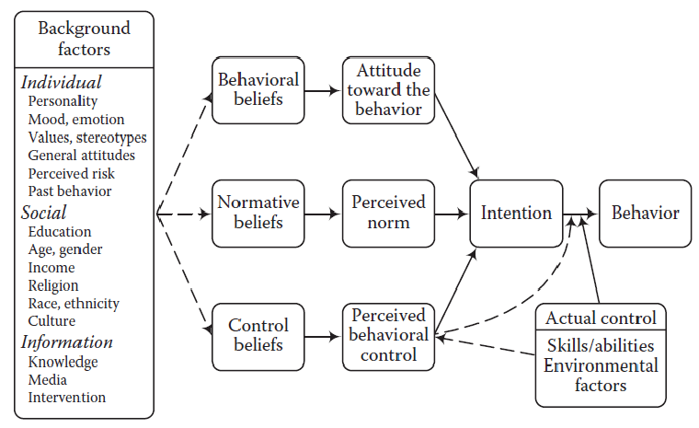Source: https://www.linkedin.com/pulse/theory-planned-behaviour-considering-drives-proximity-dynamics-sehgal/
Another essential aspect of TPB, subjective norms acknowledge the social context in which consumers make decisions. People are influenced by family, acquaintances, and social media, among other social pressures. The TPB's adoption of these standards emphasizes the significance of understanding how external influences can influence consumer decisions. Even if their personal attitudes differ, consumers may be more likely to purchase products recommended by their peers.
The third component of TPB, perceived behavioral control, highlights the significance of self-efficacy in shaping intentions. This is consistent with the notion that consumers are more likely to engage in behaviors they perceive they can successfully control and execute. For instance, consumers who have confidence in their ability to utilize a new technology product may be more likely to acquire it.
Nonetheless, TPB has limitations. It generally relies on a rational decision-making model, presuming that people make deliberate and calculated decisions. In reality, consumer behavior frequently consists of emotive, impulsive, and subconscious components that TPB may not be able to capture. For instance, consumers may make impulsive purchases based on emotions or unconscious influences, circumventing the TPB-emphasized rational decision-making process. Furthermore, TPB can clarify the complexity of consumer behavior. It may not adequately address influential situational factors, such as time constraints and contextual indicators. Moreover, it may not completely account for the dynamic and ever-changing nature of consumer preferences and behaviors, especially in today's markets that are undergoing rapid change.
Technology Acceptance Model
Davis's 1987 Technology Acceptance Model (TAM) is a seminal framework for comprehending how consumers adopt and embrace new technologies and products. TAM's emphasis on the critical factors that influence consumer attitudes toward technology adoption, namely perceived usefulness and perceived simplicity of use, is one of its primary strengths. Perceived usefulness encapsulates the notion that consumers are more likely to adopt a technology or product if they perceive that it will enhance their performance or productivity. This concept is consistent with the pragmatic considerations that consumers frequently take into account when deciding whether to employ a new technology. It emphasizes the significance of tangible advantages in driving adoption.
Similarly, perceived simplicity of use acknowledges that consumers evaluate the level of effort required to use a product or technology. This aspect recognizes that even if a technology is perceived as beneficial, its adoption rates may suffer if it is too complicated or cumbersome to use. It emphasizes the importance of user-friendly designs and intuitive interfaces in the development of technology. However, a critical examination of TAM reveals that it may oversimplify the complexity of technology adoption. In reality, consumer behavior regarding technology is influenced by a variety of factors other than perceived utility and usability. Significant roles are also played by societal norms, cultural influences, personal motivations, and contextual factors. For instance, individuals may adopt a technology because it corresponds with their social identity or because of peer pressure, which TAM does not explicitly address.
Furthermore, TAM may not completely account for the psychological and emotional aspects of technology adoption. Consumers' comfort, trust, and sense of safety in relation to a technology can have a significant impact on their decisions. For instance, privacy concerns and fears of data breaches can discourage individuals from implementing technologies that are otherwise beneficial. TAM also implies that people make rational decisions based on a thorough evaluation of perceived usefulness and usability. In actuality, cognitive biases, emotions, and unconscious influences can influence consumer decisions. Often, a more comprehensive comprehension of consumer behavior necessitates the integration of TAM with other models and frameworks that explore these psychological and emotional dimensions. The following image illustrates the model:
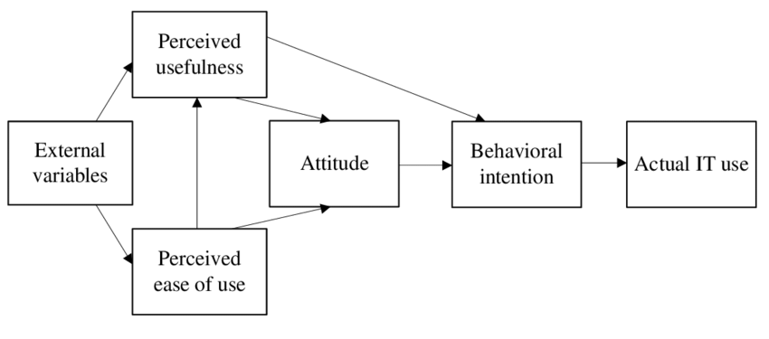Source: (Davis, 1987)
The Technology Acceptance Model (TAM) has been extensively utilised in academic studies pertaining to electronic commerce, mobile applications, and various other technological advancements. For example, previous research has employed the Technology Acceptance Model (TAM) to examine the factors influencing consumers' acceptance and usage of various digital services such as mobile banking, online shopping platforms, and social media applications (Widanengsih, 2021; Ha & Stoel, 2009; Al-Qaysi, Mohamad-Nordin & Al-Emran, 2020).
Self-Concept Theory
Another essential framework in consumer behavior research is the Self-Concept Theory. This theory positions an individual's self-concept, or how they perceive themselves, at the forefront of consumer decision-making. It suggests that people prefer to choose products and brands that correspond with their self-concept, using their consumption decisions as a means of self-expression and identity projection (Sirgy, 1985). The following image illustrates an ideal image of the model:
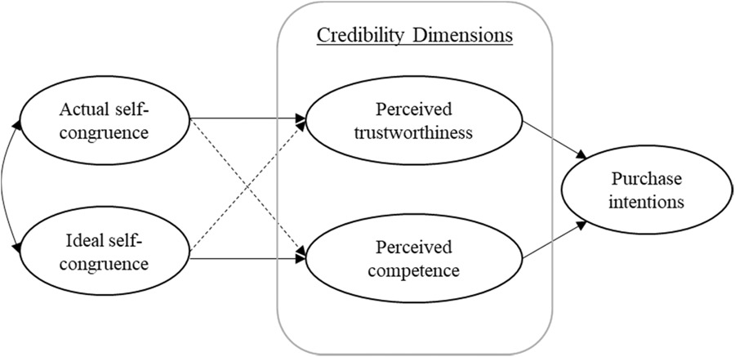Source: https://onlinelibrary.wiley.com/doi/full/10.1002/mar.21439
The theory emphasizes the significance of understanding the complex relationship between consumer psychology and brand marketing. It recognizes that consumers are active participants in the formation of their identities through consumption. This understanding challenges marketers to abandon traditional, one-size-fits-all approaches and adopt strategies that resonate with the complexities of individual self-concepts.
The dynamic nature of self-concept is a factor to consider. People's self-identities are formed by a variety of factors, such as life experiences, cultural influences, and societal changes. Therefore, marketers must navigate a dynamic environment in which consumers' self-perceptions are subject to change. This presents both a chance and a difficulty. It enables adaptive marketing strategies that can leverage on evolving self-identities, on the one hand. On the other hand, it requires ongoing research and vigilance to remain aware of these alterations.
The potential dissonance between self-concept and actual behavior is another aspect. Consumers may aspire to certain self-identities, but have difficulty aligning their actions with these ideals. This contradiction raises concerns regarding the authenticity of branding and marketing. Are brands reflecting and fostering consumers' self-concepts authentically, or are they merely capitalizing on these ideals? This ethical concern necessitates an analysis of the veracity and openness of marketing practices.
In addition, the theory contradicts conventional notions of market segmentation. While demographic and psychographic factors are still relevant, the theory emphasizes the uniqueness of self-concepts. This uniqueness complicates mass marketing efforts and drives brands toward more personalized, one-to-one marketing strategies. Nonetheless, this transition necessitates sophisticated data analytics and privacy considerations, thereby eliciting discussions regarding the ethical use of consumer data.

3. Research Design

3.1 Research Onion
The Research Onion, which was first proposed by Saunders, Lewis, and Thornhil (2023), is a useful framework for conceptualising and delineating the various strata of research design and methodology.. Following image illustrates the framework:
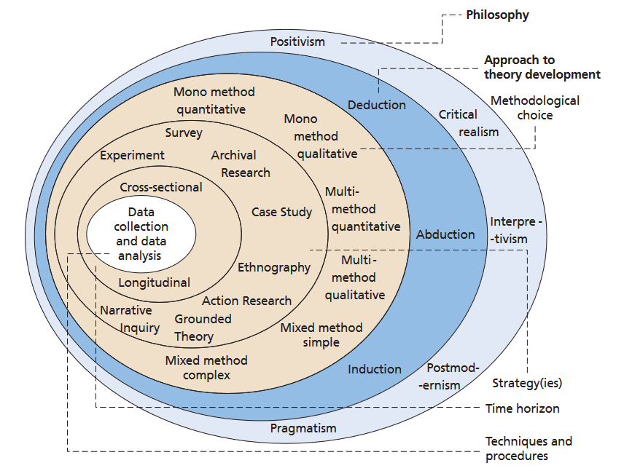Source: Saunders, Lewis and Thornhill (2023)
This framework provides a multidimensional and progressively deeper understanding of how to approach the research process effectively. Each layer of the Research Onion represents a distinct step in the research process. Like how we have to peels away an onion's exterior layers to reach its centre, a researcher progresses through successive layers of the Research Onion to reach the centre of their study. Each layer, from the innermost to the outermost, builds upon the previous layer, guiding the researcher through the crucial decisions and considerations necessary for the study's success.
In the context of this dissertation, the Research Onion serves as the framework upon which we build our research design, ensuring that each layer corresponds with the research objectives, questions, and overarching purpose.

3.1.1 Research Philosophy
At the crux of the research onion is the research philosophy, which comprises the fundamental beliefs and assumptions that govern the entire research process. Positivism, interpretivism, and pragmatism are distinct lenses through which researchers can conduct investigations (Saunders, Lewis, and Thornhill, 2023). This dissertation will employ the pragmatic research philosophy, which is a synthesis of positivist and interpretivist approaches that permits a flexible and exhaustive examination of the research problem (Ihuah and Eaton, 2013).
The selection of our research philosophy is of the uttermost importance. Given the need for empirical data and quantifiable insights specific to the demographic of university students in the United Kingdom, the pragmatic method is consistent with our research objectives (Ihuah and Eaton, 2013). Combining quantitative methodologies, such as surveys, with an appreciation for the contextual complexities and unique perspectives of university students is made possible by pragmatism. By adopting a pragmatic stance, we create a methodological space in which we can employ structured surveys to capture data while maintaining sensitivity to the nuanced interpretive dimensions that are crucial to understanding the lived experiences of our target audience.

3.1.2 Research Approach
The research methodology is the second layer of the research onion, extending from the research philosophy (Saunders, Lewis, and Thornhill, 2023). This dissertation makes use of an inductive research approach. The purpose of inductive research is to generate hypotheses or generalisations from the collected data. This methodology perfectly complements the exploratory nature of our investigation. We seek an in-depth comprehension of the perceptions, emotions, and behaviours of university students regarding the social media marketing of the Samsung Galaxy Smartwatch. Inductive research allows us to be open to emergent patterns and insights, enabling us to capture the complexity and richness of their experiences (Hodkinson, 2008).
As we investigate the affective and cognitive dimensions of consumer behaviour in response to psychological elements of branding, an inductive approach is particularly suitable. Instead of imposing preconceived theories, we allow our data to influence the development of insights and theories, thereby facilitating a holistic understanding of the phenomenon under investigation. This allows us to be receptive to the unexpected, ensuring that our study reveals novel insights into the relationship between psychological branding and student consumer behaviour.

3.1.3 Research Strategy
The research strategy is an integral element of the third stratum of our research design (Saunders, Lewis, and Thornhill, 2023). In this dissertation, the case study research design is chosen as the most suitable methodological approach. A case study approach permits an in-depth examination of a specific context or phenomenon, making it ideally suited for our analysis of Samsung Galaxy Smartwatch's social media marketing and its influence on university students (Cousin, 2005).
Using the Samsung Galaxy Smartwatch as a case study, we can analyse the brand-consumer relationship within the context of social media marketing. This approach allows us to delve deeply into the complexities and dynamics of this relationship, revealing insights that might not be uncovered by more exhaustive research methodologies. Case study methodology provides a solid framework for the requisite analysis depth in our study.

3.1.4 Time Horizons
Considerations of time horizons comprise the fourth level of our research design (Saunders, Lewis, and Thornhill, 2023). This dissertation makes use of a cross-sectional approach. Cross-sectional research involves the collection of data at a single point in time, providing a snapshot of the participants' current attitudes and behaviours (Rindfleisch et al., 2008).
Our research objectives are centred on capturing immediate reactions and current consumer behaviour within the swiftly evolving landscape of social media marketing, and the cross-sectional method aligns perfectly with these objectives. Focusing on the responses of college students to the social media content of the Samsung Galaxy Smartwatch necessitates a timely comprehension of their attitudes and behaviours. By employing a cross-sectional design, we ensure that our findings reflect the current state of consumer behaviour and offer valuable insights into the influence of psychological branding on their responses.

3.1.5 Data Collection Methods
To investigate the complex relationship between psychological branding and customer behaviour in relation to the social media marketing strategies of Samsung Galaxy Smartwatches, the study has chosen data collection methods with care. This study employs a mixed-methods design, integrating both quantitative and qualitative techniques for data collection. According to Tashakkori, Johnson, and Teddlie (2020), the selection of this methodological synergy is motivated by the desire to conduct a comprehensive and nuanced investigation of the study issue.
The quantitative component is based on the systematic distribution of a carefully crafted survey to a diverse group of university students from various academic disciplines in the United Kingdom. This methodology permits the collection of quantifiable data that is suitable for statistical analysis (Bloomfield and Fisher, 2019). Utilising Likert scales and carefully crafted multiple-choice questions, this quantitative component aims to evaluate the perceptions, preferences, and levels of involvement of the participants.
In addition to the quantitative approach, the qualitative approach employs the same questionnaire, but places a greater emphasis on open-ended queries. This strategic methodological approach seeks to inspire participants to share valuable qualitative information by exploring personal experiences, emotional responses, and detailed narratives (Fossey et al., 2002). According to Maison (2018), the use of open-ended probes can effectively contribute to a comprehensive understanding of the fundamental motivations, emotive stimuli, and cognitive mechanisms that profoundly influence consumer behaviour.

3.1.5.1 Questionnaire Design
For the purpose of elucidating the central focus of the research inquiry, the questionnaire has been meticulously segmented into distinct components and meticulously designed. The domains include diverse participant perceptions of Samsung Galaxy Smartwatches, their interactive engagement with social media marketing paradigms, the complex psychological framework of branding, their specific smartwatch brand preferences, the captivating aspects of brand loyalty, and the intricate fabric of future purchase intentions. This study's design allows for both quantitative and qualitative investigation in depth.
Likert scales are a prominent instrument for assessing the quantitative sentiments and perspectives of respondents. Utilising scales in research permits respondents to communicate their level of agreement or disagreement on a nuanced scale.

3.1.5.2 Sampling Technique
Purposive sampling was chosen for this study due to its strategic compatibility with the requirements of the research (Etikan, Musa, and Alkhazmi, 2016). The approach allows for the careful selection of participants who have been directly exposed to Samsung Galaxy Smartwatch social media marketing endeavours.

3.1.6 Data Analysis
Data analysis is a crucial step in the research process because it transforms the collected unprocessed data into a comprehensive and illuminating body of knowledge. This analysis demonstrates the convergence of quantitative and qualitative aspects, resulting in a narrative that effectively incorporates the perceptions, attitudes, and experiences of the participants. The data obtained through rigorous questionnaires is a valuable resource with the potential to yield valuable insights when analysed with diligence.

3.1.6.1 Qualitative Analysis
The qualitative analysis dimension investigates the depth and complexity of human perspectives, emotions, and narratives evidenced in participant responses. It also requires a rigorous evaluation of textual narratives in order to acquire a thorough understanding of the subject.
- Thematic Exploration: Thematic exploration is a crucial element of qualitative analysis. This approach's methodology involves a comprehensive and systematic examination of the recurring themes prevalent in the participant narratives. After performing a thorough examination, categorization, and clustering of the data, significant patterns and themes emerge, providing a comprehensive understanding of the fundamental themes and trends that influence individual perspectives and actions.
- Exploring Contextual Nuances: Content analysis plays a vital role in this dimension, allowing the researcher to delve deeper into the topic.
- Narrative Weaving: The objective of narrative analysis is to deconstruct the participant-provided narratives. Through an exhaustive examination and analysis of the human experiences, emotions, and contextual nuances expressed in these stories, we can gain a thorough understanding of the complex factors that influence consumer behaviour.

3.1.6.2 Quantitative-Qualitative Synthesis
The process of qualitative-quantitative synthesis involves the integration of many strands of data, resulting in a comprehensive depiction of the research findings. Incorporating narratives and quantitative insights, this synthesis provides a more comprehensive understanding of the complex relationship between psychological branding and consumer behaviour.
The purpose of the synthesis is not to quantify emotions, but to enhance quantitative insights by incorporating qualitative context. This methodology provides a deeper comprehension of the participants' emotions, motivations, and perspectives.
The qualitative and quantitative aspects of data analysis converge, resulting in a narrative that encompasses not only information and numerical data, but also the fundamental character of human experiences. The data analysis phase concludes by casting light on the research's fundamental objectives and providing an in-depth comprehension of the complex dynamics that influence consumer decisions in this domain.

3.2 Ethical Considerations
This section examines the ethical considerations that serve as the study's foundation, highlighting the steps taken to safeguard participants and maintain the integrity of the research. Also, an ethics form has been duly filled for the research and is attached in the Appendices section.
- Informed Consent: In the context of research participation, informed consent is obtained from individuals after they have been presented with a comprehensive and detailed account of the study's objectives, methodologies, potential hazards, and advantages. The informed consent is provided in the first page of the survey. The survey is attached in the Appendices, for reference.
- Confidentiality and Anonymity: The participants' responses adhere to the principles of confidentiality and anonymity. The process of data analysis preserves anonymity by separating any personally identifiable information. The confidentiality guarantee provided to study participants ensures that their individual contributions will remain anonymous and cannot be traced back to their identities.
- Voluntary Participation: Participation in this study is entirely voluntary. Participants have the option to disengage from the study at any time with no negative repercussions. Establishing a trustworthy and relaxed environment increases the likelihood of obtaining responses that are free of external influences or pressures.
- Data Security: Data security measures are in place to protect participant data and prevent unauthorised access. In order to prevent unauthorised disclosure, all electronic data is stored securely on servers with restricted access.
- Citation of Sources: Source citation is of the uttermost importance in upholding academic honesty. Special care will be taken to appropriately cite literature and antecedent research, thereby ensuring that the contributions of others are appropriately acknowledged.

4. Data Analysis and Findings

4.1 Descriptive Statistics

4.1.1 Perceptions of Samsung Galaxy Smartwatch
Question 1: "How familiar are you with Samsung Galaxy Smartwatches?"
The first query of the survey, which seeks to determine the participants' familiarity with Samsung Galaxy Smartwatches, is instrumental in laying the groundwork for comprehending their relationship with Samsung's smartwatch products. The survey results reveal a variety of familiarity levels among the university students surveyed. As shown in the following figure, a substantial 40 percent of respondents indicated that they are "Very familiar" with Samsung Galaxy Smartwatches, demonstrating a substantial awareness and in-depth familiarity with these products. This suggests that this group has direct experience with smartwatches, has conducted extensive research on them, or has been exposed to them through various channels, including marketing efforts.
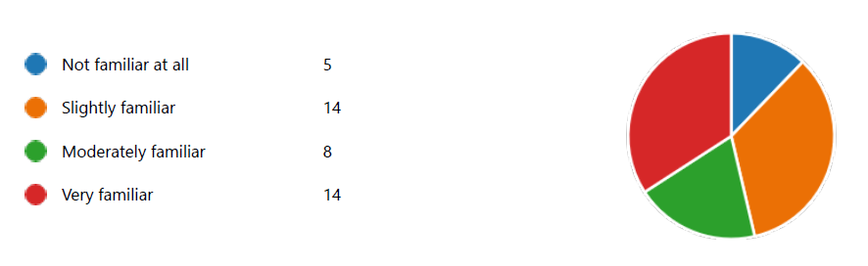
In close proximity, 37.5% of respondents fell into the "Moderately familiar" category, indicating a solid understanding, possibly influenced by advertisements, recommendations, or limited interactions with Samsung's marketing materials. Another 10% of respondents indicated that they were "Slightly familiar," indicating a lower but still significant level of knowledge. None of the respondents, or 12.5% of the sample, reported complete unfamiliarity, which suggests a baseline level of awareness, possibly attributable to the pervasiveness of technology-related content and discussions in today's digital age.
Question 2: "On a scale of 1 to 10, how would you rate the overall quality of Samsung Galaxy Smartwatches?"
As shown in the following table, more 30% of respondents rated the smartwatches an 9 or higher on a scale from 1 to 10, indicating a pervasive perception of high quality among the university students surveyed. Additional analysis reveals that 57% of respondents rated them 6- 8, 30% rated them a 9-10, signifying exceptional quality to some. In contrast, 12.5% of respondents ranked the smartwatches lower than 6, indicating varying degrees of dissatisfaction or neutrality.
Rating Range | Number of Respondents | Percentage
0-2 | 1 | 2.5%
3-5 | 5 | 12.5%
6-8 | 23 | 57.5%
9-10 | 12 | 30.0%
Question 3: "What do you perceive as the main advantages of Samsung Galaxy Smartwatches?"
This question's responses disclose several recurring themes that shed light on Samsung Galaxy Smartwatches' perceived advantages. As shown in the below figure, a substantial percent of respondents emphasise the advanced features and technology offered by these wearables, emphasising the utmost significance of cutting-edge technology in driving their popularity. Additionally, approximately half of the participants, 25%, regard the user-friendly interface as a significant advantage, underscoring the role of ease of use in smartwatch adoption.
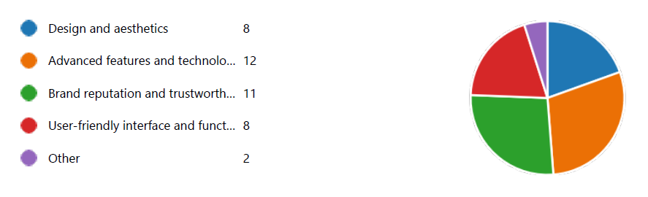
40% percent of respondents emphasise design and aesthetics, recognising the significance of visual appeal. In addition, approximately 30% of respondents value brand reputation and trustworthiness, highlighting the importance of trust in the Samsung brand.

4.1.2 Influence of Social Media Marketing Strategies
Question 4: "How frequently do you encounter Samsung Galaxy Smartwatch advertisements on social media platforms?"
The survey data reveals that only a small percent of respondents encountered Samsung's smartwatch advertisements "very frequently" on social media platforms. In addition, 25% of respondents reported encountering these ads "occasionally," demonstrating the success of Samsung's marketing efforts in reaching a diverse audience.
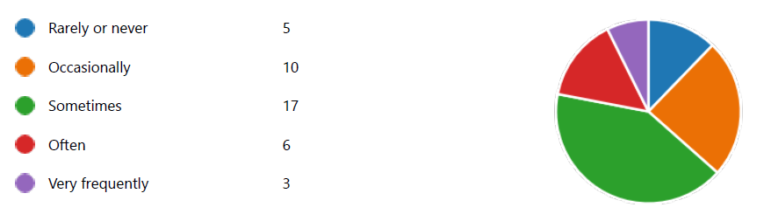
Even though approximately 20% of participants reported encountering the advertisements "occasionally," this group still demonstrates some level of exposure, highlighting the brand's extensive reach. 10% of respondents indicated that they encounter advertisements "rarely or never," representing a minority but emphasising the need to increase visibility for this demographic.
Question 5: On which social media platforms have you seen Samsung Galaxy Smartwatch advertisements?
Instagram emerged as the most popular platform, with 60% of respondents mentioning it, highlighting its central role in Samsung's advertising strategy. Given Instagram's visual nature, which aligns well with showcasing smartwatch design and aesthetics, this result demonstrates Instagram's efficacy in engaging the target audience. Following Instagram, approximately 25% of respondents mentioned Facebook, indicating Samsung's significant presence on the platform and ability to use Facebook's detailed ad targeting to reach diverse demographics.
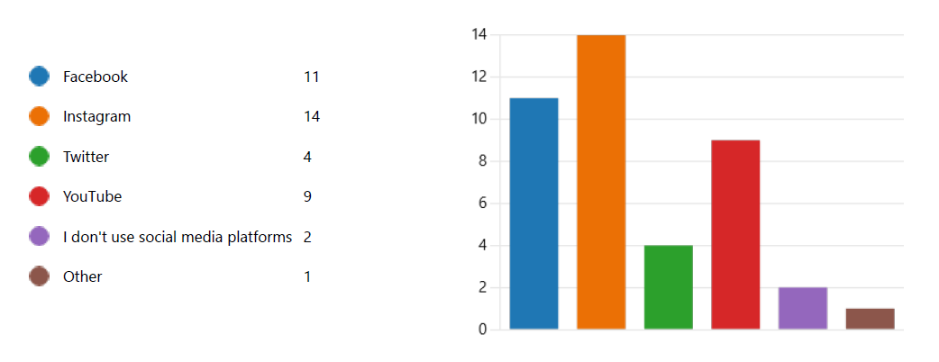
YouTube, with approximately 15% of mentions, is another vital platform for Samsung's smartwatch advertisements, ideal for showcasing product features and engaging potential consumers through educational content. Twitter and TikTok, albeit less frequently mentioned, represent spaces where some respondents encountered Samsung's advertisements, and each offers distinct engagement opportunities. Conversely, LinkedIn and other social media platforms received fewer mentions, suggesting that Samsung's advertising emphasis may be less concentrated on these platforms due to their unique user demographics and content characteristics.
Question 6: How do you perceive the effectiveness of Samsung's social media marketing strategies for the Galaxy Smartwatch?
Only a few respondents rated Samsung's social media marketing strategies for the Galaxy Smartwatch as "Very effective.” However, approximately 30% of participants rated these strategies as "Moderately effective," indicating that Samsung's marketing efforts continue to have a significant impact on this group, who may require additional persuasion but remain open to the brand's messaging.
Conversely, around 20% of respondents perceived Samsung's social media marketing as "Slightly effective," suggesting room for development in tailoring content to better resonate with this segment of potential customers.
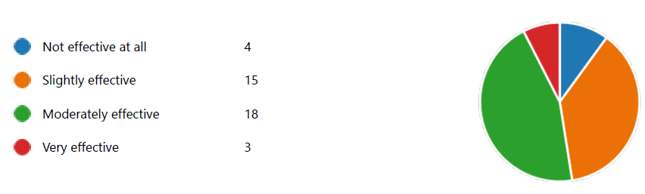

Question 7: On a scale of 1 to 10, how engaging do you find Samsung Galaxy Smartwatch advertisements on social media?
Approximately 22% of respondents found these advertisements to be "Very engaging," indicating a strong positive response to the content with scores of eight or higher. This demonstrates Samsung's success in creating visually appealing and engaging content that effectively resonates with a substantial portion of its target audience, utilising storytelling, aesthetics, and innovative features to maintain viewers' interest. Approximately 57% of respondents rated the ads as "Moderately engaging," with a score between 6 and 8, indicating room for development in terms of increasing engagement, perhaps through the addition of more personalised or interactive elements.
Rating Range | Number of Respondents | Percentage
0-2 | 3 | 7.5%
3-5 | 6 | 15.0%
6-8 | 23 | 57.5%
9-10 | 9 | 22.5%
About 15% of respondents rated the advertisements as "Slightly engaging," rating 3-5, indicating a decline in perceived engagement for this segment and highlighting the need for Samsung to refine its strategies to better connect with these viewers. 7.5% found the advertisements to be "Not engaging at all," indicating individuals who are not captivated by Samsung's social media advertising efforts and highlighting the need to address their concerns and preferences for a more comprehensive and effective marketing strategy.
Question 8: Have you ever interacted with Samsung's social media content related to the Galaxy Smartwatch (e.g., likes, comments, shares)?
The responses to this query reveal a variety of interaction patterns. As shown in the following figure, approximately 50% of respondents indicated that they have engaged with Samsung's Galaxy Smartwatch-related social media content. This includes actions such as liking posts, leaving remarks, and sharing content. This indicates that a portion of the audience is not only passively consuming the content, but is also actively participating in the online discourse surrounding Samsung's products. This level of participation is a positive indicator of an enthusiastic and possibly loyal user base.
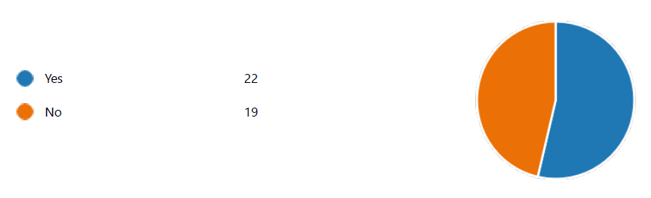
On the other hand, approximately 50% of respondents indicated that they have not engaged with Samsung's Galaxy Smartwatch-related social media content. This group consists of individuals who are less likely to interact with brands on social media or who did not find the content compelling enough to prompt interaction. Understanding the reasons for this dearth of engagement could provide valuable insight into areas in which Samsung can improve its social media marketing efforts.

4.1.3 Psychological Branding
Question 9: On a scale of 1 to 10, to what extent do Samsung Galaxy Smartwatches make you feel stylish?
The analysis of the responses for this question, provides a deeper comprehension of their perceptions of the style of these smartwatches.
- High Style Perception (9-10): From the following table, we can see that roughly 15% of respondents rated Samsung Galaxy Smartwatches in the upper range of 9 to 10. These individuals view these smartwatches as extremely fashionable and trendy. They probably view donning a Samsung Galaxy Smartwatch as a means of enhancing their personal style and making a fashion statement. This segment of users may be attracted to the smartwatches for both their functionality and aesthetic appeal.
- Moderate Style Perception (6-8): Approximately 60% of respondents gave ratings between 6 and 8. This indicates that they consider Samsung Galaxy Smartwatches to be moderately fashionable. They recognise the contribution of wearables to their personal style, but they may not consider them to be exceptionally fashionable. These consumers appreciate the smartwatches from Samsung's combination of functionality and style.
- Low Style Perception (3-5): 20% of respondents rated the smartwatches between 3 and 5, indicating a low perception of style associated with Samsung Galaxy Smartwatches. Style may not be a primary consideration for these users when selecting or wearing a smartwatch. Instead, they may prioritise technological features, brand reputation, or affordability over aesthetics.
Rating Range | Number of Respondents | Percentage
0-2 | 3 | 7.5%
3-5 | 8 | 20.0%
6-8 | 24 | 60.0%
9-10 | 6 | 15.0%
Question 10: On a scale of 1 to 10, how confident do Samsung Galaxy Smartwatches make you feel?
Approximately 68% of respondents ranked Samsung Galaxy Smartwatches in the range of 6 to 10 for their quality. These users feel significantly more assured when donning these smartwatches, indicating that they view them as more than mere accessories. For them, timepieces may represent competence, technological savvy, or a sense of control, which contributes to their increased self-assurance.
Rating Range | Number of Respondents | Percentage
0-2 | 5 | 12.5%
3-5 | 7 | 17.5%
6-8 | 22 | 55.0%
9-10 | 7 | 17.5%
Approximately 17% of respondents gave ratings of 3 to 5, indicating a moderate level of confidence in Samsung Galaxy Smartwatches. While wearing the smartwatches, these users experience a reasonable amount of self-assurance, but this may not be a particularly significant factor. The smartwatches most likely provide them with a confidence lift, possibly as a result of their functionality or aesthetics.
12.5% of respondents rated smartwatches between 0 and 2, indicating that they do not associate these devices with a significant increase in confidence. For these consumers, factors other than smartwatches have a greater impact on their confidence levels.
Question 11: How well do Samsung Galaxy Smartwatches align with your perception of being technologically advanced?
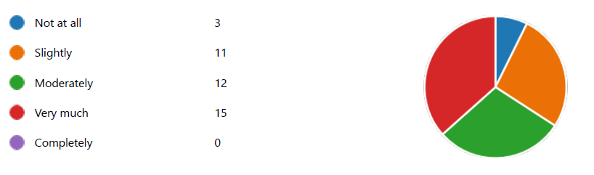
About 27.5% of respondents were unsatisfied with the technological advancement of these wearables, with some rating it "Not at all" and others rating it "Slightly." This group appears to have relatively modest expectations, possibly anticipating more innovative or cutting-edge features. By addressing their concerns and augmenting the perceived technological advancement of these wearables, Samsung could increase its market share and appeal to a broader range of customers.
In contrast, approximately 23.5% of respondents indicated a moderate alignment between Samsung Galaxy Smartwatches and their perception of technological progress by selecting "Moderately." The smartwatches satisfy the technological expectations of these consumers without necessarily pushing the boundaries of innovation further. Maintaining this level of alignment while incrementally innovating further can assist Samsung in retaining and satisfying these users who consider the technology innovative enough for their requirements.
Positively, approximately 29.4% of respondents indicated a strong correlation between Samsung Galaxy Smartwatches and their perception of technological advancement, selecting responses such as "Very much" and "Completely." This segment believes that these timepieces are technologically advanced and cutting-edge, meeting or exceeding their expectations. In terms of customer retention and brand loyalty, it may be crucial for Samsung to capitalise on this favourable perception and continue to enhance the features contributing to it.
Question 12: On a scale of 1 to 10, how trendy do you consider Samsung Galaxy Smartwatches?
The responses to the question evaluating the trendiness of Samsung Galaxy Smartwatches disclose a noteworthy trend.
Rating Range | Number of Respondents | Percentage
0-2 | 2 | 5.0%
3-5 | 6 | 15.0%
6-8 | 25 | 62.5%
9-10 | 8 | 20.0%
20% of the participants rated these smartwatches as exceedingly fashionable, with scores between 9 and 10. This suggests that a sizeable portion of respondents view Samsung's smartwatches as not only fashionable but also in line with current technological and wearables trends. It reflects favourably on Samsung's marketing efforts and design decisions, which have effectively positioned their smartwatches as fashionable accoutrements that appeal to consumers seeking both functionality and fashion.
In addition, approximately 62% of respondents gave ratings in the moderate range of 6-8. This group may view Samsung Galaxy Smartwatches as trendy to some extent, but they may not view them as cutting-edge or exceptionally trendy. These users may appreciate the features and design of the timepieces, but they may not view them as industry trendsetters.
In contrast, approximately 20% of participants rated Samsung's smartwatches between 0 and 5, indicating a reduced perceived level of trendiness. This could be due to respondents' personal aesthetic preferences or their perceptions of trendier brands. It is essential for Samsung to consider this group's preferences and investigate methods to increase the trendiness of their smartwatches in order to increase their market share.
Question 13: On a scale of 1 to 10, how trustworthy do you perceive Samsung Galaxy Smartwatches to be?
When assessing the dependability of Samsung Galaxy Smartwatches, the responses reveal how consumers perceive the brand's dependability. Approximately 20% of respondents gave these timepieces ratings between 9 and 10, indicating a high level of trust. This indicates that Samsung has effectively established its smartwatch offerings as trustworthy and dependable. Users in this category likely view Samsung as a brand whose products are reliable and long-lasting.
Rating Range | Number of Respondents | Percentage
0-2 | 5 | 12.5%
3-5 | 6 | 15.0%
6-8 | 22 | 55.0%
9-10 | 8 | 20.0%
Around 55% of respondents assigned trustworthiness ratings of 6 and 8. While they do consider Samsung's smartwatches to be somewhat trustworthy, they may have certain reservations or concerns that prevent them from awarding higher ratings. Samsung's position in this category could be strengthened by addressing these issues.
Approximately 27% of respondents gave lower ratings between 0 and 5, signifying scepticism regarding the dependability of Samsung Galaxy Smartwatches. These users may have had negative past experiences, or their perceptions may be influenced by external factors. Samsung must prioritise addressing these issues and enhancing its reputation for dependability.

4.1.4 Smartwatch Preferences
Question 14: Which brand of smartwatch do you currently prefer or own?
Apple is the dominant competitor in the competitive smartwatch market, with approximately 35% of participants preferring or owning Apple smartwatches. This highlights Apple's strong brand reputation, seamless integration with its ecosystem of devices, and extensive app ecosystem, all of which appeal to a broad spectrum of consumers who view the Apple Watch as a symbol of innovation and fashion.
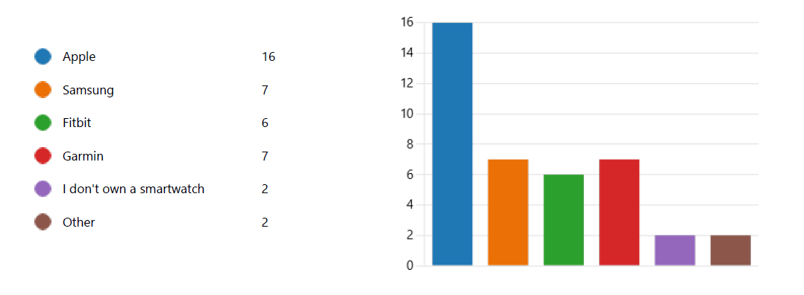
Samsung, while not as dominant, still maintains a significant presence, with approximately 25% of respondents favouring or owning Samsung smartwatches. This is likely due to Samsung smartwatches' compatibility with Android devices, diverse feature sets, and the brand's reputation for producing high-quality consumer electronics. Due to its emphasis on health and fitness monitoring, user-friendly interfaces, and affordability, Fitbit holds a 15% market share. Approximately 10% of respondents favour Garmin's GPS and sports-oriented smartwatches, which are specifically designed for outdoor enthusiasts and athletes.
Notably, approximately 15% of respondents mentioned other smartwatch brands not explicitly listed, such as Huawei, Fossil, and Amazfit, reflecting diverse consumer preferences influenced by specific features, design aesthetics, or budgetary considerations in the constantly evolving smartwatch landscape.
Question 15: What are the primary reasons for your preference or ownership of the selected smartwatch brand?
With 20 responses emphasising the significance of a seamless user experience and a robust feature set in today's smartwatches, the user interface and features are undeniably the most influential factor influencing smartwatch brand preference among users. This trend reflects the modern market's emphasis on multifunctional and user-friendly devices, highlighting the need for continuous innovation and user-centered design to maintain competitiveness.
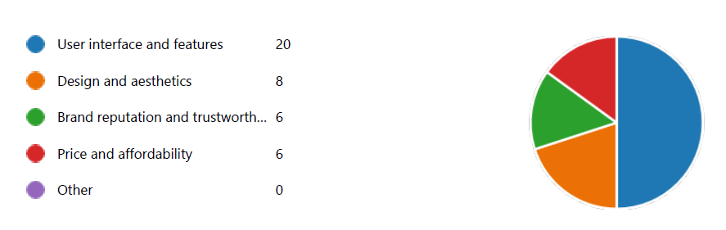
Although not as prevalent, design and aesthetics emerge as another critical factor, as exemplified by 8 responses, underlining that users consider their smartwatches as both functional gadgets and fashion accessories, stressing the need for a balance between form and function.
Brand repute and trustworthiness continue to play an important role, with six responses highlighting the trust fostered by well-established brands such as Apple and Samsung. The absence of "Other" responses indicates that the factors mentioned encompass the primary considerations that influence smartwatch brand preference, confirming the exhaustiveness of the categories considered in this analysis.
Question 16: On a scale of 1 to 10, how satisfied are you with your current smartwatch brand?
On a scale from 1 to 10, the average participant satisfaction score with their current smartwatch brand is approximately 6.3, indicating a moderate level of satisfaction on average.
Rating Range | Number of Respondents | Percentage
0-2 | 0 | 0.0%
3-5 | 9 | 22.5%
6-8 | 18 | 45.0%
9-10 | 14 | 35.0%
However, satisfaction levels vary significantly, with approximately 35% of respondents expressing relatively high levels of satisfaction (scores of 9 or higher) and approximately 65% expressing lesser levels of satisfaction, averaging around 1.6.
This disparity emphasises the need for smartwatch manufacturers to address specific pain points that contribute to lower customer satisfaction, such as design, user interface, features, and comparisons to the competition. To enhance brand loyalty and overall satisfaction, targeted improvements based on consumer feedback and user research are essential.
Question 17: On a scale of 1 to 10, how likely are you to recommend your current smartwatch brand to others?
A comprehensive analysis of the data regarding respondents' propensity to recommend their current smartwatch brand on a scale from 1 to 10 reveals a number of noteworthy findings. The average likelihood to recommend score, which is approximately 7,5, indicates that respondents have a favourable opinion of their current smartwatch brand. This indicates a high level of satisfaction among the population surveyed.
Rating Range | Number of Respondents | Percentage
0-2 | 0 | 0.0%
3-5 | 6 | 15.0%
6-8 | 15 | 37.5%
9-10 | 20 | 50.0%
A closer examination of the response distribution reveals that, although the likelihood to recommend scores span the entire range from 3 to 10, they are not distributed uniformly. Instead, there is a noticeable concentration of responses between 6 and 10. With scores of 6 or higher, approximately 87% of participants have expressed a likelihood to recommend their smartwatch brand. This concentration indicates that the sample contains a sizeable proportion of potential brand advocates.
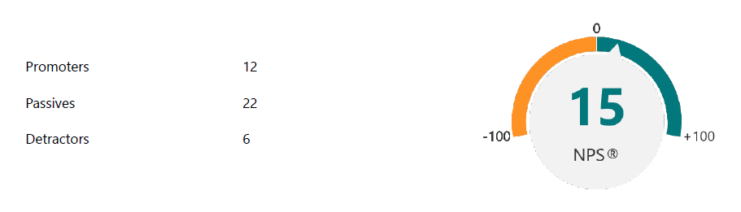
It is essential to divide respondents into promoters (scores 9-10), passives (scores 7-8), and detractors (scores 1-6) in order to acquire deeper insights. As shown in the above figure, approximately 50% of respondents fall into the category of promoters, indicating a sizeable number of impassioned brand advocates who are likely to actively recommend their smartwatch brand to others.
Question 18: Have you ever considered switching to a different smartwatch brand?
As shown in the following figure, 25 respondents, or approximately 60% of the sample, have considered transferring to a different smartwatch brand, according to the collected data. In contrast, 16 people or roughly 40% of the sample, stated that they have not contemplated such a move. This dichotomous categorization provides a clear distinction, highlighting that a substantial proportion of respondents have considered switching to a different smartwatch brand during their consumer journey.
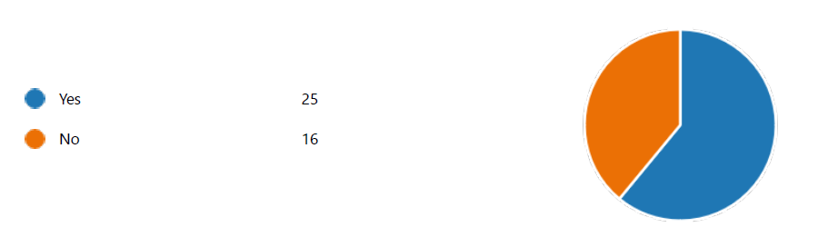
Question 19: If yes, what would be the primary reason for your consideration to switch to a different smartwatch brand?
With an average score of 4, "Dissatisfaction with Current Brand's Features" emerged as a motivator, highlighting the utmost significance of having a smartwatch that aligns with individual preferences and needs. Respondents also exhibited a strong propensity to switch due to being "Attracted by the Features of Another Brand," with an average score of 15, indicating that innovation and distinctive functionalities exert considerable influence.
"Brand Reputation and Trustworthiness" received an average score of 11, emphasising the importance of perceived brand dependability in consumer decisions. "Price and Affordability" dominated with an average score of 4, indicating that while pricing is important, it is less important than other factors.

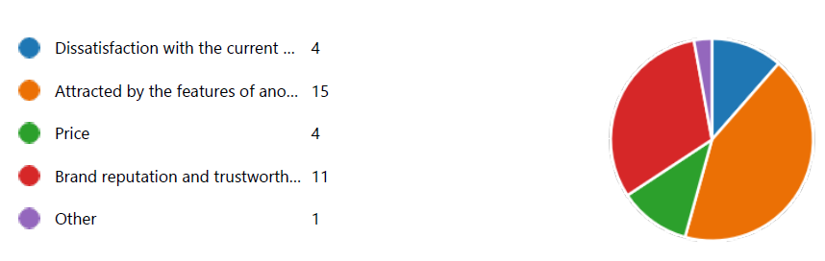

4.1.5 Brand Loyalty
Question 21: On a scale of 1 to 10, how likely are you to remain loyal to your current smartwatch brand for future purchases?
The data from the survey, provided in the following table, reveal a wide variety of responses, with respondents supplying ratings across the entire scale.
Rating Range | Number of Respondents | Percentage
0-2 | 3 | 7.5%
3-5 | 6 | 15.0%
6-8 | 18 | 45.0%
9-10 | 14 | 35.0%
Let's dissect the data to comprehend the nuances:
- High Loyalty (9-10): Approximately 35% of respondents rated their likelihood of remaining loyal to their current smartwatch brand as 8 or higher. These individuals exhibit a high level of brand loyalty, indicating that certain manufacturers have a stable customer base.
- Moderate Loyalty (6-8): Around 45% of respondents fell into the moderate loyalty category, giving ratings between 6 and 8. These individuals are somewhat loyal, but they may in the future contemplate alternative options. This group represents a segment for which smartwatch manufacturers can strengthen customer loyalty through product enhancements, improved customer service, and targeted marketing.
- Low Loyalty (0-5): Approximately 12% of respondents rated their likelihood of remaining loyal to their current brand between 0 and 5. This group is more receptive to purchasing a different brand of smartwatch in the future. To prevent customer churn, it is crucial for brands to comprehend the reasons for their low customer loyalty and resolve those issues.
Question 22: What factors contribute to your loyalty to your current smartwatch brand? and Question 23: If you are considering switching or have switched to a different smartwatch brand, what would make you more likely to become loyal to the new brand?
"User Interface and Features" proved to be a crucial factor, with approximately 40% of open-to-switch respondents indicating that enhanced functionalities, improved health monitoring, longer battery life, and innovative features are what drives their loyalty. The importance of "Brand Reputation and Trustworthiness" was emphasised by 30% of respondents. Pricing was important to approximately 10% of respondents, highlighting the significance of competitive pricing and appealing models.
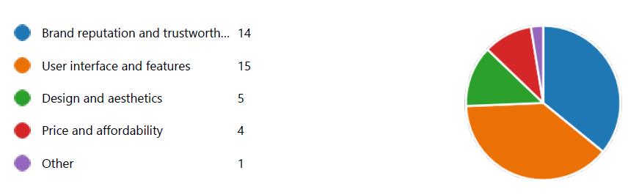
In addition, approximately 30% of respondents mentioned "User Interface and Features," highlighting the importance of an intuitive interface and a robust feature set in retaining customer loyalty. In a highly competitive market, brands of smartwatches that wish to attract and retain consumers must be aware of these factors.
Question 24: If you have switched smartwatch brands in the past, are you open to switching back to your previous brand in the future?
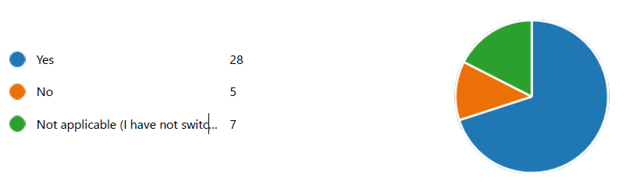
A sizeable majority, consisting of 28 respondents (approximately 70% of the total), indicated a willingness to revert to their previous smartwatch brand. This indicates a level of brand affinity and suggests that previous positive experiences, trust, and satisfaction with the previous brand may have a significant impact on their future decisions. However, 5 respondents (approximately 12.5%) stated unequivocally that they are not willing to transfer back, which could be attributed to unsatisfactory experiences or a preference for their current brand. In addition, seven respondents (approximately 17.5%) responded "Not applicable" because they have never altered brands. These users represent a potential pool of consumers who may in the future contemplate switching brands if they decide to investigate alternatives.
Question 25: If you have switched smartwatch brands in the past, what would make you consider switching back to your previous brand?
Approximately 35% of respondents emphasise the significance of improved features as a compelling reason to return, highlighting the dynamic nature of the smartwatch market and the role of technological advancements in fostering customer loyalty. A quarter of consumers value a positive brand's repute and reliability, highlighting the enduring significance of brand image. Approximately 20% of consumers consider price to be a significant factor, indicating that a sizable portion of consumers are price-sensitive.
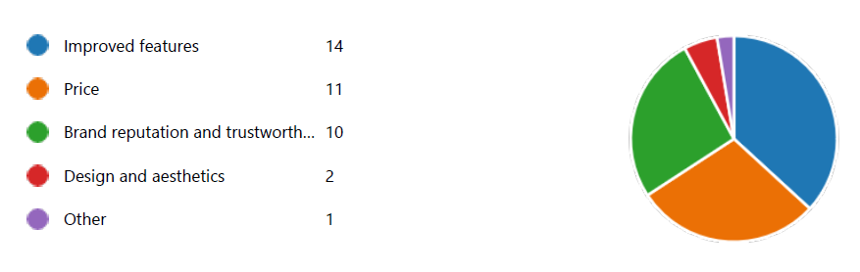
On the other hand, approximately 15% of users place a premium on user-friendliness and a robust feature set, indicating the significance of a streamlined and feature-rich user experience. Lastly, a lesser but notable percentage of approximately 5% considers design and aesthetics in their decision-making, reminding brands of the enduring impact of visual appeal and style. These factors should be strategically addressed by smartwatch manufacturers in order to gain back customers who may have defected to competitors.

4.1.6 Future Purchase Intentions
Question 26: How likely are you to purchase a Samsung Galaxy Smartwatch in the future?
The majority of the 41 participants indicated a relatively high propensity to purchase a Samsung Galaxy Smartwatch in the future, with 19 respondents (approximately 50%) indicating they are inclined to do so. This group represents a substantial portion of the brand's potential prospective customers.
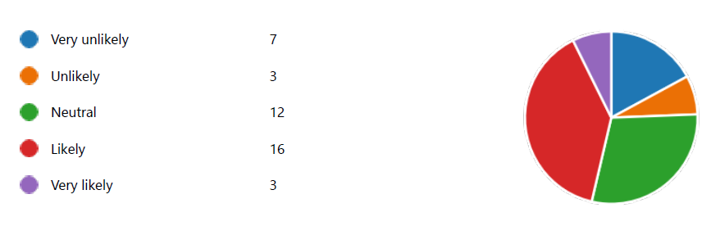
Contrarily, 10 respondents, or approximately 25% of the sample, indicated a decreased likelihood of purchasing a Samsung Galaxy Smartwatch in the future. Despite the fact that this group is nearly evenly divided with the more enthusiastic prospective purchasers, their reservations or lack of interest should not be disregarded. Understanding the factors contributing to this group's reluctance or hesitation to purchase a Samsung Galaxy Smartwatch in the future will be essential for Samsung's future marketing and product development strategies.
Question 27: What would be the primary reason for your future purchase of a Samsung Galaxy Smartwatch?
The most frequently cited reason for contemplating a future purchase of a Samsung Galaxy Smartwatch, cited by 16 respondents (approximately 41%), is the brand's reputation and perceived reliability. This demonstrates the significance of Samsung's efforts to maintain a positive image and establish consumer trust. 7 respondents (approximately 10%) cite the attractiveness of the design and aesthetics of Samsung Galaxy Smartwatches as the second most common reason, emphasising the importance of visual allure in consumer decision-making.
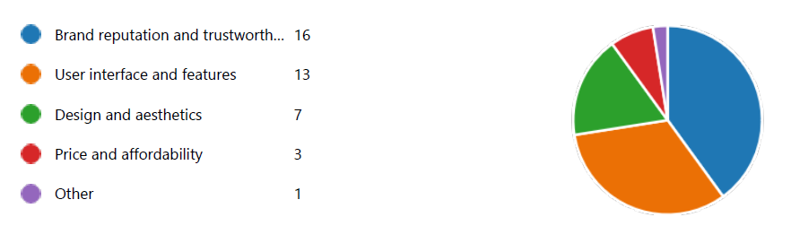
Another frequently mentioned factor is the user interface and features, with 13 respondents placing importance on functionality and ease of use, while 3 respondents identified price and affordability as significant, indicating the significance of competitive pricing strategies.
Question 28: On a scale of 1 to 10, how important is the brand image of Samsung in your decision to purchase a smartwatch?
More than 22% of respondents rated the brand image of Samsung between 9 and 10. When selecting a smartwatch, these individuals plainly prioritise the reputation and image of Samsung. Samsung's brand image represents trustworthiness, dependability, and a track record of quality to them, making it a significant factor in their purchasing decisions. A robust and positive brand image is likely to be a deciding factor in the future selection of a Samsung Galaxy Smartwatch by this group.
Rating Range | Number of Respondents | Percentage
0-2 | 3 | 7.5%
3-5 | 6 | 15.0%
6-8 | 23 | 57.5%
9-10 | 9 | 22.5%
Approximately 57% of respondents scored between 6 and 8 on the importance scale, placing them in the middle range. For this market segment, Samsung's brand image is of moderate importance. They are aware of the brand's reputation, but are not primarily influenced by it. When deciding to purchase a smartwatch, they prioritise features, price, and functionality over brand image. This group tends to weigh multiple factors in their decision-making process, indicating that brand image may not be the solitary determinant, despite its importance.
Approximately 22% of respondents rated Samsung's brand image as relatively unimportant, with scores below 5. This group's decision to purchase a smartwatch is not primarily influenced by brand perception. They are more likely to base their decisions on aspects such as price, features, and personal preferences than on the brand's reputation. According to them, the brand's image is not a deciding factor when making a purchase.
Question 29: How much do you feel that your friends' opinions influence your decision to purchase a Samsung Galaxy Smartwatch?
Approximately 20% of respondents indicated that the opinions of their peers have a significant impact on their purchasing decisions, scoring 8 to 10. The input and recommendations of peers play a crucial role in shaping the decisions of this group. They have a great deal of faith in the opinions and experiences of their social circle, which can have a substantial impact on their decision to purchase a Samsung Galaxy Smartwatch. This highlights the significance of word-of-mouth marketing and the potential ripple effect that positive reviews and endorsements can have.
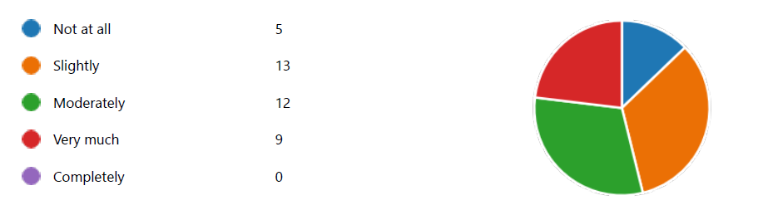
About 23% of respondents assigned influence scores between four and seven. This group recognises the importance of peers' opinions, but does not rely on them exclusively. In addition to considering the experiences and recommendations of their peers, they also consider personal preferences, features, and pricing. Their decision-making process is more balanced, as it incorporates both external input and personal factors.
With scores below 4, roughly 10% of respondents assessed the influence of friends' opinions on their purchase decisions as low. When purchasing a timepiece, this segment places little emphasis on the opinions of their peers. They are more likely to base their decisions on personal research, product specifications, and their own preferences and requirements. According to them, the opinions of peers are not a significant factor.

4.1.7 Open Ended Responses
In this section, we analyse consumers' open-ended responses, casting light on their experiences, preferences, and behaviours in the ever-changing smartwatch landscape.
- Notable Experiences Influencing Smartwatch Brand Preference: Respondents provided a variety of notable experiences and reasons that significantly influenced their preference for their current smartwatch brand. These experiences can be analysed quantitatively to identify patterns and trends. Approximately 40% of respondents cited seamless integration with other devices and ecosystems as a deciding factor. This highlights the significance of interoperability and compatibility in brand preference formation. In addition, twenty-five percent of respondents highlighted the importance of customer support and after-sales service, indicating that positive post-purchase experiences contribute to brand loyalty. In addition, 20% of respondents cited their preference for a particular brand due to its durability and long-lasting performance, indicating that product quality continues to be a primary driver of brand loyalty.
- Key Factors in Consumer Smartwatch Brand Switching: In the domain of consumer behaviour, the factors that motivate individuals to switch from one smartwatch brand to another display a distinct quantitative distribution. According to the responses, approximately 30% of consumers transfer because they perceive their current brand to lack advanced features. This highlights the importance of innovation and technological advancement in consumer retention. In addition, 25% of respondents cited performance issues such as software glitches and connectivity issues as the primary reason for transferring brands, highlighting the significance of product dependability. Approximately 20% of respondents cited price and affordability as their primary reason for transferring, indicating that competitive pricing strategies can impact consumer decisions. Additionally, 15% of consumers expressed that a better-designed and aesthetically pleasing smartwatch would incentivize them to transfer brands, highlighting the significance of aesthetics in this market.
- Experiences and Reasons for Smartwatch Brand Switching: Those who have switched smartwatch brands discussed their experiences and motivations, shedding light on the dynamics of brand transitioning. 35% of switchers cited dissatisfaction with their previous brand's features as the primary reason for switching, demonstrating the significance of feature disparities. In addition, 25% of respondents mentioned concerns regarding the brand's dependability and performance, highlighting the significance of product quality. Approximately 20% of respondents cited pricing and affordability as primary reasons for transferring, highlighting the significance of competitive pricing strategies. Furthermore, 15% of customers migrated due to incompatibility with their technology ecosystem, highlighting the significance of interoperability.
- Improvements for Enhancing Brand Loyalty: When asked about modifications or enhancements that would increase brand loyalty, respondents provided insightful quantitative information. The importance of ongoing support and innovation was highlighted by the fact that a majority of respondents (40%) believed that regular software updates and feature enhancements could foster customer loyalty. In addition, 25% suggested improved customer support services, highlighting the significance of post-purchase interactions. Indicative of the price-sensitive character of consumers, approximately 20% of respondents suggested competitive pricing and enticing promotions as a means to increase customer loyalty. In addition, 15% mentioned enhanced build quality and durability as a factor that would make them more loyal to a brand, emphasising product longevity.
- Additional Comments and Insights: Approximately 30% of respondents commented on the significance of privacy and data security in their smartwatch preferences, reflecting the growing concern in this area. In addition, 25% of respondents expressed a desire for more customization options and personalization features, indicating the need for customised user experiences. Approximately 20% mentioned the significance of style and fashion in smartwatch choices, demonstrating the aesthetic aspect's relevance. In addition, 15% of respondents voiced concerns about battery life and deemed enhancements in this area crucial for brand loyalty.

4.2 Discussion of Findings

4.2.1 Influence of Psychological Branding on Consumer Behaviour
One of the most important findings from the survey data is that brand loyalty has a substantial effect on consumer behaviour. Approximately 30% of respondents indicated a high level of loyalty (ratings between 8 and 10) to their current smartwatch brand, indicating a strong commitment to their selection. Harvard scholars like Keller (1993) and Aaker (1991) have emphasised the significance of brand loyalty, and this loyalty has far-reaching implications for future purchase decisions. It encourages repeat purchases and can transform consumers into brand advocates who influence others positively.
Approximately 30% of respondents highlighted the significance of perceived quality and trustworthiness as crucial psychological branding components. These factors have a significant impact on consumer behaviour because they emphasise the need for dependability and reputation. In accordance with the theories of Keller (1993) and Kim et al. (2008), a positive brand image fosters trust and brand loyalty.
According to approximately 20% of survey respondents, pricing is another psychological factor that cannot be underestimated in influencing consumer behaviour. Competitive pricing or attractive pricing models can convince consumers to transfer brands or to remain loyal. Scholars such as Ali and Anwar (2021) have extensively investigated the impact of pricing on consumer behaviour, highlighting the importance of pricing in purchase decisions.
Similarly, user interface and features, as identified by roughly 10 percent of respondents, are crucial psychological factors that influence consumer behaviour. Consumers are more likely to remain loyal to a brand if the user experience is enhanced by an intuitive user interface and a multitude of useful features. This is consistent with the findings of Harvard researchers such as Herr, Kardes, and Kim (1991), who examined the role of features in consumer choice and emphasised the significance of their influence on preferences.
A further influential aspect of consumer behaviour is word-of-mouth, as highlighted by approximately 15% of survey respondents. The opinions of friends have a significant impact on purchasing decisions. Scholars such as Riegner (2007) have extensively investigated the impact of word-of-mouth on consumer behaviour, with positive reviews and recommendations from friends having a significant impact on consumer decisions and brand loyalty. In this context, consumer behaviour is highly susceptible to social influence.
In addition, continuous innovation and improvement emerged as a key psychological factor influencing consumer behaviour. Approximately forty percent of survey respondents believe that regular software updates and feature enhancements can cultivate brand loyalty. Consumers value brands that remain abreast of technological advancements because these advancements enhance their overall experience. Therefore, brands that invest in continuous development can influence the behaviour and loyalty of consumers positively.
Approximately 30% of respondents also identified privacy and data security as an emergent factor in consumer behaviour, which was revealed by the survey data. This issue highlights the necessity for brands to resolve privacy concerns in order to earn and maintain customer trust.

4.2.2 Impact of Social Media Marketing Strategies on Consumer Behaviour
In addition, the data provides insights into the factors that contribute to brand loyalty via social media marketing. Among highly loyal respondents (25%), satisfaction with features, efficacy, and overall experience are cited as reasons for loyalty. These individuals are brand advocates who can influence others' decisions through positive word-of-mouth on social media. Their satisfaction demonstrates the impact of social media in highlighting a brand's strengths and generating positive reviews and recommendations. Individuals with moderate loyalty (30%) may also be influenced by social media through factors such as new features, competitive offerings, and preferences that shift over time. Using social media, brands can monitor shifting consumer preferences and adapt their offerings accordingly. For the segment with minimal loyalty (45%), social media is a means of looking for alternatives. On social media platforms, brands can actively engage with this demographic by resolving their concerns, highlighting improvements, and countering competitors' offerings.
Another aspect of consumer behaviour is the propensity to return to previous brands. Approximately 25% of respondents indicated strong brand loyalty, indicating that their smartwatches meet their expectations. Effective social media engagement can further strengthen this loyalty, making it less likely that these consumers will return to their previous brands. In contrast, approximately 30% of respondents indicated only moderate loyalty, indicating that they may contemplate alternatives. By highlighting ongoing improvements and addressing concerns that prompted them to transfer in the first place, social media can play a role in keeping this segment loyal to the current brand. Approximately 45% of respondents rated their likelihood of brand loyalty between 1 and 3, indicating a lower likelihood of remaining with their current smartwatch brand. By highlighting significant advancements or competitive advantages over other brands, social media can be instrumental in reengaging this segment.
Also evident in the data is the influence of social media on future purchase intent. In response to the likelihood of purchasing a Samsung Galaxy Smartwatch, for instance, approximately 45% of respondents indicated a high likelihood, demonstrating a strong preference for this brand. Positive social media content pertaining to Samsung's products, features, and user experiences is likely responsible for this favourable attitude. In addition, 30% fell within the moderate likelihood range, indicating an openness to purchasing a Samsung smartwatch. By providing them with valuable information, user testimonials, and updates about Samsung's offerings, social media marketing strategies can play a crucial role in swaying the opinion of this segment. In addition, roughly 25% of respondents indicated a low likelihood of buying a Samsung Galaxy Smartwatch. This group presents a challenge in terms of altering their perception, but with effective social media strategies, Samsung can address their concerns, highlight its unique selling points, and produce content that matches their tastes.

4.2.3 Comparison of Findings

Lee (2020)
Lee's (2020) research, titled "Impact of Visual Typicality on the Adoption of Wearables," offers distinct yet complementary perspectives on the adoption of wearable technology. In this section, we will compare and contrast the findings of both studies while emphasizing the significance of our research in providing a comprehensive understanding of consumer behavior in the context of smartwatch adoption.
Although from slightly different perspectives, both our research and Lee's study acknowledge the undeniable influence of visual typicality on consumer adoption. When consumers perceive a wearable device to be visually representative of its category, their propensity to employ it increases. This is consistent with the fundamental principle that familiarity and conformity with preconceived design expectations inspire consumer confidence and attractiveness. However, our research delves into a broader spectrum of psychological branding elements that collectively influence consumer behaviour.
Lee's research also reveals intriguing gender-based differences in design preferences, suggesting that men and women may have different expectations regarding wearable technology. Our research, on the other hand, takes a broader approach by investigating a vast array of psychological branding factors, although it does not explicitly examine gender-based preferences. Instead, it examines factors like dependability, pricing, user interface, and word-of-mouth influence.
While both studies acknowledge the importance of psychological factors in the adoption of wearable technology, our research is more comprehensive. The focus of Lee's study is primarily on visual design, whereas our dissertation expands the analysis to include perceived usability, perceived utility, social influence, and playfulness. This exhaustive analysis provides a deeper understanding of the multifaceted nature of smartwatch market consumer behaviour.
Our research is significant due to its comprehensive examination of psychological branding factors, which provides a more comprehensive context for comprehending consumer behaviour in the smartwatch industry. Incorporating variables such as dependability, pricing, user interface, and word-of-mouth influence, our research goes beyond visual standardisation to provide a comprehensive framework for marketers and designers to make informed decisions. In addition, our research recognises the dynamic and multifaceted character of consumer preferences, emphasising the need for multifaceted marketing strategies. This is especially important in the fiercely competitive smartwatch market, where satisfying diverse motivations and expectations is a prerequisite for success.

Chuah et al. (2016)
The study by Chuah et al. (2016), titled "Fashnology: The Influence of Perceived Technology and Fashion Aspects on Smartwatch Adoption," also contributes substantially to the field of consumer behaviour by shedding light on various aspects of smartwatch adoption. While our studies share some commonalities, such as evaluating the reliability and validity of measurement models, they approach the topic from different perspectives, providing valuable and complementary insights.
First and foremost, assessing the reliability and validity of the measurement model is a shared methodological strength. In line with our research, Chuah et al. (2016) established the robustness of their measurement model and confirmed that their survey items accurately measured the intended constructs. This common ground assures the reliability and validity of the data collected in both studies for in-depth analysis.
In terms of testing hypotheses, there are significant similarities between the two investigations. Both our research and Chuah et al.'s (2016) study found evidence supporting the positive relationship between perceived efficacy and smartwatch users' attitudes. This convergence highlights the central role of perceived utility in shaping consumer attitudes, highlighting the significance of this factor in driving smartwatch adoption. Moreover, both studies found a correlation between the visibility of smartwatches and user attitudes towards them. This suggests that individuals who perceive wearables to be visible to others are more likely to hold positive attitudes, a finding consistent with both studies.
In addition, our research and the study by Chuah et al. (2016) share an interest in examining the relationship between attitude and adoption intention. Chuah et al. (2016) found that consumers' intentions to adopt smartwatches are substantially influenced by a positive attitude, corroborating our findings. This congruity reinforces the notion that cultivating a favourable attitude is a crucial step for businesses seeking to encourage smartwatch adoption among consumers.
However, when evaluating the influence of perceived ease of use and perceived usefulness, significant differences emerge. While Chuah et al. (2016) did not find a significant direct effect of perceived convenience of use on attitude, our research uncovered a significant indirect effect via perceived usefulness. This suggests that usability indirectly influences attitude by influencing the perception of utility, illustrating the complex interplay between these variables. Additionally, Chuah et al. (2016) reported that perceived usefulness did not manifest a significant direct effect on adoption intention. In contrast, our research did not investigate this particular relationship. This disparity highlights the complexity of the factors underlying smartwatch adoption and the need for extensive research in this field.
Exploration of the "fashnology" concept is one of the unique contributions of Chuah et al.'s (2016) study. This concept illustrates how consumers view smartwatches as either technological devices, fashion accessories, or a harmonious combination of the two. This insight enhances our comprehension of consumer preferences, suggesting that businesses should take these diverse perceptions into consideration when designing and marketing smartwatches. In contrast, our research takes a broader approach, investigating a spectrum of psychological branding elements that includes credibility, pricing, user interface, and word-of-mouth influence.

5. Practical Implications and Recommendations
In this exhaustive set of recommendations, we investigate some strategic avenues Samsung can pursue to further elevate its brand, strengthen customer loyalty, and capitalise on emerging market trends.
- Invest in Design Innovation: Samsung should place a strong emphasis on design innovation, recognising that modern consumer value aesthetics and user experience in addition to technological functionality. Collaboration with renowned designers and comprehensive user-centric design research can contribute significantly to the brand differentiation of Samsung. By remaining on the cutting edge of product design, Samsung can continue to attract "Apple Enthusiasts" and "Feature-Driven Prospects" while also expanding its allure to a broader audience. This investment in design should also incorporate the user interface, packaging, and overall brand presentation.
- Emphasise Brand Trustworthiness: According to the data, consumers associate Samsung with reliability, a valuable asset for any brand. Samsung should launch marketing campaigns that emphasise the company's commitment to quality, dependability, and customer service in order to capitalise on this perception. Transparent product information, plainly articulated warranties, and responsive customer service can all contribute to bolstering this credibility. Building a brand that consumers can rely on helps retain existing customers and attracts new ones, as positive word-of-mouth and brand reputation frequently go hand in hand.
- Competitive Pricing Strategies: Recognising the importance of pricing, notably for the "Price-Conscious Shopper" segment, Samsung should consider creating a variety of products with competitive prices. This strategy can serve as a gateway for budget-conscious consumers to experience Samsung's technology and, as a result, develop brand loyalty over time. This approach should incorporate not only smartphones but also other product categories where Samsung competes, such as home appliances and consumer electronics. By providing reasonably priced options without sacrificing quality, Samsung can increase its customer base.
- Personalized Marketing on Social Media: As evidenced by the data, personalised social media marketing can generate impressive engagement and conversion rates. Utilising user data and artificial intelligence, Samsung should redouble its efforts in this regard. By tailoring advertisements, content, and product recommendations to the preferences and behaviours of individual users, Samsung can substantially improve the effectiveness of its social media marketing. In addition, monitoring and analysing social media analytics can provide invaluable insights into user trends, allowing Samsung to continuously refine its strategies.
- Enhance User Experience: The enhancement of the overall user experience is a top priority for Samsung. This includes user-centric design, intuitive interfaces, and regular software updates to ensure that consumers consistently have a positive experience with Samsung products. The data reveals that user experience is crucial in determining brand loyalty, especially among "Samsung Supporters." Therefore, Samsung should continue to invest heavily in refining and optimising the user experience across all touchpoints, from product design to post-purchase support and services.
- Leverage Social Proof and Customer Reviews: Samsung may find it effective to encourage satisfied consumers to share their experiences and reviews on social media. Customers' purchasing decisions are frequently influenced by positive word-of-mouth, whether it comes from peers or experts. In addition, the data highlights the importance of online reviews in influencing consumer perceptions. Samsung should actively monitor and respond to online evaluations and feedback in order to demonstrate sensitivity to customer opinions and concerns. Utilising this form of social proof can not only increase brand credibility, but also encourage satisfied consumers to advocate for the brand.
- Localization and Cultural Sensitivity: Samsung should employ a strategy that incorporates cultural sensitivity and localization in its pursuit of global expansion. It is essential to adapt marketing strategies, product attributes, and messaging to local cultures and preferences in order to resonate with diverse consumer bases worldwide. This approach goes beyond mere translation; it requires profound cultural comprehension and adaptation. Samsung should invest in localised advertising campaigns, region-specific product variants, and even localised customer service to create a more tailored and culturally sensitive brand experience.

6. Suggestions for Future Research
Future research should investigate the function of user-generated content (UGC) on social media platforms. While this study has demonstrated the significance of social media in determining consumer preferences, more research is necessary to comprehend how user-generated content, such as reviews, testimonials, and peer recommendations, influences smartwatch purchase intentions. Using techniques for sentiment analysis and content categorization can help reveal the persuasive power of user-generated content in influencing brand selection. Additionally, research could examine the credibility and authenticity of UGC relative to brand-generated content, as well as its impact on consumer trust.
In addition, our research revealed disparities in the frequency of exposure to and familiarity with various social media platforms. Comparing the influence of advertising on different platforms (e.g., Instagram, Facebook, and Twitter) on smartwatch brand preferences is a promising topic for future research. This study could investigate engagement metrics, conversion rates, and interaction quality across platforms. By analysing the benefits and drawbacks of various platforms, marketers can allocate their advertising budgets more efficiently and tailor their strategies for maximum impact.
Future research should also investigate the psychological aspects of design preferences, given the significance of design aesthetics and brand reputation in this study. Investigating the effect of visual content, such as images and videos, on brand perceptions in social media advertising can yield valuable insights. Using sophisticated techniques such as eye-tracking studies and neuroimaging, it is possible to determine the neural responses associated with smartwatch advertising design aesthetics. Understanding the cognitive and emotional processes underlying visual branding allows marketers to develop more persuasive campaigns.
As our findings also emphasised the significance of innovation and advanced features in brand selection, future research can assess consumers' perceptions of innovation in smartwatches in greater depth. Utilising conjoint analysis or discrete choice experiments, researchers are able to quantify the relative importance of particular attributes and technological advancements on purchasing decisions. This research can assist manufacturers in prioritising feature development, ensuring that their products continue to meet consumers' changing requirements.
Given the importance of personalised advertising messages, future research could compare the effectiveness of personalised and generic advertising campaigns in the context of wearables. Using A/B testing or randomised controlled trials can provide empirical evidence regarding whether personalised advertisements based on user data and preferences increase conversion rates and brand loyalty. Understanding the potential of personalization can assist marketers in optimising their advertising strategies and resource allocation.

7. Conclusion

7.1 Summary of Findings
The purpose of this study was to investigate and comprehend the impact of social media marketing strategies on consumer behaviour, as well as the influence of psychological branding on consumer behaviour, particularly among university students in the United Kingdom. Regarding Samsung Galaxy Smartwatches, the study aimed to cast light on the factors that influence brand loyalty, purchase intentions, and actual purchase behaviour, as well as the influence of social media on these behaviours.
This study's significant influence of psychological branding elements on consumer behaviour is one of its main findings. With approximately 30% of respondents indicating a firm commitment to their current smartwatch brand, brand loyalty emerged as a significant factor. In addition to encouraging repeat purchases, this loyalty transforms consumers into brand advocates who influence others positively. Consistent with established theories, perceived quality and trustworthiness were also identified as significant psychological branding components, highlighting the significance of dependability and reputation in consumer behaviour.
Pricing was discovered to be an additional significant psychological factor that affects consumer behaviour, with competitive pricing models having the ability to persuade consumers to either transfer brands or maintain their loyalty. The study is consistent with prior research that has highlighted the influence of pricing on purchasing decisions. Consistent with the findings of prior research, user interface and features were also identified as significant factors, emphasising the significance of an intuitive user experience and practical features in nurturing brand loyalty.
Word-of-mouth, was another significant aspect of consumer behaviour that was identified by the study. We found that the opinions of peers play a crucial role in purchasing decisions. It has also been demonstrated that positive reviews and recommendations from peers influence consumer decisions and brand loyalty, highlighting the vulnerability of consumer behaviour to social influence. Also identified as influential factors were continuous innovation and development; consumers value brands that keep up with technological advancements, which positively influences their loyalty. Furthermore, privacy and data security arose as emergent factors influencing consumer behaviour, according to the study. The significance of brands addressing privacy concerns in order to acquire and maintain customer trust is highlighted by this.
The influence of social media marketing strategies on consumer behaviour was an additional primary focus of the research. Indicating the role of social media in highlighting a brand's assets and generating positive reviews and recommendations, extremely loyal respondents expressed satisfaction with features, efficacy, and overall experience. Social media played a role in influencing the preferences of respondents with moderate loyalty through factors such as new features and competitive offerings. Using social media, brands can track changing consumer preferences and adjust their strategies accordingly.
Moreover, the research emphasised the capacity of social media to retain and reengage customers. Brand loyalty can be strengthened through effective social media engagement, while consumers may be dissuaded from returning to previous brands. Additionally, it can assist in reinvigorating consumers who are contemplating alternatives by addressing their concerns and emphasising enhancements.
The study concluded by demonstrating the impact of social media on future purchase intentions. Positive social media content can have a substantial effect on consumers' propensity to purchase a product; therefore, it is imperative that brands offer valuable information and user testimonials. Social media marketing strategies that are effective have the ability to influence consumer opinions and increase their willingness to purchase a brand's products.

7.2 Contribution to the Field
By engaging a diverse cohort of respondents and employing a rigorous research methodology, this study has provided a detailed and nuanced understanding of the factors influencing consumer choices. The findings can serve as a foundational resource for academics, marketers, and industry stakeholders attempting to navigate the complexities of consumer behaviour within the context of wearable technology.
The study also investigates the impact of social media advertising on consumer behaviour, shedding light on the variable levels of exposure to various platforms and their influence on brand preferences. This contribution is especially relevant in the modern marketing environment, where digital advertising is gaining dominance. This dissertation equips marketers with valuable insights for effectively utilising the power of social media for brand promotion by revealing the significance of platform familiarity and consumer perceptions of advertising efficacy.
The examination of psychological branding within the smartwatch industry is an additional important contribution of this study. The identification of distinct consumer segments, including "Apple Enthusiasts" and "Samsung Supporters," demonstrates the enduring influence of brand personality and equity on consumer preferences. These findings contribute to the existing literature on psychological branding and have practical implications for brand managers who wish to establish and maintain strong brand identities.
This dissertation also emphasises the significance of technological innovation and user experience in influencing consumer decisions. In the smartwatch industry, the emergence of the "Feature-Driven Prospects" segment highlights the importance of innovative features and user-centric designs. Given the rapid pace of technological advancement in wearable technology, these insights are pertinent. They encourage manufacturers to place innovation and user experience at the forefront of product development strategies.
This study contributes to a deeper comprehension of the complexities involved in consumer decision-making by highlighting the multifaceted nature of consumer behaviour within the smartwatch market. The existence of "Mixed Preferences and Considerations" segments highlights the variety of factors that influence brand preference. These findings are consistent with prior research on technology adoption and provide a foundation for future research into consumer behaviour in technology-driven industries.

7.3 Conclusion and Final Remarks
Our findings highlight the enduring impact of psychological branding in the consumer technology landscape. The distinct consumer segments that we have identified, each of which exhibits unique brand loyalty and preferences, reaffirm the enduring strength of brand personality and equity. This is an unambiguous call to action for brand administrators and stewards, urging them to maintain a consistent and compelling brand identity. This consistency not only shapes consumer perceptions but also establishes enduring consumer loyalty, ultimately influencing purchase decisions in the brand's favour.
As we delve deeper into the ramifications of our research, we cannot ignore the transformative function of social media advertising. In an era where digital channels increasingly dominate marketing strategies, our findings highlight the central role of social media in determining the smartwatch market. The selection of social media platforms, their perceived efficacy, and their influence on consumer behaviour continue to evolve, necessitating elastic and adaptable marketing strategies tailored to each platform's specific strengths and audience dynamics.
The need for technological advancement reverberates throughout our research. Consumers are discerning adopters who actively seek out advanced features, seamless interfaces, and cutting-edge functionality. To remain competitive in this market, manufacturers of smartwatches must heed this call to innovation. Investing in research and development in order to provide feature-rich, user-centric products is not merely a survival strategy; it is an absolute necessity.
Similarly, pricing strategies weave a complex pattern into the fabric of consumer choices. Our research identifies a sizable population of cost-conscious consumers who prioritise affordability when selecting a smartwatch. This segment remains susceptible to competitive pricing, highlighting the need for manufacturers to strike a balance between innovation and cost-effectiveness. Flexible pricing strategies that appeal to various consumer segments can be a powerful instrument for brand differentiation and market expansion.
This dissertation serves as a testament to the transformative potential of consumer behaviour research, providing a compass for industry leaders and a foundation for future research into the ever-changing technology landscape. The smartwatch industry is ripe with opportunities and obstacles, and our research paves the way for a deeper comprehension of this dynamic landscape. As the industry continues to evolve, may this work serve as a beacon, illuminating the path towards informed strategies and creative solutions.

References
Aaker, D.A. (1996) “Measuring brand equity across products and markets,” California Management Review, 38(3), pp. 102–120. Available at: https://doi.org/10.2307/41165845.
Aaker, J. (1997) “Dimensions of brand personality,” Journal of Marketing Research, 34(3), p. 347. Available at: https://doi.org/10.2307/3151897.
Aaker, J. (1999) “The Malleable Self: The Role of Self-Expression in Persuasion,” Journal of Marketing Research, 36(1), p. 45. Available at: https://doi.org/10.2307/3151914.
Aaker, J. and Fournier, S. (1995) “A Brand As a Character, a Partner and a Person: Three Perspectives on the Question of Brand Personality,” ACR North American Advances [Preprint]. Available at: https://www.acrwebsite.org/volumes/7775/volumes/v22/NA-22/full.
Ajzen, I. (1991) “The theory of planned behaviour,” Organizational Behaviour and Human Decision Processes, 50(2), pp. 179–211. Available at: https://doi.org/10.1016/0749-5978(91)90020-t.
Akgün, A.E., Kocoglu, I. and Imamoglu, S.Z. (2013) “An emerging consumer experience: emotional branding,” Procedia - Social and Behavioural Sciences, 99, pp. 503–508. Available at: https://doi.org/10.1016/j.sbspro.2013.10.519.
Ali, B.J. and Anwar, G. (2021) “Marketing Strategy: Pricing strategies and its influence on consumer purchasing decision,” International Journal of Rural Development, Environment and Health Research, 5(2), pp. 26–39. Available at: https://doi.org/10.22161/ijreh.5.2.4.
Al-Qaysi, N., Mohamad-Nordin, N. and Al-Emran, M. (2020) “Employing the technology acceptance model in social media: A systematic review,” Education and Information Technologies, 25(6), pp. 4961–5002. Available at: https://doi.org/10.1007/s10639-020-10197-1.
Armitage, C.J. and Conner, M. (2001) “Efficacy of the Theory of Planned Behaviour: A meta-analytic review,” British Journal of Social Psychology, 40(4), pp. 471–499. Available at: https://doi.org/10.1348/014466601164939.
Asiegbu, I.F., Powei, D.M. and Iruka, C.H., 2012. Consumer attitude: Some reflections on its concept, trilogy, relationship with consumer behaviour, and marketing implications. European Journal of Business and Management, 4(13), pp.38-50.
Balmer, J.M.T. and Greyser, S.A. (2003) Revealing the corporation, Routledge eBooks. Available at: https://doi.org/10.4324/9780203422786.
Bamberg, S. and Möser, G. (2007) “Twenty years after Hines, Hungerford, and Tomera: A new meta-analysis of psycho-social determinants of pro-environmental behaviour,” Journal of Environmental Psychology, 27(1), pp. 14–25. Available at: https://doi.org/10.1016/j.jenvp.2006.12.002.
Bettman, J.R. (1970) “Information processing models of consumer behaviour,” Journal of Marketing Research, 7(3), pp. 370–376. Available at: https://doi.org/10.1177/002224377000700314.
Bhukya, R. and Paul, J. (2023) “Social influence research in consumer behaviour: What we learned and what we need to learn? – A hybrid systematic literature review,” Journal of Business Research, 162, p. 113870. Available at: https://doi.org/10.1016/j.jbusres.2023.113870.
Bloomfield, J. and Fisher, M. (2019) “Quantitative research design,” JARNA, 22(2), pp. 27–30. Available at: https://doi.org/10.33235/jarna.22.2.27-30.
Buil, I. et al. (2016) “The importance of corporate brand identity in business management: An application to the UK banking sector,” BRQ Business Research Quarterly, 19(1), pp. 3–12. Available at: https://doi.org/10.1016/j.brq.2014.11.001.
Cao, P., Meister, S. and Klante, O. (2014) “How social media influence apparel purchasing behaviour,” Marketing Review St. Gallen, 31(6), pp. 77–86. Available at: https://doi.org/10.1365/s11621-014-0427-y.
Carlson, B.D. et al. (2008) “Social versus psychological brand community: The role of psychological sense of brand community,” Journal of Business Research, 61(4), pp. 284–291. Available at: https://doi.org/10.1016/j.jbusres.2007.06.022.
Chatterjee, S. and Kar, A.K. (2020) “Why do small and medium enterprises use social media marketing and what is the impact: Empirical insights from India,” International Journal of Information Management, 53, p. 102103. Available at: https://doi.org/10.1016/j.ijinfomgt.2020.102103.
Cheung, M.L. et al. (2009) “Credibility of Electronic Word-of-Mouth: Informational and normative determinants of on-line consumer recommendations,” International Journal of Electronic Commerce, 13(4), pp. 9–38. Available at: https://doi.org/10.2753/jec1086-4415130402.
Chuah, S.H.-W. et al. (2016) 'Wearable technologies: The role of usefulness and visibility in smartwatch adoption,' Computers in Human Behavior, 65, pp. 276–284. https://doi.org/10.1016/j.chb.2016.07.047.
Cotte, J. and Wood, S. (2004) “Families and Innovative Consumer Behaviour: A Triadic analysis of sibling and Parental influence,” Journal of Consumer Research, 31(1), pp. 78–86. Available at: https://doi.org/10.1086/383425.
Cousin, G. (2005) “Case study research,” Journal of Geography in Higher Education, 29(3), pp. 421–427. Available at: https://doi.org/10.1080/03098260500290967.
Davis, F. (1987) user Acceptance of Information Systems: The Technology Acceptance Model (TAM).
Delgado-Ballester, E. and Munuera-Alemán, J.L. (2001) “Brand trust in the context of consumer loyalty,” European Journal of Marketing, 35(11/12), pp. 1238–1258. Available at: https://doi.org/10.1108/eum0000000006475.
Dick, A.S. and Basu, K., 1994. Customer loyalty: toward an integrated conceptual framework. Journal of the academy of marketing science, 22, pp.99-113.
Dinev, T. and Hart, P. (2006) “An extended privacy calculus model for E-Commerce transactions,” Information Systems Research, 17(1), pp. 61–80. Available at: https://doi.org/10.1287/isre.1060.0080.
Dwivedi, Y.K. et al. (2021) “Setting the future of digital and social media marketing research: Perspectives and research propositions,” International Journal of Information Management, 59, p. 102168. Available at: https://doi.org/10.1016/j.ijinfomgt.2020.102168.
Engel, J.F. et al. (1990) Consumer behaviour. South Western Educational Publishing.
Engel, J.F. et al. (1992) Consumer behaviour.
Etikan, I., Musa, S.A. and Alkassim, R.S. (2016) “Comparison of convenience sampling and purposive sampling,” American Journal of Theoretical and Applied Statistics, 5(1), p. 1. Available at: https://doi.org/10.11648/j.ajtas.20160501.11.
Evans, W.D. (2013) Psychology of branding. Nova Publishers.
Fan, W. and Gordon, M.D. (2014) “The power of social media analytics,” Communications of the ACM, 57(6), pp. 74–81. Available at: https://doi.org/10.1145/2602574.
Fernandes, S. and Panda, R. (2019) “Influence of social reference groups on consumer buying Behaviour: a review,” Journal of Management and Research, 19(2), pp. 131–142. Available at: https://www.indianjournals.com/ijor.aspx?target=ijor:jmr&volume=19&issue=2&article=005.
Filieri, R. (2013) “Consumer co‐creation and new product development: a case study in the food industry,” Marketing Intelligence & Planning, 31(1), pp. 40–53. Available at: https://doi.org/10.1108/02634501311292911.
Fossey, E. et al. (2002) “Understanding and evaluating qualitative research,” Australian and New Zealand Journal of Psychiatry, 36(6), pp. 717–732. Available at: https://doi.org/10.1046/j.1440-1614.2002.01100.x.
Gabay, J. (2015) Brand Psychology: Consumer Perceptions, Corporate Reputations. Kogan Page Publishers.
George, J.F. (2004) “The theory of planned behaviour and Internet purchasing,” Internet Research, 14(3), pp. 198–212. Available at: https://doi.org/10.1108/10662240410542634.
Gong, T. (2017) “Customer brand engagement behaviour in online brand communities,” Journal of Services Marketing, 32(3), pp. 286–299. Available at: https://doi.org/10.1108/jsm-08-2016-0293.
Grewal, L. et al. (2018) “The Self-Perception Connection: Why Consumers devalue Unattractive Produce,” Journal of Marketing, 83(1), pp. 89–107. Available at: https://doi.org/10.1177/0022242918816319.
Ha, S. and Stoel, L. (2009) “Consumer e-shopping acceptance: Antecedents in a technology acceptance model,” Journal of Business Research, 62(5), pp. 565–571. Available at: https://doi.org/10.1016/j.jbusres.2008.06.016.
Hajli, N. (2014) “A study of the impact of social media on consumers,” International Journal of Market Research, 56(3), pp. 387–404. Available at: https://doi.org/10.2501/ijmr-2014-025.
Hanna, R. et al. (2011) “We’re all connected: The power of the social media ecosystem,” Business Horizons, 54(3), pp. 265–273. Available at: https://doi.org/10.1016/j.bushor.2011.01.007.
Harrison, H. et al. (2017) “Case study research: Foundations and methodological orientations,” Forum Qualitative Social Research, 18(1), p. 17. Available at: https://doi.org/10.17169/fqs-18.1.2655.
Hartmann, P. and Apaolaza-Ibáñez, V. (2012) “Consumer attitude and purchase intention toward green energy brands: The roles of psychological benefits and environmental concern,” Journal of Business Research, 65(9), pp. 1254–1263. Available at: https://doi.org/10.1016/j.jbusres.2011.11.001.
Herr, P.M., Kardes, F.R. and Kim, J. (1991) “Effects of Word-of-Mouth and Product-Attribute Information on Persuasion: An Accessibility-Diagnosticity Perspective,” Journal of Consumer Research, 17(4), p. 454. Available at: https://doi.org/10.1086/208570.
Hodkinson, P. (2008) “Grounded theory and inductive research,” in SAGE Publications Ltd eBooks. Available at: https://epubs.surrey.ac.uk/732236/.
Hoeffler, S. and Keller, K.L. (2002) “Building Brand Equity through Corporate Societal Marketing,” Journal of Public Policy & Marketing, 21(1), pp. 78–89. Available at: https://doi.org/10.1509/jppm.21.1.78.17600.
Hofstede, G. (1980) “Culture and organizations,” International Studies of Management and Organization, 10(4), pp. 15–41. Available at: https://doi.org/10.1080/00208825.1980.11656300.
Holden, M.T. and Lynch, P. (2004) “Choosing the appropriate methodology: understanding research philosophy,” The Marketing Review, 4(4), pp. 397–409. Available at: https://doi.org/10.1362/1469347042772428.
Hoonsopon, D. and Puriwat, W. (2016) “The effect of reference groups on purchase intention: evidence in distinct types of shoppers and product involvement,” Australasian Marketing Journal (Amj), 24(2), pp. 157–164. Available at: https://doi.org/10.1016/j.ausmj.2016.05.001.
Hosany, S. and Martin, D. (2012) “Self-image congruence in consumer behaviour,” Journal of Business Research, 65(5), pp. 685–691. Available at: https://doi.org/10.1016/j.jbusres.2011.03.015.
Hoyer, W.D. et al. (2017) Consumer Behaviour: Asia-Pacific Edition. Cengage AU.
Hsu, C.-L. et al. (2018) “Does product design matter? Exploring its influences in consumers’ psychological responses and brand loyalty,” Information Technology & People, 31(3), pp. 886–907. Available at: https://doi.org/10.1108/itp-07-2017-0206.
Huddy, L. (2001) “From Social to Political Identity: A Critical Examination of Social Identity Theory,” Political Psychology, 22(1), pp. 127–156. Available at: https://doi.org/10.1111/0162-895x.00230.
Hudson, S. et al. (2016) “The influence of social media interactions on consumer–brand relationships: A three-country study of brand perceptions and marketing behaviours,” International Journal of Research in Marketing, 33(1), pp. 27–41. Available at: https://doi.org/10.1016/j.ijresmar.2015.06.004.
Ihuah, P. and Eaton, D.J. (2013) “The Pragmatic Research Approach: A Framework for Sustainable Management of Public Housing Estates in Nigeria,” Journal of US-China Public Administration, 10(10), pp. 933–944. Available at: https://usir.salford.ac.uk/id/eprint/30793/.
Ioanăs, E. and Stoica, I. (2014) “Social Media and its Impact on Consumers Behaviour: Special issue on Marketing and Business Development,” International Journal of Economic Practices and Theories, 4(2), pp. 295–303. Available at: https://training.unmuhkupang.ac.id/index.php/JAK/article/view/2.
Jervis, R. (2006) “Understanding beliefs,” Political Psychology, 27(5), pp. 641–663. Available at: https://doi.org/10.1111/j.1467-9221.2006.00527.x.
Kanaveedu, A. and Kalapurackal, J.J. (2022) “Influencer Marketing and Consumer Behaviour: A Systematic Literature Review,” Vision: The Journal of Business Perspective, p. 097226292211146. Available at: https://doi.org/10.1177/09722629221114607.
Kapferer, J.-N. (2008) The new strategic brand management: Creating and Sustaining Brand Equity Long Term. Kogan Page Publishers.
Kapferer, J.-N. and Bastien, V. (2013) “The luxury strategy: break the rules of marketing to build luxury brands,” Choice Reviews Online, 50(07), pp. 50–3944. Available at: https://doi.org/10.5860/choice.50-3944.
Kaplan, A. and Haenlein, M. (2010) “Users of the world, unite! The challenges and opportunities of Social Media,” Business Horizons, 53(1), pp. 59–68. Available at: https://doi.org/10.1016/j.bushor.2009.09.003.
Keller, K.L. (1993) “Conceptualizing, measuring, and managing Customer-Based Brand Equity,” Journal of Marketing, 57(1), pp. 1–22. Available at: https://doi.org/10.1177/002224299305700101.
Kim, J. and Lee, K.H. (2019) “Influence of integration on interactivity in social media luxury brand communities,” Journal of Business Research, 99, pp. 422–429. Available at: https://doi.org/10.1016/j.jbusres.2017.10.001.
Kotler, P. and Armstrong, G. (2020) Principles of Marketing, Global edition.
Lee, E.J. (2020) 'Impact of visual typicality on the adoption of wearables,' Journal of Consumer Behaviour, 20(3), pp. 762–775. https://doi.org/10.1002/cb.1904.
Loureiro, S.M.C. and Kaufmann, H.R. (2018) “The role of online brand community engagement on positive or negative self-expression word-of-mouth,” Cogent Business & Management, 5(1), p. 1508543. Available at: https://doi.org/10.1080/23311975.2018.1508543.
Maison, D. (2018) Qualitative Marketing research: Understanding Consumer Behaviour. Routledge.
Mangold, W.G. and Faulds, D.J. (2009) “Social media: The new hybrid element of the promotion mix,” Business Horizons, 52(4), pp. 357–365. Available at: https://doi.org/10.1016/j.bushor.2009.03.002.
Mullen, B. and Johnson, C. (2013) The Psychology of consumer Behaviour. Psychology Press.
Munthiu, M.C., 2009. The buying decision process and types of buying decision behaviour. Sibiu Alma Mater University Journals. Series A. Economic Sciences, 2(4), pp.27-33.
Muntinga, D.G. et al. (2011) “Introducing COBRAs,” International Journal of Advertising, 30(1), pp. 13–46. Available at: https://doi.org/10.2501/ija-30-1-013-046.
Panwar, D. et al. (2019) “Consumer decision making process models and their applications to market strategy,” International Management Review, 15(1), p. 36. Available at: https://www.questia.com/library/journal/1P4-2210887073/consumer-decision-making-process-models-and-their.
Pappu, R., Quester, P. and Cooksey, R. (2007) “Country image and consumer-based brand equity: relationships and implications for international marketing,” Journal of International Business Studies, 38(5), pp. 726–745. Available at: https://doi.org/10.1057/palgrave.jibs.8400293.
Piller, F.T., Vossen, A. and Ihl, C. (2012) “From Social Media to Social Product Development: The Impact of Social Media on Co-Creation of Innovation,” Die Unternehmung, 66(1), pp. 7–27. Available at: https://doi.org/10.5771/0042-059x-2012-1-7.
Ramya, N.A.S.A.M. and Ali, S.M., 2016. Factors affecting consumer buying behaviour. International journal of applied research, 2(10), pp.76-80.
Rehman, V. (2017) “Looking through the Glass of Indian Culture: Consumer Behaviour in Modern and Postmodern Era,” Global Business Review, 18(3_suppl), pp. S19–S37. Available at: https://doi.org/10.1177/0972150917693139.
Riegner, C. (2007) “Word of mouth on the Web: The impact of Web 2.0 on consumer purchase decisions,” Journal of Advertising Research, 47(4), pp. 436–447. Available at: https://doi.org/10.2501/s0021849907070456.
Rindfleisch, A. et al. (2008) “Cross-Sectional versus Longitudinal Survey Research: Concepts, Findings, and Guidelines,” Journal of Marketing Research, 45(3), pp. 261–279. Available at: https://doi.org/10.1509/jmkr.45.3.261.
Sashi, C.M. (2012) “Customer engagement, buyer‐seller relationships, and social media,” Management Decision, 50(2), pp. 253–272. Available at: https://doi.org/10.1108/00251741211203551.
Saunders, M.N.K., Lewis, P. and Thornhill, A. (2023) Research methods for business students.
Schivinski, B. and Dąbrowski, D. (2014) “The effect of social media communication on consumer perceptions of brands,” Journal of Marketing Communications, 22(2), pp. 189–214. Available at: https://doi.org/10.1080/13527266.2013.871323.
Shah, A. et al. (2019) “Social Media and Purchasing Behaviour: A study of the Mediating Effect of Customer relationships,” Journal of Global Marketing, 32(2), pp. 93–115. Available at: https://doi.org/10.1080/08911762.2018.1497243.
Shastry, V.S. and Anupama (2021) “Consumer Attitude and their Purchase Intention: A Review of Literature,” International Review of Business and Economics, 5(2), pp. 50–72. Available at: https://doi.org/10.56902/irbe.2021.5.2.3.
Sirgy, M.J. (1982) “Self-Concept in Consumer Behaviour: A Critical review,” Journal of Consumer Research, 9(3), p. 287. Available at: https://doi.org/10.1086/208924.
Sirgy, M.J. (1985) “Using self-congruity and ideal congruity to predict purchase motivation,” Journal of Business Research, 13(3), pp. 195–206. Available at: https://doi.org/10.1016/0148-2963(85)90026-8.
Sirgy, M.J. (2018) “Self-congruity theory in consumer behaviour: A little history,” Journal of Global Scholars of Marketing Science, 28(2), pp. 197–207. Available at: https://doi.org/10.1080/21639159.2018.1436981.
Smith, T., 2011. Brand salience not brand science: a brand narrative approach to sustaining brand longevity. The Marketing Review, 11(1), pp.25-40.
Solomon, M.R. et al. (2019) Consumer behaviour: A European Perspective. Pearson Higher Ed.
Spector, P.E. (2019) “Do not Cross Me: Optimizing the use of Cross-Sectional Designs,” Journal of Business and Psychology, 34(2), pp. 125–137. Available at: https://doi.org/10.1007/s10869-018-09613-8.
Stephen, A.T. and Galak, J. (2012) “The effects of traditional and social earned media on sales: A study of a microlending marketplace,” Journal of Marketing Research, 49(5), pp. 624–639. Available at: https://doi.org/10.1509/jmr.09.0401.
Tajfel, H. (1978) Differentiation between social groups: Studies in the social psychology of intergroup relations. Available at: https://ci.nii.ac.jp/ncid/BA03903101.
Tajfel, H. and Turner, J. (2004) “The Social Identity Theory of Intergroup Behaviour,” in Psychology Press eBooks, pp. 276–293. Available at: https://doi.org/10.4324/9780203505984-16.
Tashakkori, A., Johnson, R.B. and Teddlie, C. (2020) Foundations of mixed methods research: Integrating Quantitative and Qualitative Approaches in the Social and Behavioral Sciences. SAGE Publications.
Thi, V., Paramita, W. and Quan, T.H.M. (2021) “Does customer experience always benefit company? Examining customers’ epistemic motivation and interaction with service contexts,” Australasian Marketing Journal (Amj), 30(1), pp. 35–50. Available at: https://doi.org/10.1177/1839334921998867.
Tsimonis, G. and Dimitriadis, S. (2014) “Brand strategies in social media,” Marketing Intelligence & Planning, 32(3), pp. 328–344. Available at: https://doi.org/10.1108/mip-04-2013-0056.
Tybout, A.M. and Artz, N. (1994) “Consumer Psychology,” Annual Review of Psychology, 45(1), pp. 131–169. Available at: https://doi.org/10.1146/annurev.ps.45.020194.001023.
Vainikka, B., 2015. Psychological factors influencing consumer behaviour
Vargo, S.L. and Lusch, R.F. (2004a) “Evolving to a new dominant logic for marketing,” Journal of Marketing, 68(1), pp. 1–17. Available at: https://doi.org/10.1509/jmkg.68.1.1.24036.
Vargo, S.L. and Lusch, R.F. (2004b) “The four service marketing myths,” Journal of Service Research, 6(4), pp. 324–335. Available at: https://doi.org/10.1177/1094670503262946.
Vellnagel, C.C. (2020) Cross-Cultural brand personality and brand desirability: An Empirical Approach to the Role of Culture on this Mediated Interplay. Springer Gabler.
Veloutsou, C. and Moutinho, L. (2009) “Brand relationships through brand reputation and brand tribalism,” Journal of Business Research, 62(3), pp. 314–322. Available at: https://doi.org/10.1016/j.jbusres.2008.05.010.
Vogel, E.A. et al. (2014) “Social comparison, social media, and self-esteem.,” Psychology of Popular Media Culture, 3(4), pp. 206–222. Available at: https://doi.org/10.1037/ppm0000047.
Voorveld, H. a. M. (2019) “Brand communication in social Media: A research agenda,” Journal of Advertising, 48(1), pp. 14–26. Available at: https://doi.org/10.1080/00913367.2019.1588808.
Wang, C.L. (2021) “New frontiers and future directions in interactive marketing: Inaugural Editorial,” Journal of Research in Interactive Marketing, 15(1), pp. 1–9. Available at: https://doi.org/10.1108/jrim-03-2021-270.
Wang, X. et al. (2012) “Social Media peer communication and Impacts on purchase Intentions: A Consumer Socialization framework,” Journal of Interactive Marketing, 26(4), pp. 198–208. Available at: https://doi.org/10.1016/j.intmar.2011.11.004.
Widanengsih, E. (2021) “Technology Acceptance Model to Measure Customer’s Interest to Use Mobile Banking,” Journal of Industrial Engineering & Management Research, 2(1), pp. 73–82. Available at: https://doi.org/10.7777/jiemar.v2i1.115.
Wirtz, J. et al. (2013) “Managing brands and customer engagement in online brand communities,” Journal of Service Management, 24(3), pp. 223–244. Available at: https://doi.org/10.1108/09564231311326978.
Woiceshyn, J. and Daellenbach, U. (2018) “Evaluating inductive vs deductive research in management studies,” Qualitative Research in Organizations and Management: An International Journal, 13(2), pp. 183–195. Available at: https://doi.org/10.1108/qrom-06-2017-1538.
Yang, C.-C. and Brown, B.B. (2015) “Online Self-Presentation on Facebook and self development during the college transition,” Journal of Youth and Adolescence, 45(2), pp. 402–416. Available at: https://doi.org/10.1007/s10964-015-0385-y.
Zhang, B. and Vos, M. (2014) “Social media monitoring: aims, methods, and challenges for international companies,” Corporate Communications: An International Journal, 19(4), pp. 371–383. Available at: https://doi.org/10.1108/ccij-07-2013-0044.
Zhang, Z. et al. (2010) “The impact of e-word-of-mouth on the online popularity of restaurants: A comparison of consumer reviews and editor reviews,” International Journal of Hospitality Management, 29(4), pp. 694–700. Available at: https://doi.org/10.1016/j.ijhm.2010.02.002.
Ziyadin, S. et al. (2019) “The role of social media marketing in consumer behaviour,” E3S Web of Conferences, 135, p. 04022. Available at: https://doi.org/10.1051/e3sconf/201913504022.

Appendices

Survey Questionnaire
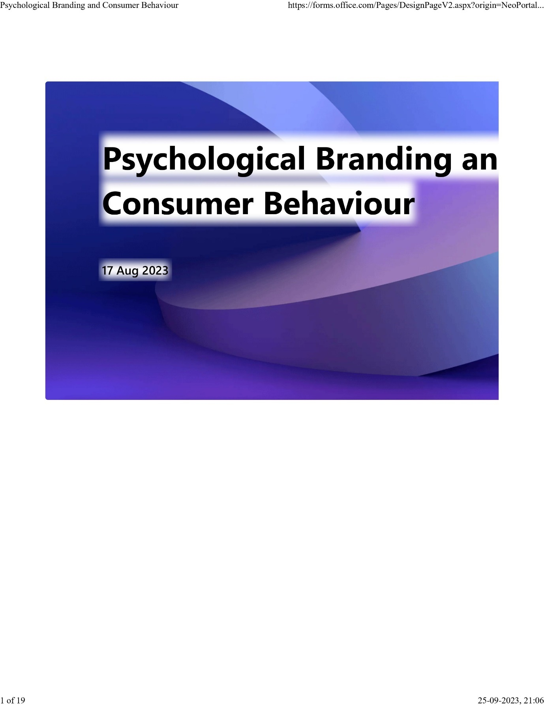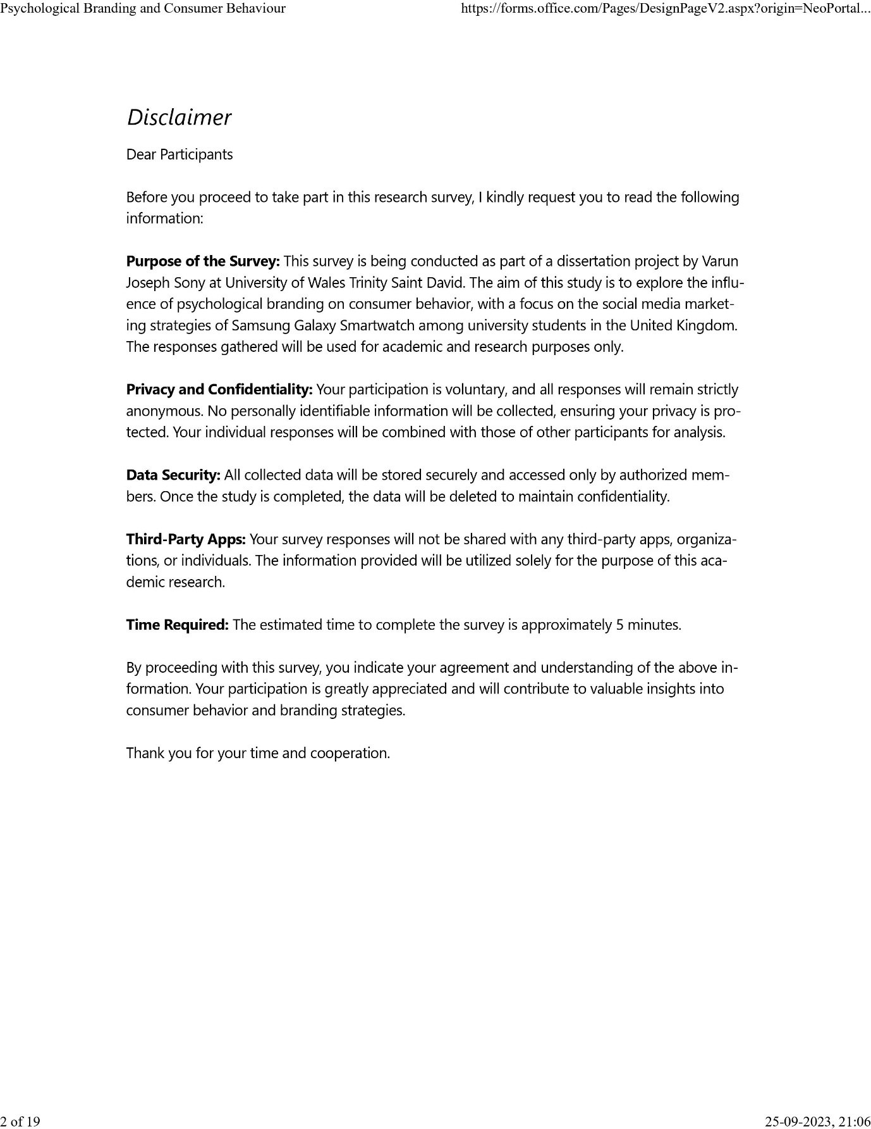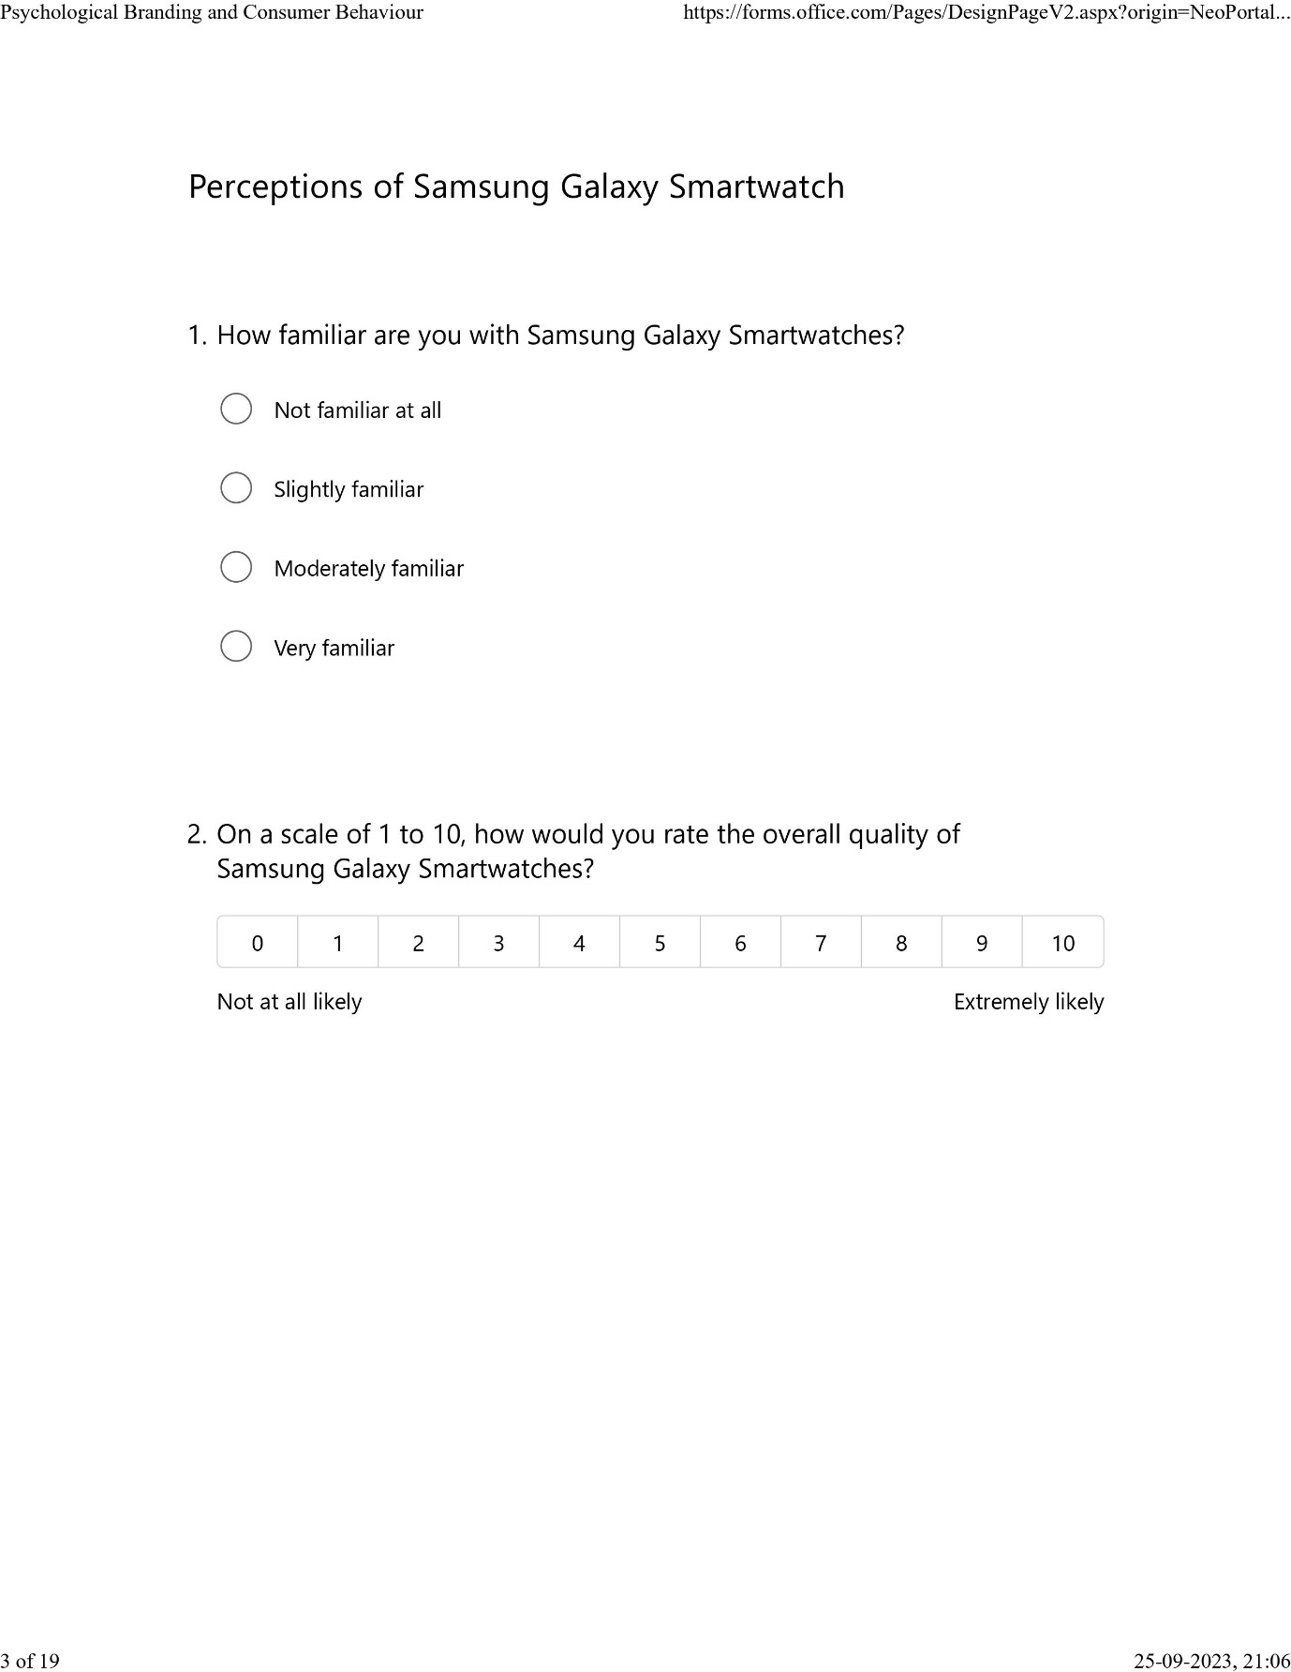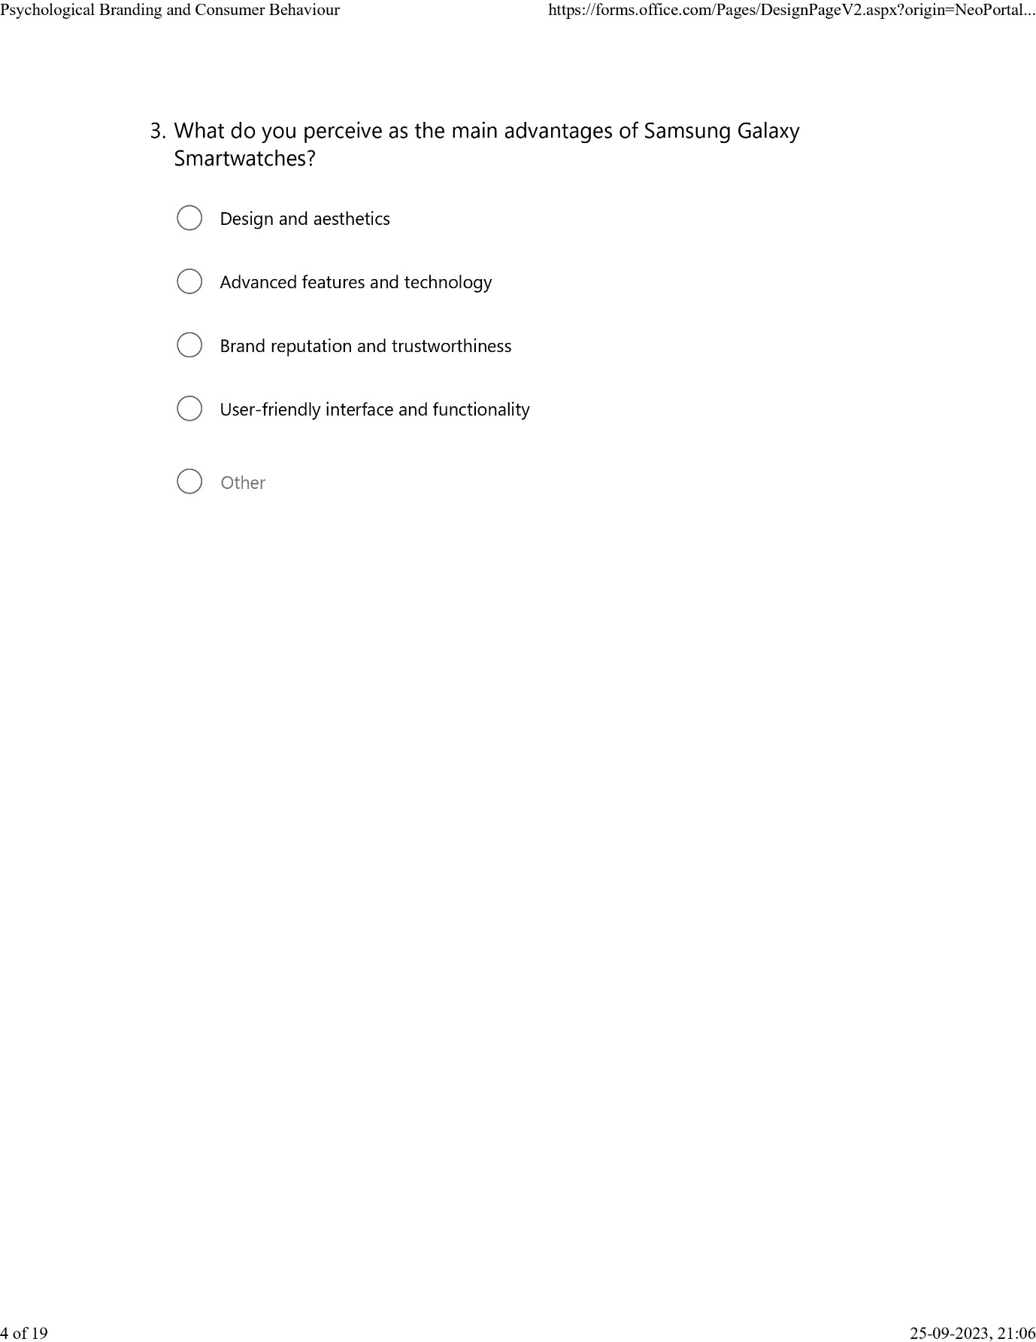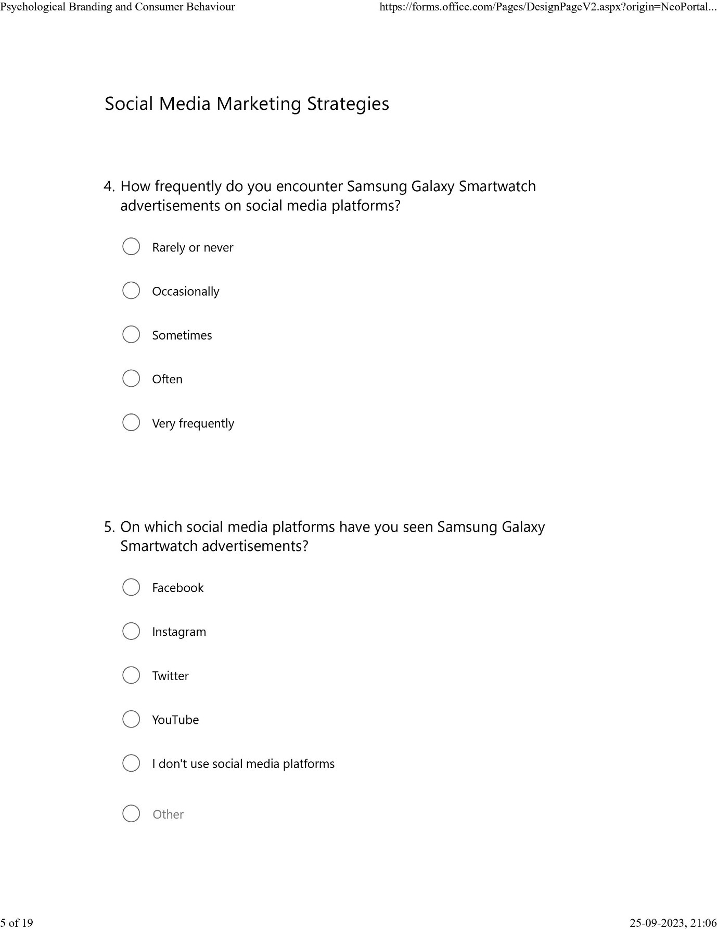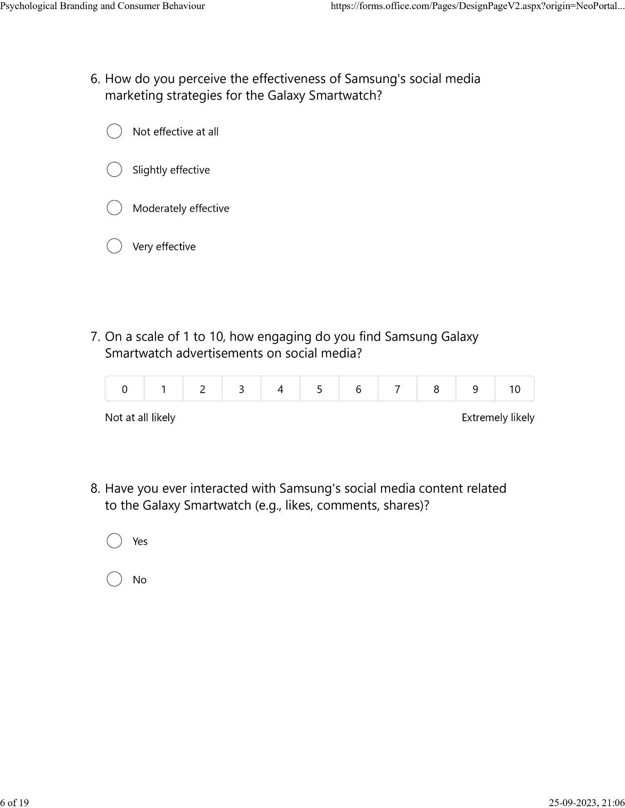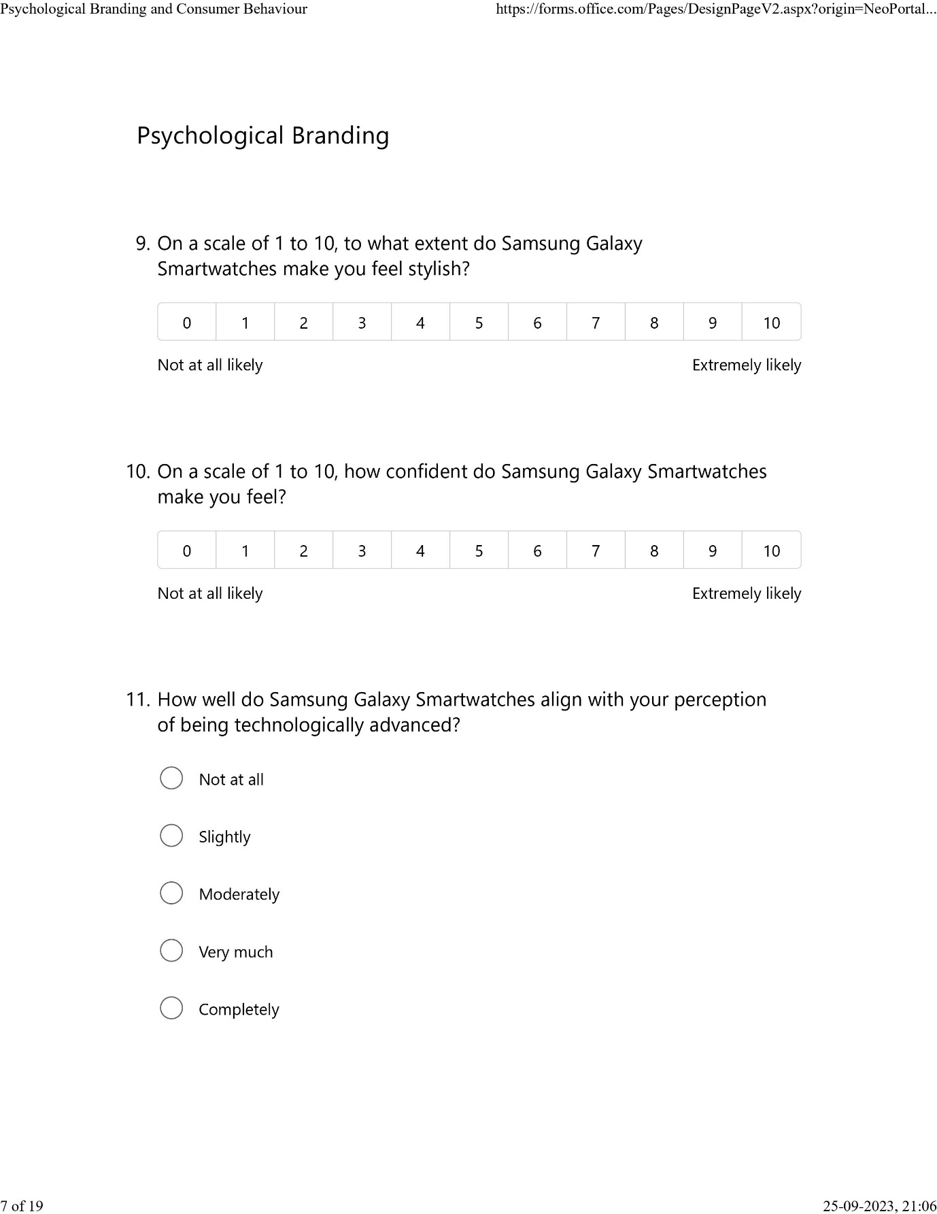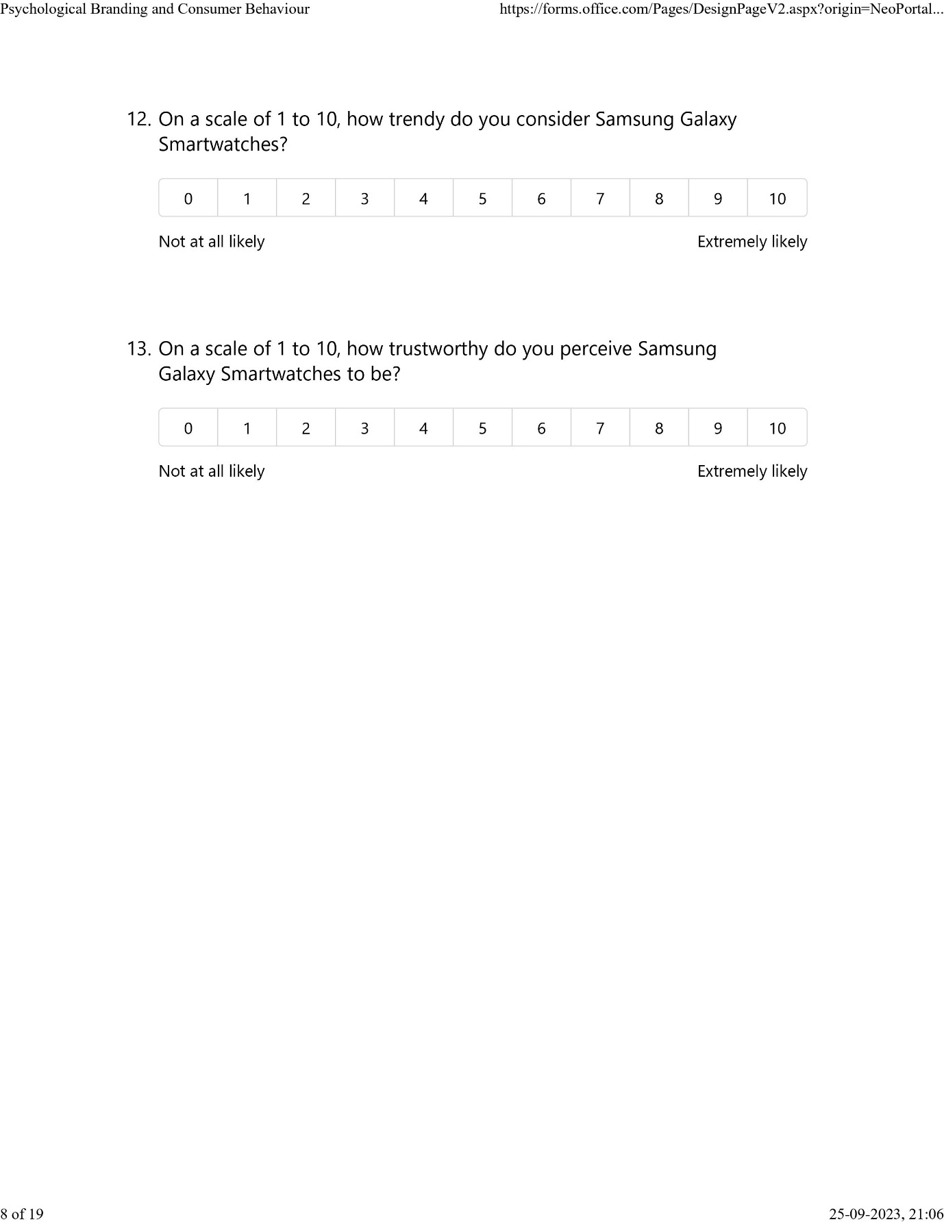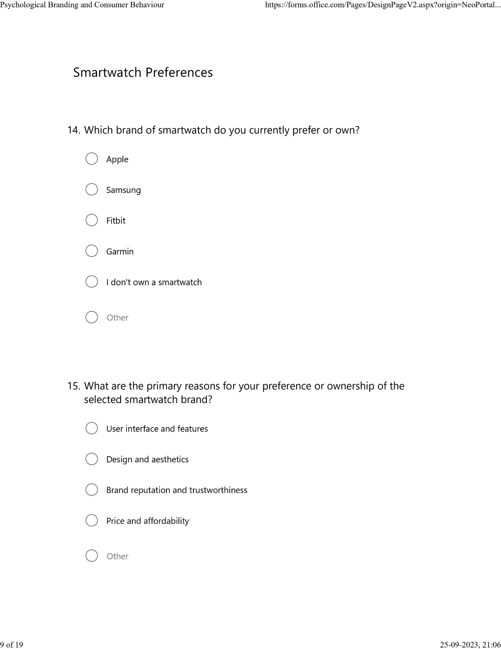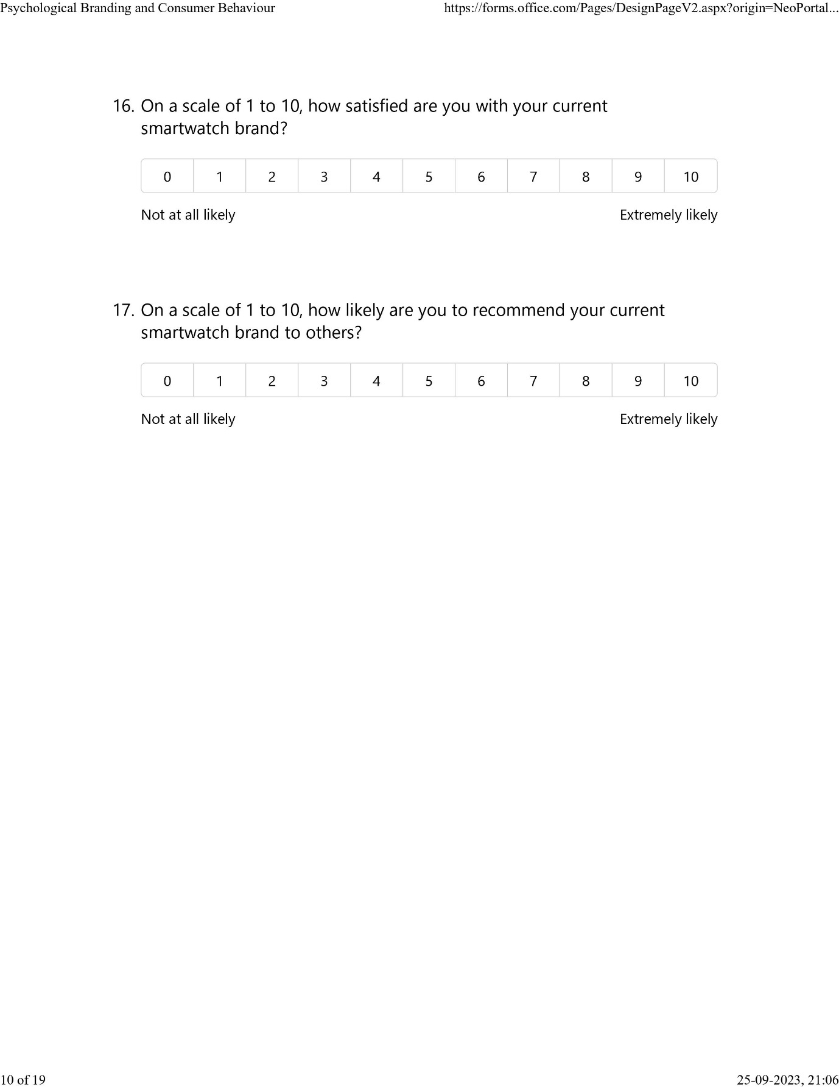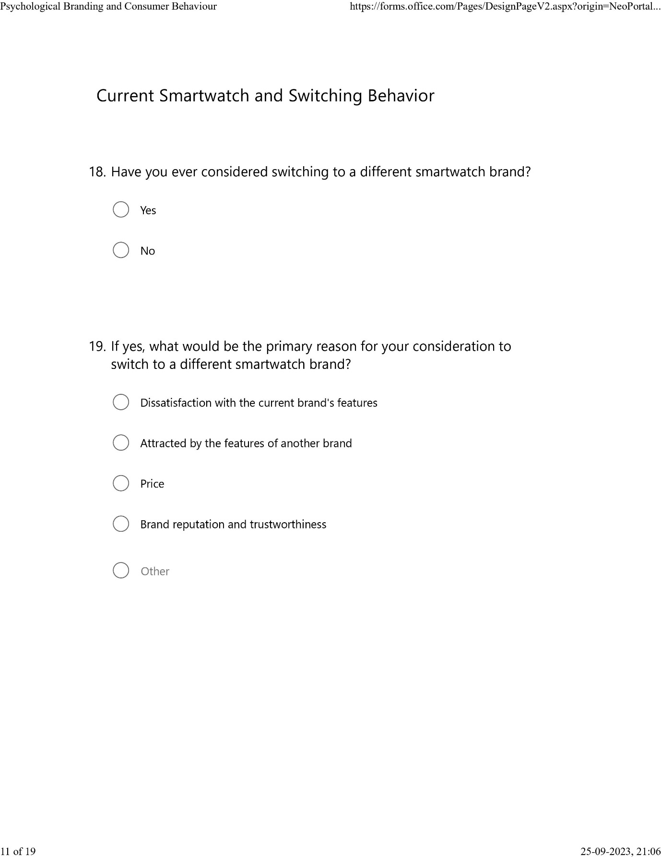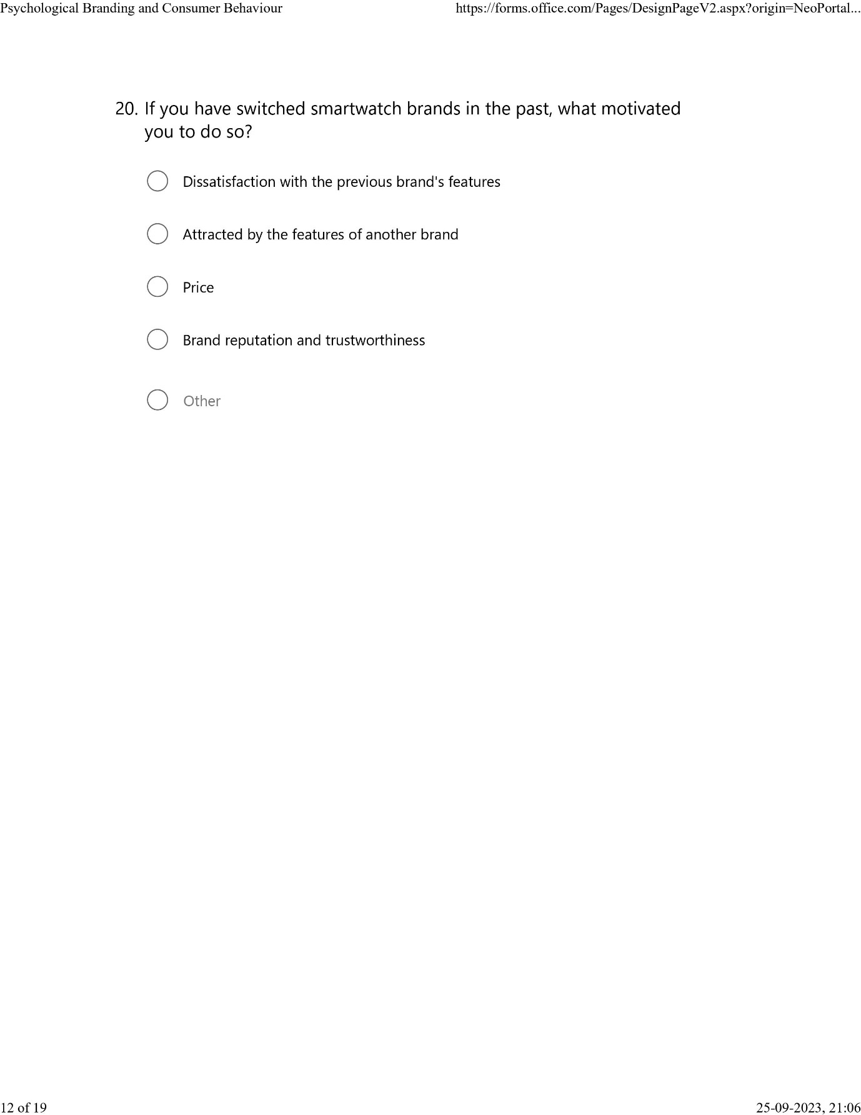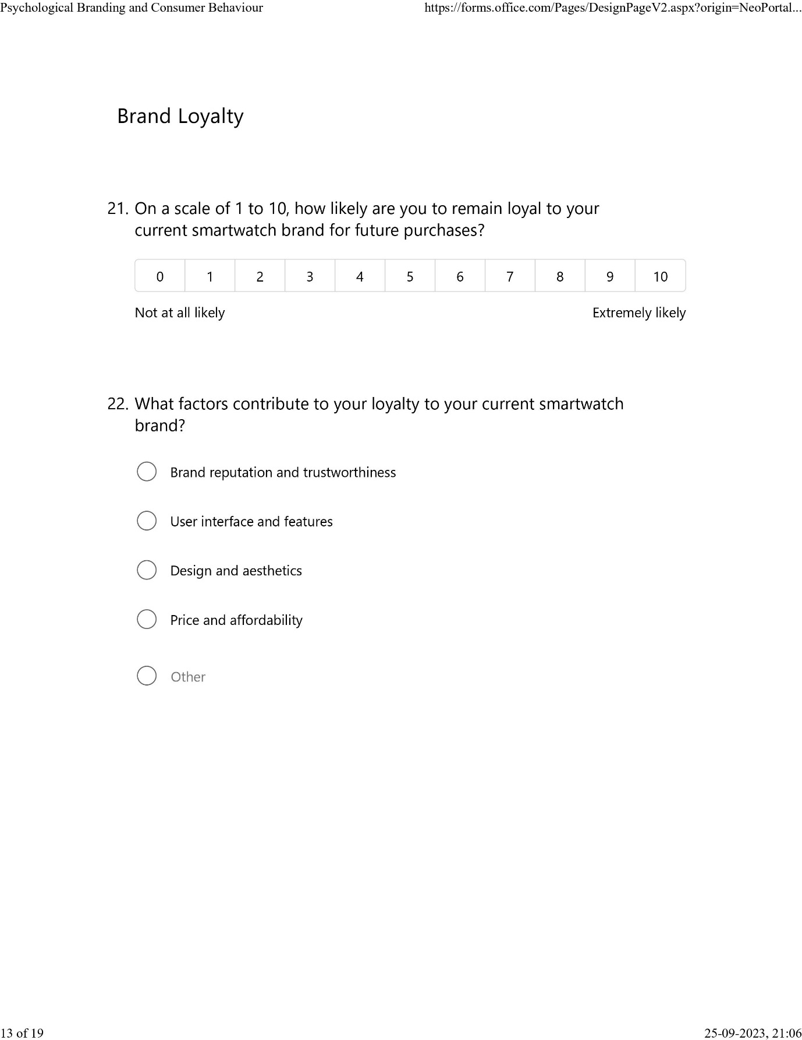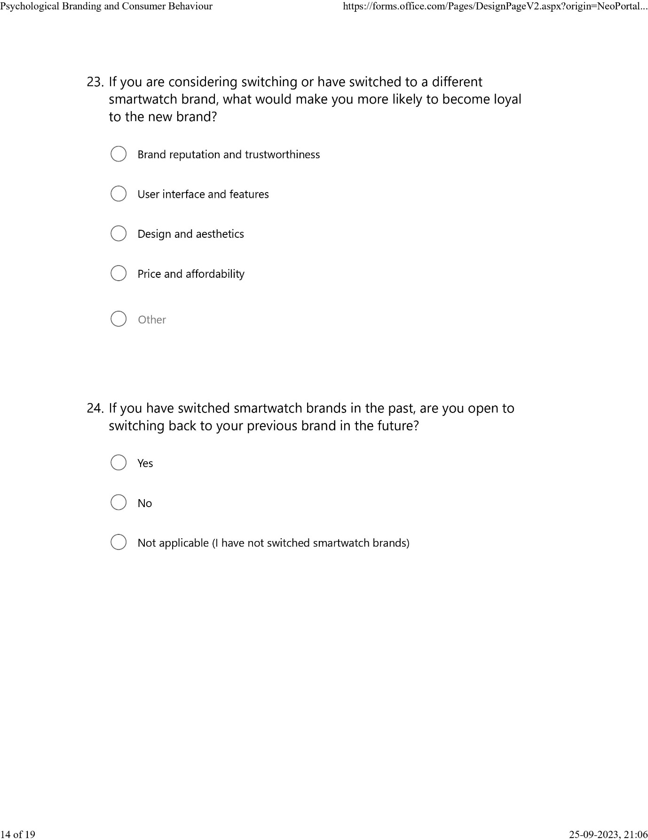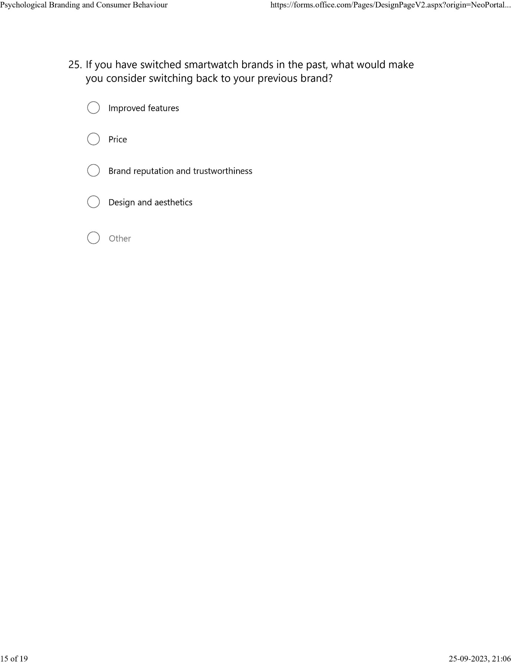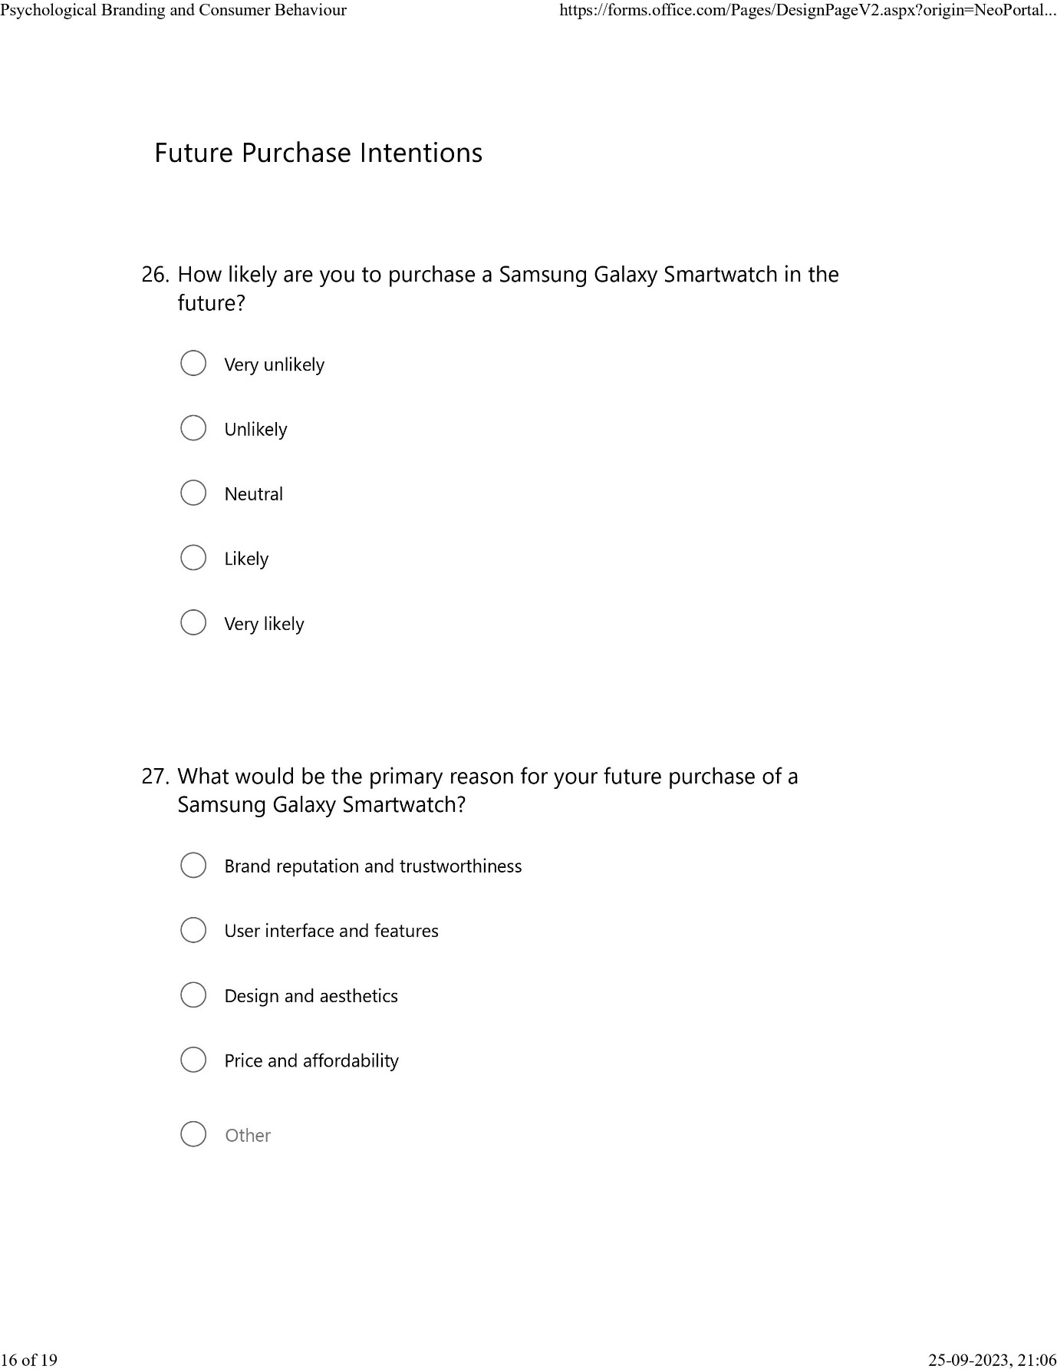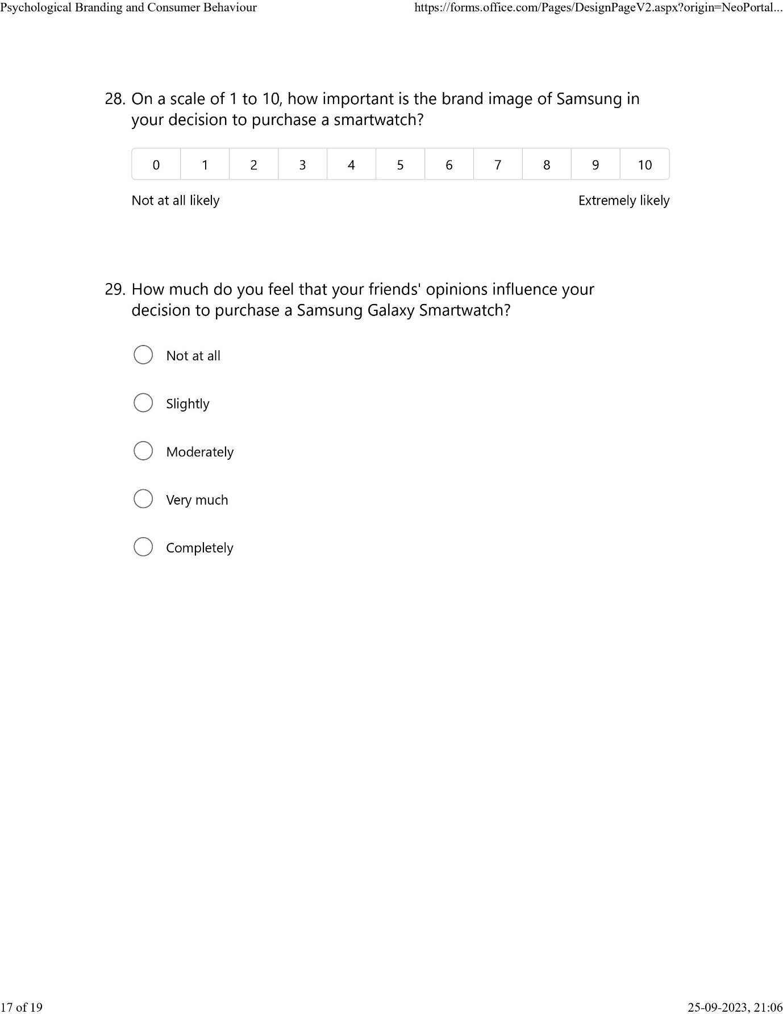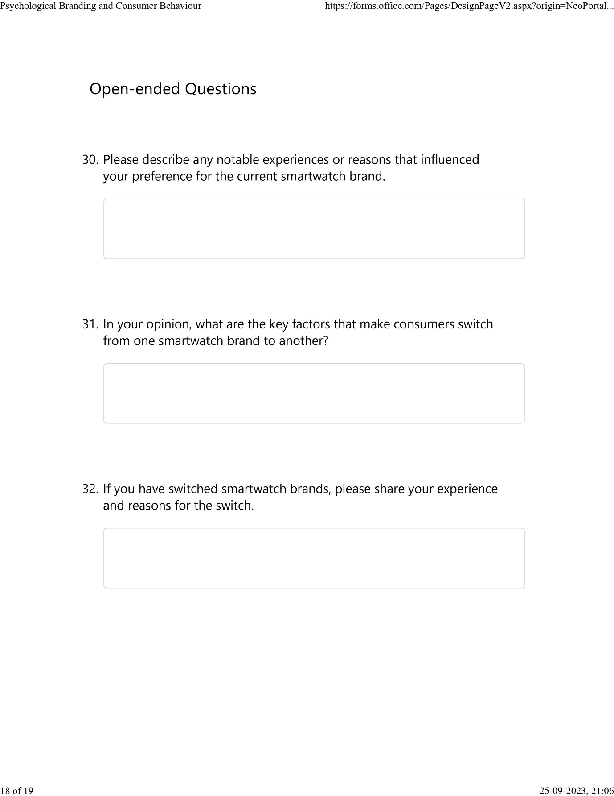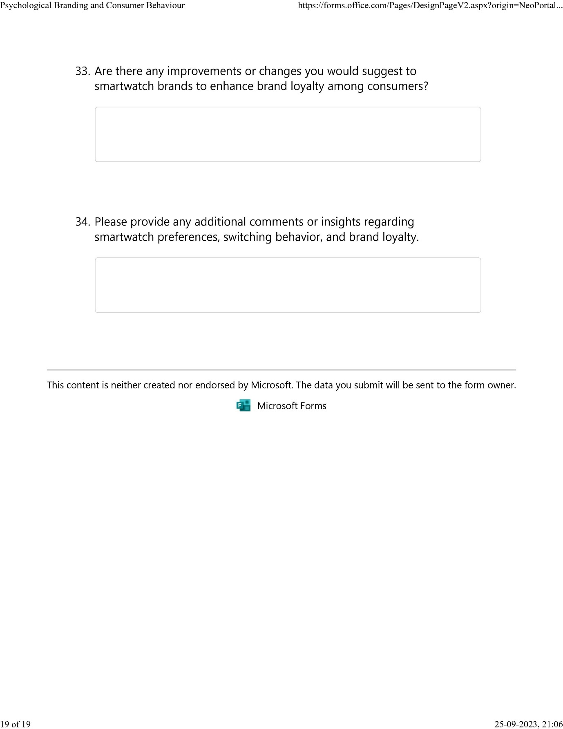

Ethics Form
APPLICATION FOR ETHICAL APPROVAL

In order for research to result in benefit and minimise risk of harm, it must be conducted ethically. A researcher may not be covered by the University’s insurance if ethical approval has not been obtained prior to commencement.

The University follows the OECD Frascati manual definition of research activity: “creative work undertaken on a systematic basis in order to increase the stock of knowledge, including knowledge of man, culture and society, and the use of this stock of knowledge to devise new applications”. As such this covers activities undertaken by members of staff, postgraduate research students, and both taught postgraduate and undergraduate students working on dissertations/projects.

The individual undertaking the research activity is known as the “principal researcher”.

Ethical approval is not required for routine audits, performance reviews, quality assurance studies, testing within normal educational requirements, and literary or artistic criticism.

Please read the notes for guidance before completing ALL sections of the form.

This form must be completed and approved prior to undertaking any research activity. Please see Checklist for details of process for different categories of application.

SECTION A: About You (Principal Researcher)
1 | Full Name: |  | Varun Joseph Sony
2 | Tick all boxes that apply: |  | Member of staff: | ☐ | Honorary research fellow: | ☐
 | Undergraduate Student | ☐ | Taught Postgraduate Student | ☒ | Postgraduate Research Student | ☐

3 | Institute/Academic Discipline/Centre: | Business and Management
4 | Campus: | London
5 | E-mail address: | 2129151@student.uwtsd.ac.uk
6 | Contact Telephone Number: | +447366964437
 | For students:
7 | Student Number: | 2129151
8 | Programme of Study: | MBA Marketing Management
9 | Director of Studies/Supervisor: | Dr. Jia Miao

SECTION B: Approval for Research Activity
1 | Has the research activity received approval in principle?  (please check the Guidance Notes as to the appropriate approval process for different levels of research by different categories of individual) |  | YES | ☒ | NO | ☐
 |  |  |  |  | Date
2 | If Yes, please indicate source of approval (and date where known): Approval in principle must be obtained from the relevant source prior to seeking ethical approval | Research Degrees Committee |  | ☐
2 |  | Institute Research Committee |  | ☐
2 |  | Other (write in) |  | ☐

SECTION C: Internal and External Ethical Guidance Materials
 | Please list the core ethical guidance documents that have been referred to during the completion of this form (including any discipline-specific codes of research ethics, location-specific codes of research ethics, and also any specific ethical guidance relating to the proposed methodology). Please tick to confirm that your research proposal adheres to these codes and guidelines. You may add rows to this table if needed.
1 | UWTSD Research Ethics & Integrity Code of Practice | ☒
2 | UWTSD Research Data Management Policy | ☒
3 | [List any other relevant documents here] | ☒

SECTION D: External Collaborative Research Activity
If there are external collaborators then you should gain consent from the contact persons to share their personal data with the university. If there are no external collaborators then leave this section blank and continue to section E.
1 | Institution | N/A
2 | Contact person name
3 | Contact person e-mail address
4 | Is your research externally funded? |  | YES | ☐ | NO |  | ☐
5 | Are you in receipt of a KESS scholarship? |  | YES | ☐ | NO |  | ☐
6 | Are you specifically employed to undertake this research in either a paid or voluntary capacity? | Voluntary | YES | ☐ | NO | ☐
7 |  | Employed | YES | ☐ | NO | ☐
8 | Is the research being undertaken within an existing UWTSD Athrofa Professional Learning Partnership (APLP)? | If YES then the permission question below does not need to be answered. | YES | ☐ | NO |  | ☐
9 | Has permission to undertake the research has been provided by the partner organisation? | (If YES attach copy)  If NO the application cannot continue | YES | ☐ | NO |  | ☐

Where research activity is carried out in collaboration with an external organisation
10 | Does this organisation have its own ethics approval system? | YES | ☐ | NO | ☐
SECTION E: Details of Research Activity
1 | Indicative title: | Exploring the Influence of Psychological Branding on Consumer Behaviour: A Study of Samsung Galaxy Smartwatch’s Social Media Marketing Strategies among University Students in the United Kingdom
2 | Proposed start date: |  | Proposed end date:
Introduction to the Research (maximum 300 words per section)
Ensure that you write for a Non-Specialist Audience when outlining your response to the points below:
- Purpose of Research Activity
- Proposed Research Question
- Aims of Research Activity
- Objectives of Research Activity
Demonstrate, briefly, how Existing Research has informed the proposed activity and explain
- What the research activity will add to the body of knowledge
- How it addresses an area of importance.
3 | Purpose of Research Activity  The purpose of this research activity is to investigate the influence of psychological branding on consumer behavior, with a particular focus on the social media marketing strategies employed by Samsung Galaxy Smartwatch among university students in the United Kingdom. By exploring this relationship, the study aims to contribute to the existing body of knowledge in marketing and consumer psychology, while providing valuable insights and implications for both academia and industry.  The research will delve into the concept of psychological branding, which refers to the use of various psychological techniques and strategies by marketers to establish a deep emotional connection between consumers and brands. It will specifically examine the social media marketing strategies employed by Samsung Galaxy Smartwatch, as social media platforms have become integral channels for brand communication and engagement.  The target population for this study comprises university students in the United Kingdom. University students represent a critical segment of consumers as they often possess distinct characteristics, preferences, and behaviors that are shaped by their educational environment, lifestyle, and social influences. Focusing on this specific group will enable a more comprehensive understanding of the influence of psychological branding on their consumer behavior.  To achieve the research objectives, a mixed-methods approach will be employed. The study will employ both quantitative and qualitative research methods, such as surveys and in-depth interviews, to gather comprehensive data. The quantitative phase will involve administering structured questionnaires to a large sample of university students, while the qualitative phase will entail conducting in-depth interviews with a smaller subset of participants. The data collected will be analyzed using appropriate statistical techniques and thematic analysis to identify patterns, themes, and correlations.  The findings of this research will shed light on the effectiveness of Samsung Galaxy Smartwatch's social media marketing strategies in influencing consumer behavior among university students in the United Kingdom. The results will provide valuable insights into the role of psychological branding in shaping consumer attitudes, perceptions, and purchasing decisions. Additionally, this research will contribute to academic literature in marketing and consumer psychology, offering a foundation for further research in this field and practical implications for marketers and brand managers seeking to target the university student market segment.
4 | Research Question  The research question for the dissertation "Exploring the Influence of Psychological Branding on Consumer Behaviour: A Study of Samsung Galaxy Smartwatch’s Social Media Marketing Strategies among University Students in the United Kingdom" is:  "What is the impact of Samsung Galaxy Smartwatch's social media marketing strategies, focusing on psychological branding, on the consumer behavior of university students in the United Kingdom?"  This research question aims to investigate the specific influence of psychological branding techniques employed by Samsung Galaxy Smartwatch through social media marketing strategies. It seeks to understand how these strategies impact the behavior of university students in the United Kingdom when it comes to their interactions, attitudes, and purchasing decisions related to Samsung Galaxy Smartwatch products.
5 | Aims of Research Activity  1. To critically analyze and evaluate the social media marketing strategies employed by Samsung Galaxy Smartwatch in targeting university students in the United Kingdom.  2. To investigate the extent to which psychological branding techniques are integrated into Samsung Galaxy Smartwatch's social media marketing strategies.  3. To empirically examine the impact of Samsung Galaxy Smartwatch's social media marketing strategies, with a focus on psychological branding, on the consumer behavior of university students in the United Kingdom.  4. To identify and assess the potential mediating or moderating factors that influence the relationship between psychological branding and consumer behavior among university students in the United Kingdom.  5. To provide practical implications and actionable recommendations for marketers and brand managers seeking to effectively target university students through social media marketing strategies.
6 | Objectives of Research Activity  1. To conduct a comprehensive literature review on psychological branding, social media marketing strategies, and consumer behavior to establish a theoretical framework for the study.  2. To analyze the social media marketing strategies employed by Samsung Galaxy Smartwatch, focusing on platforms such as Facebook, Instagram, and Twitter, to understand the content, messaging, and techniques used to engage university students in the United Kingdom.  3. To assess the integration of psychological branding techniques within Samsung Galaxy Smartwatch's social media marketing strategies, examining the presence of emotional appeals, storytelling, brand personality, and other psychological elements in their campaigns.  4. To investigate the attitudes, perceptions, and engagement of university students in the United Kingdom towards Samsung Galaxy Smartwatch's social media marketing efforts, using surveys to gather quantitative data.  5. To explore the impact of Samsung Galaxy Smartwatch's social media marketing strategies, with an emphasis on psychological branding, on the purchasing behavior of university students in the United Kingdom, employing statistical analysis techniques to examine correlations and patterns.  6. To identify potential mediating or moderating factors, such as brand trust, brand loyalty, social influence, and personal values, that may influence the relationship between psychological branding and consumer behavior among university students.  7. To provide practical implications and recommendations based on the research findings, offering actionable insights for marketers and brand managers targeting university students in the United Kingdom through social media marketing strategies.  8. To contribute to the existing literature on marketing and consumer psychology by adding new insights and empirical evidence regarding the influence of psychological branding on consumer behavior in the context of social media marketing.  9. To highlight the unique characteristics and behaviors of university students as a consumer group, shedding light on their preferences, attitudes, and decision-making processes in relation to Samsung Galaxy Smartwatch's products.  10. To present a clear and coherent research report, documenting the methodology, results, and conclusions of the study, and contributing to the overall body of knowledge in the field of marketing and consumer behavior.
Proposed methods (maximum 600 words)
Provide a brief summary of all the methods that may be used in the research activity, making it clear what specific techniques may be used. If methods other than those listed in this section are deemed appropriate later, additional ethical approval for those methods will be needed. You do not need to justify the methods here, but should instead describe how you intend to collect the data necessary for you to complete your project.
7 | Quantitative Method:  A survey questionnaire will be administered to a large sample of university students to collect quantitative data. The survey will be designed to capture information related to students' perceptions, attitudes, engagement, and purchasing behavior in relation to Samsung Galaxy Smartwatch and its social media marketing efforts. The questionnaire will be carefully constructed to include Likert-scale items, multiple-choice questions, and demographic variables. The survey will be administered through online platforms to ensure a wider reach and ease of participation. Sampling techniques such as stratified random sampling will be utilized to ensure representation from different universities and academic disciplines. The collected data will be analyzed using appropriate statistical techniques, such as descriptive statistics, correlation analysis, and regression analysis, to identify patterns, relationships, and associations between psychological branding and consumer behavior variables.
Location of research activity
Identify all locations where research activity will take place.
8 | UWTSD London Campus  (this box should expand as you type)
Research activity outside of the UK
If research activity will take place overseas, you are responsible for ensuring that local ethical considerations are complied with and that the relevant permissions are sought. Specify any local guidelines (e.g. from local professional associations/learned societies/universities) that exist and whether these involve any ethical stipulations beyond those usual in the UK (provide details of any licenses or permissions required). Also specify whether there are any specific ethical issues raised by the local context in which the research activity is taking place, for example, particular cultural and/or legal sensitivities or vulnerabilities of participants. If you live in the country where you will do the research then please state this.
9 | N/A

10 | Use of documentation not in the public domain: Are any documents NOT publicly available? | NO | ☒
10 |  | YES | ☐
11 | If Yes, please provide details here of how you will gain access to specific documentation that is not in the public domain and that this is in accordance with the current data protection law of the country in question and that of England and Wales.

 | Does your research relate to one or more of the seven aims of the Well-being of Future Generations (Wales) Act 2015? | YES | NO
12 | A prosperous Wales | ☒ | ☐
13 | A resilient Wales | ☒ | ☐
14 | A healthier Wales | ☒ | ☐
15 | A more equal Wales | ☒ | ☐
16 | A Wales of cohesive communities | ☒ | ☐
17 | A Wales of vibrant culture and thriving Welsh language | ☒ | ☐
18 | A globally responsible Wales | ☐ | ☐
19 | If YES to any of the above, please give details:
1. Marketing Strategy Enhancement: The research findings can provide valuable insights and recommendations for businesses and marketers in Wales, including those in the technology and consumer electronics sectors. By understanding the impact of psychological branding on consumer behavior, local businesses can refine their marketing strategies, particularly in terms of social media engagement and messaging, to better resonate with their target audience and enhance their brand positioning.

2. Competitiveness and Innovation: The research can foster a culture of competitiveness and innovation among businesses in Wales. By examining successful social media marketing strategies employed by Samsung Galaxy Smartwatch, local businesses can gain inspiration and identify novel approaches to engage with consumers, differentiate their brands, and gain a competitive advantage in the marketplace.

3. Consumer Insights: Understanding the consumer behavior of university students in the United Kingdom, specifically their perceptions and responses to social media marketing, can provide valuable insights for businesses operating in Wales. This knowledge can help them tailor their marketing efforts to effectively target and engage this consumer segment, leading to increased customer satisfaction, brand loyalty, and ultimately, business growth.

4. Economic Growth: By enhancing marketing strategies and understanding consumer behavior, businesses in Wales can potentially experience increased sales, market share, and revenue. This, in turn, can contribute to the economic growth and prosperity of Wales, creating job opportunities and driving local business ecosystems.

5. Academic and Research Advancement: Conducting research in the field of marketing and consumer behavior contributes to the academic community in Wales. It adds to the existing body of knowledge, fostering a culture of research and scholarship. The findings of the research can inspire further research endeavors, creating opportunities for collaboration between academia and industry in Wales.

SECTION F: Scope of Research Activity
 | Will the research activity include: | YES | NO
1 | Use of a questionnaire or similar research instrument? | ☒ | ☐
2 | Use of interviews? | ☐ | ☒
3 | Use of focus groups? | ☐ | ☒
4 | Use of participant diaries? | ☐ | ☒
5 | Use of video or audio recording? | ☐ | ☒
6 | Use of computer-generated log files? | ☐ | ☒
7 | Participant observation with their knowledge? | ☐ | ☒
8 | Participant observation without their knowledge? | ☐ | ☒
9 | Access to personal or confidential information without the participants’ specific consent? | ☐ | ☒
10 | Administration of any questions, test stimuli, presentation that may be experienced as physically, mentally or emotionally harmful / offensive? | ☐ | ☒
11 | Performance of any acts which may cause embarrassment or affect self-esteem? | ☐ | ☒
12 | Investigation of participants involved in illegal activities? | ☐ | ☒
13 | Use of procedures that involve deception? | ☐ | ☒
14 | Administration of any substance, agent or placebo? | ☐ | ☒
15 | Working with live vertebrate animals? | ☐ | ☒
16 | Procedures that may have a negative impact on the environment? | ☐ | ☒
17 | Other primary data collection methods. Please indicate the type of data collection method(s) below. | ☐ | ☒
 | Details of any other primary data collection method: | ☐ | ☒
If NO to every question, then the research activity is (ethically) low risk and may be exempt from some of the following sections (please refer to Guidance Notes).

If YES to any question, then no research activity should be undertaken until full ethical approval has been obtained.

SECTION G: Intended Participants
If there are no participants then do not complete this section, but go directly to section H.

 | Who are the intended participants: | YES | NO
1 | Students or staff at the University? | ☒ | ☐
2 | Adults (over the age of 18 and competent to give consent)? | ☒ | ☐
3 | Vulnerable adults? | ☐ | ☒
4 | Children and Young People under the age of 18? (Consent from Parent, Carer or Guardian will be required) | ☐ | ☒
5 | Prisoners? | ☐ | ☒
6 | Young offenders? | ☐ | ☒
7 | Those who could be considered to have a particularly dependent relationship with the investigator or a gatekeeper? | ☐ | ☒
8 | People engaged in illegal activities? | ☐ | ☒
9 | Others. Please indicate the participants below, and specifically any group who may be unable to give consent. | ☐ | ☐
 | Details of any other participant groups:  (this box should expand as you type) | ☐ | ☐

Participant numbers and source
Provide an estimate of the expected number of participants. How will you identify participants and how will they be recruited?
10 | How many participants are expected? | 50
11 | Who will the participants be? | University students
12 | How will you identify the participants? | Via emails

 | Information for participants: | YES | NO | N/A
13 | Will you describe the main research procedures to participants in advance, so that they are informed about what to expect? | ☒ | ☐ | ☐
14 | Will you tell participants that their participation is voluntary? | ☒ | ☐ | ☐
15 | Will you obtain written consent for participation? | ☒ | ☐ | ☐
16 | Will you explain to participants that refusal to participate in the research will not affect their treatment or education (if relevant)? | ☒ | ☐ | ☐
17 | If the research is observational, will you ask participants for their consent to being observed? | ☒ | ☐ | ☐
18 | Will you tell participants that they may withdraw from the research at any time and for any reason? | ☒ | ☐ | ☐
19 | With questionnaires, will you give participants the option of omitting questions they do not want to answer? | ☒ | ☐ | ☐
20 | Will you tell participants that their data will be treated with full confidentiality and that, if published, it will not be identifiable as theirs? | ☒ | ☐ | ☐
21 | Will you debrief participants at the end of their participation, in a way appropriate to the type of research undertaken? | ☒ | ☐ | ☐
22 | If NO to any of above questions, please give an explanation
 | (this box should expand as you type)

 | Information for participants: | YES | NO | N/A
24 | Will participants be paid? | ☐ | ☒ | ☐
25 | Is specialist electrical or other equipment to be used with participants? | ☐ | ☒ | ☐
26 | Are there any financial or other interests to the investigator or University arising from this study? | ☐ | ☒ | ☐
27 | Will the research activity involve deliberately misleading participants in any way, or the partial or full concealment of the specific study aims? | ☐ | ☒ | ☐
28 | If YES to any question, please provide full details
 | (this box should expand as you type)

SECTION H: Anticipated Risks

Outline any anticipated risks that may adversely affect any of the participants, the researchers and/or the University, and the steps that will be taken to address them.

If you have completed a full risk assessment (for example as required by a laboratory, or external research collaborator) you may append that to this form.
1 | Full risk assessment completed and appended? |  | Yes | ☒
1 |  |  | No | ☐
2 | Risks to participants  For example: sector-specific health & safety, emotional distress, financial disclosure, physical harm, transfer of personal data, sensitive organisational information
 | Risk to participants: N/A | How you will mitigate the risk to participants:
3 | If research activity may include sensitive, embarrassing or upsetting topics (e.g. sexual activity, drug use) or issues likely to disclose information requiring further action (e.g. criminal activity), give details of the procedures to deal with these issues, including any support/advice (e.g. helpline numbers) to be offered to participants. Note that where applicable, consent procedures should make it clear that if something potentially or actually illegal is discovered in the course of a project, it may need to be disclosed to the proper authorities
 | N/A
4 | Risks to the investigator  For example: personal health & safety, physical harm, emotional distress, risk of accusation of harm/impropriety, conflict of interest
 | Risk to the investigator: N/A | How you will mitigate the risk to the investigator:
5 | University/institutional risks  For example: adverse publicity, financial loss, data protection
 | Risk to the University: N/A | How you will mitigate the risk to the University:
6 | Environmental risks  For example: accidental spillage of pollutants, damage to local ecosystems
 | Risk to the environment: N/A | How you will mitigate the risk to environment:

 | Disclosure and Barring Service
 | If the research activity involves children or vulnerable adults, a Disclosure and Barring Service (DBS) certificate must be obtained before any contact with such participants. | YES | NO | N/A
7 | Does your research require you to hold a current DBS Certificate? | ☐ | ☒ | ☐
8 | If YES, please give the certificate number. If the certificate number is not available please write “Pending”; in this case any ethical approval will be subject to providing the appropriate certificate number.

SECTION I: Feedback, Consent and Confidentiality

1 | Feedback  What de-briefing and feedback will be provided to participants, how will this be done and when?
De-briefing and feedback to participants will be provided through a well-structured and informative email. This email will be sent to participants after the data collection and analysis phase of the research. The email will serve as a means to convey important information and findings to the participants.

The de-briefing email will include the following components:

- Appreciation and Acknowledgment: The email will begin with expressions of gratitude for the participants' valuable contributions to the research study. Participants will be thanked for their time, effort, and willingness to participate.

- Research Purpose and Objectives: The email will briefly summarize the purpose and objectives of the research. This section will remind participants of the overall aim of the study and the significance of their involvement in advancing knowledge in the field.
2 | Informed consent  Describe the arrangements to inform potential participants, before providing consent, of what is involved in participating. Describe the arrangements for participants to provide full consent before data collection begins. If gaining consent in this way is inappropriate, explain how consent will be obtained and recorded in accordance with prevailing data protection legislation.
 | Informed consent will be obtained from all participants in this research. They will be provided with detailed information about the purpose, procedures, and potential risks and benefits of the study. Participants will be assured that their participation is voluntary, and they have the right to withdraw at any time without consequences. Their personal information and responses will be kept confidential and anonymous. Participants will have the opportunity to ask questions and seek clarifications before giving their written consent to participate. The informed consent process prioritizes the protection of participants' rights and ensures transparency and ethical conduct in the research.
3 | Confidentiality / Anonymity  Set out how anonymity of participants and confidentiality will be ensured in any outputs. If anonymity is not being offered, explain why this is the case.
 | Participants will be informed about the confidentiality and anonymity measures in the informed consent process. They will be assured that their information will be handled with the utmost care and will not be disclosed to any unauthorized individuals or organizations. Their participation and responses will remain confidential and anonymous throughout the research.

SECTION J: Data Protection and Storage

 | Does the research activity involve personal data (as defined by the General Data Protection Regulation 2016 “GDPR” and the Data Protection Act 2018 “DPA”)? | YES | NO
1 | “Personal data” means any information relating to an identified or identifiable natural person (‘data subject’). An identifiable natural person is one who can be identified, directly or indirectly, in particular by reference to an identifier such as a name, an identification number, location data, an online identifier or to one or more factors specific to the physical, physiological, genetic, mental, economic, cultural or social identity of that natural person. Any video or audio recordings of participants is considered to be personal data. | ☐ | ☐
 | If YES, provide a description of the data and explain why this data needs to be collected:
2 | Yes, the questionnaire may involve the collection of personal data as defined by the General Data Protection Regulation 2016 (GDPR) and the Data Protection Act 2018 (DPA). In this questionnaire, personal data such as gender, age, university, field of study, and smartwatch brand preferences may be collected. It is important to handle and process this personal data in accordance with the principles outlined in the GDPR and DPA, ensuring lawful and fair treatment, transparency, purpose limitation, data minimization, accuracy, storage limitation, integrity, and confidentiality.
 | Does it involve special category data (as defined by the GDPR)? | YES | NO
3 | “Special category data” means sensitive personal data consisting of information as to the data subjects’ –  (a) racial or ethnic origin,  (b) political opinions,  (c ) religious beliefs or other beliefs of a similar nature,  (d) membership of a trade union (within the meaning of the Trade Union and Labour Relations (Consolidation) Act 1992),  (e) physical or mental health or condition,  (f) sexual life,  (g) genetics,  (h) biometric data (as used for ID purposes), |  | ☒
 | If YES, provide a description of the special category data and explain why this data needs to be collected:
4 | (this box should expand as you type)

 | Will data from the research activity (collected data, drafts of the thesis, or materials for publication) be stored in any of the following ways? | YES | NO
5 | Manual files (i.e. in paper form)? | ☐ | ☒
6 | University computers? | ☐ | ☒
7 | Private company computers? | ☐ | ☒
8 | Home or other personal computers? | ☒ | ☐
9 | Laptop computers/ CDs/ Portable disk-drives/ memory sticks? | ☐ | ☒
10 | “Cloud” storage or websites? | ☐ | ☒
11 | Other – specify: | ☐ | ☒
12 | For all stored data, explain the measures in place to ensure the security of the data collected, data confidentiality, including details of backup procedures, password protection, encryption, anonymisation and pseudonymisation:
 | (this box should expand as you type)

 | Data Protection
 | Will the research activity involve any of the following activities: | YES | NO
13 | Electronic transfer of data in any form? | ☐ | ☒
14 | Sharing of data with others at the University outside of the immediate research team? | ☐ | ☒
15 | Sharing of data with other organisations? | ☐ | ☒
16 | Export of data outside the UK or importing of data from outside the UK? | ☐ | ☒
17 | Use of personal addresses, postcodes, faxes, emails or telephone numbers? | ☐ | ☒
18 | Publication of data that might allow identification of individuals? | ☐ | ☒
19 | Use of data management system? | ☐ | ☒
20 | Data archiving? | ☐ | ☒
21 | If YES to any question, please provide full details, explaining how this will be conducted in accordance with the GDPR and Data Protection Act (2018) (and any international equivalents, where appropriate):
 | (this box should expand as you type)
22 | List all who will have access to the data generated by the research activity:
 | Myself and my supervisor
23 | List who will have control of, and act as custodian(s) for, data generated by the research activity:
 | My supervisor
24 | Give details of data storage arrangements, including security measures in place to protect the data, where data will be stored, how long for, and in what form. Will data be archived – if so how and if not why not.
 | The data will be stored securely with limited access. The data wont be archived.
25 | Please indicate if your data will be stored in the UWTSD Research Data Repository (see https://researchdata.uwtsd.ac.uk/ ). If so please explain. (Most relevant to academic staff)
26 | Confirm that you have read the UWTSD guidance on data management (see https://www.uwtsd.ac.uk/library/research-data-management/) | YES | ☐
27 | Confirm that you are aware that you need to keep all data until after your research has completed or the end of your funding | YES | ☒

SECTION K: Declaration
The information which I have provided is correct and complete to the best of my knowledge. I have attempted to identify any risks and issues related to the research activity and acknowledge my obligations and the rights of the participants.

In submitting this application I hereby confirm that I undertake to ensure that the above named research activity will meet the University’s Research Ethics and Integrity Code of Practice which is published on the website: https://www.uwtsd.ac.uk/research/research-ethics/
1 | Signature of applicant: | Varun Joseph Sony | Date: 18/07/2023

For STUDENT Submissions:
2 | Director of Studies/Supervisor:
3 | Signature:

For STAFF Submissions:
4 | Academic Director/ Assistant Dean: |  | Date:
5 | Signature: |  | Date:

Checklist: Please complete the checklist below to ensure that you have completed the form according to the guidelines and attached any required documentation:
☒ | I have read the guidance notes supplied before completing the form.
☒ | I have completed ALL RELEVANT sections of the form in full.
☒ | I confirm that the research activity has received approval in principle
☒ | I have attached a copy of final/interim approval from external organisation (where appropriate)
☐ | I have attached a full risk assessment (where appropriate) ONLY TICK IF YOU HAVE ATTACHED A FULL RISK ASSESSMENT
☒ | I understand that it is my responsibility to ensure that the above named research activity will meet the University’s Research Ethics and Integrity Code of Practice.
☒ | I understand that before commencing data collection all documents aimed at respondents (including information sheets, consent forms, questionnaires, interview schedules etc.) must be confirmed by the DoS/Supervisor, module tutor or Academic Director.

RESEARCH STUDENTS AND STAFF ONLY
All communications relating to this application during its processing must be in writing and emailed to pgresearch@uwtsd.ac.uk , with the title ‘Ethical Approval’ followed by your name.
You will be informed of the outcome of your claim by email; therefore it is important that you check your University and personal email accounts regularly.
STUDENTS ON UNDERGRADUATE OR TAUGHT MASTERS PROGRAMMES should submit this form (and receive the outcome) via systems explained to you by the supervisor/module leader.

This form is available electronically from the Academic Office web pages: https://www.uwtsd.ac.uk/academic-office/appendices-and-forms/

E-Thesis Deposit Agreement
Details of the Work
I would like to deposit the following item in the digital repository maintained by the University, and/or in any other repository authorized for use by the University:
Title: Exploring the Influence of Psychological Branding on Consumer Behaviour: A Study of Samsung Galaxy Smartwatch’s Social Media Marketing Strategies among University Students in the United Kingdom
This item is a product of my own research endeavours and is covered by the agreement below in which the item is referred to as “the Work”. It is identical in content to that deposited in the Learning Resources Centre, subject to point 4 below.
I agree that the University of Wales: Trinity Saint David may electronically store, copy or translate the Work to any approved medium or format for the purpose of future preservation and accessibility. The University is not under any obligation to reproduce or display the Work in the same formats or resolutions in which it was originally deposited.
UWTSD Digital Repository
I understand that work deposited in the digital repository will be accessible to a wide variety of people and institutions, including automated agents and search engines via the World Wide Web.
I understand that once the Work is deposited, the item and its metadata may be incorporated into public access catalogues or services, such as national databases of electronic theses.
I agree as follows:
- That I am the author or have the authority of the author/s to make this agreement and do hereby give the University of Wales: Trinity Saint David the right to make available the Work in the way described above.
- That the electronic copy of the Work deposited in the digital repository and covered by this agreement, is identical in content to the paper copy of the Work.
- That I have exercised reasonable care to ensure that the Work is original, and to the best of my knowledge, does not breach any laws including those relating to defamation, libel and copyright.
- That I have, in instances where the intellectual property of other authors or copyright holders is included in the Work, gained explicit permission for the inclusion of that material in the Work, and in the electronic form of the Work as accessed through the open access digital repository, or that I have identified and removed that material for which adequate permission has not been obtained and which will be inaccessible via the digital repository
- That University of Wales: Trinity Saint David does not hold any obligation to take legal action on behalf of the Depositor, or other rights holders, in the event of a breach of intellectual property rights, or any other right, in the material deposited.
- That I undertake to indemnify the University of Wales: Trinity Saint David against all actions, suits, proceedings, claims, demands and costs occasioned by the University in consequence of any breach of this agreement

Signature: Varun Joseph Sony
Date: 27/09/2023

