

Student Name: Mohammed Mansur Ahmed
Student Number: 1605328
Module Title: Researching and Analysing Data
Module Number: EMPL4012
Assignment Title: Analysis of Data in the IT Sector
Lecturer’s Name: Sheraz Alam Malik
January 2018

Table of Contents
Introduction 3
Rationale of the Research 4
Aim and Objectives of the Research 4
Research Question 4
Assessment of Literature 5
Outcome of Digital Technology 5
Adoption and Application of Mobile Apps 7
Steps in Mobile Application Adoption 8
Challenges of the Digital Technology 9
Linking Profitability with Digitalisation 11
Findings of the Research 11
Conclusion 13
References 14

Introduction
Research is the broader field of investigating the information and data to identify the substantial incidents and reflect the analytical consequences that guides the researcher in making decision regarding any study issue. Through the research, appropriate analysis of the facts can be placed with the calculation of statistical data for which it is very important to initiate and apply research in different perspectives of the business and social life. Collection of information is vital in the verge of research and analysing data. Proper management of primary and secondary data is essential in dealing with research as the information influence the most to the decision maker in developing strategy. Based on secondary data this report is going to assess the implication of research and analysis of data in the IT sector to understand the digital growth in the business industry.

Rationale of the Research
Digitalisation of business is not a new thing after passing almost two decades of the 21st century. The digital boom in the business sector has begun quite a long ago. The business organisations have been adopting technology in their business to increase efficiency through smartly targeting customers by designing user friendly IT features to achieve their goal. According to the report of Saul Klein, former chief executive of Skype, UK is far behind in embracing technology in their business and public sectors while American businesses like Google and Amazon is spreading massively. People are getting tech savvy and they seek everything close to them with the application of technology. Therefore, application of technology and setting business objectives associating to digital service improvement is focused in this research.

Aim and Objectives of the Research
This research aims to understand the application of digital business with the engagement of information and technology services in fostering the business growth.
The objective of this study is to reflect the application of the digital businesses to ensure the business growth and coping with the digital business era. Different aspect of digital business as well as application of IT in various business sectors in UK will be reflected in this report.

Research question
In dealing with this study the research question that address the issue of digitalisation in fostering the business growth and improving business efficiency are:
- How digitalisation of the business can lead the business growth?
- What components of digital business are leading the industry to be digitalised?

Assessment of literature
Recent research has revealed that there is evidence regarding the broad penetration of digital technologies in the business which is often considered as the digital density. It leads the business towards quantifiable productivity to accelerate the economic growth. Most of the senior executives of the business organisation think that digital technology is the way to achieve the organisational goals through supporting every operational process. Many of them believe that digital technology is the most important part of their business enabling them to attract more customer and increase revenue by adopting technology (Accenture, 2015). Nowadays, CRM (customer relationship management) systems are being applied combining mobile technologies to increase the sales and business growth through higher customer engagement. In a survey of Accenture Research (2015), 9 out of 10 executives said that they have clear expectations regarding the application of digital technologies to enhance their business from the perspective of business and customer both. Analytics is the top priority of digital application that executives explore in the business which is followed by mobile applications as the second priority. 43% responded analytics as top priority where 34% cited mobile applications as second priority.

Outcome of digital technology
From the various research and study a variety of outcomes of the application of digital technology in the business has been identified. Among them the major five outcomes of digital technologies are discussed below:
Creating revenue opportunity: According to the study, adoption of digital technology in the business may give an opportunity to target the customers more efficiently to set effective digital marketing strategy. As a result, more sales can be generated in the business that contributes to the revenue (Telefonica, 2016). Moreover, implementation of digital service opens up the opportunity of generating revenue through advertisement on web pages and affiliated marketing tools.
Increase product/service development speed: Digital technology and its engagement lead the business to achieve efficiency in developing the product or service. Technology also facilitates the organisations to identify customer choice and preferences swiftly which enable them to develop their product and service at a faster time (Small Business, 2016).
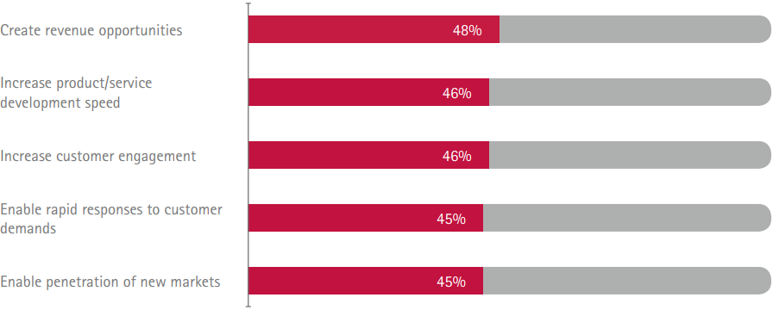
Figure: Top Five Digital technology outcome in business
Source: (Accenture, 2015)
Increase customer engagement: According to the research, customer engagement is one of the prime outcomes of applying digital technology in business. Application of mobile apps or social media is designed to target the key customer group.
Enabling response to customer demand: With digital technology, the business organisations can respond swiftly to the customer demand, because understanding of demand and preference of customer lead the business to respond efficiently (Telefonica, 2016).
Penetration to new market: Searching and putting footstep to the new market is another major outcome of the digital technology according to research. Business executives argues that digitalisation of the business enable them to attract more customer and access to new markets.
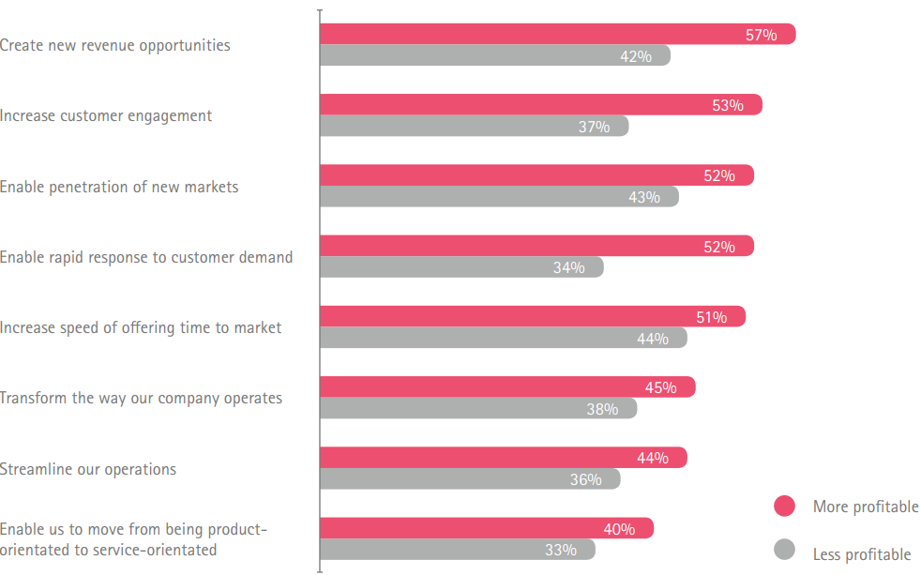
Figure- Expected Outcome of Digitalisation in terms of profitability
Source: (Accenture, 2015)

Adoption and application of mobile apps
With the higher evolve of mobility in the business era, digital technology services become difficult to provide the organisations with full potentials through single platform. Different mobility research study finds that business organisations are now applying digital and mobile technologies combined (Accenture Mobility Insights Report, 2014). It opens up a new portal of digital service for the business organisations which benefits the organisations by providing customer insights and meaningful data for strategy development.
Types of apps: Various types of apps are being used in the business industry which is backed by the type of the organisation and the nature of work they are dealing with. According to Accenture research, most equipped apps in the business are productivity, management and operations app which shows the sales data, recording of data and time management data in production.
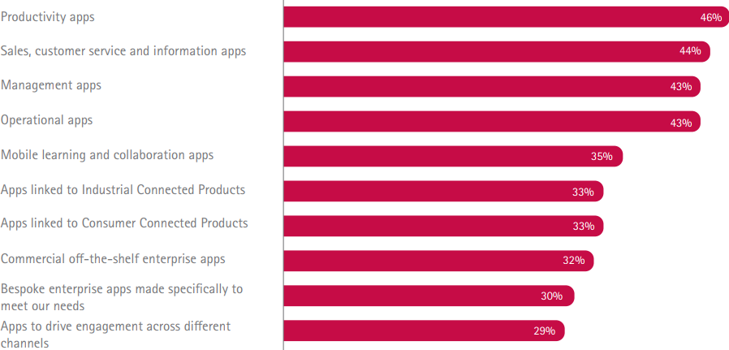
Figure- Types of Apps currently used by the Businesses
Source: (Accenture, 2015)
However, customer friendly apps are widely popular in the business industry because customers can be easily connected with the organisation and can be served efficiently. Mobile learning apps are also important type of app that enables the customers to learn about the organisations’ activities and its services (Accenture Mobility Insights Report, 2014). Some apps also work to engage different channels for the customers so that they can connect with broader digital service platform.

Steps in Mobile Application Adoption
Adoption of successful mobile apps for the business needs to go through some crucial steps that ensure how well the mobile apps can improve the operational efficiency in the business.
The following chart is showing the different steps of adopting apps in terms of the data taken from the business executives. In the first step of adopting the mobile apps, reliability of the app is analysed whether it can support the consistent performance to the business (Accenture Mobility Insights Report, 2014). Security is one of the top priorities of adopting mobile apps because the organisational data should be protected from any kind of external harm. The user experience of the app should be positive so that it can effectively address the needs of the customer and portray the solution. Data transfer to/from the cloud for the use of customers is also an important part of the mobile app adoption. Faster data transfer from the cloud can increase the customer accessibility as per research data.
Comprehensive testing program is necessary for the adoption of app in the business because it needs to be ensured by the business whether the app can effectively interact with customers. Feedback mechanism for the customer is another important phase in the development and adoption of mobile app in the organisation (Accenture Mobility Insights Report, 2014). Customers often provide feedback of different operations and services and suggestions which can be effectively gained through the mobile apps. Public app store can be linked with the organisational app which enables the user to adopt the similar kinds of apps and learn their usage. At the end, the offline accessibility of the app should be tested so that customers can access to the app and the digital services of the business at some extent.
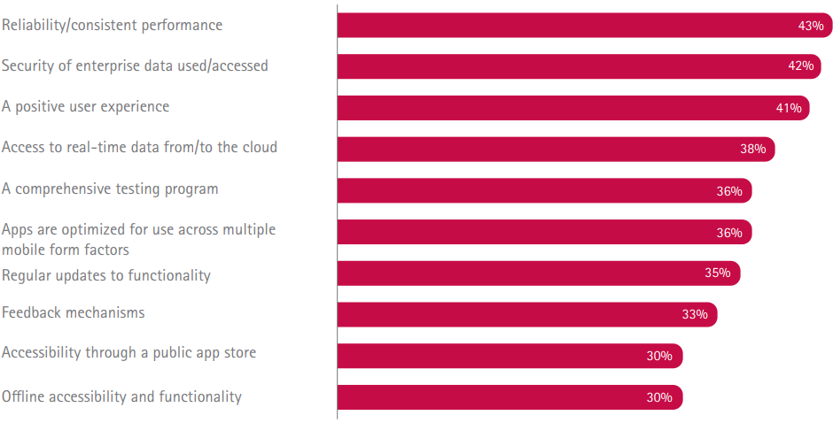
Figure: Steps in Mobile Application Adoption
Source: (Accenture, 2015)

Challenges of the digital technology
In the development and adoption of digital technologies in the business organisation, some challenges are still exist. According to the research data, the most significant challenges in the application of digital technology in business are addressed below:
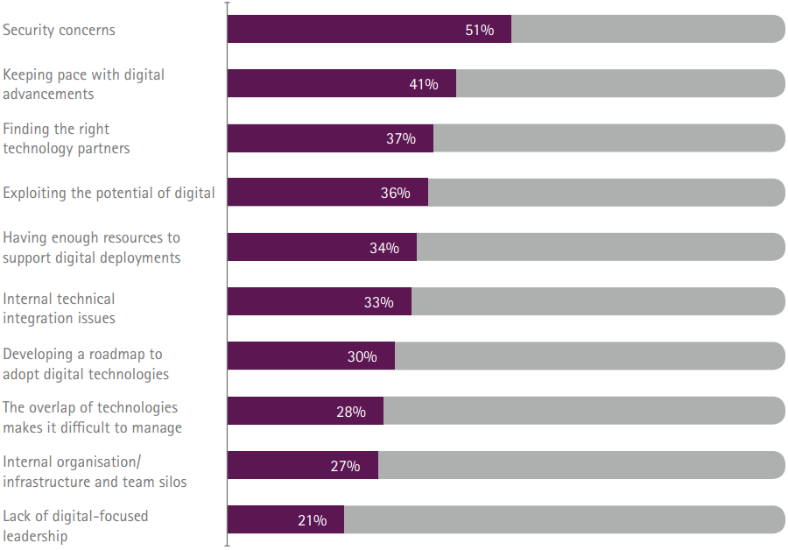
Figure- Challenges of Digital Technology
Source: (Accenture, 2015)
As the technology is getting updated every day, the risk of using technological services is also increasing regularly. There are some obstacles lying among the challenges of digitalisation of business operations (Accenture, 2015). 51% of the business executives think that security is the biggest concern for them in engaging with the technology in the business. However, keeping the same pace of the technological advancement in the digitalisation of operation is another challenge for the organisation. Because, continuous improvement of the technological sophistication in business operation is expensive for the organisation (Accenture, 2015). Finding the suitable technological partner and adequate resources are also a challenge for the business. However, internal actions of the business are not always integrated with the technological service which is another major challenge for the business in associating digital service. Lack of effective leadership and inadequate infrastructure are also major challenges in this case as the business organisation need to be efficient enough in dealing with the digital technology and applying it to business.

Linking profitability with digitalisation
Apart from the challenges and obstacles of digitalisation of the business, strategy and initiatives of digital transformation appears to be effective in increasing organisational profitability. According to the research of Accenture (2015), 7 out of 10 business executives address that digital transformation with other organisational processes have more potential in increasing organisational profitability. 87% of the employees believe that technological transformation can lead the operation towards higher efficiency that reduce the cost and maximise profitability. Around 80% of the business executives said that unified or holistic business strategy is more effective in driving the strategy into implementation than the segregated team. The gist of the research reflects the link of organisational profitability with the digitalisation of operations.

Findings of the research
After assessing all the research data regarding the application of digital technology in organisation to improve the operations and enhance efficiency, following findings are acquired:
- Business organisations are more likely to use technology not as a part of business operation but also as a CRM process. Appropriate blend of operational purpose of digital technology and CRM process can lead the business towards growth and achievement of goals.
- Organisations need to select the certain outcome that it seeks from the application of digital technology in the operation. It can be higher productivity, operational efficiency or customer engagement. Based on the appropriate outcome, it needs to design their strategy and take action.
- Blend of digital platform and mobile app has been considered at this age of business era. As customers are more engaged with the mobile device, they are more likely to use digital service with higher mobility.
- Security and other major challenges in the digital service should be managed while adopting the digital technology and profitability in the business can be increased through effective management technological issues and customer engagement.

Conclusion
Effective analysis of researching data and their application are essential in decision making of the business. This research has focused on the effective analysis of digitalisation of the business operations in the organisations. Different outcomes of digital technologies and application of mobile apps in the business to improve the business efficiency and increase customer engagement has been analysed based on acquired data. How digital services are linked with the business profitability also reflected in this research report based on which appropriate findings are elaborated. This report has been able to increase the learning of learner regarding research and analysis of information and data.

References
Accenture (2015), “Digital Density Index: Guiding digital transformation,”
Accenture Mobility Insights Report (2014). “Mobility: Fuelling the Digital Surge, Available at <http://www.accenture.com/ sitecollectiondocuments/pdf/ accenture-mobility-researchreport-2014.pdf 3 > [Accessed on: 31st December, 2017].
Accenture Interactive CMO Insights report, (2014). Available at <http://www.accenture.com/usen/Pages/insight-cmo-digitaltransformation-summary.aspx>> [Accessed on: 31st December, 2017].
Small Business (2016), UK SMEs are investing in digital transformation for faster growth, Available at <http://smallbusiness.co.uk/uk-smes-investing-tech-growth-2535098/> [Accessed on: 31st December, 2017].
Telefonica (2016), How digital growth can steady the UK’s post-Brexit economy, Available at <https://www.telefonica.com/en/web/public-policy/blog/article/-/blogs/how-digital-growth-can-steady-the-uk-s-post-brexit-economy> [Accessed on: 31st December, 2017].

