University of Wales Trinity Saint David

Programme: Certificate HE International Hotel Management
Module Name: Front office operations
Module code: M4X01920

Assignment Title: How do the departments of hotel ensure that the communications with Front Office are effective for the hotel operations

Student Name: Vasilica Georgiana Andrei
Student ID: 1815340
Lecturer Name: Jahanzeeb Qurashi

Table of contents

Introduction…………………………………………………………………3
Importance of communication between front office and other departments of hotel……………………………………………………….3
Importance of communication for effective hotel operations………….4
Conclusion………………………………………………………………….6
References …………………………………………………………………7

Introduction
Communication is an important feature that helps in ensuring necessary transfer of ideas and methods from one department to another of a hotel maintaining its smooth functioning. In this report, the importance of communication that can help in maintaining a positive link between front office and other departments have been described in brief. Benefits that can be achieved regarding services provided to consumers based on their requirements can be easily maintained based on a suitable mode of communication. Operational activities of hotel can be enhanced based on better relationship among its various individuals based on maintenance of a positive communication.

Importance of communication between front office and other departments of hotel
The front office is an important department of a hotel. It plays an exceptional role to deliver hospitality to the guests. It sets the first impression of the entire hotel to the visitors. In fact, the front office is the department that can set the stage for a pleasant and unpleasant visit for the guests. It is needed to inform the guests about public transport, location of hotel facilities. Front office staff should take an effective role about the information that will be of interest to guests. It is important to communicate to the guests properly. It is the way to manage a strong relationship between hotel management body and the guests (Bello, and Bello, 2017, p. 85). Customers are attracted towards a hotel if employees of the hotel and management can behave well and talk in a gentle way with them. It can to maintain a strong and good relationship with the customers. In order to improve a good bonding in between the customers and the hotel management body communication plays an important role.
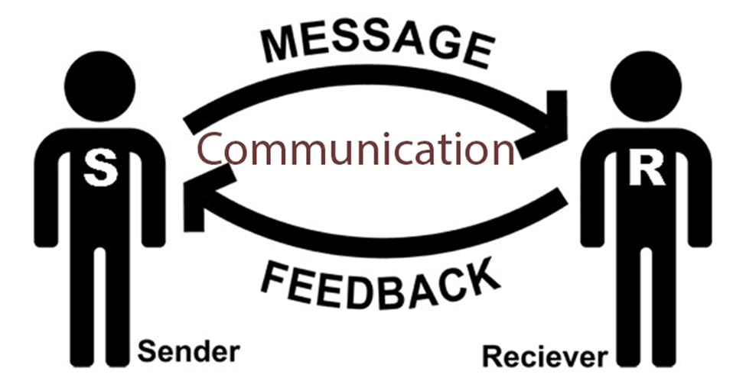
Figure 1: Mode of communication
(Source: Madhovi, and Dhliwayo, 2017)
The front office manager develops the relationship with other departments of the hotel. It is necessary to develop the communication between front office and other departments of the hotel. The overall improvement depends on it. The customers will be satisfied when they find similarity about the information what they known from the front office. It creates a good impression over the customers to come to the hotel once again and refer the hotel to others (Lin, and Vajirakachorn, 2015, p. 200). Thus, helps to improve the business of the hotel. The front office department has to maintain a good communication with housekeeping department. It clears the information regarding room status, the availability of the room for immediate guests. It also gives a clear information about the cleanness of the room, whether it is ready to occupy or not and the guests are already occupying it or not. It also informs the front office about the guests whether they will check out or not for the current day. Dirty or on change and out of order are some important information. It can be informed by the other department to the front office only when the communication gets developed in a hotel. As a result, the guests will be satisfied by the all over service of the hotel that helps to improve the business of the hotel in future.
Better service will attract better customers and providing better service is the only way to attract the customers. Due to the increase of customer’s expectations front office management form a hospitality industry where they create savvier guests’ profile. A customer can be introduced to rooms and other facilities of a hotel after they have met receptionist of a hotel. Through all those steps, a customer of a hotel mainly searches for satisfaction and care with good behaviour. Good behaviour is an essential element that is always expected by the customers. Front office management always gets connected with other departments like marketing and sales, Food and beverage, housekeeping, human resource management, security, control and maintenance. The communication helps the restaurant management to maintain the quality of the restaurant that is the primary thing they need to follow (Boz et al. 2016, p 125). Necessary information is provided by the other department to the front office due to deal with the customers properly. Housekeeping gives information about the availability of the room.
On the basis of that information, the front office updates the information. Otherwise misunderstandings will occur if wrong communication is given by the housekeeping department in between hotel department and guests. Any kind of miscommunication will create dissatisfaction on customers. Another important department is food department that will give information on foods which reach to the customers through the front office (Madhovi, and Dhliwayo, 2017, p. 329). The communication between front office and other department plays a vital role to maintain the brand name and quality of the hotel. So, the management has to make sure that proper communication is there in between the front office and other departments.

Importance of communication for effective hotel operations
Communication skills are very important in hotel industry as effective communication skills can improve daily operations of the hotel industry and there are several good habits of this procedure. Soft communication skills are very important towards customer attraction and satisfaction. Variety of customers are attracted towards a hotel if employees of the hotel and management can communicate well and talk in a gentle way with the customers (Ojo, Busayo, and Ifeoma, 2017, p. 330). A customer can visit a hotel once again when employees of that hotel can behave well with their customers. Attitudes of employees can be improved if communications between them are better. This improvement can also increase the business of that organization by attracting more customers towards them. It also helps to maintain strong relationships within an organization. Moreover, good communication skills are needed for connecting with lower-level employees of an organization and in this way, bonding between employees in an organization can improve. Communication is the key element for any kind of business when effective communication improves the growth of the business.
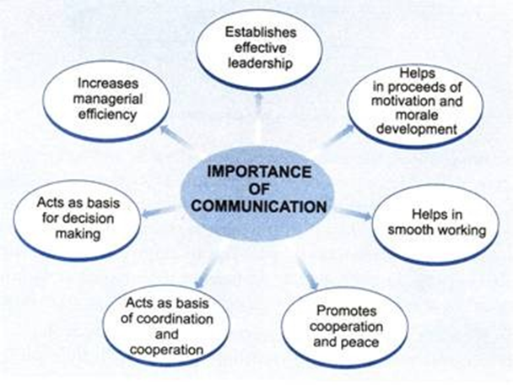
Figure 2: Importance of Communication
(Source: Lin, and Vajirakachorn, 2015)
Well executed verbal and non-verbal communication skills can be effective in the hotel industry as those have pre-discussed good applications in favour of hotel. All employees will certainly respect a customer need and they can take necessary actions based on those needs. A huge amount of business dealings can be made if better communication can be established between clients and employees (Bello, and Bello, 2017, p. 185). In this way, a better business can be maintained by an organization. This can help to increase the productivity of that organization. Generally giving concentration to a customer's need is not easy and whatever a customer wants to say has to have listened carefully. Now front office in a hotel face customer’s first and main responsibility is rested on them. Other departments in a hotel face customer after that and they have to behave carefully to their customers in a meaningful way. Attitude of employees and its daily basis improvement can also increase the business of that organization by attracting more clients towards that hotel.
Huge amount of business dealings can be made if better communication can be established between clients and employees and in this way, a better business can be maintained by an organization. The productivity of a hotel will depend upon these communication skills along with many other aspects. Thus, another useful side of productivity of better communication skills can be this type. Effectiveness of a hotel's business will depend upon the customer's arrival, departure and consciousness about this hotel. Business communication skills are very important among communication skills as a proper business type of conversations can be useful regarding expanding the business (Lin, and Vajirakachorn, 2015, p. 450). Verbal communication, written communication, face to face, non-verbal communications along with visual implications are very useful in this aspect for increasing communication. Those communication skills emphasize experience of a guest as those behave as proof that employees are responding to their customers. Service regarding guests or customers is improved through better communication skills and understanding between employees becomes so easy. These skills also improve the instruction fetching process from senior persons such that it becomes easy to serve their customers.
Effectiveness in hotel operations are well explained through previous explanations and those are very useful in many cases. Better communication skills have certain advantages like this is done for customer service improvisation and effectiveness. Overall business turnover is increased by this feature and it has to be started from the lowest level of an organization such that every person remains aware regarding this need (Madhovi, and Dhliwayo, 2017, p. 630). One more aspect of effective communication is that satisfaction regarding job of the employees are most important and productivity of hotel business along with the safety of customers influences effective communication plan. So, effective communication is important so that it can create good bonding with the customers and it is also important for the betterment of the hotel.

Conclusion
It can be concluded in this assignment that it is important to establish a proper communication between front office and other departments of a hotel. It helps the hotel employees to maintain a good bonding with the customers which helps in improving the business. Moreover, communication plays an important role in developing the relation between customers and hotel employees. It is important to maintain effective communication for effective hotel operations. This assignment also expresses smooth operation of hotel management through better communication skills and its good sides. Front office and other departments in a hotel can use this procedure for increasing their business along with customer satisfaction.

References
Bello, Y.O. and Bello, M.B., 2017. Employees’ empowerment, service quality and customers’ satisfaction in hotel industry. Strategic Journal of Business & Change Management, 4(4), pp.1001-1019.
Boz, H., Yilmaz, Ö., Arslan, A. and Koç, E., 2016. A comparison of depression and turnover intentions of hotel employees in all-inclusive and non-all-inclusive hotels. Global issues and trends in tourism, 372.
Giousmpasoglou, C., Marinakou, E. and Cooper, J., 2018. “Banter, bollockings and beatings” The occupational socialisation process in Michelin-starred kitchen brigades in Great Britain and Ireland. International Journal of Contemporary Hospitality Management, 30(3), pp.1882-1902.
Lin, X. and Vajirakachorn, T., 2015. QUALIFICATIONS REQUIRED FOR EMPLOYEES IN THE HOTEL INDUSTRY IN BANGKOK FROM HR MANAGERS’PERSPECTIVES: GETTING READY FOR THE AEC IN 2015. Bangkok: University of the Thai Chamber of Commerce.
Madhovi, P.G. and Dhliwayo, S., 2017. The relationship between customer relationship management (CRM) and performance in the hotel industry. African Journal of Hospitality, Tourism and Leisure, 6(1), pp.1-13.
Ojo, B.Y., Busayo, B.M. and Ifeoma, I.L., 2017. Mediating Effect of Service Quality on the Relationship between Employees Empowerment, and Customer Satisfaction in Hotel Industry. IOSR Journal of Business and Management, 19(7).

