Natalie Emma Male

Contemporary Approaches to Management BMSP4002

Management Approaches

Student Number: 1702161

Introduction

In 1931 Bourne leisure was established by Harry Warner. This private sector company has developed from owning one holiday park in 1931, to becoming one of the most successful and sustainable businesses in the British Travel and Tourism market. Their subsidiary companies include, Butlins, Haven and Warner Leisure Hotels, providing a diverse choice of holidays and holiday home ownership for its customers. The company employs a large compliment of staff approximately 6,000 which rises to 14,500 during the peak season. (Company profile, 2018)
This case study will be looking at the organisational functions and establishing the approaches the company uses to manage these.

Approaches to Organisation and Management

The study and approaches to management can be a valuable resource for managers within an organisation. Management and organisational behaviour enable organisations to look at the range of approaches. (Mullins & Christy, 2016, p. 35) Recognise that “If action is to be effective, the theory must be adequate and appropriate to the task and to improved organisational performance’. It is highly likely that successful companies utilise a combination of approaches from the following theories:

The Classical Management Approach

This approach looks at how Managers find the best possible way that employees can undertake their tasks efficiently. Discovered during the industrial revolution when organisations were looking at ways to increase employee’s productivity. The theory has a clear purpose with structure and planning. It is assumed that logical and rational behaviour are used. Managers are required to undertake various functions within the organisation. This ensures their employees are an appropriate fit for the job, have the skill set required and can be trained appropriately.

As Bourne Leisure was established in 1936 with only one park, it is possible that this Approach was used. Training and development techniques were vastly different than today. The technique is possibly implemented today as a lot of staff have progressed internally therefore, managers have first-hand experience of the tasks required, identifying with employees and understanding any issues. Although this is a useful model that is still popular today it does not appear to consider the Human element, social factors, personal life or control of their working environment. The company does not appear to use this as its main approach, perhaps this approach is not structured enough for the complexity of its staffing logistics and operations. Mullins et al (2016, p38 cited Simon ,1976) “ It is illusory to suppose that good designs can be created by using the so-called principles of Clasical orginisational theory”.

Scientific management

Frederick Taylor (1856-1917) started the scientific management movement. This was the first-time workplaces had been studied scientifically. The theories main points are that by simplifying and enhancing jobs, productivity would increase. He also believed managers and employees needed to have more consistent cooperation. At the time managers had little or no involvement with their staff. Taylor proposed that workers were motivated by money. If a worker had been more efficient and had produced more product than other workers, they in turn should receive more pay. The term Taylorism had been adopted.
Taylorism applies to the sole worker and does not consider human behaviour or the ability of individuals to complete tasks differently. Mullins et al. (2016) propose that although it is suggested that Taylor ignored the complexity of human relations in business. It appears he was unaware of the importance of individuals feeling and sentiments. Their ability to work in groups and the working environment. Bourne leisure states that “were one great team, with one great mission.” (Meet our team, 2018). There appears to be an emphasis on team work due to the nature of the organisation. Taylorism does seem to apply to the co-operation between staff and management and could therefore be a useful tool in the reconnection of management and its staff. Standardised sets of instructions for staff are also likely to be followed, from housekeeping instructions to maintenance diagrams.

Bureaucratic Management theory

This approach was recognised by Max Webber (1864-1920) who proposed that employees were loyal to their manager but not the organisation. He recognised informal relationships between managers and their employees and how power had become displaced. Four main features of a bureaucratic approach are, Specialisation, Hierarchy of authority, Impersonal behaviour and a system of rules. Therefore, a formal structure is required that is consistent and has a well-defined hierarchy of command. Formal written records are another key feature Consistency is important, and managers should maintain a fair and impersonal relationship. Decisions should be unbiased and equal treatment must be ensured. Many individuals prefer a bureaucratic environment and appear to thrive within its structure. Appreciating the order and security that a regimented environment provides. To the contrary many individuals do not thrive in this environment and are unable to function effectively. This could be due to personality, perception of models of authority and life experiences.

Bourne leisure is likely to practise this approach within the organisations staffing structure. The disadvantages are that previous staff have perceived a divide between staff and management. Perhaps this is due to the more impersonal aspects of a bureaucratic environment. There appears to be a defined hierarchy of command and this approach may discourage initiative. The advantages are that staff have clear guidelines to their job role and working environment. Mullins et al (20016, p 43 cited Caulkin 1998) “The overemphasis on process rather than purpose, fragmented responsibilities and hierarchical control means that it’s all too easy for individuals to neglect the larger purposes to which their small effort is being put”.

Behavioural Approaches to Management

Throughout business companies ignored personal development over profit. This led to negative attitudes, absence, high turnover and poor commitment to the job. The Hawthorne experiment was undertaken in 1927. Lighting was increased in the hope of improving productivity. Although when lighting was reduced productivity still increased. Workers over performed their tasks as they knew they were being watched. Elton Mayo concluded that workers output and satisfaction were linked to social factors and the way employees were treated at work. The study made participants feel more important resulting in a higher output
(Mullins & Christy, 2016, p. 47) Propose that “The studies undoubtedly marked a significant step forward into providing further insight into human behaviour at work and the development of management thinking”.

Bourne leisure adopts the Human Relations Approach in much of its organisational areas. It appears to be the main business model utilised. Throughout the research of the company strong examples have been evident. “Give our guests a great time and we’ll give you the opportunity of a lifetime”. (Bourne careers, 2018). There has been a large compliment of staff that have progressed internally throughout the company. Staff are encouraged and supported to reach their full potential and a lot of resources are committed to development and training. It appears that the company is using the full extent of the wealth of staff resources to ensure sustainability and continuity. Mullins & Dosser (2013, p 11) state that “The interrelationship of people, objectives, structure and management, together with the efficient use of resources, will determine the success or failure of the organisation and the extent of its effectiveness.” On the other hand, despite most company's willingness to apply the Human relations approach. It can appear that it is good PR and doesn’t represent the real working environment.

Systems Management Approach

In this approach systems rely on structure, everything is part of a system. If one part of the structure is removed the system must change to function. There are three different types.

: An open system is a system that continually interacts with the environment around it. An organisation may need to adapt to meet the needs of customers.
: A closed system is unable to change. For example, a company independent of the environment that produces high tech goods.
: A subsystem is a system that operates within a larger system. Synergy is achieved when all the parts work harmoniously and in unison with each other.
Entropy occurs when there is a lack of predictability, discord and a gradual decline into disorder. (Systems approach, n.d.) Defines the approach as “A line of thought in the management field which stresses the interactive nature and interdependence of external and internal factors in an organization. A systems approach is commonly used to evaluate market elements which affect the profitability of a business”.

Bourne leisure has many subsystems within its Holiday parks and hotels. The structure of the business makes it highly likely that different department decisions will have an impact on other areas. An open system appears to apply as the organisation is constantly interacting with the outside environment. The company is unable to deploy a closed system due to the nature of the Hospitality industry.

Contingency Approach to Management

The contingency approach believes there is no best way, or no one way to manage within an organisation. Managers are required to apply leadership to each situation. To look at each situation and apply an appropriate response. The success of this approach is dependent on the nature of the organisation. (Boddy, 2014, p. 58) Proposes that “As the environment becomes more complex managers can use contingency perspectives to examine what structure best meets the need of business”.
There is the possibility that staff have had situations where they have had to work independently and create a resolution. The advantage is that staff gain their own perspective and confidence in problem solving. The disadvantage is that mistakes can be made when staff haven't received the appropriate training, or it is more than their individual capability.

There is strong evidence to support the theory of a hierarchical structure to the business. Each department contains many sub- departments and must work in unison to ensure the smooth running of each Holiday Park or hotel. There is a defined structure of operations that filters down from the directors of the company to the service staff. Each department or staff member is directly responsible to report to his or her supervisor, who in turn must report to a senior staff member
Work Motivation and Satisfaction
(Motivation, n.d.) Internal and external factors that stimulate desire and energy in people to be continually interested and committed to a job, role or subject, or to make an effort to attain a goal.There have been many studies of work motivation and satisfaction. There are various prominent studies in Neo human relations, each recognising our needs and requirements for fulfilment.
Maslow developed his theory of a Hierarchy of needs 1943. Image one below (Burton, 2017)
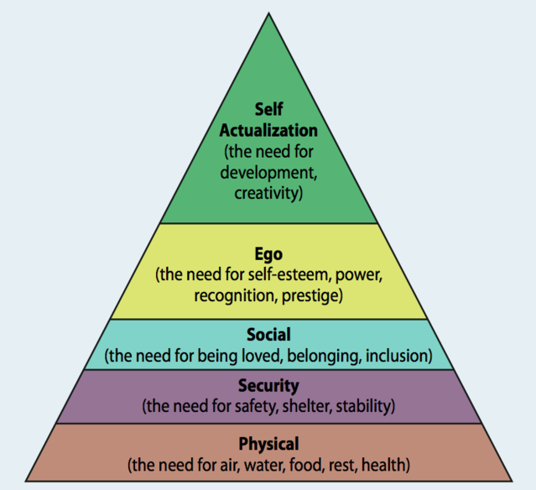
Image 1
Maslow identified that human needs should be arranged in a hierarchical order of importance, completing one level before being able to progress to the next. He believed that as humans we must move through the five stages of needs. Psychological, Safety, love, esteem to finally reach self-actualisation. Although, Maslow does make it clear that this is not necessarily fixed in this order as many people hold needs in different order of priority.
Hertzberg developed the two-factor theory, they include the Hygiene and Motivating factors He proposed that workers were motivated by personal advancement, responsibility and how interesting the work is. However, they are demotivated by the hygiene factors, poor pay, working conditions and working environment. He concluded that if these hygiene factors were present, they would not motivate employees.
Although there is merit to both these theories, they are subjective to the individual and their interpretation, wants and needs. It is difficult to apply either theory conclusively, as humans differ so greatly. It is unknown if Bourne Leisure apply any of the various motivational theories to the workforce.

There appear to be many examples of staff that have progressed, this is with little or no formal qualifications. If staff are willing to invest themselves in the company and work hard in turn the company will invest in them. There are opportunities to progress to management It seems commitment and dedication to the company over qualification can be key. However, qualifications are also highly respected. There seems to be a value in each staff member and the skills they bring to their job and their respective team, which is viewed by the staff as more of a community.
The hospitality industry is an extremely people orientated organisation, it requires a high level of customer service. Bourne leisure’s main manta is that staff should give customers the holiday of a lifetime, right from the first interaction. Mullins et al (2013 p52 cited Lashley & Lee-Ross 2003) stated that ‘Nowhere is an understanding of personality theory more important than in the service industry. Workers are required to interact with customers and during this become key part of the product.” Bourne Leisure seem to have captured the ingredients for a successful customer service model. The culture is firmly people focussed.
This is not to say that all staff feel appreciated or indeed motivated. The company’s website portrays a perfect place to work, throughout this research evidence has been present to support this. Previous staff have described the holiday parks as a fun place to work with good progression opportunities and how they enjoyed working as a team. Evidence to the contrary discovered that staff were feeling unmotivated by poor pay, long hours and the perception that there seems to be a big divide between management and staff. (Indeed, 2018). A reward system, if not present, could be a motivating factor, ensuring staff feel more motivated and valued.
The company has an extensive Human Resource Department. Their objective is to ensure every staff member is supported, valued and receives appropriate training. Although this service is available, it is unknown how many staff do not approach the department. This could be fear of getting someone in trouble, perhaps the feeling nothing will change. Consequently, this could lead to conflict, resentment or stress. Leading to sickness or eventually a staff member deciding to leave their position. Staff turnover is approximately 25%, (Company profile, 2018). However, it is unknown what other reasons make up this percentage. The company appears to be trying to value its staff through opportunities and support

Perception and communication
Perception and communication are without doubt two of the biggest aspects that can affect or indeed influence the success of any business. Reputation is everything in business and a company can lose custom overnight due to poor customer service or poor communication. Responsibility rests within organisations to make sure our experiences are positive, therefore shaping our perception. The Perception of Bourne Leisure by the public, seems to be generally good. Evidence of the company's success supports the theory that they are a trusted brand. With returning custom over the competition. That is not to say every customer has had a positive experience. This could be partly down to individual expectations. Image two below (Yüksel & Yüksel & Bowie & Chang, n.d.) Recognises some of the factors affecting consumer perception.

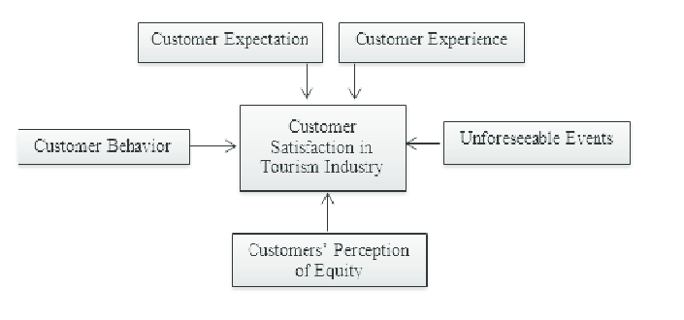Image 2

Image three below, (Heeger,2006) is a good example of how, as individuals our perception is different.

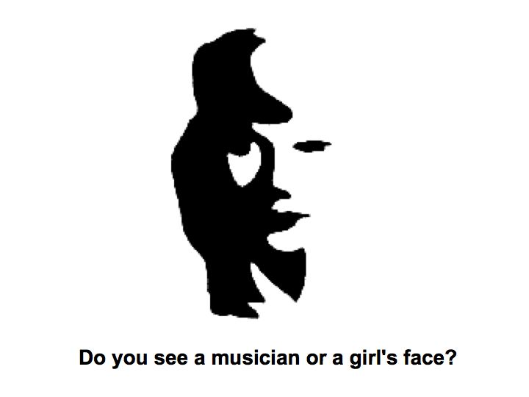
Image 3

We are shaped by our own experiences and preconceived ideas. Many factors come into perception including, cultural differences, sensory limits and psychological factors. Perception is a very individual experience and as humans we are shaped by our own perception.
Language is very important in communication. It shapes the way we are perceived and perceive the environment around us. There is a certain culture in language, depending on the region an individual is from, this could lead to a misunderstanding. Non-verbal communication, such a body language is equally important. They include gestures, posture, eye contact, tone of voice and facial expressions. Individuals in the service industry need to be mindful of their body language. Despite verbal communication, most people are aware if they are being served by someone who is uninterested. This in turn does not give the customer a good experience. The customer will remember this interaction as a poor experience and consequently affect future custom. As humans we observe communication as a tool for understanding situations and for our own survival. Mullins et al (2016, p 200 cited Locke , 1975) “ Even in a ‘safe’ environment like an office or meeting room you will feel a pull on your gaze each time someone new enters the room. And whether you want to or not, you will start to form opinions about a person in as little as three seconds”.

Organisational Context
In any organisation there will be an element of conflict and stress. It is the responsibility of management to recognise and deal with this issue accordingly. Systems should be put into place to ensure support and appropriate resources. Stress and conflict can lead to a high turnover of staff, unpleasant working conditions, absence and poor company reputation. That is not to say all stress is unproductive. (Mullins and Christy, 2013, p101) state that “Conflict, then, is not necessarily a bad thing. It can be seen as a ‘constructive’ force and in certain circumstances it can be welcomed or even encouraged”
Bourne Leisure is a Private sector company, funded by profit, borrowing and shareholders. It differs from a Public-sector company which is funded by the government for this reason there will be social and political factors that will affect business. How Brexit will affect Bourne leisure can only be speculative. However, given that they are one the largest provider of holidays in the UK, they may see families returning to the great British holiday. It is unsure how Brexit will affect the exchange rates in Europe consequently making holidays abroad more expensive. With ever changing trends, the idea of the staycation is becoming more popular. Although some families have noticed a change to their income, due to tax credits cuts and the higher cost of living. One of the company's innovative ideas is offering cheaper holidays, customers collect tokens through a major regional tabloid. Making holidays affordable and in turn ensuring bookings.

Conclusion
To summarise, the company has had to adapt as growing trends change. Perception of them organisation seems to be generally good. Bourne Leisure have ensured a longevity in this business market and have grown despite many economic and social changes. Perhaps part of the company's success is that it appears to foster many organisational approaches. The main approaches appear to be Human Relations and Bureaucratic with perhaps Scientific, Classical, Systems and Contingency approaches working alongside.
The company seems to offer good progression opportunities. Although staff feedback is generally good, there are still areas for improvement. Managers may need to reconnect with staff to understand the growing problems for their employees. As there is approximately 25% turnover this could be an area for further research. It appears part of the company’s success is viewing the customer with high importance, providing the best customer service possible. Therefore, ensuring repeat custom for the future. Finally, despite the growing social and political changes Bourne Leisure appears to be in a strong position to continue providing holidays across their main and subsidiary companies. The organisations ability to adapt to change, provides strong evidence of this.

References
Boddy, D. (2014). Management an Introduction (6th ed.). London: Pearson.
Bourne Leisure. (2018). Bourne Careers. Retrieved from Bourne Careers: https://www.bournecareers.co.uk/
Burton, N. (2017, September 17). Our Hierarchy of Needs. Retrieved from Psychology Today: https://www.psychologytoday.com/us/blog/hide-and-seek/201205/our-hierarchy-needs
Caulkin , S. (1998). Faceless corridors of power. Management Today, 65.
Company profile. (2018). Retrieved from Best Companies: https://www.b.co.uk/company-profile/?bourne-leisure-ltd-49906
Company reviews. (2018). Retrieved from Indeed.co.uk: https://www.indeed.co.uk/cmp/Bourne-Leisure/reviews
Heeger, D. (2006). Regonition. Retrieved from http://www.cns.nyu.edu/~david/courses/perception/lecturenotes/recognition/recognition.html
Lashley, C., & Lee- Ross, D. (2003). Orgnisational Behaviour for Leisure Services. Elsevier.
Locke , E. A. (1975). Personal Attitudes and Motivation. Annual review of Psychology, 26, 457-480.
Meet our team. (2018). Retrieved from Bourne careers: https://www.bournecareers.co.uk/
Motivation. (n.d.). Retrieved from Business Directory.com: http://www.businessdictionary.com/definition/motivation.html
Mullins, L. J., & Christy, G. (2013). Management and organisational behaviour (10 ed.). London: Pearson.
Mullins, L. J., & Christy, G. (2016). Management and Organisational Behaviour (11th ed.). London: Pearson.
Mullins, L. J., & Dosser, P. (2013). Hospitality Management and Oraganisational Behaviour (5th ed.). London: Pearson.
Simon , H. A. (1976). Administrative Behavoiur (3rd ed.). Free Press.
Systems approach. (n.d.). Retrieved from Business Directory: http://www.businessdictionary.com/definition/system-approach.html
Yüksel & Yüksel, 2., & Bowie & Chang, 2. (n.d.). Factors Affecting Customer Satisfaction with Tourism Products and Services. Retrieved from Reasearch gate: https://www.researchgate.net/figure/Factors-Affecting-Customer-Satisfaction-with-Tourism-Products-and-Services-Source-Yueksel_fig1_303554785

