BUSINESS PLAN
Amelda's
The Jamaican Sandwich Company
A Taste of Tradition. A Future Rooted in Legacy.

Program of Study: Certificate in Higher Education Business Skills for the Workplace
Module: Enterprise and Entrepreneurship
Module Code: LCLM4006
Assignment Title: Individual Written Business Plan
Lecturer: Fouziya Farheen
Student Name: Latoya Brown
Student Number: 2428456
October 2025

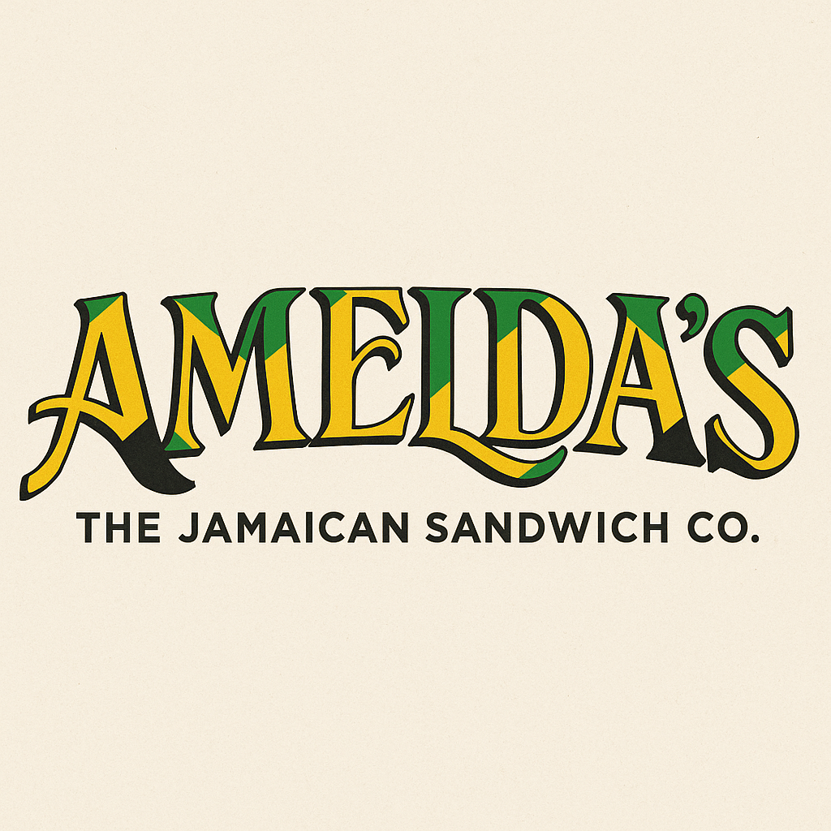



Table of Contents
1. Overview of the Business Idea
- 1.1 The Amelda's Story and Product Offering
- 1.2 Management Structure and Legal Format
2. Environmental Analysis: PESTEL Framework
3. Marketing Strategies
- 3.1 Target Market and Digital Strategy
- 3.2 Traditional Marketing and Launch
4. Funding Requirements
- 4.1 Total Investment and Sources
- 4.2 Startup and Monthly Operating Expenses
- 4.3 Financial Projections
References

1. Overview of the Business Idea
Amelda's – The Jamaican Sandwich Company, founded by Latoya Brown, is more than a fast-casual dining establishment; it honours the legacy of her grandmother Amelda, who sold fresh produce at Kingston's Coronation Market. With growing demand for diverse, authentic ethnic cuisines (Williams and Thompson, 2023), our business addresses a significant market gap for genuine Caribbean cuisine in a quick-service format. We specialise in toasted hardo bread artisan sandwiches featuring jerk chicken, curry chickpeas, and fried plantain, alongside AMEFRESH™ cold-pressed tropical juices honouring traditional Jamaican remedies.
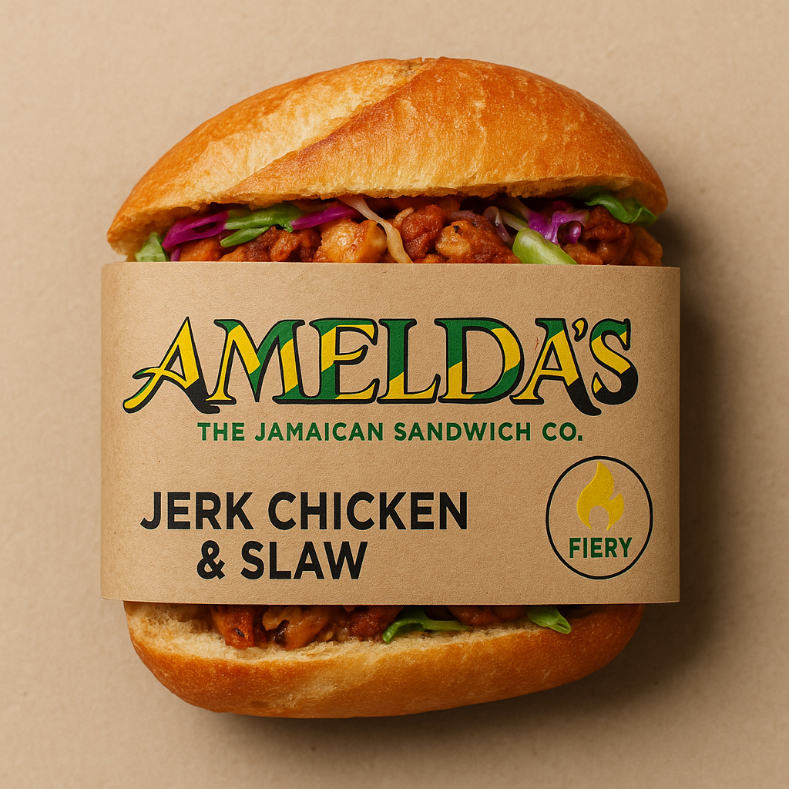

1.1 The Amelda's Story and Product Offering
Latoya Brown was raised in rural Jamaica by her grandmother, Amelda, where her grandfather farmed 'the bush' with bare hands—no chemicals, only rich island soil and natural fertilisation. Each week, Amelda loaded baskets with yams, plantains, and mangoes, riding old buses to Coronation Market, where she slept on concrete floors Friday nights to sell Saturday mornings as a 'higgler'. After selling produce, she returned home to prepare Sunday dinners with rice and peas, chicken, and natural juices—soursop for bed-wetting, Seville orange for chest colds. Today, Amelda's brings this heritage to UK high streets through authentic roti wraps, breakfast bakes with ackee and callaloo, tamarind slaw, pepper mayo, and AMEFRESH™ juices featuring soursop, mango, sorrel, and ginger. We also offer catering services for corporate events and private parties, serving 10 to 200 guests.

1.2 Management Structure and Legal Format
The organisational structure comprises Latoya Brown as Founder and Managing Director overseeing strategy, financial management, and brand storytelling; the Head Chef and Culinary Director responsible for authentic recipe preservation and staff training (UK Hospitality, 2024); the Operations Manager, Christopher Davis, handling daily operations and authentic ingredient sourcing; and the Marketing Manager, Shahnoy Morris, developing heritage-focused promotional strategies. Front-line staff includes two line cooks trained in traditional Jamaican techniques, one prep cook, and three customer service representatives trained to share Amelda's story. The company will operate as a Private Limited Company (Ltd) registered in England and Wales (UK Government, 2024), providing limited liability protection whilst facilitating investment capital access. We will register for VAT, Corporation Tax, and PAYE (HM Revenue and Customs, 2024), and trademark the Amelda's name and AMEFRESH™ brand.
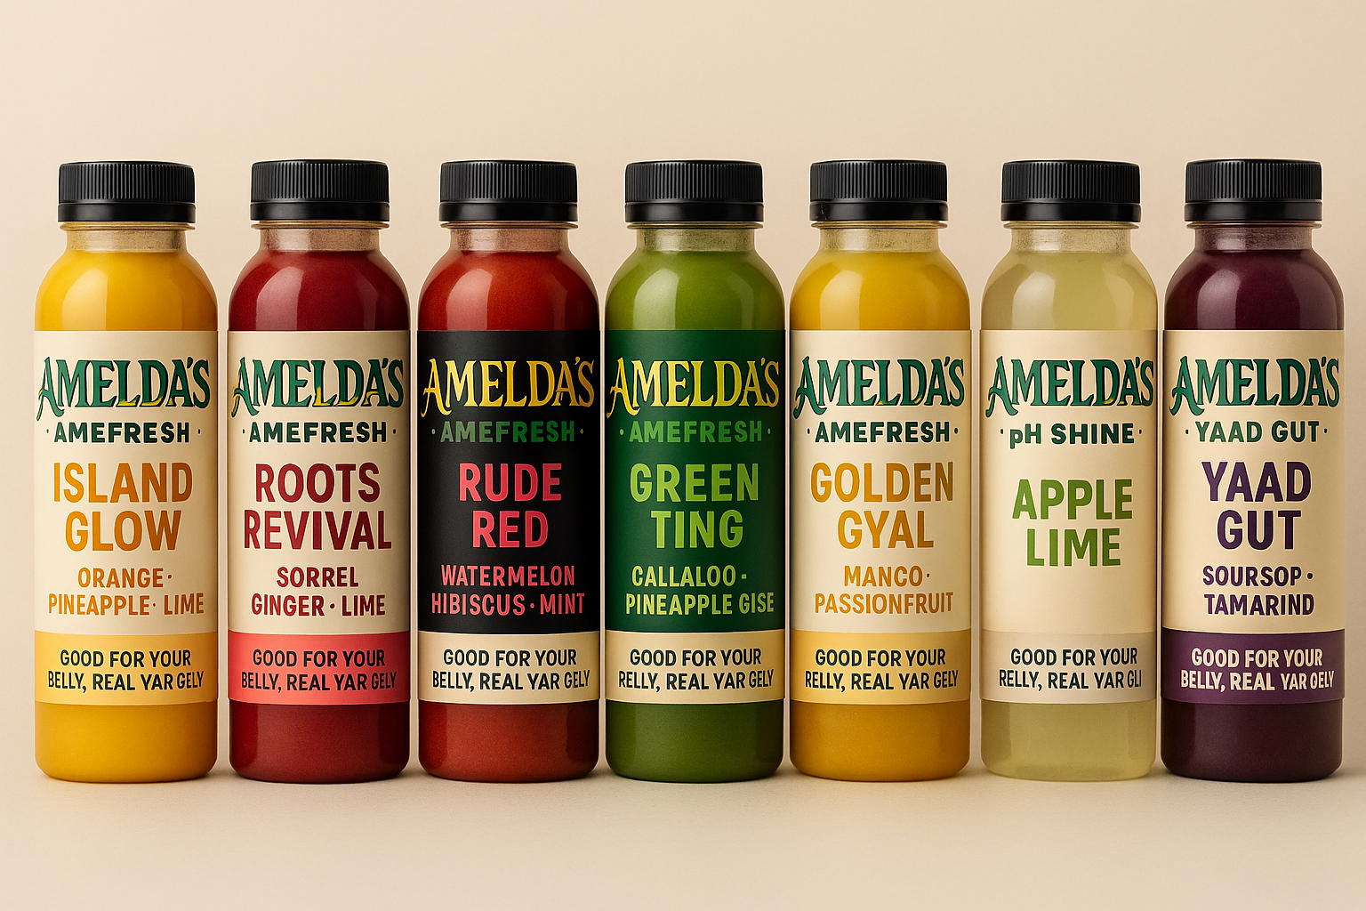
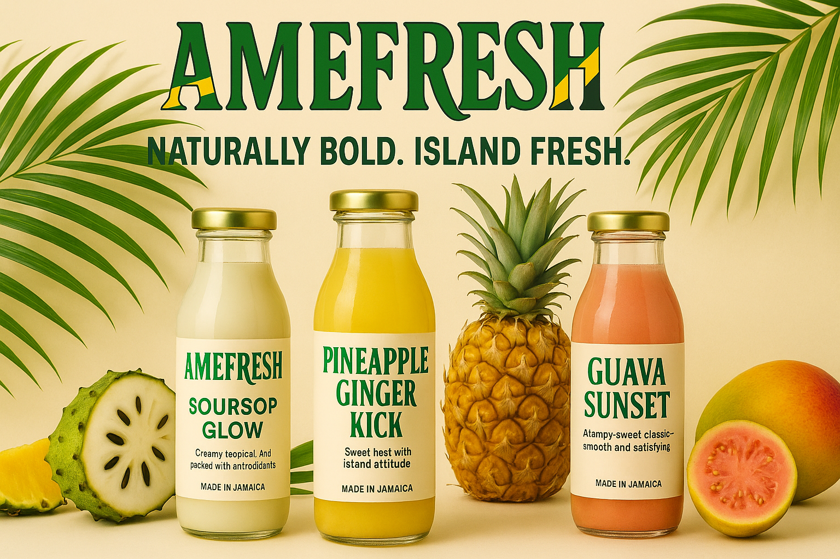

2. Environmental Analysis: PESTEL Framework
Post-Brexit trade arrangements impact imported Jamaican spices and tropical fruits for AMEFRESH™, though government support through Start Up Loans and business rate relief provides assistance opportunities (British Business Bank, 2024). Despite inflation pressures, fast-casual dining demonstrates resilience with consumers seeking authentic cultural experiences (Mintel Group Ltd, 2024). Labour costs, including National Living Wage increases, require efficient staffing models (UK Hospitality, 2024). The UK's Caribbean community of over 600,000 people represents core customers seeking genuine tastes of home (Office for National Statistics, 2024), whilst changing dining habits favour quick, quality meals with compelling origin stories (Williams and Thompson, 2023). Social media drives food trends, with vibrant Jamaican dishes suited to Instagram and TikTok marketing (Statista, 2024). Modern POS systems enable data-driven operations (Restaurant Association, 2024), whilst online delivery platforms provide crucial revenue channels (Statista, 2024). Environmental sustainability influences consumer choices (Williams and Thompson, 2023); we will use biodegradable packaging, honouring Amelda's respect for natural resources, and composting juice pul,p continuing her fertilisation cycle. Food safety regulations mandate HACCP-based systems with specialised juice production protocols (Food Standards Agency, 2024). All staff receive Level 2 Food Safety training, with allergen labelling for both sandwiches and AMEFRESH™ juices (Food Standards Agency, 2024).
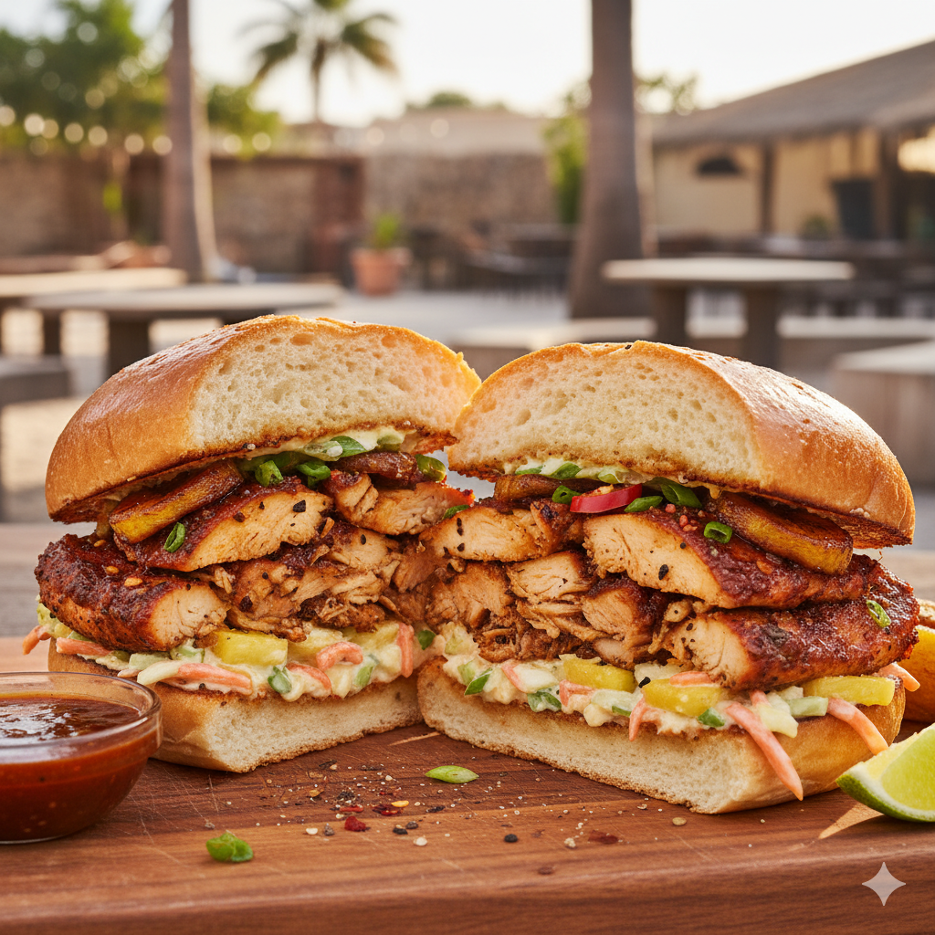

3. Marketing Strategies
Our marketing strategy establishes Amelda's as the premier destination for authentic Caribbean cuisine through multi-channel storytelling, honouring heritage whilst embracing modernity (Williams and Thompson, 2023). Our brand emphasises authenticity, generational legacy, and cultural pride using Jamaica's national colours. Our tagline, 'A Taste of Jamaica, One Bite at a Time,' communicates convenience and authenticity, whilst 'A Taste of Tradition. A Future Rooted in Legacy positions the brand as a cultural movement celebrating Caribbean women's strength through Latoya and Amelda's story.

3.1 Target Market and Digital Strategy
Primary segments include the Caribbean diaspora seeking authentic flavours and cultural connection (Office for National Statistics, 2024), heritage-conscious food enthusiasts aged 25-45 valuing authentic founder stories (Mintel Group Ltd, 2024), health-conscious consumers seeking natural cold-pressed juices with traditional medicinal benefits, and time-pressed professionals wanting quality lunch options with cultural significance. Instagram will showcase Amelda's story through food photography, historical family photos from Jamaica, traditional cooking methods, and customer testimonials using hashtags like #Ameldas #TasteTheIsland #BlackOwnedBusiness #AMEFRESH (Statista, 2024). TikTok videos will demonstrate jerk seasoning application, cold-pressing juice, and sandwich assembly whilst sharing heritage stories about Amelda and the higgler tradition. Facebook facilitates community building through detailed posts about Jamaican food culture and traditional remedy knowledge behind AMEFRESH™ ingredients. Content includes 'Meet Amelda's' brand introduction, 'From Bush to Bread' heritage narrative, menu spotlights, 'Why We Do This' mission statements about cultural representation, and community engagement, asking followers to share Caribbean family food stories. Email marketing builds relationships through monthly newsletters featuring Amelda's recipes and Jamaican cultural education.

3.2 Traditional Marketing and Launch
Flyer distribution emphasising heritage stories with opening discounts encourages trial. Local advertising in Caribbean community publications builds awareness. Corporate partnerships highlighting unique cultural offerings create steady revenue (Restaurant Association, 2024). Community engagement through Caribbean cultural event sponsorship and partnerships with community centres demonstrates an authentic commitment. Our three-phase launch begins with an invitation-only soft opening for community elders and Caribbean organisation leaders honouring tradition, followed by a grand opening week featuring Amelda's signature recipe tastings, AMEFRESH™ samples, live storytelling about grandmother Amelda, and cultural performances; then the sustainability phase, implementing loyalty programmes and weekly specials celebrating different Caribbean parishes. All materials feature Amelda's story prominently, positioning food as cultural preservation led by Latoya Brown's vision.

4. Funding Requirements
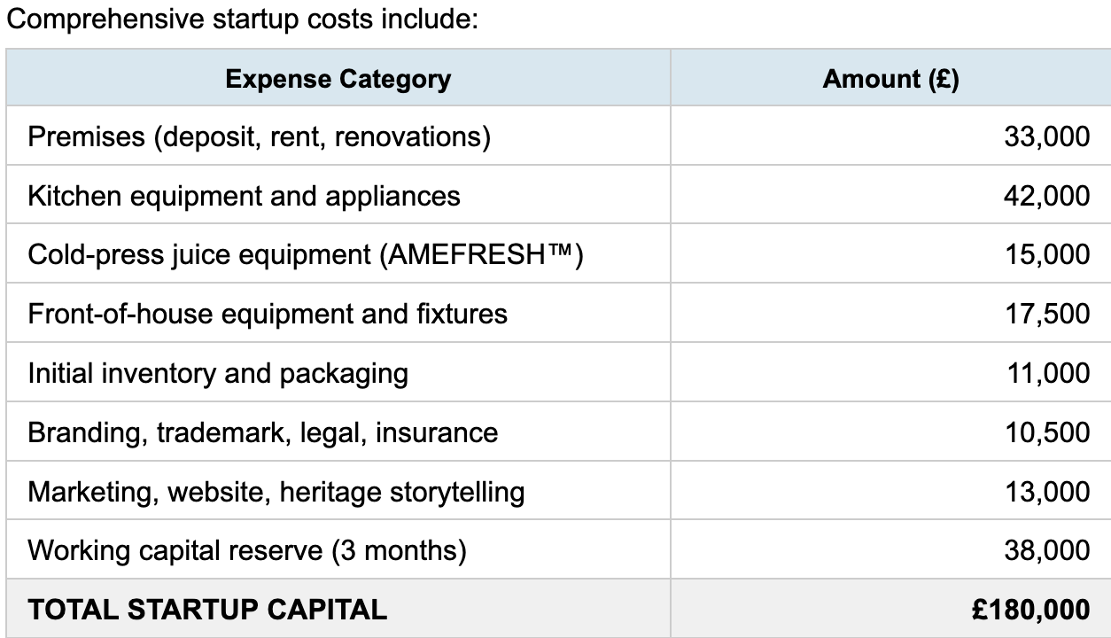

4.1 Total Investment and Sources
Amelda's requires £180,000 startup capital based on industry benchmarks, including specialised cold-press machinery (Restaurant Association, 2024). Funding sources include: Founder Latoya Brown's investment of £45,000 (25%) demonstrating personal commitment to honouring Amelda's legacy; Angel investment of £60,000 (33%) for 25% equity from investors passionate about cultural preservation and Black-owned food businesses; Bank loan of £50,000 (28%) through government-backed Start Up Loans at approximately 6% interest over five years (British Business Bank, 2024); Grant funding of £25,000 (14%) through programmes supporting ethnic minority entrepreneurs and cultural heritage businesses (British Business Bank, 2024).

4.2 Startup and Monthly Operating Expenses
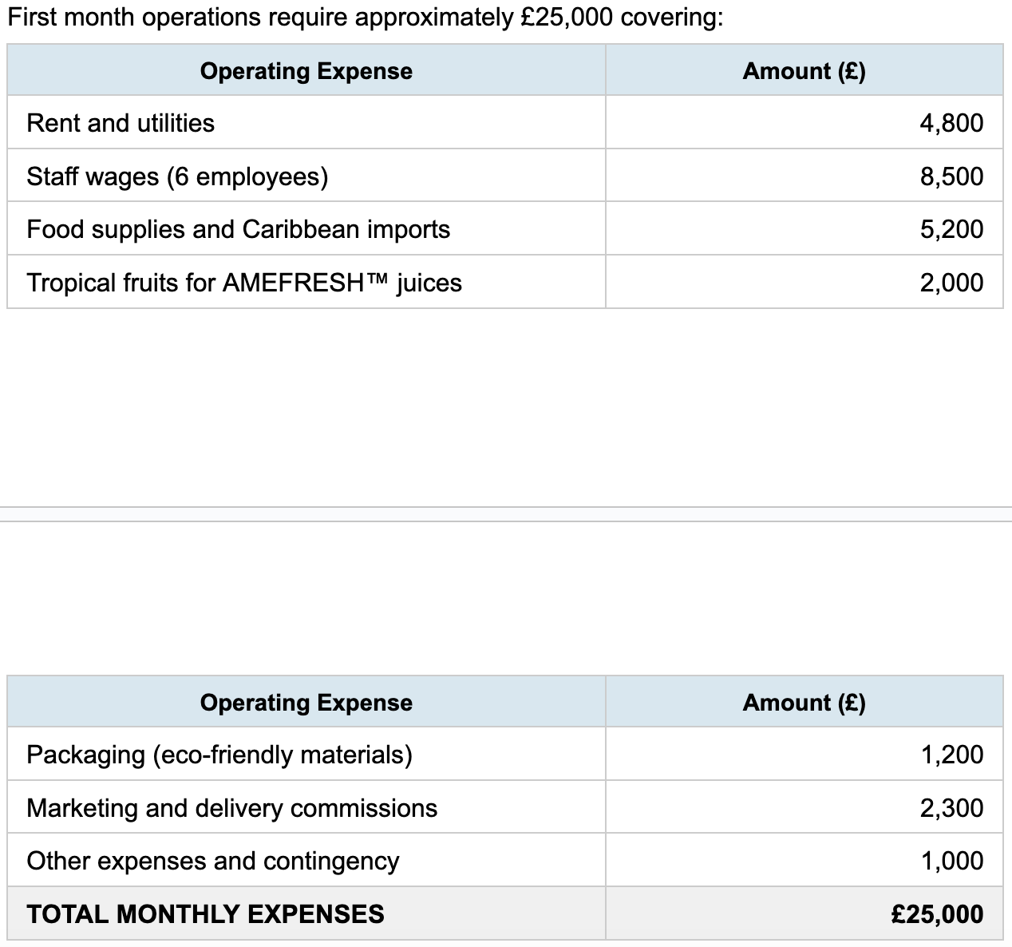

Comprehensive startup costs include premises (deposit, rent, renovations) £33,000; kitchen equipment £42,000; cold-press juice equipment for AMEFRESH™ £15,000; front-of-house equipment and fixtures £17,500; initial inventory and packaging £11,000; branding, trademark, legal, and insurance £10,500; marketing, website, and heritage storytelling £13,000; and working capital reserve covering three months £38,000, totalling £180,000. First month operations require approximately £25,000 covering rent and utilities £4,800; staff wages for six employees £8,500; food supplies and Caribbean imports £5,200; tropical fruits for AMEFRESH™ juices £2,000; eco-friendly packaging £1,200; marketing and delivery commissions £2,300; and other expenses with contingency £1,000.

4.3 Financial Projections
Based on fast-casual dining and cold-pressed juice market benchmarks (Mintel Group Ltd, 2024), we project monthly revenues of £30,000 in month one growing to £45,000 by month twelve, with sandwiches averaging £9 and AMEFRESH™ juices £4.50. Our dual product offering creates multiple revenue streams whilst sharing operational costs. Projected 65% gross profit margin on sandwiches and 70% on juices reflects strong performance potential (Restaurant Association, 2024). We anticipate breaking even at month 18 with cumulative profitability by month 30. Angel investors can expect returns through dividend distributions beginning in year three and potential exit opportunities as Latoya Brown expands Amelda's legacy to additional locations and scales AMEFRESH™ distribution to retail partners, creating significant enterprise value, honouring her grandmother's market spirit.

References
British Business Bank (2024) Start Up Loans Programme. Available at: https://www.british-business-bank.co.uk/start-up-loans/ (Accessed: 20 October 2025).
Food Standards Agency (2024) Food Safety Management System. London: FSA Publications.
HM Revenue and Customs (2024) VAT, Corporation Tax and PAYE Registration for Small Businesses. London: HMRC.
Mintel Group Ltd (2024) Fast Casual Dining UK Market Report 2024. London: Mintel.
Office for National Statistics (2024) Ethnic Group Population Estimates, England and Wales: 2023. Newport: ONS.
Restaurant Association (2024) Industry Performance and Benchmarks Report. London: Restaurant Association UK.
Statista (2024) Quick Service Restaurant Industry Statistics UK. Hamburg: Statista GmbH.
UK Government (2024) Setting Up a Private Limited Company. London: Companies House.
UK Hospitality (2024) Employment and Wage Trends in the Hospitality Sector. London: UK Hospitality.
Williams, J. and Thompson, S. (2023) Ethnic Food Trends and Consumer Preferences in Urban Britain. Journal of Food Service Business Research, 26(4), pp. 412-431.

