Gary Vaynerchuck.

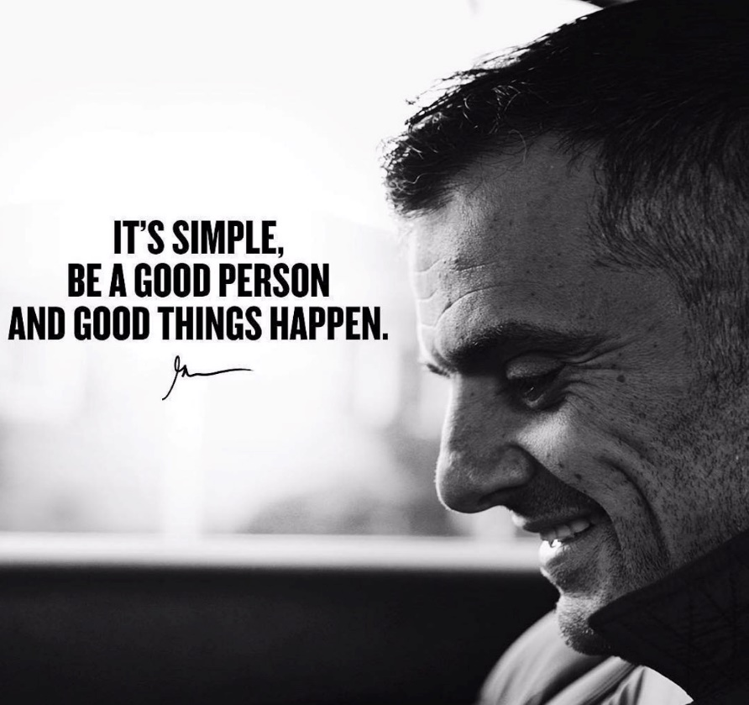
Entrepreneur, Best Selling Author, Speaker, Online Motivator & Leader of Vayner Media.

Presenter Damien Roberts – 1904978.

Bibliography.

WHAT MAKES A GOOD LEADER | DailyVee 206. www.youtube.com, https://www.youtube.com/watch?v=AzmtrHu8r38.
Escalante, Helena. ‘Gary Vee’s Philosophy on Leadership’. EntreGurus, 11 Nov. 2018, https://entregurus.com/gary-vee-philosophy-leadership/.
WHO IS GARY VAYNERCHUK? www.youtube.com, https://www.youtube.com/watch?v=0ilcARIMBv4.
What It Takes to Be Great Leader. www.youtube.com, https://www.youtube.com/watch?v=SBUB6hERTvs
Ingram, Osmond. Servant Leadership as A Leadership Model. JMSBI, October 2016. V1N1_3.pdf (ibii-us.org).
Stewart, Jan. Transformational Leadership: An Evolving Concept Examined through the works of Burns. Canadian Journal of Educational Administration and Policy, Issue #54, June 26, 2006. dulude,+#54+2006_06_26+transformational+leadership.pdf.
Bina, Soni & Ramesh Soni. Enhancing Maslow’s Hierarchy of Needs for Effective Leadership – ProQuest, 2016. https://www.proquest.com/openview/b261685db8ef1eba425a8331c2b3c838/1?pq-origsite=gscholar&cbl=39801.
Escalante, Helena. Gary Vee’s Philosophy on Leadership. Entre Gurus, 2016. Gary Vee’s philosophy on leadership - EntreGurus.
Yammarino, F.J., Dionne, S.D., Schriesheim, C.A. and Dansereau, F. Authentic leadership and positive organizational behavior. The Leadership Quarterly, 2008. Authentic leadership and positive organizational behavior: A meso, multi-level perspective (scinapse.io).

