(CDC,2019)
Practical According to Vygotsky in his theory he sighted a practical example on how a parent can support a child to develop, in his book, was the example of a father providing a child the chances to train in a play room that he has prepare with scaffolding and other items, the child was persuade to explore the apparatus and at long last the child uses it to pull himself up a few hours later the child cruising along the structures the child walk early with the support of his parents.According piaget Gross motor development, parents can help by naming object in an easy language and pratically show the child what you are talking about,for example nappy,bottle,rattle, so that,the child will start to learn the name of object(Kaye, 2015)
.
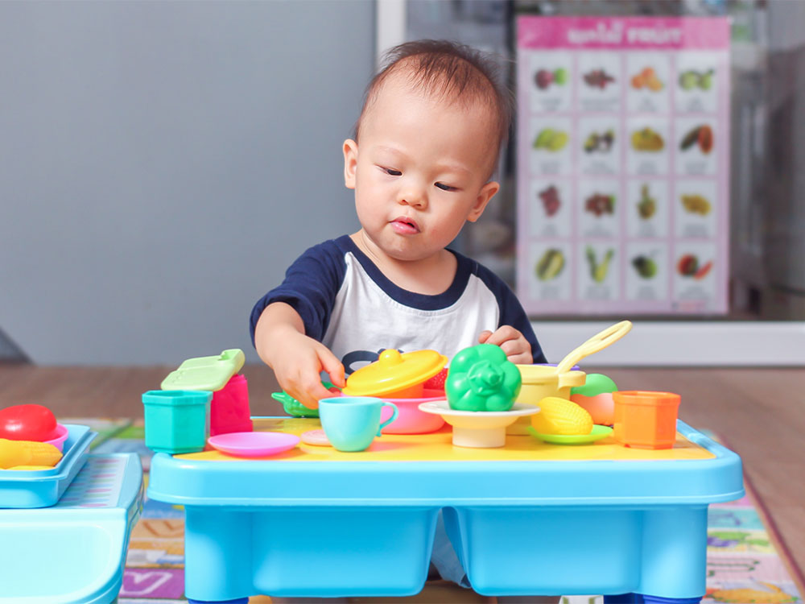

Introduction This Academic poster is presented to parenting course for parents in Birmingham on how a “child experience between the ages of 0 -5years will affect the rest of their life in the course of this Academic posters, there are many theories regather child experience but for this Academic poster we shall be discussing two relevant psychological theories, Piaget and Vygotsky, to demonstrate the amount of experience or development child will pass through between 0-5 years of their life

A child’s experience between the ages of 0 – 5 years will affect the rest of their lives

Piaget theories focuses on children development. Piaget summed his theory in three-way
- Schemas which are building block of knowledge
- Adaptation Processes these allow learner to transition from one stage another, Piaget called these Equilibrium, Assimilation and Accommodation
- Stages of Cognitive Development Sensorimotor, Preoperational, Concrete Operational, Formal Operational
The theories of piaget are based on stages and it presuppose children are differ in phases and they cannot think the same ways
Children in various stages think differently, there is a change in the logical thinking as child transition to adolescence. According to cognitive development theory, children transition in Four stage is based on their experience and maturation (Typhon and Voneche 1996)
Stages of development
Sensory-motor stage age 0 to 2 year it obvious to everyone who has observed neonate, the behavioural respiratory which infant possesses is most limited. At 0-1 a child shows few uncoordinated reflexive activities, sucking, tongue, movement, swallowing and crying, gross bodily activities. However, Piaget consider this period to be very important one because it is the crucible from which sensory-motor intelligence will subsequently emerge. (Boyd, 2014)
Sensory-motor stage develop through experiences and movement, the child five sense and brain want to see, hear, smell taste and touch as much as possible.
Child develop his or her first habit from the 4-month-old the child became aware of thing beyond his or her body as they get older and learn to do thing intentionally and the child understand that object continue to exist even if they can see them.
The physical mobility of the child increase, the child beginning to lister to sound, the child move learns to sit, crawl, stand, walk, even run, as the physical mobility of the child increase it leads to cognitive development, at this stage child can perceive the world from his or her own point of views
pre operational stages age 2-5years at this age the child will ues all his Gross motor skill walking jumb climb,also the child stair clambing skill will improve by the age of two pushing himself along toy-ride,ang the handling skill improve for most of the children become very pecuilar and several is be questions ask the child want to know everything it is the stage of earliest reasoning, and piaget calls it the inborn age because while we realised that they have amount of understanding( Mooney,2013)

The vygotsky theory of cultural history focused on the role of social interaction and cultural development of children,Vygotsky argues that speech is a critial component of the childs development,a child speech become more complex as their age advance and they develop. (Gross, 2015)
Vygotsky rejected the idea of Piaget that the development of children is independently at particular stage as a result of social interaction.According to Vygotsky indicate that children are born with four elementary mental functions attention sensation perception and memory it is the social and cultural environment that allows them to use these elementary skills to develop and envetually gain higher mental functions this development ideally happens in the zone of proximal development first there is what we can do on our own then there is the zone of proximal development which represents what we can do with the help of an adult or friend(Luria, 1976)
.
A child can perform complicated tasks with the help from advance individuals children develop through both formal and informal settings based on intheraction with adults(Lund,2014)
However, both theories have similarities they both agree that cognitive development declines as thy advance in age, while they differ in the sense that piaget asserts that children learn independently and the sources of cognitive development innate, while Vygotsky disagree by arguing that children are social creatures and their source for cognitive development come from without (Meadows,1986)

Conclusion
This poster is aims at giving you the understanding of child development from the age of 0-5years.These are the period in which children move from being a new-born, fully dependent on you for their needs. However, according to Piaget and Vygotsky both indicate in their theories that children develop and achieve breakthrough at different stages or through social interaction and cultural development.

Kolawole Osasuyi Osasuyi STUDENT ID 1815461

Apter, T. (2002) The Myth of Maturity: What Teenagers Need from Parents to Become Adults. New York: W.W. Norton
- Dr Apter Terri, is a Psychologist and she was a notable book writer of the year, she has written many credible books on children
- I used this Myth of Maturity because the source is credible and reliable based on my thoroughly studies of this book, the book has demonstrated how parents can support their child through the crucial stage in child development
- The book was useful for this poster, it makes me to understand how parents can support a child to cope. In my poster I said that parent can support by singing song with action to help him to learn body parts, reliable source
Boyd, D. (2014) Lifespan Development: Pearson New International Edition. Harlow: Pearson Education Limited
- Denise Boyd, is an instructor and educational psychology and has written many books on child such as the Developing child and lifespan Development and many others
- This book Lifespan development thoroughly and reachable addresses many analytical concepts of child development. Therefore, this was a credible source of information
- The source is credible and reliable it was helpful in this poster because the author made use of theoretical material on developmental theories which was approachable to this poster on the experience or stage of child development. It is a reliable source that explain the most productive ways children develop cognitively, it useful for any reader
Kaye, P. (2015) The first five years from birth to primary school and encourage your child development. 1st Ed. bath: crimson publishing ltd.
- Dr Philippa Kaye is a GP an author and mother who has written many books about child experience
- The First Five Year is reliable source gave information about the best way to help a child to learn or walk, and how a child skill and ability change all the time.
- This book is credible because the information I got was useful in making my poster I understand the checklist for development and the ways these skills can be stimulate. The book provides comprehensive description and specifically evaluations on the ways parents can help children, this book is useful for any reader or parents. Therefore, the book is credible and reliable..
Erikson, E. (1999) Childhood and society. 8th Ed. New York: W.W Norton and company
- Erikson Erik, is an influential theorist in the field of child development
- Erikson Erik theory is a credible and reliable source in his book childhood and society I understand that personality develop in stages in the lifespan of people and at each stage has interlink to their social experience, the book also gave information about how person must be successfully or unsuccessfully
- However, I did not use the book on my poster
Gross, R. (2015) Psychology: the science of mind and behaviour. 7th Ed. London Education: Hodder Education
- Richard Gross is a philosophy and psychology, career in teaching and author who has written many books on psychology
- Psychology the science of mind and behaviour was outstanding source for basic information of child cognitive development, the book explains in the eyes of Piaget and Vygotsky by comparing the two theory and Piaget stage of cognitive development was accurately explain
- The information in the book is credible and reliable source it was useful for this poster, because it explains Vygotsky concept of social interaction and learning processes of a child, also the proceeding of cognitive development as explain by Gross is grounded in assimilation and accommodation this area also helpful and interesting. The discussion in chapter 34 mostly in cognitive development in educational psychology are helpful for any parents or reader.

Luria, A. (1976). Cognitive Development: Its Cultural and Social Foundations. Cambridge, MA: Harvard University Press
Luria Alexander is one of the most famous psychologists in the twentieth, he is well-known for establish work on the development thought and language, a professor, author and researcher of many books, Lev Vygotsky was Luria great teacher.
- The entire chapter of cognitive development book favour of Vygotsky theories of generalization and preoccupation is particularly interesting as psychology classification is detailly examined in full Vygotsky various stages base on the supposition that the psychological process is subject change by any numbers of factor, together with socioeconomic factors, is genuinely accepted as fact by Luria. The theories were proving and experiment as results of highly trained in doing so

Mooney, C. (2013) Theories of childhood. St. Paul, MN: Red leaf Press.
Carol Garhart Mooney is an author of theories of childhood, and she is a teacher and a collage instructor she has also serve as childcare service manager for many years. In one of her books Mooney emphasis on the important of early childhood educator.
- The source and the information in this book are credible and reliable because it analyses the work of the five innovative education theorists John Dewey, Maria Montessori, Erik Erikson, Jean Piaget, and Lev Vygotsky in connection with early childhood. Mooney theories of childhood issue a fundamental introduction to each theory and describe the link of theory to bring into play and its influence on real children.
- The book is credible because the theories shed light on Vygotsky and Piaget concept and she describe her unique views, on the ways children can be supported and develop their learning, therefore this is a credible source of information for both parent and reader to promote their understanding.
Gillibrand, R., Lam, V. & O'Donnell, V. (2016) Developmental psychology. Harlow [etc.]: Pearson Education Limited.
- Gillibrand, & O’Donnell, they are both author with PhD in developmental psychology, the 2nd edition of their Developmental Psychology provides a transparent and lively scope of the major topics and concepts required by the British Psychological Society (BPS).
- This book is credible and outstanding source it provides broadly and accurate description addressing the social and cognitive elements of child development
- The developmental psychology 2nd edition was useful in this poster because it covers all strand of psychological development

