MODULE: PROFESSIONAL AND CAREER DEVELOPMENT
TASK 3: REFLECTIVE PORTFOLIO

STUDENT NAME: Shefali Begum
STUDENT NUMBER: 1918219
MODULE CODE: BMSW 4005
LECTURER’S NAME: Charles Nimoh

Table of Contents
Introduction 2
1. “Auditing my own skills and competencies using the analysis tool learned in the class (PDP). Identifying the skills required for a career of my choice. Evaluating my own skills in comparision to my chosen career” 2
Skill-Audit 2
Skill Identifications 5
"Identify the skills required for becoming assistant HR Manager" 8
"Skill Evaluation in comparison with the chosen career" 9
2. “Assessing and reflecting on the concepts I have learned from this module” 9
Conclusion 13
Reference List 14
Appendices 15
Appendix 1: Time management skill test 15
Appendix 2: Critical Thinking skill test 16
Appendix 3: Business management skill 16
Appendix 4: Communication skill 17

Introduction
The portfolio is about professional and career development in the human resource management's context. The main purpose of the project is to provide knowledge on own learning and conduct a reflective analysis. A PDP plan and a skill audit will be prepared and along with that own skills will be analysed with an Inquiry based learning model.

1. “Auditing my own skills and competencies using the analysis tool learned in the class (PDP). Identifying the skills required for a career of my choice. Evaluating my own skills in comparision to my chosen career”

Skill-Audit
The employment market is growing day by day and it becomes competitive for candidates. CPE and also (CPD) continuing professional development mainly refers to consistent and ongoing process of learning and development to gain professional competence (Plant et al. 2019). In order to fit in this twenty-one century’s job market, it is very important to conduct a skill audit. Lack of scientific knowledge and attitude potentially hinders information transference within classroom activities and effectiveness also cannot be increased. When I will not be able to perform skilfully in the classroom, it will negatively impact my professional development as well. Therefore, I have prepared a skill audit to identify strengths and weaknesses. Knowledge and understanding skill (critical thinking), time management skills, cognitive and intellectual skills (critical thinking), communication and business management skills are major skills which I have taken into account.
I have conducted a few skills assessment tests to know how I have performed in previous times. While participating in the class activities and internships, I have identified that there are few major HR skills I am able to develop yet I did not develop one particular skill which is time management.

Confidence level: 4-5 = “High”, 3-2 = “Moderate” and 1 = “Low”.
Skills | Summary | Confidence Level (1-5) | Indication | Example | Transferability  (YES/NO) | Requires improvement  (YES/NO)
Time management skill | With that skill, I can execute every task on time and met deadline of every project. | 4 | High | Working as an executor, I have seen that I can complete my project within time with responsibility. | YES | NO
Critical Thinking skill | With this skill, I can identify which will be the right applicant can become the company's employee by reviewing their skill sets. | 5 | High | While taking interviews of a few applicants, I not only see their documents, backgrounds and qualifications, rather I also check their intellectual capability. | YES | NO
Business management skill | I have focused on business management by enhancing my knowledge and practical implementation. | 5 | High | Once in the group, I participated in group work where my presentation has asked me to give a start-up idea and management plan. The person appreciated me for my realistic business plan and also praised the way I look at every component. | NO | NO
Communication skill | I hesitated too much while interacting with other team members and higher authority and also even with my group members. | 2 | Low | I have faced a recruitment problem, yet I hesitate too much to ask seniors about solutions. | YES | YES
Table 1: Skill Audit Table
(Source: Self-developed)

Skill Identifications
I have identified four major skills which I am developing these days which are - Time management, critical thinking, business management and communication skills. Among these skills, time management, critical thinking and business management skills are strong and communication skill is only quite weak [Refer to Appendices].
Skill Analysis with Inquiry-based 5E Learning Model:
From the above findings of the table and identified skills, an analysis is done in this section with an Inquiry-based learning model. This Inquiry-Based 5E Instructional Framework can mainly serve as the guide at the time of designing and implementing all instruction (Northern, 2019).

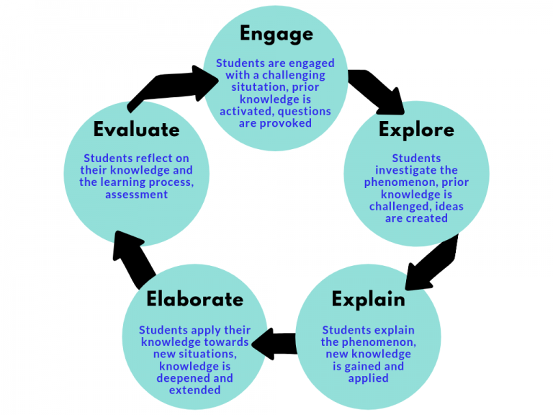
Figure 1: Inquiry learning model
(Source: Northern, 2019)
- Engage: I was engaged in a challenging situation where I was not able to communicate with my senior team members. I was stuck in a complicated recruitment process and my confidence level was quite low.
- Explore: I have investigated several HR-related phenomena and also reviewed popular companies' HR grooming styles and leadership style. So, after exploring I have implemented those following above-mentioned skills to embrace my knowledge.
- Explain: I have also explained new knowledge to my fellow group members who are also associated with the HR-recruitment process. Additionally, this elaborate process has helped me to gain knowledge on their skill gaps and intellectual knowledge.
- Elaborate: I have applied my knowledge in the new situation and my critical thinking skill has helped me to know dependencies and extensions where it is required.
- Evaluate: I have reflected on previous knowledge, learning princess and human resources’ assessment. After evaluating, I have understood that I will require to develop my communication skill for further development. If I become the assistant human resource manager and cannot possess effective and better communication skills, my subordinates will not be able to learn anything from me.
A PPD is given below in this section to make sure in which way future developments can be done. Along with that, timescales have also been mentioned and possible individual skills which are necessary for conducting daily activities are evaluated.
PPD (Personal Development Plan):
Many students use a visual metaphor to support their PDP or Personal Development Planning (Osgerby et al. 2018). Therefore, I have used this visual metaphor to represent my few skills which are considered weaker than other skills.
Learning and Development Need | Type of development | Timescales | Who is responsible? | Resources
1. Communication | Project work | 1 month | Self | Weekly tracker
2. Active listening | Reading | 1 month | Self | Feedback tools
3. Teamwork | Workshop, Conference | 15 days | Self | Communication devices
4. Administration | Mentoring | 15 days | Self | Laptop and Computer
5. Coaching | Job Shadowing | 1 month | Self | KPI metrics
Table 2: Personal Development Plan
(Source: Self-developed)

"Identify the skills required for becoming assistant HR Manager"
I want to become an assistance HR manager in future. An assistant human resource manager needs to practise specific skills to manage recruitment, training and evaluation, providing feedback to employees and employee benefits. Yudiantoro et al. (2021) have mentioned that it is important to maintain the value of competencies and motivation in the HR context. Specific skills which a HR should possess are listed below.
- Time management skill
- Business management skill
- Communication skill
- Critical thinking skill
- Administration skill
- Coaching
- Teamwork

"Skill Evaluation in comparison with the chosen career"
While analysing skill evaluation, I have focused on my problem-based learning (PBL). It is very important to use a systematic approach in problem-based learning. It is an instructional and also curriculum learner-centred approach which empowers them to conduct skill evaluation, by integrating theory and implementing knowledge and competencies to build a viable solution for a defined problem (Serevina et al. 2018).
I have reflected on my job description of the post of Assistant human resource manager. The skills which are included in the job criteria are - fluent communication skills, effective time management, business management competency, coaching, time management, administrating and critical thinking. By comparing previous existing skill-sets of mine, I can evaluate that - coaching, administrating and time management are my major weaknesses. Therefore, in order to develop those skills and convert them into strengths I will need to practise more on practical understanding. I did not build rapport with team members and my confidence level was quite low. I also did not personalise skill assessment, rather I have focused on particular one skill at a time. By reviewing feedback from seniors, juniors and higher authority, I have understood that there are specific skills which I will require to develop for my future.

2. “Assessing and reflecting on the concepts I have learned from this module”
Gibbs’ reflective framework is a theoretical framework which is used to reflect on learning mainly in a proper structured-way (Ahmed, 2020). From the viewpoint of the author, I will look into my reflective practices and analyse my previous learning. There are around five stages of the reflective cycle which are description, feelings, evaluation, conclusions and actions.
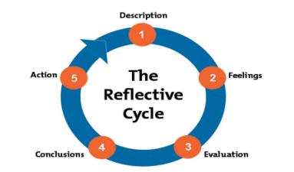
Figure 2: Gibbs’ Reflective Cycle
(Source: Ahmed, 2020)
Description
In the first stage of the model, own experience is described by reflecting and background information has is explained (Adeani et al. 2020). I have gone through a very important time in life during class activities as I have collected so much vital information and identified my prime skill gaps. On the first day, I learned that I have to have patience to learn individual skills. My tutor has guided me to build cognitive or intellectual capability. While participating in the seminar, I realised that there are so many intellectual students around me who are equally eligible like me. Therefore, from that situation, I have observed that I have to build some unique skills, so I can be recognisable among everyone. Even in our seminars, several companies' HR managers have given speeches and from there, I have learnt how they handle themselves in difficult situations. My module guide has asked me to do several exercises, so I can better implement human resource strategies.
Feelings
Li et al. (2020) has stated that Gibbs' reflective framework is quite a useful tool to mainly promote reflection and this provides idea to encourage the narrator to analyse own thoughts and previously-gathered feelings. I have felt that I focused on details too much and that's why I was not able to look after other skills which became my weakness. I felt less confident and could not talk to anyone freely as I was afraid that seniors might judge me for my question. For instance, once I did not understand a recruitment process which was very complicated and I could not execute the plan. I could not ask anyone about the process and made the wrong decision. I felt that my communication power is too low and this might negatively impact my future. In order to become an assistant human manager, one of the top criteria is to maintain fluency while communicating with people.
Evaluation
After evaluating four major skills, I have evaluated time management, business management, critical thinking and communication skills. I have scored 100 on 100 in the communication skill test which indicates my strength [Refer to Appendix 1]. I was able to answer 6 out of 10 questions in the critical thinking skill test which show that I am quite good in the particular skill [Refer to Appendix 2]. I have undertaken a test of business management where I have scored 75 out of 100 which also indicates my core strength in the peculiar skill [Refer to Appendix 3]. However, I have explained my previous experience in communication which indicates my weaknesses. Therefore, I have not scored well in communication and got 47 which pointed out my weakness in the peculiar competency [Refer to Appendix 4]. After evaluating, it can be understood that I did not focus on every domain equally which I should have done to improve my performance. From the skill assessment, I have identified that I have a major skill gap in communication. I have collected feedback from my subordinates who have informed me that I am an introvert yet in order to fit in this competitive employment market, I have to be a confident speaker. So, I can influence people and share positive attributes with them. The results of the skill assessment have shown that I could be a little more judgemental with my skills so I can identify core gaps. Except for communication, I have also reviewed that active listening, teamwork, coaching and administration are major weaknesses.
Conclusion
As per Roedema et al. (2022) Gibbs’ model helps practitioners to mainly draw conclusions to adapt scientific communication practices. I have gathered a lot of relevant knowledge regarding human resources development. For instance, when I have participated in group discussions, my team members and senior leaders have shared their working experience and from there I collect knowledge about HR's strategic implementation. I have reflected upon my past experience and gathered relevant knowledge on future recommendations. Yet, I should have done a self-assessment before it was required, so that I can identify major problems. I have analysed every possible challenge which can appear as well as I have developed my understanding on prime weakness. In order to become a skilled and professional assistant HR manager, I would need to gather practical knowledge. When I did not gather practical knowledge and increase patience, it affected me negatively. I should have used specific metrics to evaluate and monitor my own learning on a regular basis.
Action plan
An action plan is always required to invert weakness into strengths which are communication, active listening, teamwork, administration and coaching. An action plan is given below which will help me in future to develop these following skills in the short-term.
Skills | Action steps | Resources | Timeline
1. Communication | Trying to be more comfortable with the workplace environment will help me to communicate with others. | Computers, cell phone and laptops | 3 days
2. Active listening | I will need to be more conscious and stop doing subsidiary work while concentrating on a specific person. | Offline [no resources except the speaker]  Online [mobile and laptop] | 7 days
3. Teamwork | I will need to cooperate with team members by helping them to improve organisational productivity. | KPI metrics | 10 days
4. Administration | I will need to keep a record of every document on a daily basis. | Documents | 5 days
5. Coaching | I will need to play my role as a coach and share own experiences. | Feedback portal | 5 days
Table 3: Personal Development Plan
(Source: Self-developed)

Conclusion
In this portfolio, by using skills assessment tools, a few skills have been examined and evidence is given in the below section. Along with that, specific skills which are required to be a human resource manager have also been identified. A PPD and skill audit has been included in the first section. In the end, Gibbs' reflective framework has been used to reflect on my experience.

Reference List
Adeani, I.S., Febriani, R.B. and Syafryadin, S., 2020. USING GIBBS’REFLECTIVE CYCLE IN MAKING REFLECTIONS OF LITERARY ANALYSIS. Indonesian EFL Journal, 6(2), pp.139-148.
Ahmed, A.M., 2020. From reluctance to addiction: The impact of reflective journals on Qatari undergraduate students’ learning. Reflective Practice, 21(2), pp.251-270.
Li, Y., Chen, W., Liu, C. and Deng, M., 2020. Nursesâ€™ psychological feelings about the application of Gibbs reflective cycle of adverse events. American Journal of Nursing, 9(2), pp.74-78.
Northern, S., 2019. The 5 E’s of inquiry-based learning. Knowledge Quest. https://knowledgequest. aasl. org/the-5-es-of-inquiry-based-learning.
Osgerby, J., Marriott, P. and Gee, M., 2018. Accounting students perceptions of using visual metaphor as part of personal development planning: an exploratory case study. Accounting Education, 27(6), pp.570-589.
Plant, K., Barac, K. and Sarens, G., 2019. Preparing work-ready graduates–skills development lessons learnt from internal audit practice. Journal of Accounting Education, 48, pp.33-47.
Roedema, T., Rerimassie, V., Broerse, J.E.W. and Kupper, J.F.H., 2022. Towards the reflective science communication practitioner. Journal of Science Communication, 21(4), p.A02.
Serevina, V., Astra, I. and Sari, I.J., 2018. Development of E-Module Based on Problem Based Learning (PBL) on Heat and Temperature to Improve Student's Science Process Skill. Turkish Online Journal of Educational Technology-TOJET, 17(3), pp.26-36.
Yudiantoro, D.C., WA, B.S. and Wibowo, F.W., 2021. Internal Performance Evaluation of PT. Kimia Farma to Maintain Human Resources Skills and Motivation. Journal of Information Technology, 1(1), pp.37-42.

Appendices

Appendix 1: Time management skill test
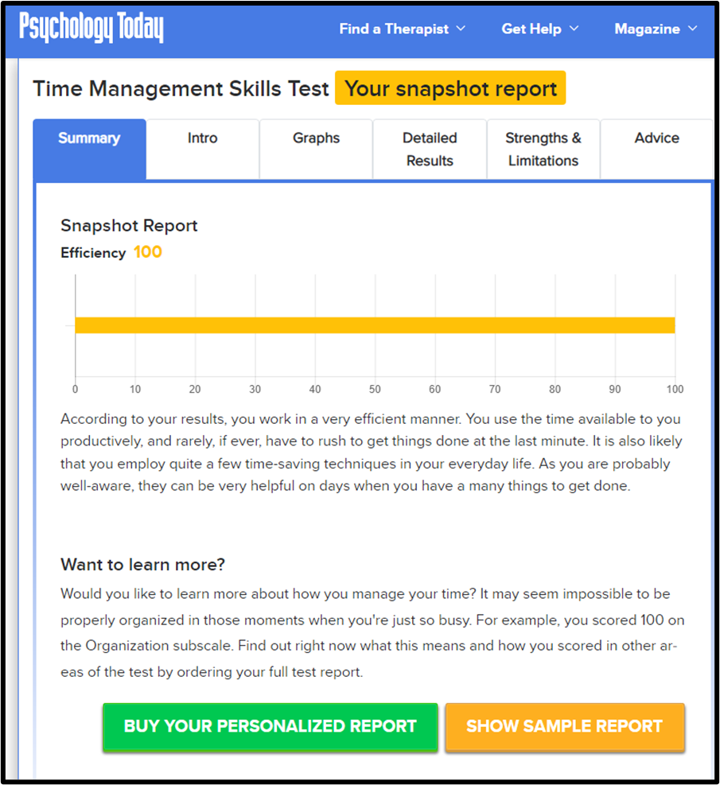
Figure 1: Results of Time management skill test
(Source: https://psychologytoday.tests.psychtests.com/bin/transfer)

Appendix 2: Critical Thinking skill test
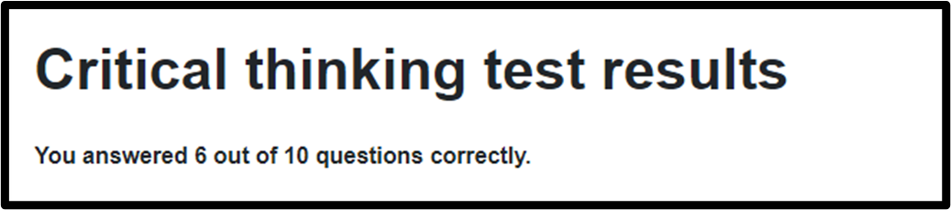
Figure 2: Results of Critical Thinking skill test
(Source: https://www.123test.com/critical-thinking-test/id=JWXGLFG662SJ&version=)

Appendix 3: Business management skill
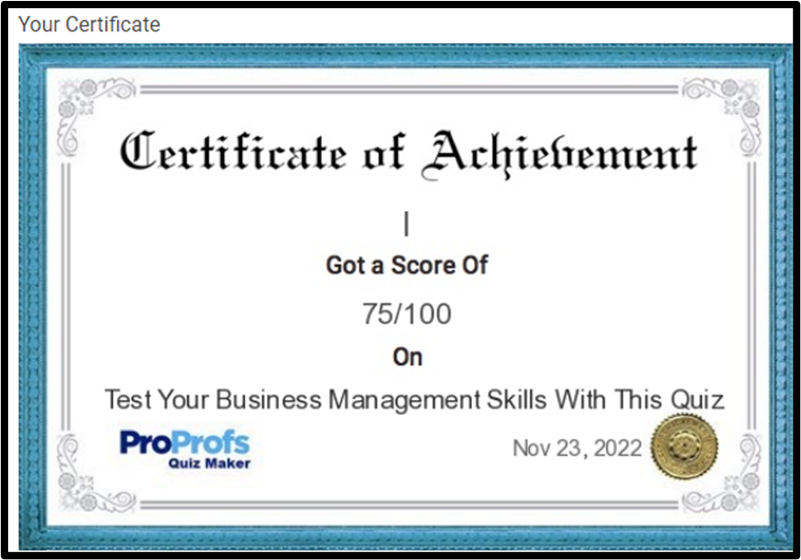
Figure 3: Results of Business management skill test
(Source: https://www.proprofs.com/quiz-school/quizreport.php?title=business-management_2&sid=299871095)

Appendix 4: Communication skill
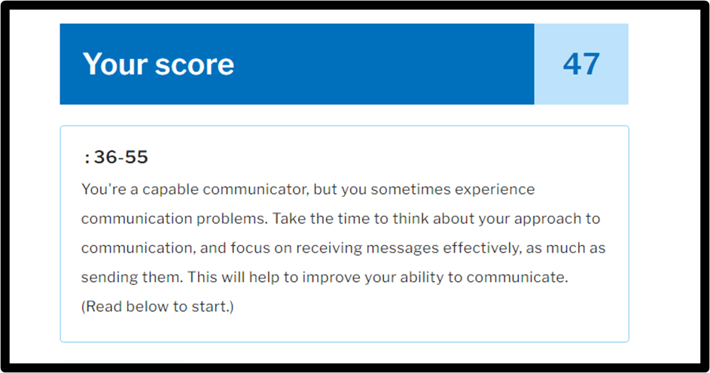
Figure 4: Results of Communication skill test
(Source: https://www.mindtools.com/a3y5cte/how-good-are-your-communication-skills)

