Marcin Soja
2219080@student.uwtsd.ac.uk
Effective Team Working and Communication What makes a successful team?
What makes a successful team?BMSW4009_SWAN
BMSW4009_SWAN
The key to a successful project is a team that performs exceptionally well. ( NextStep, 2023)
According to Biech (2007), a successful team can work together effectively to achieve a common goal. Key elements contribute to a team's success, including clear communication, strong leadership, and a shared sense of purpose.
Strong team-building abilities are essential for any organisation, regardless of an individual's job title or field. Collaborating as a group often results in better outcomes than working independently (Inc, 2014).

How did you ensure that your team was successful (link to Action Plan you did last week with your strengths and weaknesses)
A team's success depends on various factors beyond their roles or composition. However, having diverse parts and skill sets within a group is generally considered a positive aspect of team composition (Belbin, 2009).
First, to ensure we are going the right way to make us a successful team, we did the Belbin Questionnaire, which helped us describe our team role.
If we look at the attached team role circle, we can notice that in our group, we have a coordinator, teamwork, resource investigator, specialist, and implementer. Based on the roles of our team, we have a good mix of different strengths and expertise. The coordinator can help keep the team organised. On the track, the teamwork and resource investigator can help build relationships and gather information, the specialist can contribute their in-depth knowledge, and the implementer can ensure that plans are executed effectively.
Our success also depends on communication, collaboration, and a shared sense of purpose and goals. It is essential to ensure that everyone on the team is working together effectively and that there is a clear understanding of what the team is trying to achieve.
While our team composition has a good mix of different roles and strengths, there may still be some potential weaknesses that we should be aware of.

- Lack of creativity: While the roles we listed are essential for executing plans and managing resources, there may be a potential for improvement in generating new ideas or thinking outside the box by bringing to the team person who can get a more creative or innovative perspective to the table.

- Overlapping responsibilities: responsibilities between the coordinator, teamwork, and resource investigator roles must be clearly defined, and everyone knows what they are responsible for.
- Difficulty prioritising: With various tasks and responsibilities, it can sometimes take time to prioritise what needs to be done. The coordinator and implementer roles may be critical in ensuring that tasks are prioritised effectively and deadlines are met.
- Communication breakdowns: Communication can still be a potential weakness, even with various roles. Ensure that everyone on the team communicates effectively and that there are processes for sharing information and updates.

These are just a few potential weaknesses to keep in mind. It is important to regularly evaluate our team's performance and identify areas for improvement.

Are all Team Roles needed at all times? Composition of a successful team
Individuals usually have two or three Belbin Team Roles that suit them best, which can vary over time. Every Belbin Team Role has its strengths and weaknesses, and each role is crucial in ensuring the team's success. (Belbin, 2023)
Not all team roles are always needed, depending on a team's specific context, project, and goals. However, having diverse team roles can help a group achieve its objectives more effectively and efficiently. (Belbin, 2023)
For example, in a project that requires a lot of creative and innovative thinking, the Plant and the Resource Investigator roles may be more prominent. On the other hand, in a project that requires a lot of organisation and implementation, the Implementer and Completer Finisher roles may be more critical.
Therefore, it is essential to have a mix of different team roles in a team, as this helps to ensure that all aspects of a project are covered and that the team can adapt to changing circumstances. However, the relative importance of each role will vary depending on the situation.

TUCKMAN
Creating a successful team can meet various obstacles preventing teams from developing and performing effectively, resulting in poor group performance. These obstacles include insufficient preparation, the absence of structure, unclear roles, a lack of time and commitment, avoiding responsibility, and focusing on individual outcomes rather than team results.

Tuckman's five stages of small-group development provide a framework for improving the success of project teams and achieving their goals (NATVIG, 2016).

Successful teams reach the performing stage by going through several stages of development, each with unique challenges and opportunities. Teams that can navigate these stages successfully are well-positioned to achieve high levels of performance and success.

The first stage of team development is the forming stage. During this stage, the team is created, and members begin to get to know each other. At this point, team members are often polite and reserved and may need to clearly understand the team's goals or objectives. The main focus during this stage is establishing a positive working relationship between team members and laying the foundation for future collaboration.

The second stage is the storming stage. This stage can be difficult, but it is also an opportunity for team members to get to know each other better and understand their perspectives and skills. Team members assert their opinions and ideas during this stage, leading to conflicts and disagreements. The team must work through these conflicts and resolve any differences, which can help build a strong foundation for future collaboration.

The third stage is the norming stage. Team members work together more effectively during this stage, and conflicts are resolved. Communication improves, and team members feel more comfortable sharing their opinions and ideas. Common goals and objectives are established, and team members feel a sense of belonging and commitment to the team.

The fourth stage is the performing stage. During this stage, the team is fully functional and working towards a common goal, with clear roles and responsibilities. Team members have a high level of trust, communication, and collaboration and can effectively resolve conflicts and overcome obstacles. Teams at this stage are highly productive and well-positioned to achieve their goals and objectives.

The last phase in the development of a team is referred to as adjourning or transforming, which occurs when the team has fulfilled its purpose and begins the process of disbanding. At this stage, there is typically a sense of achievement and acknowledgement of the team's success. Additionally, this stage may entail adjustments in job responsibilities and expectations for team members.

To reach the performing stage, team leaders and members should build trust, open communication, clear goals and roles, and effective conflict resolution. Teams should also continually assess and improve their processes and dynamics to maintain high performance. Team leaders can play a crucial role in fostering a positive team culture by setting clear expectations, encouraging open communication, and promoting collaboration. Additionally, team leaders should provide regular feedback and recognition to team members and help to create opportunities for professional growth and development.
In conclusion, reaching the performing stage is a journey that requires hard work, dedication, and effective leadership. Teams that can successfully navigate the forming, storming, norming, and performing stages will be well-positioned to achieve high levels of performance and success. By building trust, open communication, clear goals and roles, and effective conflict resolution, teams can create a positive and productive work environment that supports their long-term success.

Conflict, positive aspects of conflict,
Looking for materials for this assessment, I found an impressive sentence - "Where there are people, there is a risk of conflict" (MindTools, 2022).
Effective teams require conflict, but it is crucial to handle it appropriately to leverage its potential benefits (Amason, 1995).
Because our team knows each other well, our conflict stage has been skipped. We did not have any issues. But we can imagine the situation - one team member, Karim, is consistently missing deadlines and not delivering her work on time, causing tension and frustration among the team members.
To manage this conflict, I can do the following:
- Schedule a team meeting to discuss the issue and encourage members to express their concerns and feelings openly.
- Try to understand why Karim is missing his deadlines. Is he struggling with the workload? Does he need additional support or resources?
- Identify areas where the team can agree and work together to find solutions.
- Focus on the issue, not the person.
- Listen actively to each team member’s words and try to understand their perspective, including Karim’s.
- Encourage team members to put themselves in Karim’s shoes and try to understand her perspective.
- If the conflict is challenging to resolve, consider bringing in a neutral third party, such as a project manager or HR representative, to help facilitate the discussion.
Using these conflict management strategies, we can help our team address the issue and find solutions for everyone. In this case, it might involve offering Karim additional support or resources, setting more realistic deadlines, or re-assigning some of his tasks to other team members.
Effectively managing conflict can help a team in the following ways:

- Improved communication: Conflict can highlight miscommunication and misunderstanding within a team. Addressing these issues can lead to more transparent communication and improved relationships. Establishing effective team communication is critical to creating a motivated and cohesive team (Navalna, 2022)
- Increased creativity: Conflict can generate a variety of perspectives and ideas. Conflict can lead to more creative solutions and innovative approaches when handled constructively.
- Stronger relationships: Addressing conflict respectfully and constructively can help build trust and foster stronger relationships among team members.
- Better decision-making: Encouraging constructive conflict can challenge assumptions, reveal biases, and help teams consider a broader range of options leading to better decision-making.
- Higher productivity: Conflict that is managed effectively can help teams avoid unproductive tension and delays, reducing stress and allowing the team to focus on the following tasks.

Effective leaders should possess conflict management skills that guide and direct others towards resolving conflicts. One helpful tool for leaders in managing conflicts is the Thomas-Kilmann Conflict Mode.

Belbin team roles,
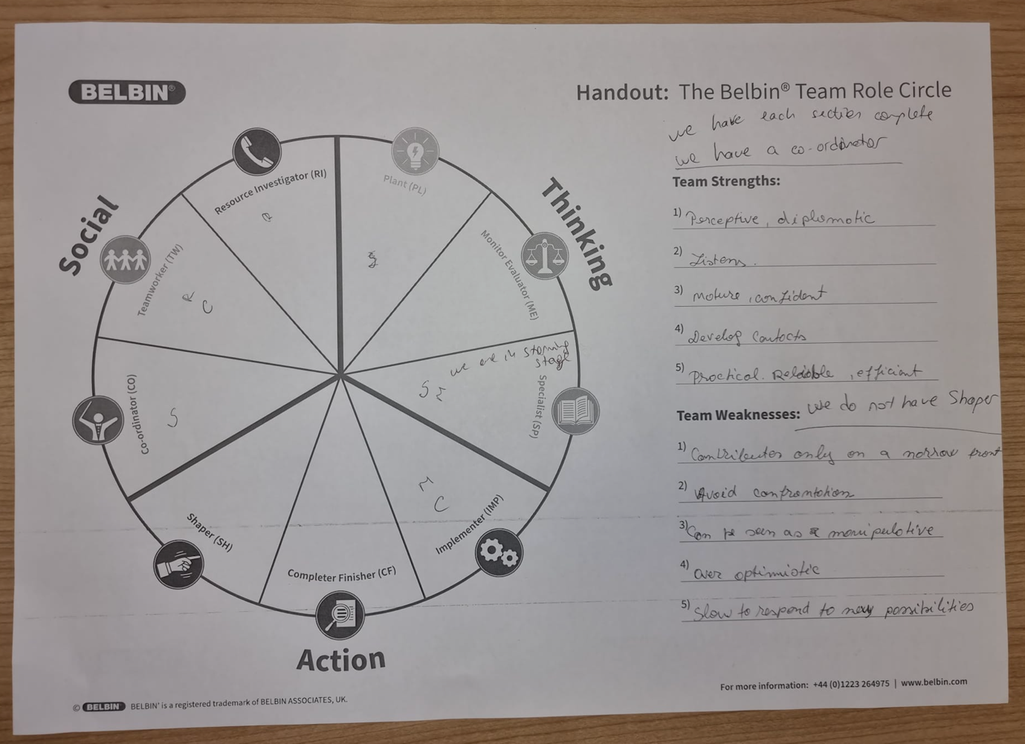

Bibliography
NextStep, 2023. HOW TO PICK EFFECTIVE TEAM MEMBERS FOR YOUR PROJECT. [Online]
Available at: https://www.nextstephub.com/effective-team-members/
[Accessed 06 02 2023].
Amason, A. C. T. K. R. H. W. A. &. H. A. W., 1995. Conflict: An important dimension in successful management teams. Organizational Dynamics, 24(2), pp. 20-35.
Belbin, 2023. The Nine Belbin Team Roles. [Online]
Available at: https://www.belbin.com/about/belbin-team-roles
[Accessed 03 02 2023].
Belbin, N. a. M., 2009. The Belbin guide to succeeding at work. London: A. & C. Black.
Biech, E., 2007. The Pfeiffer book of successful team-building tools: best of the annuals. 2 ed. s.l.:Pfeiffer.
Inc, A., 2014. Team Building. [Online]
Available at: https://video.alexanderstreet.com/watch/team-building
[Accessed 28 02 2023].
MindTools, 2022. Conflict Resolution. [Online]
Available at: https://www.mindtools.com/a0lvk13/conflict-resolution-video
[Accessed 02 03 2023].
NATVIG, D. a. S. N., 2016. A Project Team Analysis Using Tuckman's Model of Small-Group Development. Journal of Nursing Education. Journal of Nursing Education, pp. 675-681.
Navalna, O. I. a. M., 2022. The role of effective communication in the process of forming a cohesive and motivated team’. Ekonomìčnij vìsnik unìversitetu, Volume 10, p. 59–66.

