PLANT AND ASSET ENGINEERING

ACMA 6007
1
Evaluating the Effectiveness of Chosen Maintenance Strategies for Dedicated Equipment

2

Student: Joshua Ashcroft
Student ID: 2114692
Lecturer: Andrew Thorn
Internal Verifier: Kelvin Lake

Due Date: 08/04/2024

Contents
List of illustrations/tables 3
Introduction 4
About Renishaw 4
Rolled Gold Scale 5
How do we make Rolled Gold Scale 6
Critical Review of Maintenance Practices 7
Explain what the equipment does concisely and how it works. 7
Lacquer Machine 8
Current Maintenance Practices 13
Reactive Maintenance 15
Evaluation of how the current approaches to Maintenance could be Improved 18
A consideration to costs and resources required to implement proposed changes 19
Conclusion/Recommendation 20
Bibliography 21
Appendices 22
APPENDIX 1 - Assignment Brief Information 22
APPENDIX 2 – PMI 00624-01 RGS Lacquer Chamber Clean 26
APPENDIX 3 – Maintenance Checklist 2017 36
APPENDIX 4 – SDP1260-03 Lacquer Block Setup 37
APPENDIX 6 – UV Light Bulb Replacement 52
APPENDIX 7 – Spare Parts List 53
APPENDIX 7 – Certificate of Conformity 54
APPENDIX 8 – Logic Diagram 55
APPENDIX 9 – Basic Electrical Cabinet Layout 56

List of illustrations/tables

1 1
2 1
Figure 3 5
Figure 4 6
Figure 5 21

Introduction

This report is evaluating the effectiveness of chosen maintenance strategies for the lacquering process (chosen equipment) within Renishaw (workplace).

About Renishaw
‘We are a global engineering technology group. We create high precision technology for metrology and healthcare. We design and develop systems and solutions for complete precision, control, and reliability.
We are also a world leader in additive manufacturing (also known as metal 3D printing). We design and produce compact machines that ‘print' parts from metal powder. From transport to agriculture, electronics and healthcare, our breakthrough technology transforms product performance.
We have 67 key locations in 36 countries with 5,000+ employees worldwide. Over 3,000 people work for us in the UK. This is where we do much of our research and development and manufacturing.’ (AboutRenishaw, 2024)
Click Figure 3 link below to find out more…

Figure 3

Rolled Gold Scale
Rolled Gold Scale is a specific type of machine axis scale that has been manufactured at Renishaw for over 30 years, making RGS one of Renishaw’s longest serving type of scale. Due to the age of the RGS product, the manufacturing process involves a high volume of mechanical processes. Whereas some of Renishaw’s more modern scale products, such as Linear/Rotary/FSP2 scale, have followed a more modern manufacturing process like laser etching/ablation.
The easiest way of explaining what machine scale is, is by comparing it to a simple rule but only on a much smaller & accurate scale. As millimetre lines are seen on a rule, machine scale lines on RGS will every 20microns apart. And as your eyes read a rule, a read-head encoder will read the very small, manufactured lines on RGS machine scale, then relay the data onwards as shown Figure 4.
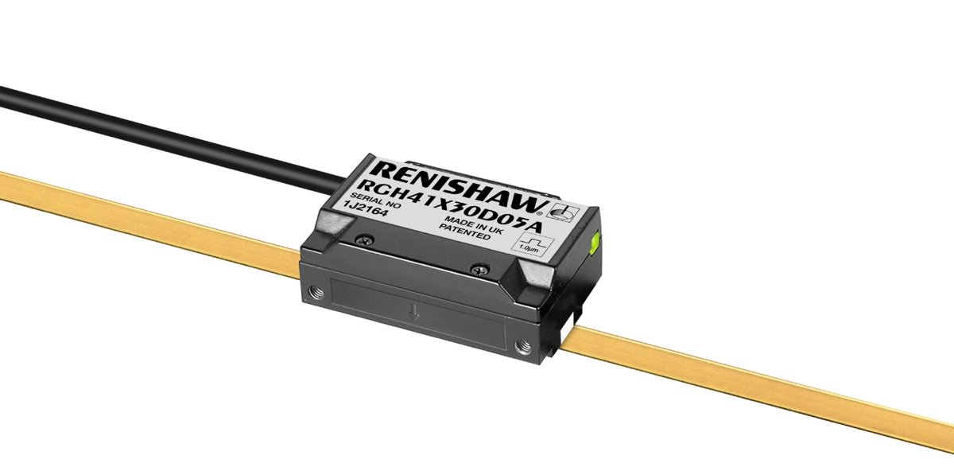
Figure 4
RGS’s key desirable customer trait is the fact it is gold. The outer gold layer adds an element of ‘gold standard’ to a piece of machinery. Due to the scale being fitted to the X, Y, Z axis of a machines moving area, it can be difficult to hide the scale on the machine surface, so the gold adds an opinion of ‘prettiness’ & ‘luxury’. RGS has survived the test of time and has been proven to work well making the almost ‘dinosaur’ like processes & machinery still very relevant to being maintained.

How do we make Rolled Gold Scale
Rolled Gold Scale (RGS) is a very long continuous strip of very thin steel bar with an outer coat of gold, approximately 10cm wide. RGS starts off as a blank with a smooth, unscratched surface.
This blank reel first runs through an embossing process to which the scale is squeezed between two pressing rollers. The hardened pressing rollers have been manufactured to a very high standard as the gold scale forms to their shape when being pressed due to RGS being much softer. RGS finishes embossing with thousands of notches 20 microns apart. If you were to analyse the formation microscopically you would see sharp peaks and troughs have been formed. The peaks & troughs are read as light & dark spots or 1’s & 0’s to a read-head encoder as it passes over the scale.
From embossing the scale gets transferred via a reel and placed onto the lacquer machine.
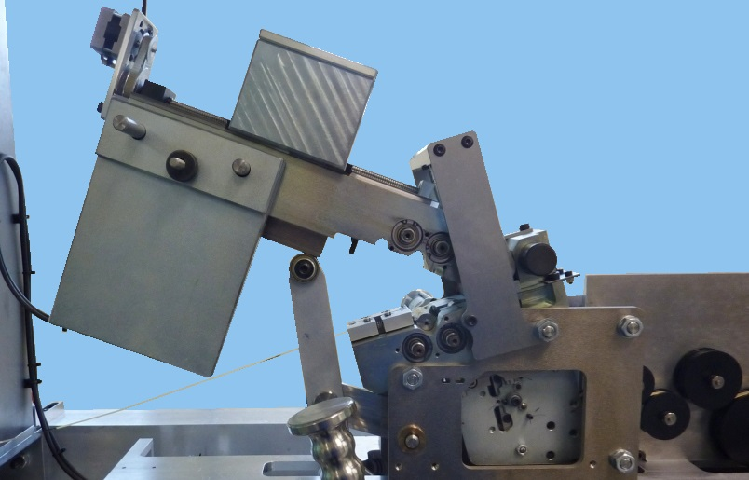
(WI-11111-19, 2024)
Figure 5 – shows a raised embossing head revealing the scale running through the centre of the rollers pictured.

Critical Review of Maintenance Practices

‘Critical review of current maintenance practices? Explain what the equipment does concisely and how it works. What is good about current maintenance practices and what is poor? Why has this approach been chosen in the past?’ - Appendix 1

Explain what the equipment does concisely and how it works.
The purpose of the lacquering machine is to apply a specific thickness of clear lacquer to the outside of functional Rolled Gold Scale (RGS) within cosmetic and functional standards.

Lacquer Machine
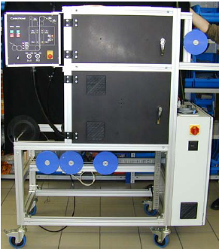
As explained the lacquer machine follows the previous embossing process. The purpose of the lacquering machine is to apply a specific thickness of clear lacquer to the outside of functional Rolled Gold Scale (RGS) within cosmetic and functional standards. The clear lacquer coat is applied to RGS to protect the scale and make more corrosion resistant. plastic A simple scratch or deformation will cause the scale to be non-functional as the light spots Vs dark spots signal strength will not be to standard.
Figure 6 – Lacquer Machine from Operating Manual

Figure 7 – WI11111 Reel Cleaning Horse
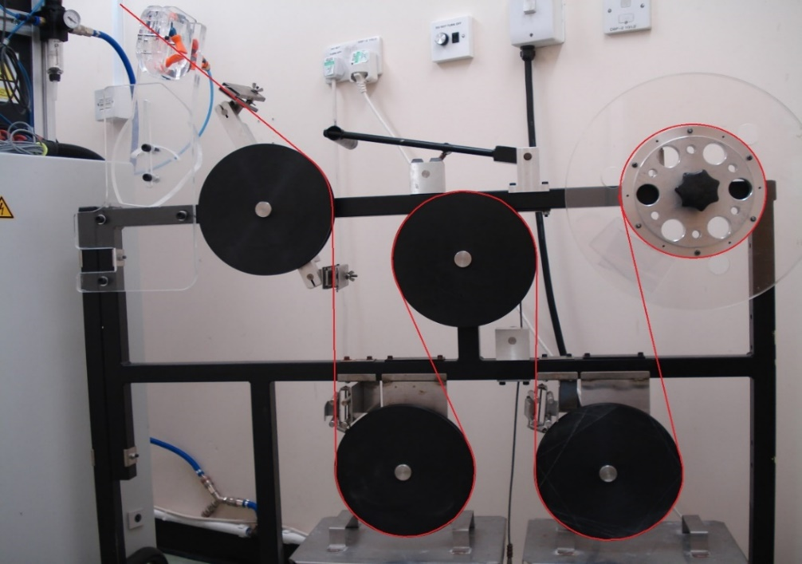
As with most machines in RGS, the reel of starting scale runs through a cleaning horse, as shown in Figure 5. This part of the machine is used to simple clean the surface of the scale before operation due to high sensitivity of damage with surface debris.
X

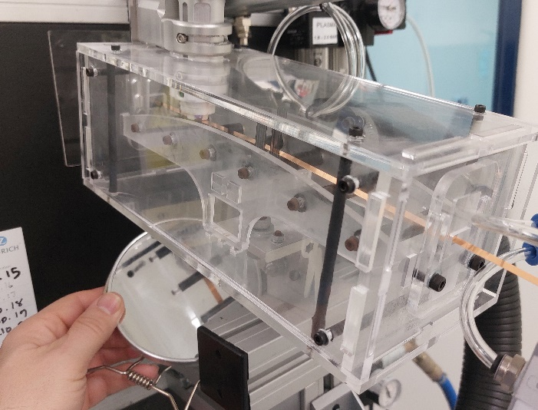
The scale passes through a plasma cleaning sub-process, as shown in Figure 5, which destroys any micro-debris left on the surface of the scale. As with painting, lacquering is all about the preparation because you want that lacquer to stick just write with no cosmetic flaws.
Figure 8 – WI11112 Plasma Cleaning Box

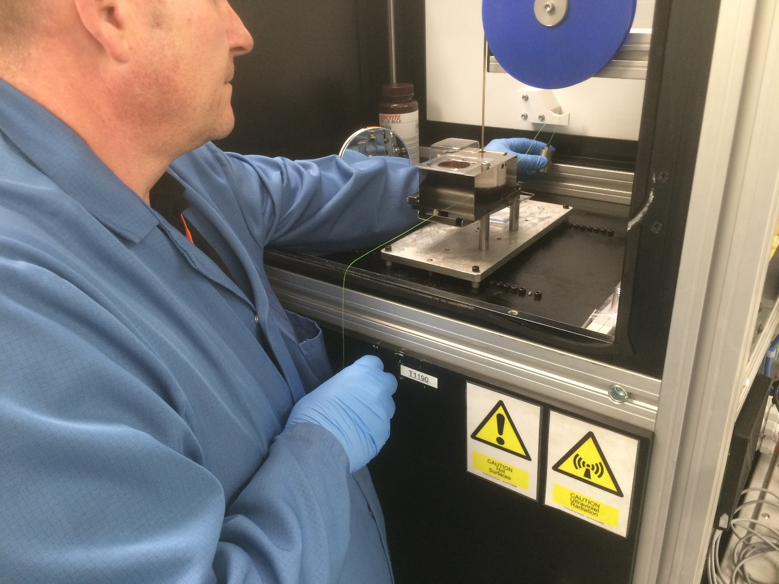
Next the scale runs into the top half of the chamber, around a tensioning wheel and into the pre-set lacquering block. The tension wheels are crucial because the scale is as thin as a ribbon so can sway easily. The lacquer block requires the most amount of training and experience on assembling correctly in a clean, functional matter. The lacquer blocks hold the lacquer in a reservoir which is linked to a fixed & moving jaw. The scale runs between these jaws and that is what plays the biggest outcome to GOOD scale.

Figure 9 – Lower Curing Chamber showing two UV lights from the Operating Manual.

Once Scale leaves the bottom of the lacquer block it enters the UV light curing chamber in the lower half. This UV light rapidly cures the lacquer 90% of the way before it leaves the machine and air cures on a reel.

Current Maintenance Practices
The machine is running most days due to production demands but to keep the quality of product consistent the machine undergoes regular maintenance activities.
As with every company, the number priority is Health & Safety. And all companies within the UK must comply and follow the Health and Safety at Work Act 1974.
The Health and Safety at Work etc Act 1974 is the primary piece of legislation covering occupational health and safety in Great Britain. It's sometimes referred to as HSWA, the HSW Act, the 1974 Act or HASAWA.
It sets out the general duties which:
- employers have towards employees and members of the public
- employees have to themselves and to each other
- certain self-employed have towards themselves and others (HSE About, 2024)
A company that does not follow this act is breaking the law, creating a dangerous work environment but also most likely reducing the lifespan of their machinery.
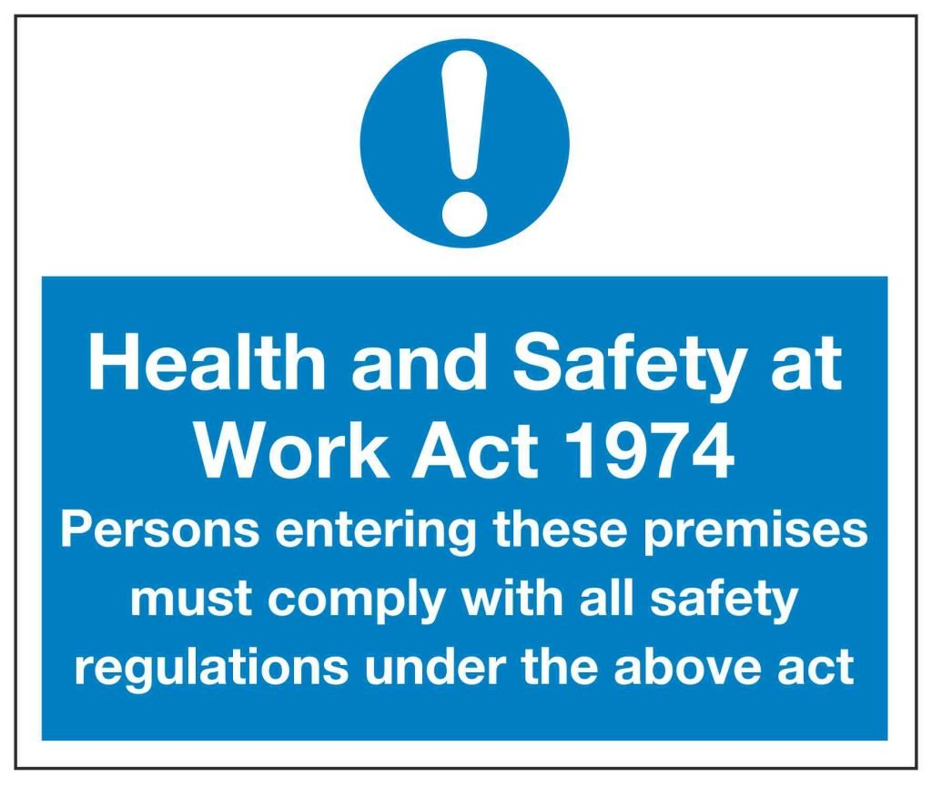
Figure 10 – HSE Sign

As the H&S Act 1974 states it is everyone’s responsibility to do some form of maintenance within the workplace. Albeit, simply cleaning the area as shown SOP1557-01 RGS Area Clean, or a more thorough quarterly clean like PMI00624 shown in APPENDIX 2. We all have a duty of care to the workplace.

Training
Renishaw provides a duty of care by giving the relevant personnel training for the required areas. Operators must be trained for use, just as Technicians must be trained for maintenance activities.
Work Instructions (WI), Standard Operating Procedures (SOP) must first be run through, followed and buddy checked before being signed off. Once sufficiently trained then the responsibility is on them to follow it.

Daily Checks
One method of maintenance practice is daily or operator checks. These checks are often simple, and fast checks that verify the running process is ok.
The cleaning of the UV curing bulbs and cleaning of the Lacquer block must be done daily.
An entry must be made in the lacquer monitoring sheet (AS712), shown below, to state that the UV chamber has been cleaned with methylated spirits with the date and signature (Figure 8). When this sheet is full, scan it and save into the ‘Sharepoint document Library’ on syteline QC gages for the lacquer machine.
Common data sheets like this provide quick an easy note from operator to engineering of what has gone on, along with production data.
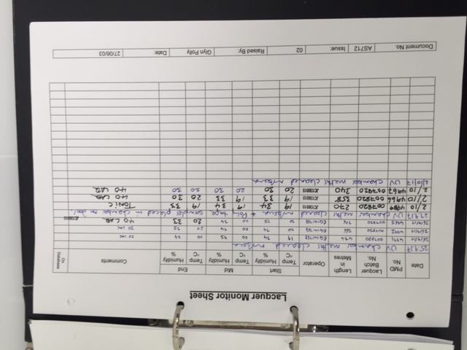

Figure 11 - AS712 Sheet WI11112 Lacquering

You could argue that process checks are all to do with quality of the part but they are actual micro maintaining the machine each time because if your data is consistently the same then not a lot has changed with the machine fortunately.

PMP Checklist
The PMP Excel checklist provides a step-by-step to do for each maintenance task.
The PMP checklist is a quick glance at maintenance actions. The checklist is linked to SOP’s which are engineering versions of WI’s but for maintenance activities.
Once this maintenance activity is complete it is then booked off via Syteline, a management tool, which then notifies prior to the next maintenance activity.

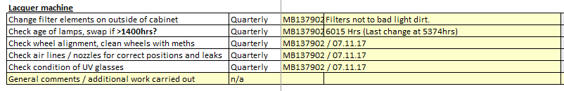
Figure 12

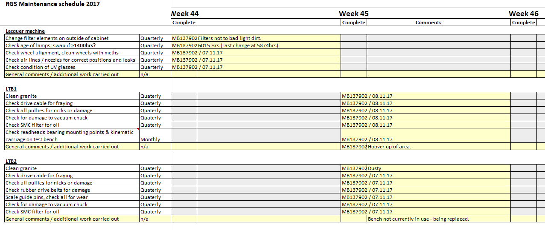
Figure 13

Reactive Maintenance
Things will always go wrong despite how much you reduce the risk; it will always be there. So sometimes the machine comes to a stop.
One common issue that can happen is jaw adjustment may wander out of position and cause a ripple effect or streak on the scale. This needs to be followed and fixed by engineering. The operator is trained to stop producing scale, and waste material. Pause the machine in standby, and phone for engineering whilst waiting next to the machine.
Reactive Maintenance is very much linked to engineering experience. The greater experience, the faster the fix. However, a simple fault-finding table like in Table1, fills in the gaps and verifies faults to an action for some maintenance staff.

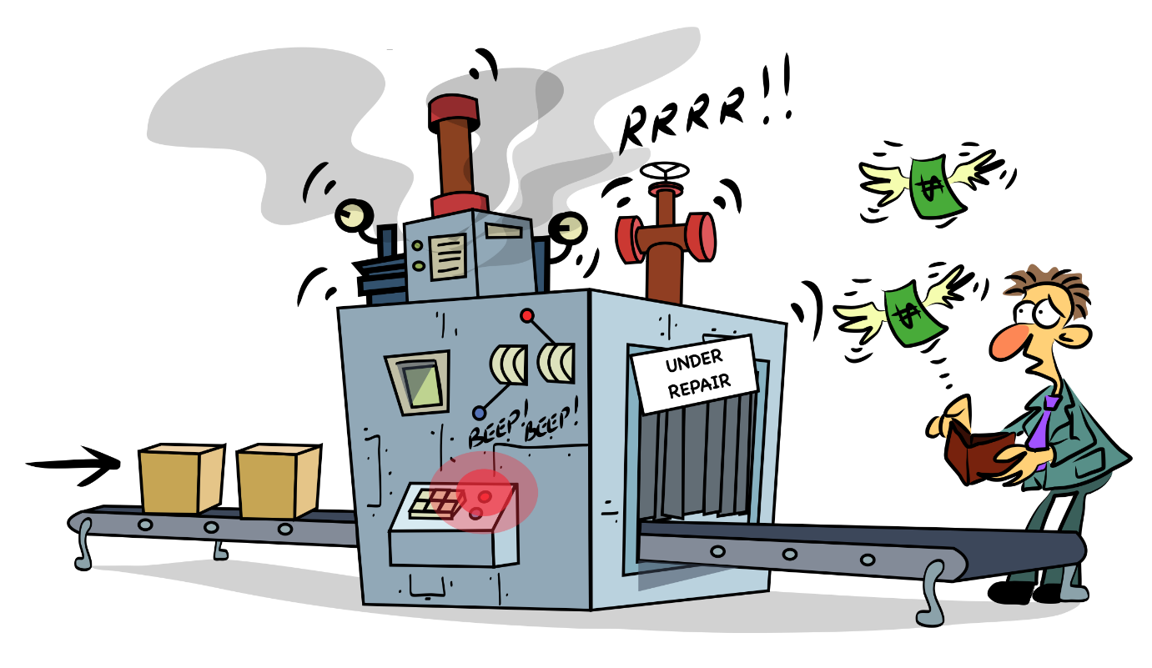
Figure 14 – Reactive Maintenance Image showing downtime and alarms mean MONEY

Table 1 - FAULT FINDING
Fault | Action
Machine will not start | Check wall isolator and control box is turned on. Check E-stop is not in.
Cannot access the lamp area of the machine | Turn the isolator switch on the control box to the off position.
Lamps won’t start | Check that the E-stop is not in.  Check the control panel to see if the Air, Fan, Tape and Door interlocks and in on and safe.
Feed Motor won’t start | Check that the lamps are ready.  Check that the tape light is active on the control panel.  Check that the speed is correctly set.
Lacquer too thin/thick – when measured to spec. | Stop machine and contact Production Engineering
Lacquer uneven across width | Stop machine and contact Production Engineering
Clear lumps in lacquer | Check for bubbles in lacquer pot. Lacquer gone past use by date. Inform engineering.
Lacquer viscosity – high. | Do not use. Inform Engineering.
Plasma pen alarm sounds. | Check for correct air pressure to pen.
Plasma pen alarm sounds. | Check for presence of substrate/scale under pen tip.
No plasma glow – purple – at pen tip. | Adjust position above substrate/scale. Stop machine and contact Production Engineering.
No plasma glow – purple – at pen tip. | Check for fault message on pen. Stop machine and contact Production Engineering

Evaluation of how the current approaches to Maintenance could be Improved

‘A full evaluation of how the current approaches to maintenance could be improved. How the current maintenance strategy can be improved? What alternative approaches could be adopted, and they could be implemented in future maintenance strategy.’ – Appendix 1

Positives of maintenance approach
The current maintenance strategy is a long lasting and accepted strategy but there would be a problem if there were no room for improvement. The maintenance plan used covers the aspects of machine maintenance needed from proactive to reactive.
Setting planned preventative maintenance which is carried before due dates is a very good way of keeping on top of machine issues before they occur. If the planned maintenance is carried to a high enough standard, then the reactive risk becomes severely lower.
The maintenance schedule is carried out by the engineering team, so the expertise is trusted and consistent.

Negatives of the current approach
The current maintenance schedule of preventative maintenance may mean that parts are being changed well before their actual life date. For instance, the UV lamps are changed every 1400hrs but perhaps a better way would be to measure the LUX level droppage of each lamp.
Another negative of the current approach is the fact it is down to a controlled engineering team because if the small team are currently busy with other or overshot maintenance activities then production can pressure mistakes to happen.
Biggest issue I personally see is operator discipline to come tell the engineering team that there is an issue. Sometimes, handwritten notes can be added to WI’s and not noticed by engineering until they take control of the machine. These notes should be verified and formally updated into the WI as soon as possible. That’s the same for SOP’s. As newly printed versions may be missing handwritten information on the used documents.

A consideration to costs and resources required to implement proposed changes

‘A consideration of costs and resources required to implement proposed changes based on issues identified in 5 and 6. Better answers will discuss change management implications.’ – Appendix 1

The costs required to make these improvements are minimal. It is more a discipline procedure that needs to take place but due to the team being a trusted old team, a lot of operators/technicians wouldn’t consult the documentation until need be.
I think a good resource would be employing younger or more ‘up to date’ team members within this product due to the nature of the ‘old I know it all’. Or maybe even setting a new training course to train the old heads up with modern documentation.

Conclusion/Recommendation

‘Conclusions/Recommendations. Conclusions based on the findings of your report and what recommendations you would make to improve the situation going forward. Consider short, medium, long recommendations.’ – Appendix 1

In conclusion, there are many maintenance steps in place to ensure a quality, well running, efficient machine is in place.
The Preventative Maintenance Plan data has moved from an easily adjustable excel folder to a more secure online management system, Syteline. Relevant training is required to be signed off.
The maintenance is carried out well within the area but cross overs are a risk due to a small engineering team. Good forward planning is needed.

Bibliography

AboutRenishaw, 2024. AboutRenishawPage. [Online]
Available at: https://www.renishaw.com/en/About-renishaw--6432
[Accessed 01 04 2024].
HSE About, 2024. HSE. [Online]
Available at: https://www.hse.gov.uk/legislation/hswa.htm
[Accessed 01 04 2024].
HSE sign, 2024. HSE Sign. [Online]
Available at: https://www.bing.com/images/search?view=detailV2&ccid=9j3ahYbi&id=CA293974B9FC8135126A191736F009E8318DB074&thid=OIP.9j3ahYbiHC3zzTSJzvZoCAHaHa&mediaurl=https%3a%2f%2flindensigns.org%2fwp-content%2fuploads%2fHealth-and-Safety-at-Work-Act-1974-Persons-enter
[Accessed 01 04 2024].
Renishaw Logo, 2024. Renishaw Logo. [Online]
Available at: https://www.cmmproducts.com/wp-content/uploads/2020/11/1280px-Renishaw_logo.svg_-1200x281.png
[Accessed 01 04 2024].
RGS Encoder Pic, 2024. RGS20 Scale. [Online]
Available at: https://www.renishaw.com/resourcecentre/download?data=10517&lang=gen&userLanguage=en
[Accessed 01 04 2024].
UWTSDlogo, 2024. UWTSDlogo. [Online]
Available at: https://i1.wp.com/theoneplanetlife.com/wp-content/uploads/2019/06/UWTSD-logo.jpg
[Accessed 01 04 2024].
WI-11111-19, R. E., 2024. Embossing RGS, Miskin: WI-11111-19 RGS Scale Embossing.

Appendices

APPENDIX 1 - Assignment Brief Information

Student name: |  | Student ID number:
Programme: | BEng Manufacturing Systems Engineering & BEng Mechanical and Manufacturing Engineering, BEng Advanced Manufacturing Operations and BSc Engineering Management
Module: | Plant and Asset Engineering
Module code: | ACMA 6007 | Contribution to Overall Module Assessment (%): | 50%
Lecturer: | Andrew Thorn | Internal Verifier: | Kelvin Lake
Assignment Title: | Evaluating the Effectiveness of Chosen Maintenance Strategies for Dedicated Equipment | Word count (or equivalent): | 2000 words
Submission deadline: | 08/04/2024 | Return date of provisional marks & written feedback: | 13/05/2024
Submission method: | All written assessments, where practical and possible, must be submitted via Turnitin unless otherwise instructed by the Lecturer. (Please DO NOT put this assessment specification into Turnitin or it will match many similarities with other students’ submissions.)  Alternative submission method (if applicable):  Late submission of the assessment will result in a late penalty mark. Penalties for late submission: Up to one week late, maximum mark of 40%. Over one week late, 0%. Only the Extenuating Circumstances Panel may approve a change to submission dates.
Academic honesty / referencing: | Academic honesty is required. In the main body of your submission you must give credit to authors on whose research and ideas your work is based. Append to your submission a reference list that indicates the books, articles, etc. that you have used, cited or quoted in order to complete this assessment.

Module Learning Outcomes
(from module syllabus)
Upon the successful completion of this module, the student should be able to:

- Evaluate the energy efficiency of equipment and processes; make informed decisions on how energy consumption can be reduced and understand the importance of asset management.
- Interpret and evaluate equipment maintenance requirements from an engineering and process perspective, in order to ensure it operates efficiently and reduces waste in processes.

TASK DESCRIPTION

You are required to select a single piece of equipment that is used in the production or an assembly process and evaluate the following: -

- A brief background to the business and what the chosen equipment does in the company.
- A critical review of how the equipment is currently maintained or not and why the current approach to maintenance has been chosen.
- A full evaluation of what could be done to improve the current approaches to maintenance and how this could be implemented in future maintenance planning and maintenance strategy development.
- A consideration of costs and resources required to implement the proposed improvements..
- Conclusions/recommendations

Word Limit: 2,000

GUIDANCE FOR Students IN THE COMPLETION OF TASKS

(Lecturer – please insert guidance for students here. Please link the task to the five common assessment criteria overleaf)

Your report should be laid out as follows and should be well referenced using the Harvard referencing system.

- Title page
- Contents Page
- List of illustrations/Tables
- Introduction: - what the assignment is about
- Critical review of current maintenance practices? Explain what the equipment does concisely and how it works. What is good about current maintenance practices and what is poor? Why has this approach been chosen in the past?
- A full evaluation of how the current approaches to maintenance could be improved. How the current maintenance strategy can be improved? What alternative approaches could be adopted, and they could be implemented in future maintenance strategy
- A consideration of costs and resources required to implement proposed changes based on issues identified in 5 and 6. Better answers will discuss change management implications.
- Conclusions/Recommendations. Conclusions based on the findings of your report and what recommendations you would make to improve the situation going forward. Consider short, medium, long recommendations.
Referencing. A good range of material from published papers, journal articles, online sources. Do not forget company resources.

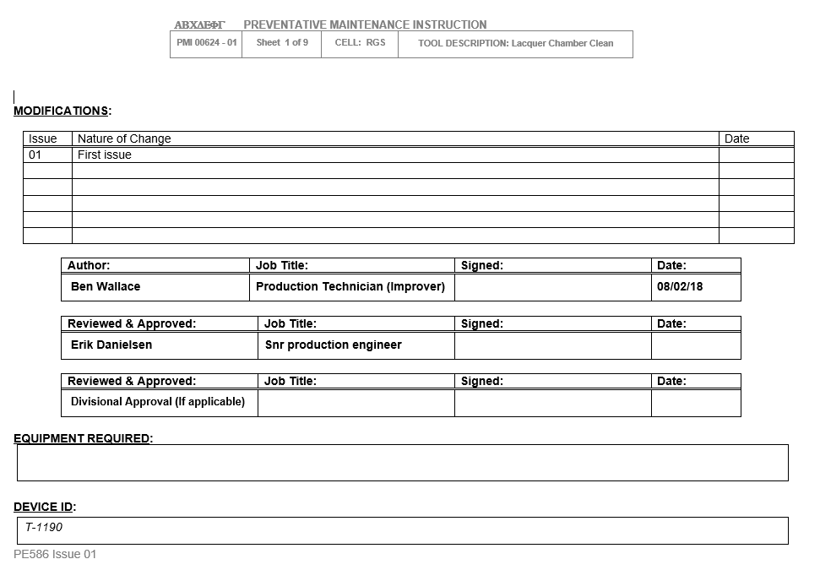
APPENDIX 2 – PMI 00624-01 RGS Lacquer Chamber Clean
Figure 15
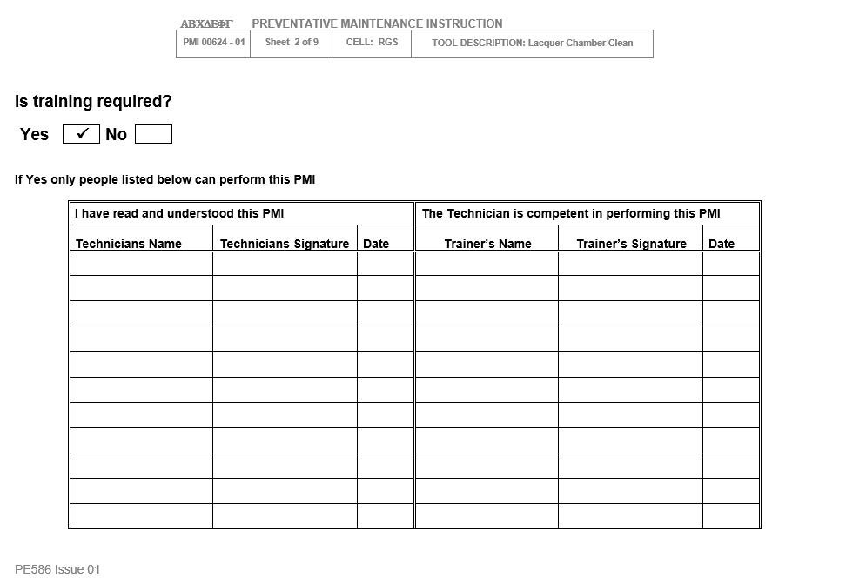
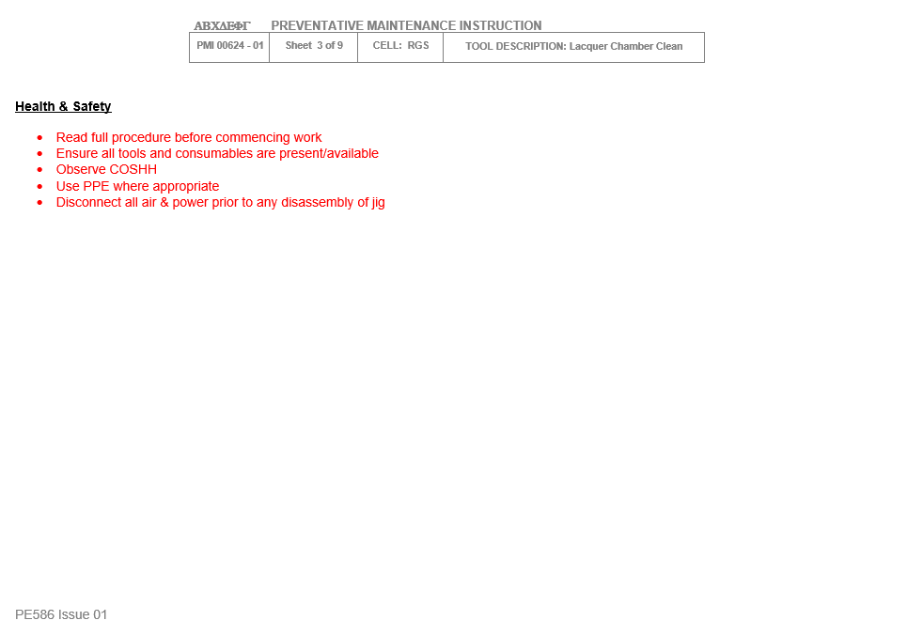

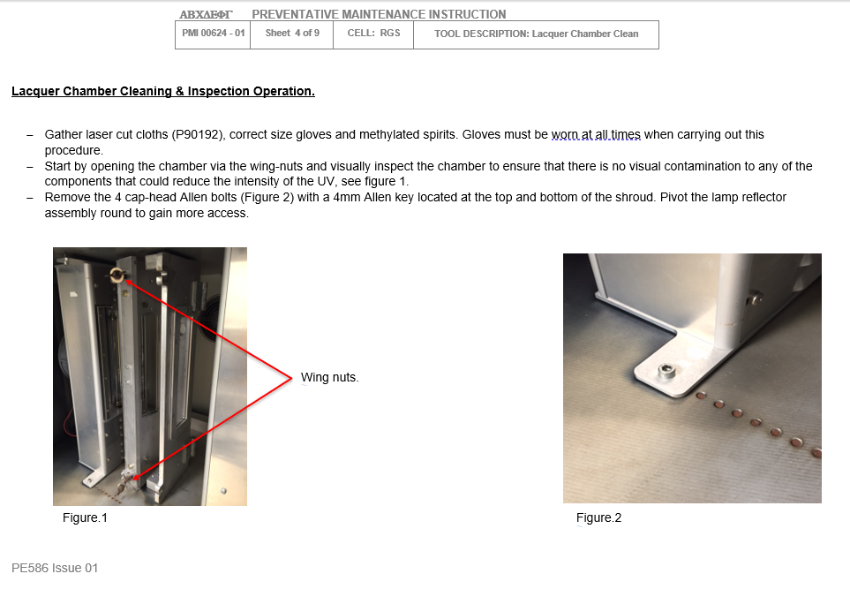

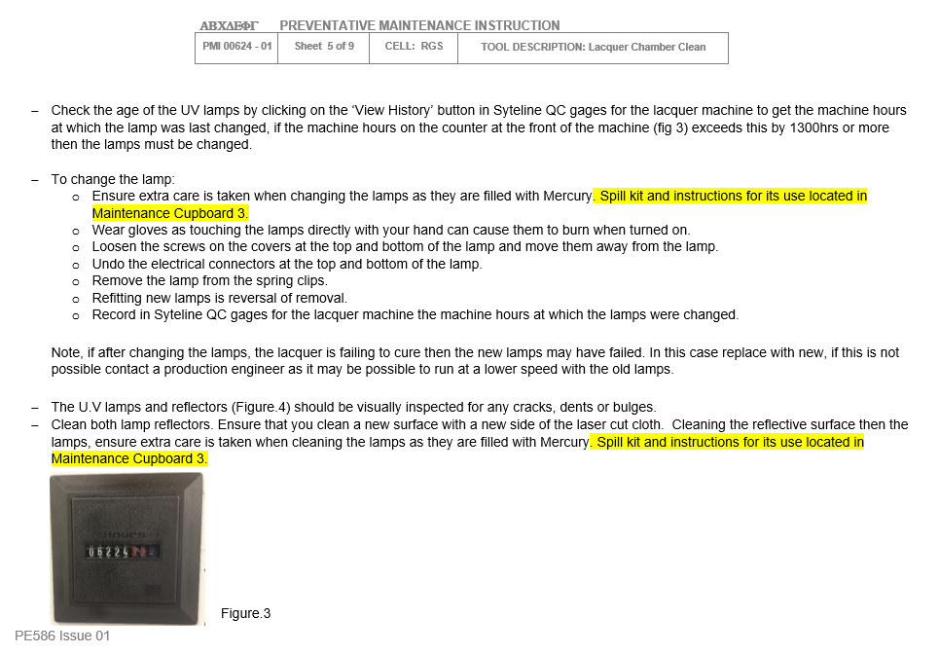

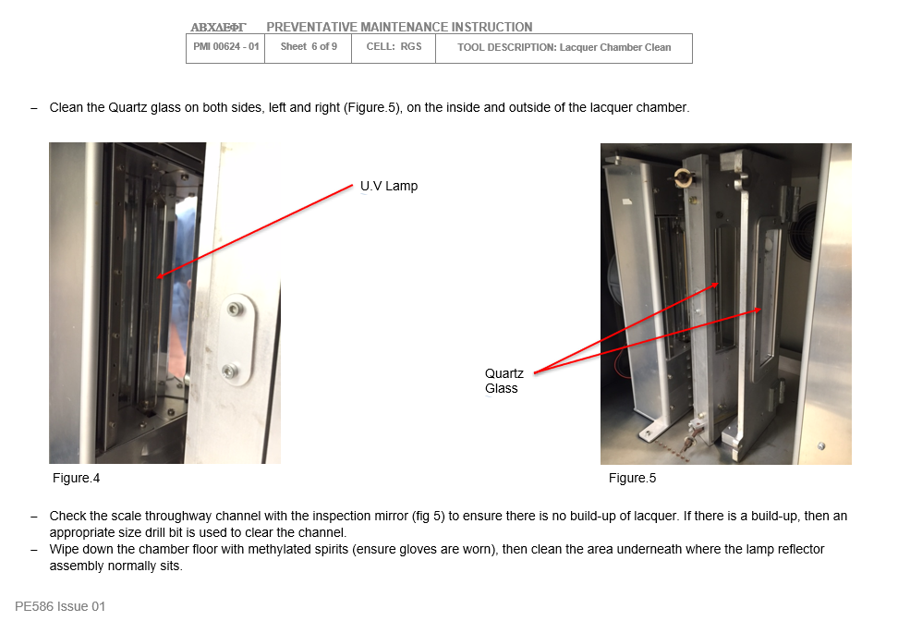

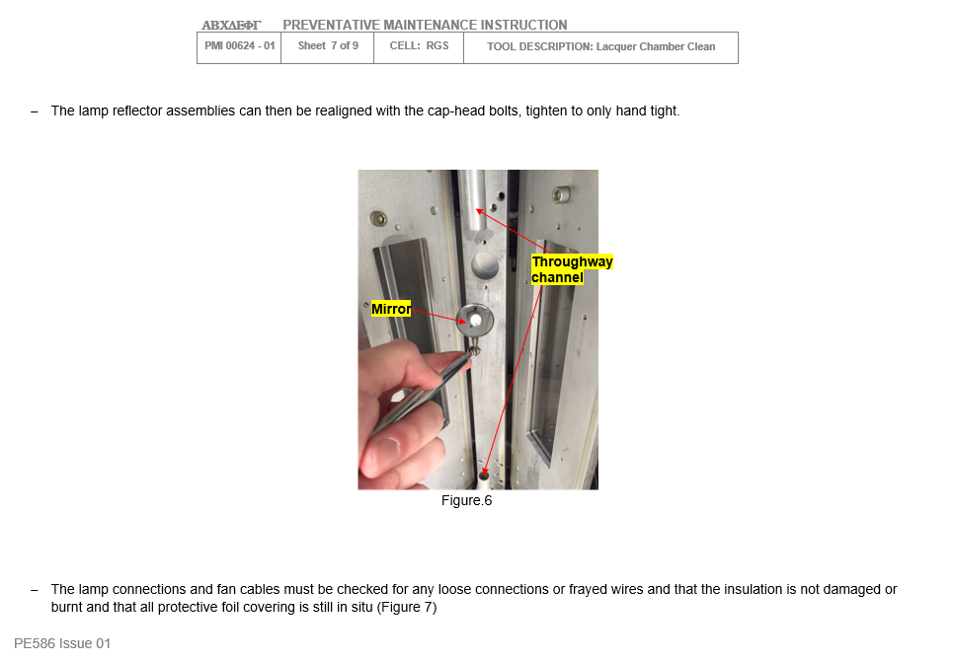

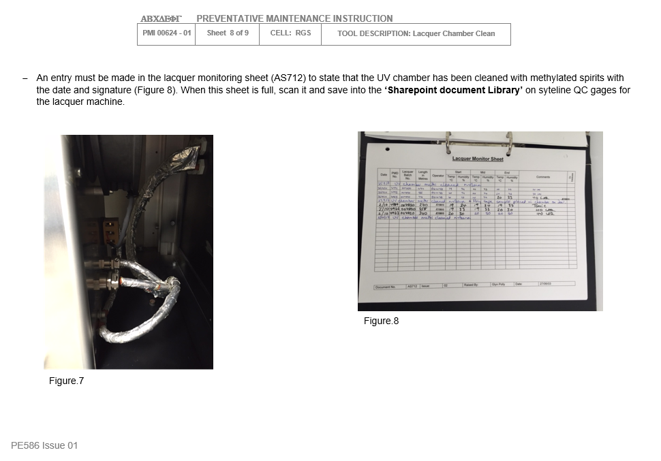

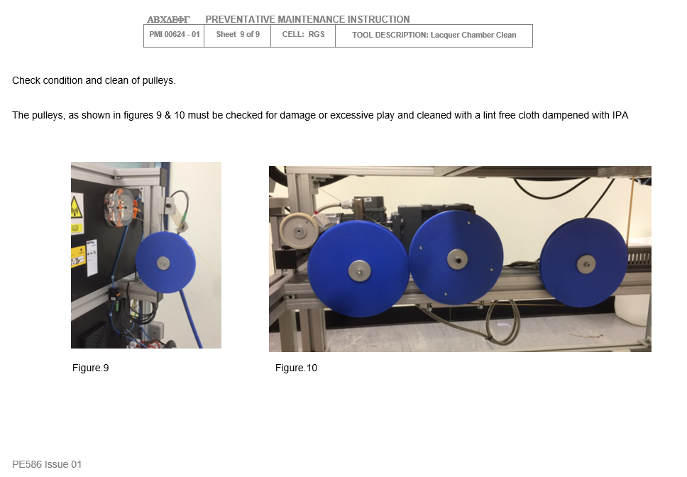

APPENDIX 3 – Maintenance Checklist 2017

APPENDIX 4 – SDP1260-03 Lacquer Block Setup
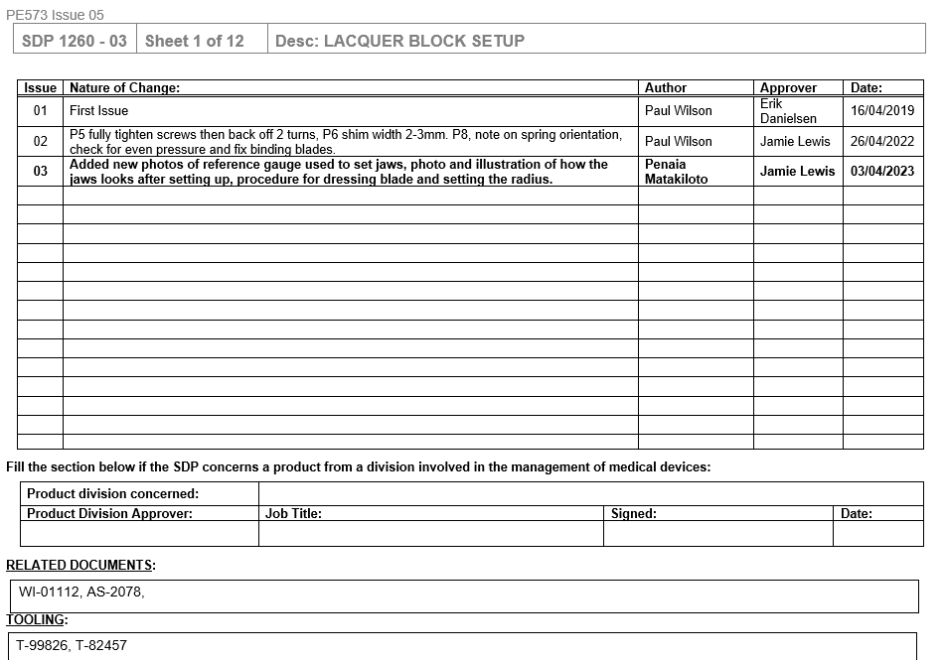
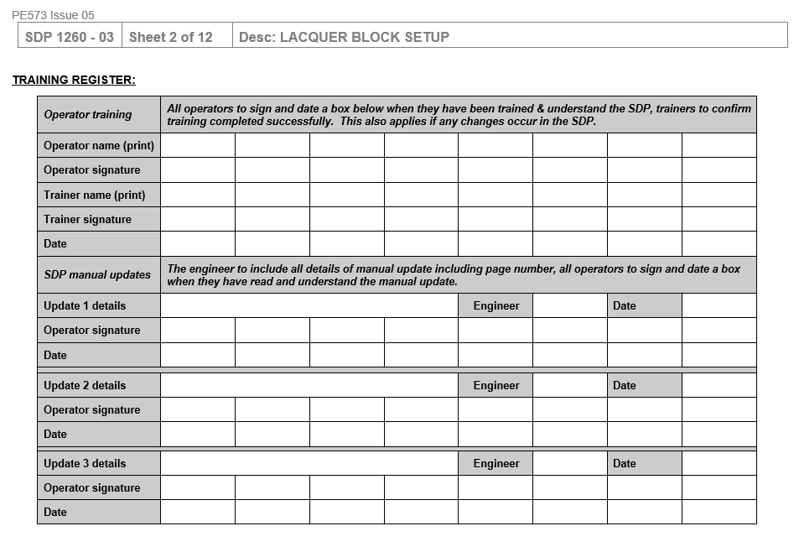

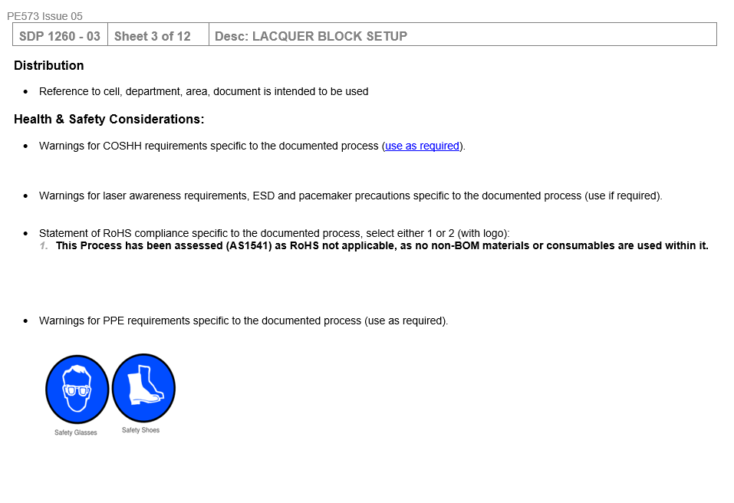

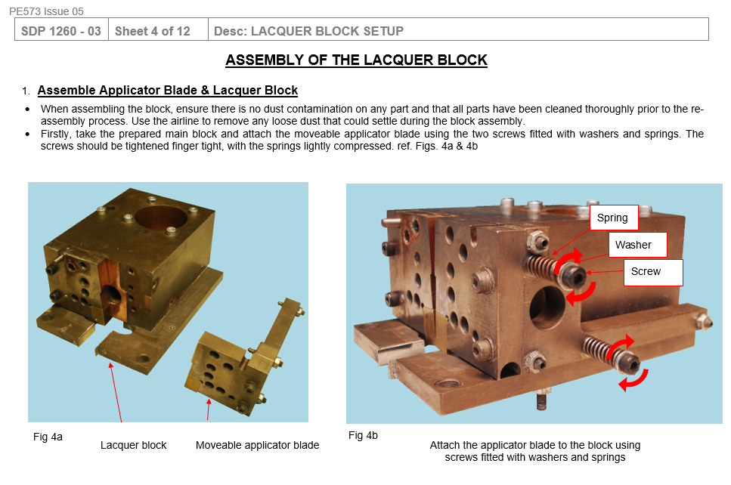

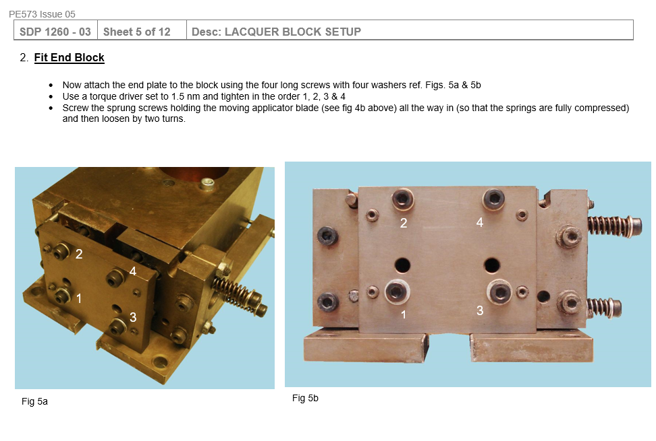

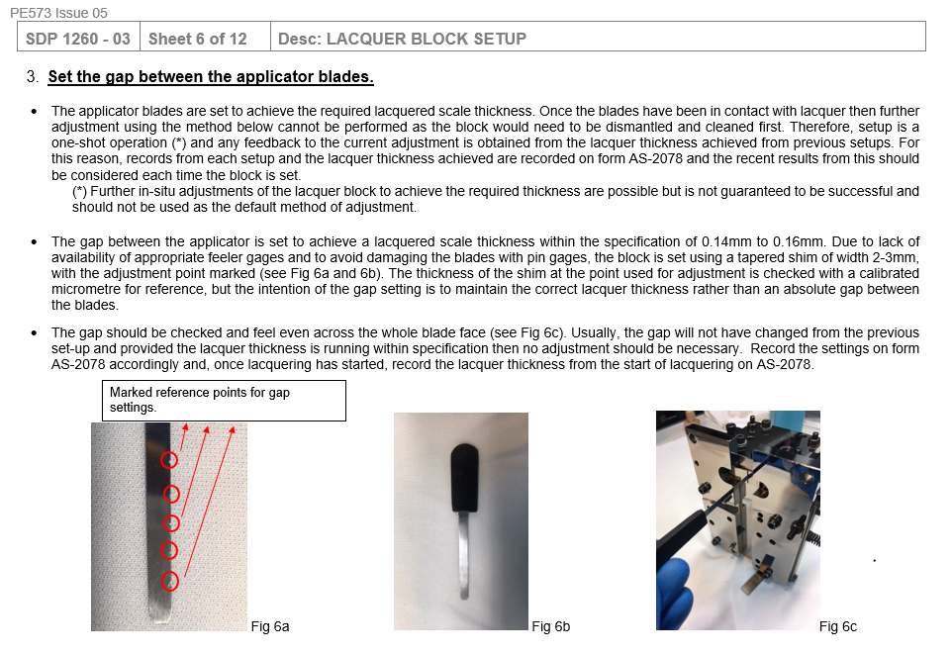

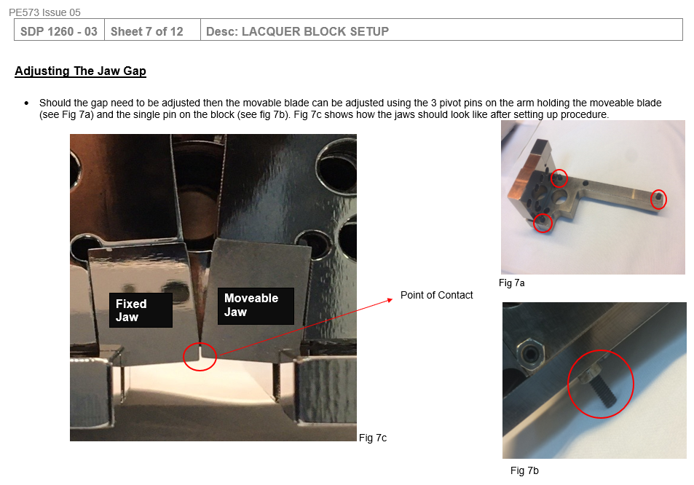

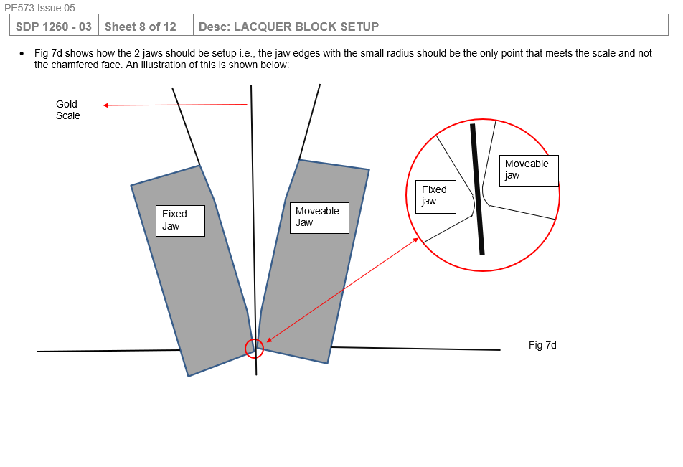

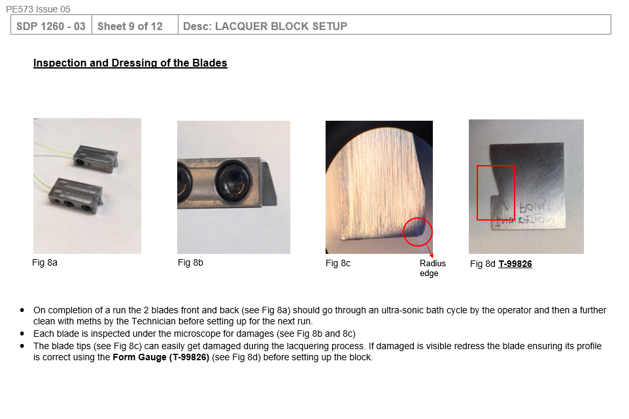

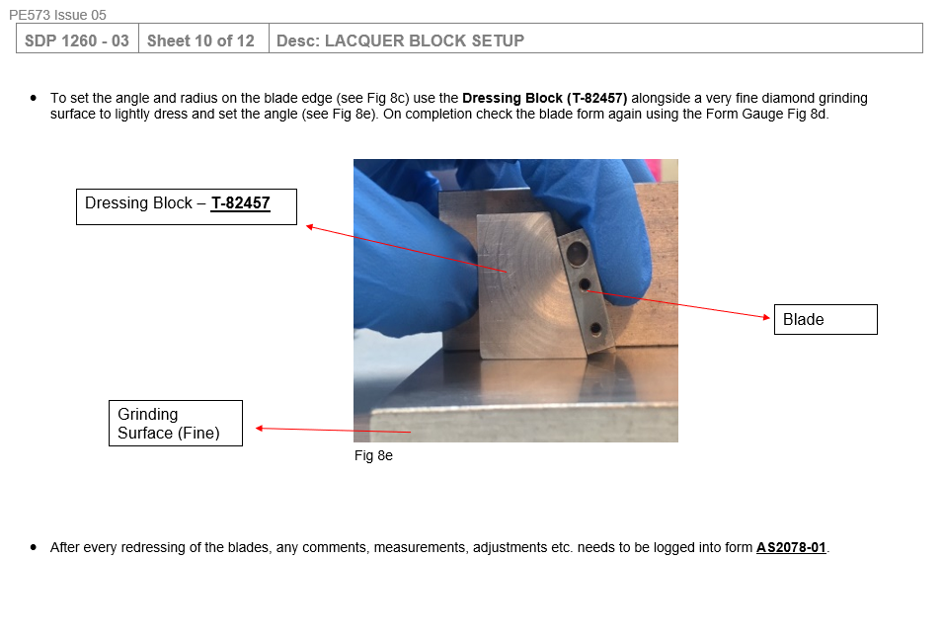

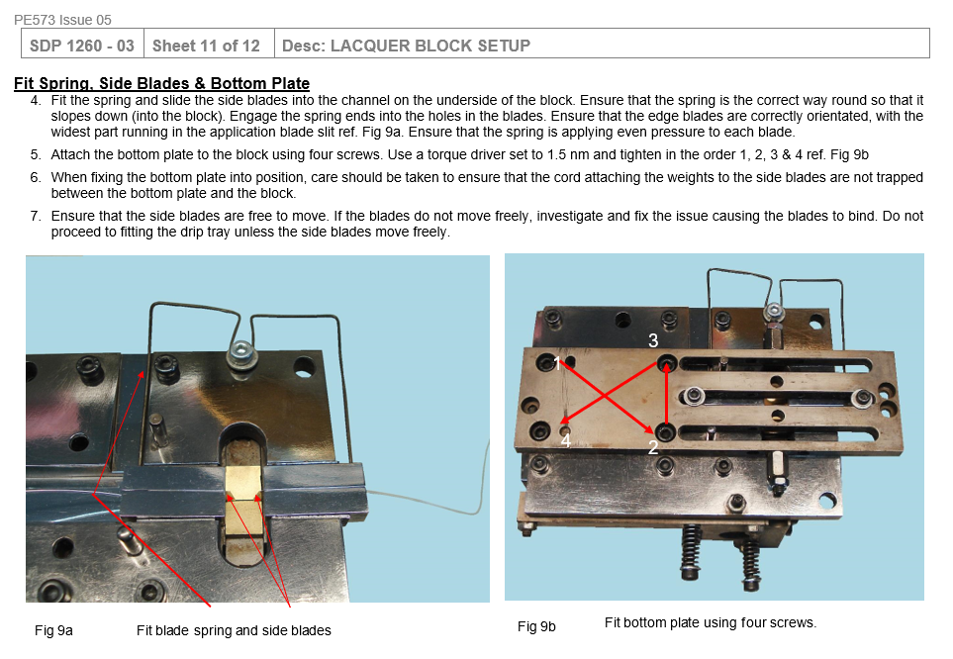

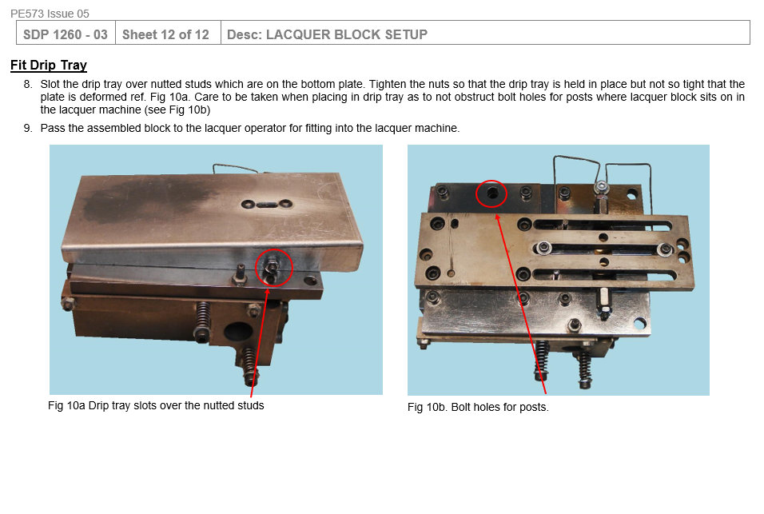

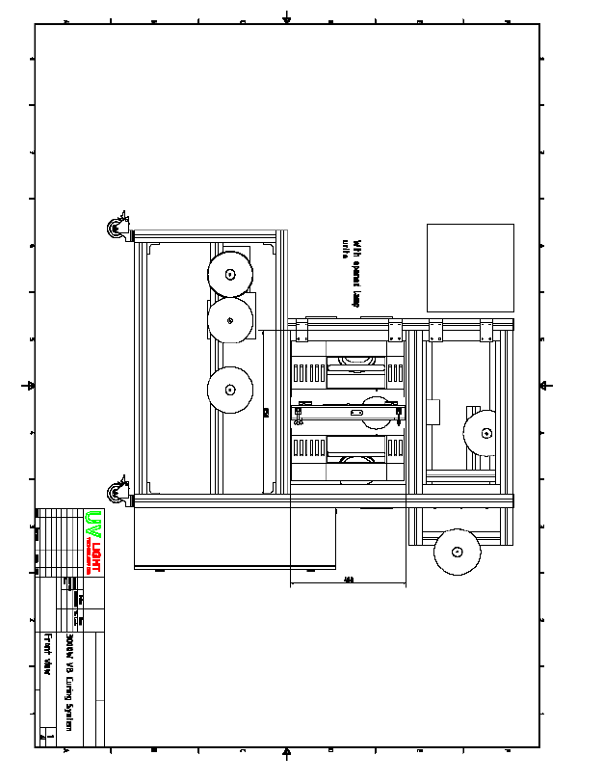
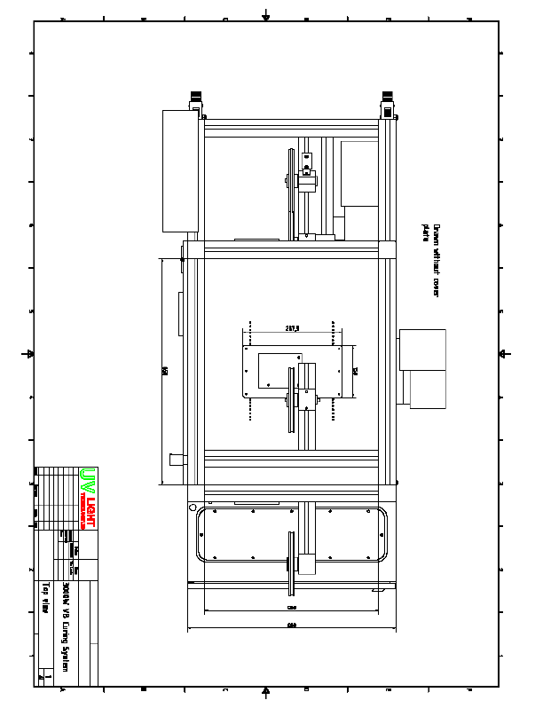

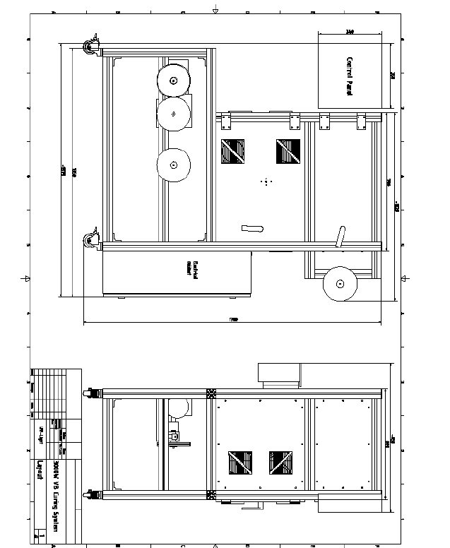

APPENDIX 6 – UV Light Bulb Replacement
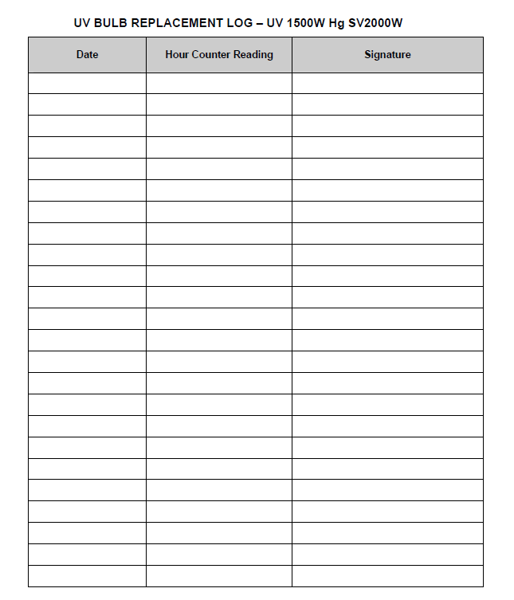

APPENDIX 7 – Spare Parts List

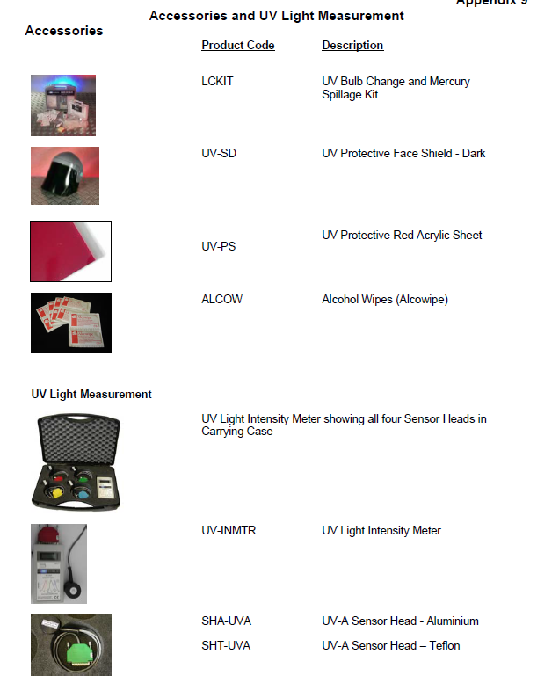

APPENDIX 7 – Certificate of Conformity

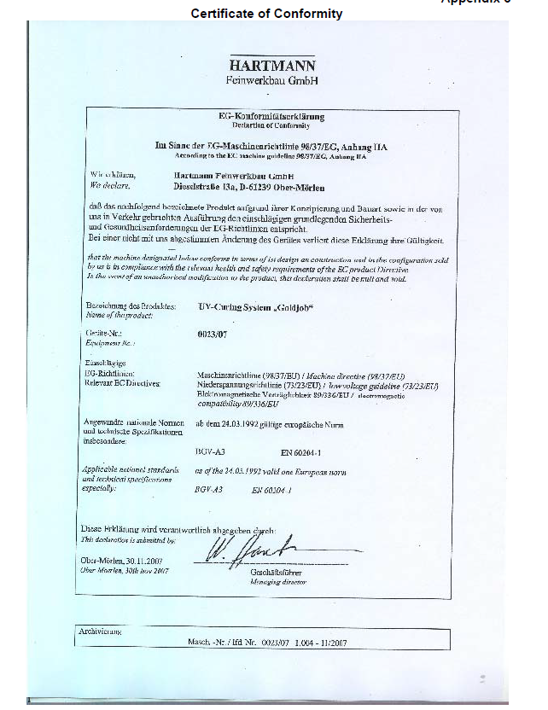

APPENDIX 8 – Logic Diagram

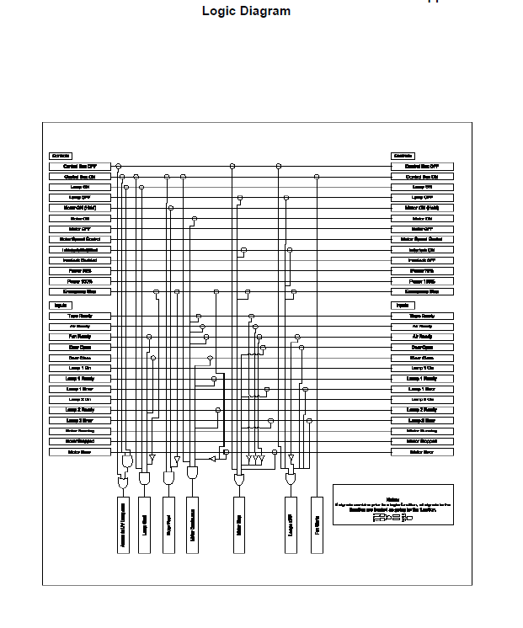

APPENDIX 9 – Basic Electrical Cabinet Layout



