An introduction to critical thinking

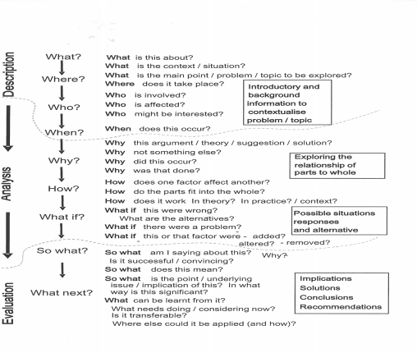

Taking a critical approach
The two texts below reflect different views on the topic of climate change. Read them both and then study the extract from an essay that mentions the two sources. Answer the questions that follow.
Text a
CLIMATE CHANGE
Most scientists now agree that global temperatures have risen over the last century, and that this trend is reflected in such phenomena as the melting of sea ice and the retreat of glaciers. There is also a consensus that over the period the level of carbon dioxide (CO2) in the earth’s atmosphere has also risen, mainly as a result of burning fossil fuels such as coal and oil. The common view is that the first change is the result of the second; in other words a warmer climate has been caused by the CO2, which has the effect of causing the warmth from the sun’s rays to be trapped inside the atmosphere; the so-called ‘greenhouse effect’. If these theories are accepted it can be expected that temperatures will continue to increase in future as carbon dioxide levels rise, and since this will have harmful effects on agriculture and other human activities, efforts should be made to reduce the burning of fossil fuels. (Lombardo, 2009)
Text b
The conventional view that global warming is caused by a rise in carbon dioxide levels has been criticised on a number of grounds. Some critics claim that the recent period of warming is part of a natural cycle of temperature fluctuations which have been recorded over the past few thousand years. They point out that Europe experienced a warm period about 800 years ago which was unrelated to CO2 levels. Other critics doubt the reliability of the basic temperature data and maintain that the apparent rise in temperatures is caused by the growth of cities, regarded as ‘heat islands’. In addition some claim that the warming is caused by a reduction in cloud cover, allowing more sunlight to reach the earth’s surface. This effect, they believe, is the result of solar activity or sunspots, which are known to fluctuate on an 11-year cycle. As a result of these doubts, sceptics argue that there is no need to attempt to reduce the industrial activity that causes carbon dioxide to be produced.
(Wong, 2007)

- The extract below summarises ideas from both Lombardo and Wong. Find two examples of a summary in the extract and match them with the original text from (a) or (b).

Summary | original
Example: . . . the significant rise in the earth’s temperature over the past century is the product of increased levels of atmospheric CO2 caused by greater use of fossil fuels | There is also a consensus that over the period the level of carbon dioxide (CO2)in the earth’s atmosphere has also risen, mainly as a result of burning fossil fuels such as coal and oil.

HOW STRONG IS THE EVIDENCE FOR GLOBAL WARMING?
Lombardo (2009) puts forward the view that the significant rise in the earth’s temperature over the past century is the product of increased levels of atmospheric CO2 caused by greater use of fossil fuels. He maintains that this position is now generally agreed, and that steps should be taken to reduce future warming by restricting the output of greenhouse gases such as carbon dioxide. However, Wong (2007) presents a range of counter-arguments. She mentions evidence of historical climate change which cannot have been caused by rising levels of CO2, and also discusses the difficulty of obtaining reliable data on temperature changes, as well as other claims that solar activity may affect the amount of cloud cover and hence temperature levels. Such uncertainty, she considers, may raise doubts about the value of cutting CO2 production. Additionally, In addition…… Another perspective is presented by Lahav (2010) who believes that money invested in studying climate change might be better spent on social endeavours to help the developing world.
- Which verbs are used to introduce the summaries? ___________________________________________________________

- Which word marks the point where the writer switches from summarising Lombardo to Wong? ___________________________________________________________

- What other words or phrases could be used at this point? ___________________________________________________________

Combining three sources
Read the third text on climate change below, and then complete the paragraph from the essay above titled: ‘How strong is the evidence for global warming?’ by summarising Lahav’s comments.
Debate on the issues around climate change have intensified recently, since while most scientists agree that global temperatures are rising as a result of ever-higher levels of carbon dioxide in the earth’s atmosphere, a minority continue to argue that the rise is insignificant, short term or unrelated to CO2 levels. The controversy clearly has important political and economic consequences, since international agreement is needed to control the output of greenhouse gases. Climate sceptics insist that computer models are unable to handle the complexity of the world’s weather systems, and so should not be used as a basis for making major decisions. Their view is that because the science of global warming is uncertain, the money that would be spent, for example, on building wind farms could be better spent on improving health and education in the developing world. (Lahav, 2010)

Adapted from: Stephen Bailey (2011) Academic Writing, A handbook for international students. Third edition. Routledge

