SBUS6104
Jade Farley
conTEMPORARY THEMES IN E-BUSINESS
Management of Contemporary e-Business Systems
The use of e-Business Systems as a tool for Gaining Competitive Advantage for Tesco

Executive Summary
This report outlines the importance of effective use of e-business models for businesses who are looking to remain competitive in the modern environment. It can be reasonably argued that Tesco are the strongest business in terms of their use of e-business models, when compared against their competitors in the grocery retail industry. One of the key reasons for this is Tesco’s use of their Clubcard. This e-business model allows them to adapt to changing consumer demands quickly, which is vital in the industry within which they operate. Tesco’s greatest e-business challenges within the industry are Amazon and trust from consumers. If Tesco can effectively utilise the e-business opportunities in front of them, then they will be able to fend off the current challenge that Amazon poses.
Moving forward, the following recommendations have been made for Tesco:
- Tesco should look to secure public trust in their e-business models, by emphasising security.
- Tesco should introduce shoppable video ahead of their competitors to bring new ways of shopping to their customers and increase consumer engagement.
- Tesco should continue to offer various benefits to Clubcard users as this e-business model provides vital consumer information. This information should further be used to ensure the business adapts quickly to changes in consumer demand to ensure consumer needs are met.
- Tesco should promote awareness of their Pay+ App and reintroduce rewards for using as awareness of the application is low.
- Tesco should continue to use e-business systems, such as CRM and ERP, to simplify their processes and increase efficiency.

Table of Contents
Executive Summary 1
1.0 Introduction 3
1.1 E-Business Systems 3
1.2 Overview of Tesco 3
2.0 Main Findings 4
2.1 Tesco Business Model 4
2.2 Contemporary Issues in E-Business 5
2.2 Emerging E-Business System Opportunities and Challenges for the Grocery Retail Sector 6
2.2.1 Industry Opportunities 6
2.2.2 Industry Challenges 7
2.3 Evaluation of Existing and Emerging E-Business Model Opportunities and Challenges for Tesco. 8
2.3.1 E-Business Model Opportunities for Tesco 8
2.3.2 E-Business Model Challenges for Tesco 10
3.0 Recommendations 10
4.0 Conclusion 11
References 12

1.0 Introduction

1.1 E-Business Systems
It is being increasingly recognised that, “If organisations want to stay competitive, they need to understand the importance of E-business to successful strategy execution’’ (Thompson, et al., 2010). E-business has received a great amount of attention in the modern environment as information technologies have developed (Shim, et al., 2002). Organisations today are frequently utilising the integration of internet technology within their redesign processes to help them gain competitive advantage (Phan, 2003). Evident success in this integration, has led to imitation from other players in the industry and from here growth in the integration of e-business in strategy execution has stemmed (Amit & Zott, 2001). It is thought that the most successful business models are those that are able to effectively integrate internet technology into all aspects of their value chain (Chesbrough, 2007).
The many categories of e-business include; Business to Business (B2B), Business to Consumer (B2C), Consumer to Business (C2B), Consumer to Consumer (C2C), People to People (P2P), Government to Citizen (G2C), Citizen to Government (C2G), Exchange to Exchange (E2E) and Intra-business (Organization Unit to Organization Unit) (Nemat, 2011). E-business transactions are performed electronically following three principle categories, which are; Electronic markets – Buying and selling goods and services, Inter-organisational systems – facilitating inter/intra-organisation flow of goods, services, communication, information and collaboration and Customer service – offering service to customers along with help, tracking orders and handling complaints (Phan, 2003).

1.2 Overview of Tesco
Tesco PLC are a British multinational grocery and general merchandise retailer. Holding 27.4% of the market share (Statista, 2019), Tesco are the UK’s largest retailer and third largest worldwide. Tesco hold the greatest dominance of online grocery retailer market share with a market share of 39% (Statista , 2016). Tesco operate in 13 Countries worldwide and are the only British grocery retailer to operate outside of the UK (TescoPoly, 2019). In 2014, Dave Lewis was appointed as Tesco’s new CEO, at a time where Tesco had reported its worst performance in 20 years due to an accounting scandal. Dave Lewis announced the ‘Tesco Turnaround Plan’ which commenced in 2016 and was set out to revive the business over a 4-year period (Armstrong, 2019). The turnaround was based on a whole new business strategy, to bring back customers’ trust in the Tesco brand. Now in the final year of the ‘turnaround, Tesco are performing stronger than ever before with forecasted continuous growth for the future. In the rapidly changing environment of the modern grocery retail industry, have Tesco successfully implemented E-business systems/models? And if so, is it this integration which is responsible for them regaining competitive advantage in leading the industry?

2.0 Main Findings

2.1 Tesco Business Model
A company’s business model sets out a business plan which identifies the products/services, target market and the anticipated expenses along with the value proposition to identify the business’s profitability and act as a basis for decision making (Magretta, 2002).
Figure 1.0 – Tesco’s Business Model
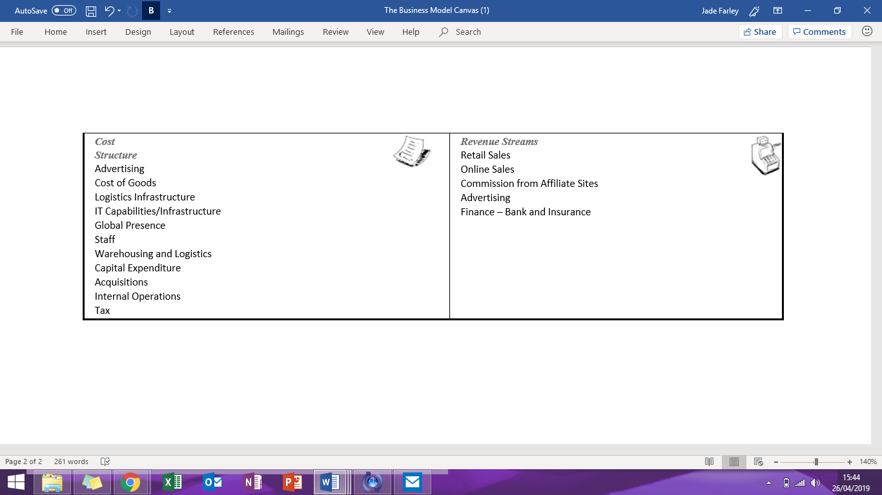
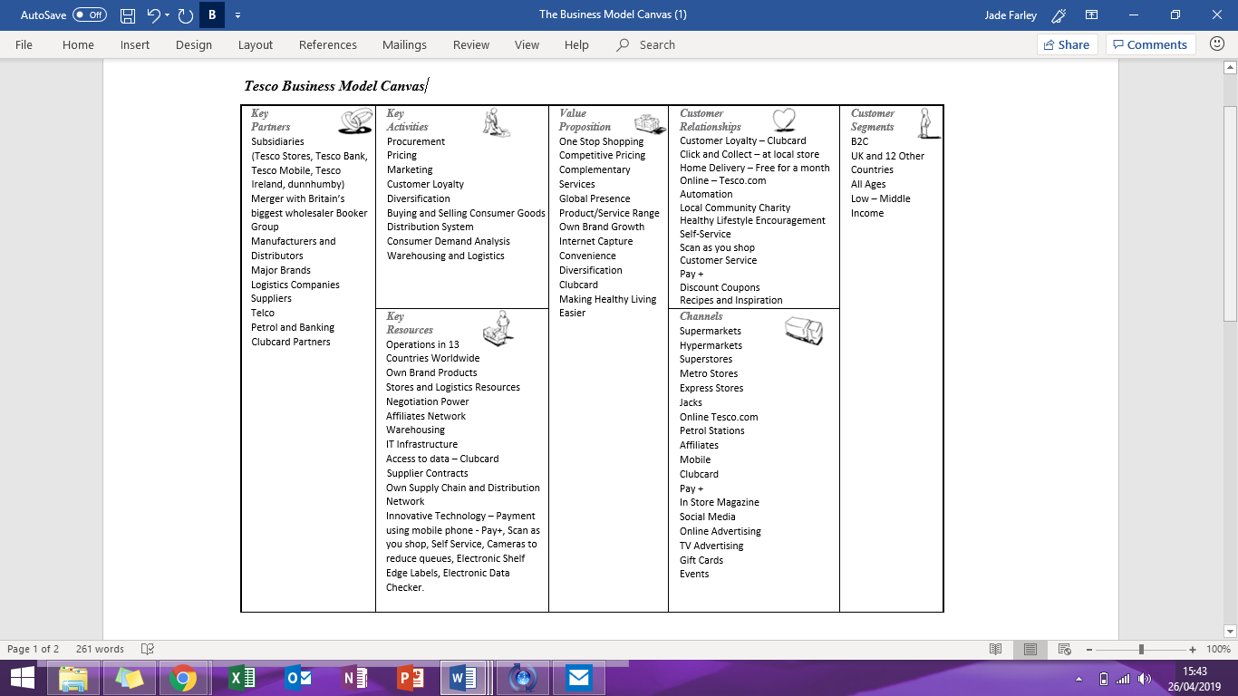
Figure 1.0, demonstrates Tesco’s business model. Tesco’s commerce began in 1919 and have ever since applied a Business-to-Consumer (B2C) model which their business model reflects. The introduction of their B2C e-commerce systems came in 2000 with Tesco.com. The direct to customer business model can be applied to Tesco’s e-commerce. The direct-to-customer model acts as a basis of commercial transactions over the internet and describes the process of selling direct to customers via the organisational website (Ginsberg, 2019). This model incorporates both supply-oriented transactions (organisation is in role of buyer) & demand-oriented transactions (organisation is in role of seller). This model integrated with their business model allows organisations to assess the viability of implementing internet based strategies by providing a structure for identifying the pros and cons for their customer management, product/service portfolio and processes and activities along with the resources and capabilities, suppliers and business networks and financial viability neccesary to do so.

2.2 Contemporary Issues in E-Business
Mobile technology has resulted in consumers being more empowered than ever before. Mobile technology has opened the doors to a digital economy and taken globalisation to greater levels (Hanna, et al., 2011). This has resulted in businesses utilising e-business, especially e-commerce, racing to find the perfect balance between localisation and globalisation, while offering the best products and services to their consumers.
Even though online security is improving, online fraud is on the rise (Garcia, 2018). This presents the challenge; how can online retailers build trust with users on their sites? Traditional methods of building trust in a brand are mostly irrelevant when it comes to e-business systems, therefore businesses utilising e-business models must find new ways to secure trust from their consumers (Gommans, et al., 2001).
Around 7 in 10 online shopping carts are abandoned (Blackburn, 2018). Therefore, businesses should implement customer journey analysis to analyse; ease of navigation, precise abandonment location and reason, efficiency and speed of site, technical considerations and customer engagement. Businesses should then further use this information to get customers engaged and placing orders and thus convert shoppers into paying customers.
Businesses spend significant amounts of money driving traffic to their online store or to use their e-business models (Wills, 2014). Therefore, it is essential that they are capturing quality leads by targeting their marketing, to avoid wasting substantial amounts of money for no return. It is easy to lose online customers to the ‘next big thing’ and failure to meet the changing consumer demands would lead to a failure in customer retention (Economic Times , 2017). Therefore, businesses must ensure they find ways to quickly identify customer demands and adapt to them fast, to retain their customers.
Through e-business systems it is easy for customers to feel a lack of personalisation in the service offered by the company (Wertz, 2017). Managing large amounts of customer data is a challenge and additionally businesses need to understand how to use that data when operating using e-business, especially through e-commerce. To overcome this issue, businesses should aim to deliver personalised content in the form of advertisement and offers.
Advancements in technology along with its ease of use have contributed to consumer power and increased competition in the e-commerce sector and for those utilising e-business (Economic Times , 2017). Omni-channel retailing is a strong approach businesses can take. The transition from multi-channel business to an omni-channel can prove challenging for many businesses.

2.2 Emerging E-Business System Opportunities and Challenges for the Grocery Retail Sector

2.2.1 Industry Opportunities
The share of individuals who have purchased food or groceries online in the UK is on the rise, by an average of 2% each year, with latest recorded levels at 29% in 2016 (Statista , 2016). Predicted figures suggest that online retail is expected to be the fastest growing grocery channel, with a growth of 3.2% in market share and a drop by 4.1% in market share is expected to be experienced by supermarket retail (Statista , 2019). This highlights potential opportunities for businesses operating within the grocery retail industry, as utilising e-business systems in response to the forecasted growth for online retail, could help them to achieve competitive advantage.
Brits are expected to spend £25billion using their smartphones this year, an increase of 66 percent on the previous year (Ecommerce News, 2019). An estimated 58 percent of people across the Uk using their smartphones for shopping, which highlights an opportunity for business operating within the grocery retail industry to invest in this platform for e-commerce.
One of the key opportunities for the grocery retail sector is shoppable video, which is approaching businesses utilising e-procurement with speed. Shoppable video allows consumers to directly purchase products through the use of video (Skulocal, 2017). While this technological innovation could prove expensive for those wishing to implement it, it could offer great competitive advantage for businesses operating within the grocery retail market as it shortens the link between customers viewing a product or service online and them purchasing the product or service by encouraging better customer engagement. In recent years, grocery retailers in the UK have experienced great difficulties with their clothing and general merchandise lines since prioritising fresh foods to regain stability (Faull, 2017). Therefore, grocery retailers are now looking to bring their clothing and general merchandise line back into the mix throughout their next phase of growth. Shoppable video could provide the platform that grocery retailers are looking for to help them re-establish their clothing and general merchandise lines.

2.2.2 Industry Challenges
One of the biggest challenges facing the grocery retail industry today is the e-business giant Amazon. For a number of years, Amazon have dominated e-commerce and continue to do so, as demonstrated by figure 2.0 below.
Figure 2.0 – The Most Popular Online Stores
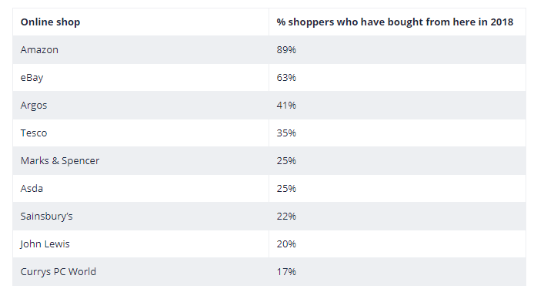
(Ecommerce News, 2019)
While Amazon’s online dominance could offer omni channel strategy potential for grocery retailers in the UK, it could pose a threat as it would see competition in the industry intensify. Amazon have also launched their own fresh produce service through e-commerce called Amazon Fresh which directly competes with the grocery retailers in the UK. As Amazon are currently the strongest player in e-commerce, them entering into the fresh food market could prove challenging for grocery retailers in the UK.

2.3 Evaluation of Existing and Emerging E-Business Model Opportunities and Challenges for Tesco.
Tesco have developed a number of e-business models which are based on strategies set out to achieve their value chain. Tesco also have some emerging e-business opportunities and some challeges which they are facing.

2.3.1 E-Business Model Opportunities for Tesco
Tesco most innovative e-business model is the development and implementation of the Tesco Clubcard, which is a sophisticated data-driven customer loyalty scheme and has proven their most effective tool in achieving their value chain, as it provides Tesco with priceless information about its customers along with changes in consumer demand (Tesco, 2019). Not only does the Tesco Clubcard provide Tesco with this valuable information but it brings on customer loyalty by offering users rewards such as discounts and rewards. A recent method of bringing in customer loyalty using the Clubcard is ‘Clubcard Prices’, which has been announced to Tesco Clubcard users this month via email, as demonstrated by Figure 3.0 below. Clubcard Prices will offer users discounts at till in store through the Clubcard app or will be applied automatically at the checkout when shopping online (Tesco, 2019).
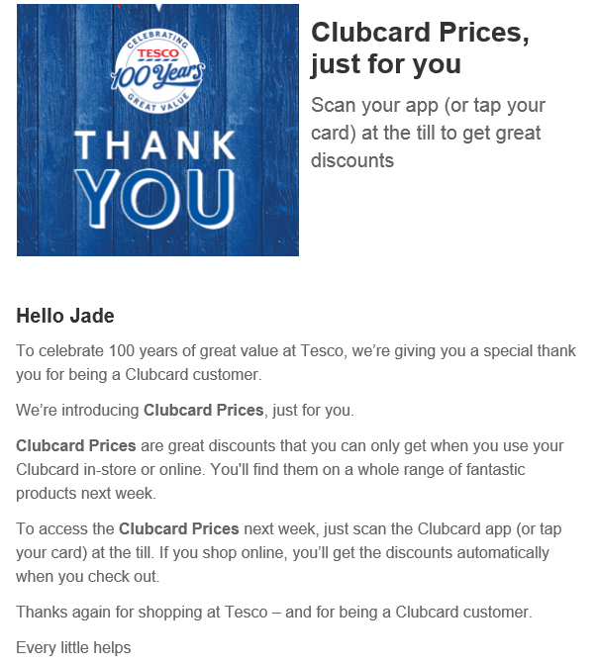
Figure 3.0 – Email Sent to Tesco Clubcard Customers Announcing ‘Clubcard Prices’

Tesco have implemented a number of e-business models to simplify their operations. Tesco utilise Radio Frequency Identification Tagging (RFID) in their supply chain, Tesco Information Exchange in their upstream supply chain of buy-side e-commerce and collaboration with suppliers and in their downstream supply chain of sell-side e-commerce and customer relationship management (CRM) (Tesco, 2019). These e-business models assist Tesco in delivering more information, such as sales data, to increase the efficiency of information flow. Another way in which Tesco are improving the efficiency of their operations and improving their customer relationship management is using Bring Your Own Device (BYOD) – Inform App for Tesco colleagues. This provides colleagues with an app which can be downloaded onto their personal mobile device and provides them with product information such as delivery dates, stock levels, product locations, product promotions and whether that product is located in other Tesco stores (Tesco, 2019). This information not only helps colleagues carry out their tasks more efficiently, but they are more able to serve customers with the information the app provides and therefore improves customers’ shopping experience at Tesco and thus, customer loyalty increases. Tesco have implemented Enterprise Resource Planning (ERP), to streamline processes and improve data visibility. ERP allows Tesco to maximise cost savings, improve business insight, enhance collaboration and increase efficiency (Mabert, et al., 2001).
Another way in which Tesco are utilising the benefits of e-business models is through the intergration of IFTTT (IF This Then That) (Tesco, 2019). Tesco’s customers are now able to automate their shopping as Tesco have teamed up with IFTTT. This partnership means that Tesco’s customers can, “set it to monitor when the price of a product changes or drops below a preset price and add it to your basket for later checkout” (Brian, 2016), and therefore improves Tesco customers’ online shopping experience. Tesco offer Click and Collect services and home delivery services, including the recent introduction of same day delivery, to bring further convenience to their customers. Tesco have responded to the increase in the use of smartphones by developing their award winning Tesco Pay+ digital wallet, which enables customers to pay for their shopping using their phone and redeem their Clubcard points at the same time (Tesco, 2019). The implementation of this e-business model is another way in which Tesco are utilising e-business to bring convenience to their customers and improve the service which they offer their customers.
Following the successful launch of same day delivery by Tesco, Tesco launched Tesco Now in June 2017, which is a one-hour delivery service designed to compete directly with Amazon’s Prime Now service which delivers products within one hour (Ecommerce News , 2017). The Tesco Now app allows customers to receive their goods within an hour of ordering them and receive live updates on the progress of their order. Tesco Now is currently only available for customers in central London, however provided the trial is successful, Tesco will be looking to expand this service across the nation.

2.3.2 E-Business Model Challenges for Tesco
In the last year, Tesco have removed their website for non-food products, Tesco Direct, which was launched in 2006. Tesco Direct was developed to offer non-food merchandise which competed directly with Argos and Amazon. However, Tesco Direct proved to be loss making and Tesco were unable to make the e-business model profitable, which consequently led to the closure of the website (Wood, 2018). Amazon pose a great threat to Tesco’s e-business models as they currently dominate e-commerce. The are current discussions of Amazon acquiring Morrisons, one of Tesco’s competitors operating within the grocery retail industry. If the acquisition goes ahead, Morrisons will provide a wholesale supply service to Amazon, allowing Amazon’s customers access to a wide range of Morrisons ambient, fresh and frozen products (Morrisons, 2018). Another emerging challenge for Tesco is that Morrisons have been in discussions with Ocado to grow Morrisons.com. Here, Ocado will deliver a store pick solution for Morrisons that leverages Ocado’s technology and Morrisons store assets (Morrisons, 2018). Partnerships between tech giants or businesses dominating the e-commerce industry and Tesco’s competitors will greatly intensify competition within the industry.

Recommendations
- Tesco should look to secure public trust in their e-business models, by emphasising security.
- Tesco should introduce shoppable video ahead of their competitors to bring new ways of shopping to their customers and increase consumer engagement.
- Tesco should continue to offer various benefits to Clubcard users as this e-business model provides vital consumer information. This information should further be used to ensure the business adapts quickly to changes in consumer demand to ensure consumer needs are met.
- Tesco should promote awareness of their Pay+ App and reintroduce rewards for using as awareness of the application is low.
- Tesco should continue to use e-business systems, such as CRM and ERP, to simplify their processes and increase efficiency.

4.0 Conclusion
It is clear that effective use of e-business models is fundamental for businesses who are looking to remain competitive in the modern environment. Tesco are the strongest business in terms of their use of e-business models, when compared against their competitors in the grocery retail industry. One of the key reasons for this is Tesco’s use of their Clubcard. This e-business model allows them to adapt to changing consumer demands quickly, which is vital in the industry within which they operate. Tesco’s greatest e-business challenges within the industry are Amazon and trust from consumers. Moving forward, Tesco should cease the e-business opportunities in front of them, placing emphasis on securing public trust in using their e-business models, introducing shoppable video ahead of their competitors, continuing to offer great benefits to clubcard users, promoting awareness of the Pay+ App and continuing to use e-business systems which simplify their processes and therefore, increase efficiency. If Tesco can effectively utilise the e-business opportunities in front of them, then they will be able to fend off the current challenge that Amazon poses.

References
Amit, R. & Zott, C., 2001. Value creation in E-business. Strategic Management Journal, 22(6), pp. 4-17.
Armstrong, A., 2019. Tesco Profits Soar as Dave Lewis Declares Turnaround is Nearly Done. Telegraph - Business, 10 April.
Blackburn, I., 2018. Ecommerce Challenges in 2018 & Beyond. Retail Gazette, 22 November .
Brian, M., 2016. Tesco now lets you automate your shopping with IFTTT. Engadget UK, 04 November.
Chesbrough, H., 2007. Business model innovation: it's not just about technology anymore. Strategy & Leadership, 35(6), pp. 12-17.
Ecommerce News , 2017. Tesco launches one-hour delivery service Tesco Now. Ecommerce News, 27 June .
Ecommerce News, 2019. Brits will spend €28 billion using their smartphones. Ecommerce News , 17 January .
Economic Times , 2017. Six Key Challenges Facing Modern E-Commerce. Economic Timers , 04 November .
Faull, J., 2017. Why re-establishing their clothing brands is next on the list for Tesco, Sainsbury's and Morrisons. The Drum, 19 January .
Garcia, K., 2018. Online buying fraud is on the rise. eMarketer, 7 March .
Ginsberg, S., 2019. Big Commerce. [Online]
Available at: https://www.bigcommerce.co.uk/blog/direct-to-consumer/#how-to-integrate-other-business-operations-accordingly
[Accessed 28 April 2019].
Gommans, M., Krishnan, K. S. & Scheffold, K. B., 2001. From Brand Loyalty to E-Loyalty: A Conceptual. Journal of Economic and Social Research , 3(1), pp. 43-58.
Hanna, R., Rohm, A. & Crittenden, V. L., 2011. We're all connected: The power of the social media ecosystem. Business Horizons, 54(3), pp. 265-273.
Mabert, V. A., Soni, A. & Venkataramanan, M. A., 2001. Enterprise resource planning: common myths versus evolving reality. Business Horizons , 44(3), p. 69.
Magretta, J., 2002. Why business models matter. Binus, pp. 36-42.
Morrisons, 2018. Morrisons. [Online]
Available at: https://www.morrisons-corporate.com/media-centre/corporate-news/morrisons-to-enter-supply-arrangement-with-amazon/
[Accessed 23 April 2019].
Nemat, R., 2011. Taking a look at differenct types of e-commerce. World Applied Programming, 1(2), pp. 100-104.
Phan, D. D., 2003. E-business development for competitive advantages: a case study. Information & Management , 40(6), pp. 581-590.
Shim, J. P. et al., 2002. Past, present and future of decision support technology. Decision Support Systems, 33(2), pp. 111-126.
Skulocal, 2017. What shoppable video technology means for retail. Skulocal, 11 October.
Statista , 2016. Statista. [Online]
Available at: https://www.statista.com/statistics/737433/online-grocery-retailers-uk/
[Accessed 19 April 2019].
Statista , 2016. Statista. [Online]
Available at: https://www.statista.com/statistics/700676/share-of-individuals-who-purchased-groceries-online-in-the-uk/
[Accessed 20 April 2019].
Statista , 2019. Statista. [Online]
Available at: https://www.statista.com/statistics/611045/grocery-retail-channel-share-united-kingdom-uk/
[Accessed 21 April 2019].
Statista, 2019. Statista. [Online]
Available at: https://www.statista.com/statistics/280208/grocery-market-share-in-the-united-kingdom-uk/
[Accessed 18 Aoril 2019].
Tesco, 2019. Our Tesco. [Online]
Available at: https://www.ourtesco.com/
[Accessed 26 April 2019].
TescoPoly, 2019. TescoPoly. [Online]
Available at: http://www.tescopoly.org/worldwide
[Accessed 24 April 2019].
Thompson, A. A., Strickland, A. J. & Gamble, J. E., 2010. Crafting and Executing Strategy: The Quest for Competitive Advantage. 17 ed. s.l.:McGraw-Hill/Iriwin .
Wertz, J., 2017. Exceptional Customer Service is Key to E-Commerce Growth. Forbes, 18 August.
Wills, B., 2014. 18 Major Benefits of e-Commerce Business for Retailers & Customers 2018. Medium, 15 December.
Wood, Z., 2018. Tesco shuts its non-foof website, Tesco Direct. The Guardian, 22 May.

