
Applied Leadership and Management in the Workplace
Module Assignment Submission
Student Name: | Jessica Rudall
Student Number: | 2308141
Module No: | BMSK4015
Module Title: | Academic and Research Skills

Statement of Confirmation of Authenticity
By the act of making this submission, the student declares that this is the work of the student named above. The work has not, in whole or in part, been knowingly presented elsewhere for assessment, or where assessment has been built on a previous assessment, this has been identified. Where materials have been used from other sources it has been properly acknowledged. If this statement is untrue, the student acknowledges that an assessment offence has been committed.
Attention is drawn to the plagiarism and unfair practice policies of both the University and of ILM.

Table of Contents
Introduction 3
Main Body 3-10
Managing Global Teams 10-11
Reflection 11-13
Conclusion 13
References 14
Appendix A Professional Development Plan 15
Academic and Research Skills
Managing Remotely – 3000 words
Introduction
According to the Office for National Statistics, Between October 2019 and March 2022, homeworking in the UK more than doubled from 4.7 million to 9.9 million people (ONS, 2022). However, due to the Covid-19 pandemic, the unforeseen situation forced individuals and organisations to rapidly train employees and adopt the use of online working styles. Many employees and managers faced difficulties adapting to this type of working, however within some time individuals managed to develop the knowledge and experience needed to work from home. Many individuals recognised the advantages of working from home, but there were also drawbacks that can be identified such as the lack of face-to-face supervision and meetings during working days, among many others (Al-Habaibeh et al., 2021). As many people now work in a flexible way, organisations, managers, and employees need to ensure that hybrid and remote work is sustainable, healthy, and effective.
Within this report will include key areas researched from various sources, analysing the literature sourced and using academic argument to link ideas together. It will include remote management, when remote management was first noticed and how it developed to this day. The report will discuss the Covid-19 Pandemic and how this saw a significant change to working from home, which includes the benefits and challenges to individuals, managers, and the organisation. It will also include evidence of data collection and analysis to illustrate the argument/findings. Managing global teams will also be discussed, including key areas that would pose a challenge to manage these global teams. Finally, the report will show a recognised reflection model which enables individuals like myself to reflect upon my research and experience into Managing Remotely.
Main body
Remote management is a type of management hat involves employers overseeing a team of employees who are working remotely, managers supervise and monitor employees through online channels (Cook, 2019).
Silvers (2023) states that people have always worked from home. Historically, during the industrial revolution women were more likely to work at home than men, performing piece work where they were paid a fixed rate for each unit of work they produced, instead of an hourly wage. This allowed them to combine childcare and earning in one place. In 1980, 53.6% of homeworkers were female, at the beginning of 2020 51% were. As agriculture contracted and factories and offices expanded, paid work in the home decreased overtime as men went out to work. This is supported by The World of Work (2019) as during the 20th Century modern offices began existing, as organisations became larger and more complex and needed more administration. Their growth was due to the technological changes including development to communication like telephones made offices more effective and improvements to transport made commuting feasible and cost effective.
However, as cities became more congested and expensive to live in, and as populations grew in urban areas, the growth came to a halt towards the end of the 20th century. Societies worried about the environmental impacts of transport and commuting therefore became more difficult and expensive, this led to a response from companies who introduced telecommuting. Telecommuting was of limited success in the 70’s and 80’s, it wasn't until a significant moment occurred in the 90’s when the US government adopted flexible and Agile working practices for federal agencies. This was a key turning point for acceptability within other countries who has already been pursuing Agile practices (World of Work, 2019).
As stated by World of Work (2019), remote working continued into the 21st century as improvements to technology made remote working much easier, more effective, and cheaper, making it more attractive to businesses. Organisations benefit from employees working remotely as it allows them to achieve cost savings. A pivotal moment which saw working from home increase was in 2020, when the coronavirus resulted in a global pandemic.
By the end of March 2020, measurements by governments worldwide were taken to reduce the movement of their population to reduce the spread of Covid-19. Due to the government lockdowns, non-essential businesses had to temporarily close, and millions of people worldwide were forced to work from home (Al-Habaibeh et al., 2021). This was supported by Carroll and Conboy (2020) who highlighted the fact that Covid-19 forced organisations and individuals into a sudden adoption of working from home, however they believe that these organisations have been forced into rapid introduction of technology and ‘tech-driven’ practices in an unprecedented and time pressured way. They argue that there is a need for a more reflective normalisation of work practices and the role technology plays as there has been minimal training on how these practices and associated technology should be introduced, integrated, or adopted to suit. There are many negative aspects related to working from home, including pressures to perform timeously and an unbalanced workload which could affect an individual’s health and wellbeing due to stress-related issues, however there are positive characteristics of working remotely using online technology.
According to the Office for National Statistics (2022) the number of homeworkers increased between October to December 2019 and January to March 2022 to more than double in the UK, increasing by 108.8%, from 14.5% to 30.6%. This is supported by CIPD (2022), as they state that the proportion of people who are working remotely has risen in 2022 and over three-quarters of the UK population are reporting better work-life balance. This shows that remote working is on the rise and as covid restrictions are lifted and offices are starting to return to normal allowing for employees to return to the office, is hybrid working here to stay or are there too many common challenges of remote work?
As stated by Mitchell, (2023) from the European Business Review, as organisations emerge from the pandemic, some employees continue to prefer face-to-face work whilst others have experienced a new way of work and cannot envision losing this ability. Hybrid work offered a solution at a time where it was unprecedented and necessary, but hybrid working allows employees to come in on certain days of the week, to others working from different locations with arranging occasional on-site meetings. Organisational leaders and teams have figured out their own best practices over the past couple of years and not many leaders or employees were trained to work in a remote or hybrid environment and therefore have had to adopt and include remote or hybrid work education as a part of leadership training, being another critical piece of this transition.
Before looking at the challenges of remote management it is important to look at advanced technology and the ability of organisations to adopt working outside of the office is facilitated by the investment in technology which enables individuals to work from any location. There are several tools needed to work remotely, to start fast and reliable internet access is one of the most important whether you are in any location WIFI, or a hotspot connection is necessary. Virtual Private Network (VPN) allows remote access to the organisation’s resources, a mobile device enables an individual to receive and send calls, texts, emails, and messages, and provide access to web and video conferencing and collaboration tools. Communication and collaboration tools include the Microsoft Office 365 suite such as Instant Messenger as it connects workers instantly unlike email. Web and video conferencing ability is needed to hold virtual meetings ensuring the organisation has an engaged team, possible investing in good quality headsets. Project and document management tools are also helpful to allow individuals to work simultaneously on projects as well as meetings and tasks and to be given a central file hosting and document management, to help improve employee productivity via an easily accessible web interface.
Another useful tool to allow individuals to develop their time management skills is the time management matrix (Covey, 1989). The figure below shows an example of how individuals can manage their time using two broad categories – importance and urgency. The idea is to be able to prioritise tasks while bringing into focus other tasks that are also important (Morgan, 2017). The figure uses personal examples.
(Covey, 1989) | Urgent | Not urgent
Important | Finishing Assignment | Focusing on planning to complete the next few assignments
Not important | Check emails | Walking the dog

Some organisations choose to use surveillance tools to monitor how employees are working and they can record their work activity and task completions throughout the day, allowing managers to monitor individuals’ performances. These surveillance tools can however have a negative impact on employees, as it takes away the element of trust between the employee and management. But managers report that the system used increases productivity and is a useful tool to measure performance, and if there were issues these can be addressed quickly (Cook, 2019). This is demonstrated by CIPD (2022) as they have stated that organisations productivity and culture are at risk if employees cannot adapt to collecting and collaborating when they are not in the same physical environment as managers. If individuals feel it’s necessary or intrusive to be monitored working remotely then it might backfire.
By looking at one figure from a survey conducted by CIPD in 2022, when organisations were asked to select an example of methods they felt were acceptable for collecting information about employees working from home, the data from the graph below shows a range of opinion, as it appeared the largest proportion 39.2% felt that none of the measures listed were acceptable, and 5.6% said they didn’t know.
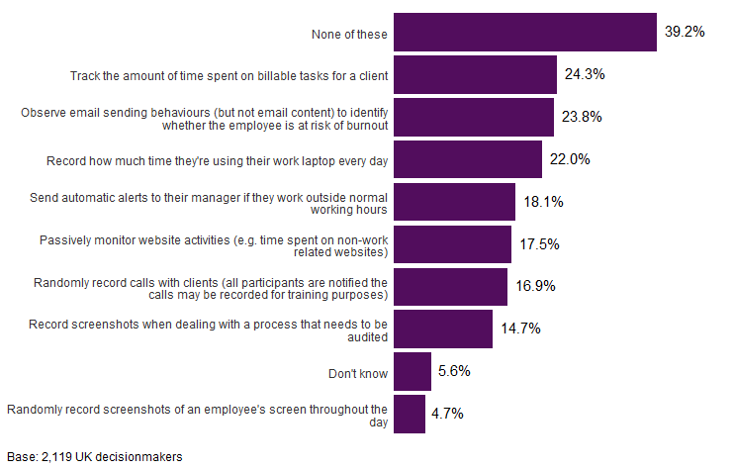
Figure 1 taken from CIPD (2022).
Although some didn’t have a strong preference for a specific example, another figure below shows that when bosses were asked over half 55.3% agreed with at least one of the eight measures previously shown.
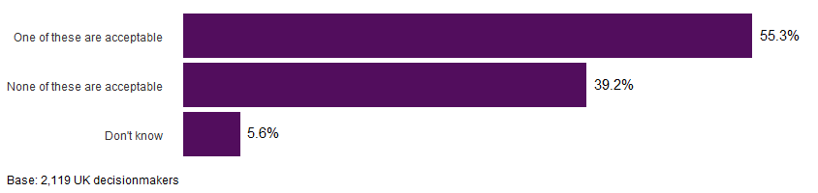
Figure 2 taken from CIPD (2022).
This demonstrated that although remote working benefited organisations at a time where it was necessary due to the lockdown from the Covid-19 pandemic, there were many common challenges that organisations and management faced that were unknown until this time. Larson et al, (2020) argues that previous high performing employees may experience declines in performance and engagement when beginning to work remotely, and with the lack of preparation and training. This suggests that managers need to understand factors that can make remote work demanding, some of these challenges will be discussed below. Firstly, lack of face-to-face supervision is a challenge to both managers and their employees as supervisors worry that employees will not work as hard or as efficiently as they would in the office. In opposition to this, many employees struggle with the reduced access of managerial support and communication, with some employees feeling that their remote managers are lacking with the support given which is not helpful for them to get their work done.
This is backed up by Cook, (2019) as she agrees that lack of supervision can mean that people start to feel disconnected and lose a sense of team unity, as face-to-face interaction helps to generate trust and understanding. Remote working would lead to the manager needing to agree regular meetings with the team. The challenge for the manager is to ensure individuals are supported and challenged to give their best, and it is essential they continue regular one-to-ones with each team member to help them feel part of the team and supplementing with supervision, mentoring, and coaching.
Cook, (2019) also states that social isolation factors are another challenge managers face when managing their remote workers. When managers see team members frequently, they are more likely to have an understanding on their personal well-being and how well they are integrating into the team. Going to work provides an important social element in many people’s lives. The lack of face-to-face contact can mean managers may miss the signs of isolation or lack of well-being. Remote working can cause people to feel isolated and affect their mental health, while also causing anxiety and guilt because employees feel they need to constantly appear busy. It also causes worry about the lack of structure and peer support that home working brings. Larson et al (2019) also indicates that social isolation is another common complaint of remote work, with employees missing the social interaction of an office setting. Over a long period of time, isolation can cause many individuals to feel less part of a team and their organisation, which can even result in possible thoughts and intentions to leave the company.
Cook (2019), also states that one of the main challenges for the manager and not the individual is that team members are no longer physically present in one location, causing managers initially fearing a loss of control as they cannot see what the team member is doing. They are no longer able to control and intervene in the employees work as they are not physical present. Managing teams remotely relies on an empowered style of management, where they trust the team member to complete the tasks they have agreed. CIPD (2022) asked bosses with regular home workers about the type of software they use to measure and monitor employee’s productivity. The results showed that 57.7%, most organisations said they do not use software to monitor their employee’s productivity, whilst 12% said they didn’t know.
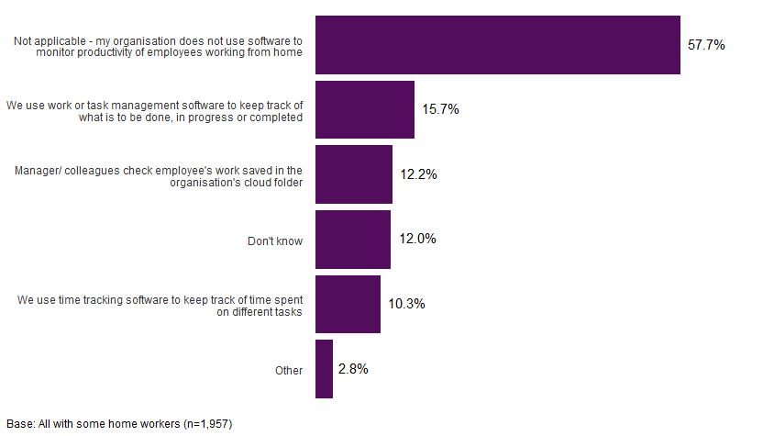
Figure 3 taken from CIPD (2022)
It would seem clear from the research that most mangers and organisations who are managing employees remotely rely on an empowered style of management and communication, where they trust the team members to complete the work that they have agreed to complete.
With the common challenges of remote working and management evident, there can be some benefits of remote working which will be looked at below. The world of work is changing and working time is increasing flexibility. The extent of technology today allows organisations to manage their workforce from various geographical locations, with high-speed connectivity and technology, employees and managers can work from anywhere in the world. This has allowed organisations to hire individuals with the right skills, knowledge, and experience more importantly than hiring people who can work in the same location.
The flexibility of remote working is attractive to employees as it appeals to both young and older individuals, and it is predicted that the trend of creating remote, agile teams is the future for work. Flexible working and virtual teams are one of the biggest drivers of transformation in the workplace. Below is a table created to show the benefits virtual teams has on the employee, manager, and to the organisation (Cook, 2019).

Employee | Manager | Organisation
Flexible Schedule | Manage by outcomes rather than just being present in the office | Increases productivity
Less time spent travelling | Empower team members to give their best | Save money with office costs and overheads
Increased time to concentrate on work without any distractions or interruptions | Improves job performance and job satisfaction | Lowers carbon footprint
Better work-life balance (more time with family, more time to exercise) | Increase well-being in the team | Attract and retain diverse talent and skills
Not dealing with office politics | Boost morale | Increase employee engagement
Less stress and increased well-being | Attracts new team members with the right skills not worrying about their location | Create a more inclusive culture

Managing Global Teams
With the rise in remote work and to succeed in the global economy, more and more organisations are relying on a geographically dispersed workforce, taking the opportunity to collaborate with people around the world. Managers from companies build teams who will offer the best expertise and knowledge from around the world, benefiting from bringing people together from different cultures, international diversity, and different perspectives on strategic and organisational challenges. Managers who lead global teams are set for difficult challenges, with team members coming from various countries and different backgrounds, working in different locations, communication can deteriorate causing misunderstanding and frustration, hindering individuals to build strong relationships with colleagues in other parts of the world (Neeley, 2015).
This is supported by Hall (2023), as cultural expectations and differences can result to careful consideration when managing a global team. Individual culture expectations vary across different countries and can influence teams’ communication styles, dynamics, and decision-making processes. Overcoming cultural misunderstanding requires developing cultural intelligence, which involves understanding and respecting everyone’s cultural differences. To navigate cultural differences, it is important that cross-cultural training and support is given to provide team members with the knowledge and skills needed. Global teams can enhance their effectiveness and productivity by acknowledging and addressing cultural differences and expectations.
Hall (2023) also stated that time zone differences also would pose a challenge in coordinating a global team, and managing this effectively is vital to maintaining effective communication across the globe. Establishing clear guidelines to schedule meetings and deadlines is priority, considering the time differences of all team members. Utilizing online tools can allow team members in different regions to communicate in real time and allow them to work together despite the distance.
Language barriers are also another challenge that managers face with global teams as it can have an effect on communication and collaboration. To overcome this, language training programs could be used to improve language skills as well as using translation tools to aid with the communication struggles between team members who speak different languages.
It is important to establish clear goals and expectations in guiding all team members to understand their roles and responsibilities. Promoting a shared vision will help connect the team’s purpose and goals to foster a sense of unity and direction. It is vital that measurable targets and performance indicators are set to evaluate individual and team performance, which will then allow the manager to regularly assess team members performance and provide constructive feedback.
Reflection
One of the most famous cyclical models of reflection is the Gibb’s Reflective Cycle which was developed by Graham Gibbs in 1988 to give structure to learning from experiences. The model is a good way to work through an experience and in repeated situations, allowing individuals to learn and plan from things that either went well or did not go well. The cycle covers six stages: Description, feelings, evaluation, analysis, conclusion, and action plan (The University of Edinburgh, 2020). Below is a diagram of Gibbs’ Reflective Cycle followed by a personal reflective cycle uses to develop own experiences and situations.
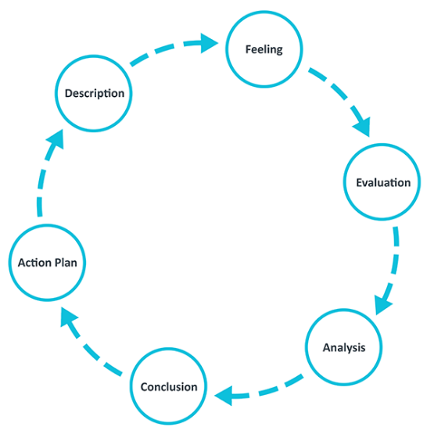

Description: To provide evidence of my own academic and research skills I had to research various topics that applied to managing remotely. This required a lot of reading and researching before beginning to write the report as I needed to gather as much relevant information that was available on the topic and ensure that the sources used were credible sources, by applying the “C.R.A.A.P Test” to them all. It was clear at this point that there was a lot of information out there and therefore it was important to narrow down the information that was relevant to producing the report. I gave myself enough time at the beginning to research, however I did not plan how much time it would take to pick out the relevant information. Therefore, I gave myself less time than anticipated to put everything together and took longer to prepare the structure for the report.
Feelings: Before beginning the report, I felt quite happy and confident that I knew what research I wanted to include, however I realised that I didn’t have loads of experience on managing remotely so it would be a bit more difficult for me. Being managed remotely makes me feel that it can be a lot of pressure as managers expectations are very high, when working at home can at times be distractive due to children and other priorities. Including lack of supervision and contact with managers which can make you feel isolated and lacking access to information.
Evaluation: The things that worked well were that it allowed more flexibility. I was able to do more with the children than I would have if I was working in the office. However, sometimes it was difficult as I felt there were longer working hours as I was having to work late in the evenings when the children went to bed.
Analysis: Through researching the topic of managing remotely it was evident that people have always worked from home, however it wasn’t until 2020 when Covid-19 hit, and the world went into lockdown that working from home significantly increased. It was evident that this put pressure on organisations to work from home, it came with unknown challenges but also had some benefits. From my own experience and knowledge, it is important that managers support all employees by taking into consideration quick actions that will make a difference.
Conclusion: I have learnt that although there were benefits to working and managing remotely, these could quite quickly become challenges and they were unknown until this time. It is important to remember that the challenges that arose were unknown until working from home increased, therefore there wasn’t an opportunity for managers to find successful resolutions to the problems.
Action plan: If I had to manage others remotely, I would ensure that I established daily check ins with employees as it would allow them to consult with myself and give them the opportunity to air their thoughts and questions. It would be important to establish rules of engagement to enable working from home to become more efficient and allow easier communication. It would benefit employees if encouragement and emotional support is offered as it allows for managers to acknowledge stress and listen to employees concerns and worries.
Conclusion
This report set out to analyse practical evidence on Managing Remotely that has been sourced from various sources, which presents findings in a structured report by using academic argument to link ideas together making use of facts, thoughts, and opinions, and data handling. The review of literature highlighted that although remote working came at an unprecedented time where there was significant need for alternative working methods, it came with many benefits to the employee and managers, however it caused a lot of challenges that were unknown until this time. This led to lack of knowledge in certain areas that were causing issues, and therefore managers, employees, and organisations were all trying to learn at the same time. In future, work will be about what employees know and can do, and not where they are located which suggests that their capabilities and competencies are going to be critical. It is important to point out the role and importance of technology as part of the transition to working remotely, as technology makes this possible. But these solutions need to be adopted and implemented to accomplish what organisations and employees need, as if not then majority will revert to face-to-face work. The Covid-19 pandemic has shown there are benefits to remote working in relation to work/life balance, productivity, diversity, and inclusion. Remote working has the potential to be beneficial, but this remains to be seen with widespread organisational adoption, as there is much to still learn.

References
Al-Habaibeh, A., Watkins, M., Waried, K., & Javareshk, M. B. (2021). Challenges and opportunities of remotely working from home during Covid-19 pandemic. www.ncbi.nlm.nih.gov/pmc/articles/PMC8626352
Carroll, N., Conboy, K. (2020). Normalising the “new normal”: changing tech-driven work practices under pandemic time pressure. www.ncbi.nlm.nih.gov/pmc/articles/PMC7358767
CIPD. (2022). What monitoring measures are acceptable when managing remote workers? www.cipd.org/uk/views-and-insights/thought-leadership/insight/monitoring-measures
Cook, S. (2019). Making a success of managing and working remotely. IT Governance Publishing.
Hall, A. (2023). Managing a Global Team: Challenges and Strategies. www.aaronhall.com/insights/managing-a-global-team-challenges-and-strategies/#Cultural_Expectations_and_Differences
Larson, B. Z., Vroman, S. R., Makarius, E. E. (2019). A Guide to Managing Your (Newly) Remote Workers. www.hbr.org/2020/03/a-guide-to-managing-your-newly-remote-workers
Mitchell, A. (2023). The Evolution of Remote and Hybrid Work. www.europeanbusinessreview.com/the-evolution-of-remote-and-hybrid-work
Morgan, P. (2017). The Business Student’s Guide To Study And Employability. Sage Publishing.
Neeley, T. (2015). Global Teams That Work. www.hbr.org/2015/10/global-teams-that-work
Office for National Statistics. (2022). Homeworking in the UK – regional patterns: 2019 to 2022. Homeworking in the UK – regional patterns - Office for National Statistics (ons.gov.uk)
Silver, H. (2023). Working from Home: Before and after the Pandemic. www.ncbi.nlm.nih.gov/pmc/articles/PMC9988592
The University of Edinburgh. (2020). Gibb’s Reflective Cycle. www.ed.ac.uk/reflection/reflectors-toolkit/reflecting-on-experience/gibbs-reflective-cycle
World of Work. (2019). The History of Remote Working. www.worldofwork.io/2019/02/a-brief-history-of-remote-working

Appendix A Professional Development Plan
Skill/Behaviour | Action needed | Resources needed | Date(s) for action | Date for review (practice skills) | Met?
Time management | Ensure time is used effectively.  Prioritising workload and tracking time spent on various tasks.  Ensuring not to take on too many tasks at once. | Keep a diary or a plan to stay on track.  Set alarms when certain things need to be done. | Each day to see where I have used my time effectively. | To be reviewed as much as possible to identify the progress I have been making.
Reflection | Take 5 mins to reflect at the end of each lecture.  Use Gibb’s Reflective cycle in each situation or experience to learn and plan. | Gibbs Reflective Cycle. | Weekly during lectures. | To be reviewed when each reflective cycle is completed to see what has changed to the last cycle.
Note Taking | Ensure I take notes to help learn about the subject and to aid with concentration.  Ensure I collect factual information. | Keep a diary of note taking from each lecture. | Weekly during lectures. | To be reviewed as much as possible to identify if I have successfully understood the outcome of each lesson/assignment.

