

Analysis and research into the application of deep learning and artificial intelligence in a congested signals environment

by
Jacob Brown

Supervisor: Jenifer Prince Devaraj

Project proposal submitted as part of the requirements for the award of
BEng (Hons) Embedded Electronics Engineering

April 2025

Contents
Abstract 3
Introduction 3
Literature 4
Algorithmic 4
Technical 4
Physical 5
Takeaways 6
Algorithm selection process 6
Proximal Policy Optimisation 6
Deep Q Network 7
Convolutional Neural Network 8
Conclusion 9
Synthetic Concept Proof 9
Theory (need to add concept proof) 9
Implementation 10
Analysis 11
Data Collection Methodology 11
Design 11
Data 13
Model Development 14
Initial Design and Dataflow 14
Build 16
Results 17
Final Design and Dataflow 20
Results 21
Analysis 21
Potential impact 22
Ethical Considerations 24
Further Research 25
Conclusion 25
Appendix 26
References 26

Abstract
The report endeavours to investigate the viability of augmenting preexisting and future wireless telecommunications processes with reinforcement learning and artificial intelligence techniques to better optimize power utilisation. The chosen technique shall be selected, developed and utilized in as effective a manor as is possible to demonstrate feasibility as well as showcasing a sound mathematical operating principle.
This mathematical principle shall then be explored in the context of a novel parameter used to clarify the similarity of simulated readings to actual readings as a means to validate the training process evaluating successfully. Then finally concluding in a summary of successes and potential ethical ramifications of implementation where they arise.

Introduction
As modern technical capabilities are expanded upon by the mobile telecommunications industry, a vast complexity hitherto unseen in radio spectrum management is emerging, where once long wave communications dominated environments urban and rural, a shift towards highly managed and distributed information broadcast can be observed in most modern handsets[1]. This approach, while undeniably increasing the data throughput for a higher demand client base within the age of the internet, also increases power consumption sizably at the tower level. This power consumption will only increase as complexity increases and appetite for data amongst the populace climbs, as it has done exponentially in the last few decades, particularly for mobile solutions[2]. To meet these higher expectations, each subsequent generation of telecommunications protocol has increased aggregate power usage, despite also increasing efficiency per bit transmitted[3].

This investigation seeks to outline the potential use-case for Artificial Intelligence (AI) in developing a robust system for radio frequency management at the tower level, through decision making at a pace and scale that would allow towers to avoid destructive interaction and better direct power into unused areas of the allocated spectrum[4], thus reducing the power consumption of broadcasts when attempting to achieve an optimal level of data throughput. The main approach that this report seeks to investigate is the potential application of an emerging concept within AI known as Deep Learning (DL)[5]. Through the application of modern deep learning techniques, it is hoped that its feasibility could be well founded and demonstrated, while also helping to reduce the ecological footprint resulting from tower power usage as well as investigating the ethical implications of including AI in decision processes for telecommunications for critical infrastructure such as telecommunications.

Through thorough statistical analysis of the effectiveness of relevant algorithms it will be possible to deign which of these systems would be best suited to management of telecommunications traffic as well as which could best be applied to the broadcasting element of possible implementation.

While tower implementation will be the primary consideration for implementation regarding hypothetical deployment, demonstration will be considered under implementation on a software defined radio (SDR) due to the greater ease of conducting feasibility studies upon these smaller and much more accessible bits of kit, equally this would cause a reduced impact on telecommunications activity if physical measurements were to be carried out.

Literature
Literature across the fields relevant to this are vast and expansive. While each field has its own limitations as to why research is not universally prevalent, such as deep Q learning being restricted to within the last decade. Q learning on its own is an area of investigation that was initially defined within mathematics around the 1990s[6]. This novelty is nothing unexpected within the field of AI, as new techniques are developed constantly[7], it does, however, limit the effective examples employed on physical hardware in lots of cases as production cycles and proof of concept are only just concluding initial phases on lots of these systems, if in development at all[8].

The Literature can largely be separated into three categories for ease of comprehension, these being the Algorithmic, Technical and Physical. Each of these representing the developments of relevant AI algorithms, specifications and observations from the radiofrequency field and physical implementations of power management algorithms respectively.

Algorithmic
Literature relating to the algorithm development side is exceedingly modern, the development of algorithms is a constantly emerging field and requires constant observation, whether it be in relation to new developments in optimisation, targeting or architecture, it is an almost perpetually evolving area. The following works are some of the most insightful for applications within cellular and telecommunications networks.
- A machine learning framework for predicting downlink throughput in 4G-LTE/5G cellular networks. Useful for its Deep Learning (DL) implementation and machine learning techniques. [9]
- Deep Reinforcement Learning for Downlink Power Control in Dense 5G Networks. Useful due to the application given to a Deep Q-Network (DQN) and Rainbow DQN, reward metrics and requirements similarity. [10]
- A Deep Q-Learning Method for Downlink Power Allocation in Multi-Cell Networks. Useful because of the benchmarking system used and hidden layer architecture which closely resembles earlier research conducted in house. [11]
- Deep Q Network (DQN), Double DQN, and Dueling DQN: A Step Towards General Artificial Intelligence. An interesting insight into the development and learning patterns of a DQN network, as well as similar permutations and their benefits [12]
- Deep Q-network Based Reinforcement Learning for Distributed Dynamic Spectrum Access. An insightful look into optimising training with Deep Reinforcement Learning, particularly regarding spectrum identification [13]
- A Systematic Study of Deep Q-Networks and Its Variations. A useful resource for detailing DQN network variations, particularly helpful in identifying the rainbow DQN modifications that would be best utilized in our specific case. [14]

Technical
Documentation and observations in a more technical sense can provide incredibly useful insights into directions of development and requirements therein, this can be things such as data-based approaches to solutions or as far removed from deep learning as requirements for operation within spectrum allocations, which certainly provides useful insights for data training purposes.
- Distributed spectrum management based on reinforcement learning. Defines operating spectrum details and demonstrates reinforcement learning regarding spectrum management. Outputs a binary mask as required in this work package. [15]
- Deep Learning Approach to Spectrum Allocation in Shared Spectrum Systems. Utilises a CNN regarding a primary and secondary user. Defines and provides example for small hardware testbed, provides signal allocation for multiple users. [16]
- Intelligent spectrum management based on reinforcement learning schemes in cooperative cognitive radio networks. Demonstrates two novel ideas for spectrum allocation using a decentralised approach, using several novel applications for reinforcement learning in a radio-based context. [17]
- 5G Standards. A very useful sources for easy to interpret and visualise diagrams for the functional protocols around 5G [18]
- Detecting Problematic Control-Plane Protocol Interactions in Mobile Networks. Good source for detailing the function of the control plane and how 3G and 4G interoperate with each other, useful for demonstrating that management for cross compatibility is valuable and with precedent. [19]
- AI-Driven 5G Network Optimization: A Comprehensive Review of Resource Allocation, Traffic Management, and Dynamic Network Slicing. The closest consideration to what this paper is investigating, with recommendations on how traffic management could be conducted with Deep Reinforcement Learning in a broader sense, while not as particular on the technical level as this report aims to be, it is still a useful insight into potential data splicing methods and similar implementation side considerations with regard to protocol. [20]
- Optimization and Performance matrices in 5G Networks. A convenient guide as to optimisation protocols presently in use within 5G networks, helpful for comparing effectiveness to, even if not directly related, as it focuses on QoS improvements instead of energy efficiency. [21]
- 5G Energy Efficiency Overview – A very helpful source for analysing the power needs and user needs of a 5G network, produces useful metrics for determining consumption per hour and per bit. [22]

Physical
Papers relating to the physical end are often more akin to either of the above fields and the complications relating to their implementation upon physical hardware units, whether that be SDRs or other similar equipment, there are nonetheless useful takeaways from all aspects of implementation that might well go un considered when approaching from a solely theoretical angle that could not be addressed in later stages of development.

- Deep Learning for Critical Infrastructure Resilience. Very insightful and interesting paper relating to power management using deep learning within the electricity industry, contains lots of very applicable features and approaches, even if limited in technical application, the direct considerations for physical electrical engineering are incredibly valuable. [23]
- -5G positioning with software-defined radios. A paper investigating the research application for 5G implementation upon SDRs, while largely experimental and using SDRs for environmental purposes, it demonstrates an enthusiasm and appetite for use within the industry, particularly as a small-scale test tool. [24]
- Using software defined radio (SDR) to demonstrate concepts in communications and signal processing courses. While a little dated, this proves a useful tool for demonstrating how LTEs and similar could be tested using SDRs connected to relatively simple computational devices. [25]
- Experimental comparison of 5G SDR platforms: srsRAN x OpenAirInterface. This paper provides details around the specification of two relatively popular SDR systems, demonstrating the requirement that is present for certain data to be processed, as is illustrated in their bench testing, with particular focus on 5G related processing, a useful characteristic to consider in the case of this report. [26]
- RSRP Prediction on LTE Network Testbed Using a Software Defined Radio (SDR) Platform. Another useful source of information on data formatting and test bench setup for future SDR usage if it is deemed possible within the timeframe, also provides useful insight into the role of SDRs in Telecommunications. [27]

Takeaways
Papers relating to the physical end are often more akin to either of the above fields and the complications relating to their implementation upon physical hardware units, be that SDRs or other similar equipment. There are nonetheless useful takeaways from all aspects of implementation that might well go unconsidered when approaching from a solely theoretical angle that could not be addressed in later stages of development that are revealed thusly.

Algorithm selection process
Identifying the correct algorithm is a critical step in the process of developing a correct and functional system capable of being scaled up to process large, continuous sets of data. In order to come to an adequately proven solution, a consultation of the relevant literature must be conducted as well as a thorough analysis of the banes and boons of appropriate algorithms from a theoretical basis.
To best summarise the decision process, it is broadly represented by the three main algorithms under investigation. All these algorithms were mentioned in some of the above literature pieces, with mainly evolutions of the Convolutional Neural Network (CNN), This is a model characterized by high reliability and accurate classifications, performed by a decision process conducted nodes within a neural network.
Deep Q networks are very similar from a classification point of view, sharing much of the same architecture, with the main alteration being the decision vector and resultant. Where a CNN produces a classification, a DQN augments a classification and produces a Q matrix, a matrix comprising a set of potential moves and the predicted accuracy and reward of those moves. While alternatively, a Proximal Policy Optimisation network (PPO) produces a remarkably reliable output classification when compared with the instability that can be inherent in some DQNs and features a trust region that allows for this stability and calibration, further details will be explained in the following.

Proximal Policy Optimisation
To build the greatest reliability, as well as to best capitalise upon developments in optimisation methods[28], a proximal policy approach was considered strongly. In an environment characterised not only by complexity but also by well enforced legislation[29], an air to the side of caution is greatly favoured.

In assessing how appropriate the PPO would be, it is necessary to characterise its fundamental differences mathematically.
$$A\left(s,a\right)=Q\left(s,a\right)-V(s)$$
Above states the action function (A) as relating to the value function (V).
$$r\left(θ\right)=\frac{π_{θ}(a|s)}{π_{θ_{old}}(a|s)}$$

With the next equation specifying ratio function (r), which demonstrates the probability of an action (a) being taken under policy $\left(θ\right)$. While the policy here is not explicit, it is nonetheless useful to characterise its application with relation to the ratio function. To consider the main benefits of the PPO, we must consider implementation of a clipping range(L) to outline a trust region.

$L\left(θ\right)=min⁡(r\left(θ\right)A\left(s,a\right),clip(r\left(θ\right),1-ϵ,1+ϵ)A(s,a)$)

This characterization denotes the mentioned trust region (Defined by the clipping range above). This acts as a net that is essentially a Hessian matrix – adding to the computation time substantially when processed as part of a Trust Region Policy Optimisation (TRPO). This processing burden increases slightly less exponentially when performed within a PPO due to the latter favouring a circumventing of the Kullback-Leibler (KL) divergence with periodic clips of the policy gradient, approximating to the KL divergence[30].
While the PPO has seen a remarkable increase in usage since its conception[7], it nonetheless requires large amounts of computing power that would be unrealistic to employ in a telecommunications tower or smaller unit and, due to its even partial inclusion of a Hessian matrix adding to the computation requirement for fast processing of information[31]. It was deigned that this would make it difficult to employ. Even if a potentially very successful model for the environment was possible to utilize, given the pace of development, the inclusion of cloud computing to reduce this burden was considered, however, relying on an additional layer of information security within this critical infrastructure seemed, after further consideration, to be suboptimal at best and potentially dangerous at worst[32], with it adding additional points of failure that could be exploited or exposed, endangering potentially millions of users, while also minimizing the impact of reducing energy usage within the tower by substantially increasing the energy consumption in another node of the telecommunications network[33].

Deep Q Network
Deep Learning Networks are one of the most promising emerging areas of the AI scene. Featuring new evolutions on the CNN framework, a DQN produces a predictive series of values that, given that a DQN algorithm hosts a similar structure to a movement algorithm, allows for a certain level of predictive movement based on a set of characteristics observed in other surrounding states to the agent[34].
Deep Q Networks have always had issues with accuracy and stability when compared to baseline CNNs and PPOs however, it has the potential to build strong correlations with configurable risk [35] which, if built on the airs of caution, could be appropriately applicable to the telecommunications space. The indication of a predictive mechanism would also introduce the ability to act pre-emptively to regular patterns of use, a trait that will likely be invaluable when considered in conjunction with standard traffic patterns observable at the tower level of a telecommunications network [36]

To best characterize the algorithm mathematically, it is necessary to consider not only the Deep Q Networks modifications to the CNN and bellman equations, but also to consider the impact that a non-deterministic environment might have given an applied Markov process[37].
In order to understand this, it is first necessary to understand Q-Learning updates work within a DQN.

$$Q\left(s,a\right)←Q\left(s,a\right)+α(r+γ\max_{a'}Q\left(s^{'},a^{'}\right)-Q\left(s,a\right))$$
The above characterises the discount ($γ)$ and reward (r) where the learning rate ($α)$ applies to determine state and action changes. This is then followed by characterisation of the loss function, which helps to scale training changes.
$$L=(r+γ\max_{a^{'}}Q\left(s^{'},a^{'}\right)-Q\left(s,a\right))^{2}$$
This produces the loss function against a Q value, however, implementation of a $Q'$ network can be committed to, this reduces the instability of the system by adding in averaged, previously learnt values that are processed in producing Q value estimates, reducing total aggregate variance in estimates.

This process demonstrates an algorithm that has the potential to build strong associations with a configurable low degree of randomness and risk, while balancing exploration rates, which will be critical for observation of activity across a broad range of frequencies, as would be the case in a telecommunications tower based implementation and even so present in an SDR, even if more limited.

It can thus be surmised that the DQN has a vast potential and, while it will inevitably have a greater level of difficulty in its true implementation, it will also have the greatest potential if it were to be implemented successfully. The decision-based output as well as the inclusion of Q matrixes allowing a great degree of flexibility with regard to building useful output before large amounts of traffic are detected, thusly potentially reducing the ecological footprint of cell tower power consumption by the greatest margin.

Convolutional Neural Network
When initially investigating AI within any radiofrequency application, there are few more prolific than the CNN, it is perhaps the most well researched, applied and understood algorithms and only falls behind Large Language Models in recognition. The fundamental basis of a CNN is mostly explained within its name, a convolutional neural network that, in order to compute a classification, traverses through a series of nodes within a neural net. Though not a requirement (As proven by You Only Look Once (YOLO) models [38]) a CNN generally performs two looks or passes, generally with one being a more vague initial pass and one a more specific, following a build up of characteristic values allowing for further and more in depth analysis of individual features within an image[39].
It is also worth noting that typically, a CNN, when employed most typically, is used for schools of AI generally referred to as Computer-Vision[40]. This sees its common applications connected to devices such as speed cameras, handwriting interpreters and systems requiring similar forms of image recognition.

In order to analyse this against the other algorithms, as well as considering the common applications as above, it is also required to characterize this mathematically. Though it is worth noting that a CNN does not perform reinforcement learning and is instead characterised as part of a data hierarchy for extracting and identifying features. The CNN approach would instead be a different, non-RL approach. As such, it is deemed that the most useful section to characterize is the convolution.

$$S\left(i,j\right)=\left(I*K\right)\left(i,j\right)=\sum_{m=0}^{M-1}{\sum_{n=0}^{N-1}{I\left(i+m,j+n\right)∙K(m,n)}}$$

As is observable from the previous two sections, this technique characterises entirely differently but does share some similarity with a DQN, namely with the Kernal weight (K) against a Q value. This equation above forms the largest fundamental component and, while Activation and Pooling are critical to CNN function, they are not critical for comparison in this sense.

However, when comparing there is a lack of that characteristic of Q values. At face value, this is not explicitly a problem, as an association to a medium input could exist, essentially performing the action desired after an input is classified. This does act against the initial training purpose of the proposed intent. While classification would be undeniably useful, for operation within a continuous environment, the model should be able to act on association as opposed to simply identifying associations. For this purpose, a model that outputs some form of action would be preferred.

Ultimately, the basis for a CNN is solid and a useful foundation to select an algorithm from and potentially even a means to improve accuracy at a later stage of development if unused to that point, its practiced reliability and well researched nature making it perfect for augmentation and adaptation. It does lack the action-based decision matrix that Q values represent and as such, considering the merits of an RL approach, will be a foundational, although not actively utilised component outside of standard PPO or DQN architecture.

Conclusion
Through a thorough analysis of the possible algorithms to use, the conclusion has been drawn that the DQN, while a potentially riskier one to implement due to the limited documentation, would serve the most benefit if it were to be fully implemented.
While the benefits of siding with a CNN would manifest in a greater ease of implementation, as well as more accurate documentation, the additional compute and lack of decision-based outputs would create additional issues in later implementation.
Equally, a PPO could have a great many benefits in terms of stability and accuracy when it comes to implementation, the primary issue arises from the additional computational complexity inherent in this setting.
As such, the main body of this investigation shall see the investigation of the potential application of a DQN as an element of deep learning within the given application. While there is an inherent risk of delays and complications with anything relating to AI, the proof of concept will remain the primary subject of research within this paper, as it seems the most reasonable to assume for the emerging area of research given that implementation will require design of systems capable of handling processes not yet attempted and would need a long period of time to produce, even from the point where specifications are developed.

Synthetic Concept Proof
To proceed with development along a physical basis, it was first necessary to demonstrate its successful operation inside an entirely synthetic environment. As such, a simple testbench was established as a baseline. Following the baseline testbench results, this is then escalated to a final synthetic proof and then analysed for potential in pursuing further.

Theory
Forming a basic test bench should follow key points within the scientific method[41]. It must be controlled, and it must be reproducible. It was deemed that in order to best demonstrate this, two scenarios would need to be employed – one of which would demonstrate the operating principle, this being that a binary set of values could be convolved against a waveform and the second being that a rudimentary AI approach could be employed to read and output data in a form that would be readily accessible and more easily comprehensible both in machine and human terms[42].

The former of these requirements was to be met via implementation within Simulink while the latter would be implemented in a separate script, developed in MATLAB as developing a synthetic signal is a large degree easier in MATLAB, mostly due to a greater ease of presenting and generating synthetic waveforms than would be present in alternative code editing platforms.

Implementation
In practice, this system followed a relatively standard implementation with few issues or limitations, the signal generation following that observable via Figure 1. This demonstrates an arbitrary, simple waveform being successfully multiplied against a constant to reduce or permit the outgoing signal (Applied within simout).

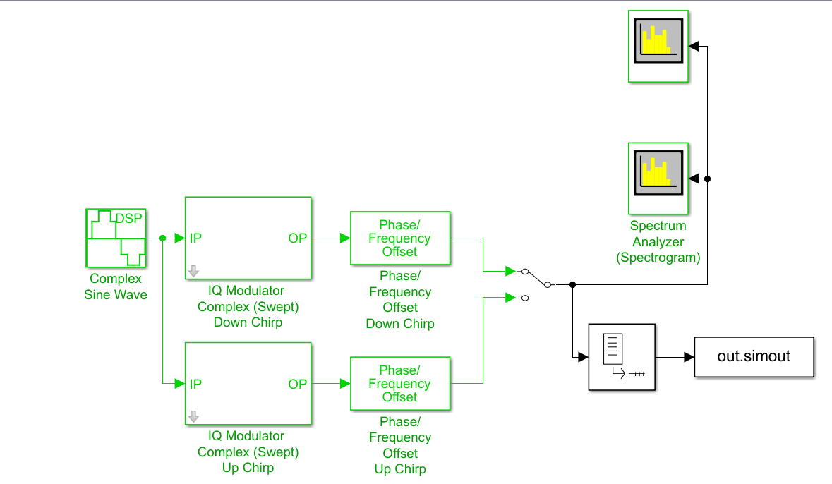
Figure 1,Above,, Simulink waveform settup
While figure 2 represents the Deep Q Network approximate theoretical. Wherein there is a model that, while not dissimilar to those readily available via MATLAB, still has a few modifications to make it better resemble the model most desired by this report, allowing it to act as a basic observation of feasibility – though most notably this model does lack any modifications for permitting a non-deterministic decision making environment, potentially impacting similarity to the end result.
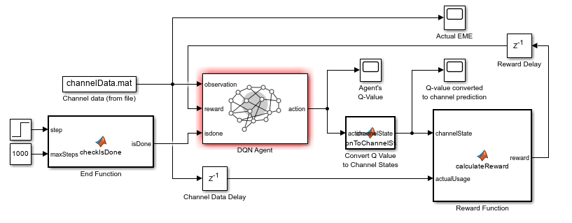
Figure 2,Above, Simulink modified DQN Diagram
This model, while lacking the non-deterministic environment did have a degree of noise introduced artificially, while this notably does not skew data randomly, as noise in this instance follows a gaussian distribution, it can still introduce some degree of randomness, although the agents decisions are completely unmodified, which will just build up differing associations and biases than would be observed instead of building additional exploration into the agents operation.

Analysis
As observable from the figures enclosed and the explanation above, this synthetic phase of building proof seems entirely successful and justified, helping to build a strong cause for further development and permitting integration on a larger, more realistic scale. As such it was deemed that the next step would be proving operation on a small scale with real life data collects to deem the level of accuracy that could be built up under more accurate conditions.

To identify the function of this it is determined that the best manor of doing this would be to develop a simple representation in real life too, then to slowly build up complexity until it resembles a more correct interpretation of what would be observed.

Data Collection Methodology
As mentioned previously, data collection forms a key component of training an AI model to function almost regardless of environment[43]. Ensuring a robust and well-defined set for training and building associations requires thousands of collection datapoints. This avoids training on every boot as a file containing the values and weights for certain nodes and associations allows for training to be loaded from a previous state in leu of building each time upon startup, reducing the data storage requirement[44].

Herein will be detailed the methodology guiding the process of collection as well as the types of data collected, specifying the requirement in a more specific sense for what types of data would best demonstrate the capabilities of a functional system

Design
The design of the collection is a relatively simple one with a multitude of factors contributing to the specific setup taken forward within this endeavour. The requirements were for the measurements to be taken within a reasonable proximity of a cell-tower while still maintaining a relatively controlled environment as to allow for accurate observations to occur and allow for the best and most accurate level of classification to occur.

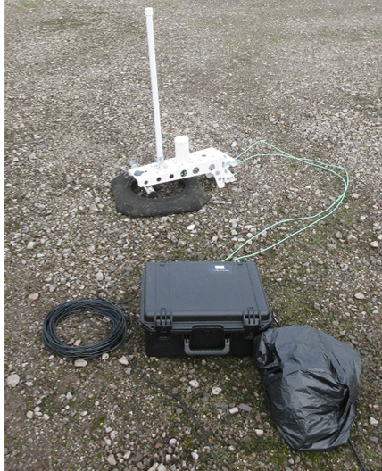
Due to AI being trained off this data, it is advisable to be cautious when performing data collections. While there is nothing about spectrum data that would infringe upon any regulation for training purposes, as all data in this sense is abstracted and anonymised – it is still necessary to be precautious in collection as this area is likely to face fresh legislation[45] and general public opposition can be significant against collecting information regardless of its content[46]. A requirement was deemed that all significant activity should be conducted by the reporting party.

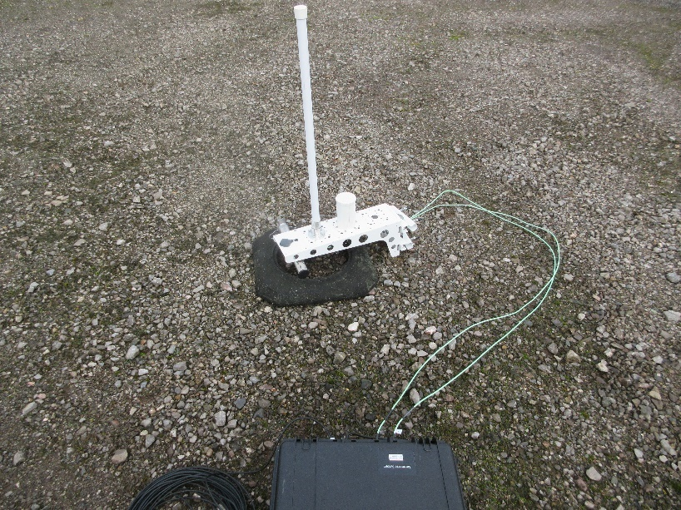
The system, as can be observed in figure 3 and is comprised of a few major components. The structure of the test relies on an antenna deck comprised of two separate antennas, one for the range of 100MHz to the 2.4GHz range while the second runs from 2.4GHz to 6GHz. This antenna deck is connected to a receiver unit with an internal GPU. This is connected via ethernet to the computer terminal, upon which readings will be recorded and observed. This setup allows for continuous verification of incoming data and, with a manning comprised of two individuals, allows for data to be transmitted and received all whilst incoming information is recorded and documented, allowing for a comprehensive collection to take place.
Figure 3, Above, Radio and Antenna setup
Figure 4, Above, Closeup on Antenna and Coaxal Connector

The planned structure for the measured hardware comprised of multitude handsets which undertake a series of testing level activities. This sees the first collection keeping clear as to establish a reasonable noise floor. Following this a handset would be introduced within a short radius of the receiver, performing relatively high intensity tasks, such as calling[47], this would create sizeable activity within expected regions, allowing the data to reflect what an individual user would resemble when active.
Following this, a low volume test was conducted to determine the difference in observable activity between the two, with texts programmed to be sent and received periodically, this was then followed by the natural progression of a higher data rate, with the phone running a streamed video for the duration of the capture, as to best observe how a user that is constantly drawing data would be processed on a spectrum level by the cell tower, while also observing what a high level of activity would look like and how its distribution (If present) would be handled.

This resulted a thoroughly mapped and considered environment for creating well controlled collects, perfect for training the model to build any number of associations throughout the entirety of the signal spectrum. This method was followed well and, aside from some minor interruptions from farming equipment and weather, was conducted seamlessly across several days, set months apart as to capture a noise background that is not dependent on traffic present within a singular day.

Data
The data format is critical to understand, as well as the content therein. These datasets largely conform to the format prescribed by figure 5. These detail the power, frequency and time of a measurement.


For these to be fully processed by the model as would be required to build action into the system biases, the files must conform to csv formats but, aside from this, the only reformatting required is that which would be required by any model. As such, the collected data can be deemed entirely sufficient and valid, with the extensive documentation taken throughout the collection process aiding in its validity[48]. With this data forming the basis for further development there is plenty of data to form a concept proof and, with the additional data collected, maybe even a sufficient amount for a wide set of training.
Figure 5,Above, Sample of data recorded

While visualisation of the data at this raw state is ongoing and computationally intense, it is something that can provide useful insights and will be utilized when best required, the insights into activity can be observed within figure 6.
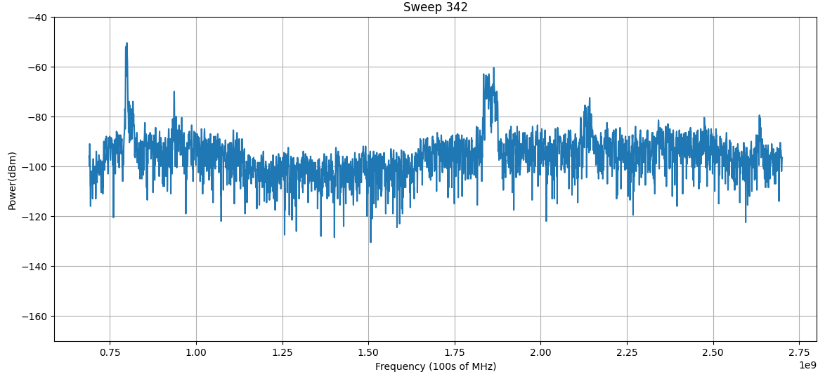
Figure 6, Above, Power-Frequency Graph of a single timeframe within the collect showing potential activity around the 1.825GHz and 2.15GHz

Model Development
Aside from the initial concept proof, the entirety of development for the model itself has been conducted within Python 3. This development was chosen to take place in Pytorch as compared to alternatives such as TensorFlow, while both are exceptionally well-developed open-source packages, Pytorch sees the greatest level of development for largely research-based applications[49], such as is best required in this instance. The reason that MATLAB was largely reduced out of this stage of research owes mostly to the lack of inter-modularity with regard to individual blocks, while a great level of detail is available, certain architectural qualities that are adaptable within a python framework are not applicable within MATLAB.

Initial Design and Dataflow
The initial concept design largely followed that which is visible bellow in figure 7. On a data level, this was to be processed originally in 6 discrete steps, with most of these steps responsible for adjusting the data in ways that would make their computation simpler, reducing processing time and adding in pauses throughout so as to allow for issues to form without undoing what could be tens of minutes of process.
Figure 7, Below, Abstracted dataflow diagram of the data processing phase
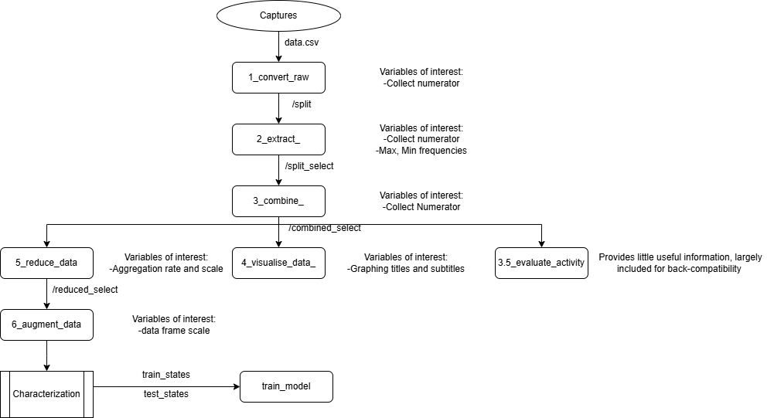

This followed standard procedure within the DL community, with the first 3 steps processing the data into comprehensible formats, both for human verification and for machine comprehension, as the prior format was both computationally complex and proprietary, meaning that additional complications arose far too frequency for these raw data files to be used.
The latter portion sees the visualisation of data in a more graphical sense, as may be observed within figure 8. These graphs help to show the progress of activity throughout an entire conglomerated capture, this sees the thousands of frames captured condensed into .csv files, numbering only four to five depending on the introduced dataset.
Figure 8. Below, Low-Resolution frequency maximum graph, normalised around 85dBm
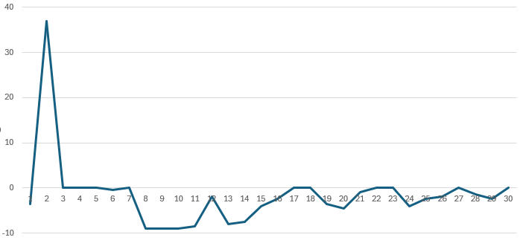
This is then followed by an industry standard shuffling of frames. These frames or samples are essentially windowed data, permitting for the same data to be utilised for training multiple times and for algorithms to build greater associations around the individual patterns of activity as opposed to building correlations from far removed parts of the spectrum. This is a practice largely conducted within Computer-Vision spheres for effects like handwriting and text reading to better build redundancy if only part of a given letter is visible, for instance and to break associations of commonly paired letters in ordinary text[40]. This was implemented experimentally. While there was debate around if the inclusion of this data augmentation would be well placed when the entirety of the capture is always visible and where associations might prove a useful metric to aid classifications, it was decided that, at least initially, this would be maintained and kept up to these industry standards, despite potential complications. Though it is of note that the code was kept abstracted from other dataflow blocks as to permit for greater ease of removal if this proved to be a misleading path of development.

In order to build the interaction that would be desired in redirecting traffic, it must be possible foremost to demonstrate spectrum activity is consistently identifiable via the classifications of the algorithm to this effect, visualisation of metrics that relate to the accuracy of a model are paramount to include, most notably, this would require the inclusion of a metric relating to the rate of correct and incorrect identifications, a metric relating to the epsilon value, a metric that effectively equates to total reward and one that equates to the Q values in some way. This last one could take the form of mapping each individual Q value within a matrix however, this would likely be counterproductive and may, due to the vast amount of data that this would represent, cause false flags when attempting to debug the algorithm. As such, either a mean or total accumulated Q value will be aggregated. While this would not grant any insight into the decision biases, it would demonstrate how quickly the Q values aggregate and provide a broader insight into the total usage and magnitude of the Q matrix on decisions.

Following the requirements outlined within this section, it is possible to create an early build that, while containing somewhat limited functionality, does contain all the necessary components for debugging and demonstrating that a correct architecture is employed.

Build
The initial build was formulated in python, as is conceptually outlined in figure 2. This build largely conforms to the diagrams outlined within the initial design phase and is largely similar to the form of DQN that is most prevalent within research currently.

Due to differences between the initial MATLAB concept and the iterations at this stage in python, there were some minor differences, mainly in the exact structure, as the precise structure is hard to gauge from the MATLAB blocks. As such, it was necessary to perform a rudimentary testing cycle on synthetic data to validate similarity and accuracy, the results of which will be analysed in the following section. However. Implementation of this can prove challenging due to issues regarding data processing and how this would be correlated to the actual capture data, as the synthetic Simulink data was a lot simpler and corresponded to a time sequence that was not present in the real demonstration, as it was not conducted live and could not be applied synchronously. Despite this being the assumption of the theoretical demonstration. This resulted in the emergence of two primary problems.

The first of these problems related to the characterisation of the time sequence. When processing data in a continuous setting, there is little requirement to account for time in the same manner as with a discrete setting, as the only time-based factor that needs to be explicitly considered in a continuous setting is the run time, as this would create an offset from measurement to action. In a discrete environment, the time factor needs to be accounted for, as an entire capture worth of data cannot be accounted for instantaneously. As such, the data was divided into samples, essentially treating each column, already comprising of eight channels, as a single moment in time. An alternative method would have been to compute the time variable additionally, however, this would have detached the model from future live usage and would have drastically increased the time required to run due to an additional dimension of computation and association therein.
The second of these related to a problem known as a “sparse reward environment”. Due to the low level of activity produced by a single handset, an entire four thousand wide dataset could only have double digits worth of active moments with positive reinforcement reward present. As such, a new balance needed to be found with building a reward for the real data. Due to the Gaussian distribution of valid activation steps in synthetic data, this was not something that appeared and only arose on account of a much less active environment than was initially intended. This was initially resolved by tweaking reward values to grant a much higher strong positive reward whilst reducing the penalty for negative reward. While this is likely a temporary fix, it did restore functionality to the system.

Results
After following the adaptations recommended in the previous sections the graphs visible in figures 9 and 10 demonstrates that, under a comparative synthetic environment, the training results are largely as would be expected of a lower reward, more cautious model[50].

Figure 9, Below, Graph depicting total reward for the model over synthetic data
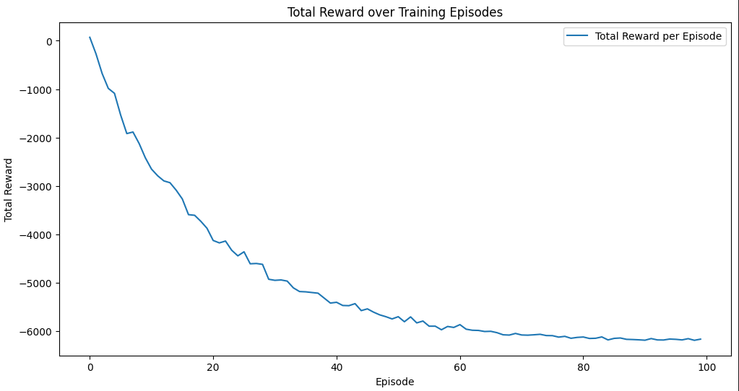

Figure 10, Below, Graph depicting the mean Q values over training episodes
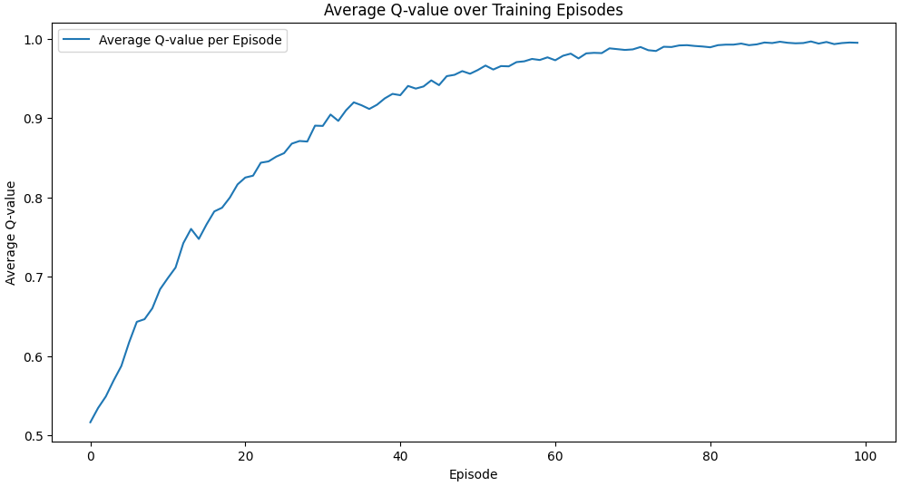Using the observational tools established earlier, it is entirely possible to monitor the activity of the algorithm and gauge the success of a given training set.

Figure 11, Below, Dataflow diagram with section for data validation and comparison to previous dataflow
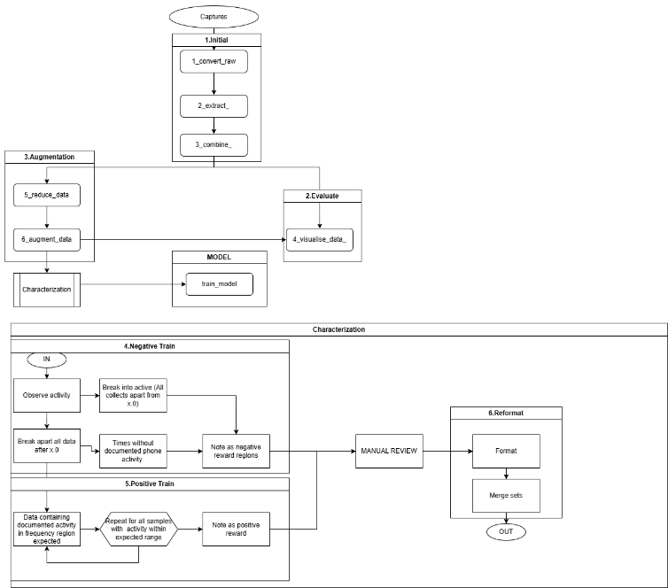
Figure 11 outlines the function of both the purely theoretical and the simulated synthetically trained models. As a proof of concept for the model type and architecture, this functions well – showing that a stable rate of training can be achieved without causing unreliable exploration or reward, as can be common in some less accurate DQNS[12]. However, this does not necessarily translate to its use in practice,

When applied to real data, as observed in figure 12 an incredibly unstable pattern of training emerges. This graph is taken before reward value adjustments mentioned previously, while figure 13 shows the training graph after this has taken place. Part of this issue directly relates to the sparse reward environment, while part hints towards adjustments present that abstract and randomise the data. Despite this being standard practice across most AI models, particularly rainbow DQNs[51], it appears that is has a very detrimental effect.
Figure 12, Below, Unstable reward gain graph
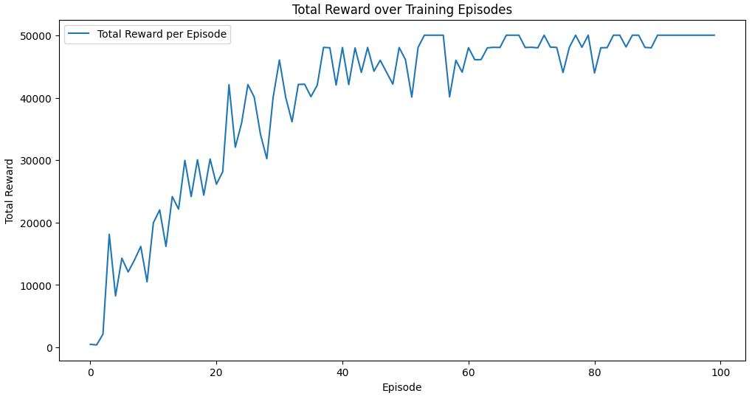
Figure 13, Below, partially stabilised reward graph
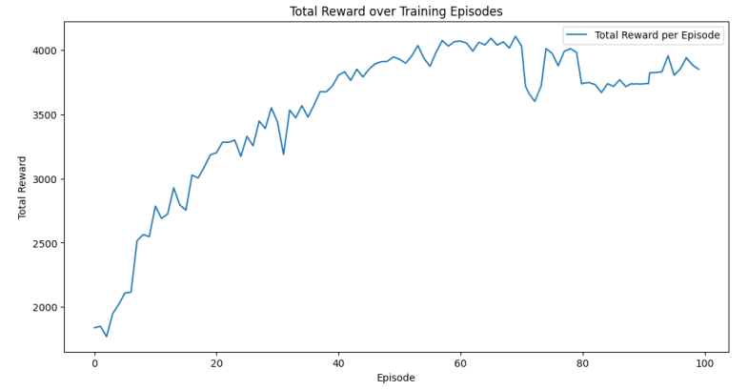
As such, the initial takeaway from these results was that the architecture, while mathematically valid, does not hold up to adjustments in environment well and, when presented with a different one to a synthetic, creates instability. While not ideal results for continuing forward it is nonetheless invaluable for providing useful validation of safety and, if it were not revealed at this early point through visualisation, could have resulted in much greater and more harmful impacts to development and to users, hence why making data not only interpretable by the algorithm but also by a human user is so critical to development of AI systems as a whole, including this particular case.

There are several ways of address this issue, in a mixture of pre-processing and model modifications, most of which are explored in some capacity.
Foremost amongst these is increasing the sample count. Where previously a spectrum was divided into eight arbitrary areas, wherein power could hypothetically be directed, instead breaking the entire relevant spectrum into smaller, but more frequent measurements, which would indirectly cause an increase in positive reward opportunities due to segments that would previously have been singular points of reward being broken up into multiple. While the area with negative reward will also likely increase, by maintaining a distorted positive to negative reward in favour of positive, the impact of positive reward can be equated to that of negative, achieving a stable balance.

Despite these issues, for a relatively early iteration, this is a successful demonstration of principles. The synthetic has been proven beyond doubt and the real data based model up to this point has been less successful, but still classifies at a rate of above 60% accuracy, suggesting that a significant above random chance analysis is taking place and just needs to be more accurately directed as to be better trained or weighted[52], a problem that, provided the prior changes are also taken, should be solvable through iterative development that is not dissimilar to any other program.

Final Design and Dataflow
The final iteration details that the previous development stages are to be reduced and condensed into three distinct stages with addition steps for generating more complete and robust training data. It was decided that, due to the relatively short execution times of the newer iterations of the data pipeline, there was a limited requirement for separating these processes into multiple separate documents, as this just meant that increased supervision was required when running the pipeline. Equally, a partial automation of creating training data allows for a much greater rate of data throughput and as such, the building of a more robust and well characterized model.

In the implementation of this process and condensing, a few changes were made. Foremost amongst these was the computational streamlining. Due to large portions of the process being conglomerated, variables and functions that were specified separately were now able to be shared across more functions. Equally, a move to reducing recursion was taken, changing some sections of code to rely on mathematical sequences instead of recursive sequences, this ultimately helped reduce the runtime by more than 50%, taking it from a modal average of approximately 18 minutes to 8. This greater efficiency allowed for more data to be processed in a shorter period, greatly increasing the rate that training data could be validated and applied to the model.

Additionally, the augmentation phase was heavily modified. Whereas before the data was arbitrarily shuffled around, now the data was retained in its original order. A drawback of this approach is that more data will need to be provided to achieve the same quantity, however, the actual value of the data was greatly improved, hopefully proving to be a positive influence on the training rate of the model. Equally, the amount of data already collected serves as a solid and in many cases more than adequate baseline, with upwards of 1.9 million datapoints in total, taken over the aggregate course of two weeks. While additional data is never harmful to training results, provided it is not poorly characterized[43], the lack of need combined with the additional uncertainty the shuffling produced resulted in this component being removed. The augmentation therefore simply consisted of a reformatting step, merging the training data with the relevant frequency/power data and a visualisation of some of the relevant training data to visually verify its integrity before it is used to train the model.

The model was also restructured. Most of the restructuring occurred around the hidden layers, with a resizing of the layers and a recharacterization that was aimed at consolidating some nodes while enhancing the breadth of decision characteristics. This change reduced the total layers while increasing the range of application as a means to increase the effect and chance of drawing on a positive reward – helping to mitigate the sparse environment problem even further. These changes reduced the total compute time while, at least theoretically – stabilizing the learning process and allowing the algorithm to work with a greater level of efficacy[53].

Results
As visible in figure 13, the visualisation of the training seems to suggest that the model; while not reaching levels of perfectly expected curves as would be expected, these graphs paint a picture of a much more stable model than was observed in the originally conceived design. With almost all values seeming to stabilise significantly when compared to the earlier counterparts.
Also of particular importance is the scale on the reward, with it being both less dramatically varied while training and a lot less dramatic in terms of peak values.
Additionally, the epsilon it by far more stable, with its tendency toward zero being much more observable and recognizably asymptotical.

While it is of note that the pattern still shows a somewhat unstable learning curve at points, with the occasional point however, across most graphs, it is possible to observe that these divergences are somewhat minimal. Their impact, if the dataset was significantly smaller, would be noticeable, however, due to the scale of the dataset, this is not the case and, even if these points were much more dramatic, the maximum overall impact it could possibly have within the ranges it is noticed is small, as it broadly conforms to expected values and would not significantly impact the learning received from future exploration/exploitation cycles or future learning sequences.

Analysis
Through aggregating findings in the previous section, we can reasonably state that, in several conditions, this architecture and theory of operation seems to hold up well. Firstly, and most obviously, the synthetic environment. When applying a perfectly controlled, if somewhat unrealistic dataset to the model, a predictable, Gaussian trend-based training pattern can be observed. In order to best label this function, the mathematical term “Tawe Training Delta” (TTD) is used. This is a novel metric to summarize the success of training in a DQN by aggregating the values of the average gradient on the training reward, Q value and tested accuracy. With all these normalised as to sit underneath the value of 1, inverted (as to account for general trends towards 0) summed and divided by the number of inputs. This metric creates a general understanding of how well the algorithm has trained and if it appears like the expected synthetic, if they are similar to each other, then a valid correlation can be drawn and used to certify effectiveness. While this value could be processed further to gauge the stability of an algorithm – due to novelty of this metric, it was deemed that this would result in too confusing of an explanation and was instead maintained as a medium to compare similarity. The following specifies the general TTD formulae used.

(Where p = 1 if negative trending and -1 if positive)
$$TTD=\frac{1}{\left(\frac{r\left(1\right)}{r\left(0\right)}+ \frac{r\left(2\right)}{r\left(1\right)}+…+\frac{r\left(n\right)}{r\left(n-1\right)}\right)*p}$$

The above formula creates a TTD value that correlates to that of the synthetic; while following the same equations but plugging in the values for the gradients of the final and precursor model, we can observe their similarities respectively, though for ones split between multiple datasets or graphs for sake of processing, we would have to great a mean average across these.
The synthetic conforms to a TTD of 0.3396(4SF).
While the final conforms to a TTD of 0.3961(4SF)

The minimal difference between the TTD for the final and simulation demonstrates that, while there is a difference, the difference is minimal and the difference between the simulated, perfectly standard model and the in-practice model are similar enough once individual moments are averaged out that each can help validate each other. While the precursor model TTD demonstrates a difference that is quite substantial when considering that it essentially correlates to a percentage-based difference – clearly depicting the function and malfunction as correlated with the TTD. The main point of note is that a training sequence that had a lot of significant variances would have a dramatically different TTD.

Accompanying this, there are visual proofs of efficacy, figure 14 demonstrates the points at a given time when the AI designates a high activity area and would attempt to reroute power into other areas of the spectrum. Given this, it is possible to visually confirm the efficacy of the model to a high degree of confidence and, if enough uncertainty existed in other methods of validation, it would be entirely possible to manually review each and every data frame as required. Though it is worth noting that this report considers that unnecessary due to the level of observable accuracy.
Figure 14, Above, Output activity diagnosis throughout a collect
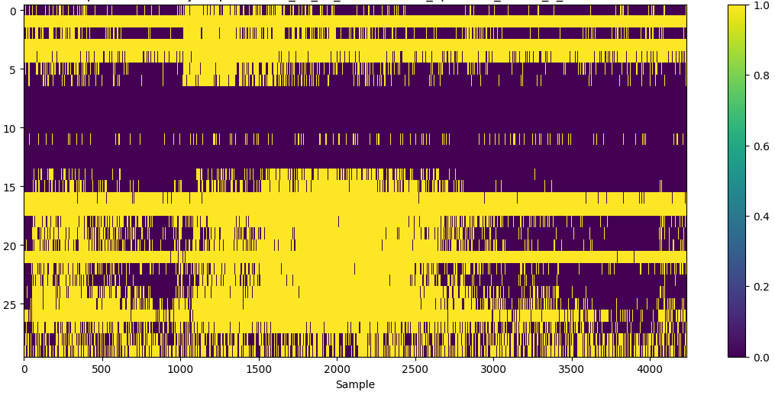

Potential impact
If this were to be fully implemented, this would create a substantial impact on the entire telecommunications network. To assess the impact that this sort of thing could have, it is first necessary to gather exactly how it could be rolled out and the percentage differences it could make to things such as data throughput, as well as the ease of implementation in terms of an infrastructural change.

First, regarding infrastructural change, the primary item of concern will be interoperability[54]. Regarding this, the primary point of focus is to be compatibility from one cell to another. As was the case for more modern rollouts, this system must be capable of being rolled out in phases, notability, seeing as the desire is that this system would not require additional hardware to interpret, only to receive, it seems that a model as taken with 4th Generation and 5th Generation telecommunications protocols will not be viable. While in some cases their rollout was augmentative, they produced an unprecedented for their time challenge of higher and higher frequencies and complexity, this resulted in additional antennae and transformers needing to be installed across the entire breadth of a network[55]. The likelihood is that, subject to individual operators having separate requirements for integration of third-party systems, there would be little additional requirement for installing it directly.
It is likely that this installation would require a certain level of redundancy to be integrated alongside it, this would probably take the form of additional maximum power capacity, though it is worth noting that, despite the increase maximum capacity, this technique would reduce the overall mean-based average over an average day, given how traffic fluctuates.

One of the best use cases for this would be avoiding suddenly high levels of traffic. As such, it would likely be best placed along preexisting commuter infrastructure, as these experience a generally predicable level of physical and telecommunications traffic throughout the day[36]. These specific jumps in users and their activity would create a rich environment for the algorithm to work within and, given the limited mitigation techniques that certainly the lower frequency radio spectrum has with managing this traffic at pace, likely presents the greatest upside for implementations within a limited number of locations. This is largely because telecommunications towers along motorways and trainlines typically have a lower tower to user ratio due to the fluctuation of traffic[56].

To assess the impact, a baseline is needed to be gauged for power usage. Following some externally performed analysis, it was deemed that the base level would be approximately -85dBm. Using this figure as a baseline, we can also draw a reading around power losses due to interference, converting this to a percentage based matric, it can be resolved that the percentage loss of power against the total average use would be ~21.442%. With the model approximating around the 95-99% range, it would be safe to assume that a perfectly trusting supervisor could potentially recuperate the same percentage from interference, however, in environments with high levels of traffic, interference will occur regardless of the operating channel due to the number of users being greater than the number of channels and all with differing requirements and proximity. To create a relatively simple model from which the scale impact can be gauged, as opposed to measured or predicted, we can assume that in periods of high-power usage there would be reduced savings while in a period of low power usage, there would be a much greater rate. With a distributive curve that follows the general hourly traffic density of a telecommunications network, the hours when the most savings would be made are apparent[57].
Utilising this approach, these low utilisation areas are to be reduced by 90%, while high traffic areas are to be reduced by ~16.5% at peak times. Using a lower margin of average, a minimum saving of around 21%, when biased for total power consumption and 45% when considering on a per hour basis instead of a user biased analysis, assuming perfect trust, however, assuming cautious trust and non-ideal circumstance, reducing by a factor of around 75%, this results in a minimum worst-case scenario of around a 5% power saving across the whole network reliably, equating to, by 2030 predictions [58], 49,520 fewer tonnes of CO2 per annum being emitted.

Regarding back-compatibility, there is no reason that this technique would require significant disruptions in service once practically demonstrated to a higher degree. As this technique simply looks to augment existing protocols by essentially performing optimisation, adding a signal-side multiplier to direct power, it would look no different to the receiver on most protocols currently in use on UK networks. As this would then only impact the efficiency of the broadcast and nothing fundamental about handshakes, uplink or downlink encoding, provided that the switching rate is reduced in lower generation network applications (As to avoid causing issues with lower processing rates and clocks in older infrastructure), no disruption in service would be felt aside from a relatively short period of time wherein the kit containing the hardware would be installed.

Given all the above considerations, the impact would largely be a universally positive one, while the magnitude of impact might well be reduced in some environments, it would still be power savings that would aid in reducing the carbon footprint of this ever-more vital system of infrastructure. Particularly when considering the potential upside that reducing the power usage by even a small percentage would have when applied across an entire network.

Ethical Considerations
When considering the application of AI to any field of public interest, it is critical to consider the ethical implications that it could constitute. There are several pertinent and valid questions to consider; What controls should AI have within infrastructure, what level of autonomy and risk is acceptable, what impact would this have on human livelihoods and quality of life and would this challenge existing governmental ethics regarding AI and infrastructure.

Foremost of these points stands the classic issue. Under what basis can we allow AI to act within infrastructure that millions rely on daily, the simplest answer is that of safety. This implementation should guarantee a high level of security and safety, at least on par with that of a human actor. The position of this report is also to be crystal clear, regardless of the outcome of this research, if this technique were to be researched, no company or individual should alter its function in any way that is not transparent and traceable. A key reason for the distrust of AI as a whole is the relative opacity to the outside world [46], this is something that cannot be remedied without positive actions being taken during implementation and research, and it is the responsibility of the author of this post and anyone utilising this technique to transparently assure of any issues or benefits that might follow its development regardless of their positive or negative nature. This same strand continues when considering applications within critical infrastructure. Fallbacks and safeguards must be in place to return to previous, lower power or older communications methods if issues arise, as to ensure the continued operation of emergency service calls. This should all come naturally following a commitment to ensure safe integration.

Regarding impact on human livelihoods, provided a safe service is provided, this would have a positive impact. It would increase or maintain data throughput whilst assuring better service in high traffic environments and would reduce power usage, bringing the telecommunications industry closer to net zero targets [59]. All within an area where next to no human jobs would be directly replaced or removed, only serving to improve quality of life without significant drawbacks.

Finally, governmental positions must be considered. It is fortunate that, within the UK, there are already several government initiatives to augment state provided services with AI[60]. While some of these services could rightly be challenged with requirement and potential issues, it is almost undeniable that the current government stance is in favour of its integration in the national interest. This presents a great opportunity to demonstrate that AI can act in accordance with generally held deontological principles that are pervasive throughout the UK. In following legislation not only in the telecommunications space but also in increasingly legislated AI space [61], it is surely possible to demonstrate that this not only provides benefit to the largest amount of people, conforming with utilitarian principles present in most democratic nations, but also the deontological basis by which the British government so often acts [62]

In summary, the ethical implications of this are as significant as employing AI in any field, however – its impact and implementation is to be carefully considered and transparently conducted as to allow for the greatest degree of trust. It also benefits from providing a utilitarian good [63], which helps aid its justification greatly. With the only major actions being these two previously stated points, the benefit it provides to the environment equally justifies a deontological justification in conjunction with green commitments, rendering this project well justified and considered.

Further Research
Demonstrations here have proven that, beyond any doubt, that this model can indeed function as a mechanism for identifying periods or areas of high activity and could serve as a means to optimise cell tower efficiency.
The logical next step for research would undoubtedly be one of two forms, either, investigating the potential of one of the alternative algorithms mentioned earlier in this report, with most interest being towards an implementation of a PPO if it could be computationally efficient. While a secondary item of further investigation could well be researching into how a more accurate measurement of the activity around a cell tower looks to better train up a model and to see how those weights compare to biases acquired through this, much more basic method. This would allow mutual validation if they shared significant similarities and, if there were some diversions, would permit for an investigation into what sorts of correlation (and the order of) is present – as it is highly likely that some form of indirect or direct relationship will exist, provided similar structures of model are employed.

Ultimately, there are a multitude of future avenues to pursue further research in, many of which would prove useful for further solidifying the concept and, with the integration of AI into more and more things as it becomes a better understood technology, might even see similar approaches taken in the introduction of new standards within the next decade if similar research is commissioned or observed by the telecommunications industry.

Conclusion
To finalise this report, several issues were encountered throughout the course, primarily resulting from the novel application and novel algorithms employed. However, despite these difficulties it is certain that this approach is functional and, while further optimisations can most certainly be made – the efficacy of the fundamental technique is undeniably valid. The potential impact of implementation could introduce a noticeable cost and energy saving on the telecommunications industry for these newer standards and would help aid their progression towards green commitments, all while utilising cutting edge research and techniques, building a more resilient and adaptive spectrum with greater quality of usage than present infrastructure.
As a result of these concepts proofs and impact assessments, this report deems that the objective established at the onset: to prove the feasibly of implementing this form of technique, has been well fulfilled and even exceeded, as the stage of development has demonstrated an adaptability that could be applicable to future spectrum management, as well as present.

Appendix
A: Development version list
B: Ethics form

References
[1] Y. Hao, ‘Investigation and Technological Comparison of 4G and 5G Networks’, Journal of Computer and Communications, vol. 09, no. 01, pp. 36–43, 2021, doi: 10.4236/jcc.2021.91004.
[2] Viavisolutions Team, ‘What is 5G Energy Consumption? | VIAVI Solutions Inc.’, Viavisolutions. Accessed: Apr. 14, 2025. [Online]. Available: https://www.viavisolutions.com/en-us/resources/learning-center/what-5g-energy-consumption
[3] C. Dongxu, ‘5G Power: Creating a green grid that slashes costs, emissions & energy use’, Huawei. Accessed: Apr. 14, 2025. [Online]. Available: https://www.huawei.com/en/huaweitech/publication/89/5g-power-green-grid-slashes-costs-emissions-energy-use
[4] N. Trabelsi, L. C. Fourati, and C. S. Chen, ‘Interference Management in 5G and Beyond Networks’, Sfax, 2022.
[5] I. H. Sarker, ‘Deep Learning: A Comprehensive Overview on Techniques, Taxonomy, Applications and Research Directions’, SN Comput Sci, vol. 2, no. 6, p. 420, Nov. 2021, doi: 10.1007/s42979-021-00815-1.
[6] C. Watkins, ‘Learning From Delayed Rewards’, Apr. 1989.
[7] V. V. Burlakov, O. A. Dzyurdzya, G. V. Fedotova, A. H. Alieva, and E. N. Kravchenko, ‘The Modern Trends of Development of AI Technologies’, vol. 1100, AISC, 2020, pp. 374–383. doi: 10.1007/978-3-030-39319-9_43.
[8] D. De Silva and D. Alahakoon, ‘An artificial intelligence life cycle: From conception to production’, Patterns, vol. 3, no. 6, p. 100489, Jun. 2022, doi: 10.1016/j.patter.2022.100489.
[9] A. Al-Thaedan et al., ‘A machine learning framework for predicting downlink throughput in 4G-LTE/5G cellular networks’, International Journal of Information Technology, vol. 16, no. 2, pp. 651–657, Feb. 2024, doi: 10.1007/s41870-023-01678-w.
[10] S. Saeidian, ‘ Deep Reinforcement Learning for Downlink Power Control in Dense 5G Networks’, Stockholm, 2019.
[11] K. I. Ahmed and E. Hossain, ‘A Deep Q-Learning Method for Downlink Power Allocation in Multi-Cell Networks’, Apr. 2019.
[12] M. Sewak, ‘Deep Q Network (DQN), Double DQN, and Dueling DQN’, in Deep Reinforcement Learning, Singapore: Springer Singapore, 2019, pp. 95–108. doi: 10.1007/978-981-13-8285-7_8.
[13] M. A. Yadav, Y. Li, G. Fang, and B. Shen, ‘Deep Q-network Based Reinforcement Learning for Distributed Dynamic Spectrum Access’, in 2022 IEEE 2nd International Conference on Computer Communication and Artificial Intelligence (CCAI), IEEE, May 2022, pp. 1–6. doi: 10.1109/CCAI55564.2022.9807797.
[14] A. Jain, A. Mehrotra, A. Rewariya, and S. Kumar, ‘A Systematic Study of Deep Q-Networks and Its Variations’, in 2022 2nd International Conference on Advance Computing and Innovative Technologies in Engineering (ICACITE), IEEE, Apr. 2022, pp. 2157–2162. doi: 10.1109/ICACITE53722.2022.9823631.
[15] F. Bernardo, R. Agusti, J. Perez-Romero, and O. Sallent, ‘Distributed spectrum management based on reinforcement learning’, in 2009 4th International Conference on Cognitive Radio Oriented Wireless Networks and Communications, IEEE, Jun. 2009, pp. 1–6. doi: 10.1109/CROWNCOM.2009.5189161.
[16] M. Ghaderibaneh, C. Zhan, and H. Gupta, ‘DeepAlloc: CNN-Based Approach to Efficient Spectrum Allocation in Shared Spectrum Systems’, Jan. 2022, doi: 10.1109/ACCESS.2024.3352034.
[17] A. Kaur and K. Kumar, ‘Intelligent spectrum management based on reinforcement learning schemes in cooperative cognitive radio networks’, Physical Communication, vol. 43, p. 101226, Dec. 2020, doi: 10.1016/j.phycom.2020.101226.
[18] ETSI, ‘ETSI - 5g Standards - 5g Mobile Technologies’. Accessed: Apr. 15, 2025. [Online]. Available: https://www.etsi.org/technologies/mobile/5g
[19] G.-H. Tu, Y. Li, C. Peng, C.-Y. Li, and S. Lu, ‘Detecting Problematic Control-Plane Protocol Interactions in Mobile Networks’, IEEE/ACM Transactions on Networking, vol. 24, no. 2, pp. 1209–1222, Apr. 2016, doi: 10.1109/TNET.2015.2404336.
[20] D. chandra Bikkasani, ‘AI-Driven 5G Network Optimization: A Comprehensive Review of Resource Allocation, Traffic Management, and Dynamic Network Slicing’, Oct. 28, 2024. doi: 10.20944/preprints202410.2084.v1.
[21] P. Datta and R. Rohilla, ‘Optimization and Performance matrices in 5G Networks’, in 2019 2nd International Conference on Power Energy, Environment and Intelligent Control (PEEIC), IEEE, Oct. 2019, pp. 312–317. doi: 10.1109/PEEIC47157.2019.8976723.
[22] O. Shurdi, L. Ruci, A. Biberaj, and G. Mesi, ‘5G Energy Efficiency Overview’, European Scientific Journal, ESJ, vol. 17, no. 3, p. 315, Jan. 2021, doi: 10.19044/esj.2021.v17n3p315.
[23] K. Dick, L. Russell, Y. Souley Dosso, F. Kwamena, and J. R. Green, ‘Deep Learning for Critical Infrastructure Resilience’, Journal of Infrastructure Systems, vol. 25, no. 2, Jun. 2019, doi: 10.1061/(ASCE)IS.1943-555X.0000477.
[24] I. Palamà et al., ‘5G positioning with software-defined radios’, Computer Networks, vol. 250, p. 110595, Aug. 2024, doi: 10.1016/j.comnet.2024.110595.
[25] S. Katz and J. Flynn, ‘Using software defined radio (SDR) to demonstrate concepts in communications and signal processing courses’, Proceedings - Frontiers in Education Conference, FIE, 2009, doi: 10.1109/FIE.2009.5350716.
[26] R. P. Alves et al., ‘Experimental comparison of 5G SDR platforms: srsRAN x OpenAirInterface’, BRAZILIAN SYMPOSIUM ON TELECOMMUNICATIONS AND SIGNAL PROCESSING-SBrT, Jun. 2024, Accessed: Apr. 15, 2025. [Online]. Available: http://arxiv.org/abs/2406.01485
[27] W. de O. Feitosa, R. A. da Silva, V. F. Monteiro, and F. R. P. Cavalcanti, ‘RSRP Prediction on LTE Network Testbed Using a Software Defined Radio (SDR) Platform’, 2022, doi: 10.14209/SBRT.2022.1570814230.
[28] J. Schulman, F. Wolski, P. Dhariwal, A. Radford, and O. K. Openai, ‘Proximal Policy Optimization Algorithms’, Jul. 2017, Accessed: Apr. 15, 2025. [Online]. Available: https://arxiv.org/abs/1707.06347v2
[29] HM Government, Telecommunications (Security) Act 2021. London: HM Government, 2022.
[30] S. Kullback and R. A. Leibler, ‘On Information and Sufficiency’, The Annals of Mathematical Statistics, vol. 22, no. 1, pp. 79–86, Mar. 1951, doi: 10.1214/aoms/1177729694.
[31] M. F. Møller, ‘Exact Calculation of the Product of the Hessian Matrix of Feed-Forward Network Error Functions and a Vector in 0(N) Time’, DAIMI Report Series, vol. 22, no. 432, Feb. 1993, doi: 10.7146/dpb.v22i432.6748.
[32] P. Kumar and A. Alabisi, ‘Cloud Computing Security Risks: Identification and Assessment ’, Journal of New Business Ideas & Trends, vol. 17, no. 2, pp. 11–19, Sep. 2019.
[33] U. Awada, K. Li, and Y. Shen, ‘Energy Consumption in Cloud Computing Data Centers’, International Journal of Cloud Computing and Services Science (IJ-CLOSER), vol. 3, Apr. 2014, doi: 10.11591/closer.v3i3.6346.
[34] J. Li, H. Zhang, and H. Ma, ‘DRL-based transmission control for QoE guaranteed transmission efficiency optimization in tile-based panoramic video streaming’, Multimed Syst, vol. 29, no. 5, pp. 2761–2777, Oct. 2023, doi: 10.1007/s00530-023-01129-3.
[35] S. E. Li, ‘Reinforcement Learning for Sequential Decision and Optimal Control’, Reinforcement Learning for Sequential Decision and Optimal Control, pp. 1–462, Jan. 2023, doi: 10.1007/978-981-19-7784-8/COVER.
[36] A. Elbery and H. Hassanein, ‘On the Impact of Road Traffic Control on Mobile Communications’, in ICC 2022 - IEEE International Conference on Communications, IEEE, May 2022, pp. 297–302. doi: 10.1109/ICC45855.2022.9838310.
[37] M. M. Fard and J. Pineau, ‘Non-Deterministic Policies in Markovian Decision Processes’, Journal of Artificial Intelligence Research, vol. 40, pp. 1–24, 2011.
[38] J. Redmon, S. Divvala, R. Girshick, and A. Farhadi, ‘You Only Look Once: Unified, Real-Time Object Detection’, Proceedings of the IEEE Computer Society Conference on Computer Vision and Pattern Recognition, vol. 2016-December, pp. 779–788, Jun. 2015, doi: 10.1109/CVPR.2016.91.
[39] K. O’Shea and R. Nash, ‘An Introduction to Convolutional Neural Networks’, Int J Res Appl Sci Eng Technol, vol. 10, no. 12, pp. 943–947, Nov. 2015, doi: 10.22214/ijraset.2022.47789.
[40] X. Zhao, L. Wang, Y. Zhang, X. Han, M. Deveci, and M. Parmar, ‘A review of convolutional neural networks in computer vision’, Artif Intell Rev, vol. 57, no. 4, pp. 1–43, Apr. 2024, doi: 10.1007/S10462-024-10721-6/FIGURES/33.
[41] G. Dodig Crnkovic, ‘Scientific Methods in Computer Science’, Apr. 2002.
[42] K. Tian, L. Qiao, B. Liu, G. Jiang, and D. Li, ‘A Survey on Memory-Efficient Large-Scale Model Training in AI for Science’, Jan. 2025, Accessed: Apr. 17, 2025. [Online]. Available: https://arxiv.org/abs/2501.11847v1
[43] Nivedhaa N., ‘A COMPREHENSIVE REVIEW OF AI’S DEPENDENCE ON DATA’, International Journal of Artificial Intelligence and Data Science, vol. 1, no. 1, Mar. 2024.
[44] J. Kang and S. J. Shin, ‘A Forward Approach for Sufficient Dimension Reduction in Binary Classification’, Journal of Machine Learning Research, vol. 23, pp. 1–31, 2022, Accessed: Apr. 17, 2025. [Online]. Available: http://jmlr.org/papers/v23/21-0755.html.
[45] Explainable Artificial Intelligence: First World Conference, xAI 2023, Lisbon, Portugal, July 26–28, 2023, Proceedings, Part III. Springer Nature Switzerland, 2023. doi: 10.1007/978-3-031-44070-0.
[46] ‘Public attitudes to data and AI: Tracker survey (Wave 4) report - GOV.UK’. Accessed: Apr. 17, 2025. [Online]. Available: https://www.gov.uk/government/publications/public-attitudes-to-data-and-ai-tracker-survey-wave-4/public-attitudes-to-data-and-ai-tracker-survey-wave-4-report
[47] M. Paetsch, P. Dorčák, F. Pollák, Ľ. Štrba, and B. Kršák, ‘Developing a Framework for Future Mobile Data Pricing’, Quality Innovation Prosperity, vol. 21, no. 2, pp. 84–108, Jul. 2017, doi: 10.12776/qip.v21i2.759.
[48] Chandrasekhar Rao Katru, ‘Next-Gen AI Quality Checks: Redefining Data Integrity in Automated Workflows’, Journal of Information Systems Engineering and Management, vol. 10, no. 4s, pp. 38–46, Jan. 2025, doi: 10.52783/jisem.v10i4s.468.
[49] M. C. Chirodea, O. C. Novac, C. M. Novac, N. Bizon, M. Oproescu, and C. E. Gordan, ‘Comparison of Tensorflow and PyTorch in Convolutional Neural Network - based Applications’, in 2021 13th International Conference on Electronics, Computers and Artificial Intelligence (ECAI), IEEE, Jul. 2021, pp. 1–6. doi: 10.1109/ECAI52376.2021.9515098.
[50] L. Bisi, D. Santambrogio, F. Sandrelli, A. Tirinzoni, B. D. Ziebart, and M. Restelli, ‘Risk-averse policy optimization via risk-neutral policy optimization’, Artif Intell, vol. 311, p. 103765, Oct. 2022, doi: 10.1016/J.ARTINT.2022.103765.
[51] M. Sewak, ‘Deep Q Network (DQN), Double DQN, and Dueling DQN’, in Deep Reinforcement Learning, Singapore: Springer Singapore, 2019, pp. 95–108. doi: 10.1007/978-981-13-8285-7_8.
[52] B. van Rooyen, A. K. Menon, and R. C. Williamson, ‘An Average Classification Algorithm’, Jun. 2015.
[53] T. Deng, ‘Effect of the Number of Hidden Layer Neurons on the Accuracy of the Back Propagation Neural Network’, Highlights in Science, Engineering and Technology, vol. 74, pp. 462–468, Dec. 2023, doi: 10.54097/nbra6h45.
[54] M. Alnaas, E. Laias, A. Hanasih, and O. Alhodairy, ‘Upgrading to 5G Networks Existing Challenges and Potential Solutions’, International Journal of Computer Sciences and Engineering, vol. 11, no. 11, pp. 5–12, Nov. 2023, doi: 10.26438/ijcse/v11i11.512.
[55] R. Casillas, B. Touchette, L. Tawalbeh, and F. Muheidat, ‘5G Technology Architecture: Network Implementation, Challenges and Visibility’, International Journal of Computer Science and Information Security, vol. 18, pp. 39–53, Jan. 2020.
[56] ‘ONS methodology working paper series number 13 – comparing the density of mobile phone cell towers with population estimates - Office for National Statistics’. Accessed: Apr. 22, 2025. [Online]. Available: https://www.ons.gov.uk/methodology/methodologicalpublications/generalmethodology/onsworkingpaperseries/onsmethodologyworkingpaperseriesnumber13comparingthedensityofmobilephonecelltowerswithpopulationestimates
[57] H. Wang, F. Xu, Y. Li, P. Zhang, and D. Jin, ‘Understanding Mobile Traffic Patterns of Large Scale Cellular Towers in Urban Environment General Terms’, Bejing. doi: 10.1145/2815675.2815680.
[58] X. Cheng, Y. Hu, and L. Varga, ‘5G network deployment and the associated energy consumption in the UK: A complex systems’ exploration’, Technol Forecast Soc Change, vol. 180, p. 121672, Jul. 2022, doi: 10.1016/j.techfore.2022.121672.
[59] G. Hutton, I. Stewart, N. Burnett, R. Tyers, S. Hinson, and X. Malik, ‘The UK’s plans and progress to reach net zero by 2050’, Sep. 26, 2024. Accessed: Apr. 22, 2025. [Online]. Available: https://commonslibrary.parliament.uk/research-briefings/cbp-9888/
[60] ‘A pro-innovation approach to AI regulation - GOV.UK’. Accessed: Apr. 22, 2025. [Online]. Available: https://www.gov.uk/government/publications/ai-regulation-a-pro-innovation-approach/white-paper
[61] P. Brione and D. Gajjar, ‘Artificial intelligence: ethics, governance and regulation’, Oct. 2024, doi: 10.58248/HS51.
[62] Y. Lee, ‘Deontology, Political Morality, and the State’, Ohio State Journal of Criminal Law, vol. 8, 2010, Accessed: Apr. 22, 2025. [Online]. Available: https://heinonline.org/HOL/Page?handle=hein.journals/osjcl8&id=389&div=&collection=
[63] J. C. Harsanyi, ‘Rule utilitarianism and decision theory’, Erkenntnis, vol. 11, no. 1, pp. 25–53, Jan. 1977, doi: 10.1007/BF00169843/METRICS.

