

Programme Name: Bachelor of Arts and Business Management
Module Name: Introducing the Modern Workplace
Module Code: LCBB4003

Student’s Name: Stefan Alexandru Dinca
Student’s ID: 2126490

Contents
Introduction 2
Organisational Structure of Tesco Plc 2
Organisational Culture of Tesco Plc 4
Process of Motivating Employees of Tesco Plc at Workplace 500 6
Leadership and Variables of Ensuring an Effective Leadership 6
Employee Motivation in Tesco Plc 6
Challenges of Motivating Employees 7
Recommendations 7
Conclusion 8
References 9

Introduction
The workplace in the modern period is evolving with advanced technologies and other innovations but a modern workplace does not mean only engaging technologies rather it refers to transforming the current internal business system and practices for interacting with their customers, partners, and employees (Temminck et al., 2013). Professional and friendly practice in an organisation pushes a company up ensuring sustainable development because it helps to provide effective motivation to the employees and a motivated employee becomes loyal to the company and provides quality services to the customers. Employee motivation is, directly and indirectly, related to the organisational structure, for example, in a functional organisational structure, an employee tends to do the respective job very efficiently while a mixed structure could create confusion that could demotivate an employee (Wayne and Martocchio, 2019). Along with the organisational structure, the process of leadership is very important to the motivation and the sustainability of an organisation. The following report will be covered organisational structure, culture, employee motivation in the workplace, behavioural management approach, and other analyses and evaluations from the perspective of Tesco Plc. The company, Tesco Plc, is a British multinational grocery and general merchandise retailer. The headquarter of the company is located in England and the main products are supermarket, hypermarket, superstore, and convenience shops chain. One stop, F&F, Booker, Makro, Premier, and others are the major brands of the company and the company is operating in over 20 countries totalling 4,676 shops. In these shops, however, around 367,387 people are working, therefore, these companies will be very relevant to the completion of the report (Tesco Plc, 2022).

Organisational Structure of Tesco Plc
The organisational structure is a process of the following work throughout an organisation which allows groups to work together within their functions to manage tasks (Litterer and Lagins, 2012). There are different types of organisational structures such as
- Functional structure
- Divisional structure
- Matrix
- Team-based and others.
The functional organisational structure is a process of dividing different organisational activities among different groups and some certain persons will be responsible for the certain task and report to the immediate higher command the organisational structure could be termed a bureaucratic organisational structure (Litterer and Lagins, 2012). Divisional structure is a process of dividing the whole task of a company into some divisions and the matrix structure is a combination of functional and divisional organisational structure. These are the major organisational structure followed by companies across the world, however, Tesco Plc's organisational structure could be divided into different segments such as corporate governance, store level structures, head office structure, and others. Corporate governance is related to the organisational structure which refers to the system by which companies are directed and controlled (Blaskova et al., 2018). The responsibilities of the board of governance or directors are to ensure governance of the company and the shareholders appoint a director to lead their company. The board of directors consists of 10 members (Tesco Plc, 2022).
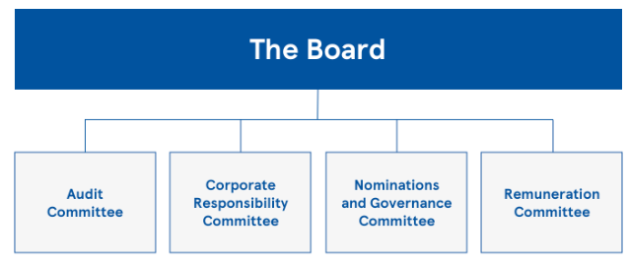
Figure 1: Tesco’s Corporate Governance; Source: (Tesco Plc, 2022)
Now, it is time to focus on the lower-level hierarchy of workflows, and it is seen that the organisational structure of Tesco Plc is very hierarchical as their business is very large. It has been seen that four layers of management in a large store. In the metro, supermarket, and hypermarket, the following organisational structure is seen. The regional manager is on the top while other managers are divided into different segments based on tasks, for example, food trading, non-food trading, personal manager, and others (Tesco Plc, 2022).
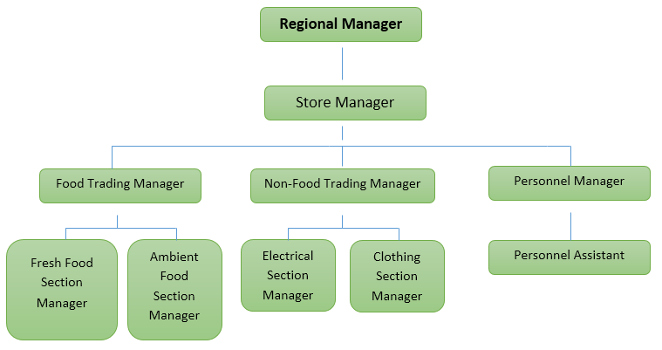
Figure 2: Store Level Organisational Structure of Tesco Plc; Source: (Tesco Plc, 2022)
The above structure could be termed the bureaucratic style of management which refers to the different functional managers will report to their upper-level managers for supervision, for example, the fresh food section manager will report food trading manager and the food trading manager will report to the store manager and the regional manager will supervise store manager, therefore, it has been seen that every type of work is flown to the higher management following a specific type of route that could be termed a hierarchal model of organisational structure (Tesco Plc, 2022). The structure is quite satisfactory to management but it could create complexity, for example, it is very difficult to take quick decisions and it may arise conflicts. Poor communication results in higher costs as well. whichever the scepticism, the organisational structure is widely followed by different organisations like Tesco, Unilever, Amazon, and others.

Organisational Culture of Tesco Plc
Organisational culture is very important in the workplace because it helps to create a comfortable environment within an organisation to work in frequently. When employees get a positive workplace environment, they can unleash their potential and it results in greater output. Organisation culture is predefined guidance or policies which guide the respective authorities to manage employees and it is a complex system which covers the shared values, beliefs, assumptions, and governance (Kang and Kwon, 2018).
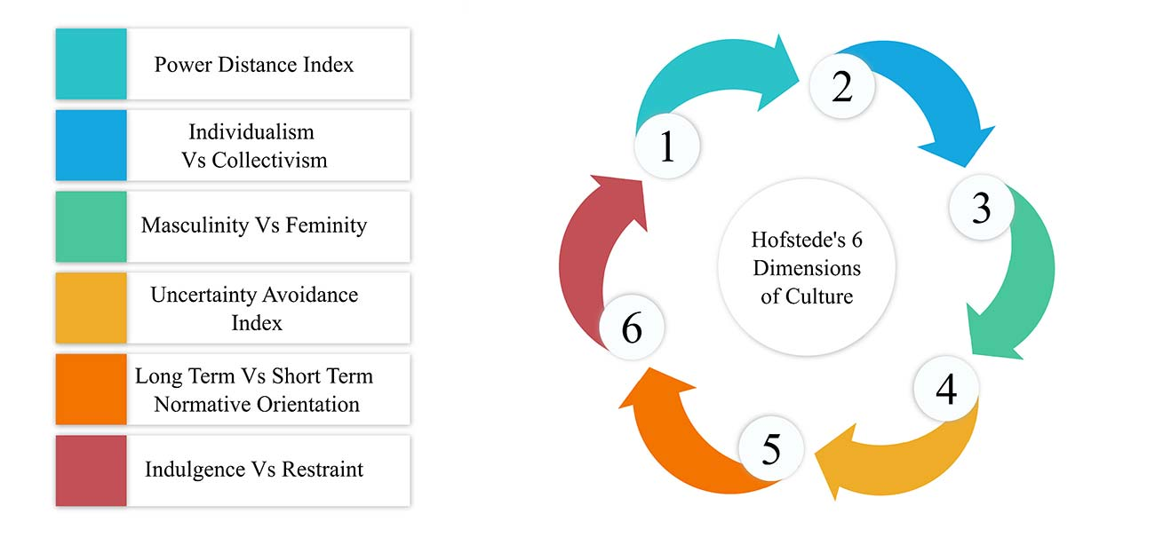
Figure 3: Hofstede Cultural Dimensions; Source: (Kowlanwa and Parkins, 2014)
Hofstede's cultural dimension refers to the six dimensions as power distance index, individualism vs collectivism, masculinity vs femininity, uncertainty avoidance, normative orientation, and indulgence vs restraints (Kowlanwa and Parkins, 2014). The model helps a lot with internationalisation and takes appropriate measures for marketing in a specific region. The performance of Tesco in terms of the power distance index is that the company has a hierarchal organisational structure which helps with visibility and easier access to management. The regional management can take a decision which refers to satisfactory power distribution. Individualism work culture refers to the focus on individual achievement while collectivism culture refers to team achievement. Tesco plc efficiently manages the balance between collectivism and individualism. Tesco regularly encourages their employees to creativity and considers their creativity and performance for promotion. Gender equality is highly maintained by the company and every task is divided equally among the employees and it is seen that the score is very satisfactory. Tesco provides flexibility to their employees and allows them to take fair decisions in urgency, and the management of Tesco has a risk-taking mentality as they believe that no risk no gain proverb. But the management is highly capable of taking calculative risks. In terms of long and short-term normative orientation, the performance of the company is very efficient to ensure long-term goal achievement than short-term goals because they focus on sustainability. A higher indulgence score indicates a culture to be more affording towards people's gratification as well as their happiness and needs. A more restraining culture, on the other hand, indicates a culture governed by social norms and rules. For Tesco, the organizational culture is a healthy mix between the two, with an inclination toward indulgence. Mutual trust is ensured in the organisation and the core value of the organisation is to serve the customer efficiently. Understanding people, customers, and employees and trying to ensure better every day is central to their culture (Tesco Plc, 2022). The company strongly focuses on the customers, communities, employees, and the planet. Workplace diversity, competitive remunerations, a collaborative workplace environment, and others are the major part of the culture of the organisation.

Process of Motivating Employees of Tesco Plc at Workplace

Leadership and Variables of Ensuring an Effective Leadership
Leadership is a process of directing subordinates to achieve a certain goal or objective. On the other hand, it refers to the ability to influence others. Without perfect leadership, an organisation cannot achieve the expected outcome. There are different types of leadership such as autocratic, democratic, laisses-fair, participative, transformational, and others (Cushway, 2014). An efficient leader needs to ensure the proper use of money, time, and resources. And a leader needs to have different characteristics such as the ability to influence others, transparency, calculative risk-taking, integrity, optimism, activity, visionary, and others. Tesco follows the democratic leadership style in its organisation (Cushway, 2014). Every employee of the organisation can share their ideas with the top management which is an important medium of motivation for the employees.

Employee Motivation in Tesco Plc
Motivation is a process of boosting employees’ mindset taking different tactics by the HRM team (Limone and Hasarangan, 2014). A manager or a leader needs to motivate and tie all the employees with a knit to attain success. It increases the performance of employees because a motivated employee can unleash their potential easily. Here, two motivational theories are going to be described which are used in Tesco Plc successfully.
Maslow’s Hierarchy of Needs:
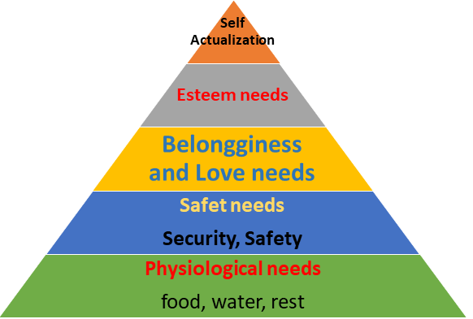
Figure 4: Maslow’s Theory of Hierarchy; Source: (Koys, 2016)
Food, shelter, treatment, and clothes are the basic physiological needs of a man and without them, he or she cannot work well, Tesco plc offers a competitive salary and other incentives which meets their employees’ physiological needs (Koys, 2016). The company is very efficient to provide job security, workplace safety, and a better way of living and taking the steps the company meets employees' safety needs. Providing them appreciation and recognizing their works is possible to ensure their social needs (Koys, 2016). The company provides both formal and informal support to their employee to ensure their self-esteem and actualization needs.
Herzberg Two Factors Theory
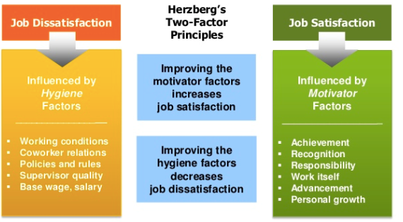
Figure 5: Herzberg Two Factor Theory of Motivation; Source: (Farland, 2014)
Salary, supervisor quality, coworker relations, working conditions, and other hygiene factors are the cause of job dissatisfaction and achievement, recognition, career growth, advancement, and others are the motivating factors and it could be said that improving motivating factors increase job satisfaction (Farland, 2014). Tesco Plc is very careful regarding the two factors and provides due support to their employees whenever necessary.

Challenges of Motivating Employees
The Major challenges for motivating employees are poor communication, clarity and uncertainty, finding faults in others, and others. Most of the cases, it has been seen that the higher authority does not provide clear information to the employees, and for this, the subordinates feel in a fix. Top management of some branches criticizes their employees severely and it creates a complexity of motivation.

Recommendations
The company's performance is satisfactory for motivating employees but sometimes the company fails to ensure due motivation, and for this, the following recommendations could be considered to improve the current performance.
- The behavioural approach of management could be very impressive to improve the performance of the company in terms of employee motivation. The approach focuses on individual behaviour, motivations, and social interactions. Emphasizes training and development of employees, innovative incentives, empowering employees, and others could be taken to manage the behaviour of the employees (Cushway, 2014).
- The management should provide sufficient information and clear direction because the company is facing poor communication problems. Different types of communication models such as Berlo's model of communication, Helical model of communication, and others could be followed by the management of the company (Jackson and Millar, 2017).
- Although the company follow democratic leadership, the company considers the comments of managers which creates a complexity to execution rather the lower level employee could have innovative ideas and the company should provide the opportunity to participate toward all employees in the planning although it will be a time consumable it will bring satisfactory output (Farland, 2014).

Conclusion
Tesco Plc is very proactive to manage its employees with an efficient hand and its organisational structure, culture, values, and others are well-defined and up to the mark. The functional organisational structure is followed by the company which helps a unit to be specialized although it is time-consuming for strategic decision-making. The workplace culture is satisfactory and has already been evaluated using Hofstede's cultural dimension. The democratic leadership style helps the company to motivate its employees. The company is facing some problems in motivating their human resources such as poor communication, clarity and uncertainty, finding faults in others, and others. To solve the problems, the company can follow the behavioural approach of management, ensuring effective communication with employees and management, and a proper leadership style. After following the recommendations, the company will be able to improve its current performance of motivating employees and it could be said that these actions will help the company ensure sustainability.

References
Blaskova, M., Bízik, M. and Jankal, R. (2018). Model of Decision Making in Motivating Employees and Managers. Engineering Economics, 26(5), pp.2–19. doi:10.5755/j01.ee.26.5.8727.
Cushway, B. (2014). Human resource management. 4th ed. New Delhi: Crest Publishing.
Farland, V. (2014). Leadership Challenges in Motivating Employees. SSRN Electronic Journal, 1(1), pp.12–18. doi:10.2139/ssrn.2825798.
Jackson, J.R. and Millar, D. (2017). Barriers To Effective Communication. Journal of Business Communication, 6(2), pp.12–15. doi:10.1177/002194366900600207.
Kang, M.-Y. and Kwon, J.-W. (2018). Hofstede Cultural Dimension Measuring through World Values Surveys. The Institute of Management and Economy Research, 9(2), pp.13–21. doi:10.32599/apjb.9.2.201806.137.
Kowlanwa, H. and Parkins, J. (2014). A replication of Hofstede’s uncertainty avoidance dimension across nationally representative samples from Europe. International Journal of Cross-Cultural Management, 14(2), pp.12–30. doi:10.1177/1470595814521600.
Koys, D.J. (2016). Human resources management and a culture of Respect: Effects on employees' organizational commitment. Employee Responsibilities and Rights Journal, 1(1), pp.18–24. doi:10.1007/bf01385453.
Limone, C. and Hasarangan, W. (2014). Motivating employees to grow up. Employment Relations Today, 27(3), pp.10–26. doi:10.1002/ert.3910270309.
Litterer, G. and Lagins, K. (2012). An introduction to management. 7th ed. Santa Barbara Calif.: Wiley.
Temminck, E., Mearns, K. and Fruhen, L. (2013). Motivating Employees towards Sustainable Behaviour. Business Strategy and the Environment, 24(6), pp.1–12. doi:10.1002/bse.1827.
Tesco Plc (2022). Tesco PLC. [online] Tesco plc. Available at: https://www.tescoplc.com/.
Wayne, R. and Martocchio, J.J. (2019). Human Resource Management. 14th ed. Harlow: Pearson Education Limited.

