TASK 3
Google account

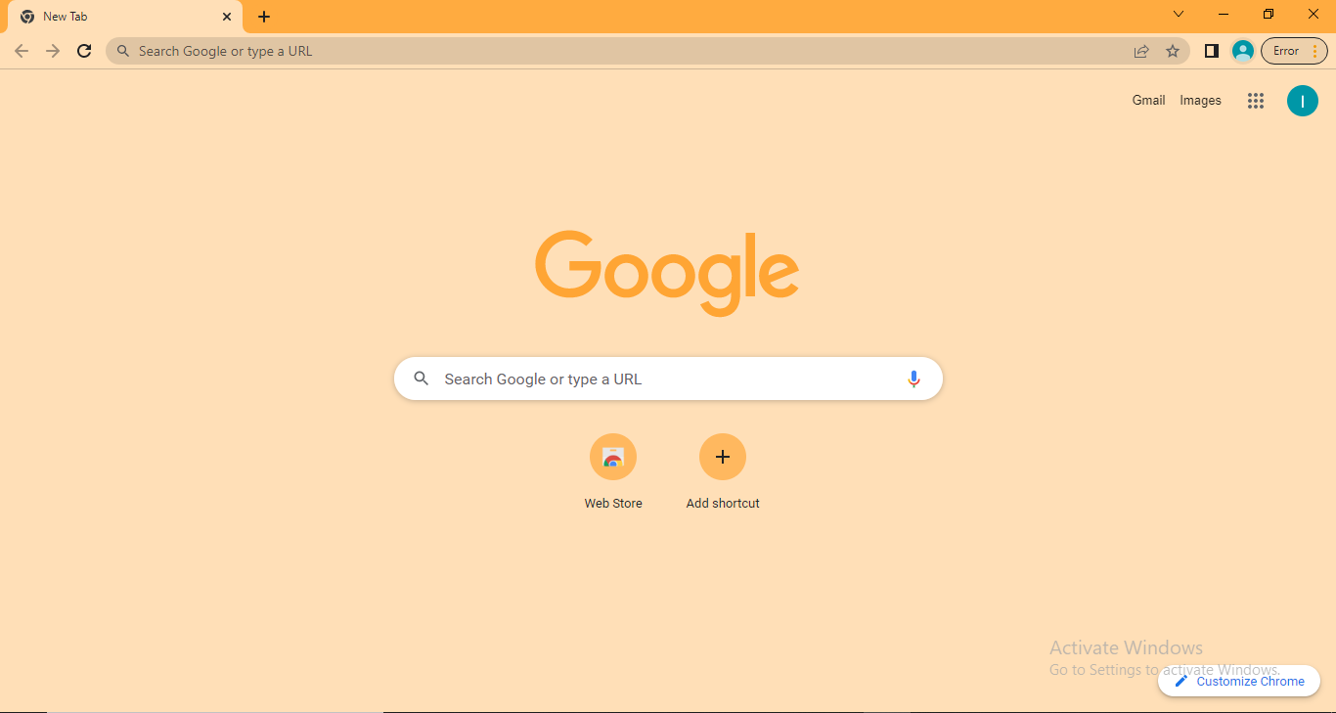
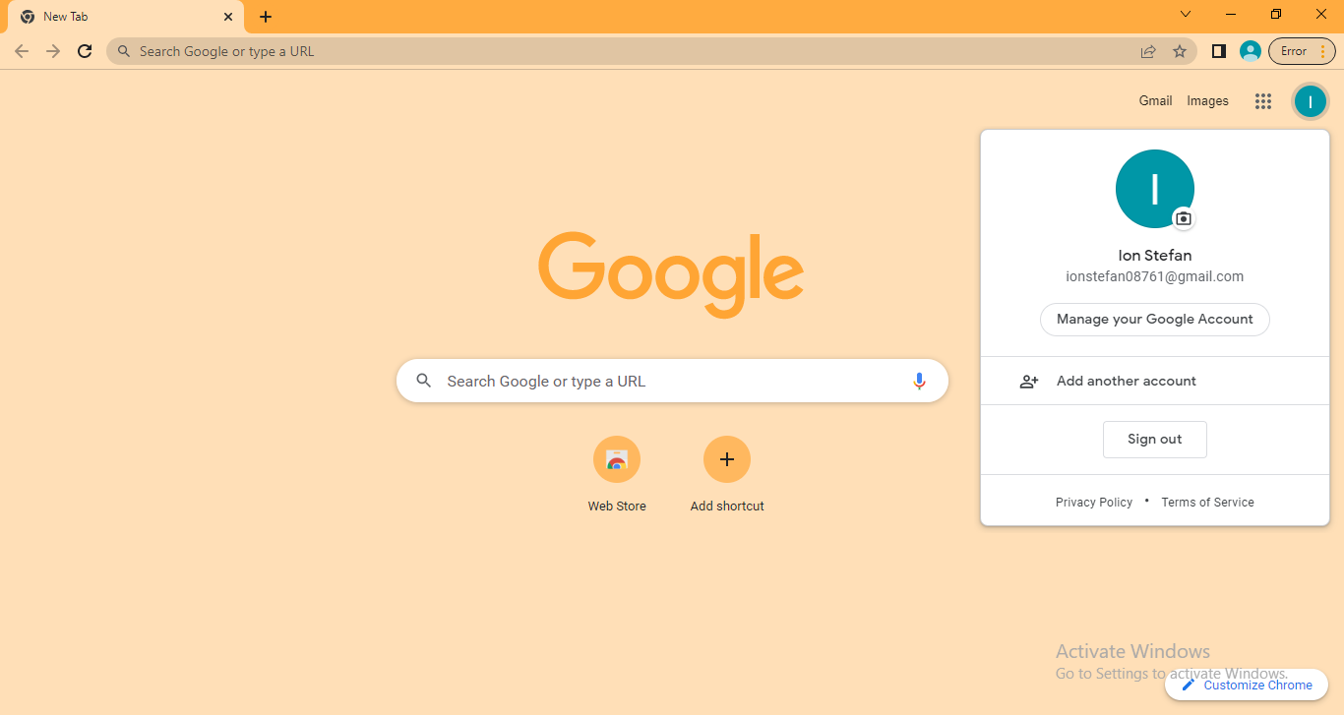
Gmail account
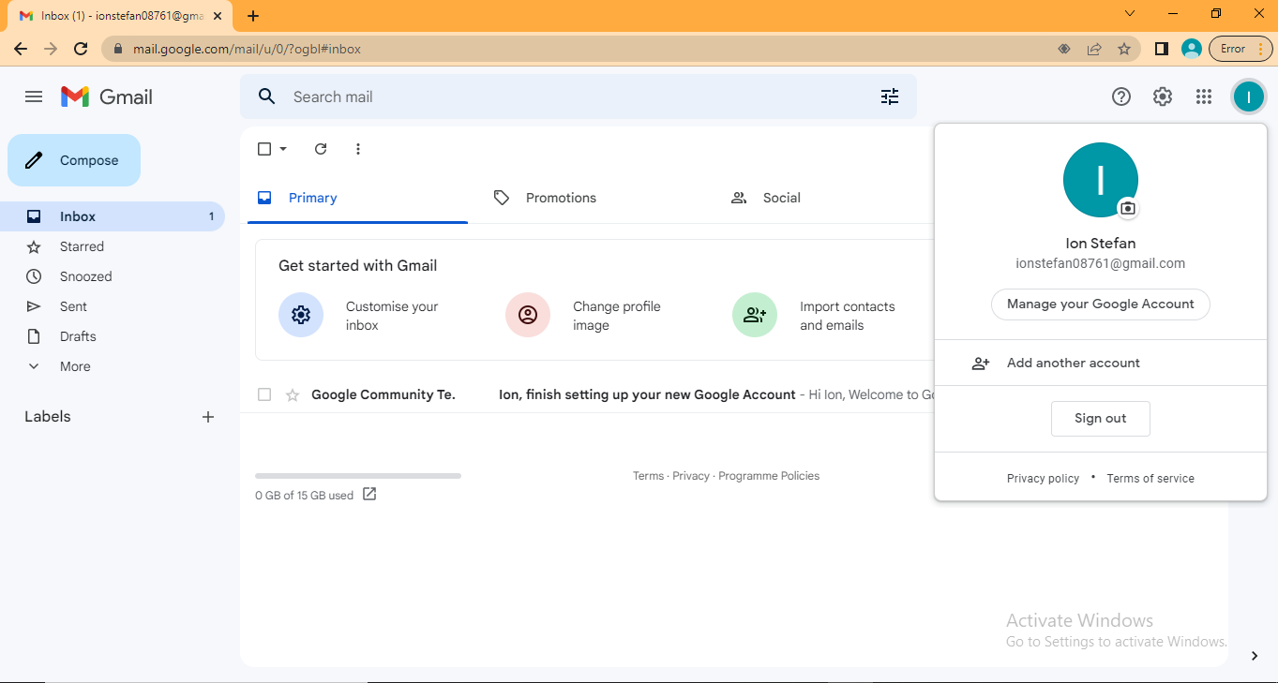
- Connect and collaborate from anywhere with digital tools
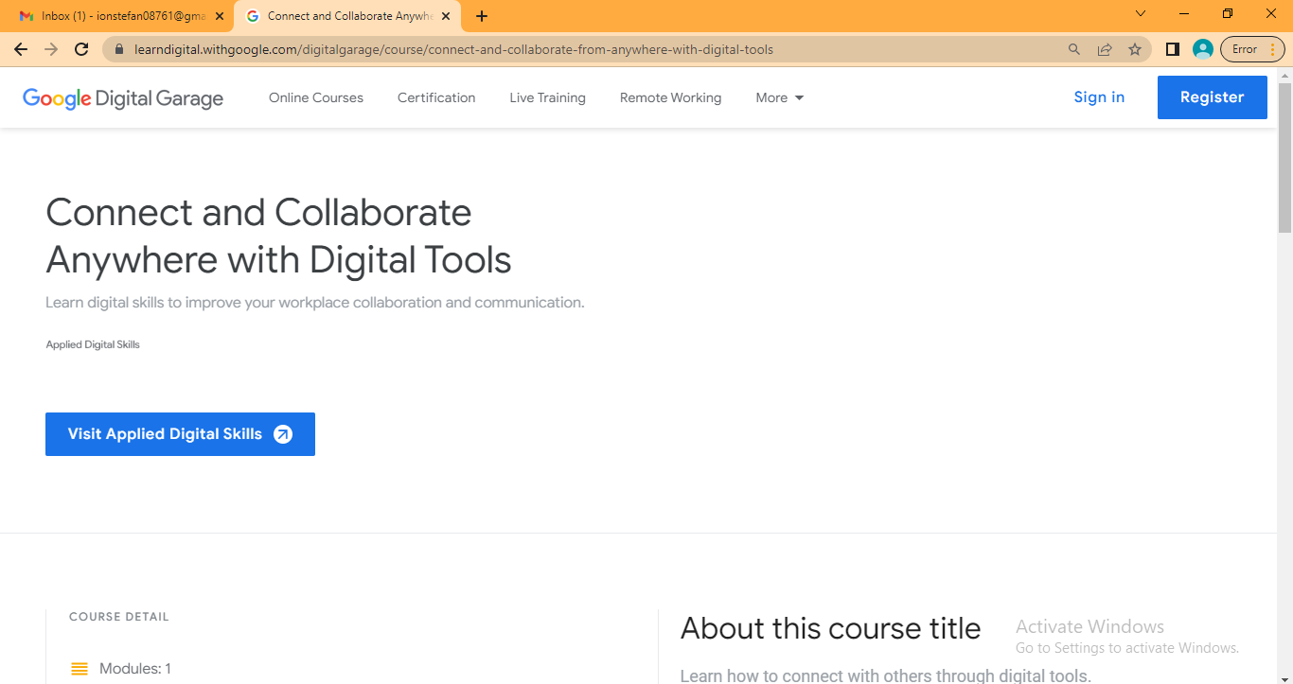
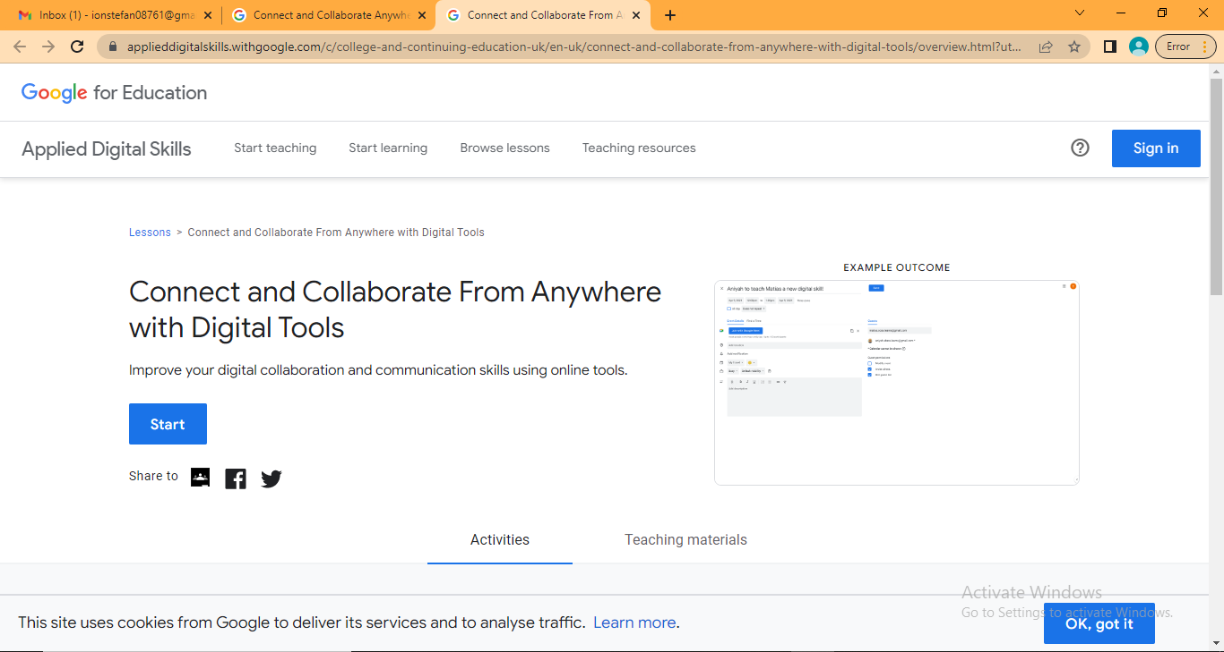

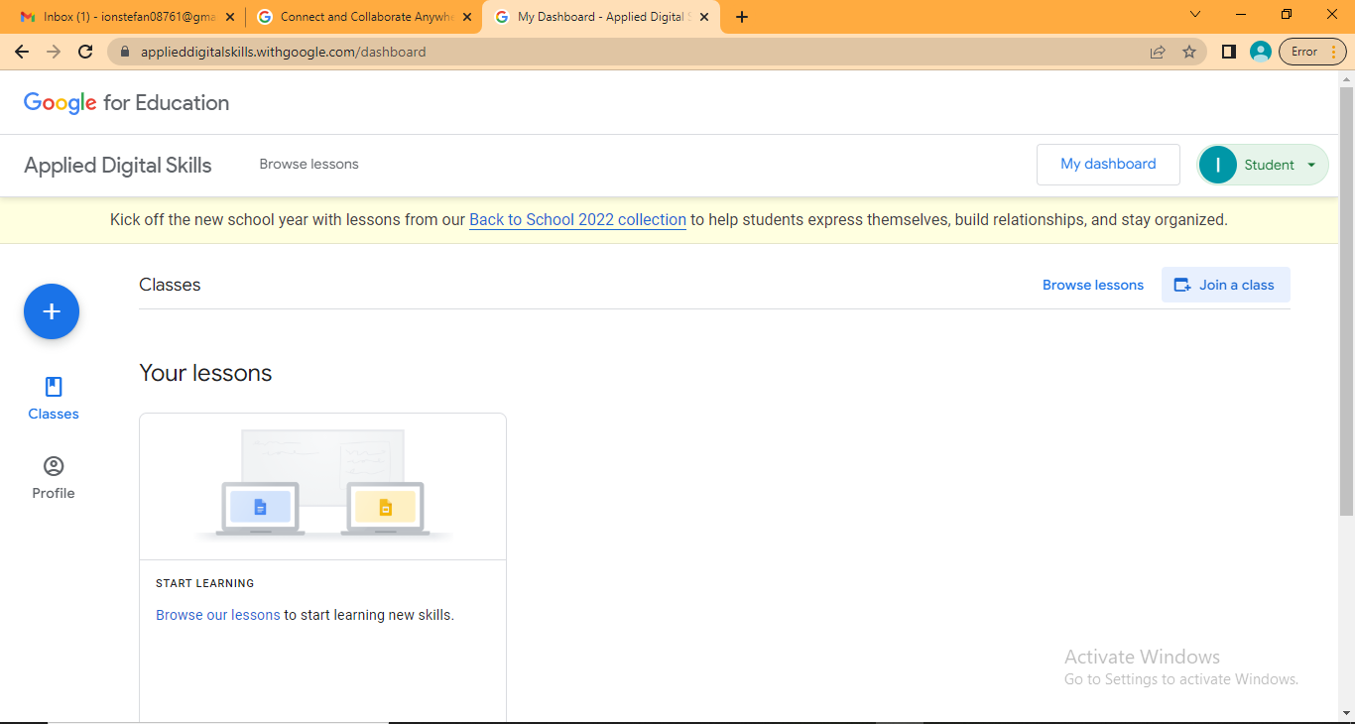
Class 1
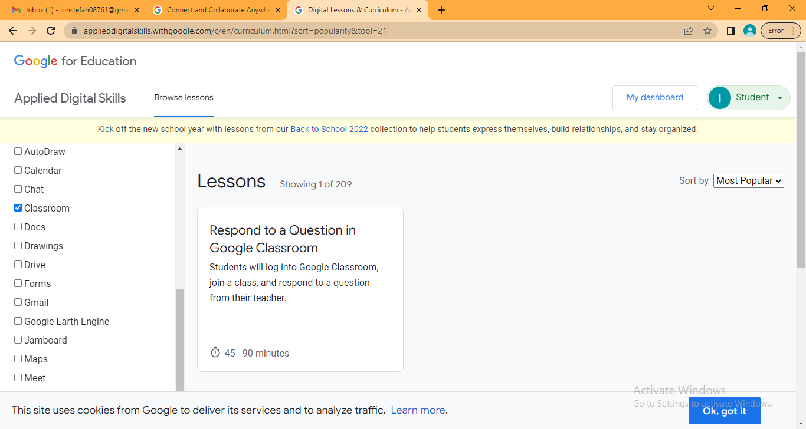
Class 2
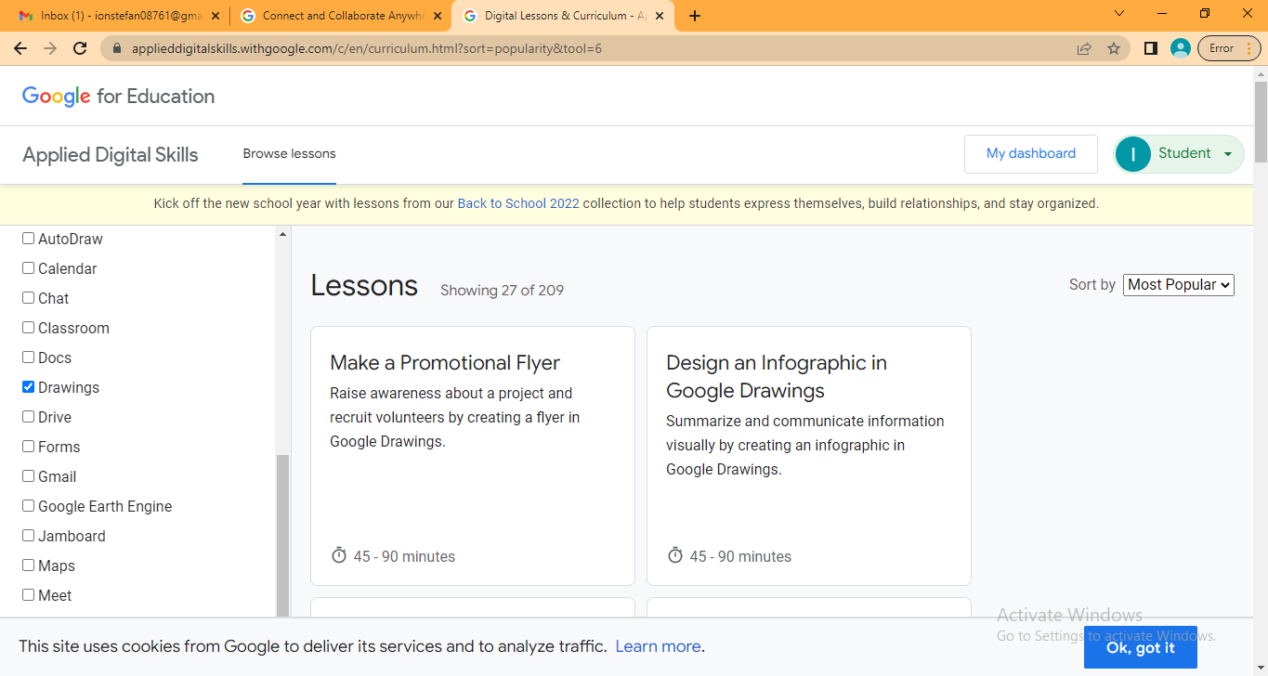
Class 3
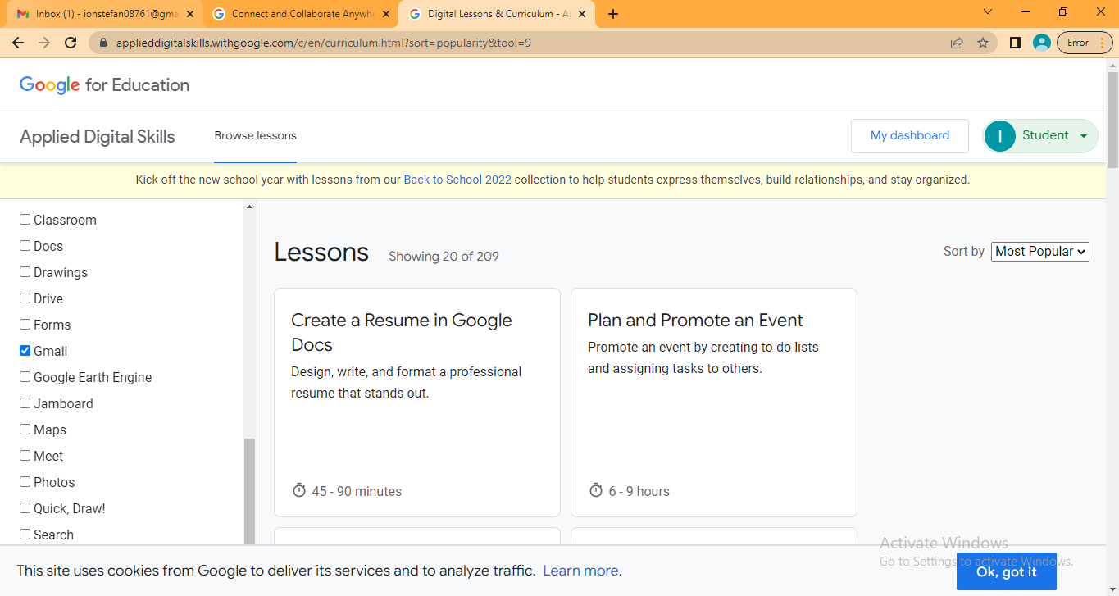
Class 4
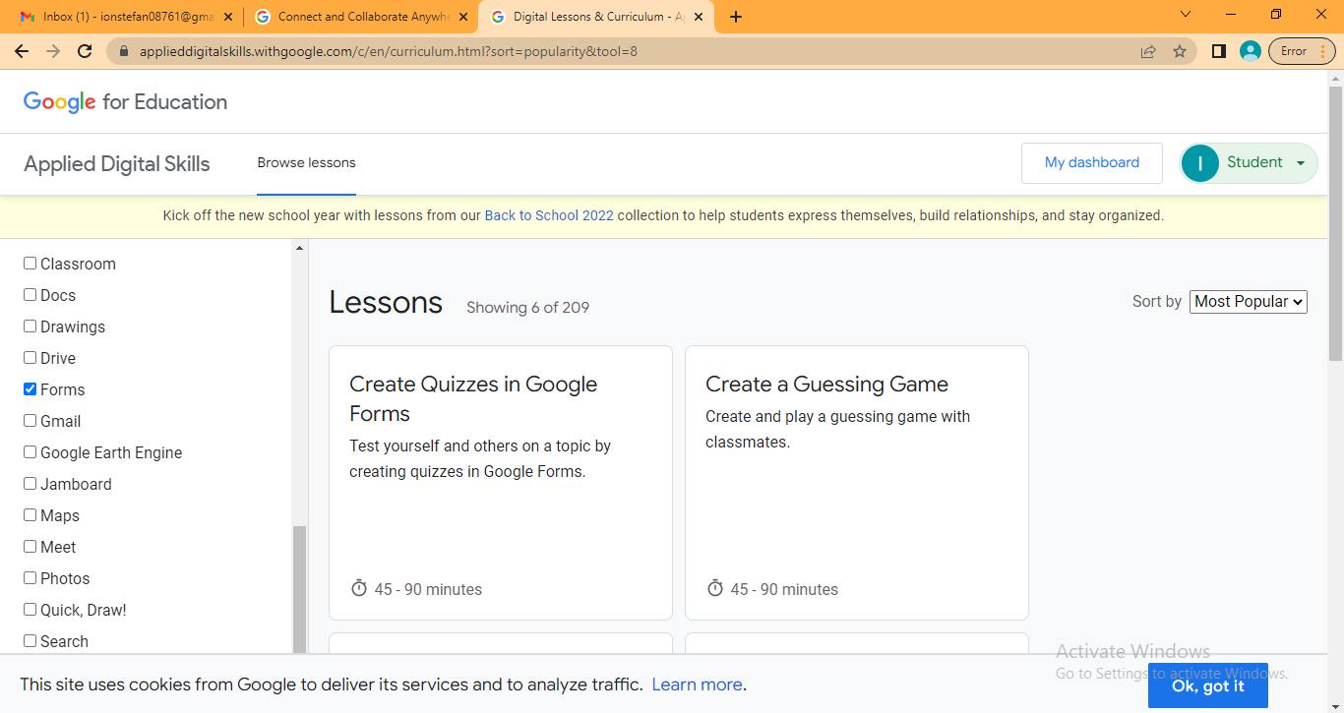
Class 5
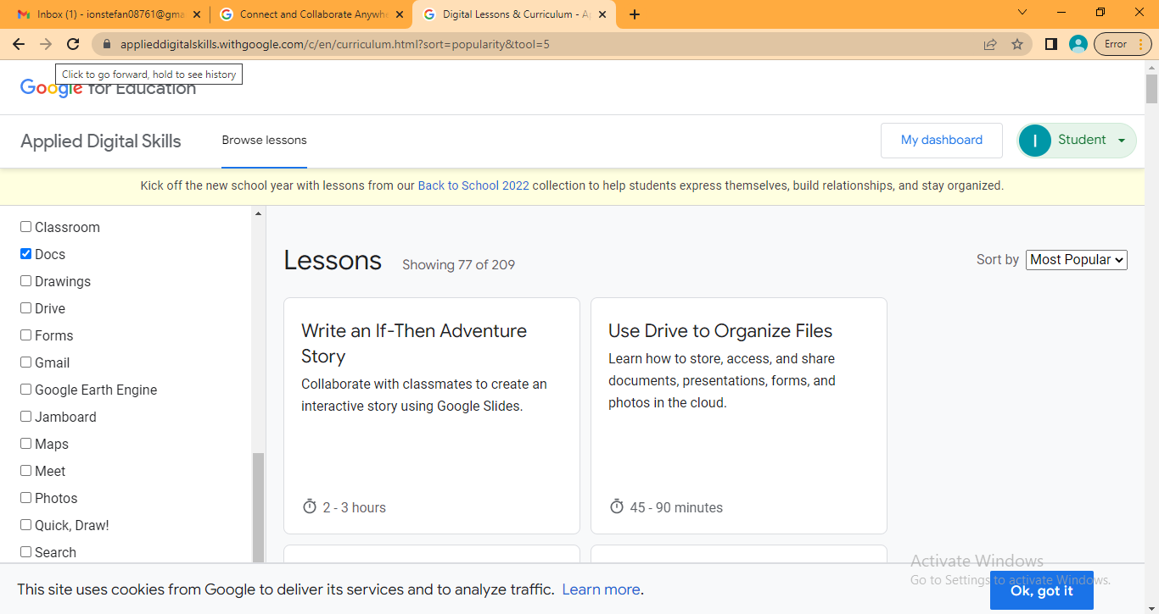

- Structure an argument in a presentation
The argument presented is to setup a healthy environment and comfortable space in the office setup.

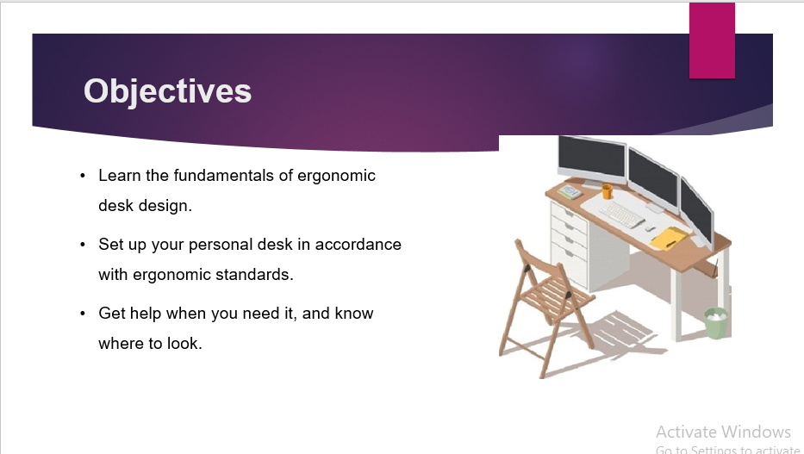

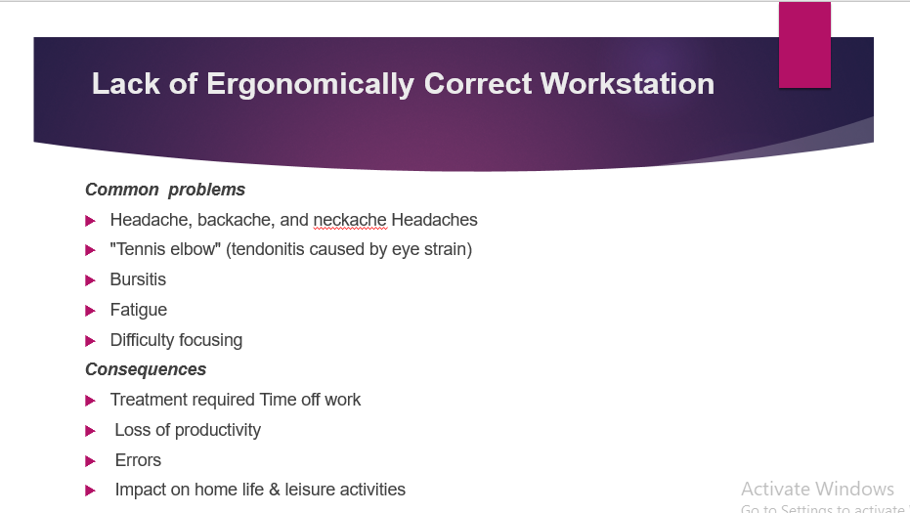
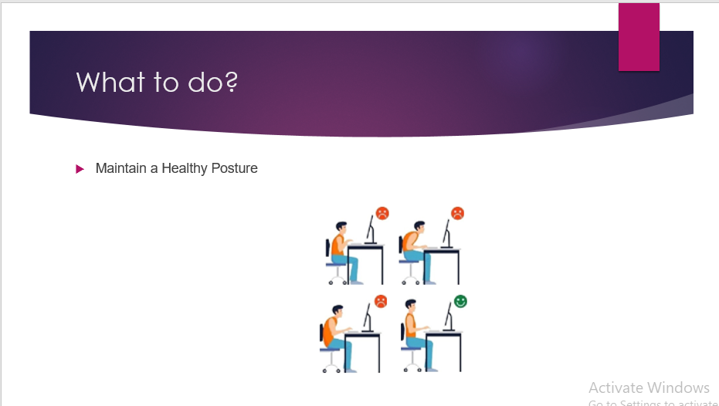
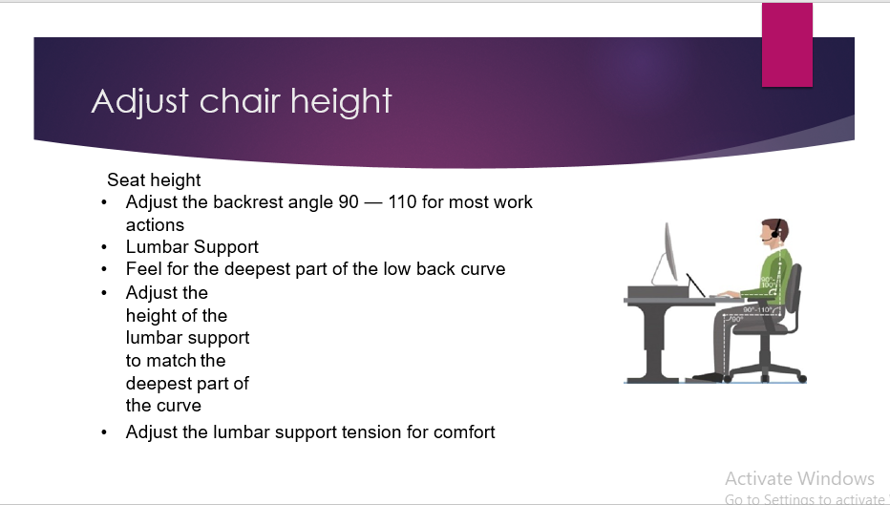

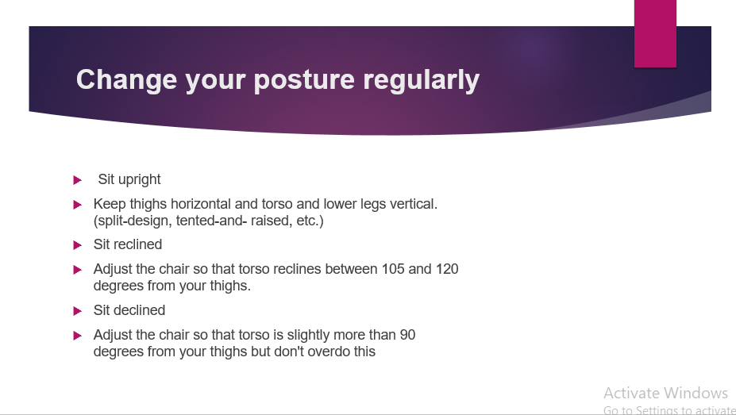
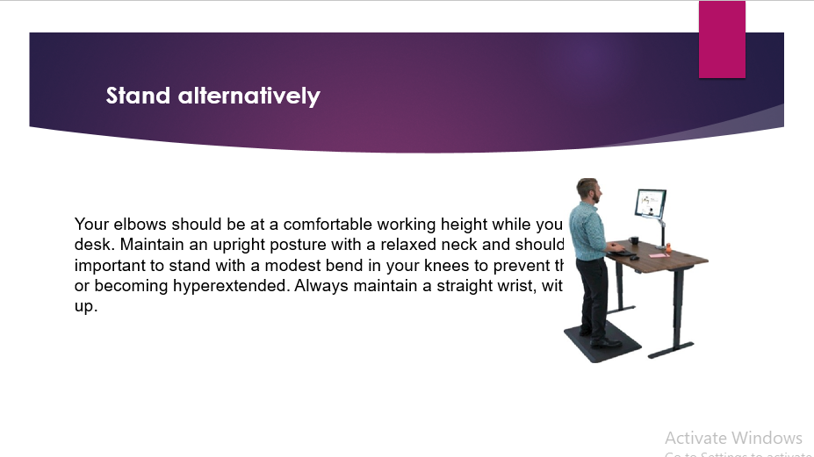
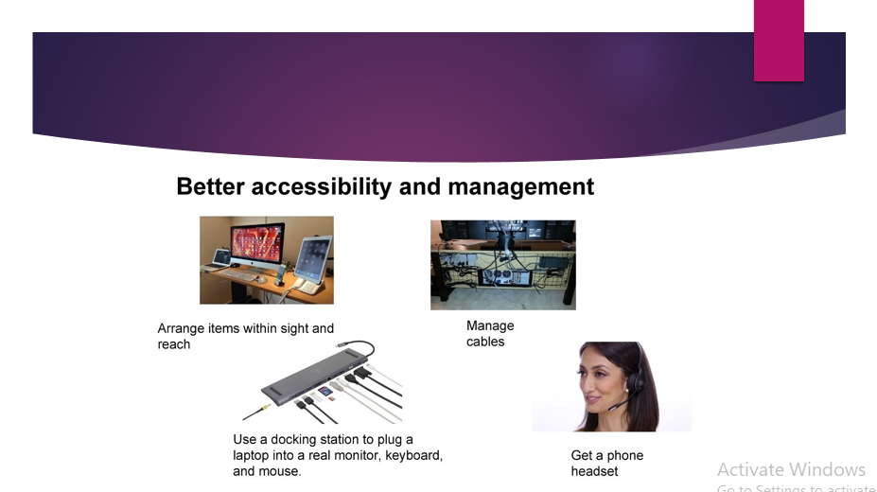
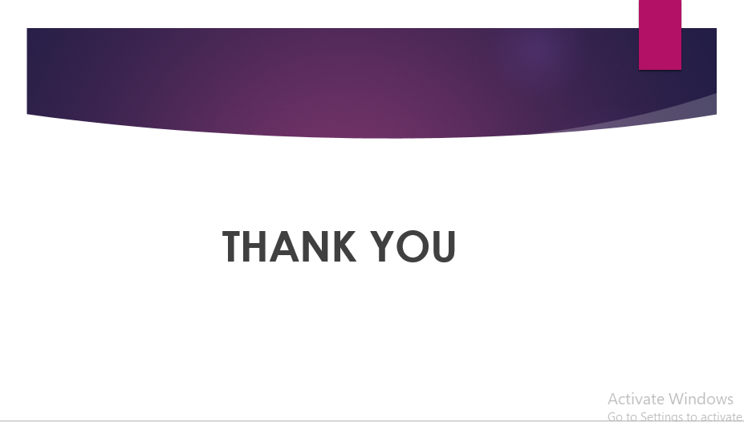

- Make a promotional flyer
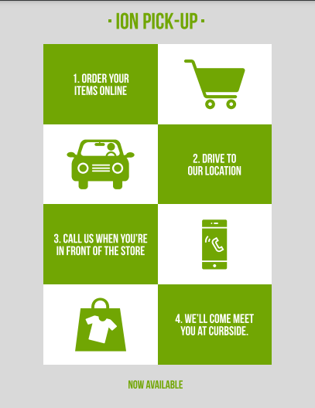
- Communicating Using Email
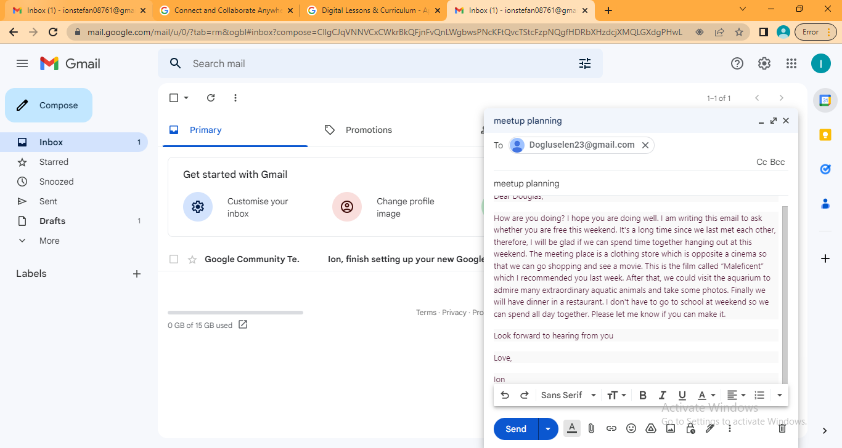

- Avoid Online Scams
Online scams have been increased since everything has been online now, Following are the steps I followed to avoid inline scams.
Always shop from trusted stores while shopping online.
Be aware of con artists who create phone online businesses with the intention of taking advantage of people who are more trusting over the Christmas season. Remember to use care whenever you are making a purchase online, regardless of how well-known the merchant is, and always use a secure payment method.
It is a wasted chance to visit a website by clicking on a link in an email or social media post rather than putting the URL of the website directly into the address bar.
By reading the comments that are made below a business's social media postings, you may learn what other people think of the social media marketing that a company is doing.
Google the store, the products it sells, and the reviews left by previous customers.
Investigate if or whether any unsatisfied customers have formed any groups on Facebook.
During the Christmas season, you should keep a close check on your bank accounts for any unusual activity; if you have any reason to suspect fraud, you should call your bank as soon as possible.
Scamwatch is an additional resource that may be used to report fraud.
There is no need for you to be concerned about the security of your money; you can relax now.
Before you input any payment information, the "https" prefix should always appear at the beginning of the address bar in your web browser, which is where you type in URLs. This ensures that any information that is sent between your device and the shop is encrypted and safe (unable to be easily intercepted or read). In the event that there is a data breach, you should also give serious consideration to the idea of preserving your credit card information or any other sensitive data on the servers of an online retailer, since this information runs the risk of falling into the wrong hands.
Be wary of the phishing attempt.
Always be on the lookout for fraudulent emails and text messages, such as fake item arrival announcements or offers that are too good to be true, which may put you under undue pressure to take rapid action or run the risk of missing out.
Take a look at the most recent e-mail and text message hoaxes that pretend to be from Commonwealth Bank.
If you can, limit the amount of work you perform over public Wi-Fi.
Avoid joining automatically to open Wi-Fi networks if at all possible. Never make purchases or perform financial transactions while connected to public Wi-Fi, since cybercriminals often loiter on these networks in order to intercept your activity or even set up rogue hotspots for you to connect to. This is because public Wi-Fi networks allow anybody to connect to them.
Close all of your online accounts.
You should never use the same password for your online banking, email, and social media accounts as you do for any other websites you use. Two-factor authentication is an additional layer of security that can be added to your online shop account. This type of authentication requires something in addition to your username and password in order to access your account. For example, it might require a one-time verification code that is delivered to you through a different channel.
Check to see that your accounts on social networking sites are safe.
The gathering of personally identifiable information from social networking platforms and its subsequent use by cybercriminals to guess passwords, create targeted phishing messages, and develop many other forms of online fraud is a popular activity. Think about limiting the amount of personal information you disclose on your social media platforms, and utilise the privacy options available to limit the people who may access your data.

