

BMSW5105_LON
Workplace Culture and its impact on Organisational Efficiency

Prepared for
Mr Syed Jaffery

UNIVERSITY OF WALES: TRINITY SAINT DAVID
PRIFYSGOL CYMRU: Y DRINDOD DEWI SANT

Prepared by
Pinar Altintas (1818319)

January 7, 2021

Table of Contents

Introduction 3
Environmental scanning tool 3
PESTLE Analysis 3
Porter’s five forces 5
Hofstede analysis 8
Theoretical overview 11
Cultural and ethical standards 12
Impact on organizational efficiency 12
Conclusion 15
References 16

Introduction
Organisational culture refers to the collection of expectation, values and practices within companies that guides the actions of the departments to achieve the overall organizational objectives and aims. It is often referred as the collection of traits in making a firm what it is (DICKSON, 2018). This research report will shed lights on the organizational culture and context of Next Plc. It will identify the external and internal capabilities of the company by including Hofstede model and Porter’s five forces. A theoretical overview has been provided in the later section of the report along with the identification of the cultural and ethical behaviour if the company to achieve its strategic objectives. The impact of each aspects has been reflected onto the efficiency of the company. Next Plc. is a British Multinational clothing company with it headquarter in England. Most of the outlets of the company are located in UK, and around 500 stores are in Europe, Middle East and Asia. Reportedly, the annual revenue of the company was £4,167.4 million in 2019 and the operational income was £762.0 million (Ishiiet al., 2020).

Environmental scanning tool

PESTLE Analysis
Political
Being an international company, the operations of Next Plc. is located in different countries, which puts the company in different political risks. In order to achieve dynamic success in the retail industry, the company needs to diversify its operations in the systematic risks of unstable political environment. Belonging to a retail industry, the company needs to face high degree of risks in terms of military invasion, political relation among the countries and legal framework within the operating country (Persia and Rea, 2016). The tariffs and trades related to consumer services also shed equivalent risk to the political environment of a country that can further be huge threat for Next Plc.
Economic
Factors such as saving rates, inflation rates, and economic cycle and foreign exchange rates highly impact the economic condition of a country. During the global pandemic situation, each factor have been highly affected in all the countries, irrespective of their political and social stabilities. The stability in the Therefore, the economic factors can be highly questionable for the company while operating in different countries. The stability of the currency might not be stable that can increase the exchange rate of the company, impacting the quality of the infrastructure of the retail industry and skill level of the workforce.
Social
The shared value of the people in UK is higher compared to most of the countries Next Plc. operates in Middle East and Asian countries. If can provide high scope to the company to determine skilled employees from the local communities and also divide (Masood and Baig, 2016). Nevertheless, the educational level and standards of the people are also higher in most of the states where the company has its operations, therefore, he entrepreneurial spirit of the population to encourage innovation and creativity is also higher.
Technological
Technological advancement is increasing at a fast pace. The impact of this technological disruption may provide the company with scopes and opportunities of profitability. It involves the analysis on the impact of technology on the competitors, cost structure of the overall industry and increasing rate of technical diffusion, besides, he advancement of technological advancement is paving a way for digital revolution that will impact the value chain of the service sector and the retail industry. Moreover, due to increasing practice of contact less transactions, the customers are supporting and appreciating the concept of real time product pickups, deliveries and returns, along with in-store application with robotics features and centralized operating system.
Legal
The lawsuits and regulations in different countries are not same. Therefore, for an international company like Next Plc., belonging to a highly demanding sector of retail industry, the legal frameworks and policies sometimes might act as challenges as well as might become opportunity for the company to achieve higher rate of stability (Stevenson and Cole, 2018). In the UK market, the inclusion of Brexit will change more law structures for the retail industry, which will significantly impact the supply chain management of the retail industry. Supply from the English Channel might get blocked that will share hindrance to the supply of products from UK to Europe. In order to collaboratively search for other similar channels or passage for supply will require huge investment and time for the companies.
Environmental
The environmental practices of Next Plc., highly support and encourage the concept of sustainable growth, development and manufacturing of green products and eco-friendly services. Therefore, special focus needs to be made on the waste management, development of ecological products, supporting renewable energy and transforming to digital platforms for providing services. However, since along supply chain management is followed to relocate products in the extreme rural places of many developing countries, therefore, the regulations for waste management sustainable business, water and air regulations might impact the business practices of Next Plc.

Porter’s five forces
The external competition analysis of Next Plc will be done by considering the five market forces of competition evaluation by Porter, which are as follows:
- Competition in the industry
As a result of active management is the store portfolio of Next Plc., the majority of the stores has made a profit with a percentage of 98% stores making at least 10% profit. More than 20% of the mainline store has 81% turnover rate, while more than 15% share 94% turnover rate. However, during the second quarter of 2016, the directory of Next Plc., suffered excessively from the poor stock availability as a result to which the customers switched to purchasing more number of stocks from the mid-season of the company's stock that was available from the huge seasonal catalogues. The acquisition of the UK Cash customers helped the firm to increase the active customer base by 11%.
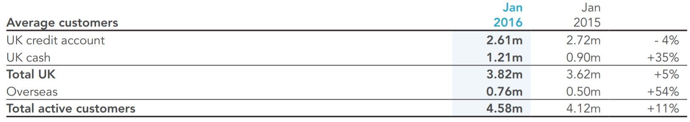
Figure 1: Directory customer base of Next Plc.
(Source: Nextplc.co.uk, 2016)

2. Potential of new entrants into the industry
Next Plc has a global presence, which will be difficult for a new entrant company to reach the extent to which loyalty customer and market stability has been achieved by Next Plc. Therefore, the potential impact of the new entrants will be significantly low for Next Plc. Within the domestic industry as well, the company had an over achievement against the records of target buying margins of the customers. It increased the gross margin of the firm and helped in overcoming poor debt conditions. The credit sales were, however, poorly impacted, as only 2% growth in the credit sales were recorded.
- Power of suppliers
The company implemented the strategy of reducing the minimum payment which further increased the higher balances in the third quarter of 2016. The benefit that was gained got partially offset by the reduction of APR in the third quarter of 2015. With the aim of the improved user interface, marketing, catalogue, delivery services, and credit, the further objectives of the company were lead for the 2017 financial year. Eventually, by the second quarter of 2017, 45% of deliveries were made online and 98% of orders by value were made from the desktop PC and the balance of orders were mostly taken from the phones and tablets.
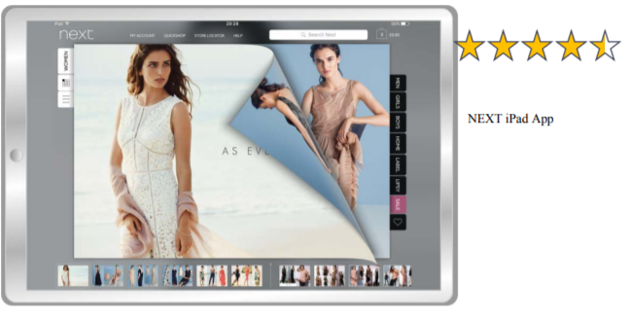
Figure 2: Improved user interface by Next Plc. In the new iPad App
(Source: Nextplc.co.uk, 2016)

- Power of customers
In August 2016, the new iPad app was launched by the Next Plc., which was aimed to give the customers the best quality services that included filtering abilities and look and feel like a real book or catalogue turning experience in the website. The conversion rates were noted to improve from 8% to 10% for the iPad application using customers. The new version of the iPad application was planned to be launched by the second quarter of 2016, with better searching and exploring capabilities that however got delayed by two months. Besides, in the same year, the android version of the application was launched by the company that also received tremendous recognition from the audience. The delivery service has been improving by considering two vital points for improving the daily service performances:
- By providing the customers with the option to return and collect goods and products through the third-party parcelling chops
- By narrowing the window of the home delivery options to a distinctively pre-advised two-hour window
- Threat of substitute products
With the advancement in technology and changing trends of the customers, the segments of the company have also changed significantly that now includes Next Online, Next Finance, Next Retail, Next to International Retail, Next Sourcing, and many others. Since the company is based In the UK with numerous services offering practices like footwear, accessories, clothing, and home products, therefore, the values and services of the firm have changed greatly over the years. For example, Next Online is an online business that sells home wear and clothing in Eire and the UK. Similarly, Next Finance provides the services of crediting the purchases of the customers for the product brought online through next pay and next3step. Nevertheless, Next Retail is a chain of retail outlets that consists of 500 stores in the UK and Eire. Next3step is specifically designed to provide the customers with the service of credit accounts. It mainly allows them to spread the costs of the orders in three consecutive payments which are made for the next three months from the date of purchase. The greatest benefit of this feature is: it does not incur any interest charges for the product brought. The Next Sourcing sources and designs the branded products of Next Plc. On the other hand, the Next International Retail compromises the different franchise and the completely owned stores that are present overseas. The franchise partner of the company operates in more than 150 stores that are vastly differentiated in 32 countries internationally.

Hofstede analysis
Organisational culture aids in the inclusion of better accession of work along with provision of better rules and regulation in a company and Next Plc is not an exception to this rule. However, the application of Hofstede models provides the necessary information about the accession of better understanding of the cultural overview and its impact on an organisation.
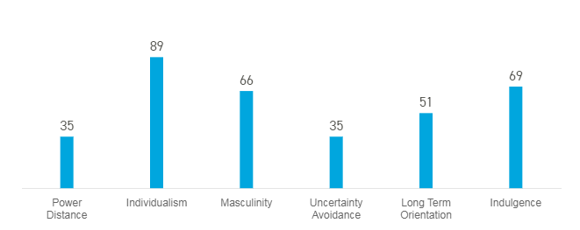
Figure 3: Hofstede Model
(Source: hofstede-insights.com, 2020)

Based on the prior-mentioned graphical representation, it enunciates an overview of the cultural as well as impact on the company due to the above-mentioned factors. Likewise, in the first place, it defines about the presence of accession of authority holds by limited number of managerial body. “Power distance” holds the first bar in the graphical representation. This represents the accession of power to execute decision in an organisation which quantified to 35. Thus, it can be stated to the fact that, the practicing of power and involvement of employees in the company is not equally distributed. In the second bar, it shares the personal satire and fulfilment of individualistic needs as well as desire. “Individualism” ranks highest in this prior mentioned Hofstede Model. It ranges to 89. Therefore, it can be stated to the fact that, the working culture in the UK fails to access proper teamwork in the company and Next Plc is not an exception to this rule.
Masculinity holds third position in the pictorial representation. It numbers to 66. It is a common plight that, organisation is a coagulation of employees hailing from different types of social, cultural as well as gender scenario. Thus, in respect to this satire, it defines as the absence of equal diversity in gender artefact in the organisations based at UK. Therefore, it leads to the degradation of the working satire among the employees of the company. Furthermore, as the masculinity ranges to 66 in number, therefore, this signifies the ruling authority in UK based firms inclined towards male. However, in context NEXT Plc. the presence of disparity among gender results in creation of dissatisfaction among the employees of the company. On the other hand, speaking about the presence of “Uncertainty Avoidance”, as per the graphical representation, it number to 35. Therefore, this quantity signifies about the practicing as well as adapting the quintessential array of professional work in an organisation. Furthermore, as the number ranges to 35, therefore, it defines about the accession of the inclusion of planning as per the demand of the situation. In addition, in respect to Next Plc. it sheds light into the absence of proper and prior planning as for better execution of the daily work. This signifies poor accession and practicing of time, negligence in adherence to innovative skill set and promotes advantages in the quintessential work.
Long term orientation, according to the Hofstede Model number to 51. Thus, it defines about the practicing of the normative approach in the working and productivity among the organisations in the UK. Thus, in respect to Next Plc. the working culture shares relative familiarity with the working satire. In addition, as the number ranges to 51, therefore, it signifies about the accession of taking experience and knowledge from the prior incident in present as well as futuristic work. Thus, in context to organisations in the UK, the employees of the company relies on the previous experience to execution of any decision in accordance to future achievement as well as success. However, in respect to Next Plc. this esteemed organisation is not an exception from this rule.
On the other hand, speaking about the indulgence, the presence of active presence of participation workers in an organisation aids in inclusion of better creation of work. Furthermore, it aids in introduction of innovative thoughts, ideas that helps in execution of mitigating the needs as well as demand of the customers. However, in respect to the prior mentioned graphical representation, it defines as the accession of quantity, which ranges to 69. Thus, it can be concluded to the statement that, the presence of indulgence among the employees of the company aids in execution of equal involvement in more than above-average manner. Therefore, in context to the companies based at UK, unlike Next Plc. this picture shares the information regarding the import of indulgence of the workers. In addition, the employees of the company are aware of the personal needs as well as desire for accumulation of personal goal.
Based on the above discussion, it can be concluded to the fact that, the presence of the Hofstede pictorial presentation shares the cultural as well as working atmosphere of the UK based organisation and Next Plc. is not an exception to this rule. Likewise, the practicing of the equality in the NEXT Plc. leads to creation of better working satire. According to the sources report, the company holds larger proportion of female work in the organisation, in comparison to male (nextplc.co.uk, 2020). Therefore, as per the graphical representation, it is discarded in Next Plc. Thus, it helps in execution of praiseworthy goods and service. Furthermore, it helps in execution of better customers integration, due to the presence of job satisfaction among the staffs of the company. This leads to addressing the needs of the customers, which results in acceleration of profit.
However, on the other hand, speaking about the involvement in the working satire of the employees, as per the implication of the model along with the rules and regulation, Next Plc. provides necessary training to the staffs. Thus, according to the referential context, the company exercise creation of better working atmosphere for the staffs of the company for better persuasion of teamwork (nextplc.co.uk, 2020). Moreover, it helps in eradication of individualism mindset of the employees to work. On the other hand, as per the prior mentioned discussion, as the dwellers of UK are more inclined towards fulfilment of personal desire and dream, therefore, it leads to the degradation of the working satire. Furthermore, it serves as one of the prime reasons that enumerates creation of barriers that restricts better deliberation of work.
According to the sources report, as per the relevance with the graphical representation, it can be subject to the fact that, the presence of “Uncertainty Avoidance” in the UK organisation aids in creation of absence of proper planning and processing. Therefore, in respect to Next Plc. due to the advancement due to the pandemic situation, the company aids in increment in employee turnover rate. Therefore, according to the sources report, the management of Next Plc. enumerates the creation of fear among the job due to the economic crisis. Therefore, it leads to increment in the dissatisfaction of the job among the employees of the company. Furthermore, it results in execution of creation of poor brand image of the company in the present market.
Speaking about the recommendation, the company can follow the adaptation of “Equality Act, 2010” for better creation of working atmosphere in Next Plc. Furthermore, the financial manager of the company can promote the accession of better planning as well as processing of better working satire in the esteemed organisation.

Theoretical overview
In the global pandemic situation as well, many significant operations have been carried out by the firm that includes Interim dividend payment dates, AGM, and trading announcements. An advanced form of Trading announcement and implementation will be done by the company on 5th January 2021 (hl.co.uk, 2020).
The elementary financial objective of the company is to deliver long-term returns to its stakeholders through a strategic combination of sustainable growth in the earnings per share as well as the payment of the cash dividends. To achieve these financial objectives, the following strategies are considered and followed by the company:
- Developing and improving the range of the products and services being offered by the Next Plc to measure the sales performance successfully
- To increase retail sales by practicing profitability. The appraisals of the new stores need to ensure that they meet the demanding financial criteria before investing. Therefore, the success of the outlet will be measured based on the profit contribution that is achieved and the return on the capital against the predetermined appraised target.
- Increase in the total number of overall profitability Next Plc., directory customers and their expenditure. This aim has been created for both UK as well as the international markets.
- Net margin and gross margin are needed to be maintained by the efficient sourcing of products, stock control, and stock management
- Focusing on the satisfaction level of the customers and the service provided by the company in both directories as well as the retail store
- Maintain the financial strength of the group with the help of efficient financial structure and secure balance sheet
- Returning and generating surplus cash to the stakeholders by backs or special dividends (Nextplc.co.uk, 2020).

Cultural and ethical standards
In order to sail through the risks and uncertainties, the company targeted developing and providing the product range and sustainability measures. The board of management in the company reviews the business strategy regularly to ensure that the profit and sales are maximized in the company and the operations processes are made efficient. It follows disciplined approaches for budgeting, sales, cost control, and investment return for ensuring that the company continues in generating stronger cash flows and profit. The senior board of management considers strategic risk factors with the aim to penetrate the wider economy and maintain business stability n the unstable economic situation in the international business market.
The ways in which the selection and designing of the product are made, the success of the company greatly depends on this factor. If the company is not able to manage the identified risk in the short term, are disposed of at a lower price. But the involvement of new strategic planning in the middle of financial planning is usually avoided by the firm (Nextplc.co.uk, 2020).

Impact on organizational efficiency
By far the greatest issue being faced by the company is the lack of spontaneous conversation between colleagues (Nextplc.co.uk, 2020). The ability to learn for mitigating different challenges and issues, communication, and dealing with internal organizational changes are some of the major issues faced by the employees of Next Plc. that tends to reduce the quality and efficiency of the employees as well as the talent management extent compared to its competitors. The young employees who are joining the firm as trainees or interns, fresh graduates with nee degrees and new previous experience in the corporate field are extremely smart, talented, and fast learners.
However, due to the lack of sufficient resources and an effective communication system, a long-term relationship is not built with these employees. The young millennial employees search for companies that provide additional perks like open communication policies, flexibility in the work culture, open and transparent policies, and appreciation for their efforts and talents along with sufficient monetary benefits. The companies that can meet at least some of the criteria become the ones in eh marketplace where these employees tend to share their efforts and commitments.
Therefore, the best talents in the market are usually taken off by the other competitors of Next Plc., in its different target markets due to the lack of communication and internal regulatory management. Since the best lot is missed away by the company, the investment made in the training, coaching, and grooming of the existing employees or the new employees is comparatively higher compared to the competitors.
The retention strategy is also compromised which makes the company get into a continuous investment cycle for training the employees and grooming them. In the pandemic situation, the practice of one-way communication has increased exponentially due to increasing work from home culture and the regulatory measures of the local and national government had limited and marginalized the scopes to explore new strategies and ventures. Therefore, the problem-solving arenas where it required large groups to mitigate the issues, usually resulted to be unwieldy inefficient, and frustrating to the employees. Perhaps, the situation got worsen by one of the most discouraging proliferation in business practices, all over the world that is slide presentations and group meetings for extended periods of time. The ling group meeting became excessively damaging, boring, tiring, and ineffective to the employees as after a certain period of a tie, the one-way lecture seemed to be rattling by the presenter continuously for hours, the bullet points that were already visible to the audience over the screen.
Yet, it is to recognize the work from home culture to be a permanent feature for a normal life going forward, depending on the responsibilities of the employees, the extent of success and failure will vary from department to department. Person to person and their job to job. Eventually, there will be a balance between office working and at home.
However, to implement this balance, it will require care and tome. In order to enhance the work from home facilities, the strategy of one way fits all solution will be developed by the company, where it will find out the departments that are necessary to come onto fields such as product delivery executive and sales executives. The rest important departments such as customer care executives, product designing teams, the financial data management team will be allowed to work from home. In this way, the public gathering will be reduced and a sustainable substitute to run the business will be identified by the company. With the aim to grow higher and increase its product range and substitutes, the global pandemic situation and lockdown has not impacted to impede the development and growth of the company in its new business, which primarily included beauty, licensing, and total platform.
The new ways of collaboration and partnership have helped the company to shape up new challenges faced in the international market, in terms of market penetration and stability. Although a constant stoppage in the manufacturing and designing process was impacted to some extent that also reflected the efficiency of the supply chain management, but upheaving the served accelerated the rate of growth and development in different phases of lockdown and when it was being partially lifted over.
With the help of partnership and company collaboration, a number of benefits in different segments and departments of the company were noticed that mainly included the departments of the web system, online warehouse maintenance, marketing, online distribution, credit, call centres, retail system, and retail logistic management. The efficient management of this department and sectors helped the company to reflect positive impact over the online product selling and delivery application in the UK, an online market of the company in the international overseas, Next stores and its partner stores in the international market as well.
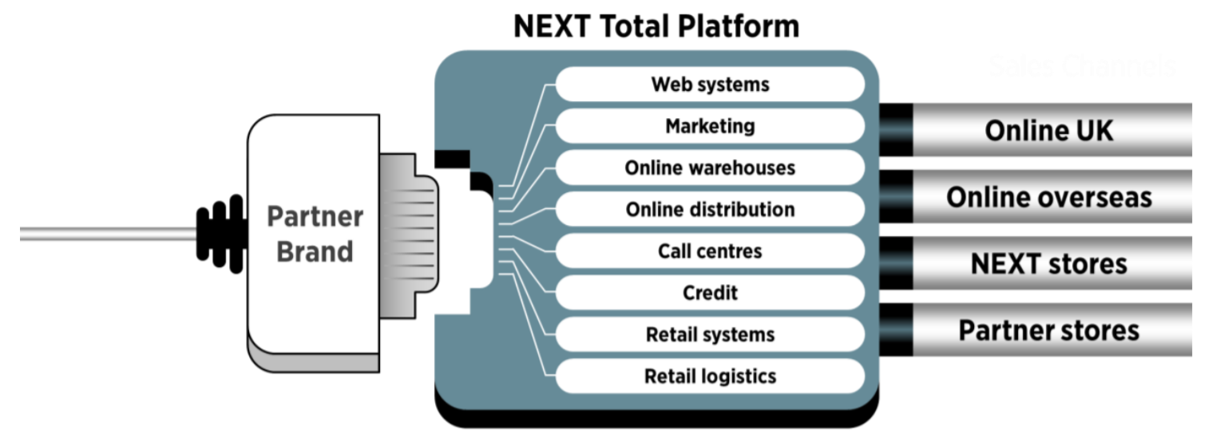
Figure 4: Benefits of partnership and collaboration
(Source: Nextplc.co.uk, 2020)

The total platform of the company involves the strategy of pay as you go, which is a new stop solution for effective operation management to the online business of the company. The customers were able to pay by the simple commission over the sales and there were no hidden charges or uncomfortable step change for the supplying company to increase the fixed costs or no capital requirements for supporting the growth.

Conclusion
From the above discussion, it can be concluded that since fashion is a volatile sector, the fashion industry is also a vulnerable industry, which needs to be in trends and latest fashion assistance to remain competitive in the target market. The strategies being implemented by the company are effective enough to share competition in the coming few years. However, focusing on talent management, recruitment, hiring, and managing the employment strategies are highly important for the company. While making a partnership with the firms, the effectiveness of the company will be identified from the internal workplace efficiency, which will further generate an efficient scope to engage a large number of talented employees in the long run.

References
DICKSON, M., 2018. Report and consultant insight on financial management of Next Plc UK.
hl.co.uk, 2020. Next Plc (NXT) Ordinary 10P Shares Company Information. [online] Hargreaves Lansdown. Available at: <https://www.hl.co.uk/shares/shares-search-results/n/next-plc-ordinary-10p-shares/company-information> [Accessed 18 December 2020].
hofstede-insights.com, 2020 [Online] Available at: https://www.hofstede-insights.com/country/the-uk/ [Accessed on 18thDecember, 2020]
Ishii, T., Tamura, A., Shibata, T., Kuroda, K., Kanda, T., Sugiyama, M., Mizokami, M. and Moriyama, M., 2020. Analysis of HBV Genomes Integrated into the Genomes of Human Hepatoma PLC/PRF/5 Cells by HBV Sequence Capture-Based Next-Generation Sequencing. Genes, 11(6), p.661. https://www.mdpi.com/2073-4425/11/6/661
Masood, B. and Baig, S., 2016. Standardization and deployment scenario of next generation NB-PLC technologies. Renewable and Sustainable Energy Reviews, 65, pp.1033-1047. https://www.sciencedirect.com/science/article/pii/S1364032116303884
Nextplc.co.uk, 2016. Annual Reports and Accounts. [online] Nextplc.co.uk. Available at: <https://www.nextplc.co.uk/~/media/Files/N/Next-PLC-V2/documents/reports-and-presentations/2016/NEXT-Annual%20report%20Web%20FINAL.pdf> [Accessed 18 December 2020].
Nextplc.co.uk, 2016. Results for The Year Ending January 2016. [online] Nextplc.co.uk. Available at: <https://www.nextplc.co.uk/~/media/Files/N/Next-PLC-V2/documents/reports-and-presentations/2015/NEXT%20FINAL%20Website%20PDF.pdf> [Accessed 18 December 2020].
nextplc.co.uk, 2020 [Online] Available at: http://www.nextplc.co.uk/~/media/Files/N/Next-PLC-V2/documents/corporate-responsibility/cr-2015-our-people.pdf [Accessed on 18thDecember, 2020]
nextplc.co.uk, 2020 [Online] Available at: https://www.nextplc.co.uk/corporate-responsibility/gender-pay-report#:~:text=across%20job%20roles.-,We%20have%20a%20significantly%20larger%20proportion%20of%20women%20than%20men,are%20closely%20linked%20to%20seniority. [Accessed on 18thDecember, 2020]
Nextplc.co.uk, 2020. ANNUAL REPORT & ACCOUNTS JANUARY 2020. [online] Nextplc.co.uk. Available at: <https://www.nextplc.co.uk/~/media/Files/N/Next-PLC-V2/documents/2020/annual-report-and-accounts-jan20.pdf> [Accessed 18 December 2020].
Nextplc.co.uk, 2020. Our Strategies and Objectives. [online] Nextplc.co.uk. Available at: <https://www.nextplc.co.uk/about-next/our-strategies-and-objectives> [Accessed 18 December 2020].
Nextplc.co.uk, 2020. Results for The Half Year Ending July 2020. [online] Nextplc.co.uk. Available at: <https://www.nextplc.co.uk/~/media/Files/N/Next-PLC-V2/documents/2020/websitepdf-july-20%20SA.pdf> [Accessed 18 December 2020].
Persia, S. and Rea, L., 2016, October. Next generation M2M Cellular Networks: LTE-MTC and NB-IoT capacity analysis for Smart Grids applications. In 2016 AEIT International Annual Conference (AEIT) (pp. 1-6). IEEE. https://ieeexplore.ieee.org/abstract/document/7892789/
Stevenson, M. and Cole, R., 2018. Modern slavery in supply chains: a secondary data analysis of detection, remediation and disclosure. Supply Chain Management: An International Journal. https://www.emerald.com/insight/content/doi/10.1108/SCM-11-2017-0382/full/html

