Module Name: Digital Skills for Personal and Professional Growth
Module Code: BMSW4008
Task 2: Finance Excel Spreadsheet
Task 2: The Importance of Excel in The Digital Era (750 Words)
Student Name: Sebastian Ropel
Student Number: 2423021
Lecturer: Mohammad Cassamo
Deadline: 12/12/2025
Wordcount: 794

Al Acknowledgement
I confirm that I have not presented any Al generated materials as my own work. I confirm that I have copies of my drafts, notes, and other resources I used, which I may be asked to provide in evidence

The Importance of Excel in the Digital Era

Microsoft Excel is one of the most useful tools for businesses in the digital era. Even with many apps available today, Excel is very important because it helps people organise data, understand numbers, and plan for the future. As Reedy and Parker (2017) explain, using Excel helps people work more effectively with information and make better decisions, which is essential for business success.
Excel has been very helpful in my business plan. It helped me to organise all financial information in one spreadsheet, showing all income from dine-in meals, takeaway meals, weekly packages, and monthly premium packages. It also lists expenses such as wages, food supply, trays, petrol, marketing, rent, licenses, and software. Using Excel formulas like SUM, adding and subtracting, or automatic totals allows me to see immediately how much money the business makes or spends each month (Dadwal, 2020). It also gives me a complete overview of my business’s financial situation at any time and reduces the chance of making errors in calculations.
One big advantage of Excel is that it helps me spot patterns and trends in my data. For example, my spreadsheet clearly showed that sales raised significantly from June to September. This rise appeared across dine-in, takeaway, weekly packages, and premium subscriptions. Many people try to get fit for summer, so they buy more healthy meals during this period. Excel made this trend easy to identify because the monthly totals update automatically, and I can compare months side by side (Byrd, 2021). Identifying such patterns allows me to plan in advance, so I can ensure that the business is prepared for periods of high demand, including having enough staff and stock to meet customer needs.
Excel also shows a fall in sales in November and December. The sales numbers dropped after September, showing slower demand in late autumn and winter. Seeing this trend helped me plan strategically. I reduced stock orders during the slower months and planned smaller marketing budgets to avoid unnecessary expenses (Sandhu, 2020). Without identifying these trends, I could have overstocked or overspent on advertising during months when customer demand was low.
Excel can also be very useful for staff planning. Because summer months are busy, I used the spreadsheet to test the effect of hiring extra staff. The sheet showed wages rising during peak months, and I could check whether higher income would cover those wages. This helped make the decision to add one kitchen staff member and one delivery driver (Soltanifar, Hughes & Gocke, 2021). Being able to see how hiring extra staff would impact the business helped me make the decision and prevented overstaffing and overspending during quiet months.
A very important use of my spreadsheet is tracking monthly net cash flow. It calculates this automatically with the formula: Net Cash Flow = Total Income – Total Expenditure. The numbers update automatically whenever I change any value. Here are the actual net cash flows from my sheet:

January: £13,611
February: -£480 (a small loss)
March: £1,307
April: £2,892
May: £3,819
June: £5,512
July: £5,929
August: £6,384
September: £6,566
October: £8,973
November: £8,455
December: £7,163

The year-to-date total net cash flow in the sheet is £70,131.32. These figures let me see which months are strongest and which months need extra attention. For example, February was a low point with a small loss, while October and November were strong months. Knowing this allows me to save money during good months and prepare for weaker ones (Pinto & Guarda, 2020).
Another advantage of Excel’s automatic updates is that it can be used to recalculate any price rises. For example, if food costs rise or petrol prices increase, I can simply change one cell, and all totals recalculate instantly. I frequently use SUM to total rows and columns and simple formulas to calculate percentage changes between months. These simple Excel tools make it easier for me to manage the business (Sandhu, 2020).
Charts are another very useful feature. Turning numbers into a simple chart allows me to see the rise in summer and the dip in winter quickly. Charts also help when I share the plan with partners or lenders because visuals make the data easier to understand (Burgess, Marwick & Poell, 2018).
Excel can also be used to track food supply and trays to make sure I never run out and never buy too much. Conditional formatting can highlight Low stock helping me reorder supplies in time. For marketing, the spreadsheet showed me when extra advertising would be most effective mostly before and during the summer peak (Dadwal, 2020).
Overall, Excel is essential for my business. The spreadsheet allows me to make decisions based on data rather than guesswork. Without Excel, managing the financial and operational aspects of my business would be more difficult and less accurate.

REFERENCES

- Burgess, J., Marwick, A. & Poell, T. (2018) The SAGE Handbook of Social Media. London: SAGE.
- Byrd, L. S. (2021) Cultivating Entrepreneurial Changemakers Through Digital Media Education. IGI Global.
- Dadwal, S. S. (2020) Handbook of Research on Innovations in Technology and Marketing for the Connected Consumer. IGI Global.
- Pinto, F. M. & Guarda, T. (2020) Digital Marketing Strategies and Models for Competitive Business. IGI Global.
- Reedy, K. & Parker, J. (2017) Digital Literacy Unpacked. Facet Publishing.
- Sandhu, K. (2020) Digital Transformation and Innovative Services for Business and Learning. IGI Global.
- Soltanifar, M., Hughes, M. & Gocke, L. (2021) Digital Entrepreneurship. Springer.

Module Name: Digital Skills for Personal and Professional Growth
Module Code: BMSW4008
Task 1: Questionnaire Creation and Data Collection
Task 1: Website Development Project
Task 1: 1000-Word Analysis Report
Student Name: Sebastian Ropel
Student Number: 2423021
Lecturer: Mohammad Cassamo
Deadline: 12/12/2025
Wordcount: 1056

Al Acknowledgement
I confirm that I have not presented any Al generated materials as my own work. I confirm that I have copies of my drafts, notes, and other resources I used, which I may be asked to provide in evidence

1000-Word Analysis Report — Aesthetic Food
Introduction
This report explains what I learned from the survey of 50 people in Swansea and how these results influenced Aesthetic Food’s business idea, website and marketing. Collecting real customer information is important because it helps a business understand what people want. As Reedy and Parker (2017) explain, good digital planning comes from using real data, not guessing. By looking at the results, I was able to design the website, menu and marketing materials in a way that matches what local people need. “To see the online survey results please refer to Appendix A.”
Key survey findings
I focused on four important questions from the survey: how often people eat out (Q7), the main reasons for choosing meals (Q8), barriers to healthy eating (Q10), and the meal types people want (Q11). These questions were the most useful for understanding customer habits. Pinto and Guarda (2020) say that customer insights are essential for designing digital marketing strategies, and this survey gave very clear results.
Q7 – How often people eat out
39 out of 50 people (78%) eat meals prepared outside their home 3–5 times per week. Eight people eat out 1–2 times, one person eats out every day, and two people rarely eat out.
Analysis:
People in Swansea already depend on ready-made meals and takeaways. They want fast and convenient meal options. This supports the idea that Aesthetic Food can attract many customers by offering quick ordering, takeaway and delivery. Because of this, the website includes a big “Order Now” button and simple navigation so customers can order food quickly. Sandhu (2020) says that digital services need to be easy and fast for users, which matches the behaviour shown in the survey. “To see the website please refer to Appendix B.”
Q8 – Main reason for choosing meals
28 people (56%) choose meals based on convenience and saving time. Healthy nutrition was chosen by 14 people (28%). Taste was chosen by 5 people, and high protein by 3 people.
Analysis:
Convenience is the most important factor. People want meals that are quick and easy more than anything else. This strongly affected the website and the marketing materials. The website uses simple messages like “Meals ready when you are” and “Save time.” Dadwal (2020) explains that customers prefer simple and quick solutions. For this reason, the website and posters focus on speed, convenience and easy ordering.
Q10 – Barriers to eating healthy
46 out of 50 people (92%) said the main problem is lack of time. A few mentioned limited access to healthy food or not liking the taste.
Analysis:
Time is the biggest barrier. This supports the idea of Aesthetic Food because the business is designed to save people time with meal-prep services and ready meals. Because the customers are not very worried about price, the business does not need to focus on big discounts. Instead, the marketing can highlight benefits such as saving time and eating healthy easily. Soltanifar, Hughes and Gocke (2021) explain that successful digital businesses solve real lifestyle problems, and this shows that Aesthetic Food is solving the right problem.
Q11 – Most wanted meal options
37 people (74%) chose balanced meals. Eight wanted high-protein fitness meals, three wanted customisable options, and two wanted vegetarian or vegan meals.
Analysis:
Most customers want balanced meals that they can eat every day. Fitness meals are also popular with a smaller group. This created the idea for the structure of the menu on the website. The balanced meals appear first, followed by high-protein meals, and then vegetarian options. McKeever (2020) explains that businesses must offer products that match customer needs, and this data made it clear which meals should be highlighted.
How findings shaped the business idea
The survey supported the main ideas in the business plan. Nearly everyone in the survey lives in Swansea, and almost all are full-time workers or students. These groups are busy and rely on fast meals, which is exactly who Aesthetic Food aims to serve. The interest in balanced meals and high-protein meals also supports the idea of offering healthy dishes and fitness meal plans. Hisrich, Peters and Shepherd (2017) point out that entrepreneurs should base their decisions on customer needs, and the survey results clearly show that the Aesthetic Food concept is suitable for the local market.
How findings shaped the website
The website was designed to be very simple and easy to use because the survey showed that people value convenience. The homepage includes a strong call to action and short messages that show how the service saves time. The menu page is divided into categories that match the survey results, such as “Balanced” and “High Protein.” The SEO strategy also came from the survey findings since most people live in Swansea. Keywords such as “healthy meals Swansea” and “meal prep Swansea” were added to improve visibility online. Kotler and Keller (2021) explain that using the right keywords helps people find the business online.
How findings shaped marketing materials
Marketing materials created in Canva were designed to send a clear and simple message. The posters, leaflets and Instagram posts focus on convenience and healthy food because these were the most important factors for customers. Burgess, Marwick and Poell (2018) explain that online content works best when it is simple and visually appealing. Because price was not a big problem mentioned in the survey, the marketing focuses more on benefits such as saving time and eating healthy meals prepared by professionals. The flyer also mentions fresh ingredients, which matches the business aim of offering high-quality meals. To see the flyer please referrer to Appendix C.
Conclusion
In conclusion, the questionnaire results were very helpful for developing Aesthetic Food. The findings clearly showed that people in Swansea want convenient and healthy meals that save them time. These results created the business idea, the website design, the menu, and the marketing materials. The information proved that the target audience is mainly workers and students who rely on fast meals several times a week. Authors like Reedy and Parker (2017) and Dadwal (2020) support this approach by saying that digital businesses should always use real data to understand what customers want. The survey confirmed that Aesthetic Food meets a real need in the local area, and it also gave clear direction on how to design the online experience so it is simple and effective. By listening to customer feedback, the business can grow stronger and offer even better services to the people of Swansea.

Appendix A: Online survey (Microsoft form 2025)

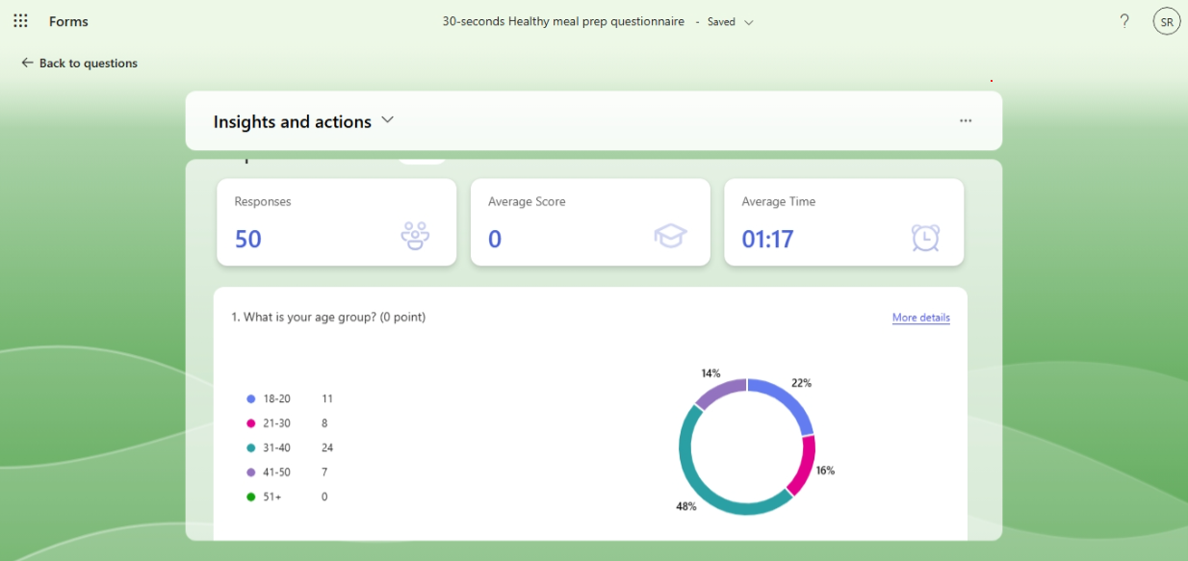

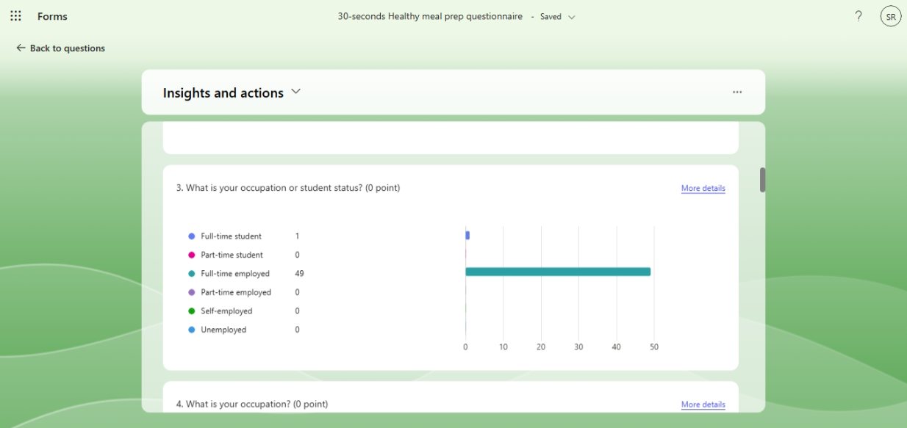
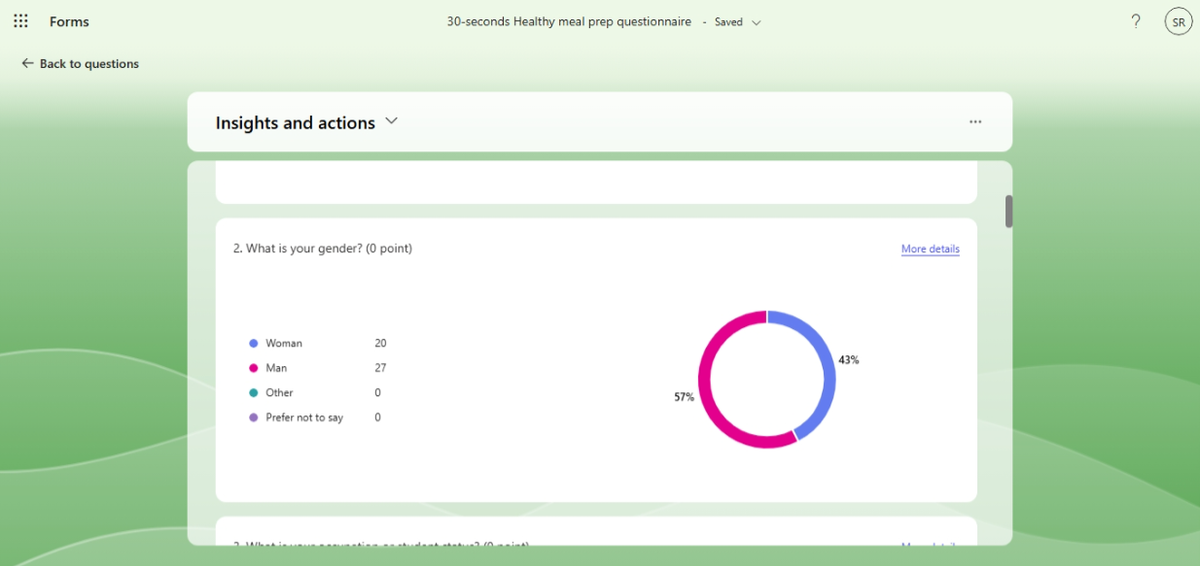
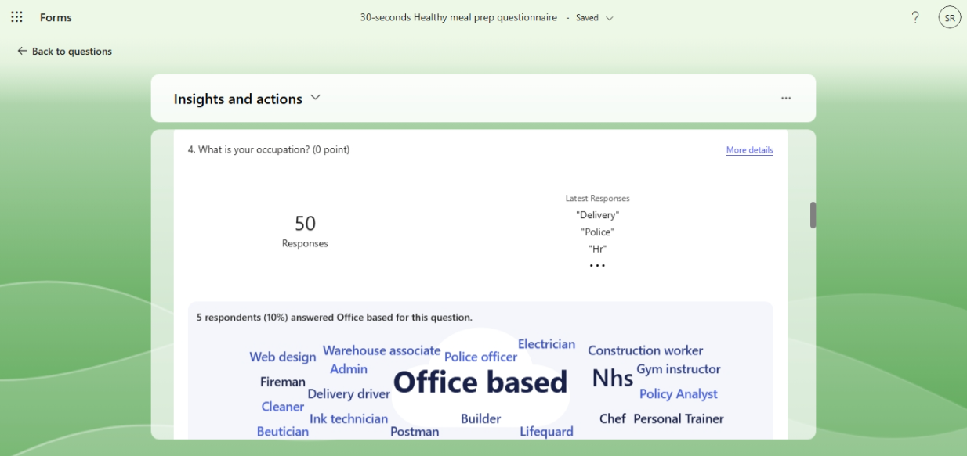

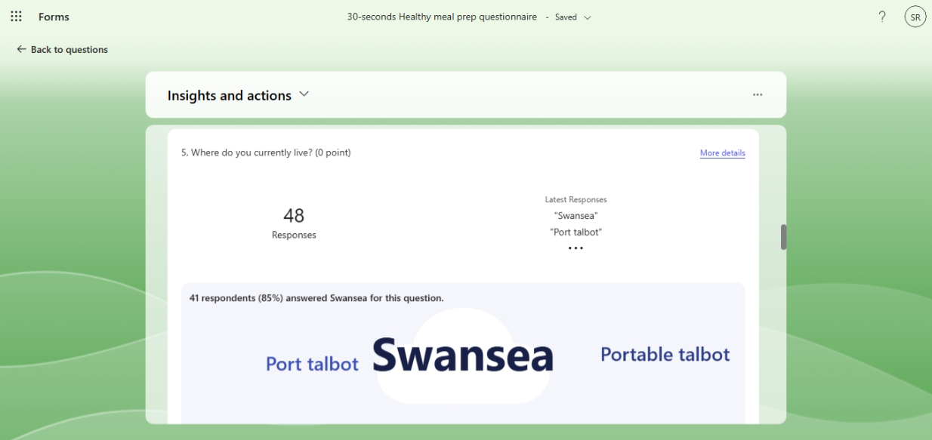

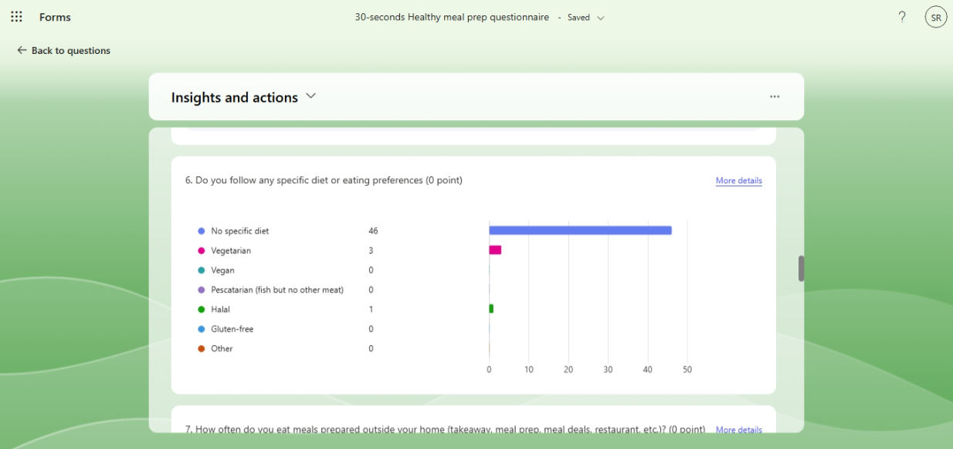

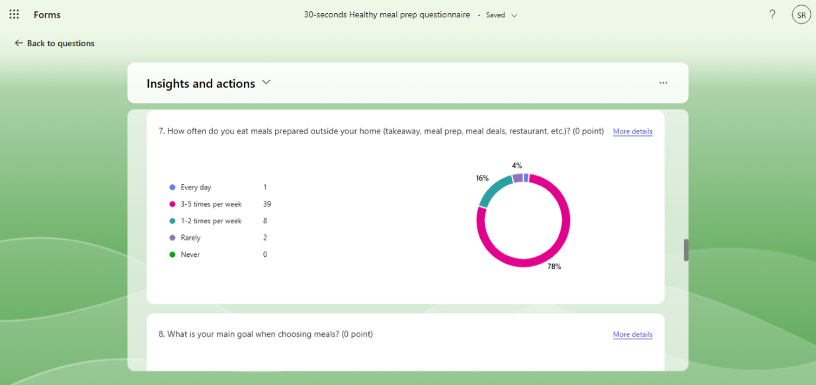

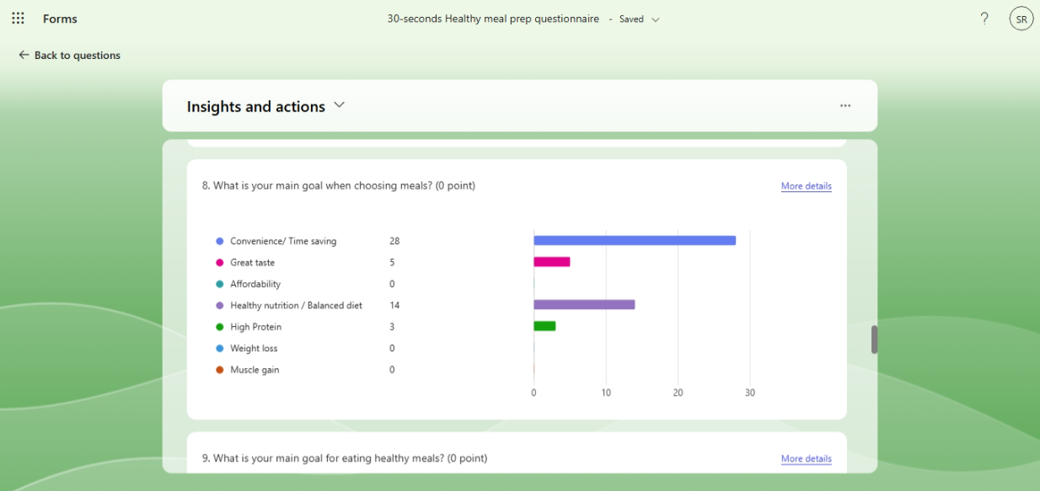

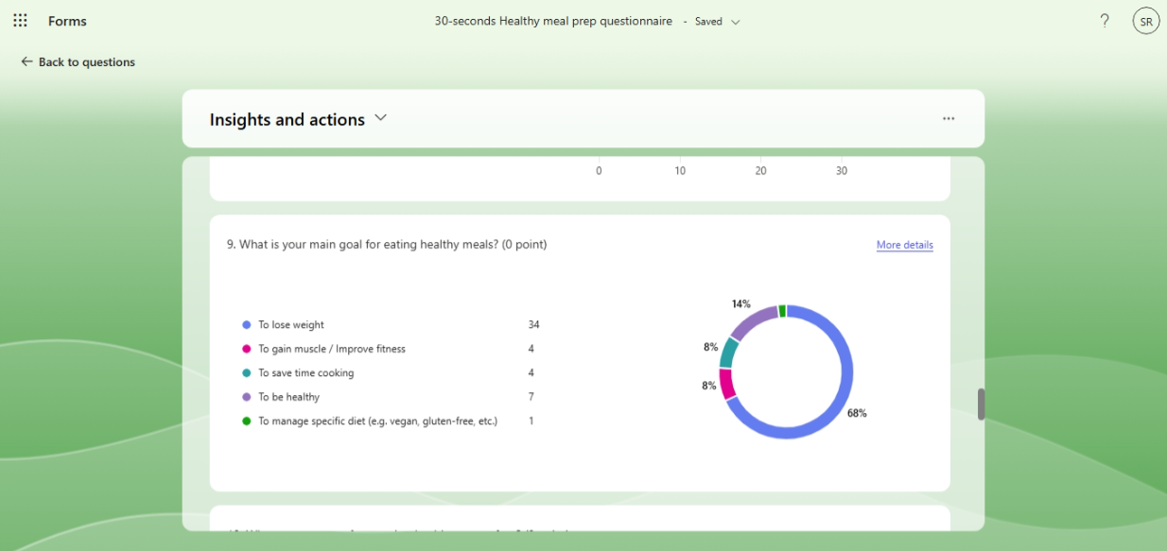

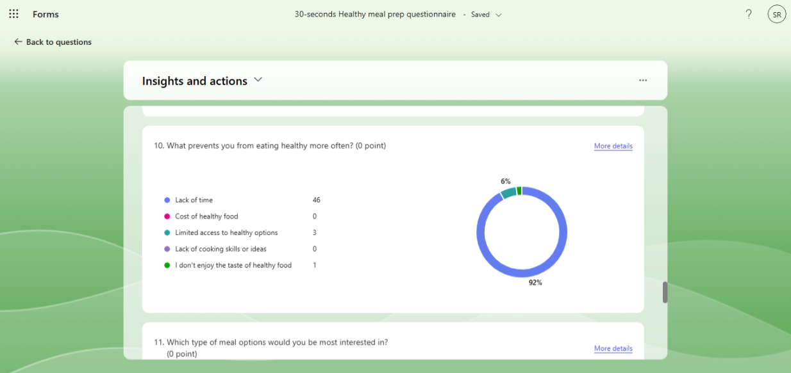

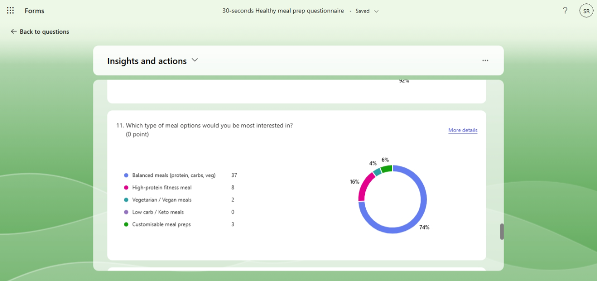

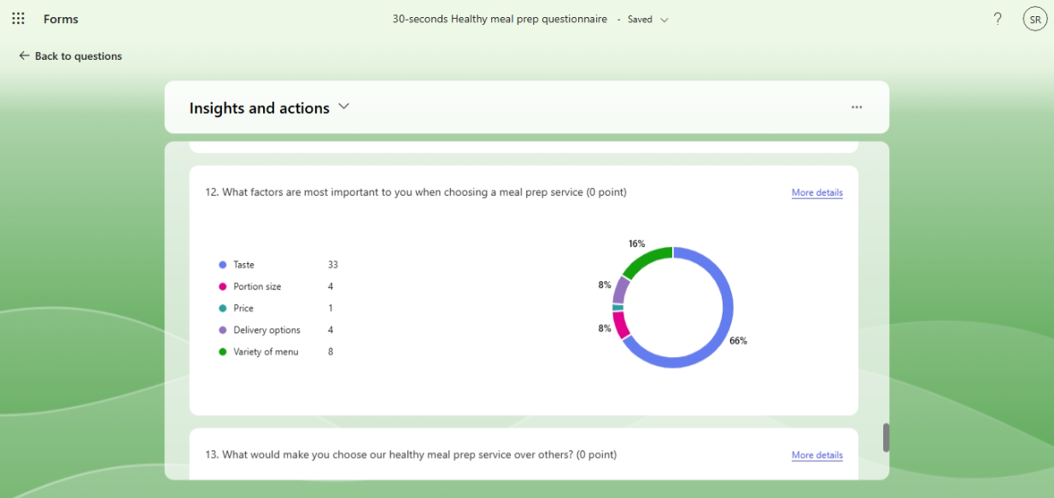

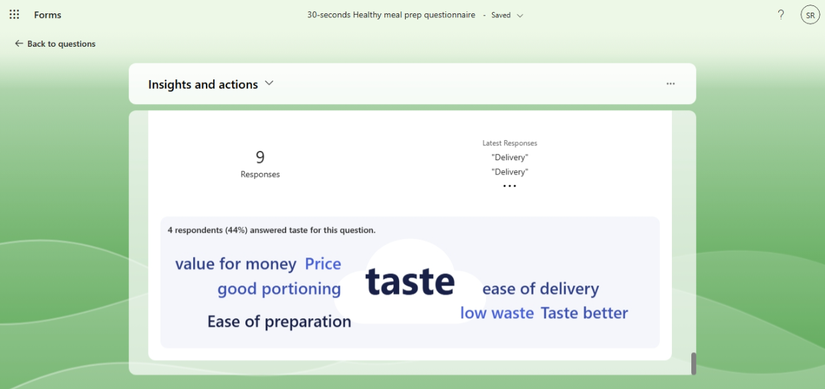

(Microsoft form 2025)

Appendix B: Website (Wix 2025)
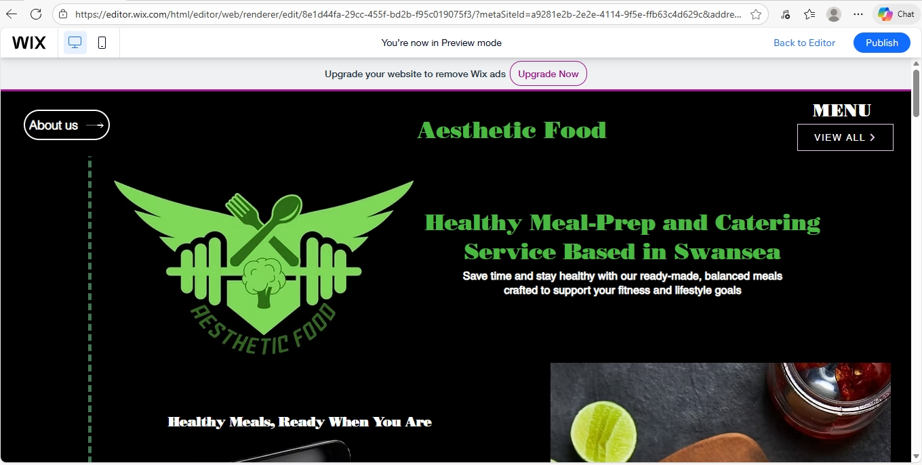

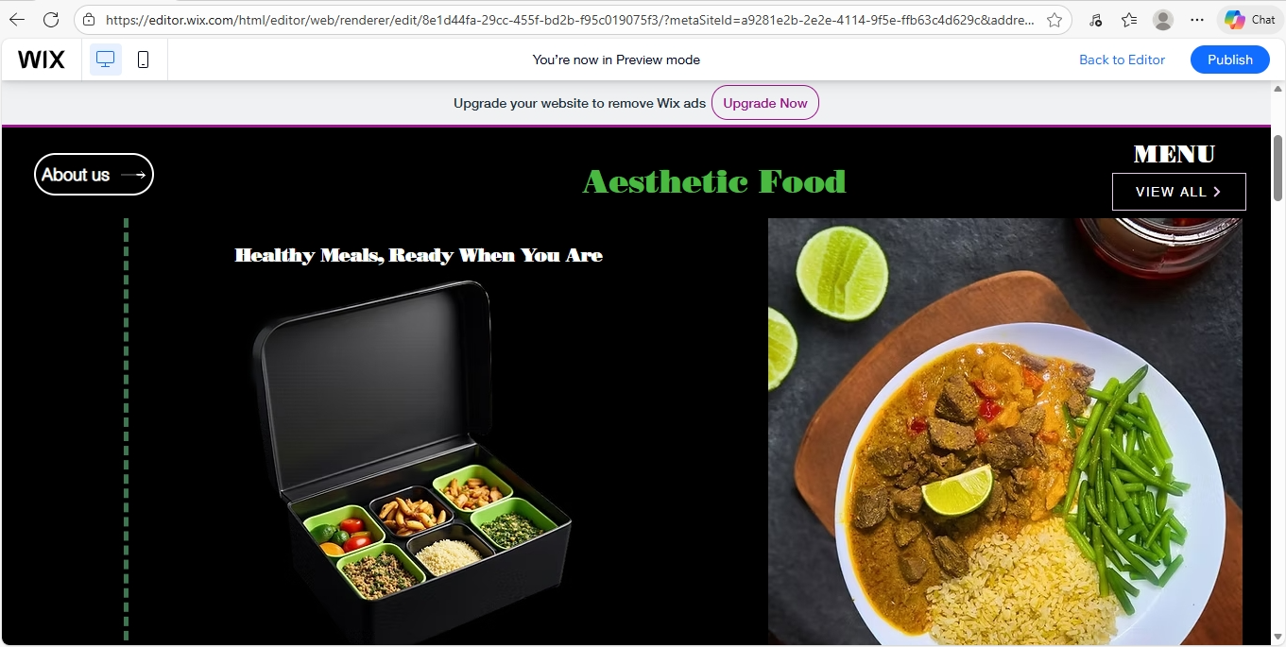



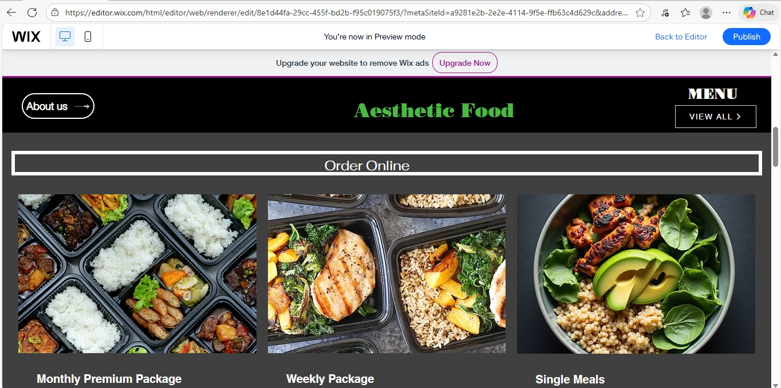

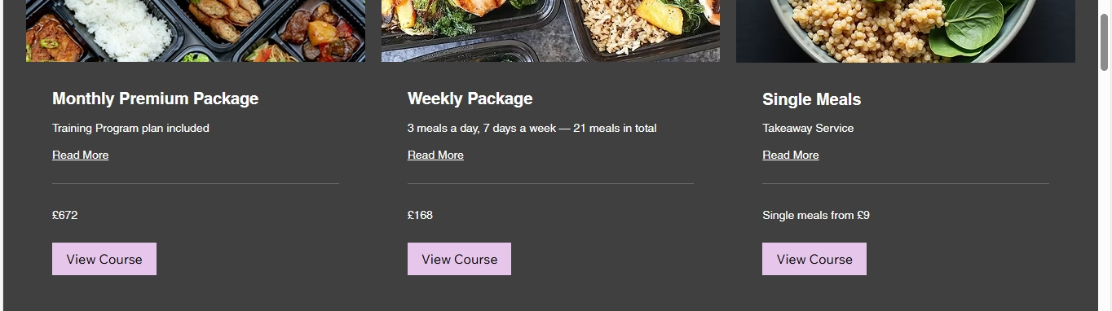

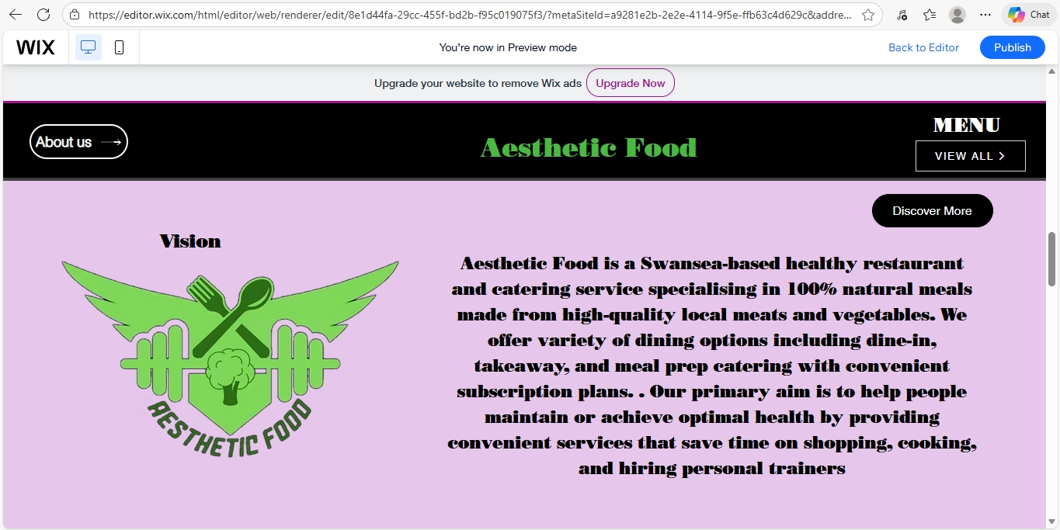

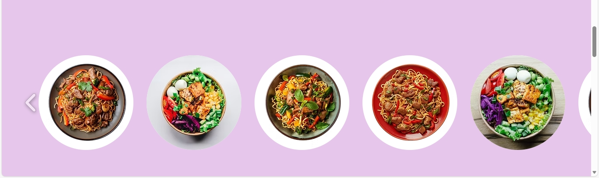

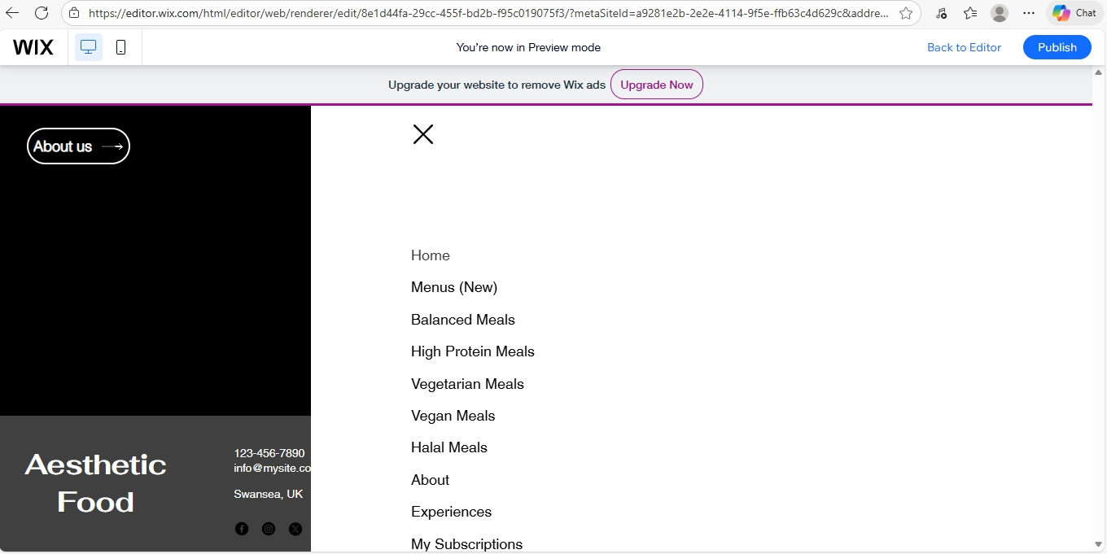

(Wix 2025)

Appendix C: Flyer (Canva 2025)
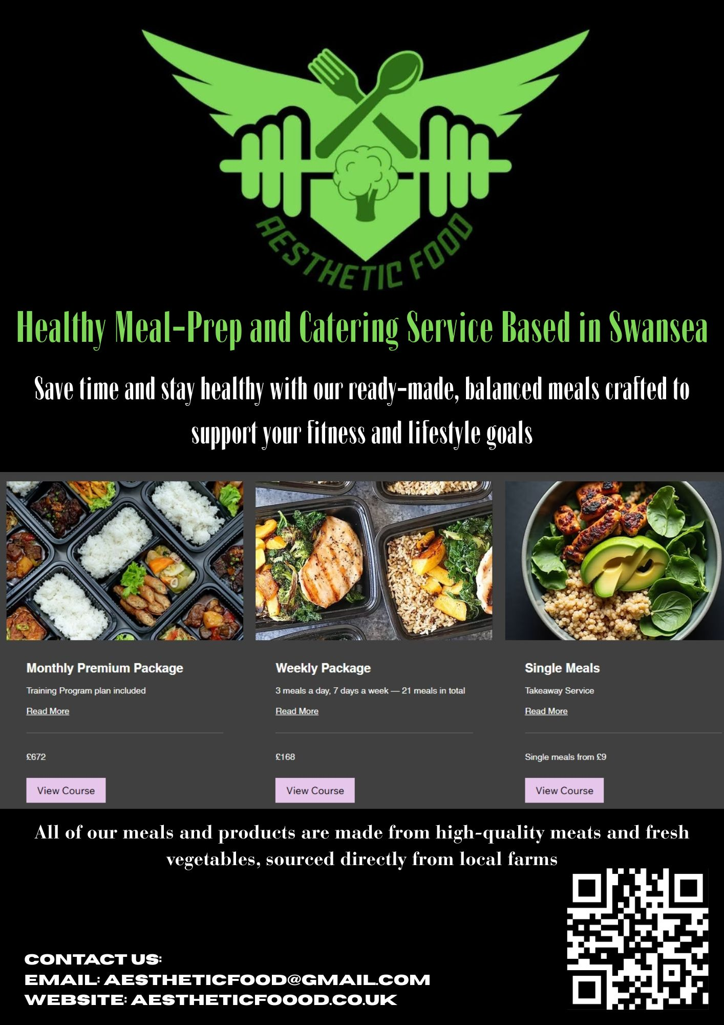

(Canva 2025)

REFERENCES

- Reedy, K. and Parker, J. (eds.) (2017) Digital Literacy Unpacked. Facet Publishing. Available at: https://ebookcentral.proquest.com/lib/trinity/detail.action?docID=5490897.
- Dadwal, S. S. (ed.) (2020) Handbook of Research on Innovations in Technology and Marketing for the Connected Consumer. IGI Global. doi:10.4018/978-1-7998-0131-3.
- Byrd, L. S. (ed.) (2021) Cultivating Entrepreneurial Changemakers Through Digital Media Education. IGI Global. doi:10.4018/978-1-7998-5808-9.
- Sandhu, K. (ed.) (2020) Digital Transformation and Innovative Services for Business and Learning. IGI Global. doi:10.4018/978-1-7998-5175-2.
- Pinto, F. M. and Guarda, T. (eds.) (2020) Digital Marketing Strategies and Models for Competitive Business. IGI Global. doi:10.4018/978-1-7998-2963-8.
- Soltanifar, M., Hughes, M. and Gocke, L. (2021) Digital Entrepreneurship. Springer. doi:10.1007/978-3-030-53914-6.
- Burgess, J., Marwick, A. and Poell, T. (2018) The SAGE Handbook of Social Media. SAGE Publications Ltd. Available at: http://www.doi.org.ezproxy.uwtsd.ac.uk/10.4135/9781473984066.
- Kotler, P. and Keller, K. (2021) Marketing Management. Pearson Education Limited.
- Hisrich, R. D., Peters, M. P. and Shepherd, D. A. (2017) Entrepreneurship. McGraw-Hill Education.
- McKeever, M. P. (2020) How to Write a Business Plan. Nolo/NOLO Press.

