Exercises for Functions – 2 (SOLUTIONS)

2. Calculate the area of the shaded part of the below.
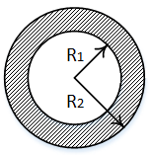
2a We have already written function calculatecircle() to help us to solve the area of the circle. Reuse this function in your new program (you can copy and paste it, or move it to its own file and use import if you like)

Sample output:

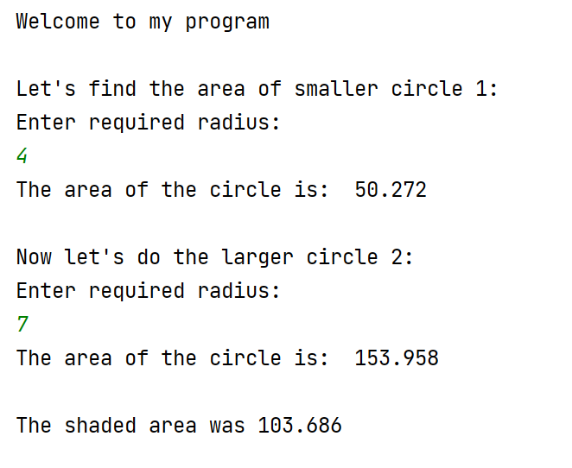

Solution:

def calculatecircle():
print("Enter required radius: ")
radius = float(input())
result=radius * radius * 3.142
print("The area of the circle is: ", result)
return result
def main():
print("Welcome to my program\n")
print("Let's find the area of smaller circle 1: ")
circle1 = calculatecircle()
print("\nNow let's do the larger circle 2: ")
circle2 = calculatecircle()
shadedArea = circle2 - circle1
print("\nThe shaded area was", shadedArea)
main()

2b. If the outer radius is smaller than the inner radius, we'll end up with a negative area.

For example:

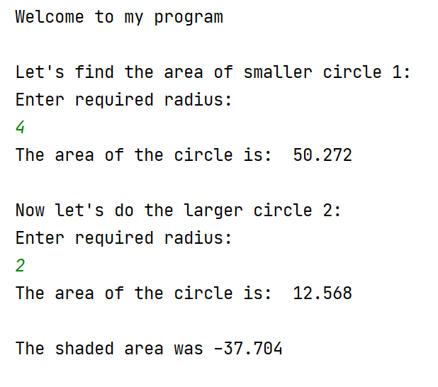

Warn the user about this if it occurs.

Sample output:

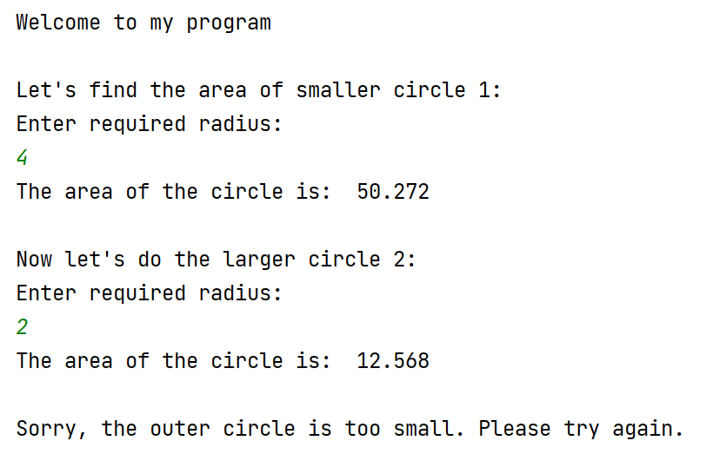

Solution:

def calculatecircle():
print("Enter required radius: ")
radius = float(input())
result=radius * radius * 3.142
print("The area of the circle is: ", result)
return result
def main():
print("Welcome to my program\n")
print("Let's find the area of smaller circle 1: ")
circle1 = calculatecircle()
print("\nNow let's do the larger circle 2: ")
circle2 = calculatecircle()
if(circle2 < circle1):
print("\nSorry, the outer circle is too small. Please try again.")
else:
shadedArea = circle2 - circle1
print("\nThe shaded area was", shadedArea)
main()

