

University of Wales Trinity Saint David
BA (Hons) Business Management
BUSINESS MANAGEMENT
INDIVIDUAL PRESENTATION
MANAGING PEOPLE
Student Name: Ovidiu Muresan
Student ID-2131059
Lecturer-Laila Maazouz
Submission-Resit 04-01-2024

Table of Contents
Introduction 3
6 different talent acquisition strategies 5
Explanation of incentive methods 18
Conclusion 27
Reference list 28

Introduction
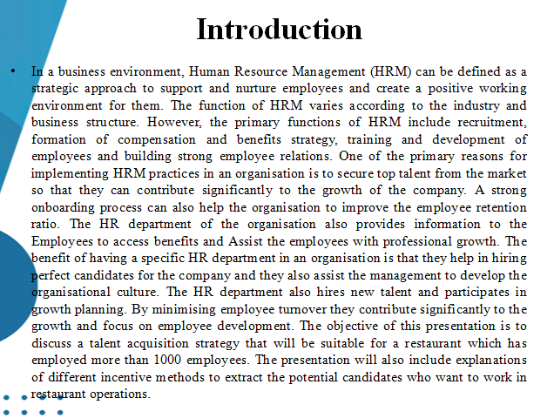
In a business environment, Human Resource Management (HRM) can be defined as a strategic approach to support and nurture employees and create a positive working environment for them. The function of HRM varies according to the industry and business structure. However, the primary functions of HRM include recruitment, formation of compensation and benefits strategy, training and development of employees and building strong employee relations. One of the primary reasons for implementing HRM practices in an organisation is to secure top talent from the market so that they can contribute significantly to the growth of the company. A strong onboarding process can also help the organisation to improve the employee retention ratio. The HR department of the organisation also provides information to the Employees to access benefits and assist the employees with professional growth. The benefit of having a specific HR department in an organisation is that they help in hiring perfect candidates for the company and they also assist the management to develop the organisational culture. The HR department also hires new talent and participates in growth planning. By minimising employee turnover, they contribute significantly to the growth and focus on employee development. The objective of this presentation is to discuss a talent acquisition strategy that will be suitable for a restaurant which has employed more than 1000 employees. The presentation will also include explanations of different incentive methods to extract the potential candidates who want to work in restaurant operations.

6 different talent acquisition strategies
Theoretical implications
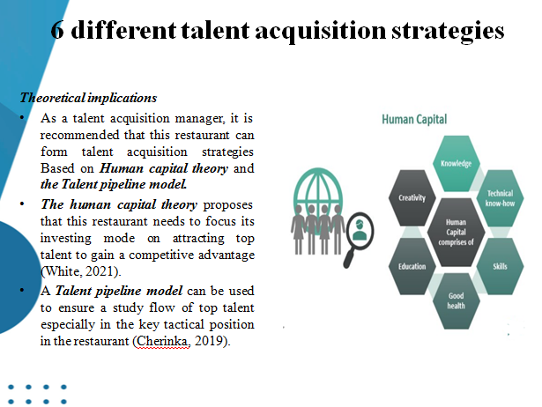
- As a talent acquisition manager, it is recommended that this restaurant can form talent acquisition strategies Based on Human capital theory and the Talent pipeline model.
- The human capital theory proposes that this restaurant needs to focus its investing mode on attracting top talent to gain a competitive advantage (White, 2021).
- A Talent pipeline model can be used to ensure a study flow of top talent especially in the key tactical position in the restaurant (Cherinka, 2019).
One of the main reasons for using a talent acquisition strategy to recruit talent from the market to this restaurant is to hire the top talented candidates so that they can contribute significantly to the growth of the company. The human capital theory focuses on candidates' skills and knowledge and they are regarded as the most valuable assets. One of the key principles of this theory is to invest in the education and training of the employees so that they can develop the required skill that is important to work in this restaurant. Training and development are also required so that the employees become more productive. By acquiring restaurant-specific knowledge they can also get more career opportunities in the company. The talent pipeline model can be regarded as a strategic approach of the HR department to ensure a continuous supply of skilled and educated candidates for the tactical position of the Restaurant. This model is designed to focus on the employee requirement of the company. One of the primary objectives of using this model in designing the Talent acquisition strategy is that it considers workforce planning. By using this model, the restaurant can also plan on the competence required from the employees.

Short-term talent acquisition strategies
Job posting on the online platform
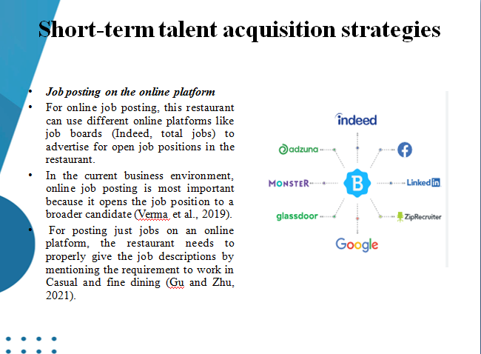
- For online job posting, this restaurant can use different online platforms like job boards (Indeed, total jobs) to advertise for open job positions in the restaurant.
- In the current business environment, online job posting is most important because it opens the job position to a broader candidate (Verma et al., 2019).
- For posting just jobs on an online platform, the restaurant needs to properly give the job descriptions by mentioning the requirement to work in Casual and fine dining (Gu and Zhu, 2021).
The Talent acquisition manager needs to craft the job description in such a way that it can attract the top talent from the market. It is also important to provide information regarding growth opportunities. The biggest benefit of job posting on an online platform is its wide reach. The potential candidates can see the job posting from online job portals and different networking sites like LinkedIn. Online job posting is also a cost-effective method to attract talent. Many online portals provide the opportunity to post the job free or at minimum cost and this facility are suitable for the restaurant which wants to spend a minimum on job posting. It can also enable the restaurant to use the budget effectively in other areas like talent development.

Referral programs
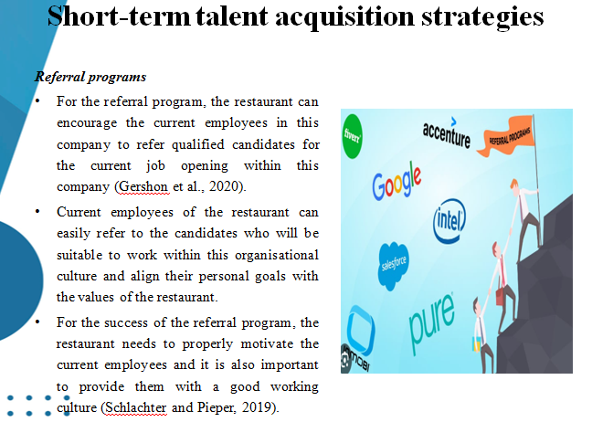
- For the referral program, the restaurant can encourage the current employees in this company to refer qualified candidates for the current job opening within this company (Gershon et al., 2020).
- Current employees of the restaurant can easily refer to the candidates who will be suitable to work within this organisational culture and align their personal goals with the values of the restaurant.
- For the success of the referral program, the restaurant needs to properly motivate the current employees and it is also important to provide them with a good working culture (Schlachter and Pieper, 2019).
One of the most important benefits of referral programs is that it helps in increasing employee engagement by engaging them in the recruitment and talent acquisition process. The employees of the company become active participants in implementing the recruitment strategy and hiring new recruits in the company. If the restaurant provides an additional incentive to the current employees, then they will be motivated to refer to other people and will seek out the most suitable candidate for this restaurant. A referral program can also pool high-quality candidates into the restaurant who will be suitable to work in the fine dining restaurant. The current employees of the Restaurant easily understand the values and mission and vision of the company and they can provide better judgement in finding out suitable candidates for the open job posting. The referral program is also the first effective measure to recruit new employees.
On-site recruitment
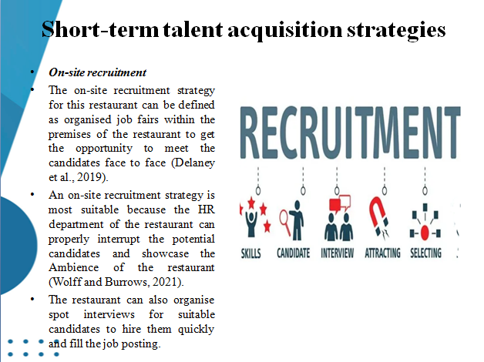
- The on-site recruitment strategy for this restaurant can be defined as organised job fairs within the premises of the restaurant to get the opportunity to meet the candidates face to face (Delaney et al., 2019).
- An on-site recruitment strategy is most suitable because the HR department of the restaurant can properly interrupt the potential candidates and showcase the Ambience of the restaurant (Wolff and Burrows, 2021).
- The restaurant can also organise spot interviews for suitable candidates to hire them quickly and fill the job posting.
One of the biggest advantages of onsite recruitment is that it helps indirectly interact with the candidates and the employers can easily determine capabilities to work in a casual and fine dining restaurant. From face-to-face interactions, the recruitment manager can easily determine the communication skill of the candidates and easily get a sense of their skill level and personality. Personal interaction is also important because it provides insight information of the candidate which is not possible to convey through online platforms and online resumes. The recruitment manager can also showcase the ambience of the restaurant and discuss the casual and fine dining system in the company. In this way, even the potential candidate can understand the skill requirement and they can get a sense of the work environment in the company.

Long-term acquisition strategy
Internship and apprenticeship program
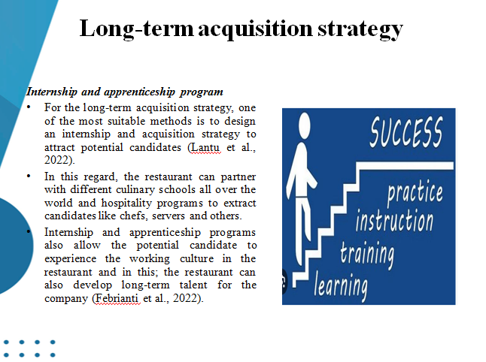
- For the long-term acquisition strategy, one of the most suitable methods is to design an internship and acquisition strategy to attract potential candidates (Lantu et al., 2022).
- In this regard, the restaurant can partner with different culinary schools all over the world and hospitality programs to extract candidates like chefs, servers and others.
- Internship and apprenticeship programs also allow the potential candidate to experience the working culture in the restaurant and in this; the restaurant can also develop long-term talent for the company (Febrianti et al., 2022).
The benefit of having an internship and apprenticeship program in this restaurant is that the restaurant then provides an opportunity for the potential candidate to experience the working environment in this industry. By offering the apprenticeship program, this restaurant can easily attract talented and motivated candidates who want to contribute significantly to the casual and fine dining operation of this restaurant. The internship program is also useful to provide real-life examples of working in the hospitality industry and the company can develop the skills that are most suitable for the operation of this restaurant to meet the specific need. So, it can be said that the interns of the restaurant can gain the requested skill set that is aligned to meet the industry and Restaurant standards.

Talent development Pathways
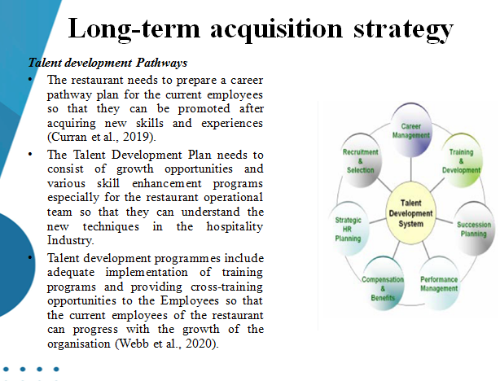
- The restaurant needs to prepare a career pathway plan for the current employees so that they can be promoted after acquiring new skills and experiences (Curran et al., 2019).
- The Talent Development Plan needs to consist of growth opportunities and various skill enhancement programs especially for the restaurant operational team so that they can understand the new techniques in the hospitality Industry.
- Talent development programmes include adequate implementation of training programs and providing cross-training opportunities to the Employees so that the current employees of the restaurant can progress with the growth of the organisation (Webb et al., 2020).
With the help of a career development plan, this restaurant can nurture its existing employees and provide them with an opportunity to grow with the restaurant. The objective of the talent development pathway is to enhance the skills and knowledge of the employees so that they can progress in their careers and the restaurant can also meet the need for specific skills and talent. The Talent development plans so that the employees can be produced in such a way so that the employees can clearly understand the career opportunities in the restaurant. The restaurant needs to clearly outline the responsibilities and skills required to work in a casual and fine dining restaurant. A clear specification of the roles and responsibilities will be helpful for the employees to get a sense of direction to progress with the organisation.

Industry partnership
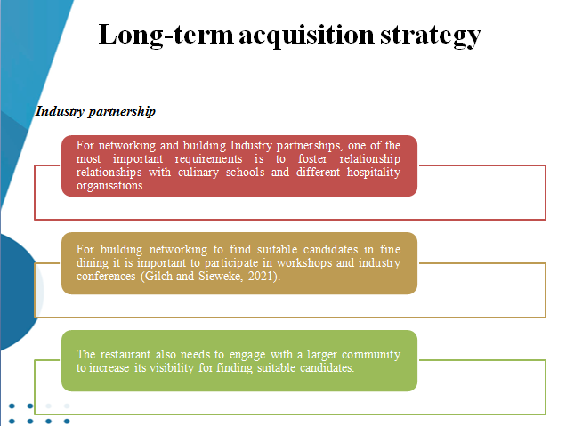
- For networking and building Industry partnerships, one of the most important requirements is to foster relationship relationships with culinary schools and different hospitality organisations.
- For building networking to find suitable candidates in fine dining it is important to participate in workshops and industry conferences (Gilch and Sieweke, 2021).
- The restaurant also needs to engage with a larger community to increase its visibility for finding suitable candidates.
Industry partnership is also beneficial for this restaurant because it provides access to a larger talent pool. For industry partnership, it is essential to collaborate with other restaurants in this industry to get exposure to the larger talent pool which this organisation cannot reach through traditional channels of recruitment. This talent acquisition method is helpful in sharing knowledge and resources to achieve common goals. If this restaurant partners with other reputable culinary schools and organisations in the hospitality industry then it also improves the brandy. The enhanced reputation of the employer brand will also help the restaurant to attract talented candidates from the market. Networking can also provide valuable opportunities like mentorship and career growth to the employees of the restaurant. On the other hand, industry partnership is also helpful in addressing the challenges of the hospitality industry collaboratively. Industry partnership is beneficial for this restaurant to pool resources for the growth of this organisation.

Explanation of incentive methods
Theoretical implications
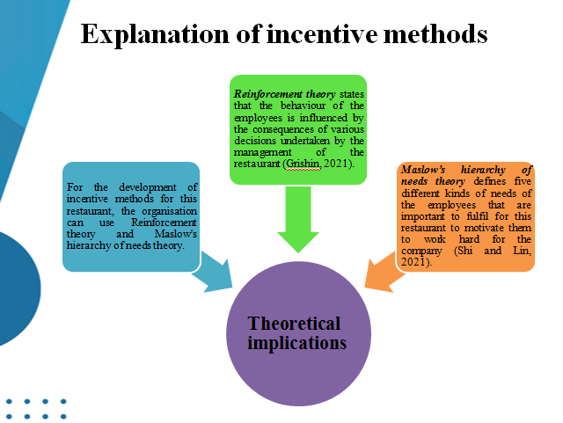
- For the development of incentive methods for this restaurant, the organisation can use Reinforcement theory and Maslow's hierarchy of needs theory.
- Reinforcement theory states that the behaviour of the employees is influenced by the consequences of various decisions undertaken by the management of the restaurant (Grishin, 2021).
- Maslow’s hierarchy of needs theory defines five different kinds of needs of the employees that are important to fulfil for this restaurant to motivate them to work hard for the company (Shi and Lin, 2021).
According to the reinforcement theory, there are two kinds of reinforcement such as positive and negative reinforcement. For positive reinforcement, the restaurant can provide monetary benefits, promotions and praise them for their efforts. On the other hand, negative reinforcement includes using adverse stimuli to get desired behaviour from the employees. Negative reinforcement includes punishment and extinction. Maslow's hierarchy of neat theory proposed that this restaurant needs to consider different kinds of needs to motivate the employees. The salary structure of the restaurant must be designed in such a way that it can at least meet the psychological needs (food, shelter and water). After the fulfilment of psychological needs, the employees of this restaurant will look for safety needs, needs for love and belonging, self-esteem and self-actualization.

Monetary incentive method
Performance-based bonuses to the Employees
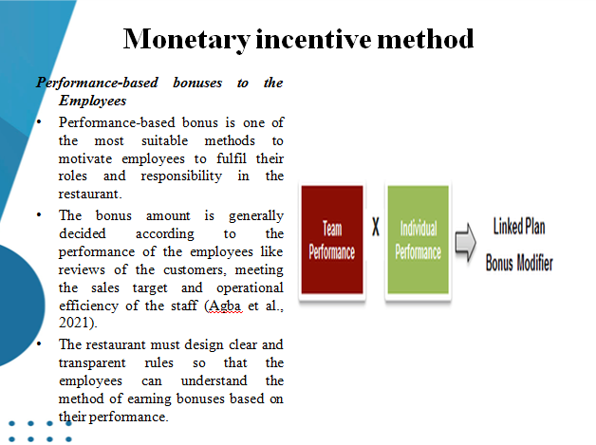
- Performance-based bonus is one of the most suitable methods to motivate employees to fulfil their roles and responsibility in the restaurant.
- The bonus amount is generally decided according to the performance of the employees like reviews of the customers, meeting the sales target and operational efficiency of the staff (Agba et al., 2021).
- The restaurant must design clear and transparent rules so that the employees can understand the method of earning bonuses based on their performance.
For providing the performance-based bonus the first step is to clearly define the performance Matrix to all the employees so that all of them can get equal opportunities to get bonuses. Transparency should be maintained in communicating the actual performance of the employees otherwise, the objective of this monetary incentive cannot be achieved. One of the primary causes of providing performance-based bonuses is to motivate employees to grow and acquire more knowledge of the industry. The bonus program of the restaurant should be aligned with the objectives of the operation of this restaurant so that it can support the strategic objectives.

Adequate salary packages
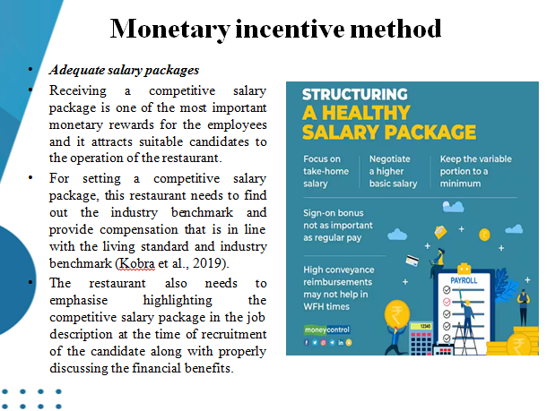
- Receiving a competitive salary package is one of the most important monetary rewards for the employees and it attracts suitable candidates to the operation of the restaurant.
- For setting a competitive salary package, this restaurant needs to find out the industry benchmark and provide compensation that is in line with the living standard and industry benchmark (Kobra et al., 2019).
- The restaurant also needs to emphasise highlighting the competitive salary package in the job description at the time of recruitment of the candidate along with properly discussing the financial benefits.
The first step is to provide an adequate and competitive salary package to the employees of this restaurant to conduct market research to understand the benchmark of this industry. The compensation package must be fair and equal for all employees. The salary of the restaurant must be designed according to the experience and jobs and skills of the employees. The objective of providing a competitive salary package to the employees of this restaurant is to retain the top talent of the company and to improve the employee retention ratio.
Non-monetary incentive method
Growth opportunities
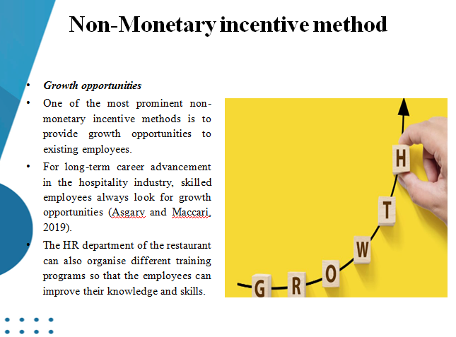
- One of the most prominent non-monetary incentive methods is to provide growth opportunities to existing employees.
- For long-term career advancement in the hospitality industry, skilled employees always look for growth opportunities (Asgary and Maccari, 2019).
- The HR department of the restaurant can also organise different training programs so that the employees can improve their knowledge and skills.
This non-monetary incentive method is most appropriate to retain the skills and knowledgeable employees for the continuous operation of the restaurant. For providing growth opportunities to the Employees one of the most important goals is to provide them with adequate training and development programs so that they can improve technical skills like knowledge on food and beverage and soft skills like communication and leadership. Apart from that, cross-training is also required so that the employees can gain experience from working in different departments in the restaurant. It will help them to get exposure to different operational contexts of the restaurant.

Employee recognition program
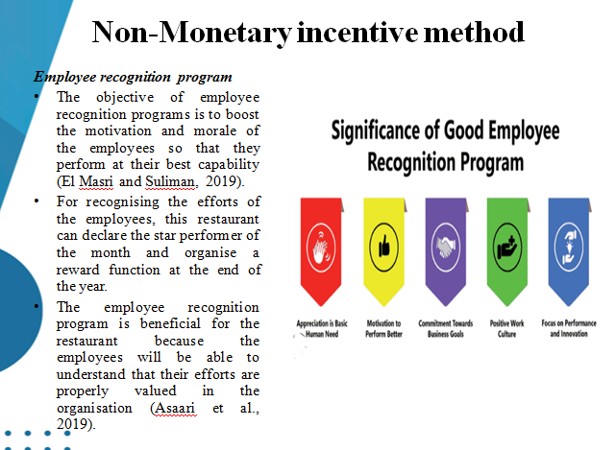
- The objective of employee recognition programs is to boost the motivation and morale of the employees so that they perform at their best capability (El Masri and Suliman, 2019).
- For recognising the efforts of the employees, this restaurant can declare the star performer of the month and organise a reward function at the end of the year.
- The employee recognition program is beneficial for the restaurant because the employees will be able to understand that their efforts are properly valued in the organisation (Asaari et al., 2019).
For developing an employee recognition program, the most important criterion is to establish transparent rules and regulations so that the employees can understand specific behaviours and skills desired by the company. The efforts of the employees need to be regularly recognised and it is also important to acknowledge their performance in a timely manner. Different employees have different skills and knowledge and for this reason, the restaurant needs to have multiple recognition channels to recognise the different preferences and skills of the employees. A recognition program is also essential for this restaurant to promote the concept of teamwork. If the employees of this restaurant are properly acknowledged for their valuable contribution to the growth of the organisation, then they will foster collaboration and efforts.

Conclusion
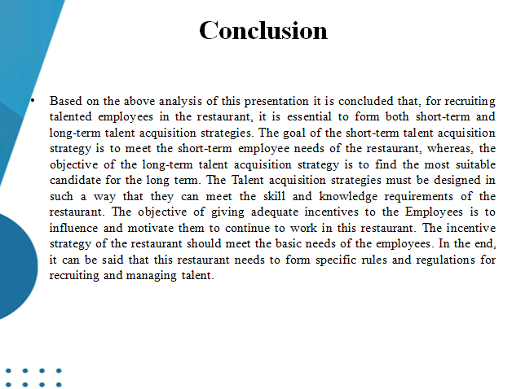
Based on the above analysis of this presentation it is concluded that, for recruiting talented employees in the restaurant, it is essential to form both short-term and long-term talent acquisition strategies. The goal of the short-term talent acquisition strategy is to meet the short-term employee needs of the restaurant, whereas, the objective of the long-term talent acquisition strategy is to find the most suitable candidate for the long term. The Talent acquisition strategies must be designed in such a way that they can meet the skill and knowledge requirements of the restaurant. The objective of giving adequate incentives to the Employees is to influence and motivate them to continue to work in this restaurant. The incentive strategy of the restaurant should meet the basic needs of the employees. In the end, it can be said that this restaurant needs to form specific rules and regulations for recruiting and managing talent.

Reference list
Agba, A.O., Omang, T.A., Enukoha, C.N. and Eteng, F.O., (2021). Performance based incentives and employees’ productivity in commercial organisations. Quantitative Economics and Management Studies, 2(2), pp.129-139.
Asaari, M.H.A.H., Desa, N.M. and Subramaniam, L., (2019). Influence of salary, promotion, and recognition toward work motivation among government trade agency employees. International Journal of Business and Management, 14(4), pp.48-59.
Asgary, N.H. and Maccari, E.A., (2019). Entrepreneurship, innovation and sustainable growth: Opportunities and challenges.
Cherinka, R., (2019). Using Cyber Competitions to Build a Cyber Security Talent Pipeline and Skilled Workforce. In Intelligent Computing: Proceedings of the 2018 Computing Conference, Volume 2 (pp. 280-289). Springer International Publishing.
Curran, O., MacNamara, A. and Passmore, D., (2019). What about the girls? Exploring the gender data gap in talent development. Frontiers in sports and active living, 1, p.3.
Delaney, H., Devane, D., Hunter, A., Hennessy, M., Parker, A., Murphy, L., Cronin, P. and Smith, V., (2019). Limited evidence exists on the effectiveness of education and training interventions on trial recruitment; a systematic review. Journal of clinical epidemiology, 113, pp.75-82.
El Masri, N. and Suliman, A., (2019). Talent management, employee recognition and performance in the research institutions. Studies in Business and Economics, 14(1), pp.127-140.
Febrianti, D., Megasyara, I. and Mas’adah, N., (2022). Exploration of the implementation of PKL in achieving MBKM goals in Accounting Study program. International Journal of Science, Technology & Management, 3(1), pp.6-21.
Gershon, R., Cryder, C. and John, L.K., (2020). Why prosocial referral incentives work: the interplay of reputational benefits and action costs. Journal of Marketing Research, 57(1), pp.156-172.
Gilch, P.M. and Sieweke, J., (2021). Recruiting digital talent: The strategic role of recruitment in organisations’ digital transformation. German Journal of Human Resource Management, 35(1), pp.53-82.
Grishin, N.V., (2021). Reinforcement theory and study of the impact of internet technologies on political participation of modern youth. RUDN Journal of Political Science, 23(1), pp.47-59.
Gu, G. and Zhu, F., (2021). Trust and disintermediation: Evidence from an online freelance marketplace. Management Science, 67(2), pp.794-807.
Kobra, M.K., Khalil, M.I., Rubi, M.A., Kulsum, U. and Zayed, N.M., (2019). Factors and strategies to drive the choice of women graduates to enter into tourism and hospitality sector: A perceptual strategic study. Academy of Strategic Management Journal, 18(6), pp.1-7.
Lantu, D.C., Suharto, Y., Fachira, I., Permatasari, A. and Anggadwita, G., (2022). Experiential learning model: improving entrepreneurial values through internship program at start-ups. Higher Education, Skills and Work-Based Learning, 12(1), pp.107-125.
Schlachter, S.D. and Pieper, J.R., (2019). Employee referral hiring in organizations: An integrative conceptual review, model, and agenda for future research. Journal of Applied Psychology, 104(11), p.1325.
Shi, Y. and Lin, X., (2021). A Test of Maslow's Hierarchy of Needs Concept by a Correlational Model among Adult Learners. American Association for Adult and Continuing Education.
Verma, A., Yurov, K.M., Lane, P.L. and Yurova, Y.V., (2019). An investigation of skill requirements for business and data analytics positions: A content analysis of job advertisements. Journal of Education for Business, 94(4), pp.243-250.
Webb, T., Dicks, M., Brown, D.J. and O’Gorman, J., (2020). An exploration of young professional football players’ perceptions of the talent development process in England. Sport management review, 23(3), pp.536-547.
White, B., (2021). Human capital theory and the defectology of aspirations in policy research on rural youth. The European Journal of Development Research, 33(1), pp.54-70.
Wolff, M. and Burrows, H., (2021). Planning for virtual interviews: residency recruitment during a pandemic. Academic pediatrics, 21(1), pp.24-31.

