DS 1 assessment for week 4 submission

[2534022] Habib Urehman
- Please add 4–6 screenshots or photos of your digital life.
- You can use your phone or laptop.
- For each screenshot, write one or two sentences explaining what it shows.

Screenshot/Photo 1
[Digital Screenshots ]
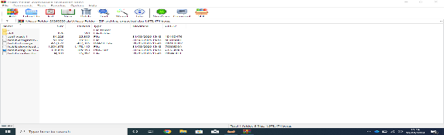
I learned how to screen shot in my first week . good digital tool learned how to do it by pressing windows button and print screen button together.

Screenshot/Photo 2
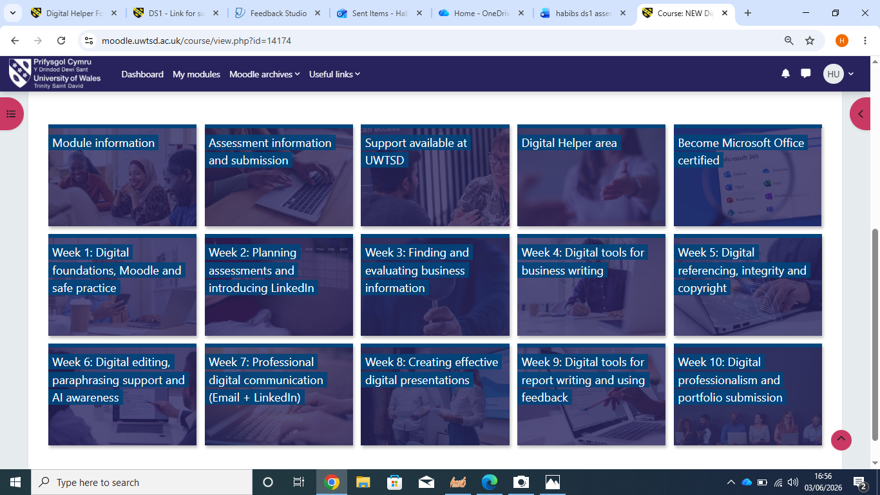 Moodle i have accessed moodle to gain info on course work and assesment submission

Screenshot/Photo 3
[Microsoft one drive]
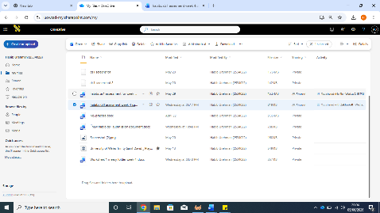I used Microsoft one drive to save my files and downloads. it’s a great tool. It is a cloud-based storage service that lets you store share and sync files online.

Screenshot/Photo 4
[Microsoft power point]
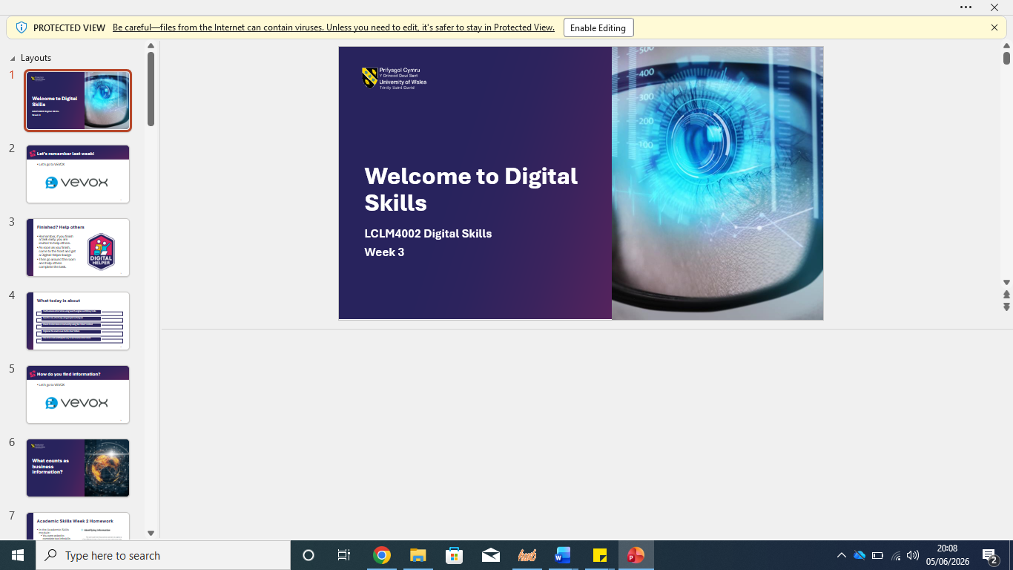
This tool I used specifically for digital presentation. software application like poster boards. slides projectors etc. brilliant tool.

Screenshot/Photo 5
[office 365]

This tool I used to create documents that I saved on files. it’s a great tool for content creation and has special ai assistance if I get stuck with presentations or document creation.

Screenshot/Photo 6
[linked in]

I used LINKED IN for info about how to find jobs. manage my career and build business connection. linked in is connected to a range of social media platforms too. Brilliant tool

My Short Reflection
- Write 5–8 simple sentences about your digital life.
- You can use the sentence starters below if helpful.
My digital life is deeply woven into my daily routine, serving as a dynamic bridge between my professional tasks and personal connections. Whether I am checking local updates or managing remote work or simply staying in touch with friends. However balancing digital life with real world presence is still challenging for me as I am new to this digital world. I have a long way to go. And i also learned about the craap system to help me find credible and reliable info its main features it checks and evaluates info for you needs by identifying sources which a credible and also determines why why the contents exist –to inform teach or sell or persuade-and checks for bias .as i could not put up a screen shot of jisc i am writing in detail about the uses of jisc here jisc is a online assessment app that help me evalute and develop my digital skills and its also a assessment app and a skills building platform.

Sentence starters
- I use digital tools to help me with searching online making documents etc.
- I feel confident when I do group work or alone
- I want to improve my grammar because its not up to standards
- I often use these tools: do banking, making formal documents browse the web etc.
- I sometimes feel nervous about deadlines ..
- I hope this module will help me gain better skills and confidence in all aspects of life.
- Digital skills are important for me because I want to make a career with a good salary or maybe open my own business.
You can write more if you want.

Submission Checklist
Before you submit, please check:
​​​ ☐ I added 4–6 screenshots x
☐ I wrote short sentences for each screenshot x
☐ I wrote my short reflection x
☐ My work is my own x
☐ My file opens correctly x
​​☐ My file opens correctly x

