James Denton – 1702202
Design and Evaluation of Wireless Sensor Networks
Wireless Networks and Simulation
Simon Downes

Table of Contents

- Research and Evaluation of Modulation Schemes
  - Introduction
  - What is Modulation and why is it used?
  - BPSK vs QPSK vs QAM
  - Conclusion
  - Testing methods
  - Experiment Results

- Wireless Sensor Network Design and Evaluation
  - Introduction
  - Backbone Network Implementation
  - Wireless Sensor Network Implementation
  - Performance
    - PATHLOSS_AND_FADING_AND_SHADOWING
  - Conclusion

- References

Research and Evaluation of Modulation Schemes

Introduction
Wireless networks are prolific all over the developed world in the form of phones, computers and countless other devices communicating via radio-based cellular and WiFi networks. Modulation is what facilitates this, allowing for long distance transmission of data at reasonable amplification power, allowing data to better resist alteration from interference, and finally, allowing for more efficient usage of the limited viable section of the electromagnetic spectrum capable of supporting radio communications (e.g. greater spectral efficiency). [1]

What is modulation and why is it used?
The way that modulation works is by utilising a carrier wave, which is a high frequency waveform, and encoding the data being transmitted onto it. The main benefits of which are that it allows for transmission over long distances [2] and that it allows for far greater spectral efficiency, which is measured in b/s/Hz or “bits per second per hertz” and is heavily dependent on the form of modulation that is used. A more recent form of modulation such as 64 QAM (Quadrature Amplitude Modulation) is capable of conveying up to 6 bits, a significant improvement on the earlier 16 QAM, capable of only 4 bits. [1]

Waves are affected by 3 characteristics. These are Amplitude (height of a waveform), Frequency (which can effectively be thought of as “number of waves per second”), and phase (which is how “shifted” the waveform is to the left or right). [3] As a result of this, the 3 forms of analogue modulation are AM (Amplitude Modulation), PM (Phase Modulation) and FM (Frequency Modulation), where in which the amplitude, phase or frequency is altered to match the input. FM is superior to AM in the sense that it is less susceptible to noise, however it also utilises more bandwidth. [4]

However, the focus of this assignment is on digital modulation schemes, which differ from analogue modulation in a number of ways. The main difference between analog and digital modulation is that analog modulation consists of sine waves and digital of square waves. Another difference between the two is that sine waves occur naturally and are analog (i.e. are very variable and produce continuous data). Square waves are essentially the opposite, as they operate in only two states (1 or 0 i.e. discrete data) and do not occur naturally (i.e. they are a man-made creation). [5] A further difference between the two is that digital modulation schemes can use error correction codes to improve SNR (Signal-to-noise Ratio), whereas with analog modulation, the improvement is fixed, though bandwidth can be exchanged for better SNR. [6]

BPSK vs QPSK vs QAM
A good modulation scheme will excel in at least one of these categories. The first is BER (Bit Error Rate). When transferring data, it is inevitable that some interference/noise will be encountered. This interference will then alter the bits of the data by some margin. BER is a measurement of this. [7] The second factor is Bandwidth usage. Due to the limited viable space of the electromagnetic spectrum, a modulation scheme should transfer as much data as possible while using as little bandwidth as possible. [1] Finally, Complexity of implementation. The complexity of the implementation may make it more susceptible to failure and increase the cost to implement it. [7]

BPSK (Binary Phase Shift Keying) and QPSK (Quadrature Phase Shift Keying) both belong to the PSK (Phase Shift Keying) family of modulation schemes. [2]

Phase Shift Keying is a digital modulation method currently used in communication systems due to its efficient signal power use. [8] When compared with ASK (Amplitude Shift Keying) and FSK (Frequency Shift Keying), it has improved performance, but at the cost of a more complex signal detection system. [7] In BPSK, the data is encoded within the phase of an amplitude carrier signal. It works by utilising an initial phase of zero, followed by a “burst of carrier” to represent one. Zero is represented by an initial 180° phase followed by the same “burst of carrier”. Both can be observed under “Output Frequency” in Figure 1 [8]
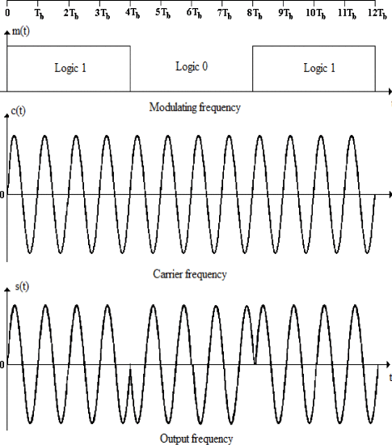
Figure 1: PSK Modulation [8]

QPSK differs to BPSK in that it has four possible states (or rather, phases) instead of two. This means that it can encode two bits per symbol and can therefore carry twice as much data as BPSK while utilising the same bandwidth, and hence has greater spectral efficiency. BER is also the same. [7]

The main applications of PSK are in domestic WiFi, Satellite TV (which both use QPSK) and early space communication. Probability of error increases with level of modulation, but bandwidth utilisation goes down. [7]

QAM (Quadrature Amplitude Modulation) is a method of modulation in which the data is encoded within both the phase and amplitude of the carrier signal. [8] it utilises a combination of M-ASK (Amplitude Shift Keying) and M-PSK (Phase Shift Keying) modulation schemes and has the same average signal power as PSK. As a result of this QAM is more spectrally efficient than PSK modulation methods, with basic 16 QAM able to carry 4 bits (compared to QPSK’s 2 bits and BPSK’s 1 bit). One drawback of QAM is that as level of modulation increases, so does probability of error. It also requires inefficient (in terms of power consumption and efficiency) linear amplifiers, as it utilises ASK modulation, which requires this. Finally, QAM also has a more complex circuit that makes its implementation and simulation more difficult than previous discussed methods. The main applications of QAM are cable TV and mobile cellular telephone networks. [7]

Conclusion
After evaluating the 3 optional modulation techniques, it is clear that there is no definitive “best” technique, as they each have individual benefits and drawbacks. QPSK features identical bandwidth usage and BER to BPSK, while transmitting twice the data. In comparison to QAM, it offers significantly lower power consumption due to not requiring the high power linear amplification of ASK/QAM. QAM does offer a higher spectral efficiency (4 bits at 16 QAM), but also has a higher complexity in its circuit design that makes it significantly harder to simulate or implement. With this in mind, the modulation scheme chosen for simulation is BPSK, as despite the benefits of QPSK and QAM, the difficulty to simulate them is too great.

Testing Methods
The complexity of wireless networks means that deploying a test-bed system with real components can be difficult. As such, simulators are popularly used as an alternative. However, both are a necessary and complementary part of network design and validation. An ideal development process would involve a simulation stage to test theoretical network performance and refine the design. This would then be followed by a test-bed stage used to confirm the theoretical performance of the network and identify any performance inhibitors or points of failure. This is done as no matter how accurate a simulation; it will never be 100% representative of whatever it is simulating. [10]

In addition to this testing, production of mathematical models is also a good idea. In the case of WSN’s (Wireless Sensor Networks) for example, it would be a good idea to predict network lifetime by creating a model on power consumption of nodes to ensure that the network will last long enough to fulfil its intended purpose. [11]

Experiment Results
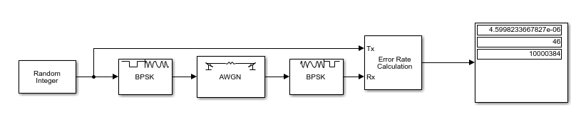
Signal to Noise Ratio (SNR) (Db) | Bit Error Rate  (BER)
10 | 4.6%
9.8 | 6.3%
9.6 | 8.8%
9.4 | 14.2%
9.2 | 21.7%
9.0 | 32.8%
8.8 | 46.5%
8.6 | 68%
8.4 | 99.7%
8.2 | 100%

The independent variable of this experiment is the Signal-to-Noise Ratio (SNR) (measured in decibels), and this is varied to produce more noise and evaluate the ability of the modulation scheme to prevent interference. The method of calculating BER is “number of bits in error” divided by “total number of bits transferred”, meaning that if 1000 bits were transferred and 46 bits were in error, the bit error rate would be 4.6% (as can be seen in the figure above. The top value is BER, the middle value is number of errors and the bottom value is total number of bits transferred).

As can be seen in the table above, the BER at 10 decibels of SNR was 4.6%, and as the SNR dropped, the BER continued to rise to 8.8% at 9.6 decibels, and then to 21.7% at 9.2 decibels, 46.5% at 8.8 decibels, 68% at 8.6 decibels and 99.7% at 8.4 decibels before finally reaching a 100% BER at 8.2 decibels. What this shows is that the BER will increase exponentially as the SNR decreases, which is in line with the research, which reports this phenomenon for BPSK, QPSK and QAM.

Wireless Sensor Network Design and Evaluation

Introduction
The project being undertaken is the creation of a smart farm. The general concept of this is to implement a wireless sensor network that will facilitate monitoring of crop health and soil quality (such as high/low acidity), aerial drones that will periodically fly over fields to capture data on fields to take photographs, measure crop water levels, detect weeds, spray fertiliser and pesticides, etc. [12] The farm will also feature autonomous tractors that plough fields based on a pre-set route without a human operator. The system will also implement livestock health monitoring and position monitoring via sensor nodes attached to each animal. Smart warehouses and greenhouses will also be implemented to monitor the temperature and humidity of the environment and toggle heaters and cooling fans to ensure the correct environment for the crop/yield and ensure freshness. [13] The farm produces milk, so this is required to ensure it doesn’t sour.

Backbone Network Implementation
The backbone consists of a LOWPAN Gateway for all of the nodes to connect to. This is then connected to a router, which connects to a wired node PC (Farmers John’s PC), and to a wireless access point, which is used to provide network access to 3 wireless nodes (Wife 1, Wife 2 and Wife 3).

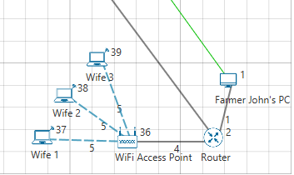

Wireless Sensor Network Implementation

In order to implement such a system, an extensive Wireless Sensor Network is required, implementing sensor nodes on all aerial drones, livestock and automated machinery, and at all farm buildings to ensure communication between all nodes and ensure automated farming equipment is able to feed information back to a sink node and be remote managed (e.g. change the path of the vehicle). The farm has 20 cows, 5 sheep and has 1 shepherd dog. Each has a sensor node to allow its position to be calculated in combination with other tracking nodes installed at all fields to facilitate real-time tracking based on distance to nearby nodes. Each field’s nodes are connected to a sink node to which all data is fed back for processing. [14]

Additionally, all animals have a smart collar connected to the wireless sensor network containing a heart rate monitoring sensor, a rumination sensor to monitor nutrition and a temperature sensor to monitor the temperature of the animal. This will feed data back to a sink node, which will alert the farmer if any abnormal values are detected. [15]

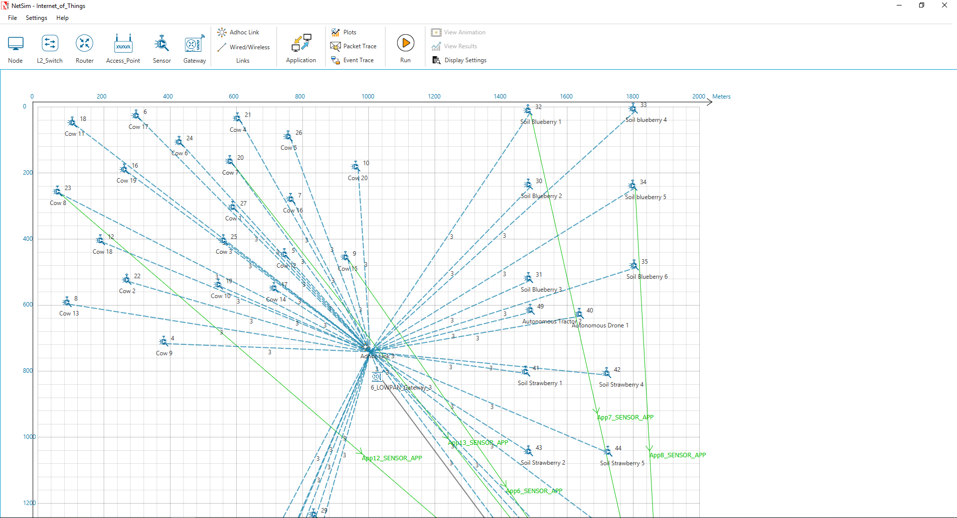
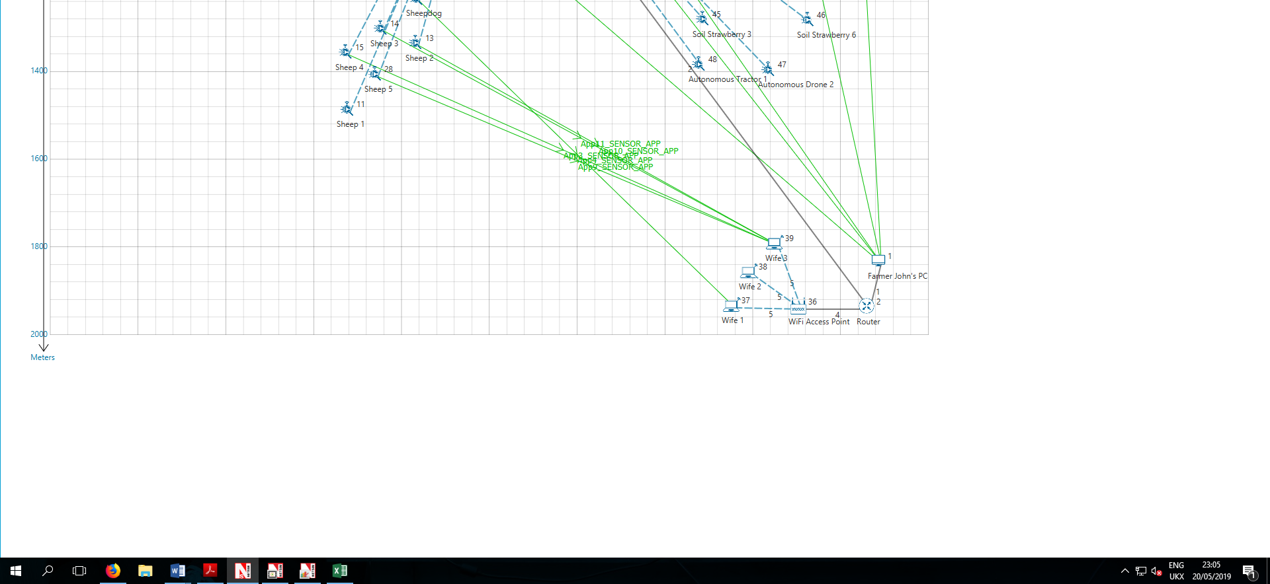

The cows are represented as Cow 1-20 and are set up with the RANDOM_WALK mobility model that has them move at a velocity of 1m/s. This is because cows are not herded and typically graze freely. The sheep are represented as Sheep 1-5, and are placed next to the Shepherd dog, which is represented as Sheepdog. The 5 Sheep and Sheepdog are set up under the GROUP_MOBILITY mobility model to represent sheep herding by a shepherd dog. They are moving at a velocity of 2m/s.

The autonomous tractor vehicles perform jobs such as tilling, seeding, spraying of pesticides, harvesting crops and transporting crops. All of this is done without any human drivers. Utilising a GPS system, the tractor is able to obtain positioning information in real-time and follow any route provided, allowing it to be used in harvesting and transport of product, with remote tracking and control of the tractor facilitated through connection to the wireless sensor network. [16] The tractor also features a motion sensor to allow it to detect obstacles in its path and attempt to go around them, avoiding any disasters.

The Autonomous Tractors are represented as “Autonomous Tractor 1” and “Autonomous Tractor 2” and setup under the RANDOM_WALK mobility model with a velocity of 10m/s.

GPS tracking is used for the autonomous agricultural drones to ensure they stay on course. They will be equipped with Taguchi gas sensors. This will act in the same capacity of a biological human nose by detecting the emitted odours of the Strawberries and Blueberries when sufficiently ripened and allow the farmer to harvest the fruits at the most opportune moment. They will also be equipped with an IR thermal Camera. This will be used to detect wildlife that could be harmful to the crops, and to monitor plant temperature to aid in detected plant-based diseases, and to monitor the level of water inside plants. There will also be a standard camera to be used for manual analysis should it be needed. [12]

The Autonomous Drones are represented as “Autonomous Drone 1” and “Autonomous Drone 2” and setup under the RANDOM_WALK mobility model with a velocity of 30m/s.

Soil Monitoring is done via nodes deployed in fields. These contain a PH Sensor for monitoring pH and feeding back to the sink node. For the Blueberry fields, the PH will be maintained between 4.5 and 5.5 and for the Strawberry fields, a pH of 5.5 to 6.5 is necessary for a healthy plant. This means that the soil must be acidic. The pH reading will be sent to the autonomous drones, which will drop phosphorous-rich fertiliser if the soil pH is too alkaline. [17]

The soil monitoring nodes are represented as “Soil Strawberry 1-6” and “Soil Blueberry 1-6”, with 6 nodes in the Strawberry field and 6 nodes in the Blueberry field. They are all setup under the NO_MOBILITY mobility model as they are stationery nodes set up at fixed points in the field.

Network Performance

The delay is highest on source 29, exceeding 47000 microseconds with the lowest delay being on source 9, at just below 30000 microseconds. This is likely because the destination of 1 is a wired node, and so has less delay than the wireless nodes on the backbone network. The reason for this is likely because source 29 has a destination of source 37, which is connected to the backbone network via a wireless access point, which is already saturated due to data transfer to destination 39.

The throughput is lowest on source 29, which corresponds with the highest delay in the graph above. The highest throughput is on source 9, which again corresponds to the above graph, where it has the highest delay.

PATHLOSS_AND_FADING_AND_SHADOWING

After enabling PATHLOSS_AND_FADING_AND_SHADOWING under the channel characteristics option, the delay values changed considerably. source 9 still has the lowest delay, but has dropped considerably to below 10000 microseconds. One reason for this could be that source 23 and 20 packets were not delivered, decreasing the load on the backbone network. The delay is highest on source 28, which has changed from the original graph, where the highest delay was on source 29, however, both nodes have a destination of 39, which is a wireless node and would explain the high delay.

The throughput values have also changed considerably. The lowest throughput (if 23 and 20, which failed to deliver, are ignored), is source 9, with a throughput of 0.000001. The reason for which is most likely just that the destination of 39, which is shared with 4 other sources, is connected to the main backbone network via a wireless access point, and is highly saturated. The Highest throughput is source 13, which has a destination of 39. The reason for this is most likely that priority was given to this source over the other 3 nodes with the same destination node.

Conclusion
In conclusion, the modulation scheme chosen in the first task BPSK, was unable to be configured within NetSim, as the modulation scheme was fixed as O-QPSK, so the two were unable to be compared for this reason. However, in the first task experiment, the modulation scheme was able to function perfectly well with low bit error rate at reasonable AWGN Channel Signal-to-noise ratio’s. However, in the second task implementing a wireless sensor network in NetSim, the modulation scheme (O-QPSK) did not perform well, as the number of dropped packets was high, with additional interference such as PATHLOSS_AND_FADING_AND_SHADOWING resulting in even more error packets, to the point where several links were unable to deliver packets entirely. As such, BPSK would make a far more suitable modulation scheme for a wireless sensor network.

References

References

[1] | P. Rysavy, "Challenges and Considerations in Defining Spectrum Efficiency," Proceedings of the IEEE, vol. 102, no. 3, pp. 386-392, 2014.
[2] | B. Chirag, A. Lohith and H. S. Prashantha, "Comparative performance analysis of various digital modulation schemes in AWGN channel," in 2017 Innovations in Power and Advanced Computing Technologies (i-PACT), Vellore, 2017.
[3] | R. Academy, "How does modulation work? | Tait Radio Academy," Tait Communications, [Online]. Available: https://www.taitradioacademy.com/topic/how-does-modulation-work-1-1/. [Accessed 16 May 2019].
[4] | RF Wireless World, "amplitude modulation vs frequency modulation vs phase modulation | difference between amplitude modulation, frequency modulation and phase modulation," RF Wireless World, 2012. [Online]. Available: http://www.rfwireless-world.com/Terminology/amplitude-modulation-vs-frequency-modulation-vs-phase-modulation.html. [Accessed 16 May 2019].
[5] | "Difference between Analog and Digital Communication (with Comparison Chart - Electronics Coach," Electronics Coach, 2019. [Online]. Available: https://electronicscoach.com/difference-between-analog-and-digital-communication.html. [Accessed 17 May 2019].
[6] | B. Friedlander and E. Pasternak, "Communications using a mixed analog-digital modulation technique," in Conference Record of Thirty-Fifth Asilomar Conference on Signals, Systems and Computers (Cat.No.01CH37256), Pacific Grove, 2001.
[7] | G. S. Kishore and H. Rallapalli, "Performance Assessment of M-ary ASK, FSK, PSK, QAM and FQAM in AWGN Channel," in 2019 International Conference on Communication and Signal Processing (ICCSP), Chennai, 2019.
[8] | S. O. Popescu, G. Budura and A. S. Gontean, "Review of PSK and QAM - Digital modulation techniques on FPGA," in 2010 International Joint Conference on Computational Cybernetics and Technical Informatics, Timisoara, 2010.
[9] | F. Xiong, Digital Modulation Techniques, Londra: Artech House, 2000.
[10] | L. Bergamini, C. Crociani and A. Vitaletti, "Simulation vs real testbeds: a validation of WSN simulators," Sapienza Università di Roma, Roma, 2009.
[11] | A. Testa, A. Coronato, M. Cinque and J. W. Augusto, Static Verification of Wireless Sensor Networks with Formal Methods, IEEE Computer Society, 2012.
[12] | S. e. a. "IOT-based drone for improvement of crop quality in agricultural field," in 2018 IEEE 8th Annual Computing and Communication Workshop and Conference (CCWC), Las Vegas, 2018.
[13] | A. e. a. "Smart farming using IOT," in 2017 8th IEEE Annual Information Technology, Electronics and Mobile Communication Conference (IEMCON), Vancouver, 2017.
[14] | A. Abid, F. Khan, M. Hayat and W. Khan, "Real-time object tracking in wireless sensor network," in 2017 10th International Conference on Electrical and Electronics Engineering (ELECO), Bursa, 2017.
[15] | A. Patil, C. Pawar, N. Patil and R. Tambe, "Smart health monitoring system for animals," in 2015 International Conference on Green Computing and Internet of Things (ICGCIoT), Noida, 2015.
[16] | H. Wang and N. Noguchi, "Autonomous maneuvers of a robotic tractor for farming," in 2016 IEEE/SICE International Symposium on System Integration (SII), Sapporo, 2016.
[17] | T. Spengler, "How to Acidify Soil for Strawberries | Home Guides | SF Gate," Hearst Newspapers, LLC, [Online]. Available: https://homeguides.sfgate.com/acidify-soil-strawberries-39231.html. [Accessed 20 May 2019].

