

Academic Discipline of Hospitality and Tourism Management BA 3 Year International Hotel Management

Hotel Placement – Managing Hotel Administration

Student Name: Mahir Mollik
Student ID: 2119456
Submission Date: 03/06/24

Contents
Reflection on Supervisory Experience at Wynyard Hall UK 3
Introduction: 3
Reflection on Experience and Personal Development 4
Experience of Shadowing a Supervisory Position 4
Impact on Personal and Vocational Development 4
Critical Analysis of Work-Based Skills and Technical Knowledge 5
Importance of Work-Based Skills and Technical Knowledge 5
Insights from the Shadowing Experience 5
Reflection on Organizational Issues 6
Encountered Issue: Performance Management 6
Impact on Department and Solutions 6
Future Action Plan 6
Areas for Improvement 6
Specific Steps 7
Conclusion 8
References 9

Reflection on Supervisory Experience at Wynyard Hall

Introduction:

Wynyard Hall UK is a prestigious hotel in the UK renowned for its excellent administrative operations and exceptional guest services. The hotel's administrative architecture focuses on integrating advanced technology, effective managerial tactics, and streamlined operations. The administrative role of the hotel is overseeing guest services and ensuring smooth operations in several departments, including the management of the Reception/Front Office. This paper offers a firsthand narrative of the author's role as a manager at a freshly refurbished hotel. The essay offers a succinct contemplation of the complete encounter employing Kolb's experiential learning methodology. The brochure also offers suggestions for addressing the hotel's problems.

Reflection on Experience and Personal Development

Experience of Shadowing a Supervisory Position

The supervisory position at Wynyard Hall UK provides excellent insights into the complex realm of hotel management and administration. While working at Wynyard Hall UK, I held the position of Management Trainee Officer and was in charge of supervising the day-to-day activities of the front office. This role necessitated active engagement and meticulous oversight of the company's day-to-day managerial activities. The key responsibilities of the role involve overseeing the check-in and check-out processes, ensuring efficient coordination between different departments, and resolving any issues raised by guests. I was appointed to a job that gave me excellent insights into this organisation due to fortunate circumstances (Gupta, S., 2012).
The Kolb's experimental learning model aptly mirrors my experience in such case. The concept enables the exhibition of certain tasks through direct involvement and real-life participation. Under the guidance of multiple experienced supervisors and active involvement in the decision-making process, my understanding of essential language-based skills such as communication, problem-solving, and task management was greatly improved (Kolb, 1984).
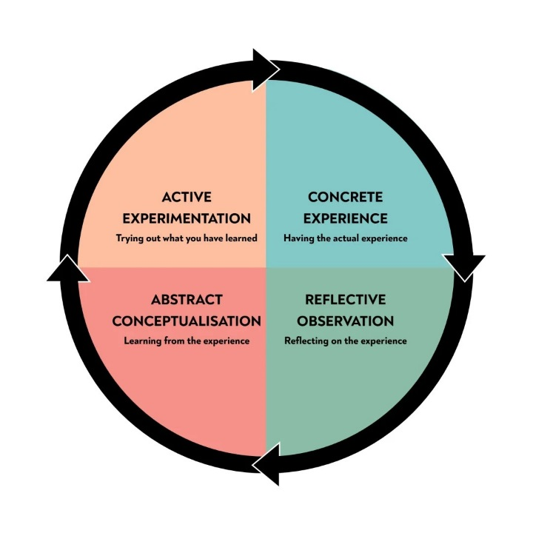
Graph: Kolb’s Reflective Cycle
During the phase of reflective observation, we assessed the effectiveness of several supervisory techniques. A situation arose in which a guest expressed dissatisfaction with an issue, highlighting the importance of promptly addressing the problem and demonstrating compassionate communication. The acknowledgment of the importance of effective guest service management The abstract conceptualization step is achieved through the utilisation of both interpersonal abilities and technology expertise. During the active experimental phase, these observations were used to autonomously manage smaller jobs. The knowledge I acquired was reinforced, and my confidence in managing guest expectations was enhanced (Abdulwahed, 2009).

Impact on Personal and Vocational Development

The experience significantly contributed to both my personal and professional development. While my previous industry experience and academic learnings provided a solid basis, my practical work at Wynyard Hall significantly enhanced my understanding of the fundamental operational dynamics. Proficient communication skills are vital for effectively and concisely presenting information to both employees and visitors. In order to provide a standardised approach to delivering services and to coordinate efforts across several departments, collaboration is essential (Gronroos, 2000).
My proficiency in resolving issues promptly, efficiently allocating time, and prioritising tasks has significantly enhanced my work management abilities. Furthermore, our individual aptitudes, such as adaptability, composure, and self-assurance, were also evaluated and improved. This position highlights the interconnectedness of several skills required for success in hotel management, while also pinpointing specific areas that need further refinement.

Critical Analysis of Work-Based Skills and Technical Knowledge

Importance of Work-Based Skills and Technical Knowledge

An extensive understanding of technical knowledge and a high level of proficiency in essential abilities are essential for effectively overseeing hotel operations. During my internship at Wynyard Hall, I observed firsthand the need of possessing a comprehensive knowledge of hotel administration systems, particularly property management systems. Efficient administration involves managing guest reservations, room assignments, and payments. Familiarity with the opera property management system facilitates these tasks (Lashley, 2018).
In scenarios characterised by unforeseen complications, such as maintenance problems or overbooking, the need of crucial skills such as problem-solving and decision-making was highlighted. Efficiently examining circumstances, evaluating options, and quickly implementing solutions is crucial for maintaining visitor satisfaction and service excellence (Baum, 2006).

Insights from the Shadowing Experience

Resolving a double-booking issue exemplifies the effective utilisation of the property management system to engage with front office staff and cleaning personnel. We effectively rectified the problem for the affected visitor. The seminar emphasised the need of possessing both technical proficiency and collaborative abilities in the process of resolving problems. A solid understanding of technical concepts is crucial for comprehending health and safety rules and ensuring strict compliance with them. To maintain a secure workplace for both employees and visitors, it is crucial to adhere closely to established standards and regularly conduct necessary training sessions (Pizam, 2010).

Reflection on Organizational Issues

Encountered Issue: Performance Management

Throughout the course of the placement, there was a concern within the housekeeping department regarding the management of their performance. The most significant obstacle that had an effect on the overall pleasure of the guests and the quality of the service was the struggle to maintain consistent performance standards among the team.

Impact on Department and Solutions

The inconsistency in performance resulted in variations in room readiness and cleanliness, which in turn harmed both operational efficiency and visitor perceptions. To tackle this issue, numerous solutions were suggested, drawing upon pertinent theories and practical concerns.
.
- Performance Measurement Systems: for tracking and evaluating staff performance regularly a more robust performance measurement system should be implemented (Armstrong, 2020).
- Training and Development: for ensuring all staffs are equipped with the necessary knowledge & skills, enhanced training programs should be ensured. High standards can be maintained & staff morale can be boosted through ongoing training and development (Noe, 2017).
- Feedback Mechanisms: clear feedback mechanisms should be established for providing constructive feedback & recognizing exemplary performance, which aligns with Herzberg’s Two-Factor Theory. This theory emphasizes the importance of opportunities for growth & recognition in motivating employees (Herzberg, 1968).

Future Action Plan

Areas for Improvement
Based on my experience, the following areas for improvement were identified by the management of the Wynyard Hall.
Goal | Actions | Deadline | Required resources
Enhanced Communication | Implementing strategies for improving interdepartmental communication for ensuring a cohesive approach to guest service. | Seven months. | Arranging workshops regularly for enhancing communication skills of different levels of staffs.
Advanced Training | Developing comprehensive training programs that focuses on interpersonal skills & technical knowledge. | Six months to a year | Designing and implementing ongoing training programs, customized according to the different roles within the hotel.
Performance Management | Implementing a structured performance management system for consistently monitoring and enhancing staff performance. | Six months | Scheduling regular performance reviews for setting improvement goals & providing feedback to the employees.
Feedback and Recognition | Establishing regular feedback sessions and recognition programs for retaining staff & motivating (Lourenço, 2016). | Six months to a year | Developing a recognition program for encouraging continuous improvement & rewarding outstanding performance.
If all these recommendations are considered, the company will be better manage their employees & continue to maintain their reputation for excellence.

Conclusion

The position at Wynyard Hall provides a comprehensive understanding of the necessary job-related technical knowledge and skills needed for effective hotel management. The hands-on experience, along with professional and personal development, highlights the importance of collaboration, communication, and project coordination in overseeing and achieving guest service benchmarks. By utilising Kolb's Experiential Learning Model, I can effectively showcase my extensive comprehension of work-related technical knowledge and skills in this particular subject. By reflecting on the experience, individuals can pinpoint areas that need development and create a well-thought-out plan to enhance service quality and administrative efficiency. I have the necessary skills and confidence to make a positive contribution to the hotel industry.

References
- Armstrong, M. (2020). Armstrong's Handbook of Performance Management: An Evidence-Based Guide to Delivering High Performance. 6th ed. Kogan Page Publishers.
- Baum, T. (2006). Human Resource Management for Tourism, Hospitality, and Leisure: An International Perspective. Thomson Learning.
- Gronroos, C. (2000). Service Management and Marketing: A Customer Relationship Management Approach. 2nd ed. Wiley.
- Herzberg, F. (1968). One More Time: How Do You Motivate Employees? Harvard Business Review.
- Kolb, D. A. (1984). Experiential Learning: Experience as the Source of Learning and Development. Prentice Hall.
- Lashley, C. (2018). Hospitality Management: A Brief Introduction. 3rd ed. Goodfellow Publishers Ltd.
- Noe, R. A. (2017). Employee Training and Development. 7th ed. McGraw-Hill Education.
- Pizam, A. (2010). International Encyclopedia of Hospitality Management. 2nd ed. Butterworth-Heinemann.
- Abdulwahed, M. and Nagy, Z.K., 2009. Applying Kolb's experiential learning cycle for laboratory education. Journal of engineering education, 98(3), pp.283-294.
- Lourenço, S.M., 2016. Monetary incentives, feedback, and recognition—Complements or substitutes? Evidence from a field experiment in a retail services company. The Accounting Review, 91(1), pp.279-297.
- Gupta, M., Chawla, R., Sharma, M.L., Das, S. and Gupta, S., 2012. Scientific Meeting of the Interventional Pain Special Interest Group of the British Pain Society: 8 September 2012 Wynyard Halle Hotel, Manchester, UK. British Journal of Pain, 6(4), pp.170-173.

