

ENTREPRENEURSHIP ASSESSMENT 1: LCMB7004

Module Tutor: Malani Gunaratnam

Student: Dike Victor Meme
ID No. 1602426
Assessment total number of words = 2447. Front page, contents page and references = 618. Total = 3065

Table of Contents
Assessment (1) 2
Introduction 2
Concept of enterprise 2
Concept of entrepreneurship 2
Major characteristics of entrepreneurship are as follows 4
Innovation 4
Risk- taking ability 5
Vision or long-term goals 5
Various traits and attributes of entrepreneurs 6
Creativity 6
Persuasiveness 6
Strong decision making 6
Effective communication skills 7
Strong leadership 7
Ability to make proper strategy 7
Motivation of entrepreneurs 8
‘For profit’ and ‘Not for profit’ organisation 9
Conclusion 10
References 11

Assessment (1)

Introduction
This assignment is focused over the knowledge about enterprise and entrepreneurship. Difference between entrepreneur and intrapreneur will also be discussed. The major traits, attributes, characteristics and motivation of entrepreneur will also be discussed. Difference between profit and not for profit in small organisations will be discussed.

Concept of enterprise
Enterprise is defined as planning a business which is associated with starting and running the business. It is also associated with each and every activity of the business. All business activities are linked with doing production, assembling the raw material, marketing and brand promotion and selling the products of the company (Ismoilov & Mullabayev, 2020).
Enterprise consists of all the production and operation activities all together. It also associates assembling and manufacturing the products or services which need to be delivered to the clients. An entrepreneur needs to involve completely in each and every activity of the business so that he can ensure about proper growth and development of the business (Brixy, et al., 2012).

Concept of entrepreneurship
Entrepreneurship has been defined as a concept of creating and developing a new business which is running to make profit. It can also be defined as a desire to start and implement a new business which is very fruitful for the future of the owners and the stakeholders ( Buckley & Casson , 1998).
Following picture is displaying the important features of entrepreneurship:
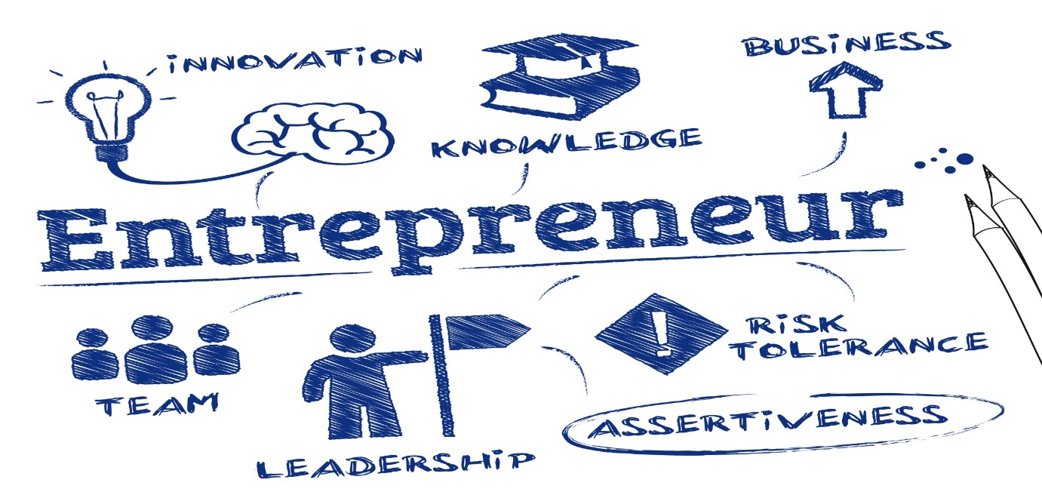
Source: Google Scholar Images.
There are many stages have been developed to start and run the new business which is the major factor of executing the different types of stages of the new business. In most of the cases, the entrepreneur is the sole owner of its business ( Broaddus, 2020).
Starting of a new business with a unique business idea is defined as a new start-up. A new business is always associated with many types of risks which have to be faced by the owners and stakeholders (Akhter , 2019).
Entrepreneurship is totally related with starting of a new business. It also considers fresh starting and fresh opening of the business. Becoming an entrepreneur need a lot of power and strength to deal with many types of problems
It is related with promoting small business development which is very important for the growth of the GDP of the country. Small businesses help in growing the economy of the country which makes the country economically strong. Apart from this, entrepreneurship helps the youngsters or other person in finding their bread and butter (Campaigns, 2020).
An entrepreneur is defined as a person who has the capability to establish, start-up and run a new business so that he can get succeed in the future. Moreover, it is also related with starting a new venture which is full of risk and uncertainty. It can be said that facing challenges should be the ability of the new entrepreneur (Rauch, et al., 2018).

Major characteristics of entrepreneurship are as follows

Innovation
There is always a lot of innovative services and plans are required to promote the business of the company. Many of the plans are made in order to adopt latest technique and new innovative services in the company
It is very well known that innovation is the key of achieving short- and long-term success of the company. The innovative services can be related with new product development, new technology for manufacturing the product, new digital marketing techniques and many other services are associated with innovations (Kickul & Lyons, 2020).
Apart from all the above stated services, innovation is also a part of change management. If the company would like to achieve short- and long-term success, it needs to adopt innovations and latest technology (Martin & Martinez, 2019).
Innovations not only helps in achieving competitive advantage but also it is helpful in improving the business process. Now a days, various latest technologies are existing which can make the business process easy and convenient. For example: Use of digital technology helps in improving the promotional and marketing policies of the company. It can also be said that, now a days, use of digital technology is very common because it helps in promoting the brand of the company. Apart from this, it is also useful in enhancing the sales of the organisation
Innovations are also using in doing production and packaging of the products. Use of latest tools for making the business process easy is also very important. Actually, use of innovations is always very helpful in gaining better results because it is the need of an hour. Constantly changing global business environment need a lot of changes in the work process which can be possible only with the help of latest techniques and innovations(Ritala, et al., 2020).

Risk- taking ability
Risk taking ability of the owner is one of the important features of the entrepreneurship. There are many types of risk factors exists which are associated with the new business. Operational risk and market risk are very common types of risk which is attached with the business of the company (Riepe, et al., 2020).
All the entrepreneurs need to be efficient in taking different types of risk. Setting the price is also a very challenging task for the entrepreneurs because a lot of risk is associated with eth market price of the product
Changing requirements and expectations is also very difficult to meet. Now a days, customers have become very curious about the receiving the quality of the products and services of the company. Entrepreneurs need to do a lot of research on understanding the point of view of various customers so that they can frame a suitable marketing strategy for entering in the market

Vision or long-term goals
The major vision of the company is related with setting long term goals which are connected with the wellbeing of all the stakeholders of the company. Pre-setting of objectives helps in planning the business activities and also helps the entrepreneur in implementing the plans (Saura, et al., 2017).
In short, it can be said that there are a lot of changes and fluctuations exists in the entrepreneurship.

Various traits and attributes of entrepreneurs

Creativity
A lot of creativity exists in the entrepreneurship because a successful entrepreneur is always very creative. Creativity involve new features which helps in boosting the sales of the company. If the sales of the company are at a massive level, it would be very good for the future of the company, apart from this, if the sales of the company are not good, it would provide a drastic effect on the business (Todor , 2016).

Persuasiveness
It is a very important feature of the entrepreneur. It also helps the entrepreneurs in convincing the clients. In short, it can be said that making the other people convince about their product and services is the main important feature of the entrepreneurs
In other words, it can be said that an effective entrepreneur needs to have a strong set of interpersonal skills because convincing customers, suppliers and other people require a lot of understandings. If the clients, customers and other people are constantly getting convince with the entrepreneur, it would be very good for the future of the company (Rauch, et al., 2018).

Strong decision making
The entrepreneurs are always good at decision making of every part of the company. The entrepreneurs need to be extremely careful about each and every minute decision of the company. Overall, it can be said that strong decision making is the major important feature of the organisation (Yasmin, et al., 2015).
In most of the cases, entrepreneur is the sole owner of the company that is why a lot of factors depends upon his ability of taking decisions at the right time. If the right decisions have been taken at right time, it would be good for the success of the business (Kickul & Lyons, 2020).
It is not only about the right decision making but also it involves the foresights of the business environment. The entrepreneur needs to update about future business scenario so that he can take the right decision at the right time. It can be said that strong research is required for taking short- and long-term decisions (Brixy, et al., 2012).
An entrepreneur needs to fulfil many strategies which are related with the progress of the company. It needs a very effective decision-making power (Yasmin, et al., 2015).

Effective communication skills
The entrepreneur always has a very good communication skill. It is associated with the growth and development of the business. Effective communication not only helps in establishing better relationship with the customers and stakeholders but also it improves the relationship with its employees. It can be said that it plays a major role in the success of the company ( Hicks, 2020).
If the entrepreneur will be good at communication, he would be able to deal effectively with his subordinates for their work. Solving the problems of all the human resource managers is also very much depends upon effective communication ( Mikkelson & York, 2015). The entrepreneur should always be aware about the message, he is going to give to his subordinates. It can be said that effective communication not only resolve the problems of the employees but also it helps in improving the sales of the company.

Strong leadership
An effective leader is very strong at motivating its employees towards achieving the goal. A good entrepreneur is also a good leader which guides his subordinates towards achieving the goal of the organisation (Zulch, 2014).
Effective leadership helps the subordinates in not only understanding their day-to-day tasks but also it is able to make them understand about their future goals and objectives (Cherry , 2019). An entrepreneur needs to inculcate a very effective leadership strategy because strong leadership is a key of getting long term success.
Situational leadership style and transformational leadership style is best suitable for the new entrepreneurs because situational leadership style not only helps the new leaders in taking decisions according to the situation but also it helps in helps in improving the operational process of the company. At the other hand, transformational leadership style promotes innovations and creativity, which are the key of achieving success ( Dai & Chen, 2013).
Effective leaders are not only helping in providing better services to the clients but also it helps the employees in giving their best efforts.

Ability to make proper strategy
A well-established entrepreneur needs a lot of power for making long term strategy for the benefit of the company. The strategy not only involved human resources strategy but also it involved product development strategy and marketing strategy. It can be said that a successful entrepreneur always associated with a lot of brain storing techniques of making future plans.
Business strategy and strategic management plays a major role in the success of any new venture (Hussain, 2019). If the entrepreneur is able to achieve long term success, he needs to work hard over the framing suitable strategy so that they can work according to the strategy.
An entrepreneur needs to be very good at framing strategies so that he can become successful in his future. An entrepreneur needs to be very smart at making strategies related to consumers and marketing strategies. A command over the knowledge of consumer behaviour and marketing need to be inculcate by the entrepreneur (Jelassi & López, 2020).

Motivation of entrepreneurs
Motivation is the most important feature of the entrepreneurs. Starting and implementing the new business is such a critical task. A lot of motivation is required to boost the confidence of the employees of the organisation (Kuvaas, et al., 2020).
Motivating the human resources of the company is also very important in achieving long term success. Sometimes, employees do not get satisfaction, that is why a high level of motivation is necessary for the growth of the organisation.
There are various types of motivational factors exists which are necessary to boost the morale of the employees. Some employees get happy only with the help of money whereas some employees get motivated by appraisals. Solving the queries of the employees are also very necessary. If the employees are confused, it would not be good for the future of the company. That is why motivation is the most important feature of the entrepreneurs (Shadrach, 2017).
Following picture is displaying the factors which affect the growth of entrepreneur:
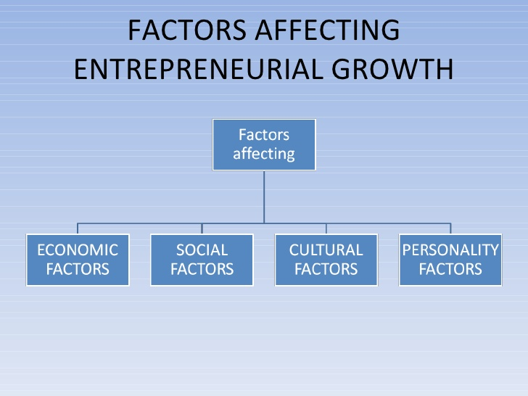
Source: Google Image.

‘For profit’ and ‘Not for profit’ organisation
Some organisations have a specific goal about the business. Profit making is one of theimportant goals which is usually used by the organisations. The various business activities of the organisation like planning, developing, implementing and executing the production or other services are based upon earning profit (Viader & Espina , 2014).
Increasing the sales, cost reduction activities, marketing and promotional activities have been done in order to earn a significant amount of profit. In short, it can be said that profit making is the major objectives of the company.
‘Not for profit’ organisations do not work for only earning the profit but also it works for serving the society. If the people of the society are receiving benefits from the ‘Not for profit’ organisation, it would be very good for achieving the long-term targets of the company(Viader & Espina , 2014).
Usually ‘not for profit making organisations’ are the part of those organisations which are not working only for receiving the money. Their major role is only giving their best efforts towards the betterment of the society. They are very much concern towards the well-being of the people of the society. Many organisations work only for improving the status of the people of the society. These types of organisations work not only for the benefit of the society but also these companies are doing activities for improving the climate conditions.
This type of companies is not working for only earning profit but also these companies are working for the well-being of the people of the society. Many types of services like providing free club, trusts and many other environment friendly techniques are the part of ‘not for profit’ organisations. In short, it can be said that producing environment friendly products and selling these products are very good for the future of the society (Viader & Espina , 2014).

Conclusion
On the basis of above description, it can be said that entrepreneurship is such a challenging task. Most of the people are working for starting their new business. Many special characteristics are existingwhich are the necessary part of the entrepreneurs. These special characteristics not only helps in developing a satisfactory level of entrepreneurship but also it helps in improving the performance of the business.

References
Akhter , K., 2019. The role of digital marketing platform (Facebook, Instagram, Twitter) on the success of Domino's Pizza Bangladesh. dspace.bracu.ac.bd.
Broaddus, . H., 2020. Top 3 Most Effective Marketing Strategies For Your Organic Products. [Online]
Available at: http://www.centrafoods.com/blog/the-top-3-most-effective-marketing-strategies-for-your-organic-products
Brixy, U., Sternberg, R. & Stüber, H., 2012. The selectiveness of the entrepreneurial process. Journal of Small Business management , 50(1), pp. 105-131.
Buckley, P. & Casson , M., 1998. Analyzing foreign market entry strategies: Extending the internalization approach. Journal of international business studies, 29(3), pp. 539-561.
Campaigns, I., 2020. Digital marketing terms. [Online]
Available at: https://www.campaignmonitor.com/resources/glossary/integrated-campaigns/
Dai, Y.-D. & Chen, K.-Y., 2013. Transformational vs transactional leadership: Which is better?: A study on employees of international tourist hotels in Taipei City. International Journal of Contemporary Hospitality Management, 25(5), pp. 760-778.
Hicks, J., 2020. Leader communication styles and organizational health. The health care manager, 39(4), pp. 175-180.
Hussain, S., 2019. Sensory marketing strategies and consumer behavior: sensible selling using all five senses. IUP Journal of Business Strategy, 16(3), pp. 34-44.
Jelassi, T. & López, F. M.-., 2020. Overview of the e-Business Strategy Framework. Strategies for e-Business, pp. 35-48.
Kickul, J. & Lyons, T. S., 2020. Understanding social entrepreneurship: The relentless pursuit of mission in an ever changing world. New York: Routledge.
Kuvaas, B., Buch, R. & Dysvik , A., 2020. Individual variable pay for performance, controlling effects, and intrinsic motivation. Motivation and Emotion, pp. 1-9.
Martin, J. & Martinez, J., 2019. Entrepreneurs' attitudes toward seasonality in the tourism sector. International Journal of Entrepreneurial Behaviour & Reserach .
Mikkelson, A. & York, J., 2015. Communication competence, leadership behaviors, and employee outcomes in supervisor-employee relationships. Communication Quarterly, 78(3), pp. 336-354.
Rauch, A., Fink, M. & Hatak, . I., 2018. Stress processes: An essential ingredient in the entrepreneurial process. Academy of Management Perspectives, 32(3), pp. 340-357.
Ritala, P., Vanhala, M. & Järveläinen , K., 2020. The Role Of Employee Incentives And Motivation On Organisational Innovativeness In Different Organisational Cultures. International Journal of innovation management , Volume 4, p. 24.
Saura, J., Sánchez, P. P.-. & Suárez , L. C., 2017. Understanding the digital marketing environment with KPIs and web analytics. Future Internet, 9(4), pp. 1-76.
Shadrach, N., 2017. A study on the impact of the balanced scorecard as a performance management system on performance and motivation in the retail industry.. ukzn-dspace.ukzn.ac.za.
Todor , R., 2016. Blending traditional and digital marketing. Bulletin of the Transilvania University of Brasov Economic Scieneces , pp. 1-51.
Ismoilov, R. B. & Mullabayev, B. B., 2020. The Essence Of Small Business And Private Entrepreneurship And The Theoretical Basis Of Its Development. American Journals of applied science, 2(8), pp. 45-50.
Viader, A. M. & Espina , M. I., 2014. Are not-for-profits learning from for-profit-organizations? A look into governance. Corporate Governance.
Yasmin, A., Tasneem, S. & Fatema , K., 2015. Effectiveness of digital marketing in the challenging age: An empirical study. International Journal of management science and busienss administartion , 1(5), pp. 69-80.
Zulch, B., 2014. Leadership communication in project management. Procedia-Social and Behavioral Sciences, Volume 119, pp. 172-181

