

LEVEL 7 ASSESSMENT SPECIFICATION

Student name: |  | Student ID number:
Programme: | MBA
Module: | Marketing Management
Module code: | HKBM 7012 | Contribution to Overall Module Assessment (%): | 75%
Lecturer: | Dr Arion WONG | Internal Verifier: | Dr Katherine Mo
Assignment Title: | Assignment 1 | Word count (or equivalent): | 3000 words
Submission deadline: | 11 July 2022 | Return date of provisional marks & written feedback: | Within 20 days after submission
Submission method: | All written assessments, where practical and possible, must be submitted via Turnitin unless otherwise instructed by the Lecturer. (Please DO NOT put this assessment specification into Turnitin or it will match many similarities with other students’ submissions.)  Alternative submission method (if applicable):  Late submission of the assessment will result in a late penalty mark. Penalties for late submission: Up to one week late, maximum mark of 50%. Over one week late, 0%. Only the Extenuating Circumstances Panel may approve a change to submission dates.
Academic honesty / referencing: | Academic honesty is required. In the main body of your submission you must give credit to authors on whose research and ideas your work is based. Append to your submission a reference list that indicates the books, articles, etc. that you have used, cited or quoted in order to complete this assessment.

Executive Summary
The report assesses on Best Mart 360˚’s current situation in relation to key areas of a marketing plan with regards to leisure food chain retail store market in Hong Kong.

Objective
The objective of this marketing report is to base on the following analysis and make the best recommendation to eventually increase the revenue by 30% in 2022-2023 financial year (Best Mart 360˚, 2021).

Marketing plan
By using PEST analysis and Porter ‘s five forces analysis to analyze to external factors and recommend Best Mart 360˚ to stay in the market.
By using value chain analysis and SWOT analysis to analyze to internal factors and recommend Best Mart 360˚ should seize the opportunity of growth trend on online shopping with the strength of providing high product variety.
The group is targeting on all people with mass marketing and positioning of medium price and medium level of service quality.
For marketing mix, Best Mart 360˚ provide high variety of products, competitive pricing, expanding retail stores, but lack of promotion when comparing with competitors such as Abouthai.

Recommendations
The strategy is to improve on digital marketing to increase revenue. As there is a growing trend on online shopping and company should leverage digital marketing which means to advertise through digital channels such as website, social media and mobile app. The tactics are 1. Enhance social media marketing and 2. Enhance e-commerce.

Table of content
1. Introduction 3
2. Situation Analysis 4
2.1 External 4
2.2 Internal 7
3. Segmentation, Targeting and Positioning 11
3.1 Segmentation 11
3.2 Targeting 11
3.3 Positioning 11
4. Marketing Mix Strategy 13
4.1 Product 13
4.2 Price 13
4.3 Place 13
4.4 Promotion 14
5. Future Developments in the Area of Marketing 15
5.1 Future Developments in Segmentation, Targeting and positioning 15
5.2 Future Developments Marketing Mix 15
6. Conclusion and Recommendations 17
6.1 Conclusion 17
6.2 Recommendations 17
6.2.1 Enhance social media marketing 18
6.2.2 Enhance e-commerce 18
7. References 19
7.1 Academic References 19
7.2 Non-academic References 21

Introduction
“Best Mart 360˚ (優品360˚)” is a brand of leisure food chain retail store and established in 2013. Best Mart 360˚ offer various product such as snacks, confectioneries, frozen and chilled food, personal care, groceries and household products (Best Mart 360˚, 2022).

In 2022, the economy of Hong Kong still affected by the COVID-19 pandemic but the market is improving gradually. As at 31 May 2022, the number of total retail sales during Apr 2022 to May 2021 recorded $349,279 million HKD with 4% growth when compared to Apr 2021 to May 2020 $335,637 million HKD (Census and Statistics Department, 2022).

Even though with the tough situation, Best Mart 360˚ still offering high variety products. The objective of company is to offer “Best Quality” and “Best Price” products (Best Mart 360˚, 2021).

The scope of the study is to assesses the current situation of Best Mart 360˚’s leisure food chain retail store business and focus on business-to-customer (B2C) in Hong Kong market.

The objective of this marketing report is to base on the following analysis and make the best recommendation to eventually increase the revenue by 30% in 2022-2023 financial year (Best Mart 360˚, 2021).

Situation Analysis
The definition of Situation analysis is to analyze on both internal and external factors of the business (Steenburgh and Avery, 2010).

2.1 External
By using PEST analysis and Porter ‘s five forces analysis to analyze to external factors for Best Mart 360˚.

Hong Kong still under a challenging COVID19 situation in 2022. As the immigration control by the Hong Kong government is still strict, number of visitors from 1 January 2022 to 30 April 2022 dropped by 27.3% as compared to the corresponding period in 2021 (Hong Kong Tourism Board, 2022).

During the five months ended 31 May 2022, the vaccination rate is start picking it up (The Government of the Hong Kong Special Administrative Region, 2022). The Hong Kong government relax on group gathering restrictions and social distancing.

There will be a second wave of Consumption Voucher Scheme by Hong Kong government to simulate local economic and consumption.

The lifestyle for Hong Kong people is changed because of the pandemic of COVID19. Hong Kong people prefer to stay home to enjoy leisure food and the need of frozen food also increased. In the industry of Bread, pastry, confectionery and biscuits market recorded $9,891 million HKD in Apr 2022 to May 2021 with 3.44% growth when compared to corresponding period in 2021 recorded $9,562 million HKD (Census and Statistics Department, 2022).

Also, Hong Kong people are paying more and more attention to a healthy lifestyle. The total annual consumption of Hong Kong citizens purchasing organic products under the epidemic reached 7.67 billion HKD, an increase of 800 million HKD compared with 2019 (Hong Kong Organic Products Consumption Behavior Survey Report, 2020).

There is a growing trend on e-commerce sales in Hong Kong. As at December 2021, e-commerce sales recorded around 170 billion HKD with 13.3% growth when compared to same period last year (Statista, 2022).

2.1.1 Competitor Analysis
For the Competitors-759 store during the six months ended 31 October 2021, the Group’s recorded a revenue of HK$971,637,000 (2020: HK$1,083,184,000) with negative growth of 10% as compared with the same period last year (CEC-COILS, 2022). 90% of the product supply are imported by the own procurement network globally. The Group is operating 170 shops and the average floor area per shop is 2,000 square feet (759 store, 2022). And the stores are mainly located in residential areas or shopping malls (CEC-COILS, 2022). The group has a Facebook account with 380,000 followers and an Instagram account with 25,000 followers (759 store, 2022).

Another competitor is AbouThai, which was founded in 2015 but growing rapidly in recent year. Their products mainly imported from Thailand, including frozen foods, snacks and drinks, household products, herbal oils, make-up products etc. As at February 2022, the group operating 25 stores (AbouThai, 2022). There will be a “Songkran Festival” discount event in April to have a price promotion to attract customers (HKET, 2019). They re-opening the online store on February 2022 and offer a free shipping on purchases over $600 HKD to attract customers to shop online (Yahoo, 2022). In order to recruit new member to shop online and offline, Abouthai have “Welcome Reward”, “Birthday Reward”, “Redeem points for cash coupon/gifts”, “Exclusive shopping discounts” and “Extra spending rewards” to attract new member (Abouthai, 2022).

During the early stage of the pandemic, the masks supplies were shortage and the masks on the market were almost sold out in a short time. AboutThai was quick to react and sold 5,000 packs of masks at the “pop-up” in Kowloon City (HK01, 2020). Later on, they launched a Abouthai Care mask which is made in Hong Kong to improve social responsibility (HKET, 2020). The group has a Facebook account with 380,000 followers and an Instagram account with 36,000 followers. The style of the social media platform is fun and catch on the latest trend to create an image that not only selling, but also entertaining (AbouThai, 2022). By improving social responsibility, Abouthai created a positive image to their target audience. Social responsibility means a company act ethically and with sensitivity towards social, cultural, economic, or environmental issues on business action (Lindgreen and Swaen, 2010).

Table 2.1.2: Competitor Analysis.
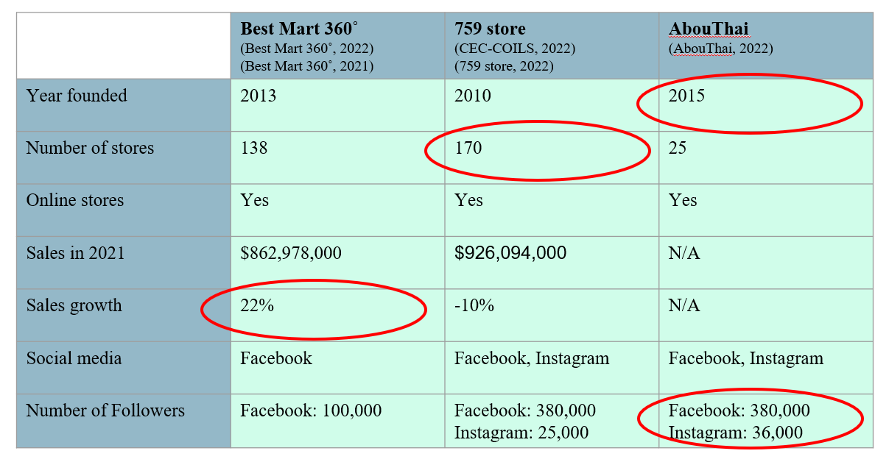
Source: Constructed by the author.

2.1.2 PEST Analysis
By using PEST Analysis, it analyzes 4 factors which included Political, Economic, Socio-Cultural and Technological in relation of the business environment (Sammut-Bonnici and Galea, 2014).

Table 2.1.2: PEST Analysis.
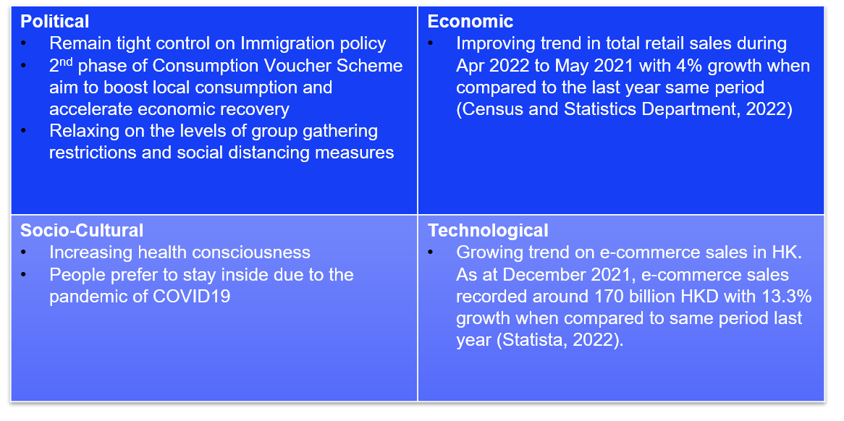
Source: Constructed by the author.

2.1.3 Porter ‘s five forces analysis
By using the Porter ‘s five forces analysis, it analyzes the market environment and help to make a recommendation by identifying the rivalry among existing competitors, threat of new entrants, threat of substitute products, bargaining power of supplier, bargaining power of buyers (Porter, 2008).

The rivalry among existing competitors is 759 store and AbouThai. This factor is favorable to Best Mart 360˚. As the competitor has low diversity and low brand loyalty from its customers.
The threat of new entrants is favorable to Best Mart 360˚, as the market is high barriers to entry. The Capital requirements is high as the property, plant and equipment costs 459,244,000 HK dollars as 30 Sep 2021 (Best Mart 360˚, 2021). There is total 138 Best Mart 360˚ s’ stories in HK (Best Mart 360˚, 2021).
The threat of substitute products is unfavorable to the group as the number of substitute products are high e.g., convenience store, supermarket.
The bargaining power of suppliers is favorable to the group as the number of suppliers are high and group switching costs are low.
The bargaining power of buyers is unfavorable to the group as low buyer switching costs and not much differences between competitors.
After using the Porter ‘s five forces analysis, the decision of Best Mart 360˚ is to stay in the market.

Figure 2.1.3: Porter ‘s five forces analysis for Best Mart 360˚.
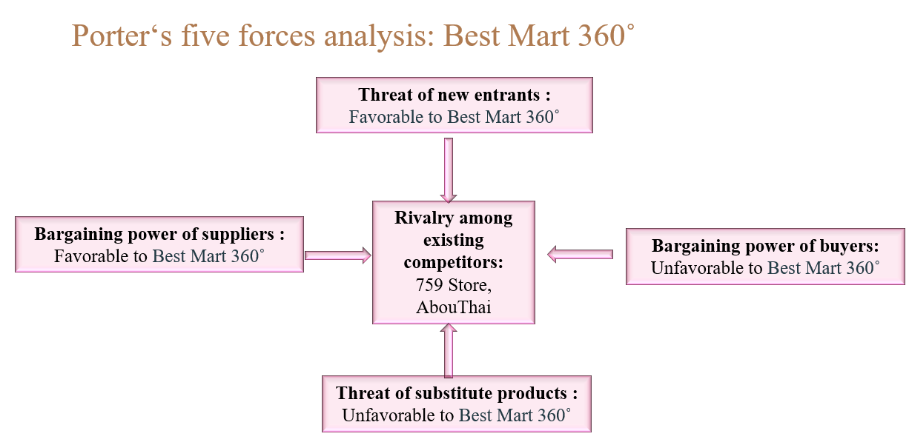
Source: Constructed by the author.

2.2 Internal
By using value chain analysis and SWOT analysis to analyze to internal factors for Best Mart 360˚.
Best Mart 360˚ during the six months ended 30 September 2021, the Group’s recorded a revenue of HK$862,978,000 (2020: HK$709,387,000) with growth of 22% as compared with the same period last year (Best Mart 360˚, 2021).
Best Mart 360˚ is operating 138 retail stores and only 20% of the stores are selling frozen foods in Hong Kong as at 18 June 2022 (Best Mart 360˚, 2022). The stores are mainly located in residential areas or shopping malls and the floor area from 402 square feet to 2,626 square feet (Best Mart 360˚, 2021). Best Mart 360˚ offer high variety of products included 900 brands and 3,000 stock-keeping units of imported products (Best Mart 360˚, 2021).

By optimizing the product range, the Group will also eliminate the unpopular product and allow more space for more new products. The group also created number of high-quality private labels to create price advantage and quality control over its products.

The group launched a membership scheme in 2015 and aim to expand customer base, create customer loyalty. And the group upgraded the new version of mobile app 2020 with more exclusive benefits such as special discount products, APP e-stamp promotion which can attract more new members (Best Mart 360˚, 2021). The group has a Facebook account with 100,000 followers and no Instagram account (Best Mart 360˚, 2022).

2.2.1 Value chain analysis
By using the value chain analysis, it analyzes company primary and support activities that create profit margin to its final product or service (Porter, 2001).
In the primary activities for the inbound logistic of Best Mart 360˚is that in order to ensure the inventory level, the staffs will conduct regular checks to maintain the product quality (Best Mart 360˚, 2021).
For operations, the group formulated an effective pricing policy to overcome the pandemic of COVID19 (Best Mart 360˚, 2021).
For outbound logistic, the group has outsourced to a local logistic company (Best Mart 360˚, 2021),
For marketing & sales, there is a membership scheme and offering stamp reward, special discounts and latest promotion information (Best Mart 360˚, 2021).
For service, the group will collect customers’ suggestion and feedback on the satisfaction of the products’ quality (Best Mart 360˚, 2021).
In the support activities for procurement, the group source around the world and has a variety range of products from suppliers and created own private label products (Best Mart 360˚, 2021).
For technology development, the group designed a mobile app to collect customer data and then analyze big data to reformulate its marketing strategy (Best Mart 360˚, 2021).
For human resource management, the group provides training to the staff especially the new joiner (Best Mart 360˚, 2021).

Table 2.2.1: Value Chain Analysis for Best Mart 360˚.
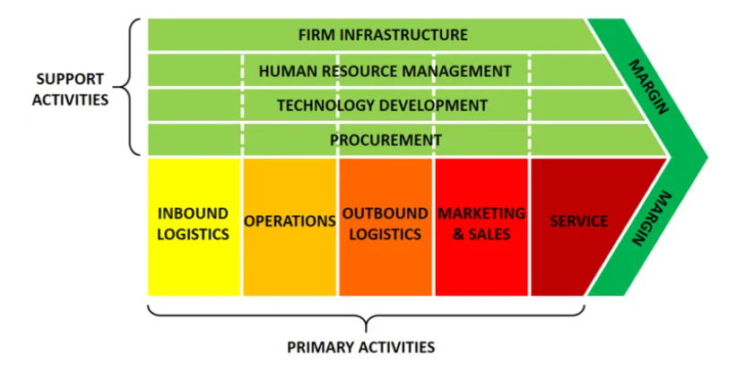
Source: Porter, 2001.

2.2.2 SWOT analysis
SWOT analysis is a pros and cons analysis by looking at company strengths, weakness, opportunities and threats to understand company’s competitive advantage (Leigh, 2009).
The Strengths of Best Mart 360˚ are 1. Product selected matches the market trend which is also a competitive advantage, 2. High product variety, 3. Better App experience by customer, 4. Offering a high-quality private label.
The weaknesses of the group are 1. Less retail stores, 2. Smaller average floor per shop.
The opportunities are 1. The upcoming 2nd consumption vouchers, 2. Increasing expenditure on purchasing leisure food online, 3. Vaccination rate steadily picked up.
The threats are 1. Maintaining stringent immigration control, 2. People from prefer to stay home changed to going out, 3. Increasing health consciousness.

Table 2.2.2: SWOT Analysis for Best Mart 360˚.
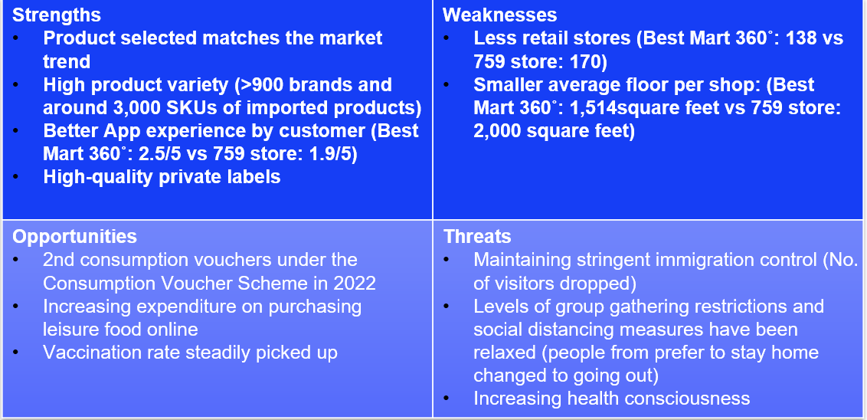
Source: Constructed by the author.

Segmentation, Targeting and Positioning
This is a three-step tool included Segmentation, Targeting and Positioning to help analyzing company’s product or service on how to communicate the features and benefits to their target customer (Dibb and Simkin, 1991).

3.1 Segmentation
In order to develop a suitable marketing mix or positioning strategy, company need to select the most appropriate market segments for a business to achieve commercial effectiveness (Wind and Bell, 2007). For the leisure food chain retail store market, as Best Mart 360˚ is providing everyday products for common use. The company is using Mass Marketing. Mass Marketing is a strategy to use single message for all people (Tedlow and Jones, 2014).

3.2 Targeting
Target means company target on potential segment and select one or more segments to enter (Moutinho, 2000). In Best Mart 360˚ case, the group is using Mass Marketing and have no specific group to target which because of the nature of the leisure food chain retail store market.

3.3 Positioning
Figure 3.3.1: Positioning for Best Mart 360˚.
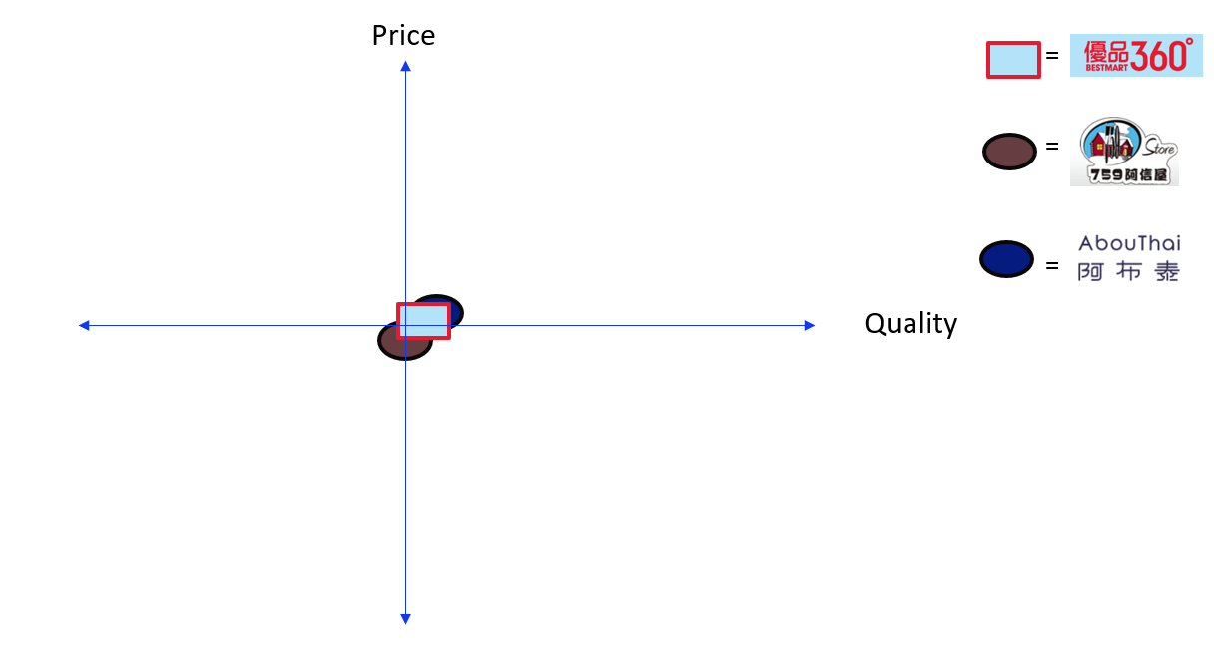
Source: Constructed by the author.

Positioning means customers perceive where our company stands when compare to the competitors (Camilleri, 2018). As now, the positioning is similar between the group and our competitor. With the successful marketing plan, we aim at move up the quality perception viewed by customers. As a right positioning can easily perceived by customers in order to differentiate with competitors such as Abouthai.

Marketing Mix Strategy
Marketing mix is a set of controllable elements to help company understand what elements should be combined in order to gain growth. It included 4PS-Product, Price, Place, Promotion (Singh, 2012).

4.1 Product
Product can be defined as tangible or intangible (Singh, 2015). As Hong Kong is a rapid development environment, the group need to ensure the products are satisfying the needs of the customers in the product of marketing mix. Best Mart 360˚ offered high variety of products included more than 900 brands and 3,000 stock-keeping units of imported products and cancel the unfavourable products in exchange of space to put in new products (Best Mart 360˚, 2021).

4.2 Price
Company should make sure item sell at a right price for consumer expectations (Håkansson and Waluszewski, 2005). To keep a competitive pricing strategy, the procurement department source the products globally to make sure at a best price. Also, Company owns a number of high-quality private labels to achieve better price advantage and can have high degree of quality control (Best Mart 360˚, 2021).

4.3 Place
Place refers to where the company sell the product (Goldsmith, 1999). The group expand the retail stores from 112 to 138 retail store and mainly located in the local community or residential area. The group aim to provide a convenient and comfortable shopping experience with a larger space. Also, there is an online website for Best Mart 360˚ to sell online (Best Mart 360˚, 2022).

4.4 Promotion
Promotions are the tools that the group informs the potential customers about their product and persuades them to buy it (Goi, 2009). The group has a membership scheme to provide member benefits, in store advertisement and TV advertisement (Best Mart 360˚, 2021).

Future Developments in the Area of Marketing
As Hong Kong still under the COVID19 situation and there is a growing trend on e-commerce sales in Hong Kong, Best Mart 360˚ need to quickly react to the new normal and adapt it in the future marketing plan. New normal often occur after a critical event and lead to people behave different from the past (Dziuban et al. 2018).

5.1 Future Developments in Segmentation, Targeting and positioning

Best Mart 360˚ need to keep on Mass Marketing as the leisure food chain retail store market can target on all people. But in order to increase the revenue by 30% in 2022-2023 financial year, the group need to further improve the quality in the positioning to differentiate with competitor such as Abouthai by the following recommendation.

Figure 5.1.1: Positioning for Best Mart 360˚.
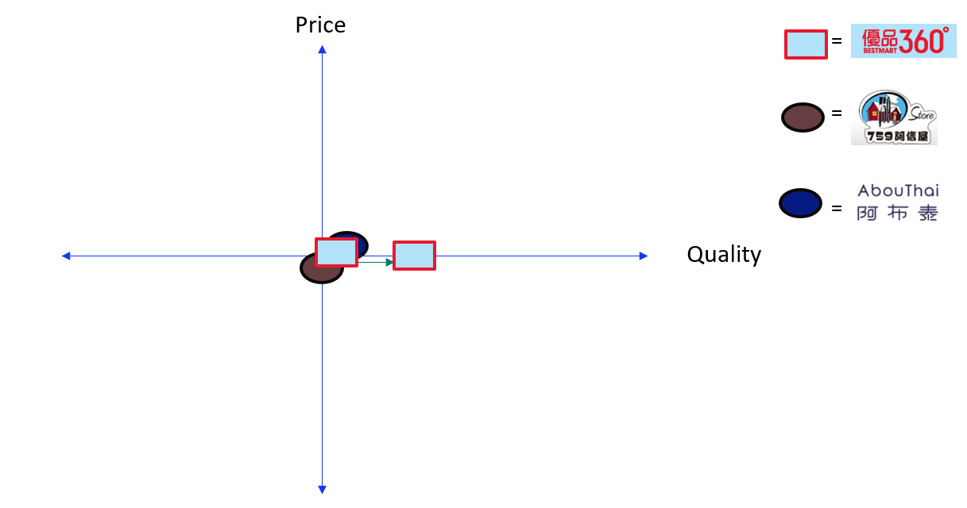
Source: Constructed by the author.

5.2 Future Developments Marketing Mix
In relation to technological development, promotion should not only focus on the traditional media, also need to develop new media promotion which will further explain in recommendation.
For place, the group should keep expanding the retail stores and offering a convenient shopping experience to customers. But we should not limit to physical stories, need to further improve the online store website.
The group need to keep on offering variety of the products to customers. Keep sourcing a wide spectrum of global products to optimize its product portfolio at stores best price.

Conclusion and Recommendations

6.1 Conclusion
To conclude, Best Mart 360˚ provides leisure food with multi-brands while the price is comparable to its competitors such as 759 store and Abouthai. It promotes and distributes through both physical and online platforms.
The competitive environment is still favorable to Best Mart 360˚ and it should be staying in the market.
The group is targeting on all people with mass marketing and positioning of medium price and medium level of service quality. In order to achieve the goal, the group need to improve the quality.
With the strength in product selected matches the market trend and high product variety, Best Mart 360˚ should seize the opportunity on online shopping.
The group has fewer presence and followers in social media platforms compared to its competitors. Abouthai is especially done well in the new media promotion with highest followers in both Facebook and Instagram.

6.2 Recommendations
The objective of the recommendations is to increase the revenue by 30% in 2022-2023 financial year (Best Mart 360˚, 2021).
The strategy is to improve on digital marketing to increase revenue. As there is a growing trend on online shopping and company should leverage digital marketing. Digital marketing means to advertise through digital channels such as website, social media and mobile app (Kannan, 2017).

The tactics are 1. Enhance social media marketing and 2. Enhance e-commerce

6.2.1 Enhance social media marketing
To benchmark our competitor especially Abouthai, Best Mart 360˚ should enhance social media marketing in order to update our target audience on our product, promotion. Social media marketing means using social media such as Facebook, Instagram to promote and engage with customers (Evans, Bratton and McKee, 2021).
First, the group need to set up an official Instagram account. As style of the Abouthai’s social media platform is fun and catch on the latest trend to create an image that not only selling, but also entertaining (AbouThai, 2022). The future style of Best Mart 360˚ social media should be more fun and localized content.

6.2.2 Enhance e-commerce
As there is a growing trend on e-commerce sales in Hong Kong, Best Mart 360˚ should improve the shopping experience on the website (Statista, 2022). To benchmark Abouthai’s free shipping on purchases over $600 HKD, Best Mart 360˚ can offer free shipping on purchases over $500 HKD in order in attract new and existing customers.
For membership program, Best Mart 360˚ need to benchmark Abouthai to have “Welcome Reward”, “Birthday Reward”, “Redeem points for cash coupon/gifts”, “Exclusive shopping discounts” and “Extra spending rewards” in order to recruit new member to shop online and offline (Abouthai, 2022).

References

7.1 Academic References

Camilleri, M. A. (2018) Market segmentation, targeting and positioning, In Travel marketing, tourism economics and the airline product: Springer Cham.

Dibb, S. and Simkin, L. (1991) Targeting, segments and positioning, International Journal of Retail & Distribution Management, p.1-7. Available at: https://eclass.uoa.gr/modules/document/file.php/D344/%CE%A3%CE%B7%CE%BC%CE%B5%CE%B9%CF%8E%CF%83%CE%B5%CE%B9%CF%82/TARGETING%2C%20SEGMENTS%20AND%20POSITIONING.pdf (Accessed: 18 June 2022).

Dziuban, C.et al. (2018). Blended learning: the new normal and emerging technologies. International journal of educational technology in Higher education, p. 1-16. Available at: https://link.springer.com/article/10.1186/s41239-017-0087-5 (Accessed: 18 June 2022).

Evans, D., Bratton, S. and McKee, J. (2021) Social media marketing. AG Printing & Publishing.

Goi, C. L. (2009) A review of marketing mix: 4Ps or more. International journal of marketing studies, p. 2-15. Available at: https://pdfs.semanticscholar.org/006a/f4780f1cff9f7075ab5b7073f4cebb32c3d5.pdf (Accessed: 18 June 2022).

Goldsmith, R. E. (1999) The personalized marketplace: beyond the 4Ps. Marketing Intelligence & Planning. Available at: https://d1wqtxts1xzle7.cloudfront.net/30890238/23-with-cover-page-v2.pdf?Expires=1657129572&Signature=RuZhO4~2ygZx2JPvvR~kEUCKhQY~vcAofIJ24sxaNJE5Rhdq4AkH0te3BCjPgi9fX7FDgyjInjGJezyHGmyGh3hC5zOLoWwUCJuS2TNRcs~akUf1i-8OtcHvorecxzeKmOaAYPZOrPRwAzYc2d27vjwuv3BRk9vcY3Ea3d7kf3SzDvFRWu3Vgk~S8C8IH84ijdAIQbzHRa-VxJAi6~LhWyosDV5uPQ9saXIvSm70xQALgKj7FFst7obi-qMjgIMgUMHXNt1Mqtcbqh8K5mXsU-Y4zVllpElFkGKPkCye~KesDhWWSU8gMlktyhRqbJfM82arIS8y8zgoUGprXgUunQ__&Key-Pair-Id=APKAJLOHF5GGSLRBV4ZA (Accessed: 18 June 2022).

Håkansson, H. and Waluszewski, A. (2005) Developing a new understanding of markets: reinterpreting the 4Ps. Journal of Business & Industrial Marketing. Available at: https://www.emerald.com/insight/content/doi/10.1108/08858620510592722/full/html (Accessed: 18 June 2022).

Kannan, P. K. (2017) Digital marketing: A framework, review and research agenda. International journal of research in marketing, p. 22-45.

Leigh, D. (2009) SWOT analysis. Handbook of Improving Performance in the Workplace: Volumes 1‐3.

Lindgreen, A. and Swaen, V (2010) Corporate social responsibility, International journal of management reviews, p.1-7. Available at: https://orca.cardiff.ac.uk/id/eprint/55309/1/Article%2053.pdf (Accessed: 18 June 2022).

Moutinho, L. (2000) Segmentation, targeting, positioning and strategic marketing. Strategic management in tourism: CABI.

Porter, M. E. (2008) The five competitive forces that shape strategy: Harvard business review.

Porter, M. E. (2001) The value chain and competitive advantage. Understanding business processes, p.50-66. Available at: https://books.google.com.hk/books?hl=zh-TW&lr=&id=vNldIVx6BQ4C&oi=fnd&pg=PA50&dq=value+chain+analysis+porter&ots=FCKygBOJ0Q&sig=Vlr5KKrB9uGQ0gPW9q5tx_06FG0&redir_esc=y#v=onepage&q=value%20chain%20analysis%20porter&f=false (Accessed: 18 June 2022).

Sammut-Bonnici, T. and Galea, D. (2014) PEST analysis Available at: https://www.um.edu.mt/library/oar/bitstream/123456789/21816/1/sammut-bonnici%20pest.pdf (Accessed: 18 June 2022).

Singh, M. (2012) Marketing mix of 4P’s for competitive advantage IOSR Journal of Business and Management, 3(6), 40-45 Available at: https://d1wqtxts1xzle7.cloudfront.net/28251386/G0364045-with-cover-page-v2.pdf?Expires=1656190953&Signature=UsgoUsl7sflOcl05felG3X6JH7sqZADyfWBTD058R~92lYyw7RTWmjdBSd1RFe9aSBy-4LImaTCaljyu8rDjFF5rYRK~3nQfRvqc2u3Z67MYHDxC2VA23MlcQC2tFzmCFkg0y~wWwpDca7llfRSoxy2pDA0qDWuz7JN1LiC3J72asgZcsxTPpdRjktBftH7ijR~8ffQaLgrHWaittlmxlgdjsyvR7Lt0N8YgzL8lUCcfG~wnKx1KQmOLXXfYe0MbWa1qG1RdCergwgg-25-mVRd7S2w-VbH5GVIN1-G4U1pXYv~PMPsxjISdQCnwncaKTMotuU~el85DIaSZxQJugQ__&Key-Pair-Id=APKAJLOHF5GGSLRBV4ZA (Accessed: 18 June 2022).

Singh, V. and Jain, A. (2015) ‘Consumer trust in retail: Development of a multiple item scale’, Journal of Economics, Business and Management,10 October, p.973. Available at: http://www.joebm.com/papers/318-BM00049.pdf (Accessed: 18 June 2022).

Steenburgh, T. J. and Avery, J. (2010) Marketing analysis toolkit: situation analysis: HBS Case.

Tedlow, R. S. and Jones, G. G. (2014) The rise and fall of mass marketing (RLE Marketing): Routledge.

Wind, Y. J. and Bell, D. R. (2008) Market segmentation. In The marketing book: Routledge.

7.2 Non-academic References

AbouThai (2022) About us Available at: https://www.abouthai.com/aboutus (Accessed: 18 June 2022).

Best Mart 360˚ (2021) Annual Report 2020/2021 Available at: https://www.bestmart360.com/image/file/0.12609700%201626441268.pdf
(Accessed: 18 June 2022).

Best Mart 360˚ (2021) Interim Report 2021 Available at: https://www.bestmart360.com/image/file/0.71999100%201639299208.pdf (Accessed: 18 June 2022).

Best Mart 360˚ (2022) Store Locator Available at: https://www.bestmart360.com/index.php?route=information/sale_address (Accessed: 18 June 2022).

CEC-COILS (2022) 2021/2022 Interim Report Available at: http://www.0759.com/doc/art/finance/2022011901/202201190001.pdf (Accessed: 18 June 2022).

HKET (2019) 【歡迎香港人轉載】AbouThai 3年開12店 泰國老闆娘：物色大舖想大到似超市咁Available at: https://ps.hket.com/article/2368243 (Accessed: 18 June 2022).

HKET (2020) 香港製造! 阿布泰自家出品! 3E>99% Abouthai Care 口罩 獨立包裝售$79/30個Available at: https://sme.hket.com/article/2781172/%E9%A6%99%E6%B8%AF%E8%A3%BD%E9%80%A0-%20%E9%98%BF%E5%B8%83%E6%B3%B0%E8%87%AA%E5%AE%B6%E5%87%BA%E5%93%81-%203E%3E99-%20Abouthai%20Care%20%E5%8F%A3%E7%BD%A9%20%E7%8D%A8%E7%AB%8B%E5%8C%85%E8%A3%9D%E5%94%AE-79-30%E5%80%8B (Accessed: 18 June 2022).

HK01 (2020)【武漢肺炎】AbouThai「快閃」賣五千包口罩 創辦人：望回饋居民 Available at: https://www.hk01.com/%E7%AA%81%E7%99%BC/428728/%E6%AD%A6%E6%BC%A2%E8%82%BA%E7%82%8E-abouthai-%E5%BF%AB%E9%96%83-%E8%B3%A3%E4%BA%94%E5%8D%83%E5%8C%85%E5%8F%A3%E7%BD%A9-%E5%89%B5%E8%BE%A6%E4%BA%BA-%E6%9C%9B%E5%9B%9E%E9%A5%8B%E5%B1%85%E6%B0%91 (Accessed: 18 June 2022).

Hong Kong Organic Resource Centre (2020) Hong Kong Organic Products Consumption Behavior Survey Report Available at: http://www.hkorc.org/?page_id=2766 (Accessed: 18 June 2022).

Hong Kong Tourism Board (2022) Monthly Report - Visitor Arrival Statistics Available at: https://www.discoverhongkong.com/content/dam/dhk/intl/corporate/newsroom/tourisum-statistics/2022/tourism_stat_04_2022.pdf (Accessed: 18 June 2022).

Statista (2022) eCommerce - Hong Kong | Statista Market Forecast Available at: https://www.statista.com/outlook/dmo/ecommerce/hong-kong (Accessed: 18 June 2022).

The Government of the Hong Kong Special Administrative Region (2022) Hong Kong Vaccination Dashboard Available at: https://www.covidvaccine.gov.hk/en/dashboard (Accessed: 18 June 2022).

Yahoo (2022) 阿布泰網店重開！AbouThai即日起重啟網店 4大類必買防疫用品及食品, 11th February. Available at: https://hk.news.yahoo.com/%E9%98%BF%E5%B8%83%E6%B3%B0-%E7%B6%B2%E5%BA%97-%E7%B6%B2%E8%B3%BC-%E9%98%B2%E7%96%AB%E7%94%A8%E5%93%81-%E9%A3%9F%E5%93%81-224024754.html (Accessed: 18 June 2022).

759 store (2022) Store Location Available at: https://www.759store.com/shop.php?type=&lang=eng&brand=1&list=&tabs=# (Accessed: 18 June 2022).

