March 21, 2021
cristian-marin pena
University of Wales Trinity Saint David
1908795
understanding and engaging in the customer experience
plan a at marks and spencer-does it deliver on crm?

Executive Summary

The aim of the report is to analyse the Customer Relationships Management practices within Marks and Spencer organisation, given the challenges the organisation faces because of the Post Covid safety procedures, starting the main findings with methods for building a good customer relationship, and weighing the advantages and disadvantage of Customer Relationships Management software system.
The report continues with the Marketing Segmentation process, analyses the criteria that should be met for the process to be fully effective and identifies different segmentation models that can be used by organisations, followed by the recommended strategy to use when segmenting customers.
The repot analyses different ethical positions that can be associated with Marks and Spencer organisation, followed by Marks and Spencer’s Sustainability strategy that results from their market practices as well as analysing the marketing competition that the organisation faces, continuing with the Quality Management System that the organisation has put in practice over the years.
A conclusion has been drawn from the main findings that shows Marks and Spencer is a Consequentialist organisation and delivers on Customer Relationships Management, followed by recommendations that aim to improve the products, services, profitability, and sustainability that the organisation offers.

Contents

Executive Summary 1
Introduction 3
Main Findings 3
Building Customer Relationships 4
Segmentation 6
Ethics & Sustainability 8
Quality Management 11
Conclusion 13
Recommendations 14
Acknowledgements 15
Appendices 16
Reference List 23

Introduction

The report has been requested by Understanding and Engaging in the Customer Experience module, University of Wales Trinity Saint David, on March 03, 2021 and it has been compiled by Cristian-Marin Pena on March 21, 2021. The purpose of the report it to provide overview of Marks and Spencer sales strategy, as a result of Post Covid challenges, highlighting the Customer Relationship Management values and benefits through loyalty, trust and satisfaction. The report will also analyse the benefits of Marks and Spencer’s Segmentation strategy and the basic requirements that should be met to ensure the Marketing Segmentation efficiency, the ethical position that the organisation has adopted and how these factors influence customer relationships as well as customer’s satisfaction, using journal articles, books and trusted websites.
The report with the Quality Management aspects of the organisation being analysed from different perspectives, Total Quality Management tool and the five principles of its successor, Six Sigma tool, . The report finalises with a conclusion based on the main finding, weighing the Customer Relationships Management within the organisation and recommending

Main Findings

Marks and Spences organisation started with Machel Marks in 1884, when he opened his first marketplace in Leeds, having the slogan: ‘Don’t ask the price, it’s a penny’ (https://marksintime.marksandspencer.com). However, the company started to take shape in 1894, thanks to Michael’s partnerships with Thomas Spencer, the products being displayed on trays for customers to be able to inspect them (https://blog.s4rb.com/). The store was named ‘Penny Bazaar’ and allowed the customers to inspect the store without any pressure to buy.
Along with needles, threads, and buttons, in 1920’s Marks and Spencer started selling more of life’s essentials, including underwear, and the bra has become their most iconic product (https://fashion-history.lovetoknow.com/).
In 1930 the organisation started its food and clothing departments, expanding its range of products to be able to compete with the growing trend, and 1932, the biggest stores contained 20 departments, including man and ladies clothing, underwear, footwear, extravagant goods, household line, gramophone records, toys and food and textiles, sales increasing three time by the end of 1939, and food represented the Marks and Spencer’s future (https://www.referenceforbusiness.com/).
1948 was the year when the self-service food shopping was introduced, revolutionising the food retail spaces, customers being able to choose their own food items from the shelves (https://www.mylearning.org/).
In 1950’s, they continued with a new style of dress, influenced by Christian Dior ‘Corolle’ collection, continuing with chilled chicken, exotic Chinese, and Indian ranges, helping the customers to spend less time when preparing dinner (https://marksintime.marksandspencer.com). In 1970’s, the organisation started introducing stores in France, Belgium and Europe (https://fabrikbrands.com/).

In 1990’s, Marks and Spencer have introduced the puddings, increasing the sales considerably, and in 2010 ‘Enhancing Lives. Every Day’ was their aim, shaping the organisation’s values of ‘Innovation’, ‘Inspiration’, ‘Integrity’ and ‘In Touch’, values that resulted in their ethical programme called ‘Plan A’, introduced in January 2007, which in 2020 helped them become the world most sustainable major retailer, focusing on climate change, sustainable materials, and reduce waste (Calnan, 2020).
In 2020 there were 1,038 Marks and Spencer stores in the United Kingdom, and 481 stores located worldwide, selling products such as clothing, cosmetics, household items and luxury goods, revenue figures reaching 10.2 billion pounds (Wunsch, 2020).
Marks and Spencer’s online platform has grown considerably between 2011 and 2017, with a revenue of approximately 370 million pounds, which has affected the number of customers entering the stores, decreasing with more than half of million. (Wunsch, 2020)
In the present, Marks and Spencer’s delivers high quality food, clothing home products and financial services (https://www.companieshistory.com/). They have over 80,000 employees serving over 32 million customers, having customer-focused digital innovation the central of their business (https://www.linkedin.com).

Building Customer Relationships

When it comes to customer relationships, the best strategy to use is Customers Relationships Management (Fig.1.1 and Fig.1.2, Appendices), which is a business strategy that will reduce costs, and increase customer loyalty and profitability, with a remarkably simple philosophy: ‘Put the customer first’, helping businesses to better understand customer need, improving the way that the product is offered to them (Lund, 2021).
Kulpa (2017) states that there are three types of Customer Relationships Management, as following:
- Operational, which is a tool that focuses on marketing, sales and service. It deals with past customer data, automating the process to increase the experience for both businesses and customers. It is very efficient for businesses with shorter sales cycle and high repeat sales.
- Analytical, which analyses customer data, providing a better understanding of market trends and customer needs for the management and improving customer satisfaction. It is efficient for businesses in higher priced markets, where the competition is high.
- Collaborative, when businesses share customer information with outside companies. The strategy allows certain businesses to create a greater customer experience by gaining data that they do not have access to. It is an excellent tool for markets were innovation and new product development is the way to success.

According to Lund (2021), Customer Relationships Management works in three steps, as following:

1. Supports a customer-centric strategy.
Customers are the businesses main priority (Fig. 2.0, Appendices). When customers interact with organisations, they form an opinion. Through time, they use the opinions to create an image of the business, therefore an image of the business values. Focusing on customer experience will build trust and loyalty.

2. Centralises all customer data.
Customers Relationships Management software will collect information, including phone numbers, addresses, and last contact made, which is used to track the marketing, sales and customer service activities, improving customer loyalty and customer experience.

3. Automates customer-facing business processes.
Business-facing processes help the business run efficiently, including budgeting and planning. Customer facing processes include sales, marketing, and customer service (Fig. 4.0).

According to Stobierski (2017), before embracing the Customer Relationships Management strategy, there are a series of advantages and disadvantages that should be taken on board.
Advantages of using the strategy include:
- Data entry can be automated, saving hours of research by integrating with web and social media search.
- An efficient dashboard streamlines sales activities, custom dashboards and reports making tasks much easier for Sales department.
- Potential to increase revenue, Customer Relationships Management tool being connected directly to a boost in revenue.
- Easier collaboration-having all customer data in a single location will allow Sales and Marketing to stay on top of deals.
- Enables automation for repetitive task, as automated sales tasks will return more sales, saving Sales Department time for more sales.
- Scalable- as the business grows, the Customer Relationships Management grows with it.
Disadvantages of using the strategy include:
- Burdensome data entry. Depending on the Customer Relationships Management tool chosen the Sales Department may need to enter a lot of data manually, resulting in less time for selling.
- Dependent on proper setup, meaning that if Customer Relationships Management tool is not set up properly at the beginning, it may result in a significant loss of time.
- Focused on the wrong person, as the Customer Relationships Management tool tends to focus on the needs of sales manager more that on sales reps.
- Can be costly, as it can come with a significant subscription cost, depending on the number of users, which can be an issue for small businesses.
A waste of time if used incorrectly, as it need an efficient sales plan to avoid irrelevant information.

Segmentation

STP is the acronym for Segmentation, Targeting and Positioning. It is a model that helps businesses segment the market, create marketing campaigns which target the customer segments and modify the business positioning according to the customer’s needs and expectation (Wright, 2020).
According to Dopson (2019), Marketing Segmentation is the process of grouping a specific type of people who have certain needs in common and providing personalized content to them, increasing the sales and marketing efficiency.
Dopson (2019) argues that before using Marketing Segmentation, a basic criteria needs to be met:
- Market size, as the business market must be large enough for segmentation to be justified
- Audience differences
- Finance, as the cost of segmentation and the revenue generated must be calculated
- Accessibility, as the segments determined must be reachable.
When using market segmentation, businesses can use three methods to identify segments: Homogeneity, which refers to common needs, Distinction, referring to the unique criteria that represents a group, Reaction, which refers to the market response (Tarver, 2020).
Hanlon (2021) states that there are several segmentation models that can be used to segment the audience, such as:
- Demographic, including age, gender, income, education, ethnicity, education, and profession.
- Psychographic, referring to the behaviour, connected to the purchase choices. The model can include lifestyle, hobbies, personality, television programmes and magazines chosen, representing the reasons for the choices made. The information can be gathered through interviews, surveys, and customer data.
- Geographic, including the country, state, city or town, population density, climate.
- Technographic, including mobile use, apps, and software.
- Behavioural, habits, tendencies, and product features.
- Needs-based, referring to products and services needed by specific customer groups.
- Value-based, representing the business value of specific customer groups.
According to Baker (2020), the best strategy to follow when segmenting customers is:
1. Determining the goals of customer segmentation.
The goals should be in line with the customer needs, customer service, targeted campaigns, products and opportunities, and service efficiency.
2. Choosing the customer segmentation groups.
Customer segmentation should be in line with the segmentation models: Demographic, Geographic, Psychographic, Technographic, Behavioural, Needs-based, and Value-based.
3. Targeting and reaching the customers segments.
Targeting customers segments can be achieved by informing Marketing department, Sales department, and Service Department. Once de information has been delivered and understood, the departments can use it as following:
- Marketing will be able to personalize the content, to meet the customer needs and increase brand awareness.
- Sales will be able to identify the characteristics the customer groups have in common, and the best methods that can be used to communicate with the customers.
- Service will be able to use the customers segments to prepare the resources needed regarding the actual and potential challenges that customers may experience.
4. Analysing customer segments and making the necessary adjustments.
Customer segments analysis can provide detailed information that will influence the way the customers can be structured, making changes and updates in needed.
In Rizzi’s opinion, segmentation provides a great deal of information about customer. The information can then be used to create targeted marketing campaigns. It is a more affordable and efficient method of reaching customers and generate revenue. Evolving fast, the technology has enabled customers to develop new sets of behaviour and expectations when buying and using products, which is easier to provide using advanced analytics.
As the customer needs and behaviours change over time, it is especially important that businesses keep a record and continuously revise and correct the segments (https://blogs.spectrio.com).
For segmentation to be effective it should be dynamic in two ways:
- First, the focus should be on the needs and behaviours that are changing fast, rather that personality features, which tend to persist in time
- Second, the segments should be redesigned fast by technology, variable economics, and new customer roles (Rizzi, 2020).

Marketing strategies allow businesses to achieve goals and objectives. There are several strategies that Marks and Spencer has used over time, such as products services innovation, marketing investment and customer experience, which has helped the business grow (https://www.mbaskool.com).
Marks and Spencer’s marketing mix analyses the business/brand, an analysis that highlight the strategy of 4Ps (Product, Price, Place, Promotion).
The product strategy that Marks and Spencer uses is covering items for all ages, including clothing and footwear, furniture items, food, wines and flowers, selling its in house brand more than the international brands (https://www.mbaskool.com/).
The pricing strategy that Marks and Spencer follows is competitive, having its own in house brands, being priced between medium and high category thanks to its premium quality (https://corporate.marksandspencer.com/).
However, because of the increased competition, customers have more options to choose from. As a response to the competition, the organisation adopts a dynamic pricing strategy during seasonal time, offering discounted price for specific products.
When analysing the place strategy, being an international brand, Marks and Spencer has more than 1000 stores in more than 50 countries, having its major business in UK, where approximately 850 stores can be found. The company also has its own website, allowing customers to buy products that will be delivered at their doorsteps (https://www.mbaskool.com/).
The promotion strategy that Marks and Spencer uses is to align the advertisement campaign with digital marketing and in store strategy. The organisation uses social media and television advertisement.
According to Ward (2018), Marks and Spences does not have specific target market, targeting a variety of customers with their range of products instead. The organisation tends to create middle age targeted clothing that it fails to mention.
In Ward’s opinion, John Lewis and Tesco’s are Marks and Spencer’s main competitors, because of their similar product and price range, Tesco being known for its leading supermarkets, and John Lewis as the most relatable competitor, targeting the middle-class families, offering similar price ranges.

Ethics & Sustainability

According to Oxford Languages (2021), the word ‘Ethics’ is defined as ‘moral principles that govern a person’s behaviour or the conducting of an activity’.
In Singer’s opinion, ethics, or moral philosophy, represents the discipline that helps individuals differentiate what is good or right from what is bad or wrong. It contains of the basic concerns which signify practical decision-making.
Business ethics represents the way a business should act when facing an ethical dilemma, depending on the way the business is governed, the way the stock is traded, or business social involvement (White, 2019).
From a United Kingdom cultural perspective, to reach its desired goal, every business must create work ethics and codes of conduct. However, when building trust and integrity for the business there are several issues that can be identify along the way:
- Fundamental ethical issues, including trust and integrity, factors that ensure organisational success. Business integrity represents a committed and honest way a business can be conducted, which will build and maintain customer trust, ensuring a continuous increase in customer numbers as well as keeping the loyal customers.
- Governance and compliance, as it is especially important that businesses obey health and safety rules, laws, and financial decrees, which will lead to conduct policies within the business.
- Diversity in the workplace, representing the difference in strength, knowledge, and experience. Sharing information and opinions from different location and situations encourages and trains decision-making, leading the business to success. The ethical response to diversity must be the equal opportunity, allowing businesses to value every employee, keeping them engaged and loyal to the business.
- Decision-making ethics: ethical issues require a decision-making process that depends on several factors, including protecting the employee, protecting consumer rights, and protecting the common good, values and beliefs of all employees (https://www.iqualifyuk.com/).
Hart (2021) states that Consequentialism is a theory that represents an ethical method of deciding how the right ethical act should be chosen, consequences being all that matters. Consequentialism evaluates actions by weighing the consequences against a desired outcome.
According to Hart (2021), Consequentialism can be applied in two forms: Act consequentialism, determining the appropriate action to be the one generating the highest number of desired consequences, and rule consequentialism, determining the morally appropriate act to be the one according to a rule whose monitoring would generate the desired outcome.
Spall (2020) argues that, while consequentialism target is to make the world a better place, it does not always focus on analysis.
Advantage of Consequentialism:
- It can be applied universally, as the consequences can be measured
- It can be applied systematically, as the consequences are numerical and an ethical decision through mathematical evaluation can be made.
Disadvantages of Consequentialism:
- Reaching a decision through consequentialism theory can be time-consuming, when identifying and analysing the consequences
- Consequential theory is limited to the analyst, as it will be sufficient information for a perfect decision
- Consequentialism represents actual and probable/expected consequences, and consequences based on probability can lead to poor decision (https://ethics.org.au).
According to Spall (2020), non-consequentialism means that when establishing the moral quality of an action no consequence should be taken into consideration. Consequences can be taken into consideration, but they should not be the decisive force when making a decision.
Marks and Spencer inclines to an ethical level, through its initiatives and campaigns, aiming for the most eco-friendly retailer (Gwynn, 2017).
Sustainability refers to the ability of an organisation to align non-financial aspects within the marketing practices in a way that they benefit the business. Combining the three elements, economic, environmental, and social, to the business advantage leads to a sustainability strategy, business and sustainability goals being aligned (https://sphera.com/).
Over the time, several ethical issues have been noticed, coming from different angles, including climate change, human rights, workers’ rights, animal rights, and technologies and political activities, as following:
- People: even though Marks and Spencer scores Ethical Consumer Best Rating, other organisations, including The Guardian and Reporter Brasil, reported that a Marks and Spencer’s supplier purchased animals from a farm that was using workers as modern-day slaves (https://www.business-humanrights.org/)
- Environment: even though Marks and Spencer scores Ethical Consumer Best Rating, the organisation has been criticised for using sustainable fish, as in 2017 only one third of the fish it sold was certified by MSc
- Animals: in 2016, the Grocer magazine declared that Marks and Spencer confirmed that the organisation had failing in the supply chain, as one its diary suppliers used to keep their animals in limited conditions
- Politics: the organisation scores the worst Ethical Consumer Rating, as a result of its tax avoidance strategy (https://www.ethicalconsumer.org/).
As a result of the market competition, as well as other organisations, Marks and Spencer has its own rivals, including Tesco, ASDA and Aldi. There are a number of reasons why Marks and Spencer is not in the first place on the market raised, including:
- Limited market share, as a result of strong competition from other retail brands
- Continuous protection of their brand from fake/imitation products, being a popular brand
- Other retail brands are a threat, because of their discounted prices
- Being a global retailer, Marks and Spencer organisation has to obey different regulations according to the countries they operate in (https://www.mbaskool.com/).

Quality Management

Through Quality Management, businesses maintain the quality at a desired level. It ensures consistency when providing products and services by supervising different activities (Freeman, 2019).
In Garvey’s opinion, Quality Management can be divided in four components, as following:
- Quality Planning, referring to the quality standards of specific projects as well as the way to implement them
- Quality Improvement, referring to the act of increasing the reliability of the outcome
- Quality Control, the process of maintaining the process standards to the desired level
- Quality Assurance, ensuring that the product meets certain requirement through certain processes (Garvey, 2019).
According to Markgraf (2019), the aim of Quality Management is to ensure that the employers and employees work together for the benefit of the business improving the products and services, the workplace culture, and the customer satisfaction.
When improving the quality, the methods consist of three components: process improvement, product improvement and people-based improvement (https://corporatefinanceinstitute.com/).
The are several methods that can be used when improving quality, including Six Sigma, which is a tool for business and quality management, aiming to improve quality by identifying errors and their cause, as well as maintaining consistency (Eby, 2017).
In Hayes opinion, over the years the Six Sigma has become a tool that can be use by every industry that focuses on business statistics, including financial analysis and business management. Engaging in business processes and making them more efficient, the Six Sigma tool improves the customer service and products, helping businesses build customer trust and loyalty (https://www.sixsigmadaily.com/).
Kumar (2021) states that the Six Sigma tool consists in five principles, such as:
- Customer focus, bringing maximum benefit to the customer
- Value measurement and Problem finding, finding problematic areas of the business that need to be changed through a data collection system
- Error remove, removing processes that do not contribute to customer value
- Employee engagement, embracing a system that helps all employees engage in the problem-solving process
- Flexible and responsive system, removing the inefficient processes which in return will ensure business progress through transformation.

Barone (2020) states that Total Quality Management is the action of identifying and eliminating errors, ensuring employees work at the desired standards, and improving the customer experience.
According to Eby (2017), Total quality Management is the predecessor of several management tools, including Six Sigma, and it consists in eight principles: customer satisfaction, employee commitment, decision-making, effective communications, strategic thinking, integrated system, process centred, and continuous improvement (Fig. 5.0, Appendices).
To remain, competitive, several Marks and Spencer’s suppliers embraced Total Quality Management, aiming to reduce the carbon emissions and costs through their improvement programs (https://www.tqm.com). With the help of Total Quality Management, they have been able to identify their main energy consumers, review the conditions of auxiliary equipment, including ventilation systems and lighting equipment, create plans to reduce the energy consumption, energy efficiency increasing up to 33% (https://www.tqm.com).
Applying Quality Management, Marks and Spencer organisation has become more environmentally sustainable, by limiting their consumption and reducing waste. Through Marks and Spencer Logistics they aim to achieve the highest levels of workplace safety, health protection and environment protection, security, ethics, and legality (https://www.tankcontaineroperators.com/).
According to M&S Logistics, Marks and Spencer keeps monitoring the quality and performance of all operations, they are committed to obey all health and safety regulations, providing safely and healthy conditions, and to provide environmental sustainability worldwide, recognising the importance of social responsibility, including human rights and ethical trading and bribery.

Conclusion

Customer Relationships Management is a business strategy that provides a better understanding of customer needs. The strategy improves the quality of products and services, reduces costs, increases profitability and customer loyalty.
Marks and Spencer’s is a worldwide retailer with roots in the nineteen century marketing. Over the years, the organisation has established a reputation for being innovative and customer oriented, providing products of all ages and services according to customer needs, building customer trust and loyalty.
As a result of the market challenges faced in the past, the organisation has continuously included new products at affordable prices, displaying in the present a large range of products, including food, clothing, and house furniture, that helped compete on price.
To avoid ethical dilemmas, businesses must implement work ethics and codes of conduct based on trust and integrity, governance and compliance, diversity in the workplace, and a decision-making process based on certain factors, including protecting the employee, protecting customer rights, and protecting the common good. Marks and Spencer inclines to an ethical level, through its initiatives and campaigns, aiming for the most eco-friendly retailer.
Inclining to a Consequentialist position, Marks and Spencer has continuously improved its sustainability strategy over the years, aligning the economic, environmental, and social elements in a way that has best benefited the business.
To ensure competitivity, Marks and Spencer’s have used the Total Quality Management tool that helped the organisation identify the main energy consumers by reviewing the condition of auxiliary equipment and creating am energy consumption plan, increasing energy efficiency with 33%.

Recommendations

According to AJ Bell Youinvest (2017), there are five thing factors that Marks and Spencer organisation must improve, ensuring an increase in products and services, sales, customer service, and sustainability:
1. Improve fashion basics.
Marks and Spencer is a leading retailer in underwear and jeans. Improving those area will attract customers that will become curious about other items that the store has to offer.
2. Embrace Style rather that Fashion.
A more classical approach instead of the M&S prints across its products would match their demographic. Another improvement would be the return of ‘Piece of the season’, suitable for every customer.
3. Focus on quality, not price.
Instead of reducing the prices to compete with other retailers, Marks and Spencer should focus on improving the quality of their products. The quality improvement should be done to its own branded products rather than external brands. The Rosie Huntington Whiteley lingerie range is a good example of what can be accomplished when providing quality, a stylish range of products that last for a significant time.
4. Reduce store spaces.
Stopping the expansion in the number of stores can authorize over 45 million pounds in costs linked to the value of specific sites.
5. Improve the IT, online and click and collect.
Marks and Spencer should offer free delivery and returns as well as the ‘Click and collect’ service to ensure as many ways to the market as possible. The improvement will attract more young customers as well as keeping the existing customers happy (https://www.youinvest.co.uk/).

Acknowledgements

I would like to express my sincere gratitude Mr. Christian Felices for providing his invaluable guidance and suggestions throughout the course of the report. I would especially thank Mr. Christian Felices and Ms. Marie Pitson for constantly motivating me to work harder.

I would like to thank Ms. Elena Moise for her opinion and Mr. Stefan Burhala for thoughts during the preparation of this report.

Appendices

Fig. 1.1 – Customer Relationships Management
Fig. 1.2 – Customer Relationships Management Revenue
Fig. 2.0 – Customer-Centric Strategy
Fig. 3.0 – Customer Data
Fig. 4.0 – Business-facing process / Customer-facing process
Fig. 5.0 – Total Quality Management

Fig. 1.1

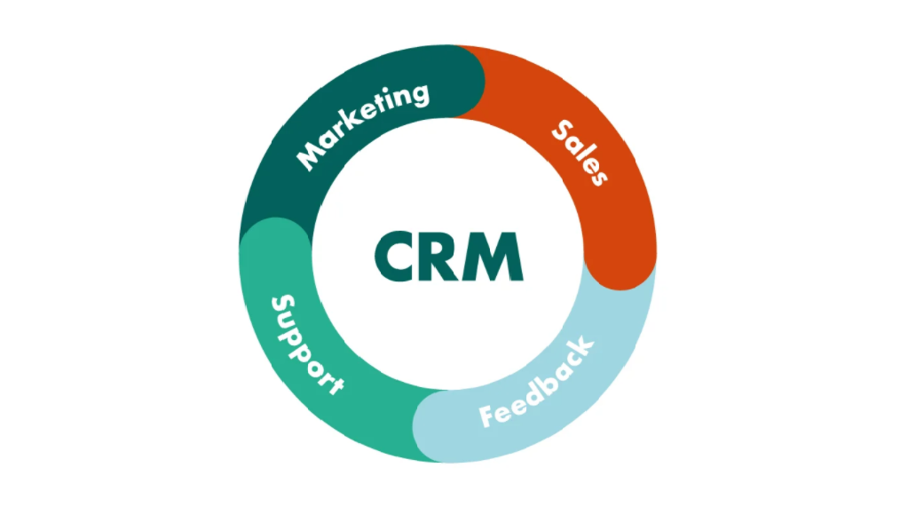
Fig. 1.2

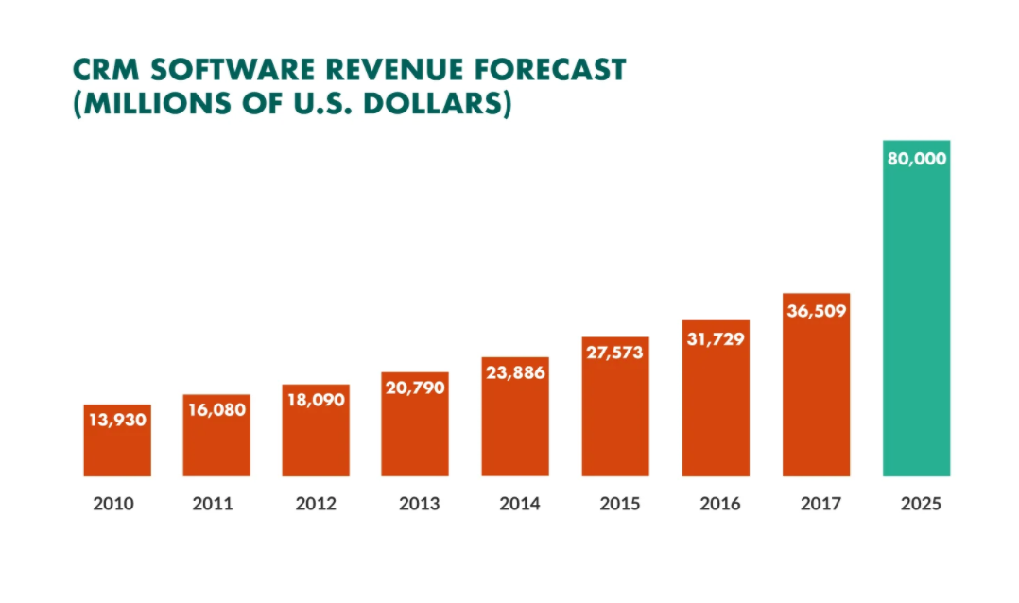

Fig. 2.0

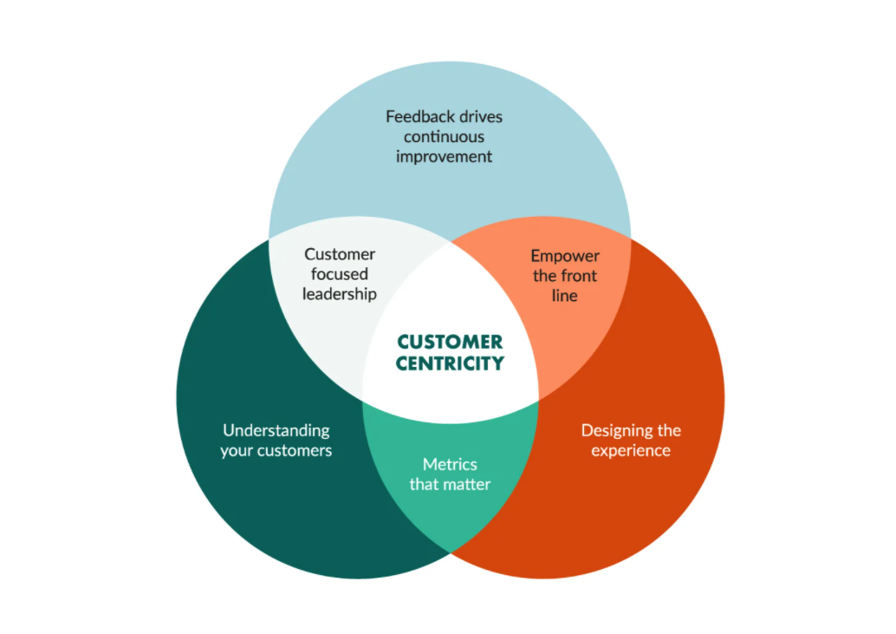

Fig. 3.0

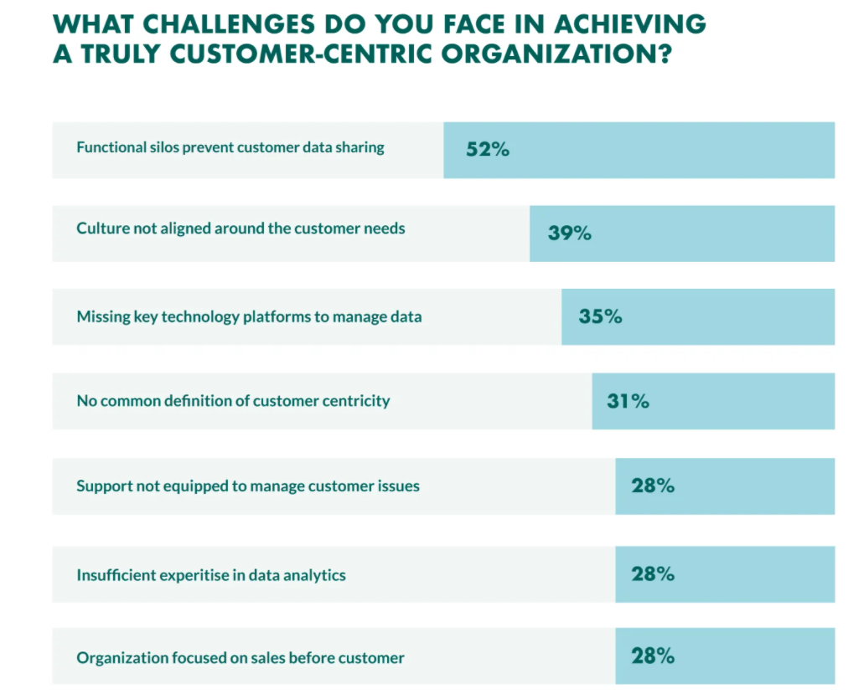

Fig. 4.0

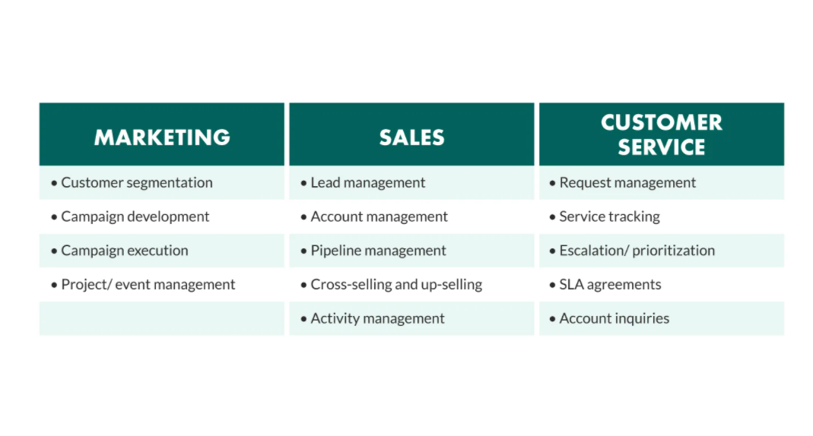

Fig. 5.0

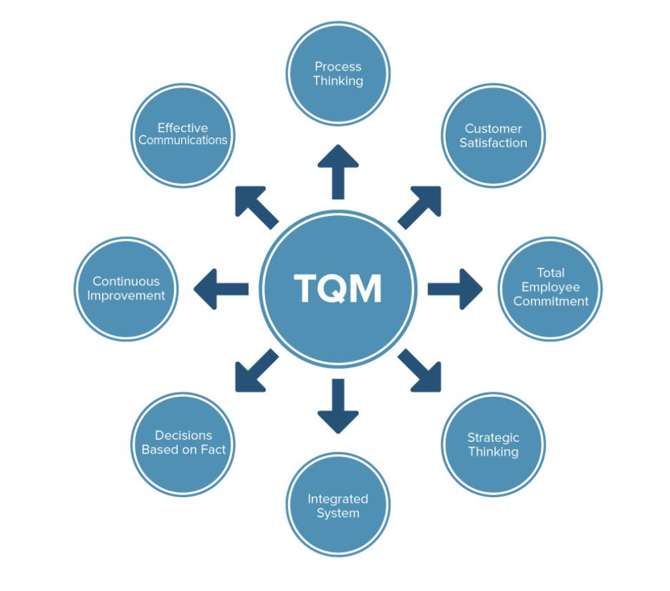

Reference List

Marks in Time, (2021), History, available at: https://marksintime.marksandspencer.com/ms-history/timeline (Accessed: March 11, 2021)
S4RB (Mar 14, 2018), The History of M&S, This is not just a store, it’s an M&S store since 1884, available at: https://blog.s4rb.com/the-history-of-marks-and-spencer (Accessed: March 11, 2021)
Love to Know (2021), Marks and Spencer, available at: https://fashion-history.lovetoknow.com/fashion-clothing-industry/marks-spencer (Accessed: March 11, 2021)
Reference for Business (2021), Marks and Spencer p.l.c.-Company Profile, Information, Business Description, History, Background Information on Marks and Spencer p.l.c., available at: https://www.referenceforbusiness.com/history2/68/Marks-and-Spencer-p-l-c.html (Accessed: March 11, 2021)
My Learning (2021), A Snapshot of M&S Food Through Time, available at: https://www.mylearning.org/stories/mands-timelines--food/880? (Accessed: March 11, 2021)
Fabrik Brands (2021), Quintessentially British brands: It’s not just branding, it’s Marks and Spencer branding, available at: https://fabrikbrands.com/marks-and-spencer-branding/ (Accessed: March 11, 2021)
Calnan, M. (Dec 15, 2020), M&S to relaunch its ‘Plan A’ sustainability programme, available at: https://www.thegrocer.co.uk/marks-and-spencer/mands-to-relaunch-its-plan-a-sustainability-programme/651342.article (Accessed: March 11 2021)
Companies History.com (2021), Marks & Spencer, available at: https://www.companieshistory.com/marks-spencer/ (Accessed: March 11, 2021)
Linked In, (2021), Marks and Spencer, available at: https://www.linkedin.com/company/marks-and-spencer (Accessed: March 11, 2021)
Wunsch, N. (Sep 25, 2020), Marks and Spencer: Statistics & Facts, available at: https://www.statista.com/topics/3707/marks-and-spencer/ (Accessed: March 11, 2021)
Lund, J. (Mar 02, 2021), What is CRM? The definitive guide to CRM success (Strategy, Process, Trends), available at: https://www.superoffice.com/blog/what-is-crm/ (Accessed: March 11, 2021)
Kulpa, J. (Oct 24, 2017), Why Is Customer Relationship Management So Important?, available at: https://www.forbes.com/sites/forbesagencycouncil/2017/10/24/why-is-customer-relationship-management-so-important/?sh=3513cd2e7dac (Accessed: March 11, 2021)
Stobierski, T. (Feb 8, 2017), What Are The Pros And Cons Of Using A CRM, available at: https://pepperlandmarketing.com/blog/pros-and-cons-of-using-a-crm/ (Accessed: March 11, 2021)
Dopson, E. (May 17, 2019), Segmentation 101: A Strategist’s Complete Guide To Marketing Segmentation, available at: https://www.singlegrain.com/digital-marketing/strategists-guide-marketing-segmentation/ (Accessed: March 12, 2021)
Tarver, E. (Jul 28, 2020), Market Segmentation, available at: https://www.investopedia.com/terms/m/marketsegmentation.asp (Accessed: March 13, 2021)
Baker, K. (Feb 24, 2020), The Ultimate Guide To Marketing Segmentation: How To Organise Your Customers to Grow Better, available at: https://blog.hubspot.com/service/customer-segmentation (Accessed: March 13, 2021)
Hanlon, A. (Jan 26, 2021), The segmentation, targeting, positioning (STP) marketing model, available at: https://www.smartinsights.com/digital-marketing-strategy/customer-segmentation-targeting/segmentation-targeting-and-positioning/ (Accessed: March 13, 2021)
Rizzi, V. (Oct 24, 2020), What is marketing segmentation and is it crucial for your business?, available at: https://entrepreneurhandbook.co.uk/why-market-segmentation-is-crucial-for-your-business/ (Accessed: March 13, 2021)
Spectrio (2021), Use Customer Segmentation to Increase Sales and Customer Satisfaction, available at: https://blogs.spectrio.com/use-customer-segmentation-to-increase-sales-and-customers-satisfaction (Accessed: March 13, 2021)
MBA Skool Team (Apr 19, 2020), Marks and Spencer Marketing Mix (4Ps) Strategy, available at: https://www.mbaskool.com/marketing-mix/services/17122-marks-and-spencer.html (Accessed: March 13, 2021)
Ward, E. B. (Dec 13, 2018), ‘Marks and Spencer’: online shopping experience, available at: http://blogs.brighton.ac.uk/ebw10/2018/12/13/marks-and-spencer-online-shopping-experience/ (Accessed: March 13, 2021)
Wright, M. (Sep 30, 2020), The Complete Guide to STP Marketing: Segmentation, Targeting & Positioning, available at: https://www.yieldify.com/blog/stp-marketing-model/ (Accessed: March 13, 2021)
Marks and Spencer (Aug 17, 2020), M&S Food Shows Customers Its Quality Food Comes at “Remarksable” Prices, available at: https://corporate.marksandspencer.com/media/press-releases/5e0f046f7880b21924350282/m-and-s-food-shows-customers-its-quality-food-comes-at-remarksable-prices (Accessed: March 13, 2020)
The Ethics Centre (Feb 15, 2016), Ethics Explainer: Consequentialism, available at: https://ethics.org.au/ethics-explainer-consequentialism/ (March 14, 2021)
Oxford Languages (2021), available at: https://languages.oup.com/google-dictionary-en/ (Accessed: March 14, 2021)
Singer, P. (Feb 02, 2021), Ethics philosophy, available at: https://www.britannica.com/topic/ethics-philosophy (Accessed: March 14, 2021)
White, J. (Jul 24,2019), What Is Business Ethics? Definition, Overview, and Example, available at: https://www.thestreet.com/personal-finance/what-is-business-ethics-15026364 (Accessed: March 14, 2021)
IQualifyUk (2020), Business ethics from a UK cultural perspective, available at: https://www.iqualifyuk.com/library/business-management-section/business-ethics-from-a-uk-cultural-perspective/ (Accessed: March 14, 2021)
Spall, B. (Jan 19, 2020), A Brief Introduction to Consequentialism Ethics, available at: https://benjaminspall.com/consequentialism/ (Accessed: March 14, 2021)
Gwynn, S. (March 14, 2017), M&S, Starbucks, Microsoft and L’Oreal named among world’s most ethical companies, available at: https://www.campaignlive.co.uk/article/m-s-starbucks-microsoft-loreal-named-among-worlds-ethical-companies/1427188 (Accessed: March 14, 2021)
Sphera Research (Jan 17, 2020), How to Build Your Sustainable Business Strategy, available at: https://sphera.com/spark/how-to-build-your-sustainable-business-strategy/?utm_source=Google&utm_medium=Text&utm_campaign=Spark&keyword=sustainable%20business&matchtype=b&device=c&gclid=EAIaIQobChMIiYSGgomz7wIVDNPtCh1gvQOoEAMYAyAAEgIElPD_BwE (Accessed: March 15, 2021)
Business& Human Rights Resource Centre (Jun 08, 2017), Brazil/UK: JBS supplied beef to UK retailers from Brazilian farm being investigated for forced labour; comments from Waitrose, NHS, Marks and Spencer, Co-Op, Sainsbury’s, Lidl and Princes, available at: https://www.business-humanrights.org/en/latest-news/braziluk-jbs-supplied-beef-to-uk-retailers-from-brazilian-farm-being-investigated-for-forced-labour-comments-from-waitrose-nhs-marks-spencer-co-op-sainsburys-lidl-and-princes/ (Accessed: March 16, 2021)
Ethical Consumer Research Association (2021), Marks and Spencer Group plc, available at: https://www.ethicalconsumer.org/company-profile/marks-spencer-group-plc (Accessed: 15 March 2021)
MBA Skool Team (Apr 26, 2020), Mark and Spencer SWOT Analysis, Competitors, STP, UTP, available at: https://www.mbaskool.com/brandguide/lifestyle-and-retail/5219-marks-and-spencer.html (Accessed: March 15, 2021)
Corporate Finance Institute (2021), Quality Management, available at: https://corporatefinanceinstitute.com/resources/knowledge/strategy/quality-management/ (Accessed: March 16, 2021)
Freeman, G. (Feb 01, 2019), What is Quality Management and Why Does it Matter?, available at: https://www.qualitymag.com/articles/95237-what-is-quality-management-and-why-does-it-matter (Accessed: March 16, 2021)
Garvey J. (May 16, 2019), Total quality management methods to drive team performance, available at: https://www.peoplegoal.com/blog/quality-management-techniques-to-drive-team-performance (Accessed March 16, 2021)
Markgraf, B. (Feb 13, 2019), Quality Management System Goals & Objectives, available at: https://smallbusiness.chron.com/quality-management-system-goals-objectives-58994.html (Accessed: March 16, 2021)
Eby, K. (May 29, 2017), Six Sigma for Beginners, available at: https://www.smartsheet.com/all-about-six-sigma#:~:text=Six%20Sigma%20is%20a%20set,and%20accuracy%20of%20process%20results. (Accessed: March 17, 2021)
Hayes, A. (Nov 28, 2020), Six Sigma, available at: https://www.investopedia.com/terms/s/six-sigma.asp (Accessed: March 17, 2021)
Six Sigma Daily (Jan 09, 2020), What is Six Sigma, available at: https://www.sixsigmadaily.com/what-is-six-sigma/ (Accessed: March 17, 2021)
Kumar, P. (Mar 11, 2021), Everything You need to know About What is Six Sigma, available at: https://www.simplilearn.com/what-is-six-sigma-a-complete-overview-article (Accessed: March 17, 2021)
Eby, K. (Jun 21, 2017), A Quality Principle: Everything You Need to Know about Total Quality Management, available at: https://www.smartsheet.com/total-quality-management (Accessed: March 17, 2021)
TQM Consultants Co. LIMITED (2021), Marks & Spencer (Asia Pacific) Limited, available at: https://www.tqm.com.hk/m-s (Accessed: March 17, 2021)
M&S Logistics (2021), Quality, Health, Safety, Environment & CSR, available at: https://www.tankcontaineroperators.com/home/quality-accreditation/ (Accessed: March 17, 2021)
AJ Bell Youinvest (Nov 08, 2017), Five thing that M&S needs to do better (even if Steve Rowe is starting to get it right), available at: https://www.youinvest.co.uk/articles/investmentarticles/131749/five-things-ms-needs-do-better-even-if-steve-rowe-starting-get-it (Accessed March 17, 2021)

