

Student Name: Ionut Alexandru Andruta
Student ID: 2133015
Module title: Managing Food and Beverage Operations BMIH6002
Lecturer: Jessica Newport

Table of Contents
Introduction 3
Section 1: Reflection on the Placement Experience 4
Section 2: Academic and Technical knowledge related to placement 6
Section 3: The organisational issues and proposed solutions 7
Conclusion 8
References 9

List of Figure
Figure 1: Gibbs Reflective Cycle Model 5
List Table
Table 1: Importance of Academic and Technical knowledge 6

Introduction
My placement was at Abbots Barton Hotel which was located at 36 new Dover Rd. I had an experience of the placement from September 20/3/2024 to November 15 1024 in housekeeping, Frontline, and maintenance. I got the supervision of the general manager John Smith during my placement. It was an extensive experience to work with my colleagues in this hotel that helped me in learning (Hagg, 2023). It has improved my overall guest experiences, management skills, interpersonal skills, and professional skills that will build my future career. This will include a reflective analysis of the experiences of placement through the Gibbs Reflective cycle model. An alignment with academic knowledge will be entitled Identifying the organisational issues and proposed solutions for those. Learning objectives are,
- Gain hand on experiences
- Understand the business of hospitality
- Identify strengths and weaknesses

Section 1: Reflection on the Placement Experience
To reflect on the placement experiences the selected model is the Gibbs reflective cycle that was established in 1988. This reflection model will help to describe their experience in six different stages description, fillings, evaluation, analysis, conclusion, and action plan. The reflection is provided below:
Description
During my placement at Abbots Barton Hotel, I was under the guidance of general manager John Smith in the maintenance front office and housekeeping Sectors. In the housekeeping department, there was intense work pressure and my supervisor allowed me to observe and learn first-hand experiences about the guest servicing (Johnston et al, 2022). I have also taken part in different operational activities that are required to provide high-quality services and enhance guest experiences through satisfaction in the hospitality sector.
Feelings
Initially, I was excited and nervous as well as this was my dream placement in the hotel. It helped me to improve my professional skills and different departments request different types of skill sets to complete their responsibilities. The housekeeping, food, and beverage operations require attentiveness from guests, and communication skills and problem-solving skills are the higher importance.
Evaluation
The F&B department requires technical and interpersonal skills to understand the guest's preferences and handle their complaints diplomatically so that the problems can be solved easily and customers will be satisfied also (Vallen et al, 2014). Efficient serving skills are necessary during peak hours as understanding the preferences of customers quickly to handle the huge work pressure. An employee needs to work with multiple responsibilities for which complexity can arise.
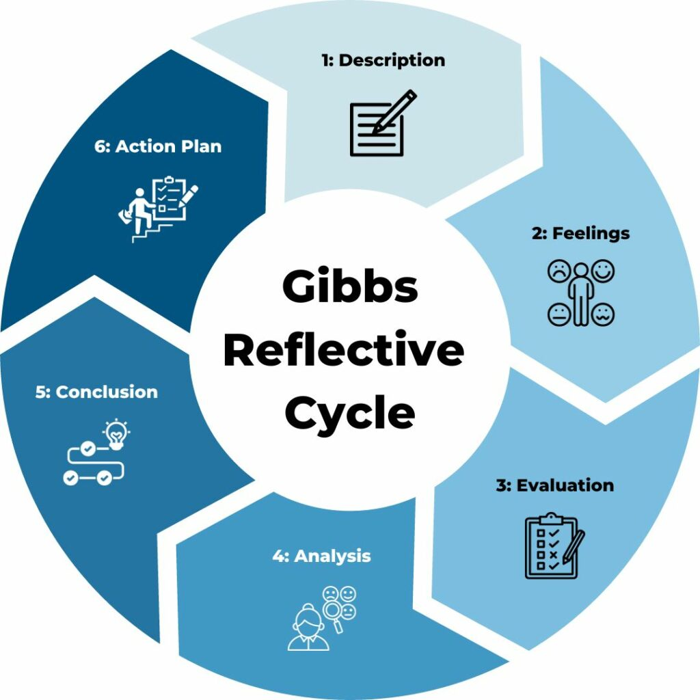
Figure 1: Gibbs Reflective Cycle Model
Source: (Fallon and Rutherford, 2020)
Analysis
I have analysed the quality of supervisors during my internship and how they manage all the responsibilities and maintain quality emphasising different skills like teamwork, communication, and time management to enhance guest services (Ambardar and Raheja, 2017). The food and beverage department needs to coordinate with other departments and also line housekeeping, maintenance, human resources, accounting, and finance to ensure transparency and consistency of workflow.
Conclusion
The placement at Abbos Burton Hotel increased my knowledge about real-world experiences. In shadowing the supervisory role in the F & B department, I have gained the ability to manage all the responsibilities effectively. This has improved my hospitality skills, technical knowledge, and emotional intelligence.
Action Plan
I need to improve some areas like handling pressure, conflict resolution, and guest communication to improve professionalism in the hospitality sector. For this, I can seek mentors for advice and take part in online and offline courses.

Section 2: Academic and Technical knowledge related to placement
The placement has developed some key skills that are fundamental to developing a successful career in the hospitality sector. Both interpersonal and technical skills have been developed through this experience that are provided below:
Table 1: Importance of Academic and Technical knowledge
Skills | Description
Communication Skills | In the F&B department of the hospitality sector, the front desk executives have paramount responsibilities to enhance guest satisfaction through word of mouth. Effective communication is necessary to enhance the alignment with guests, kitchen staff, waiters, and other employees and customers. I have developed strong academic skills that helped me to make better communication in the placement (Parmar and Dalal, 2017).
Teamwork | Strong coordination is necessary to ensure service efficiency. Every team member has separate responsibilities but everyone should be flexible to handle any uncertain situation (Singh, 2015).
Task Management | The housekeepers in the F & B department require disciplined task management to ensure synchronisation among tasks, timeframe, service, and food delivery. My prior academic skills are related to this where I have learned to break down the tasks according to priority and complete those.
Other related skills like adapting and resilience are required to provide detailed attention in work and maintain a positive attitude towards the organisation and the department. It will increase the guest experience (Bhatnagar and Nim, 2019). Knowledge about guest services is also required such as understanding their personal tests, CRM, comfort the guest in uncertain circumstances, etc. This placement has helped to improve this skill that influenced the service delivery improvements.

Section 3: The organisational issues and proposed solutions
I encountered several Issues during my placement at Abbots Barton Hotel. There was a staff shortage at the F&B department for which in the peak seasons the employees faced higher work pressure that tense to mental health issues. It is also impacting the department issues, service qualities, employee morale, and overall efficiency (Chatterjee, 2022). Staff shortages increase turnover, and reduce the quality of foods and others. The supervisor faces difficulties in maintaining high-quality food services to the guests increasing the risk of errors and reducing guest satisfaction. During peak seasons, I had to support my co-workers and I learned about guest reception, understanding their preferences and others. This was a great learning opportunity for me that gave me hands-on experience in the hospitality sector.
Proposed Solutions
To address this issue, the hotel can take some initiatives that are provided below,
- Make an effective workforce planning that will include cross-training staff, reallocation of employees in peak seasons, and others.
- Make strategies to reduce employee turnover through overtime pay, appraisal, recognition, feedback, incentives, and others.
- Effective training should be provided to the employees related to multitasking, handling work pressures, maintaining quality standards of the products, etc.
- In the peak seasons temporary staff can be employed
- The routine and repetitive tasks can be automated for example digital checklists for housekeeping or mobile POS systems to reduce the pressure on the employees of the F&B department.

Conclusion
The placement experience at Abbots Barton Hotel has improved my essential professional skills and knowledge through hands-on experiences. In the housekeeping of the F & B department, I have learned inventory management, providing higher guest services, task management, teamwork, understanding guests, and others (Adeani et al, 2020). My supervisor helped me to learn this through engaging in different works and integrating those with academic perspectives. A growth mindset and continuous improvement are necessary to develop a career in the hospitality sector.

References
Adeani, I. S., Febriani, R. B., and Syafryadin, S. (2020). Using GIBBS’reflective cycle in making reflections of literary analysis. Indonesian EFL Journal, 6(2), 139-148.
Ambardar, A., and Raheja, K. (2017). Occupational Safety and Health of Hotel Housekeeping Employees: A Comparative Study. International Journal of Hospitality and Tourism Systems, 10(2).
ASET (2017) Good Practice Guide for Workbased and Placement Learning in Higher Education. Sheffield: ASET.
Bhatnagar, E., and Nim, D. (2019). Impact of housekeeping services and practices on customer satisfaction and repeat business.
Chatterjee, P. (2022). Role of Housekeeping Cleaning Equipment and Agent in the world of Hospitality Industry. International Journal of Research Publication and Reviews, 3(8), 1642-1646.
Fallon, M. and Rutherford, D. (2020) Hotel Management and Operations. London: Wiley.
Hagg, E. (2023) Internship Guide: Work Placements Step by Step. 5th Ed. The Hague: Eleven International Publishing.
Johnston, R., Clark, G. and Shulver, M. (2022) Service Operations Management: Improving Service Delivery. 5th Ed. London: Pearson.
Parmar, S., and Dalal, P. (2017). A study of musculoskeletal disorder among housekeeping staff in hotel industry. Int J Home Sci, 3(3), 83-5.
Singh, A. (2015). Hotels Housekeeping Innovative Trends and Modern Practices-An overview. Journal for Studies in Management and Planning, 1(3), 540-548.
Vallen, G.K. and Vallen, Jerome J. (2014) Check-In CheckOut: Managing Hotel Operations. 9th Ed. Harlow: Pearson Education Limited.
Walker, J.C. (2021) Introduction to Hospitality. 8 th Ed. Harlow: Pearson Education Limited.

