Lighting Study Task

Inspiration: The Killing (clip available on moodle)

Emulate-
- You must emulate the lighting style.
- You must emulate the scene content (character enters location, turns on torch, and proceeds to investigate location).
- You must use locked off shots, pan/tilt, hand held.

Experiment-
- You can experiment with framing and composition.

Working as a crew:
As you complete today’s tasks you must work as a crew.

Each individual within the team will have a distinctive role, with specific responsibilities. You must NOT step out side of the duties associated with the role and infringe upon the responsibilities of anyone else in the team.

- Director - key responsibilities include: The director is the leading creative artist. The director works directly with the actors on their performances and has final creative control on almost every aspect of the film. The director plays a large role in casting, script revisions, shot composing and even editing.

- 1AD – Assistant Director - key responsibilities include: The assistant directors (AD) department is the bridge between the director and the rest of the production crew. A first assistant director heads up the department and acts as the director's right hand, taking on the important practicalities of a shoot and ensuring a disciplined, safe and effective working environment.

- DOP (Director of photography) - key responsibilities include: The director of photography (D.O.P.) is in charge of the overall visual look of the film, as seen through the camera. They recommend which cameras and lenses to use for the production. They design the shot’s framing, and the camera movements in conjunction with the director. They are also in charge of the camera crew, lighting design and collaborating with the gaffer.

- Camera operator – key responsibilities include: Positioning/moving the camera, exposing. The camera operator physically controls and operates the camera during filming, under the direction of the D.O.P. (Director of Photography). The camera operator controls the shot’s framing, and the camera movements as instructed by the director of photography.

- Camera assistant (1AC)– key responsibilities include: The 1st AC is the chief assistant to the camera operator. The 1st assistant cameraperson is in charge of measuring and pulling focus during filming. This person also helps setup and build the camera, as well as maintain and clean the camera and lenses.

- Camera assistant (2AC)– key responsibilities include: The 2nd AC is also known as the loader. The 2nd assistant cameraperson is primarily responsible for maintaining and filling out all the camera reports. This person also runs the slate or clapper to maintain sync and the correct labelling for each and every shot.

- Lighting gaffer - key responsibilities include: The gaffer is also known as the chief lighting technician. This person is primarily responsible for developing a lighting plan according to the desires of the Director of Photography. The gaffer informs the grip on where and which lights are to be placed. The gaffer is in charge of creating the best possible lighting scenario according to the camera framing.

- Lighting grip - key responsibilities include: Grips essentially “shape the light”. This includes creating pattern and shadow effects, colouring light, diffusing light or blocking light. Grips provide the quality of light that the gaffer desires. They also provide a variety of rigging, securing and safety measures.

The Killing Scene Breakdown
Section 1
Shot 1  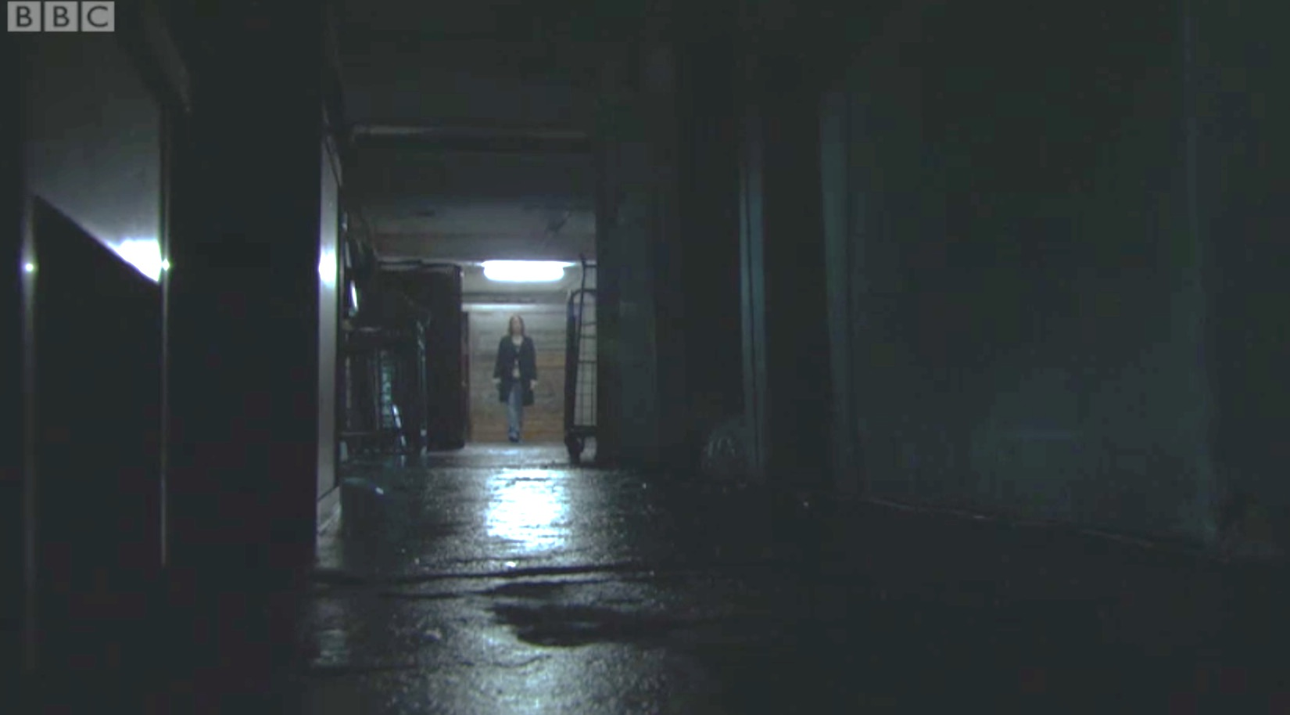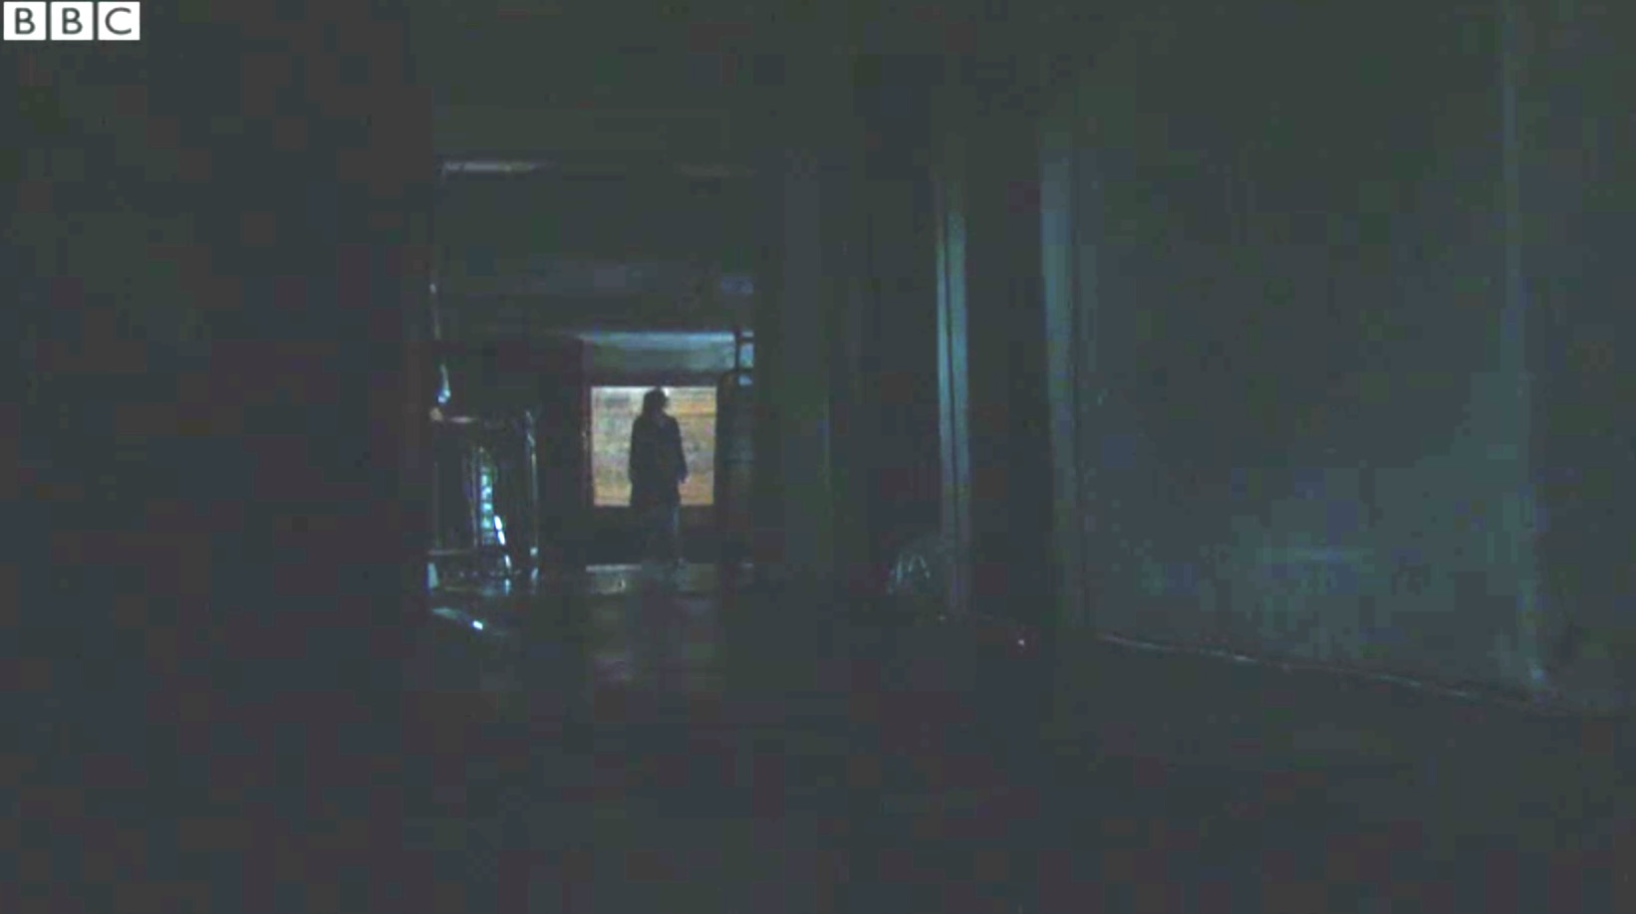  Description:  Static camera  Character silhouetted as light goes off | Shot 2  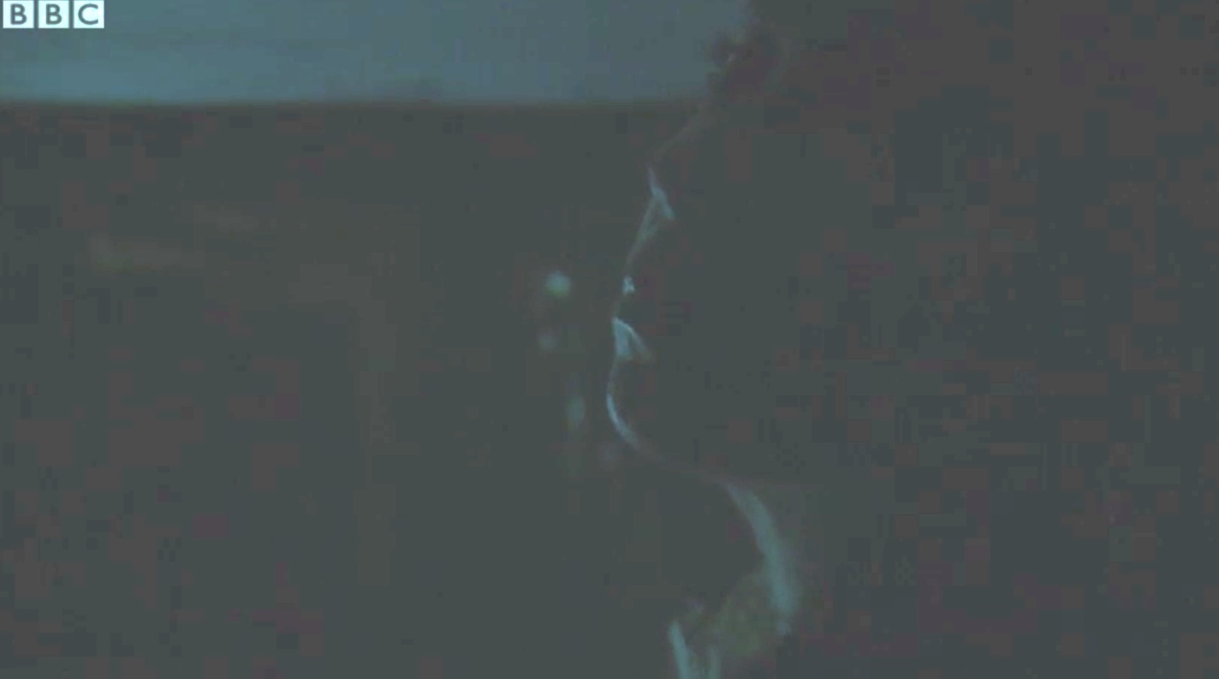  Description:  Static camera  Subdued lighting, lighting highlights characters face
Shot 3  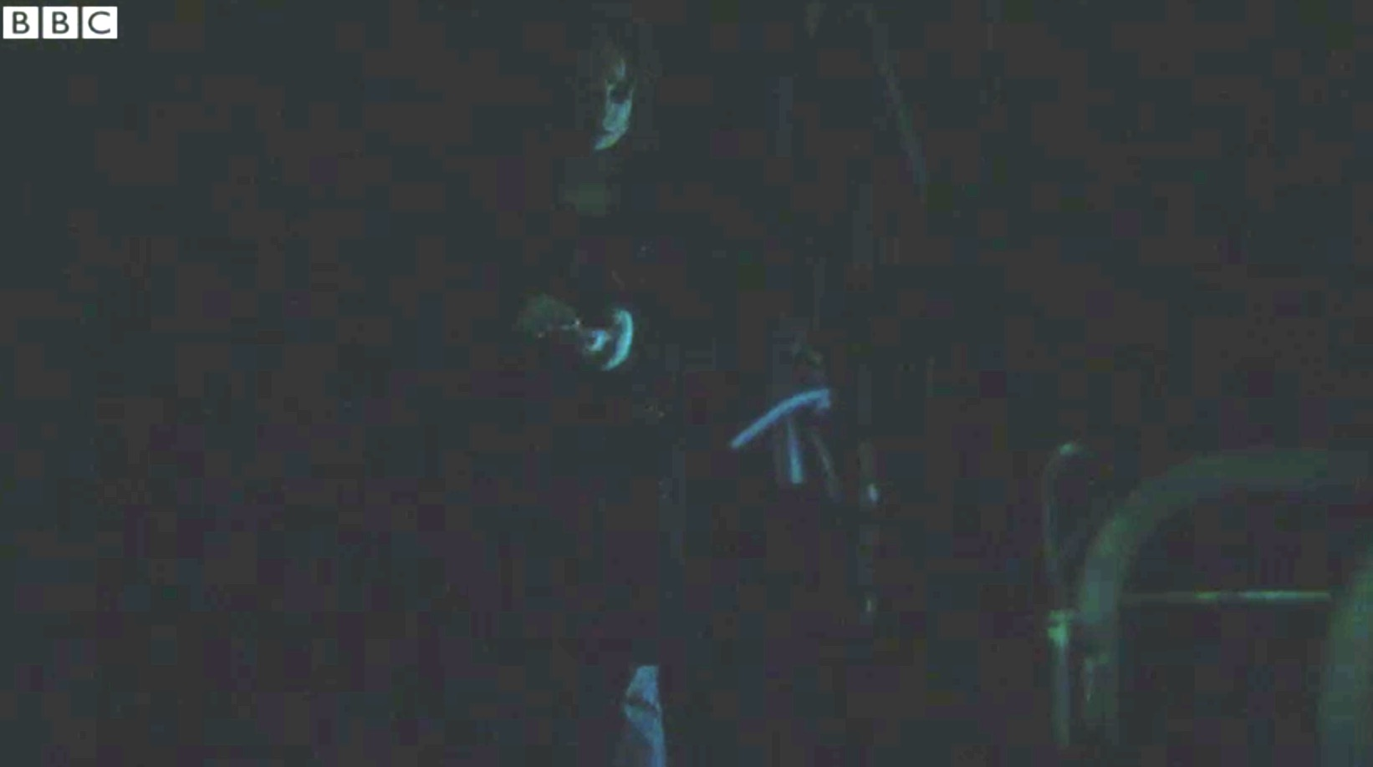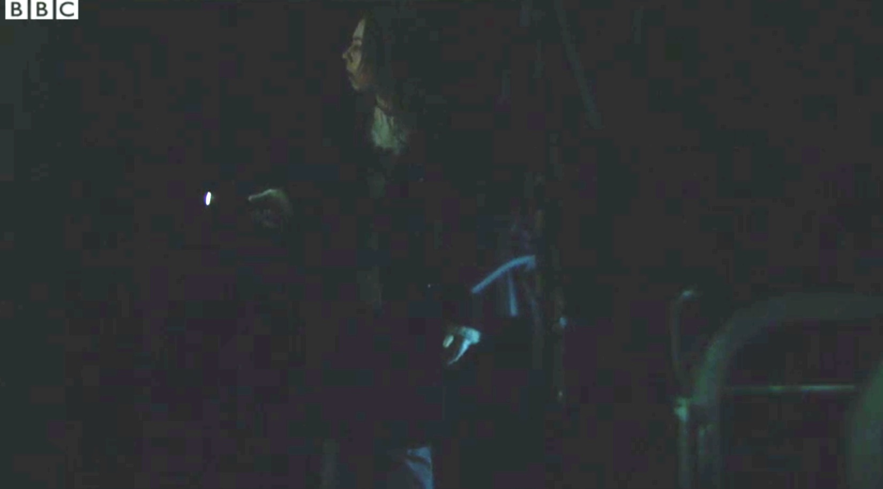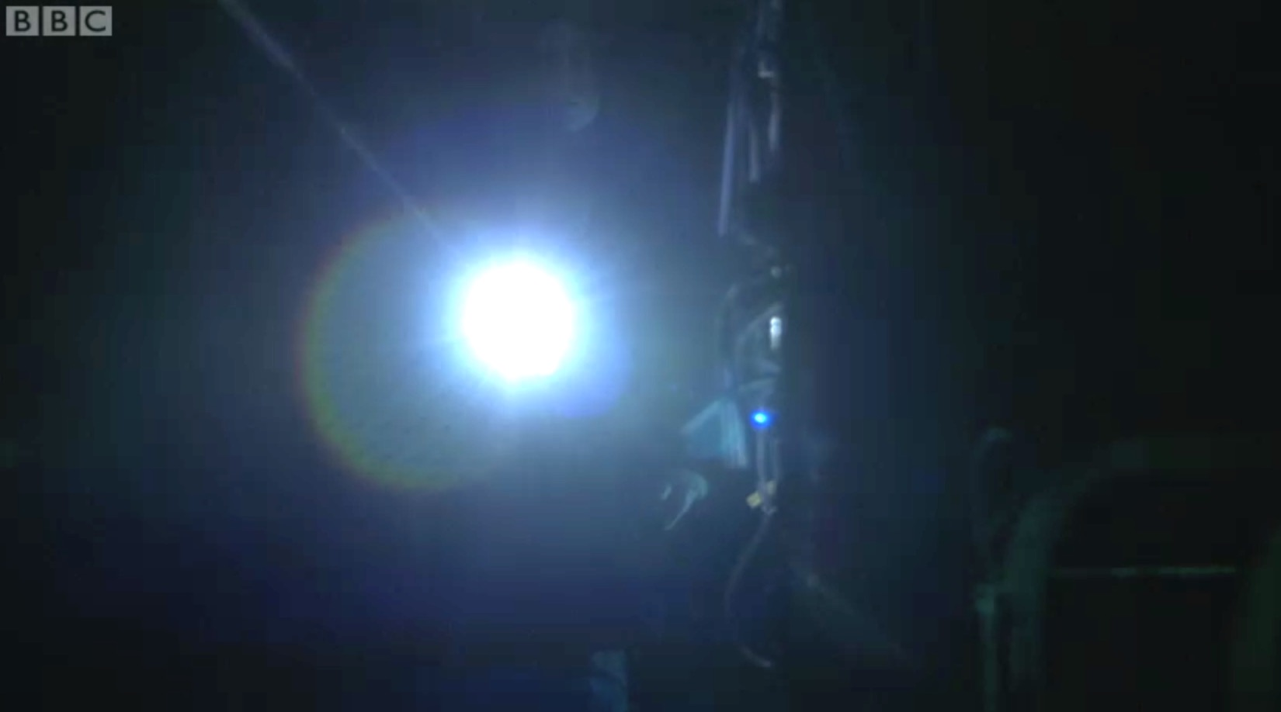  Description:  Static camera  Subdued lighting. Character turns on torch, as torch moves across scene light reflects onto character. Lens flare as torch moves across scene. | Shot 4  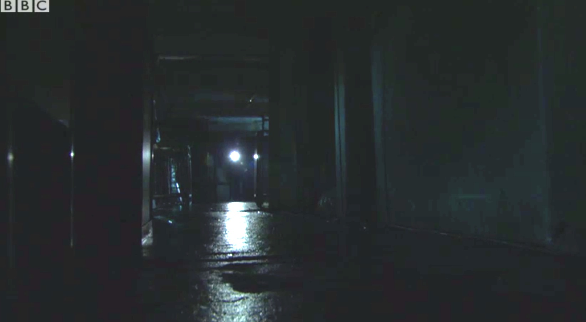  Description:  Static camera
Section 2
Shot 5  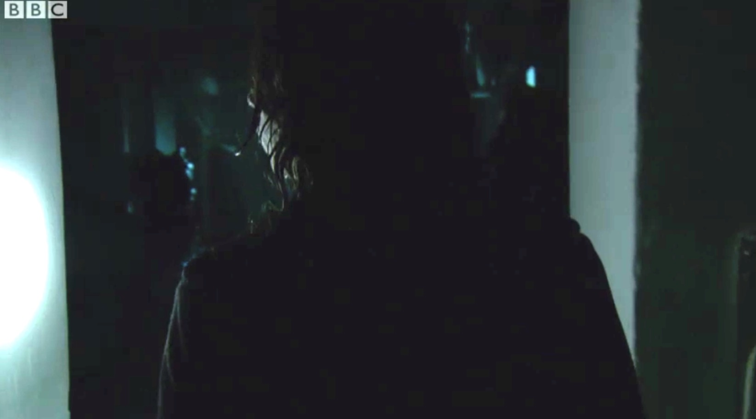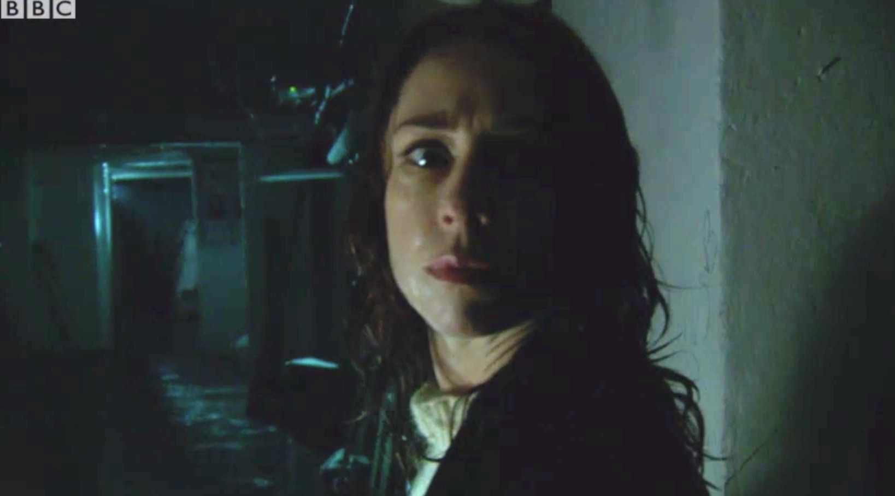  Description:  Hand held following character though environment  Dimly lit, see end of corridor, and light reflected onto characters face | Shot 6  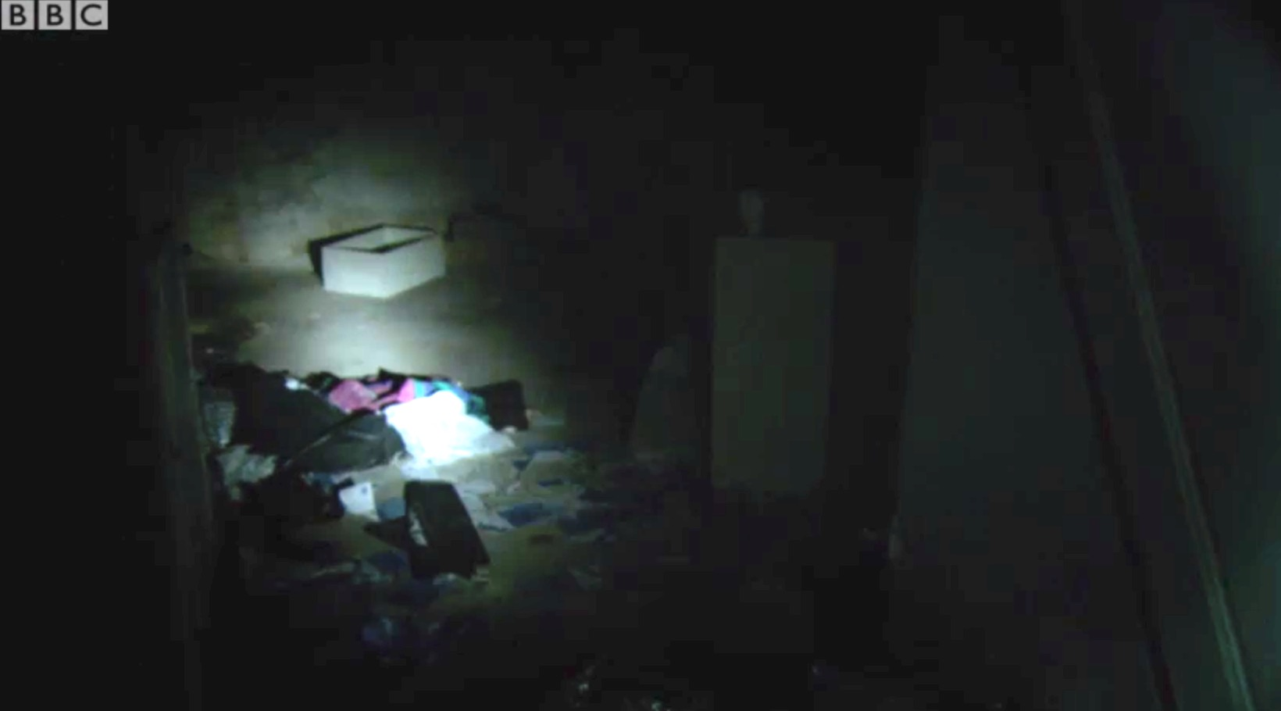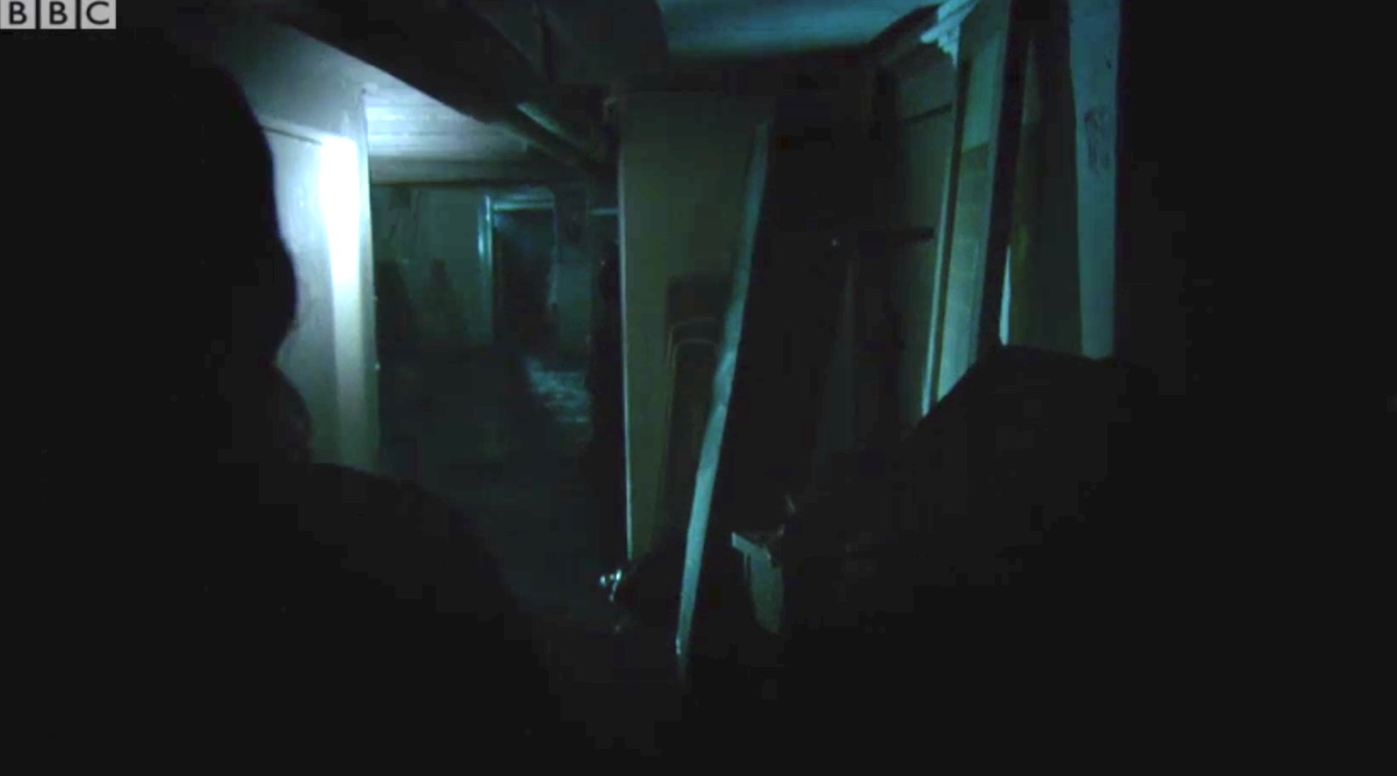  Description:  Hand held following character though environment  Torch picks out objects in location
Shot 7  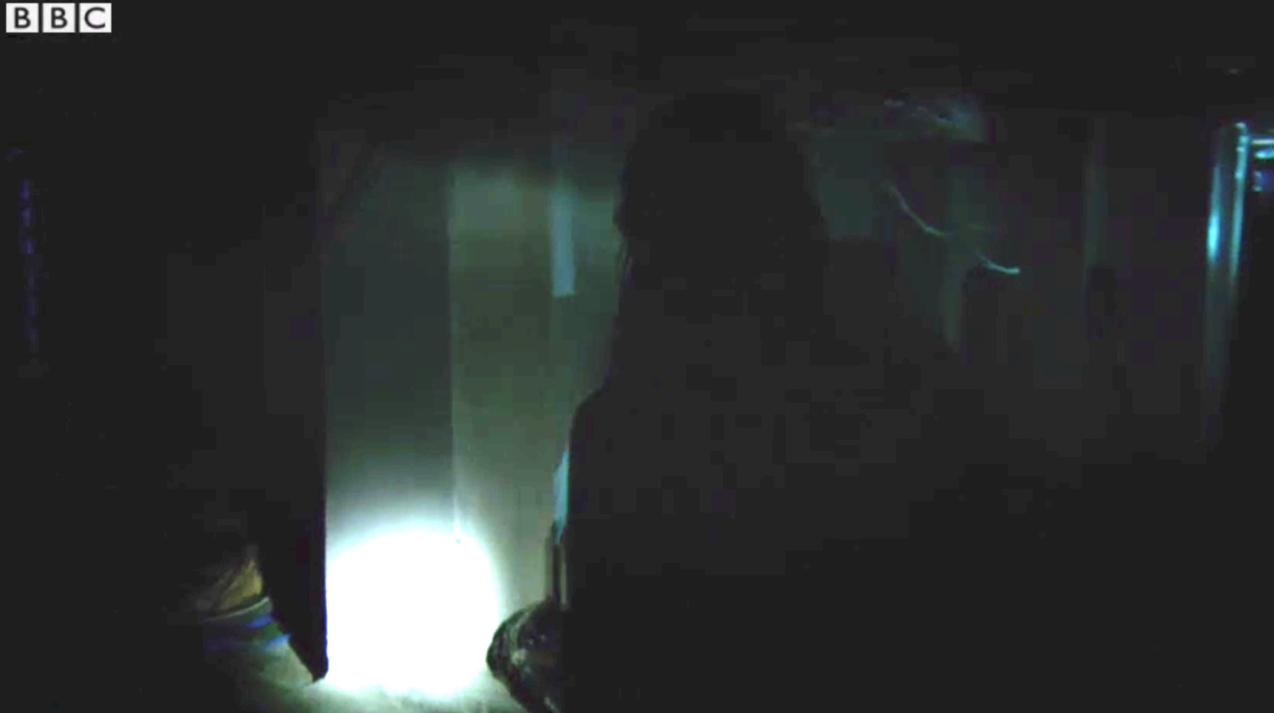  Description:  Hand held following character though environment  Character silhouetted against light of torch | Shot 8  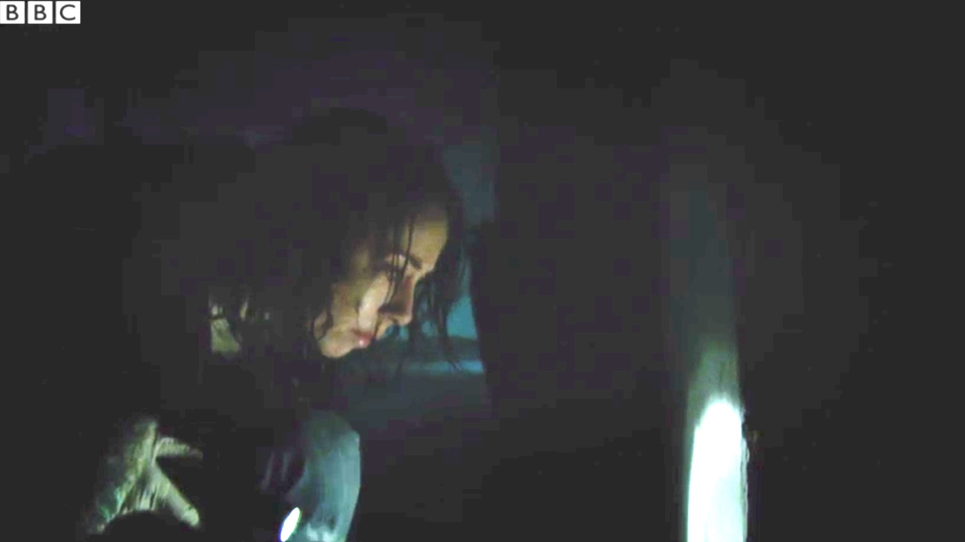  Description:  Hand held following character as leans down  Light reflected off wall onto characters face, slight light in background to add depth to scene

Calling the Roll
- 1AD – ‘Quiet on set’
- 1AD – ‘First Positions’
- 1AD– ‘Turnover’
- Camera op – ‘Camera rolling’
- Sound op – ‘Sound rolling’
- Camera operator – ‘Mark it’
- 2AC – Calls out the scene
- 2AC – brings the clapper down
- Camera operator – ‘Set’
- Director – ‘Action’
- Director – ‘Cut’
Lighting notes
Light and Shadow
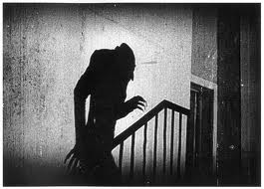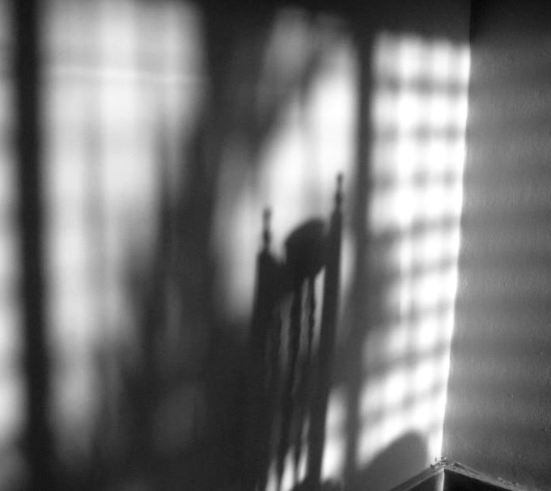
Hard lighting Soft lighting
Lighting tools
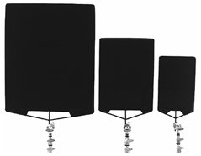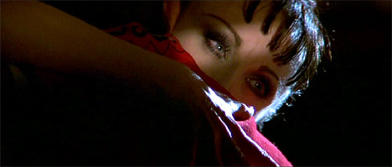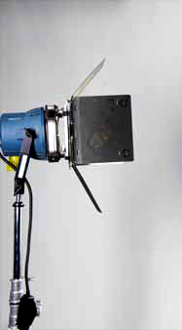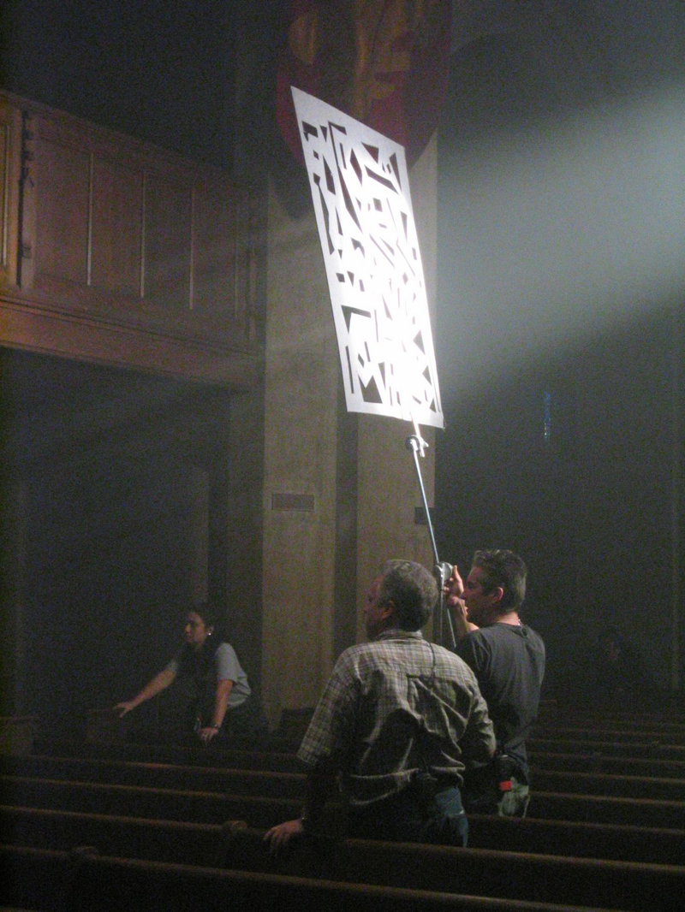
Flags /Barn doors Cucoloris/Cookies
Can be used to create and control shadows/negative fill. These tools can help fracture the light
Used to cut and shape light. so that it appears more natural.

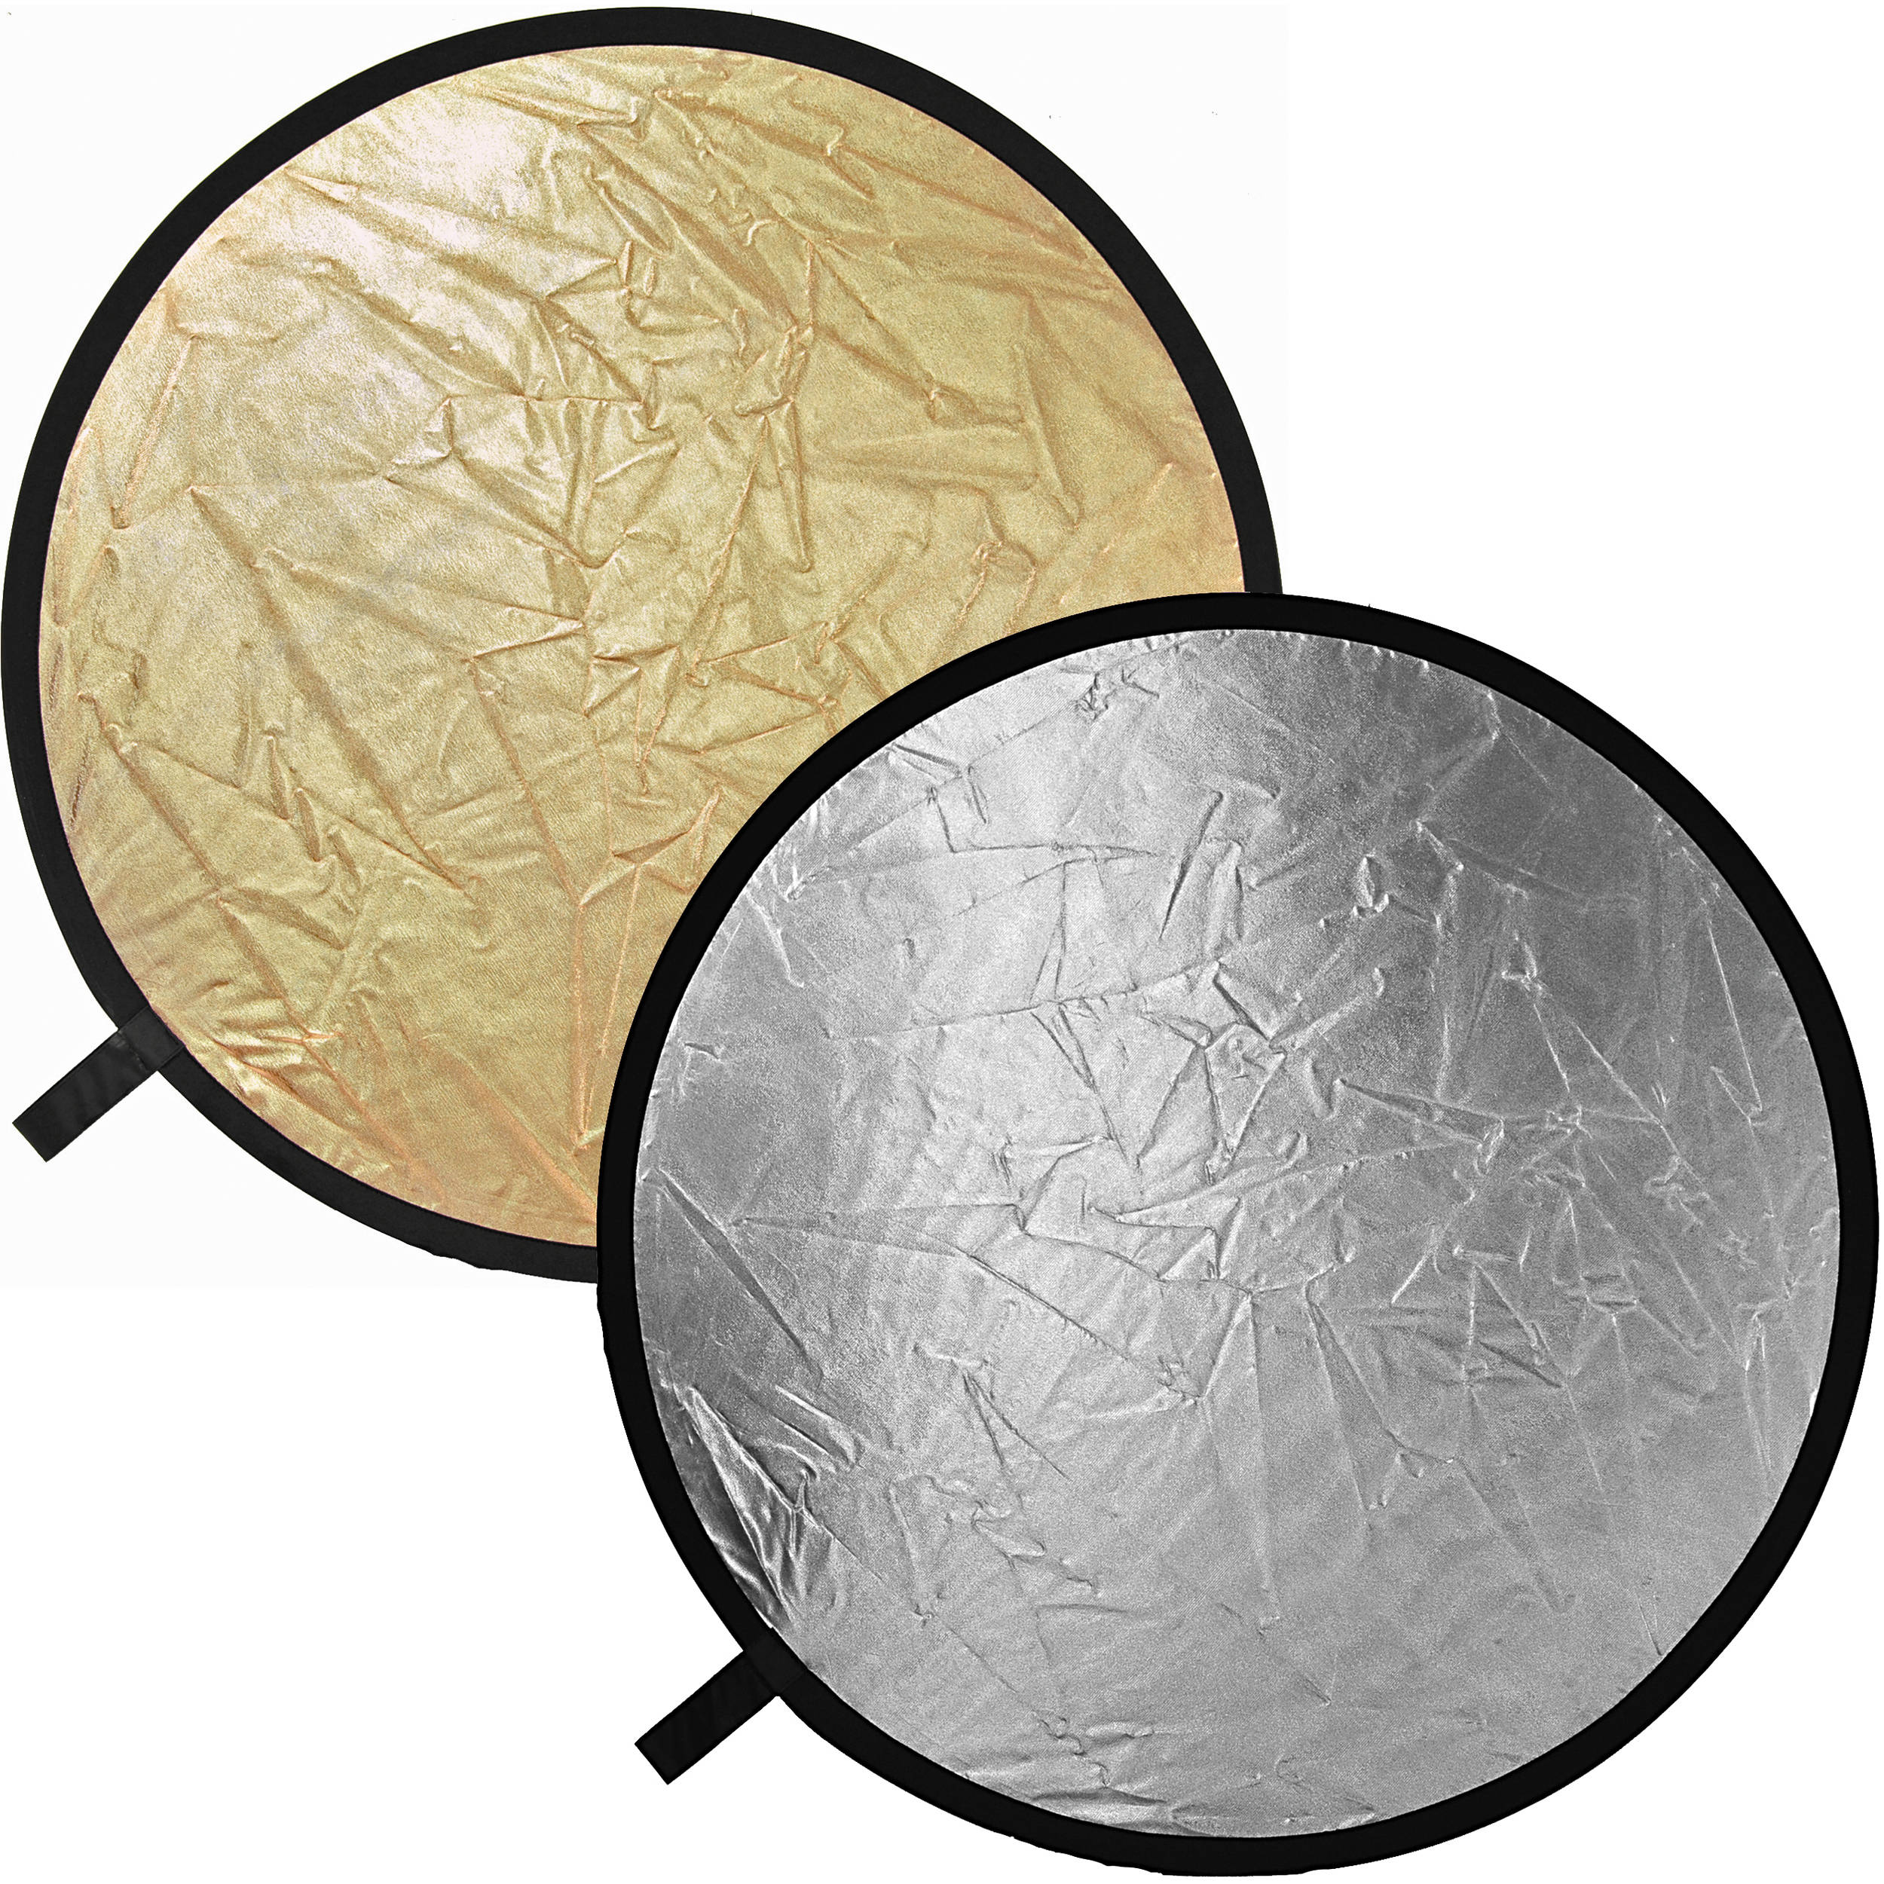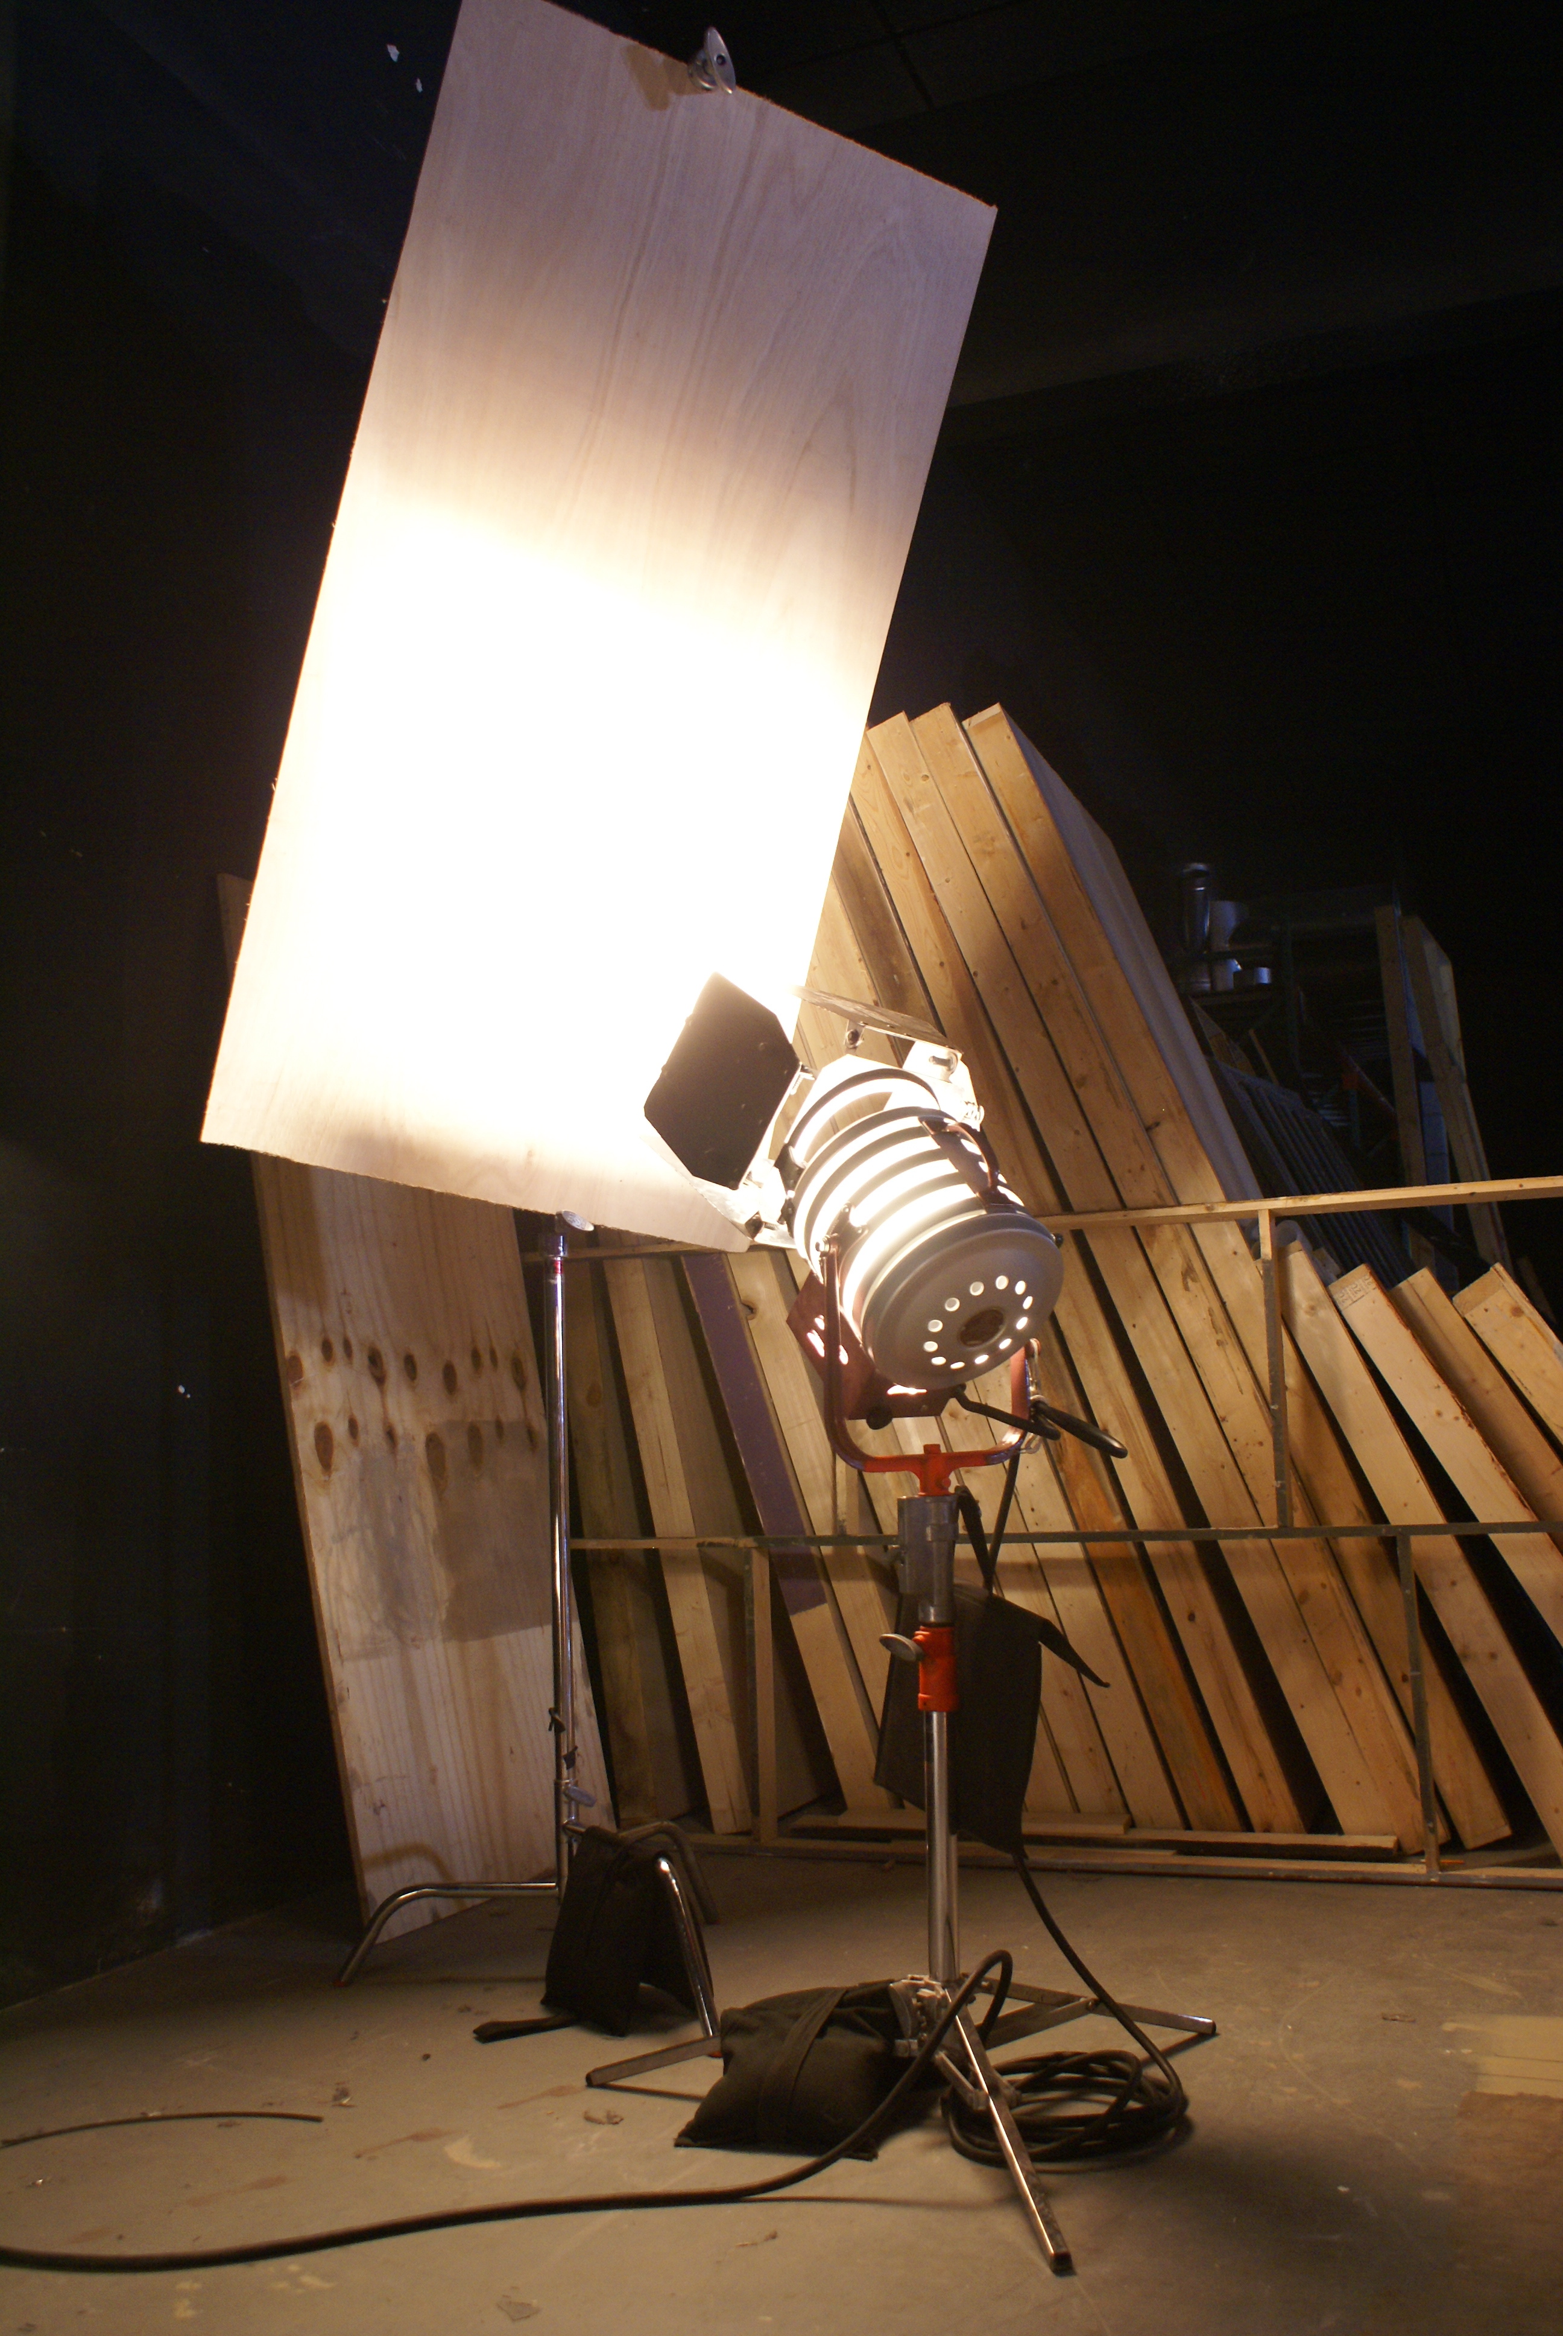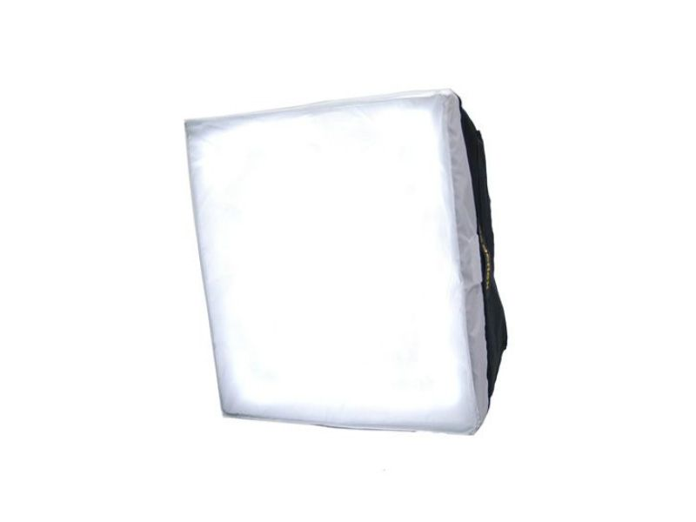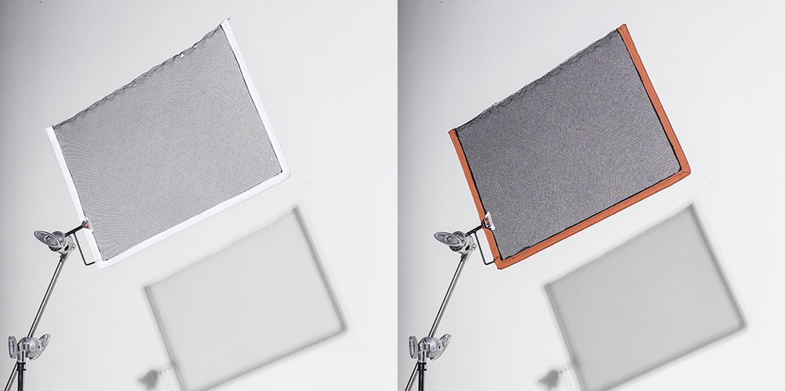
Reflectors/Bounce boards Soft boxes / Diffusers / Scrims
Use reflective services to bounce light, These tools can help soften the light or decrease
this will help create soft light. You can also use such things the intensity of the light.
as white ceilings to bounce lights and give a scene a soft diffused
wash of light.
Scrim

Colour Temperatures
3200k tungsten
5600k daylight
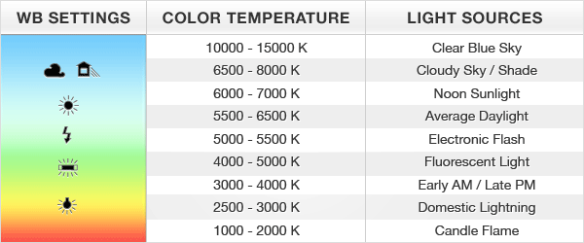

Tips for Directors
Communication is key - Director is creative leader. Actors and crew work best with directors who have a clear vision and communicate it clearly

- Know exactly what you want from the scene/shot
- Some things to contemplate and consider are: identifying emotional tone, what you’re trying to convey in a scene/shot, from what/who’s point of view is the story being told, who are the characters/character.

Working with actors
- Be polite and low key with everyone
- Subtext – what’s really going on in a scene, inform actors what motivates the character.
- Talk them through the scene, what's at stake in the scene.
- If the actor doesn’t have much training may ask them to personalise it.
- Be positive in front of cast and crew, on set is delicate situation.
- Use encouraging language.

But what if your not getting what you want as a director?
- Don’t tell the actor what to do/ correct a performance.
- Use encouraging language.
- ‘Lets try one more its growing, what do you think about trying …’
- Encourage an environment of co-creation, let them feel part of the creative process, it will raise confidence.

Tips for DOPs
As a DOP you may want to consider the following, and get conformation from the director:

Discuss the following with the director:
- What is the overall story?
- From who’s point of view is the film/scene/shot? (Is it in the characters head, an observation of the scene from a distance, an invisible presence….)
- What emotions are associated with the film/scene/shot?

Based on the information from the director, consider the following in your visual approach for filming:
- How does my intended camera work reflect a particular point of view?
- How does the intended visuals (camera work/movement/angles) reflect the directors desired emotional tone for the scene/shot?
- How might the audience visually perceive the film/scene/shot? And why?
- What’s my reason or motivation behind the intended camera work/camera movement/angle?
- How do my intended visuals help the audience understand the film/scenes meaning?

Tips for Camera Operators
- Know your camera, and how to operate it manually (adjust shutter speed, aperture, ISO, white balance).
- You should be able to manipulate the exposure to produce the DOPs creative desires for the visuals (for example shallow focus/deep focus, motion blur and so on).
- Ensure you are recording in the correct format you should always check the camera menu settings thoroughly (main things to check: resolution, frame rate, audio settings and so forth).
- Always ensure you have focused a shot (use the digital zoom function to ensure your image is in focus).
- If using a clapperboard to mark clips ensure the board is clearly in frame and legible.

Tips for Camera Assistant
Clapperboard:
- MOS: Scene without sound, and place your hands between the sticks.
- Camera is the DOPs name.
- Roll: each new card is a new magazine as it were so a new roll. Normally each camera have own letter so A camera and B camera. So roll 2 on camera A marked as A02.
Scene/Slate/Takes-
- UK system works with slate numbers: The slate number should start at 1 for the first shot of the day, and increment every time the camera position and/or lens is changed. The take number should reset to 1 each time the slate number changes, and increment every time the camera stops rolling.
- American system neglects slate numbers. A number is used for the scene you are shooting and a letter added for the shot you are on. So first shot filmed for scene 3 would be 3, then 3A, 3B, 3C, etc. Takes attached to shots not scenes, so if go from 3a to 3b start from take 1 on shot 3b again.

