Morgan_Fiona_2501925-BMDS7007-CW2.docx

Assignment Title: Digital Strategy Proposal

I confirm this essay is my own original work and does not include text created by a generated artificial intelligence tool.

Title: Stakeholder engagement within Aneurin Bevan University Health Boards Digital Strategy, Transformation through digital 2019.


​​(Jane Holmes, 2018)​

Introduction

Stakeholders play an important role when implementing a digital strategy effectively and efficiently ​(Khodyakov, Savitsky and Dalal, 2016)​. Aneurin Bevan University Health Boards (ABUHB) Digital Strategy (Digital Strategy, Transformation of Digital) was established in 2019, with specific goals and themes ​(Aneurin Bevan University Health Board, 2019)​. ABUHB digital strategy would not be successful without the key stakeholders. Having a varied multi agency approach would have assisted with establishing pathways and providing an effective and responsive deliver of the digital strategy projects ​(NHS England and NHS Improvement, 2019)​.

This essay will critically reflect the multi and inter disciplinary working involved in ABUHBs digital strategy by using Driscoll reflection tool ​(Tanquary E., Hanratty P. and Martin B., 2020)​. The Driscoll approach uses 3 main questions ‘What, So What, Now what’​(Tanquary E., Hanratty P. and Martin B., 2020)​. Figure 1 illustrates how this reflective approach will guide the critical thinking of the how the stakeholders were engaged whilst developing and implementing the ABUHBs digital strategy.
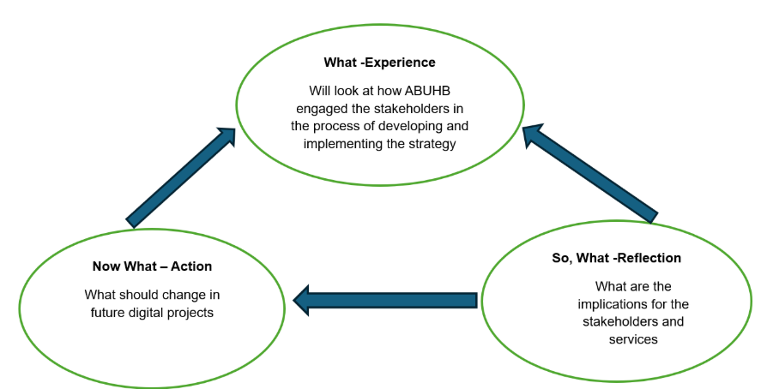
Figure 1. Adapted from Driscoll approach ​(Tanquary E., Hanratty P. and Martin B., 2020)​.
This will assist in identifying the stakeholders needed for a success digital strategy, the effectiveness of engaging the multi agencies, my own experiences and how having a balance of consensus and groupthink approach when conducting a digital project.

ABUHB Digital Strategy’s stakeholders.

ABUHB’S digital strategy outlines the need to improve the digital experience for both staff and patients, it provides evidence to prove how the digital projects have assisted them. However, a lack of clarity of the stakeholders at an early stage of the digital strategy would have caused difficulties with the development of the projects. Due to excluding stakeholders, ABUHB had a lack of understanding of the stakeholders' perspectives, expertise, collaboration which had a detrimental effect on the multi and inter disciplinary working with the roll out of the strategy (Potthoff et al., 2023).
I believe this lack of clarity led to project failures with unmet goals, scope creep, decreased implementation capacity and uncompleted projects. A clear identification of internal and external stakeholders would have ensured coherent considerations of the implementation of the strategy, and the ABUHB’s digital infrastructure was compatible throughout the health board and partner organisations, allowing understanding of what the project needs and where everyone fits within it.

Figure 2 illustrates who are the internal and external stakeholders ABUHBs that should have been included within the digital strategy.
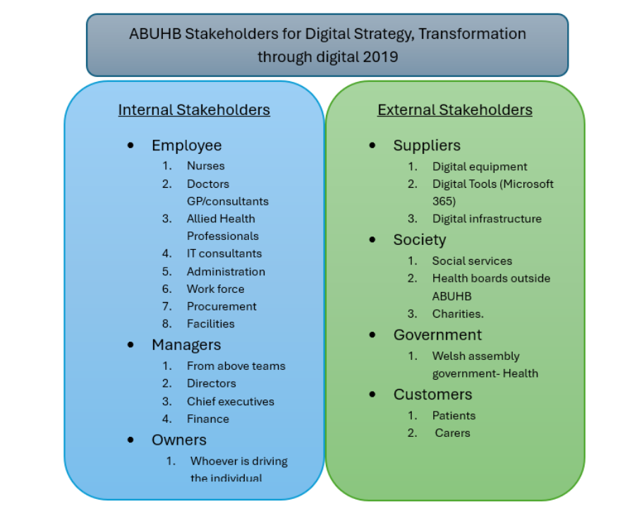
Figure 2 Identification of ABUHB Internal and external stakeholders for the Digital Strategy 2019.

The level of stakeholder involvement would vary depending on the project. A stakeholder analysis by using a power interest matrix (figure 3) would have provided a clear picture of which stakeholders were priority and would establish their participation, power and interest within each individual project (Thamma-reddi Latha, 2023). The analysis would contribute to how best to involve the stakeholders and how to communicate to each group.

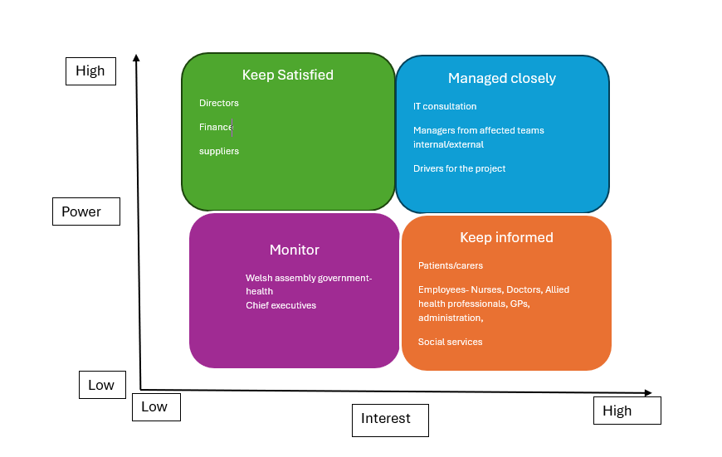
Figure 3 Stakeholder analysis of the stakeholders ABUHBs digital strategy. Adapted from (Thamma-reddi Latha, 2023)

Stakeholder Engagement

The digital strategy has not provided details of how ABUHB would engage with the internal or external stakeholders. I disagree with the way the digital strategy has not provided a clear plan of how this would be implemented, If the stakeholder engagement is weak there could be project malfunctions and delays with the strategy. The organisation needs to make sure their stakeholders are fully engaged in the process for the projects to be successful ​(Robu and Lazar, 2020).​ To get the most out of the engagement process ABUHB would need to consider the stakeholders power confidence and expertise to determine if collaborative working or separate working would be best to ensure a successful strategy.
The digital strategy states that ‘digital skills need to be developed within all levels of the health board’ ​(Aneurin Bevan University Health Board, 2019)​. In my experience, ABUHB lacks coherence with the developing learning resources for their stakeholders and often provides the training once the implementation is already in place. ABUHB implemented the roll out of Microsoft 365 in 2022 as part of this digital strategy. On launch day, I recall that staff who were unaware of how to access documents they required. The digital changes affected departments who could not access paperwork, patients’ information and appointment bookings, therefore, causing delays in appointment times. ABUHB did engage with the roll out of nominated super users, the so-called digital champions, to inform staff of the changes, but failed to ensure every department had representation. Lack of engagement caused major delays as well as frustration, which impacted not only staff but patients. When planning to implement a digital strategy the health board needed to effectively communicate with both the managers and the workforce to ensure a smooth roll out of the project ​(Aaltonen et al., 2024)​. I strongly believe that not including key stakeholders in the education of the new software would have impacted on staff compliance and engagement in future projects. Clear guidance and engagement meetings to all staff would have helped with a smooth rollout of the software. Having a question/answer forum on launch day may have eased the transition.
The digital strategy also states ‘ABUHB will create a digital culture that matches the expectations of the people they serve’ (Aneurin Bevan University Health Board, 2019). It is important the community are part of the development of the digital strategy from the start. Their involvement in the implementation and review process could ensure that ABUHB meet their expectations. Patient engagement is essential to inform, educate and provide policy changes as well as assist with service delivery ​(Bombard et al., 2018)​. The health board involved the public with patient engagement meetings and has used several media platforms to raise awareness of changes and improvements. Considerations of both the public and health professionals' perspectives, when reviewing the implementation of the digital strategy, will assist with the improvement of the process ​(Jones, 2018).
Personally, within Occupational Therapy, we review our service regularly, through patient surveys, which allows patients to express their experiences. Conducting a thorough patient engagement, allows the team to reflect on practice and provide areas for improvement. Having reviews from other stakeholders who engage in the service would provide another perspective of the service and assist with project development. Although the digital strategy does not indicate how ABUHB would engage the community, I agree with the health board communication efficiency through using different media to ensure communities are involved and informed. By using different types of communication will allow more opportunity for the community to be part of the success of the strategy. Considering the demographics and the lack of digital equity, it may be impossible to ensure all the population has a say or will be informed of changes which in turn could cause project failure.

Consensus/ Groupthink within decision making

It is important for stakeholders to communicate with each other effectively to make unified decisions regarding the goals of the digital strategy to ensure the digital projects are a success. Consensus decision making is a dynamic process which allows the group to find solutions that everyone agrees with, making sure all opinions, ideas and concerns have been considered ​(Madden, 2017)​. However, these decisions can be influenced through ‘Groupthink’. This phenomenon happens when a group reaches a decision and has not considered the clinical/digital reasoning due to the group dynamics and trying to keep the peace (Callaway and Esser, 2006). This circumstance often results in individuals withholding their opinion, flawed decision making and can lead to project failure​.​ I believe it is important to allow every stakeholder to have a say and state their opinion. This can be difficult especially if there is a dominant character who feels strongly about their opinion. I have witnessed this through an orthopaedic directors meeting. A waiting list clerk wanted to change details of a spreadsheet which would only benefit herself, when different hierarchical members from the meeting tried to offer their opinion, she would talk over them to ensure her opinion would be agreed. The room became quiet and despondent, and the team agreed for the changes even though this would not benefit anyone else. This demonstrated the group members dynamics affected the decision making by causing the members to minimise the conflict and reach a consensus decision without critically evaluating. This type of decision making can lead to vulnerability to certain professional groups if they are not heard within the digital strategy and could also lead to implementation failures ​(DiPierro et al., 2021)​. However, this is usually seen with a senior member having more of a dominant role and the lower position members contributing less and have fewer opportunities to engage in the group decisions ​(Choi et al., 2024)​.
There is a need to achieve a balance between consensus and groupthink so the digital strategy can be effective. In my experience, having structure to a meeting is key, with a defined purpose, an agenda, structured discussion and action plans. This will allow the members to understand what the meeting is about and therefore keeping the meeting focus. An allocated leader to guide the meeting to ensure everyone has a say and their opinions can be heard. The leader should assess throughout the meeting to ensure the meeting is developing in the right way, the meeting is organised, everyone is listening, providing constructive thinking and having discussions of important issues. This will ensure all perspectives are being met and considered ​(Lorsbach, 2026).​
Having stakeholders who are at the same professional level or have the same interest in a meeting allows more focused driven discussions so decisions can be made ​(NHS England, 2026)​. I found being part of a large regional orthopaedic meeting where everyone was put into subgroups categorised by their area of work, helped the planning and decision making on the future of elective orthopaedic services. I feel, because everyone had a common focus and goal in the subgroup (preadmission) they did not feel intimidated. This allowed discussions to be made on the future of all Wales standards within orthopaedic preadmissions services. There was a facilitator within the meeting to ensure everyone was able to put their opinions across and allowed decisions to be made. If the digital strategy took these steps when involving stakeholders, I feel there would be more focus driven projects where everyone feels valued, this would prevent project delays and failures.

Conclusion

ABUHB’s digital strategy failed to provide details of the stakeholders that would be involved in the implementation of the strategy. For a digital strategy to be implemented effectively identification of stakeholders is vital to mitigate risks. Through my own experience highlighting downfalls of the roll out of a digital project, it is necessary all stakeholders to be involved in the process to avoid negative impact on services. Otherwise, stakeholders could become disengaged and reluctant to be supportive of other projects. The importance of unified decision making when carrying out a digital strategy is essential to avoid implementation failure. It is crucial that all stakeholders have their opinions heard to ensure vulnerability of stakeholder groups does not happen.

References
​​Aaltonen, K. et al. (2024) “Stakeholder engagement: Theoretical and methodological directions for project scholarship,” International Journal of Project Management, 42(7), p. 102649. Available at: https://doi.org/10.1016/J.IJPROMAN.2024.102649.

​Aneurin Bevan University Health Board (2019) Digital Strategy - Transformation Through digital, https://abuhb.nhs.wales/files/key-documents/digital-strategy/.

​Bombard, Y. et al. (2018) “Engaging patients to improve quality of care: a systematic review,” Implementation Science : IS, 13(1), p. 98. Available at: https://doi.org/10.1186/S13012-018-0784-Z.

​Callaway, M.R. and Esser, J.K. (2006) “GROUPTHINK: EFFECTS OF COHESIVENESS AND PROBLEM-SOLVING PROCEDURES ON GROUP DECISION MAKING,” Social Behavior and Personality: an international journal, 12(2), pp. 157–164. Available at: https://doi.org/10.2224/SBP.1984.12.2.157.

​Choi, J.J. et al. (2024) “Medical residents’ perceptions of group biases in medical decision making: a qualitative study,” BMC Medical Education, 24(1), p. 661. Available at: https://doi.org/10.1186/S12909-024-05643-4.

​DiPierro, K. et al. (2021) “Groupthink among health professional teams in patient care: a scoping review,” Medical teacher, 44(3), p. 309. Available at: https://doi.org/10.1080/0142159X.2021.1987404.

​Jane Holmes (2018) Helping bring integrated care teams to life: Bill’s story | RCNi. Available at: https://rcni.com/primary-health-care/opinion/comment/helping-bring-integrated-care-teams-to-life-bills-story-141871 (Accessed: April 13, 2026).
​Jones, E. (2018) “Practical steps to improving the quality of care and services using NICE guidance.”

​Khodyakov, D., Savitsky, T.D. and Dalal, S. (2016) “Collaborative learning framework for online stakeholder engagement,” Health Expectations, 19(4), pp. 868–882. Available at: https://doi.org/10.1111/hex.12383.

​Lorsbach (2026) Avoiding Groupthink in the Boardroom | AHA Trustee Services, https://trustees.aha.org/avoiding-groupthink-boardroom. Available at: https://trustees.aha.org/avoiding-groupthink-boardroom (Accessed: April 20, 2026).

​Madden (2017) · Developing Participation Guidelines · Procedures for Consensus Decision Making · Optional Stances for Participants · Comments on Facilitation A PRACTICAL GUIDE FOR CONSENSUS-BASED DECISION MAKING, https://www.tamarackcommunity.ca/hubfs/Resources/Tools/Practical%20Guide%20for%20Consensus-Based%20Decision%20Making.pdf.

​NHS England (2026) NHS England » Shared Professional Decision-Making: putting collective leadership into practice, https://www.england.nhs.uk/nursingmidwifery/shared-governance-through-collective-leadership/sdm/. Available at: https://www.england.nhs.uk/nursingmidwifery/shared-governance-through-collective-leadership/sdm/ (Accessed: April 20, 2026).

​NHS England and NHS Improvement (2019) Multi-disciplinary teams Liaison and Diversion Manager and Practitioner Resources, https://www.england.nhs.uk/wp-content/uploads/2020/01/Multidisciplinary-Teams.pdf.

Potthoff, S. et al. (2023) “Towards an Implementation‐STakeholder Engagement Model (I‐STEM) for improving health and social care services,” Health Expectations, 26(5), pp. 1997–2012. Available at: https://doi.org/10.1111/hex.13808.

​Robu, D. and Lazar, J.B. (2020) “Shaping successful stakeholder engagement by design: Digital transformation in healthcare,” Proceedings of the European Conference on Knowledge Management, ECKM. Available at: https://doi.org/10.34190/EKM.20.055.

​Tanquary E., Hanratty P. and Martin B. (2020) Reflective writing for Nursing Health and Social Work . Boomsbury publishing PLC.
​ ​

