Financial Management for the Hotel Industry
Assignment 1

Business Report – Comparison of Two Hospitality Organisations

Student Name: Jeler Alin-Bogdan
Student ID: 2223715
Lecturer: Tristan Hawkins
Module Code: BMIH5007
AI AKNOWLEDGEMENT
I declare that no AI was used to sustain or reflect my research for this assessment.

Table of Contents

Introduction 3
Total Revenue 3
Market Position 6
Growth Potential 9
Financial Commitment to CSR (Corporate Social Responsibility) 10
Recommendation 11
Conclusion 12
References 13
Appendix 16

Introduction
Premier Inn is a popular brand of low cost, economic, family-friendly, business and leisure hotel chain. The organization is appreciated for the ability to generate value and great accommodation services classified as budget hotel (Premier Inn, 2024). On the other hand, Shangri-La Hotel is a luxury brand in the accommodation industry with focus on luxury services (Shangri-La, 2024). The brand associates with high quality services, customized experiences and ensuring comfort at different locations around the world.
In the following report, both businesses i.e. Premier Inn Hotels and Shangri-La Hotels will be compared on total revenue, market position, growth potential and CSR initiatives, similarities and differences will be analyzed. The recommendations that follow, are made using expert observations, current revenue and performance of both organizations.

Total Revenue
Revenues
Revenue | Pre Covid |  | During | Post Covid
 | 2018 | 2019 | 2020 | 2021 | 2022 | 2023
Shangri-La Hotels | £3099.55 | £3046.51 | £789.03 | £945.44 | £1114.42 | £1632.43
Changes in Percentage | 85.38% | -1.71% | -74.10% | 19.82% | 17.87% | 46.48%
Premier Inn Hotels | £2007.4 | £2049.1 | £2071.5 | £589.4 | £1,703.4 | £2,625.2
Changes in Percentage | -35.37% | 2.07% | 1.09% | -71.55% | 189% | 54.12%
Table No.1: Revenue
(Source: Created by the Student)
The revenue of Shangri-La hotels before Covid 19 i.e. 2018 and 2019 was £3099.55 million and £3046.51 million (Shangri-La, 2019). Furthermore, the revenue of the business in 2020 was £789.03 million and £945.44 million in 2021 in the marketplace (Shangri-La, 2021). On the other hand, the revenue of the business at the end of 2023 was £1632.43 million which has increased from £1114.42 million in 2022 due to the improvement on global travelling market (Shangri, 2023). However, this growth was not exponential, and some geographical districts experienced slow increases in demand.
The revenue of Premier Inn in 2018 and 2019 was £2007.4 million and £2049.1 million on marketplace (Premier Inn, 2019). The business has revenue of £2071.5 million in 2020 as well as £589.4 million in 2021 (Premier Inn, 2021). Furthermore, in 2023, Premier Inn generated a total revenue of £2,625.2 million which is higher as compared to 2022 of £1,703.4 million (Premier Inn, 2023). The increase in 2023 was backed by the higher rate of recovery in the UK market and due to the dominant position of the business in the marketplace. In comparison of revenue performance, Premier Inn generated more revenue than Shangri-La and has a steeper rise in 2023 with a faster recovery from the pandemic impact in the primary market.
Furthermore, Premier Inn has recovered its position better than Shangri-La Hotels due to its dominance presence in the marketplace of the United Kingdom. The revenue of Premier Inn shows a growth rate of nearly 54.12% in 2023 comparing to 2022 (Premier Inn, 2023). On the other hand, the revenue of Shangri-La increased by approximately 46.48% in 2023 compared to 2022. The variation of differences in the growth rates of revenues also shows that Premier Inn’s revenue bounce back was stronger, demonstrating a better ability to cope with changing market environment and demand. The 7.64% difference within the percentage growth rates shows that Premier Inn has been able to leverage the travel market through its market recovery strategies mainly in the UK, while Shangri-La struggled in certain geographical zones which slowed down the overall growth of revenue.
Break Even Point of the Businesses:
Shangri-La Hotels:
= 96108600 x 2141790000 /(2141790000 - 975048000)
= 1764266000 (Converting in GBP)
= £1347.03 million
Premier Inn:
= 502.7 x 2625.2 / (2625.2 - 1631)
= £1327.39 million
The management of Shangri-La hotels must generate a revenue of £1347.03 million while the administration of Premier Inn has to generate revenue of £1327.39 million for their survival in the marketplace.
Costs
Cost | 2022 | 2023
Shangri-La Hotels | £1200.1 | £1474.96
Changes in Percentage | 5.04% | 22.90%
Premier Inn Hotels | £1605.8 | £2133.7
Changes in Percentage | 1.43% | 32.87%
Table No.2: Costs
(Source: Created by the Student)
Shangri-La Hotels had a cost of £1474.96 million in 2023 and £1200.1 million in 2022. However, high operating expenses such as administrative and marketing costs lowered overall profitability (Shangri-La, 2023). However, the operating costs at Premier Inn was £2133.7 million in 2023 and £1605.8 million in 2022 (Premier Inn, 2023). A major strength is that despite the increase in its operating cost, it was able to enhance its profitability in 2023. In comparison, both companies had high costs although Premier Inn was more efficient in cost control, resulting in significantly greater operating profits compared to Shangri-La that exhibited a larger familiar operating expenditure.
Sources of Revenue
In the marketplace of the UK the main sources of revenue for Shangri-La Hotels are room bookings, hosting events, food & beverages services, luxury products such as bath gift sets, condiments, luxury hair and body care products, electronics, toddler items, gift cards (Shangri-La, 2024). The improvement in the domestic tourism revenue has also boosted the growth in revenue. However, it has been faced with some problems like threats of increased competition and the probability of increased operation costs which affect the overall profits. Meanwhile, the primary source of income for Premier Inn is the accommodation services offered, particularly within the low-priced segment of the hospitality industry in the UK. Premier Inn increased their sales using domestic and business travel providing economy stay and packages suitable for the above travelers. Marketing strategies and promotional events, goods selling such as pillows, luxury beds, have helped boost the occupancy levels in hotels and its revenue (Premier Inn, 2024).

Revenue Trends and Factors
Revenues in both companies increased in 2023, although the pattern of this increase was different. In comparison to 2022, there is an upward revenue trend in both the businesses in 2023 which demonstrate the recovery from Covid 19. Both hotels have shown a significant increase from 2022 to 2023, the upward momentum of Premier Inn is higher as there is a sign of better growth in 2023 comparing to Shangri-La where the pace of upward trend is comparatively slower because of variations in the region regarding demand for travelling (Shangri-La, 2023). Furthermore, the revenue growth of Shangri-La depicts a slow recovery because of the forces of competition, increased operating expenses, and difficulty in appealing tourism for overseas markets. On the other hand, Premier Inn experienced a boosted revenue growth across the United Kingdom using efficiency in cost control, favorable pricing strategy and increased number of customers both from leisure and business travel (Premier Inn, 2023). Meanwhile, the revenue of both businesses is impacted by factors such as customers, position, luxury versus economy, staff, products, quality versus quantity perspective, marketing strategy and costs. Hence all these factors point out a contrasting revenue growth within these two businesses (Premier inn, 2024).

Market Position
Premier Inn Hotel
Market Share: The total market size of the hospitality industry of the United Kingdom is valued at £24.7 billion in 2023 (Statista, 2024). The market share of Premier Inn in the hospitality sector of the UK is around 12% and the business offers 72000 rooms in 800 hotels in marketplace (Premier Inn Hotels, 2024).
Customer Demographics: The core audience of Premier Inn incorporates families, working business customers and tourists in search of an economical hotel with comfortable facilities. Its target market embraces both residents within the nation and visitors from other parts of the world. The business is classified as business-economic class which means real and substantive prices for business and economy travelers (Premier Inn Hotels, 2024). Furthermore, people trust Premier Inn being considered a proper family hotel which only amplifies the value of the brand and builds customer loyalty.
Brand Perception: The brand perception of Premier Inn is reliable, family friendly and affordable. This positive perception in turn makes the service more reachable creating easy transactions using price factor offering consistent quality in products, strong brand health through Brand Index where customers can leave their opinions and recommendations, awareness score and competitive in services and prices through their competitors (Premier Inn, 2024).
Shangri-La Hotels
Market Share: The market share of Shangri-La Hotel is low comparing to Premier Inn as the business has one hotel only in United Kingdom situated in London with over 200 luxury rooms. Shangri-La Hotels owns more than 100 luxury hotels all around the world (Shangri-La, 2024).
Customer Demographic: Shangri-La targets high-income individuals by aiming at luxury tourists and business individuals who want quality services of high standards. Furthermore, as a brand that targets high income costumers, the business positioning is built through the idea of luxurious and personalized service delivery.
Brand Perception: The brand perception of Shangri-La is luxury and comfort which offer premium services to its customers (Shangri-La, 2023). However, it occupies only one hotel in the UK, which hinders the ability to reach many customers compared to Premier Inn.

Positioning Map:
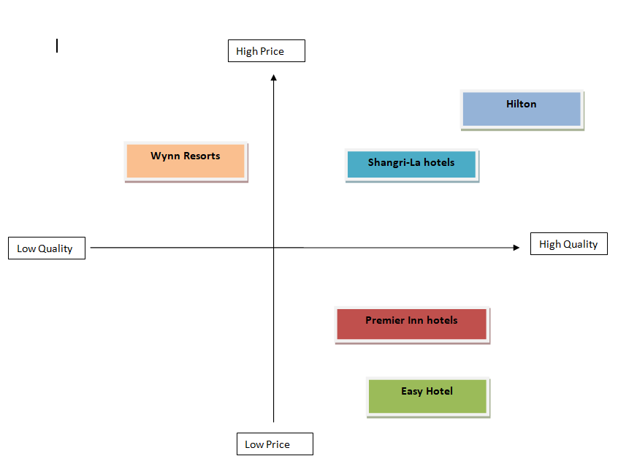
Figure No.1: Positioning
(Source: Created by the Student)
Shangri-La Hotels are positioned on high price and high-quality segment while Premier Inn hotels are positioned on high quality and low-price segment.
Utilization of Theory:
Both hotels utilize different theories to enhance their operations in the hospitality industry of United Kingdom. The administration of Shangri-La Hotels utilizes demand and supply theory to alter their pricing strategy on the market. If demand is high and supply is low, in this scenario, they enhance their prices and vice versa (Jumayeva, 2024). Highlighted on Shangri-La financial report (Shangri-La, 2023) presenting solid occupancy trends in 2023.
On the other hand, the administration of Premier Inn utilizes the pricing theory by targeting value-conscious travelers and setting corresponding low prices. Meaning that Premier Inn can cover its accommodation costs with extensive customer reach through its value-based tariffs to maximize the occupancy level. This strategy is evident in the company’s financial outcomes as Premier Inn consistently generates good operational and financial performance, steady revenue increases and enhanced positioning on economy hotel subsector (Premier Inn, 2023)
Premier Inn is on low price position on Bowman Clock Theory providing economy services while keeping organizational stability. The Bowman Clock Theory states eight different positions that focus on price as well as perceived value that helps the business to gain competitive advantage (Almutairi, 2023). Maintaining cost leadership as strategic positioning, Premier Inn targets value-driven customers and offers affordable prices while offering similar services as the competitors. Using the above strategy, Premier Inn guarantees high occupancy and stable revenues growth to strengthen its positions as budget hotel and meet cost-conscious customer expectations (Premier Inn, 2023). Henceforth, both hotels establish these theories by ensuring that their pricing mechanisms are relevant to the identified markets for better financial returns.

Growth Potential
Premier Inn Hotels: The business has high growth potential in the marketplace of United Kingdom as high demand for budget friendly accommodations from customers. In addition, the expansion strategy of the firm must involve the opening of other hotels and expansion of hospitality rooms available to the public internationally (Shenkar et al., 2021). Currently, there are major opportunities for the development of domestic tourism due to staycations that became popular after Covid-19 pandemic. Furthermore, low-cost model implemented by Premier Inn remains popular through leisure and business travelers, while Premier Inn expands in Germany for growing opportunity (Premier Inn, 2022). However, the potential barriers are related to operational costs, increasing competition from other low-cost hotel franchises, and assessing a consistent service standard as the chain expands.
Shangri-La Hotels: The growth prospects for Shangri-La in the UK are comparatively modest due to their specialization in luxury hotels and comparatively smaller scale. However, there are market opportunities in improving demand of luxury travel due to international travelers and business customers (Conrady et al., 2020). Furthermore, the expansion strategy involves opening new hotels in other strategic locations in UK as well as strategic marketing on specific segment of high-end business travelers resulted from joint ventures or collaborations with corporations for greater customer engagement (Olson et al., 2021). In addition, Shangri-La has powerful brand image, classified as luxury hotel, the brand could use this strength to attract tourists to its UK facility and expand locations around the country. Furthermore, potential barriers for growth process include high costs related to luxury standards, competition from other luxury brands and economic determinants of luxury travel expenditure (Shangri-La, 2023).
Based on market opportunities and threats analysis, Premier Inn has broader opportunities on budget market. However, Shangri-La has opportunities in luxury segment and strategic locations. On same side, both identified an increase in operating costs related to expansion.

Financial Commitment to CSR (Corporate Social Responsibility)
Premier Inn Hotels has shown a strong financial commitment towards CSR in delivering and supporting several charitable causes for society. In the subsequent five years, Premier Inn will invest £20 million towards the “Build it, Beat it" appeal, in partnership with Great Ormond Street Hospital (GOSH) Charity (Premier Inn, 2023). This project involve Children’s Cancer Centre creation with a vision in changing outcomes for kids with cancer and protecting lives. Furthermore, Premier Inn massive financial support offered in the above project highlights the hotel’s commitment to enhance the welfare of children and protection of human life. The commitment has a long-term nature which shows Premier Inn values and the importance of community through Corporate Social Responsibility.
Shangri-La Hotels demonstrates a financial investment towards CSR, however lower than Premier Inn. Through their charitable activities, the company drawn £4 million for “Critically Ill Children” as CSR program, that Shangri-La has embarked in its operation around the world in the pursuit of addressing the plight of vulnerable groups (Shangri-La, 2024). Although the financial amount is lower compared to Premier Inn, Shangri-La focuses on supporting the critically ill children, which corresponds to its luxurious brand values and social responsibility initiatives.
Premier Inn and Shangri-La have common charitable work as CSR initiative that enhance children’s health among other objectives of the businesses.
Despite CSR initiatives presented above for both businesses, the issues of operational management on carbon footprint are present for Shangri-La and Premier Inn. Furthermore, Premier Inn has declared its target of reaching net-zero carbon emission by 2040 (Hospitality Inside, 2024). On the other hand, Shangri-La has intended to bring down its intensity of carbon emission by 15% in 2025 (Global Data, 2024). To improve CSR, both hotels should eminently support the use of renewable energy sources as well as, promoting sustainable practices that would show their progress on environmental sphere.

Recommendation
The recommendations for the businesses are addressed below:
Premier Inn should consider the expenditure on international markets to enhance their customer base and revenue margins. Expanding the business internationally will help in generating higher revenue and remove dependency of domestic market in current growing competition (Shenkar et al., 2021). Although Premier Inn has a current location in Germany that generates better positioning already, by opening new hotels and strategic locations can assist in taking the emerging and shifting European budget hotels market share. Furthermore, this expansion will consequently occur within its established business model which focuses on delivering accessible, value for money accommodation services to business and tourists. Considering the benefits, it has received from its operations in the UK and the continuously increasing market for cheaper travel services, the expansion model of Premier Inn is suitable for the international expenditure.
Shangri-La should improve its digital marketing and consumer engagement tactics to enhance brand recognition in UK luxury hotel market (Urefe et al., 2024). Shangri-La also has a comparatively weaker standing than competitors as low presence in UK market. Furthermore, by introducing personalized discounts, social media initiatives, and advertisements, Shangri-La could attract a higher number of international and business guests (Olson et al., 2021). Focusing on beneficial customer loyalty programs and relationships with corporations could help the business in finding ways to patronize services offered. Examining the current business environment and anticipating demand for luxurious experience among tourists and business travelers, Shangri-La should improve on digital marketing strategies and expand locations around United Kingdom.

Conclusion
The comparison of Premier Inn and Shangri-La Hotels shows that both businesses have individual strategies fitting their positions in the market. Premier Inn has higher revenues and high scale growth in total revenues from being a market leader in the budget hotel market. Meanwhile, Shangri-La with brand positioning classified as luxury brand, experiences slower growth in revenues, however greater opportunity in premium segment. Furthermore, both hotels showed their recognition through common CSR initiatives and willing to reduce carbon footprint. Premier Inn should consider expanding internationally to increase potential growth while Shangri-La could benefit from improving digital marketing strategies and customer engagement efforts. The above tailored approach ensure that each organization, Premier Inn and Shangri-La enhances market position and proceeds to deliver value to its customers.

References
Almutairi, M.M.Q., (2023). The Impact Of Market Analysis On The Company Strategy. Journal of Positive School Psychology, pp.401-412.
Conrady, R., Ruetz, D. and Aeberhard, M., (2020). Luxury Tourism. Market Trends, Changing Paradigms and Best Practices. Editorial: Springer.
Global Data (2024) Shangri-La Asia’s path to emission reduction: Analyzing targets and achievements, Hotel Management Network. Available at: https://www.hotelmanagement-network.com/data-insights/shangri-la-asia-net-zero-targets/ (Accessed: 03 October 2024).
GOV UK (2024) Shangri-La Hotels Pte Limited, GOV.UK. Available at: https://find-and-update.company-information.service.gov.uk/company/01751095 (Accessed: 11 October 2024).
Hospitality Inside (2024) Premier inn: ‘Force for good’ - more than Green Energy, Hotellerie für Insider. Available at: https://hospitalityinside.com/en/Premier-Inn-Force-for-Good-more-than-green-energy#:~:text=The%20hotel%20group%20has%20ambitious,to%20net%20zero%20by%202040. (Accessed: 03 October 2024).
Jumayeva, Z. (2024). THEORY OF SUPPLY AND DEMAND AND ITS MARKET RELATIONSHIP EFFECT. Modern Science and Research, 3(2), 426-432.
Olson, E.M., Olson, K.M., Czaplewski, A.J. and Key, T.M., (2021). Business strategy and the management of digital marketing. Business horizons, 64(2), pp.285-293.
Premier Inn Hotels (2024) The Economic Impact of Premier Inn Hotels. Available at: https://cdn.whitbread.co.uk/media/2023/08/The-Economic-Impact-of-Premier-Inn-hotels_2022-study_final.pdf (Accessed: 4 October 2024).
Premier Inn (2023) FY23 results. Available at: https://cdn.whitbread.co.uk/media/2023/04/Final-FY23-RNS-Final-Combined.pdf (Accessed: 29 September 2024).
Premier Inn(2019) 2019-annual-report-and-accounts.pdf. Available at: https://cdn.whitbread.co.uk/media/2021/02/03114337/2019-annual-report-and-accounts.pdf (Accessed: 03 October 2024).
Premier Inn (2021) Annual report and accounts 2020/21. Available at: https://cdn.whitbread.co.uk/media/2021/05/05141427/23076_Whitbread_AR2020_web.pdf (Accessed: 09 October 2024).
Premier Inn (2023) We’re a Force for Good - Premier Inn, Force for Good | Premier Inn. Available at: https://www.premierinn.com/gb/en/why/force-for good.html#:~:text=Over%20the%20next%20five%20years,care%20and%20save%20more%20lives. (Accessed: 29 September 2024).
Premier Inn (2024) Premier Inn Hotels: Book Direct, Premier Inn hotels | Book direct. Available at: https://www.premierinn.com/gb/en/home.html (Accessed: 29 September 2024).
Premier Inn (2024) Our Pledge to reach net zero carbon emissions ten years early. Available at: https://www.premierinn.com/gb/en/news/2021/net-zero-carbon-emissions.html (Accessed: 6 October 2024).
Premier Inn (2024) Supporting Great Ormond Hospital, Children’s Charity. Available at: https://www.premierinn.com/gb/en/why/gosh-childrens-charity.html (Accessed: 8 October 2024).
Shangri-La (2024) About Us. Available at: https://www.shangri-la.com/london/shangrila/about/ (Accessed: 11 October 2024)
Shangri-La (2023) Annual Report 2023 - Sitecore - Shangri-La Hotels and Resorts. Available at: https://sitecore-cd.shangri-la.com/-/media/Project/Shangri-La-Group/Investor/Files/Public-Disclosures/Latest-Top-Publications/2023_Annual_Report_E.pdf (Accessed: 5 October 2024).
Shangri-La (2024) Corporate Social Responsability, Shangri-La. Available at: https://www.shangri-la.com/kualalumpur/shangrila/about/corporate-social-responsibility/ (Accessed: 9 October 2024).
Shangri-La (2019) Annual report 2019 - Shangri-La hotel. Available at: https://sitecore-cd.shangri-la.com/-/media/Project/Shangri-La-Group/Investor/Files/Public-Disclosures/Financial-Information/Financial-Reports/2019Annual-Report-Eng.pdf (Accessed: 03 October 2024).
Shangri-La (2021) Annual report 2021 - Sitecore - Shangri-La hotel. Available at: https://sitecore-cd.shangri-la.com/-/media/Project/Shangri-La-Group/Investor/Files/Public-Disclosures/Latest-Top-Publications/2021_Annual-Report_E.pdf (Accessed: 09 October 2024).
Shangri-La (2024) Corporate social responsability. Available at: https://www.shangri-la.com/kualalumpur/shangrila/about/corporate-social-responsibility/ (Accessed: 7 October 2024)
Shangri-La(2024) Environmental and Social Governance. Available at : https://www.shangrilaexperiences.com/community-and-social-impact (Accessed: 6 October 2024).
Shangri-La (2024) Luxury escape at best rate: Shangri-La Hotels and Resorts, Shangri. Available at: https://www.shangri-la.com/ (Accessed: 29 September 2024).
Shangri-La (2024) Pioneers of Asian Hospitality. Available at: https://www.shangri-la.com/group/our-story/ (Accessed: 7 October 2024).
Shenkar, O., Luo, Y. and Chi, T., (2021). International business. Routledge.
Statista (2024) Hotel Industry Market Size UK 2023, Statista. Available at: https://www.statista.com/statistics/1364712/hotel-industry-market-size-uk/#:~:text=In%202023%2C%20the%20market%20size,of%2016.42%20billion%20British%20pounds. (Accessed: 12 October 2024).
Urefe, O., Odonkor, T.N., Obeng, S. and Biney, E., (2024). Innovative strategic marketing practices to propel small business development and competitiveness. Magna Scientia Advanced Research and Reviews, 11(2), pp.278-296.

Appendix
Shangri-La Hotels
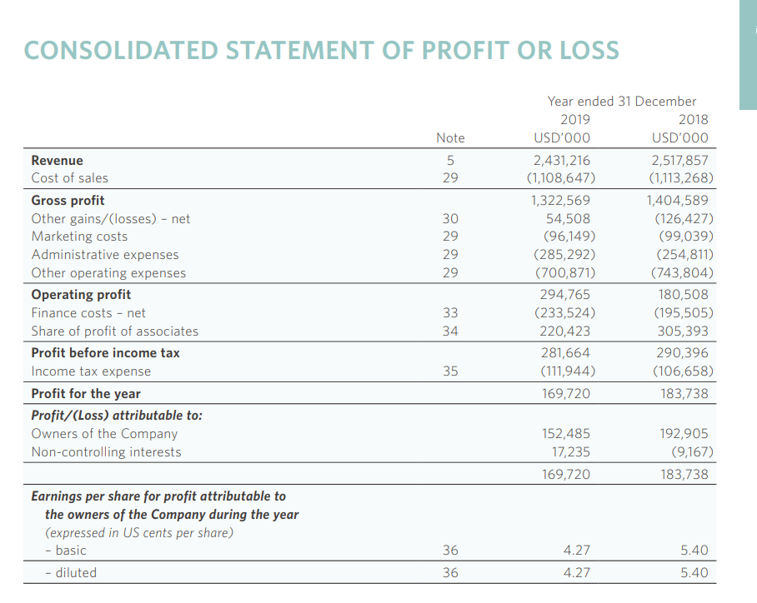
Figure 1: Income statement
(Source: Shangri-La, 2019)

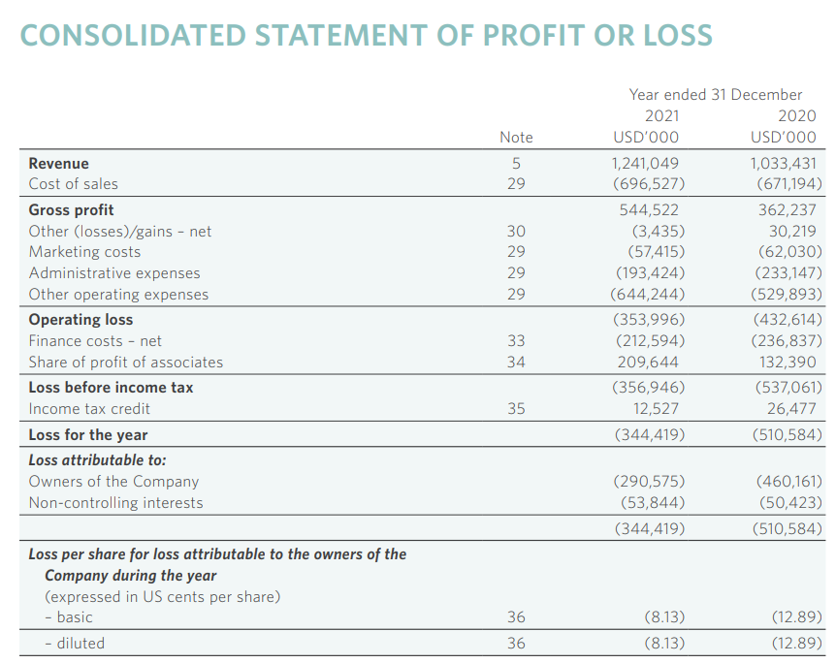
Figure 2: Income statement
(Source: Shangri-La, 2021)
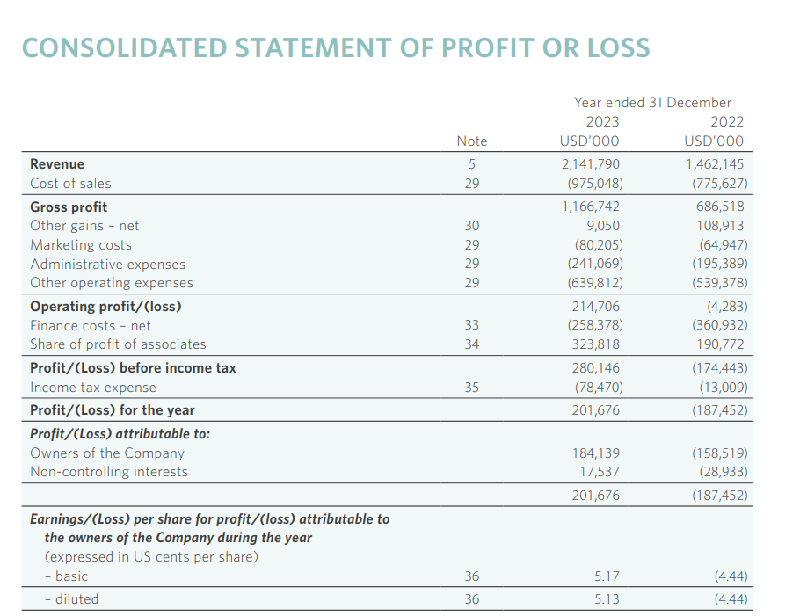
Figure 3: Income statement
(Source: Shangri-La, 2023)

Premier Inn
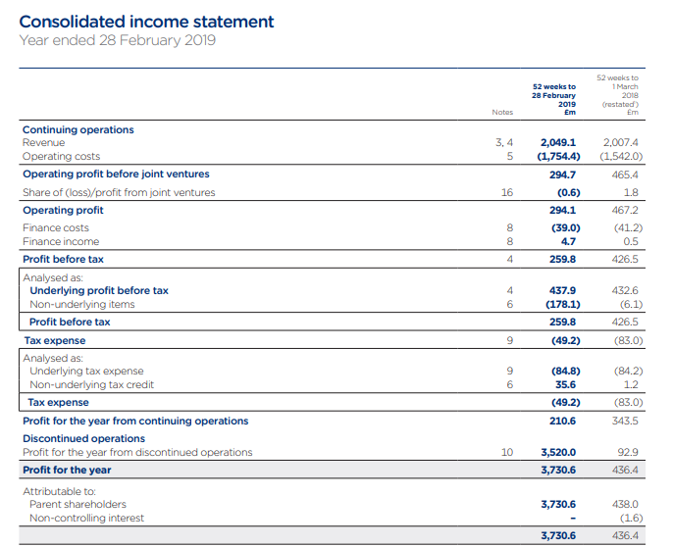
Figure 4: Income statement
(Source: Premier Inn, 2019)

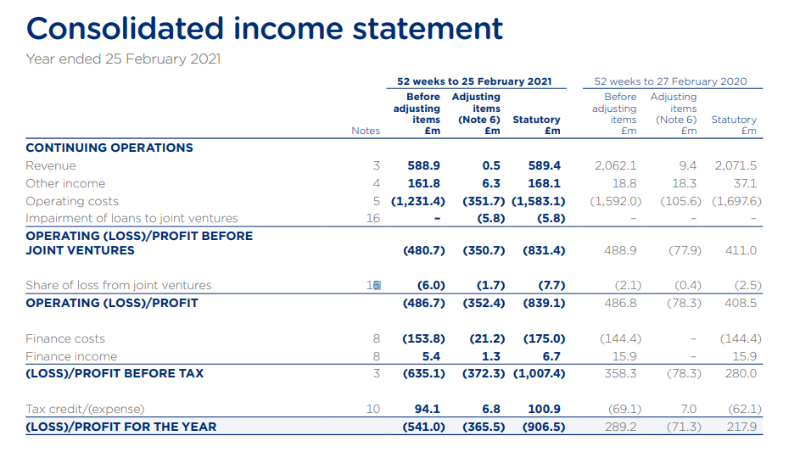
Figure 6: Income statement
(Source: Premier Inn, 2021)
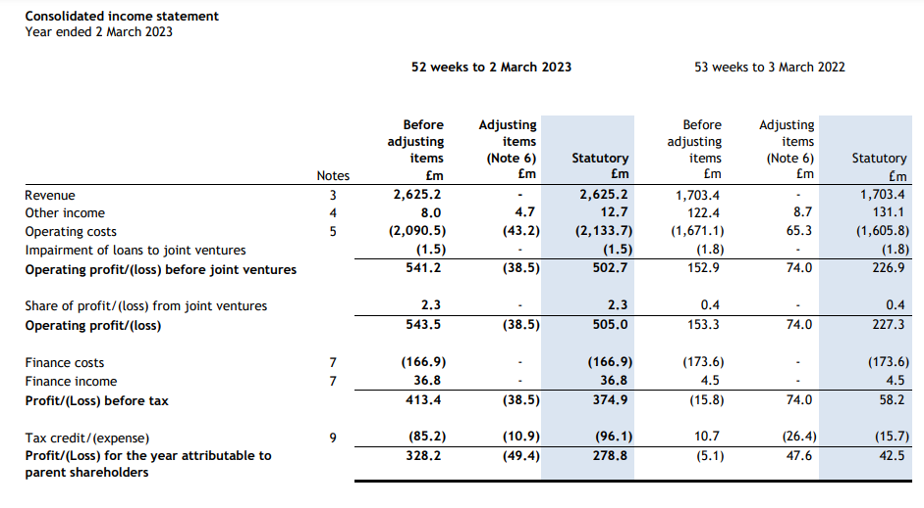
Figure 7: Income statement
(Source: Premier Inn, 2023)

