Effective Team Working and Communication
BMSW4002

EFFECTIVE COMMUNICATION SKILLS – SOURCE OF INTERPRETING MESSAGE BETWEEN INDIVIDUALS

Student’s name: Vesela Basheva
Student’s ID: 1913742
Lecturer’s name: Akinseye Aluko

Executive Summary
The report in regards to the studies conducted on communication skills. Teamwork and outstanding communication techniques build entire efforts together with effective outcomes. It has been briefly discussed effective teamwork together will increase team efficiency by means of activities and events to promote growth in an organization.

Table of Contents
Introduction 4
Discussion 4
Definition 4
Different types of communication skills 4
Berlo's 5
Shannon 7
Relationship between effective teamwork and communication: 10
Conclusion 11
Reference 12

Introduction
Initially, the main discussion is based on the activities and theories done in-class sessions to enhance good communication skills in the learners. An individual required to adapt and utilize essential skills in every field. The transmission of words between individuals will equip the learner to differentiate the entire message transformation based on the vocal tone, gesture, body language, eye contact, and others. It was explained and discussed how; to and fro flow of words will affect the whole environment of the workplace. The point of interactions between each employee will play an immense role in the overall productivity of the organization. Communication skills are not only the synchronized work environment but also removes the mess and confusion in work stations for making a healthy fruitful environment in every organization (Cho, 2015). It is advised by every company that while recruiting a new candidate in the organization one should have efficient communication skills so that it will never hamper the company’s growth and development. Adding a person with good communication skills in an organization will work as a catalyst between team members, co-workers, and official's with a positive productive attitude for the whole organization (Al-Tokhais, 2016).

Discussion

Definition
Communication as the word depicts common to all – It is a skill which is required for every individual to explain his thought process and emotions in the physical expressive form so that it can be understood by everyone, it may be in any language depends upon the location and ethics Greene, 2016). Efficient communication skills are the basic need of the organization for the mutual benefit of the individual as well as for organization growth.

Different types of communication skills
Verbal Skills –Use of Vocal Cord: In this form of communication individual uses air pressure in his vocal cords to interpret his message into audible form. The relationship between listener and speaker belongs to this form of communication in between. This type of communication is highly user friendly between individuals addressing several persons in a single interval of the time slot.
Non-verbal Skills: Also one of the important types of communication introducing the personality of a person with body language, eye contact, gestures, hand movements, facial expressions without sounds. A smiling face, sadly gestures, the flair of excitement in someone's expressions show the non-verbal communication skills supporting overall communication between individuals.
Written Skills- Another type of communication skill especially supports professionalism in an organization while writing emails, chat process, text message. It also helps people to communicate while doing paperwork or e paperwork. In this global era of digital development, maximum communication is done by written skills worldwide. Everyone is using this medium of communication skills by writing text, chit chat in social media.
Visual Skills – It is also another essential type of communication skill that supports entire communication between individuals. Good relationships build by effective visual expressions. Visual communication sometimes leads to misunderstanding by the observer which can cause problems in the entire conversation.

Berlo's
The skills of effective communication learning include crucial factors that deal with so many important aspects to maintain a stable or equivalent level of communication between communicators. According to Berlo’s Model effective communication or the interconversion of information will only take place when there is an equal level of participation by two or more partiers during communication. This effective model relates that the conversation can be considered when there is equal participation between two parties or we can say that communication takes place on an equal level between two or parties. Focusing on the following statement, the theory of Berlo's depicts that effective communication act as a showcase in the whole phenomenon as a whole (Orejudoet al., 2017). In other words, we can say that sender required to concentrate on the elements, practical learning skills that are being delivered in the communication to identify and understand the aspects of the sender. For example - The coefficient of communication skills or communication will be effectively delivered when a message is stable and equally responded by the receiver end, we can also add that communicated message by sender ends only if the source of information or received message will be replied or acted by listener end. Now studies also illustrate,by expanding the basic example of a relationship in the workplace. According to Berlow's model, effective communications consist of the source or sender through which numbers of messages are transported till receivers end. So it’s finally concluded that the sender along with the receiver must the same type of criteria for the flow of information between each other, which includes communication skills, attitude, culture, interaction, social system, knowledge, and teachings (Paufler, 2019). The message is defined as a piece of information conveyed to the receiver by a meaningful sequence of words. Hence to understand and identify the flow of communication between receiver and sender will depend on the factorization of the message which includes coding, decoding, structural explanation, elemental concepts, and contents. Biological organs and senses also play an essential role in depicting messages such as hearing, seeing, touching, tasting, smelling, and finally mental understanding. As a part of an organization, one needs to understand the entire elements of information and need to a breakdown in understandable nimble pieces so that the entire communication is analyzed and acted upon fully. The breakdown information into simple understandable sentences will help everyone to understand the concept fully which would we beneficial for organizational and personal growth. In another manner, the theory illustrates that communication elements must be simplified further in natural ways. The simplification of information will finally help varieties of people, cultures, and societies to operate massive information in productive acts and tasks. For the smooth working of an organized exchange of information must be understood by everyone irrespective of caste, culture, religion, human races. Hence, Berlo's theory supports the atmosphere and work culture of every organization with effective positive outcomes (KOIZUMI 2017).
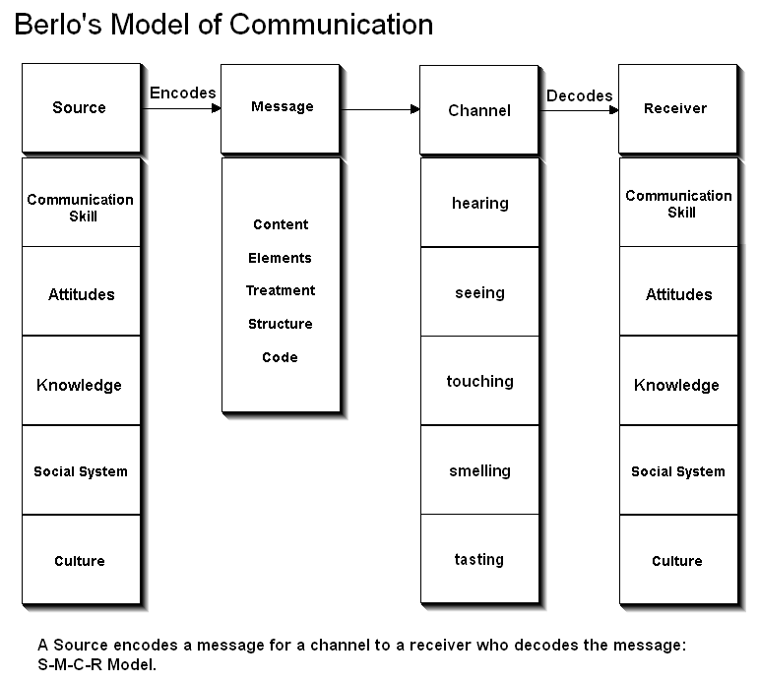

Figure: Berlo’s Model of Communication
(Source: KOIZUMI, 2017)

Shannon
Technically this viral coded formula differentiates number employees who are worked with computing techniques and also used many ways to visualize the speed of the internet as well as data connectivity. Which is in our case is 30 kbps as C=3000*log2 (1001). As per Shannon's theory, formularize also helpful for the satellite TV channel ‘sat their maximum capacity. If S/N ratio is 20 DB on TVchannelsand 10 MHz is the video bandwidth the formula states that C=10000000*log2 (101), then the total value calculated is of maximum capacity is 66 Mbps. Technically this formula explains the relationship between bandwidth and S/N ratio (S/N- Signal to Noise ratio). As per the discussed theorem, it is considered that C=B*log2(1+S/N). In this equation 'C' as channel capacity, 'B' as bandwidth, 'S' represents as the average power of a signal, and 'N&#39; act as average noise power. The signal to noise ration expressed in decibels ( called a unit of hearing).In a clear signal always noise ratio is minimum to convey proper message channel in the entire mode of communication. This theory can be used in the modem or medium to transfer. For example for the audio signal in the telephonic line formula plays a vital role to get the maximum value of channel capacity. This 'Shannon'model, set of formulas ensures and helps us to obtain the maximum capacity of different electronic equipment and devices efficiency. In this study, it was included that the permissible role of equipment and devices such as satellite TV, modem, should not be exceeded from their maximum values to maintain their original noise level. By using Shannon formulas, equipment, and devices have been tested till showing a maximum capacity to users which do exceed (Yockey 2000). Shannon's method proved beneficial theorem by giving central idea or concept in digital and IT sectors for their primary framework and R & D purposes.
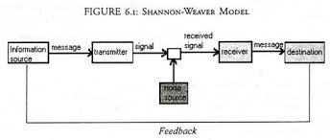
Figure: Shannon-Weaver Model
(Source: Yockey,2000 )

The model of Schramm: Schramm = Define and explain. Now relate to you and give examples based on your workplace.
This model highlights the methods of encoding/decoding so that information process flows completed from sender to receiver. It includes identification of information along with an understanding of the message. Similarly to Berlo's model of communication along with a fascinated elemental model of Schramm showing the same platform of experimental hypothetical factors. Schramm's model defines that encoding decoding factors are playing an essential role to understand the whole necessary information sender-receiver relationship to make a piece of information more efficient and effective in entire communication. Within an interface, if the information is not organized or structured carefully the receiver will not able to understand it effectively. Overall the factorization of effective communication between two or more individuals can be marked with the help of quality of delivering of the information from the sender to the receiver which includes sending of the message, identification, and decoding by receiver end. In another word, we can conclude that encoding /decoding are the major factors for transforming information as objected in this theory (Koshida 2019). Based on the following technical approaches it is demonstrated well that understanding elements along with encoding/decoding plays a major part in channelizing communication between parties.

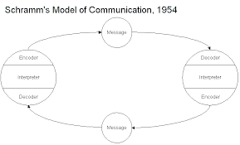
Figure: Schramm’s Model of Communication, 1954
(Source: Koshida, 2019)

Relationship between effective teamwork and communication:
Teamwork and Communications skills prove a significant productive framework in an organization, both are co-related to each other in the professional and domestic world.
Efficient team building along with effective communication skills builds the organization pillars of success. Teamwork not only conquers winning abilities in individuals but also promotes unity among the entire organization. For active team-building entire team members required to better understand each other. The practice of knowing each appetite in between teammates will help the entire team to work together with maximum outcomes by using behavioral, knowledge, and leanings. Team means everyone's efforts, not a single person involved but all work together to build and promote efficient culture. Learning and training of individual teammates in the entire work slot promote wealth and prosperity all around along with the growth and development of the organization.
We can take the example of various team players to support our analysis, every team defeats another team based on good teamwork with fully organized communication channels between them, training of every teammate required time to time to sharpen the key skill of and individual. Team building activities are supposed to be not only technically sound but also enjoyable. The teamwork is also supported by many scholars, well said that playing football is better than reading Holly Bible. It shows that humans should work on their characteristics by practically indulging in the team physically, behaviorally, and mentally. Ineffective team building all experience positive aspects overall by switching off bad experiences to achieve the entire goal. Besides team building promotes not only the willingness to win but it also develops a sense of humanity between each other. Moreover finally if someone develops good team-building etiquettes in him or herself he or she will be the best-mutated version of his personality. On behalf of humanity teammates also aware how to support or cherish their partners at the time of support and excitement of winnings,
The best part to build team spirit is to inculcate good communication skills with coordination to achieve goals. Communications help us to plan and take decisions according to the situation by knowledge sharing and impartment. Finally, we can add that effective communication is working as an efficient tool by forming a building block for organization success and achievement.

Conclusion
As per report and analysis performance is ensured in an organization by every employee by building an efficient team. Each team member is required to build a fruitful positive bond among themselves with pure heart and beliefs. On daily basis to build organizational culture one should be optimistic with his teammates for a better understanding of his department or internal issues so that the entire team will be productive to the whole organization will be able to focus for future goals whereas communication skills work as fuel for entire work process flow.
We hope based on the following studies readers understand the necessity of communication skills with teambuilding which will overall impart a clear picture of growth and development for an organization.

Reference
Al-Tokhais, A., 2016. The relationship between communication effectiveness and multicultural employees’ job outcomes (Doctoral dissertation, Kent State University).
Cho, I.Y., 2015. The relationship of communication skill, communication self-efficacy and communication related educational needs. Journal of the Korea Academia-Industrial cooperation Society, 16(4), pp.2593-2601.
Greene, J.O., 2016. Communication skill and competence. In Oxford Research Encyclopedia of Communication.
KOIZUMI, Y., 2017. The Poetics of Sympathy in Joel Barlow’s Epic: A Paradoxical Reading of The Columbiad (1807). The Journal of the American Literature Society of Japan, 2017(16), pp.5-24.
Koshida, S., 2019. Schramm–Loewner-evolution-type growth processes corresponding to Wess–Zumino–Witten theories. Letters in Mathematical Physics, 109(6), pp.1397-1413.
Orejudo, S., Zarza-Alzugaray, F.J., Casanova, O., Rodríguez-Ledo, C. and Mazas, B., 2017. The relation of music performance anxiety (MPA) to optimism, self-efficacy, and sensitivity to reward and punishment: Testing Barlow’s theory of personal vulnerability on a sample of Spanish music students. Psychology of Music, 45(4), pp.570-583.
Paufler, P., 2019. William Barlow’s early publications in the ‘Zeitschrift für Krystallographie und Mineralogie’and their influence on crystal structure research. Zeitschrift für Kristallographie-Crystalline Materials, 234(11-12), pp.769-785.
Yockey, H.P., 2000. Origin of life on earth and Shannon's theory of communication. Computers & Chemistry, 24(1), pp.105-123.

