Cerys Versey (2217178)
[Company name] [Company address]
Critical Evaluation of Braun’s Multiplier and Wallace Tree Multiplier Using VHDL

Introduction
Binary numbers underpin almost all electronics from simple logic gates to complex programmable gate arrays. However, without the use of operators such as plus, minus, divide and multiply ( + - ÷ x) the use of binary numbers is extremely limited. The use of such operators allows for greater complexity of calculations allowing for a far greater use of binary in electronics as a whole. With the use of such operators allowing for the creation of Field programmable gate arrays (FPGA’s) that allow the user to configure hardware using software [1]. These operators allow users to complete seemingly simple calculations such as addition in much quicker time periods than previously possible. The advantages are vast and clear to see with the use of binary multipliers exploding over the last few years. This has meant leaps have been made in there development focusing on reduced cost and increased speeds [2].
Multiplication is a particularly key operation in DSP and is conducted using binary multipliers. Multiplier architecture can affect the overall speed at which computational problems can be solved making them cruxes of digital signal processing [3] .Binary multipliers are comprised of full and half adders which pass the value between them to conduct the operation. In the following report two types of multipliers will be focused on Braun’s and Wallace with a surface level review of others such as Booth and column bypass to help enhance the readers understanding of the challenge of multipliers in VHDL.
Back ground research
Binary multipliers are comprised of combinational logic systems which allow the performance of arithmetic operations such as multiplication [4]. Multipliers are used in a range of applications from calculations to computers although predominately used in signal processing tasks. The original binary multiplier was created during the late 1960’s by Arthur Alec Robinson[5]. This initial ground work lead to a series of further developments that ultimately lead to the modern binary multipliers that are present today. There are a variety of different multipliers such as column bypass, modified booth, Baugh Wooley, Bruan and Wallace tree multipliers. Each with there own drawbacks and benefits.
One such type is Column bypass [6] these are specifically designed to be power saving. Its design focuses on turning on or off different parts of the multiplier architecture to save power. The system inserts extra zeros into the input values therefore reducing the overall number of switching required hence reducing the amount of power used. This is done by looking at the input coefficient if it is a zero the adders associated with it simply aren’t turned off.
A booth multiplier is designed to be most similar to that used in traditional maths. It looks at the current bit and previous bit to plan what to do next [7]. Modified booth multipliers take the same principles as the original booth multiplier but reduces the number of partial products this is done by using a look up table. Booth multipliers are often chosen for its straightforward design, ease of scaling and its ability to decrease the number of addition and subtraction required [8].

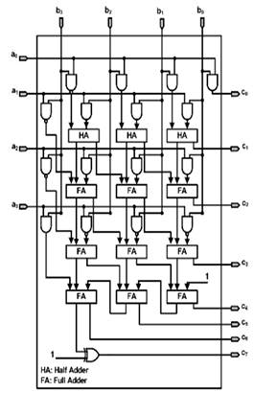
Figure 1 - Baugh Wooley diagram
A baugh wooley multiplier is a multiplier designed specifically for high speed. It is a parallel multiplier that is designed to use fewer adders and more iterative steps than other multipliers [9]. By reducing the number of adders it reduces its critical path delay. Critical path delay is the combinational path delay between the input and output and can also be considered as the maximum delay in the multiplier [10].
Bruan and Wallace
Braun’s and Wallace are both parallel multipliers, this means they both use combinational logic circuits without the need for a feedback loop [11]. Both multipliers output the same answers however they perform different sequences of calculations and have different architectures.
Wallace tree multipliers use a mix of partial sum adders also known as half adders and carry save adders known as full adders to complete its calculations. Wallace tree multipliers get there name from the way in which the adders can be arranged to look like a tree [12]. Wallace tree multiplier design is focused on speed however this can mean that it uses more power than similar binary multipliers.
There are many adaptations of Wallace multiplier such as modified Wallace tree which focuses on reduced area and Booth-Wallace which focuses on reduced area and time.
Bruan multipliers also know as carry array multiplier is one of the simplest design of all binary multipliers. The multiplier design doesn’t require any logic registers however the required number of adders increases substantially with the number of bits present in the calculation. This can lead to large numbers of multipliers when there is a large number of bits which can subsequently lead to high power consumption. Bruan multipliers use a parallel processing scheme allowing for use in signed and unsigned operations. There are many types of Bruan multipliers which focus on different attributes such as low power Bruan [13].
Inconclusion the drawback of the Wallace tree multiplier is its high-power than other designs but often also faster. The drawbacks to the Braun multiplier is the large space it can take on the board due to the large number of components but it does benefit from a simplistic scalable design.

Flowchart
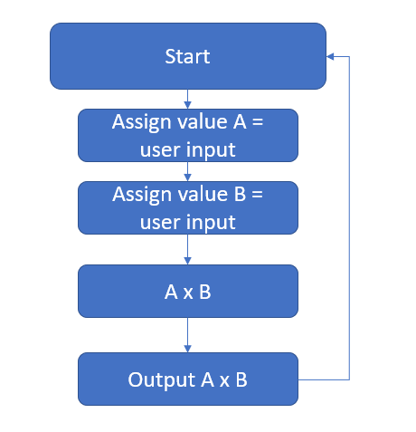
Figure 2 - multiplier flowchart
One of the most effective ways to understand the process of the multipliers is to look at the way in which they process calculations. Below is the step by step process for both a 8x8 Brauns and Wallace multiplier.
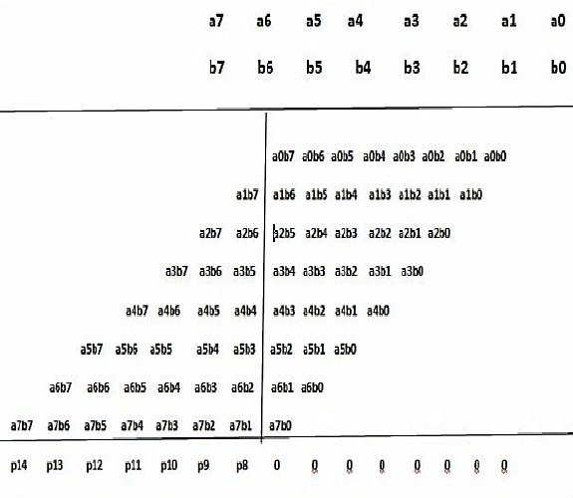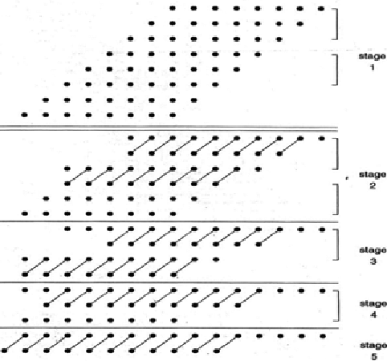
Figure 3 – Wallace architecture
Figure 4 - Bruan architecture

As can be seen from the above diagrams despite both multipliers producing the same numerical results the process in which they draw that conclusion is rather different this is to the way in which the connections are designed.
Design process
To design code for both the Wallace and Braun multiplier diagrams were used this allowed for confirmation of variables and structure of each multiplier. The multiplier diagrams shows each full and half adder and the branches that connect them together. Full adders and half adders are the fundamental building blocks of all binary multipliers. A full adder is comprised of three inputs A, B and Carry in (C In) with two out puts Sum (S) and Carry out (C out) . Where as half adders have only two inputs A and B and two outputs Sum (S) and Carry (C). As half adders only have two inputs they are commonly used at the start of a multiple architecture so can simply take in the Binary value inputs without the need to read in a carry value too.
Multiplier block diagram braun – Structure of Braun

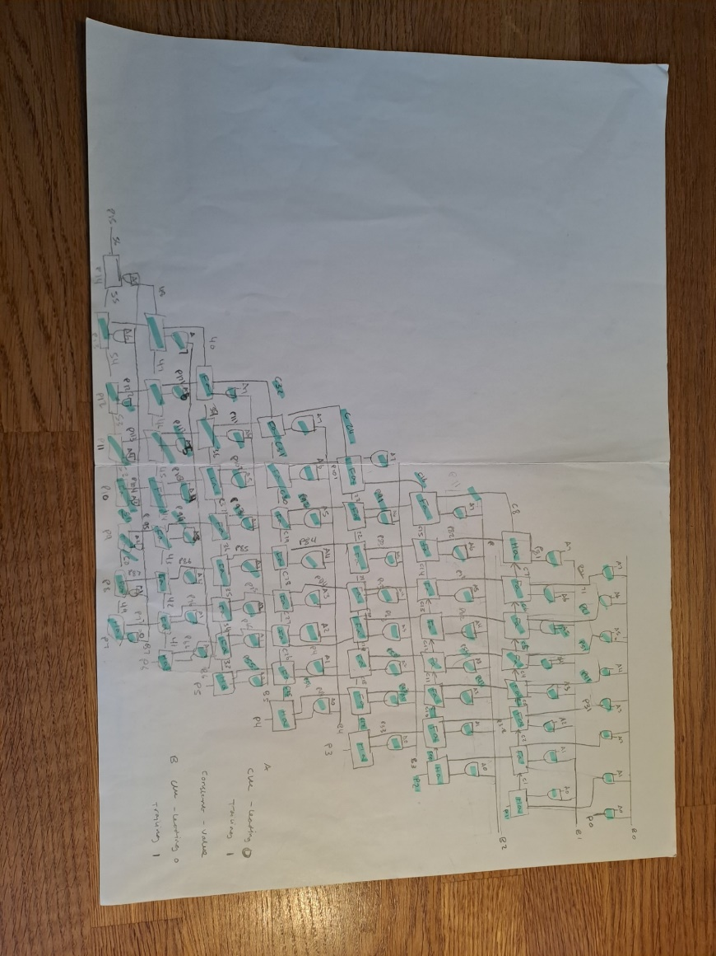
Figure 5 - Bruan Block diagram
Multiplier block diagram Wallace – Structure of Wallace
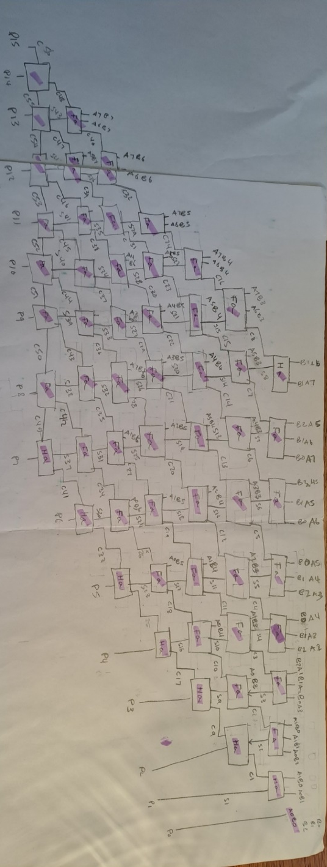
Figure 6 - wallace block diagram
As can be seen from the two above block diagrams
Block diagrams were first initially draw out on paper then coded in Vivado, it is a software specifically designed for coding of FPGA’s and allows the user to code in VHDL. It allows for the user to analyse key features of FPGA such as power usage, board layout, circuit diagrams and timings constraints present in the design. The user could choose to use a third intermediate software such as Simulink to recreate the diagram and then use the built in tool boxes to create the VHDL code.
Methodologies of design
To be able to turn the diagram into VHDL code each part of the circuit was carefully considered and broken down. By doing the same iterative process no section was missed.
For both multipliers the first action was to create the constraint files for both the Full and Half adder. To do this both the input and output were created and assigned. The Boolean expression comes from the gates used to create the Half and Full adder truth tables.
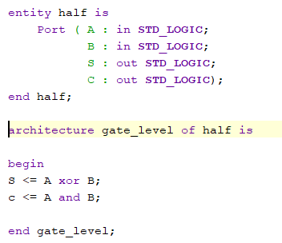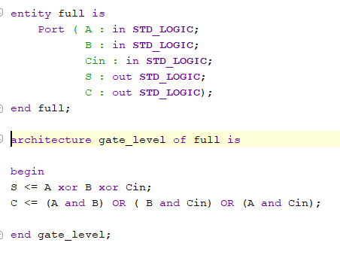
Figure 7 - full adder code
Figure 8 - Half adder code

Once the constraint files were created the entity file was created. For both Wallace and Bruan the entity files sets up the inputs A B and the output P. Once the entity is created the various variables need to be created the variables are pulled from the calculations that happen in each step.
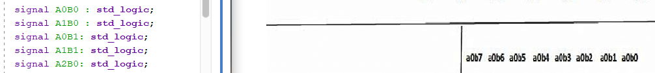
Figure 9 - Assigning variables
One all the variables are created they need to have values assigned to them to create each step of the calculations this is done by using the And gates in each step.
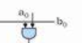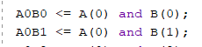
Figure 10 - And gate assignment
Once each of And gate variables are assigned the Full and half adders were created. For the Wallace multiplier it was spit into different rows where as the Braun multiplier was split into different columns this allowed for simple checking and problem solving as rather than having to re-review the whole design the user can simply check the relevant row or column. Once this was done the entity could be closed.
Once the code was created it was tested thoroughly by running a series of numbers through to confirm its operation.
Initially 00, 11,FF were run through both of the multipliers to confirm they work. Each value was re-ran a number of times thoroughly test each multiplier. By using the logic diagram you can see the logic in each section of the multiplier for trouble shooting.
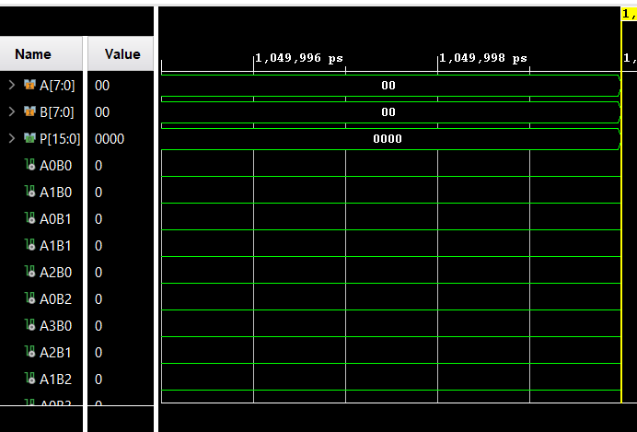
Figure 11 - Wallace mutiplier with input 00
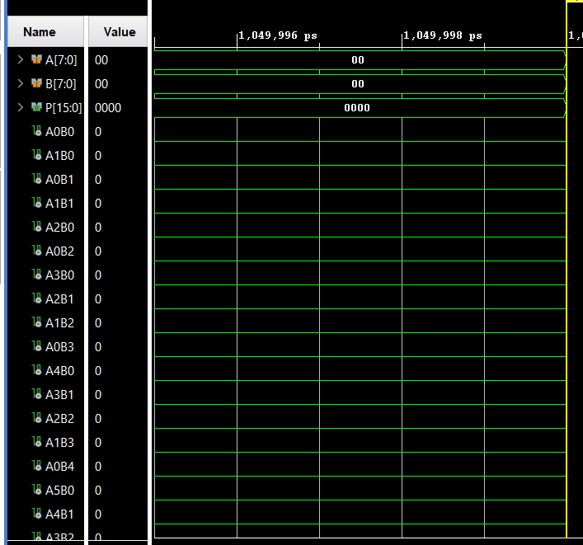
Figure 12 - Bruans input 00x00 output 0000
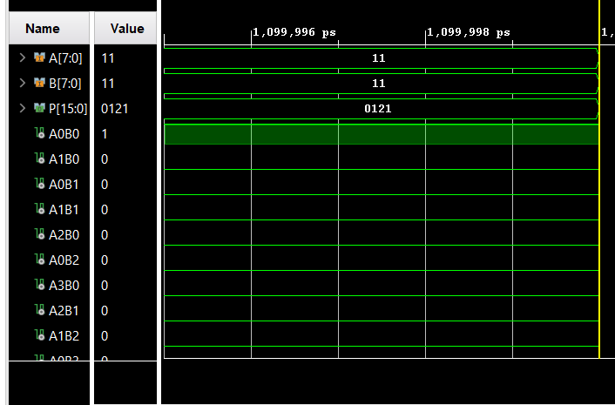
Figure 13 - Wallace Input 11 Output 121
Once the multipliers were confirmed to work the code was implemented onto the basys 3 FPGA. The Basys 3 is a training board based on the Artix-7 FPGA specifically designed for educational with its low cost and multiple different connection points it is the perfect educational tool [14]. The physical board was tested against the same set of variables that the software version was. The initial input was FF x FF which in binary equivalent is 11111111 x 1111111 or in this case all switches high. The output in Hexadecimal is FE01 or 1111111000000001 which as can be seen in the figure below is the correct output.
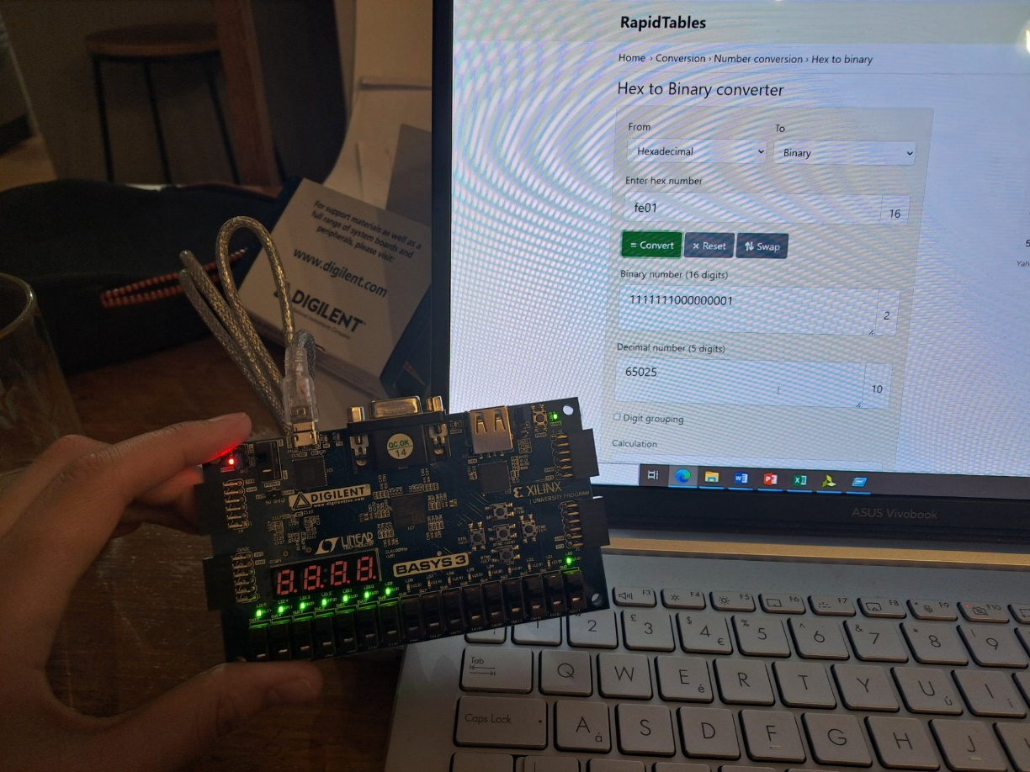
Figure 14 - FPGA Showing output
Another test was ran using AA X AA as inputs which is equivalent to 1010101010101010 the output is equivalent to 70E4 or 0111000011100100.
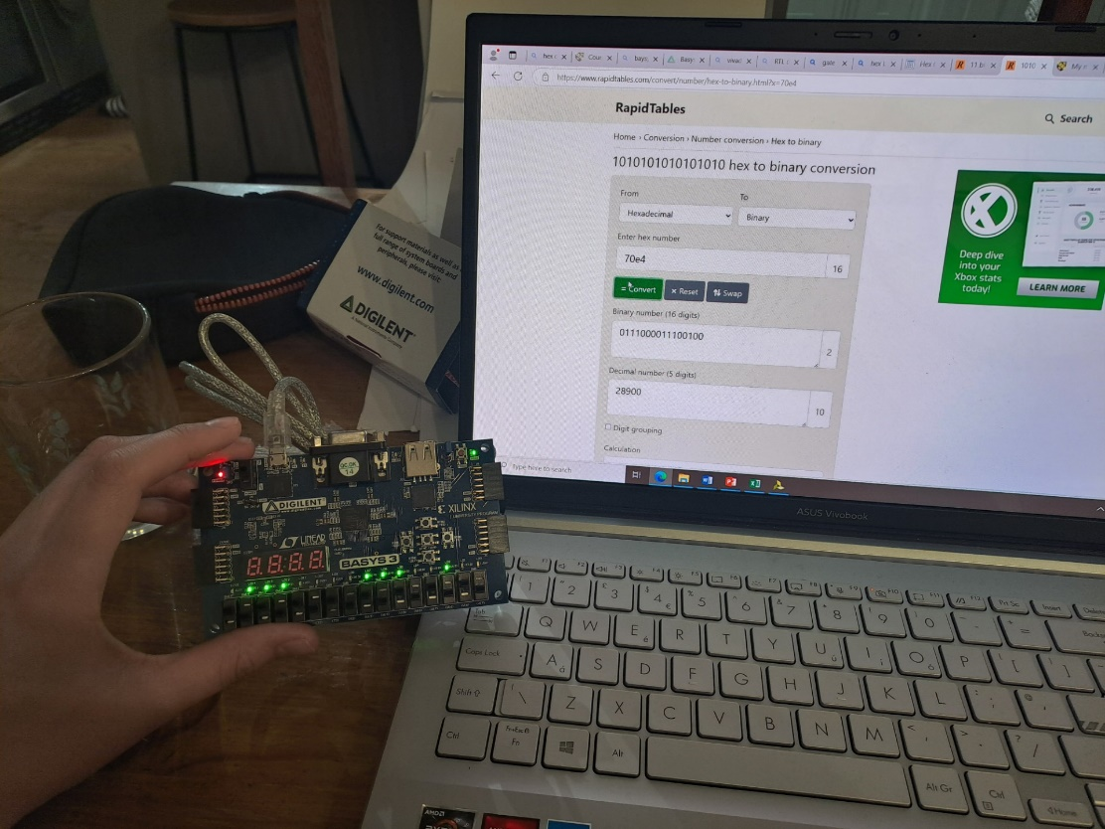
Figure 15 - FPGA with physical output
This was done with both the Bruan and Wallace architecture.
To program the code there is a number of steps that must be completed. Firstly the user should setup there Vivaldo programme to use the Artix-7 base. The specific reference file will depend on the FPGA used this can be found in the data sheet or how to guide for the FPGA. Once this is done the user should simulate the code and test it full works as has been done above. Once this is done the user must run synthesis. Synthesis is important for implementation as it turns the RTL design ( A digital signal representation of the design) to a gate level netlist ( A gate level connection list, including component and gates) .
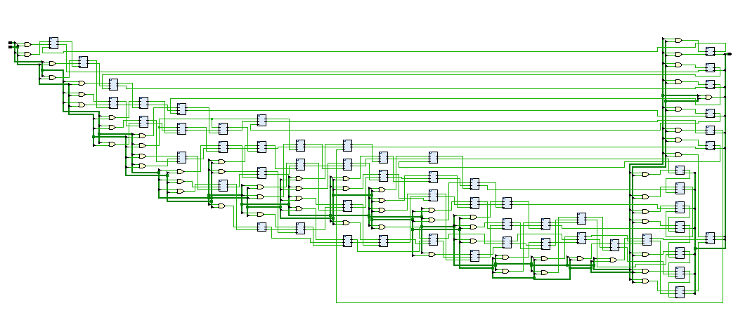
Figure 16 - Bruan RTL Design

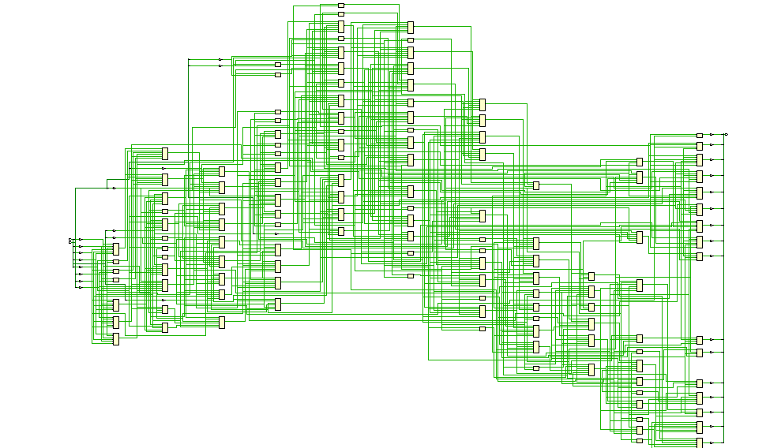
Figure 17 – Bruan implementation schematic Design
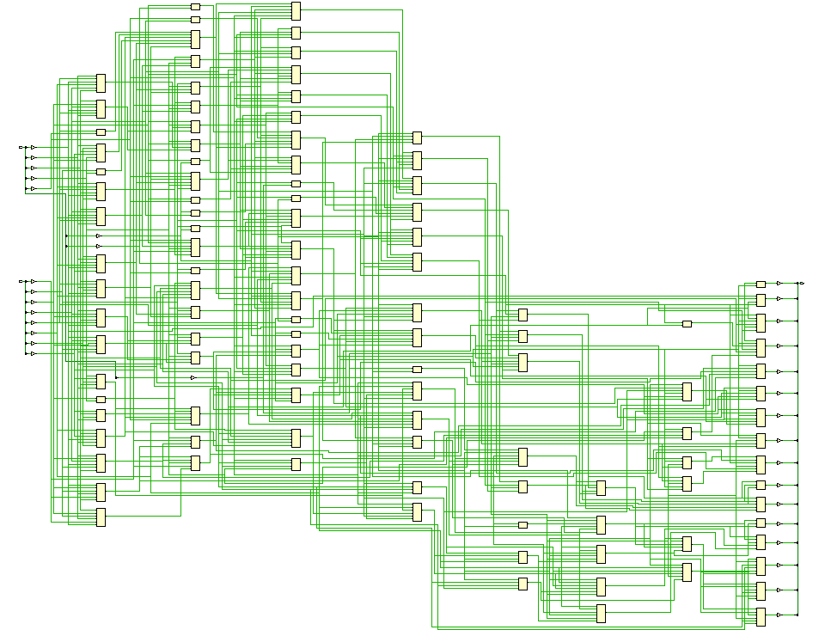
Figure 18 – Wallace implementation schematic
Once the synthesis is run the use must assign the pins the pins that need setting will be subject to the choice of FPGA the required pins can be found on the datasheet.
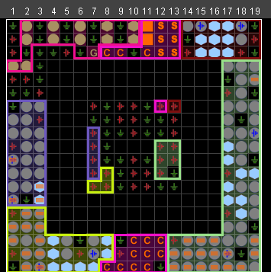
Figure 19 - Bruan I O planning
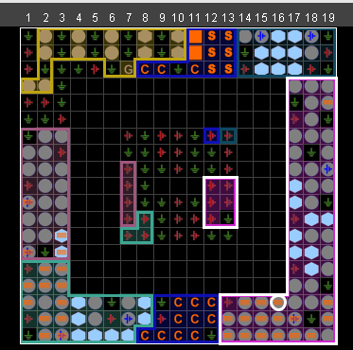
Figure 20 - Wallace IO Planning
Once the synthesis is ran the device picture can be found this is where the layout of various paths sit within your FPGA.
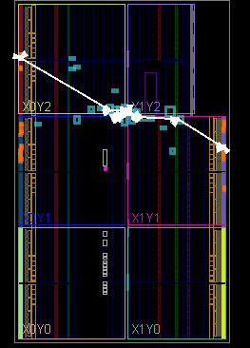
Figure 21 - Bruans device photo
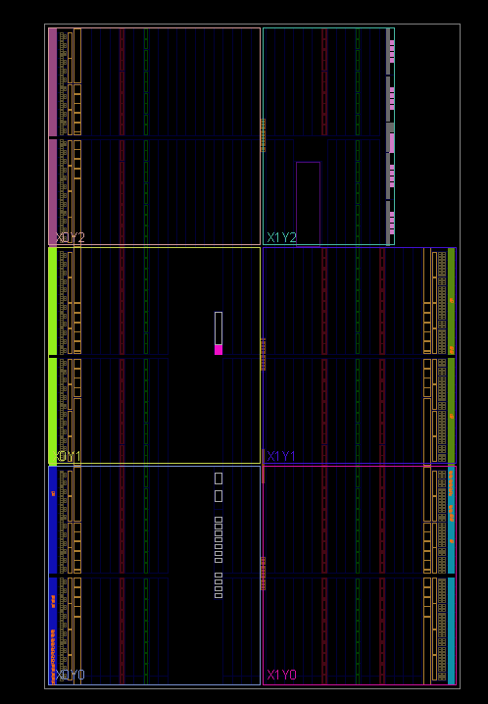
Figure 22 - Wallace device
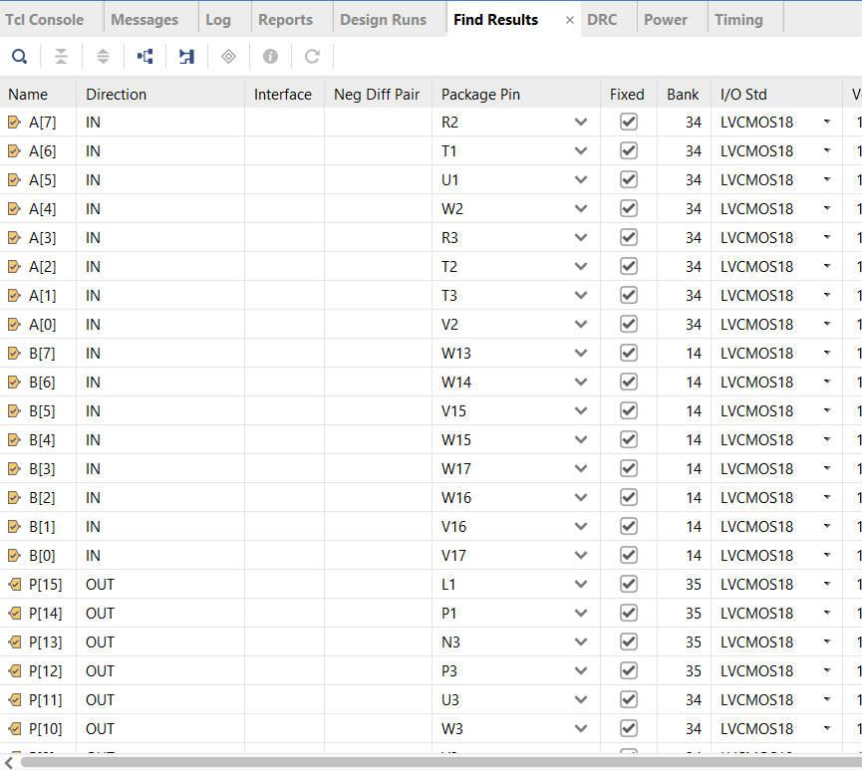
Figure 23 - Pin assignment

Once the pins have been sent implementation needs to be ran this is the programme that sets the pins you have assigned. Once this is done the user simply needs to generate the bit stream and then program the FPGA.
Different multiplier architectures have different key attributes. Some multipliers focus on power saving whereas others focus on timing. These key attributes can be critically analysed using Xylinx’s Vivado software.
One key aspect of FPGA design is timing. The time it takes for operations to execute can massively affect the overall output. As discussed above designers have spent years working out the best way to reduce the time that FPGA’s take to execute. Similar analysis can be done with the tools available in Vivado.
To help the reader better understand the benefits and draw backs of both the Bruans and Wallace tree multipliers timing, power and utilisation analysis were conducted on both. 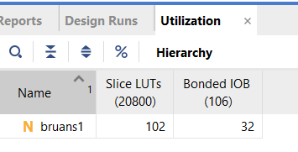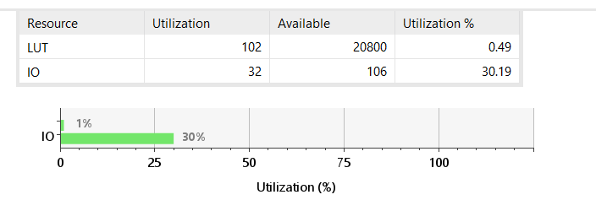
Figure 24 - Bruan utilisation
Firstly timing analysis was done on the Braun multiplier.
Task 3
Firstly the delay was calculated manually. This was done by assuming an And gate has a 1 ns delay and a full and half adder both have a delay of 2ns (nano seconds = 10^-9).
The overall shortest delay in the system is the time it takes for P(0) to output its value. However, this isn’t a fair test as if this was compared to the Wallace it would be the same as is simply the time it takes to pass through an And gate i.e. 2ns. This is why the user must compare how long it takes for the last bit in the array to produce a value as this means the full operation of the multiplier has been conducted.
For the shortest delay it is calculated by delay in the 1st And gate multipled by the delay in the carry out adders) .
Bruan shortest delay
Shortest delay = 1ns + 7^2 = 50 ns
To calculate the longest delay it is the route that passes through the most adders to get from the initial input to P(15).
Bruans shortest delay
Longest = 1ns + 14^2 = 197 ns
The delays were then manually calculated for the Wallace tree multiplier.
Wallace shortest delay
Shortest delay = 1 + 7^2 = 50 ns
Wallace longest delay
Longest delay = 1 + 14^2 = 197 ns
As can be seen from above when you manually calculate the delay values they are the same this is due to the number of gates that each multiplier uses. The longest delay and shortest delay are then calculated using vivado. To do this the user must first initially set up the constraint file which in this case is the virtual clock.
Vivado Bruans shortest delay
This the work negative slack pre implementation.
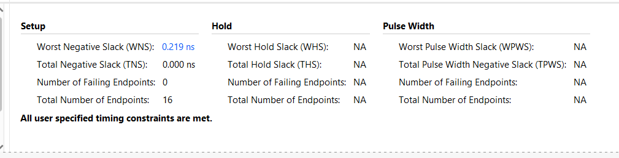
Figure 25 - Timing constraints report
Once the initial timing report is run for the synthesis. The pins are assigned and implementation is reran and the timing report for implementation is created. Once this is created the user must look at the combinational delays.
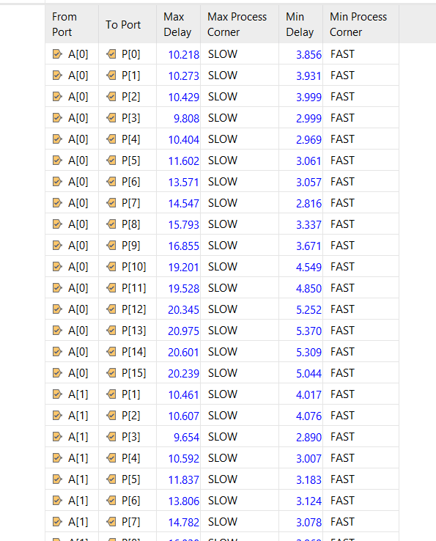
Figure 26 - combinational delays for Bruan multiplier
As can be seen from the above combinational delays the max delay for the Bruan multiplier is 20.239 ns not the 197 ns calculated.
The above process was then reran for the Wallace multiplier.
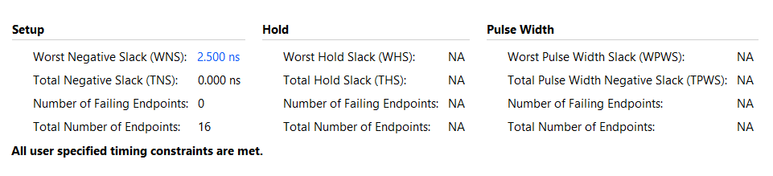
Figure 27 - Wallace synthesis design delay
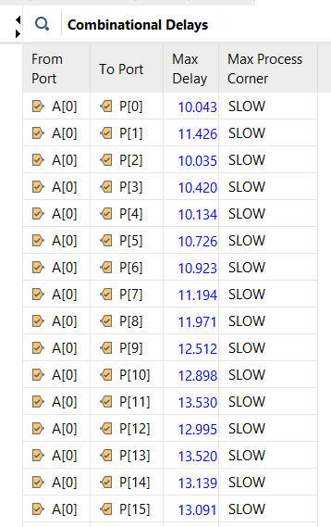
Figure 28 - Wallace combinational delays
To help the reader review the delays the manual and computer calculated delays were input into a table for easy comparison.
 | Shortest delay (ns) | Longest delay (ns)
Manual delay Bruan | 50 | 197
Manual delay Wallace | 50 | 197
Vivado delay Bruan | 10.218 | 20.039
Vivado delay Wallace | 10.043 | 13.091

As can be seen from the above table the Bruans multiplier is much slower than its Wallace equivalent it also shows the requirement for software analysis to show the true time it takes the multiplier to compute.
Next a power analysis was ran on both the Wallace tree and Braun multiplier to see which one uses the most power.
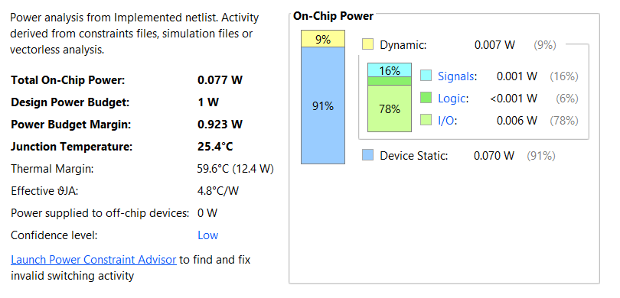
Figure 29 - wallace power analysis
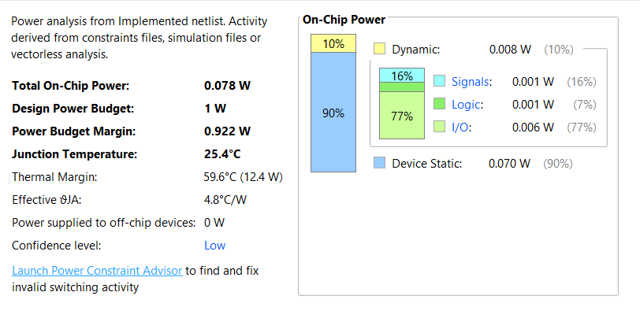
Figure 30 - Bruan power analysis
As can be seen from the above analysis the Bruan multiplier uses more than that of the Wallace tree by 0.001 W. 0.001 W is very small however when multipliers are scaled this could be a much bigger and more significant difference.
Conclusion
In conclusion Bruan and Wallace multipliers are both simple binary multipliers allowing multiplication of Hexadecimal numbers with relative ease. However, the Wallace tree multiplier is much quicker than its Bruan equivalent and in the above tests used 0.001 W to conduct the same operation. However it is worth noting that to further improve the speed and power usage of the multiplier the user should consider either variations on the original Bruan and Wallace multipliers. Such as Booth-Wallace which focuses on reducing the area of the multiplier and reducing the delay [15] or a modified Wallace which simply focuses on reducing the area.
The reader should also consider moving away from Bruan and Wallace style multipliers if they are looking for certain key attributes such as a Baugh-Wooley for speed or a column bypass for power saving.
Figure 1 - Baugh Wooley diagram 2
Figure 2 - multiplier flowchart 4
Figure 3 – Wallace architecture 4
Figure 4 - Bruan architecture 4
Figure 5 - Bruan Block diagram 5
Figure 6 - wallace block diagram 6
Figure 7 - full adder code 7
Figure 8 - Half adder code 7
Figure 9 - Assigning variables 7
Figure 10 - And gate assignment 7
Figure 11 - Wallace mutiplier with input 00 8
Figure 12 - Bruans input 00x00 output 0000 9
Figure 13 - Wallace Input 11 Output 121 9
Figure 14 - FPGA Showing output 10
Figure 15 - FPGA with physical output 10
Figure 16 - Bruan RTL Design 11
Figure 17 – Bruan implementation schematic Design 11
Figure 18 – Wallace implementation schematic 12
Figure 19 - Bruan I O planning 13
Figure 20 - Wallace IO Planning 13
Figure 21 - Bruans device photo 14
Figure 22 - Wallace device 14
Figure 23 - Pin assignment 15
Figure 24 - Bruan utilisation 16
Figure 25 - Timing constraints report 17
Figure 26 - combinational delays for Bruan multiplier 17
Figure 27 - Wallace synthesis design delay 18
Figure 28 - Wallace combinational delays 18
Figure 29 - wallace power analysis 19
Figure 30 - Bruan power analysis 19
Figure 31 - Bruan input 00 x 00 output 0000 22
Figure 32 - Bruan input 11 x 11 output 0121 23
Figure 33 - Bruan input FFXFF output FE01 23
Figure 34 - BRUAN DEVICE 24
Figure 35 - Example route taken across the fpga bruan 24
Figure 36 - BRUAN SCHEATIC 24
Figure 37 - Wallace schematic 25

References
[1] | "FPGA Full Form" Geeks for Geeks. Accessed: 24/04/2025. [Online]. Available: FPGA Full Form | GeeksforGeeks

[2] | "What is Binary Multiplier : Working & Its Applications" ELprocus. Accessed: 21/04/2025. [Online]. Available: Binary Multiplier : Types, Block Diagram, Working and Its Applications

[3] IOSR Journal of Electronics and Communication Engineering (IOSR-JECE) e-ISSN: 2278-2834,p- ISSN: 2278-8735.Volume 13, Issue 1, Ver. II (Jan.- Feb. 2018), PP 29-38 www.iosrjournals.org
[4] | "Multiplication 22" CSBio Accessed: 21/04/2025. [Online]. Available:L12-Multilplication.ppt
[5] | "Storing 2048 bits on a CRT in 1947" The Manchester Mark 1 Accessed: 21/04/2025. [Online]. Available : Photo Gallery 1
[6] International Journal of Advanced Scientific Technologies in Engineering and Management Sciences (IJASTEMS-ISSN: 2454-356X) Volume.2,Issue4,April.2016
[7] .V.N.Prasanna Kumar. Int. Journal of Engineering Research and Application ISSN: 2248-9622, Vol. 7, Issue 12, (Part -6) December 2017, pp.81-86
[8] | "What are the advantages and disadvantages of booth's multiplication?" Brainly Accessed: 21/04/2025. [Online]. Available : What are the advantages and disadvantages of booth's multiplication? - Brainly.in
[9] | A.Kiran" | FPGA Implementation of High Speed Baugh | Wooley Multiplier using Decomposition Logic  ?" Bahra Univeristy Accessed: 21/04/2025. [Online]. Available :1509.03575

[10] | "Resolve Timing Failures in IP Core Generation and Simulink Real-Time FPGA I/O Workflows" Mathworks Accessed: 21/04/2025. [Online]. Available : Resolve Timing Failures in IP Core Generation and Simulink Real-Time FPGA I/O Workflows

[11] | D.Ravi " | Design and Implementation of Wallace Tree Multiplier using Higher | Order Compressors  " Accessed: 21/04/2025. [Online]. Available : 546213IJVDCS9984-85.pdf
[12] M. Verma, S. Sharma and S. S. Rout, "A Comparative Study of Wallace Tree Multiplier and Binary Multiplier Performance," 2024 International Conference on Communication, Control, and Intelligent Systems (CCIS), Mathura, India, 2024, pp. 1-6, doi: 10.1109/CCIS63231.2024.10932105. keywords: {High performance computing;Digital signal processing;Routing;Control systems;Hardware;Table lookup;Intelligent systems;Hardware design languages;Adders;Optimization;Multiplier;high speed;wallace tree multiplier;binary multiplier;verilog},
[13] | " | Design and Analysis of Low Power Braun Multiplier | Architecture  " International jorunal of pure and applied maths Accessed: 21/04/2025. [Online]. Available : 454.pdf
[14] |  | " | Basys 3  " Xylinx Accessed: 21/04/2025. [Online]. Available : https://digilent.com/reference/programmable-logic/basys-3/start
[15] Advances in Computational Sciences and Technology ISSN 0973-6107 Volume 10, Number 5 (2017) pp. 1257-1272 © Research India Publications http://www.ripublication.com

Appendix
Figure 31 - Bruan input 00 x 00 output 0000
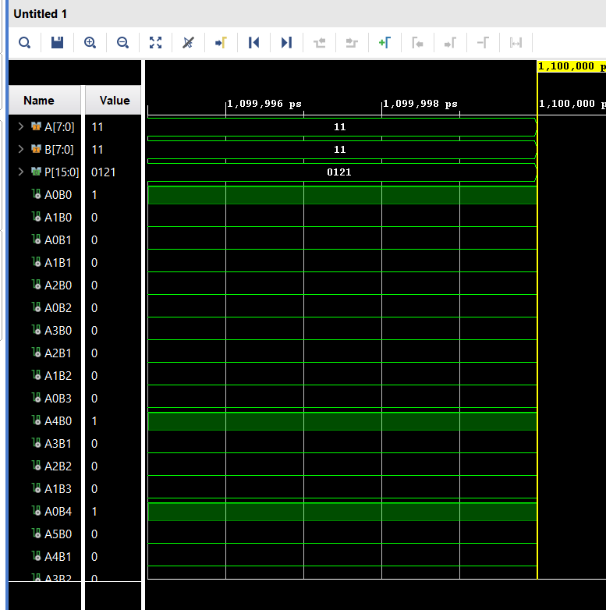
Figure 32 - Bruan input 11 x 11 output 0121
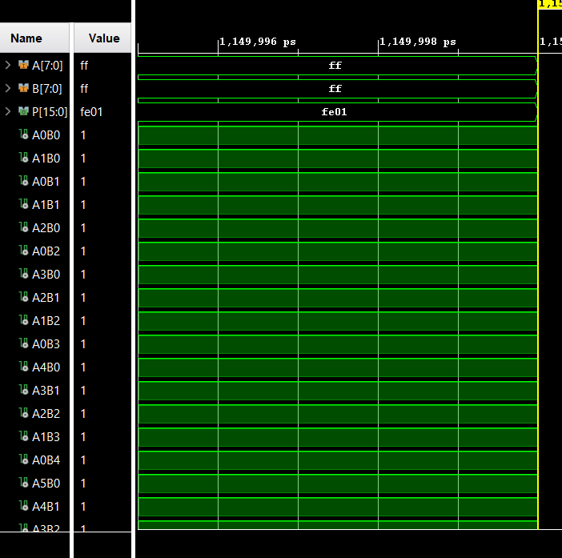
Figure 33 - Bruan input FFXFF output FE01
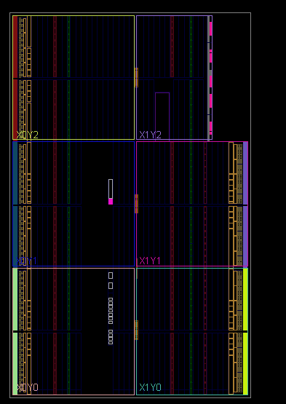
Figure 34 - BRUAN DEVICE

Figure 35 - Example route taken across the fpga bruan
Figure 36 - BRUAN SCHEATIC
Figure 37 - Wallace schematic
References

Code
Bruan
entity bruans1 is
Port ( A : in STD_LOGIC_VECTOR (7 downto 0);
B : in STD_LOGIC_VECTOR (7 downto 0);
P : out STD_LOGIC_VECTOR (15 downto 0));
end bruans1;

architecture Behavioural of bruans1 is
signal A0B0 : std_logic;
signal A1B0 : std_logic;
signal A0B1: std_logic;
signal A1B1: std_logic;
signal A2B0: std_logic;
signal A0B2: std_logic;
signal A3B0: std_logic;
signal A2B1: std_logic;
signal A1B2: std_logic;
signal A0B3: std_logic;
signal A4B0: std_logic;
signal A3B1: std_logic;
signal A2B2: std_logic;
signal A1B3: std_logic;
signal A0B4: std_logic;
signal A5B0: std_logic;
signal A4B1: std_logic;
signal A3B2: std_logic;
signal A2B3: std_logic;
signal A1B4: std_logic;
signal A0B5: std_logic;
signal A6B0: std_logic;
signal A5B1: std_logic;
signal A4B2: std_logic;
signal A3B3: std_logic;
signal A2B4: std_logic;
signal A1B5: std_logic;
signal A0B6: std_logic;
signal A7B0: std_logic;
signal A6B1: std_logic;
signal A5B2: std_logic;
signal A4B3: std_logic;
signal A3B4: std_logic;
signal A2B5: std_logic;
signal A1B6: std_logic;
signal A0B7: std_logic;
signal A7B1: std_logic;
signal A6B2: std_logic;
signal A5B3: std_logic;
signal A4B4: std_logic;
signal A3B5: std_logic;
signal A2B6: std_logic;
signal A1B7: std_logic;
Signal A7B2: std_logic;
signal A6B3: std_logic;
signal A5B4: std_logic;
signal A4B5: std_logic;
signal A3B6: std_logic;
signal A2B7: std_logic;
signal A7B3: std_logic;
signal A6B4: std_logic;
Signal A5B5: std_logic;
signal A4B6: std_logic;
signal A3B7: std_logic;
signal A7B4: std_logic;
signal A6B5: std_logic;
signal A5B6: std_logic;
signal A4B7: std_logic;
signal A7B5: std_logic;
signal A6B6: std_logic;
signal A5B7: std_logic;
signal A7B6: std_logic;
signal A6B7: std_logic;
signal A7B7: std_logic;

signal c1: std_logic;
signal c2: std_logic;
signal c3: std_logic;
signal c4: std_logic;
signal c5: std_logic;
signal c6: std_logic;
signal c7: std_logic;
signal c8: std_logic;
signal c9: std_logic;
signal c10: std_logic;
signal c11: std_logic;
signal c12: std_logic;
signal c13: std_logic;
signal c14: std_logic;
signal c15: std_logic;
signal c16: std_logic;
signal c17: std_logic;
signal c18: std_logic;
signal c19: std_logic;
signal c20: std_logic;
signal c21: std_logic;
signal c22: std_logic;
signal c23: std_logic;
signal c24: std_logic;
signal c25: std_logic;
signal c26: std_logic;
signal c27: std_logic;
signal c28: std_logic;
signal c29: std_logic;
signal c30: std_logic;
signal c31: std_logic;
signal c32: std_logic;
signal c33: std_logic;
signal c34: std_logic;
signal c35: std_logic;
signal c36: std_logic;
signal c37: std_logic;
signal c38: std_logic;
signal c39: std_logic;
signal c40: std_logic;
signal c41: std_logic;
signal c42: std_logic;
signal c43: std_logic;
signal c44: std_logic;
signal c45: std_logic;
signal c46: std_logic;
signal c47: std_logic;
signal c48: std_logic;
signal c49: std_logic;
signal c50: std_logic;
signal c51: std_logic;
signal c52: std_logic;
signal c53: std_logic;
signal c54: std_logic;
signal c55: std_logic;
signal c56: std_logic;

signal p2_1: std_logic;
signal p3_1: std_logic;
signal p3_2: std_logic;

signal p4_2: std_logic;
signal p4_3: std_logic;
signal p4_4: std_logic;

signal p5_2: std_logic;
signal p5_3: std_logic;
signal p5_4: std_logic;
signal p5_5: std_logic;

signal p6_2: std_logic;
signal p6_3: std_logic;
signal p6_4: std_logic;
signal p6_5: std_logic;
signal p6_6: std_logic;

signal p7_2: std_logic;
signal p7_3: std_logic;
signal p7_4: std_logic;
signal p7_5: std_logic;
signal p7_6: std_logic;
signal p7_7: std_logic;

signal p8_2: std_logic;
signal p8_3: std_logic;
signal p8_4: std_logic;
signal p8_5: std_logic;
signal p8_6: std_logic;
signal p8_7: std_logic;
signal p9_1: std_logic;
signal p9_2: std_logic;
signal p9_3: std_logic;
signal p9_4: std_logic;
signal p9_5: std_logic;
signal p10_1: std_logic;
signal p10_2: std_logic;
signal p10_3: std_logic;
signal p10_4: std_logic;
signal p11_1: std_logic;
signal p11_2: std_logic;
signal p11_3: std_logic;
signal p12_1: std_logic;
signal p12_2: std_logic;
signal p13_1: std_logic;

component full
port (A : in std_logic;
B : in std_logic;
Cin: in std_logic;
S : out std_logic;
C : out std_logic);
end component;

component half
port (A : in std_logic;
B: in std_logic;
S : out std_logic;
C : out std_logic);
end component;

begin

A0B0 <= A(0) and B(0);
A0B1 <= A(0) and B(1);
A0B2 <= A(0) and B(2);
A0B3 <= A(0) and B(3);
A0B4 <= A(0) and B(4);
A0B5 <= A(0) and B(5);
A0B6 <= A(0) and B(6);
A0B7 <= A(0) and B(7);
A1B0 <= A(1) and B(0);
A1B1 <= A(1) and B(1);
A1B2 <= A(1) and B(2);
A1B3 <= A(1) and B(3);
A1B4 <= A(1) and B(4);
A1B5 <= A(1) and B(5);
A1B6 <= A(1) and B(6);
A1B7 <= A(1) and B(7);
A2B0 <= A(2) and B(0);
A2B1 <= A(2) and B(1);
A2B2 <= A(2) and B(2);
A2B3 <= A(2) and B(3);
A2B4 <= A(2) and B(4);
A2B5 <= A(2) and B(5);
A2B6 <= A(2) and B(6);
A2B7 <= A(2) and B(7);
A3B0 <= A(3) and B(0);
A3B1 <= A(3) and B(1);
A3B2 <= A(3) and B(2);
A3B3 <= A(3) and B(3);
A3B4 <= A(3) and B(4);
A3B5 <= A(3) and B(5);
A3B6 <= A(3) and B(6);
A3B7 <= A(3) and B(7);
A4B0 <= A(4) and B(0);
A4B1 <= A(4) and B(1);
A4B2 <= A(4) and B(2);
A4B3 <= A(4) and B(3);
A4B4 <= A(4) and B(4);
A4B5 <= A(4) and B(5);
A4B6 <= A(4) and B(6);
A4B7 <= A(4) and B(7);
A5B0 <= A(5) and B(0);
A5B1 <= A(5) and B(1);
A5B2 <= A(5) and B(2);
A5B3 <= A(5) and B(3);
A5B4 <= A(5) and B(4);
A5B5 <= A(5) and B(5);
A5B6 <= A(5) and B(6);
A5B7 <= A(5) and B(7);
A6B0 <= A(6) and B(0);
A6B1 <= A(6) and B(1);
A6B2 <= A(6) and B(2);
A6B3 <= A(6) and B(3);
A6B4 <= A(6) and B(4);
A6B5 <= A(6) and B(5);
A6B6 <= A(6) and B(6);
A6B7 <= A(6) and B(7);
A7B0 <= A(7) and B(0);
A7B1 <= A(7) and B(1);
A7B2 <= A(7) and B(2);
A7B3 <= A(7) and B(3);
A7B4 <= A(7) and B(4);
A7B5 <= A(7) and B(5);
A7B6 <= A(7) and B(6);
A7B7 <= A(7) and B(7);

P0 : P(0) <= A(0) and B(0);

P1_0 : half port map (A=>A1B0 , B=>A0B1 , S=> P(1), c=>C1);

P21 : full port map (A=>A2B0, B=>A1B1 , Cin=>C1 , S=>P2_1, C=>C2);
p2_0 : half port map (A=>A0B2 , B=>p2_1 , S=>P(2) , C=>c9);

P31 : full port map (A=>A3B0, B=>A2B1 , Cin=>C2 , S=>P3_1, C=>C3);
p32 : full port map (A=>A1B2 , B=>p3_1 , Cin=>C9 , S=>p3_2 ,C=>c10);
P3_0 : half port map (A=>A0B3, B=>p3_2 , S=>P(3), C=>C17);

p41 : full port map (A=>A3B1 , B=>A4B0 , s=>p4_2, Cin=>C3 , C=>c4);
P42 : full port map (A=>A2B2, B=>P4_2 , Cin=>C10 , S=>P4_3, C=>C11);
P43 : full port map (A=>A1B3, B=>P4_3 , Cin=>C17 , S=>P4_4, C=>C18);
p4_0 : half port map (A=>A0B4 , B=>P4_4 , s=>p(4) , C=>C25);

P51 : full port map (A=>A4B1, B=>A5B0 , Cin=>C4 , S=>P5_2, C=>C5);
P52 : full port map (A=>A3B2, B=>p5_2 , Cin=>C11 , S=>P5_3, C=>c12);
P53 : full port map (A=>A3B2, B=>p5_3 , Cin=>C18 , S=>P5_4, C=>C19);
P54 : full port map (A=>A3B2, B=>p5_4 , Cin=>C25 , S=>P5_5, C=>C26);
p5_0 : half port map (A=>A2B3 , B=>p5_5 , s=>p(5), C=>c33);

P61 : full port map (A=>A5B1, B=>A6B0 , Cin=>C5 , S=>P6_2, C=>C6);
P62 : full port map (A=>A4B2, B=>p6_2 , Cin=>C12 , S=>P6_3, C=>c13);
P63 : full port map (A=>A3B3, B=>p6_3 , Cin=>C19 , S=>p6_4, C=>c20);
P64 : full port map (A=>A2B4, B=>p6_4 , Cin=>C26 , S=>P6_5, C=>C27);
P65 : full port map (A=>A1B5, B=>p6_5 , Cin=>C33 , S=>P6_6, C=>C34);
p6_0 : half port map (A=>A0B6 , B=>p6_6 , s=>p(6), C=>c41);

P71 : full port map (A=>A6B1, B=>A7B0 , Cin=>C6 , S=>P7_2, C=>C7);
P72 : full port map (A=>A5B2, B=>p7_2 , Cin=>C13 , S=>P7_3, C=>c14);
P73 : full port map (A=>A4B3, B=>p7_3 , Cin=>C20 , S=>p7_4, C=>c21);
P74 : full port map (A=>A3B4, B=>p7_4 , Cin=>C27 , S=>P7_5, C=>C28);
P75 : full port map (A=>A2B5, B=>p7_5 , Cin=>C34 , S=>P7_6, C=>C35);
P76 : full port map (A=>A1B6, B=>p7_6 , Cin=>C41 , S=>P7_7, C=>C42);
p7_0 : half port map (A=>A0B7 , B=>p7_7 , s=>p(7), C=>c49);

P81 : half port map (A=>A7B1, B=>c7 , S=>P8_2, C=>C8);
P82 : full port map (A=>A6B2, B=>p8_2 , Cin=>C14 , S=>P8_3, C=>c15);
P83 : full port map (A=>A5B3, B=>p8_3 , Cin=>C21 , S=>p8_4, C=>c22);
P84 : full port map (A=>A4B4, B=>p8_4 , Cin=>C28 , S=>P8_5, C=>C29);
P85 : full port map (A=>A3B5, B=>p8_5 , Cin=>C35 , S=>P8_6, C=>C36);
P86 : full port map (A=>A2B6, B=>p8_6 , Cin=>C42 , S=>P8_7, C=>C43);
P8_0 : full port map (A=>A1B7, B=>p8_7 , Cin=>C49 , S=>P(8), C=>C50);

P91 : full port map (A=>A7B2, B=>c8 , Cin=>C15 , S=>P9_1, C=>C16);
P92 : full port map (A=>A6B3, B=>p9_1 , Cin=>C22 , S=>P9_2, C=>c23);
P93 : full port map (A=>A5B4, B=>p9_2 , Cin=>C29 , S=>p9_3, C=>c30);
P94 : full port map (A=>A4B5, B=>p9_3 , Cin=>C36 , S=>P9_4, C=>C37);
P95 : full port map (A=>A3B6, B=>p9_4 , Cin=>C43 , S=>p9_5, C=>c44);
P9_0 : full port map (A=>A2B7, B=>p9_5 , Cin=>C50 , S=>P(9), C=>C51);

P101 : full port map (A=>A7B3, B=>c16 , Cin=>C23 , S=>P10_1, C=>c24);
P102 : full port map (A=>A6B4, B=>p10_1 , Cin=>C30 , S=>p10_2, C=>c31);
P103 : full port map (A=>A5B5, B=>p10_2 , Cin=>C37 , S=>p10_3, C=>c38);
P104 : full port map (A=>A4B6, B=>p10_3 , Cin=>C44 , S=>p10_4, C=>c45);
P10_0 : full port map (A=>A3B7, B=>p10_4 , Cin=>C51 , S=>p(10), C=>c52);

P111 : full port map (A=>A7B4, B=>c24 , Cin=>C31 , S=>P11_1, C=>c32);
P112 : full port map (A=>A6B5, B=>p11_1 , Cin=>C38 , S=>p11_2, C=>c39);
P113 : full port map (A=>A5B6, B=>p11_2 , Cin=>C45 , S=>p11_3, C=>c46);
P11_0 : full port map (A=>A4B7, B=>p11_3 , Cin=>C52 , S=>p(11), C=>c53);

P121 : full port map (A=>A7B5, B=>c32 , Cin=>C39 , S=>P12_1, C=>c40);
P122 : full port map (A=>A6B6, B=>p12_1 , Cin=>C46 , S=>p12_2, C=>c47);
P12_0 : full port map (A=>A5B7, B=>p12_2 , Cin=>C53 , S=>p(12), C=>c54);

P131 : full port map (A=>A7B6, B=>c40 , Cin=>C47 , S=>P13_1, C=>c48);
P13_0 : full port map (A=>A6B7, B=>p13_1 , Cin=>C54 , S=>p(13), C=>c55);

p14 : full port map (A=>A7B7 , B=>c48 , s=>p(14), Cin=>c55 , C=>C56);
p15 : p(15)<= C56;

end Behavioural;

Wallace code
library IEEE;
use IEEE.STD_LOGIC_1164.ALL;
--use IEEE.std_logic_arith.ALL;
--use IEEE.std_logic_unsigned.ALL;

entity wallace is
Port ( A : in STD_LOGIC_VECTOR (7 downto 0);
B : in STD_LOGIC_VECTOR (7 downto 0);
P : out STD_LOGIC_VECTOR (15 downto 0));
end wallace;

architecture Behavioral of wallace is

component Full is
Port ( A : in STD_LOGIC;
B : in STD_LOGIC;
Cin : in STD_LOGIC;
S : out STD_LOGIC;
C : out STD_LOGIC);
end component;

component Half is
Port ( A : in STD_LOGIC;
B : in STD_LOGIC;
S : out STD_LOGIC;
C : out STD_LOGIC);
end component;

signal A0B0 : std_logic;
signal A1B0 : std_logic;
signal A0B1: std_logic;
signal A1B1: std_logic;
signal A2B0: std_logic;
signal A0B2: std_logic;
signal A3B0: std_logic;
signal A2B1: std_logic;
signal A1B2: std_logic;
signal A0B3: std_logic;
signal A4B0: std_logic;
signal A3B1: std_logic;
signal A2B2: std_logic;
signal A1B3: std_logic;
signal A0B4: std_logic;
signal A5B0: std_logic;
signal A4B1: std_logic;
signal A3B2: std_logic;
signal A2B3: std_logic;
signal A1B4: std_logic;
signal A0B5: std_logic;
signal A6B0: std_logic;
signal A5B1: std_logic;
signal A4B2: std_logic;
signal A3B3: std_logic;
signal A2B4: std_logic;
signal A1B5: std_logic;
signal A0B6: std_logic;
signal A7B0: std_logic;
signal A6B1: std_logic;
signal A5B2: std_logic;
signal A4B3: std_logic;
signal A3B4: std_logic;
signal A2B5: std_logic;
signal A1B6: std_logic;
signal A0B7: std_logic;
signal A7B1: std_logic;
signal A6B2: std_logic;
signal A5B3: std_logic;
signal A4B4: std_logic;
signal A3B5: std_logic;
signal A2B6: std_logic;
signal A1B7: std_logic;
Signal A7B2: std_logic;
signal A6B3: std_logic;
signal A5B4: std_logic;
signal A4B5: std_logic;
signal A3B6: std_logic;
signal A2B7: std_logic;
signal A7B3: std_logic;
signal A6B4: std_logic;
Signal A5B5: std_logic;
signal A4B6: std_logic;
signal A3B7: std_logic;
signal A7B4: std_logic;
signal A6B5: std_logic;
signal A5B6: std_logic;
signal A4B7: std_logic;
signal A7B5: std_logic;
signal A6B6: std_logic;
signal A5B7: std_logic;
signal A7B6: std_logic;
signal A6B7: std_logic;
signal A7B7: std_logic;

signal c1: std_logic;
signal c2: std_logic;
signal c3: std_logic;
signal c4: std_logic;
signal c5: std_logic;
signal c6: std_logic;
signal c7: std_logic;
signal c8: std_logic;
signal c9: std_logic;
signal c10: std_logic;
signal c11: std_logic;
signal c12: std_logic;
signal c13: std_logic;
signal c14: std_logic;
signal c15: std_logic;
signal c16: std_logic;
signal c17: std_logic;
signal c18: std_logic;
signal c19: std_logic;
signal c20: std_logic;
signal c21: std_logic;
signal c22: std_logic;
signal c23: std_logic;
signal c24: std_logic;
signal c25: std_logic;
signal c26: std_logic;
signal c27: std_logic;
signal c28: std_logic;
signal c29: std_logic;
signal c30: std_logic;
signal c31: std_logic;
signal c32: std_logic;
signal c33: std_logic;
signal c34: std_logic;
signal c35: std_logic;
signal c36: std_logic;
signal c37: std_logic;
signal c38: std_logic;
signal c39: std_logic;
signal c40: std_logic;
signal c41: std_logic;
signal c42: std_logic;
signal c43: std_logic;
signal c44: std_logic;
signal c45: std_logic;
signal c46: std_logic;
signal c47: std_logic;
signal c48: std_logic;
signal c49: std_logic;
signal c50: std_logic;
signal c51: std_logic;
signal c52: std_logic;
signal c53: std_logic;
signal c54: std_logic;
signal c55: std_logic;
signal c56: std_logic;

signal s2: std_logic;
signal s3: std_logic;
signal s4: std_logic;
signal s5: std_logic;
signal s6: std_logic;
signal s7: std_logic;
signal s8: std_logic;
signal s9: std_logic;
signal s10: std_logic;
signal s11: std_logic;
signal s12: std_logic;
signal s13: std_logic;
signal s14: std_logic;
signal s15: std_logic;
signal s16: std_logic;
signal s17: std_logic;
signal s18: std_logic;
signal s19: std_logic;
signal s20: std_logic;
signal s21: std_logic;
signal s22: std_logic;
signal s23: std_logic;
signal s24: std_logic;
signal s25: std_logic;
signal s26: std_logic;
signal s27: std_logic;
signal s28: std_logic;
signal s29: std_logic;
signal s30: std_logic;
signal s31: std_logic;
signal s32: std_logic;
signal s33: std_logic;
signal s34: std_logic;
signal s35: std_logic;
signal s36: std_logic;
signal s37: std_logic;
signal s38: std_logic;
signal s39: std_logic;
signal s40: std_logic;
signal s41: std_logic;
signal s42: std_logic;
signal s43: std_logic;
signal s44: std_logic;

begin

A0B0 <= A(0) and B(0);
A0B1 <= A(0) and B(1);
A0B2 <= A(0) and B(2);
A0B3 <= A(0) and B(3);
A0B4 <= A(0) and B(4);
A0B5 <= A(0) and B(5);
A0B6 <= A(0) and B(6);
A0B7 <= A(0) and B(7);
A1B0 <= A(1) and B(0);
A1B1 <= A(1) and B(1);
A1B2 <= A(1) and B(2);
A1B3 <= A(1) and B(3);
A1B4 <= A(1) and B(4);
A1B5 <= A(1) and B(5);
A1B6 <= A(1) and B(6);
A1B7 <= A(1) and B(7);
A2B0 <= A(2) and B(0);
A2B1 <= A(2) and B(1);
A2B2 <= A(2) and B(2);
A2B3 <= A(2) and B(3);
A2B4 <= A(2) and B(4);
A2B5 <= A(2) and B(5);
A2B6 <= A(2) and B(6);
A2B7 <= A(2) and B(7);
A3B0 <= A(3) and B(0);
A3B1 <= A(3) and B(1);
A3B2 <= A(3) and B(2);
A3B3 <= A(3) and B(3);
A3B4 <= A(3) and B(4);
A3B5 <= A(3) and B(5);
A3B6 <= A(3) and B(6);
A3B7 <= A(3) and B(7);
A4B0 <= A(4) and B(0);
A4B1 <= A(4) and B(1);
A4B2 <= A(4) and B(2);
A4B3 <= A(4) and B(3);
A4B4 <= A(4) and B(4);
A4B5 <= A(4) and B(5);
A4B6 <= A(4) and B(6);
A4B7 <= A(4) and B(7);
A5B0 <= A(5) and B(0);
A5B1 <= A(5) and B(1);
A5B2 <= A(5) and B(2);
A5B3 <= A(5) and B(3);
A5B4 <= A(5) and B(4);
A5B5 <= A(5) and B(5);
A5B6 <= A(5) and B(6);
A5B7 <= A(5) and B(7);
A6B0 <= A(6) and B(0);
A6B1 <= A(6) and B(1);
A6B2 <= A(6) and B(2);
A6B3 <= A(6) and B(3);
A6B4 <= A(6) and B(4);
A6B5 <= A(6) and B(5);
A6B6 <= A(6) and B(6);
A6B7 <= A(6) and B(7);
A7B0 <= A(7) and B(0);
A7B1 <= A(7) and B(1);
A7B2 <= A(7) and B(2);
A7B3 <= A(7) and B(3);
A7B4 <= A(7) and B(4);
A7B5 <= A(7) and B(5);
A7B6 <= A(7) and B(6);
A7B7 <= A(7) and B(7);

--first stage

P0 : P(0) <= A(0) and B(0) ;

ha11 : half port map(A=>A1B0,B=>A0B1,S=>P(1),C=>C1);

fa12 : Full port map(A=>A2B0,B=>A1B1,Cin=>A0B2,S=>S2,C=>C2);
fa13 : Full port map(A=>A3B0,B=>A2B1,Cin=>A1B2,S=>S3,C=>C3);
fa14 : Full port map(A=>A4B0,B=>A3B1,Cin=>A2B2,S=>S4,C=>C4);
fa15 : Full port map(A=>A5B0,B=>A4B1,Cin=>A3B2,S=>S5,C=>C5);
fa16 : Full port map(A=>A6B0,B=>A5B1,Cin=>A4B2,S=>S6,C=>C6);
fa17 : Full port map(A=>A7B0,B=>A6B1,Cin=>A5B2,S=>S7,C=>C7);
ha1 : half port map(A=>A7B1,B=>A6B2,S=>S8,C=>C8);

--second stage
ha21 : Half port map(A=>S2,B=>C1,S=>P(2),C=>C9);
fa22 : Full port map(A=>S3,B=>C2,Cin=>A0B3,S=>S9,C=>C10);
fa23 : Full port map(A=>S4,B=>C3,Cin=>A1B3,S=>S10,C=>C11);
fa24 : Full port map(A=>s5,B=>C4,Cin=>A2B3,S=>S11,C=>C12);
fa25 : Full port map(A=>S6,B=>C5,Cin=>A0B3,S=>S12,C=>C13);
fa26 : Full port map(A=>S7,B=>C6,Cin=>A1B3,S=>S13,C=>C14);
fa27 : Full port map(A=>s8,B=>C7,Cin=>A2B3,S=>S14,C=>C15);
fa28 : Full port map(A=>A7B3,B=>A6B3,Cin=>c8,S=>S15,C=>C16);

--third stage
ha31 : Half port map(A=>S9,B=>C9,S=>P(3),C=>C17);
fa32 : Full port map(A=>S10,B=>C10,Cin=>A0B4,S=>S16,C=>C18);
fa33 : Full port map(A=>S11,B=>C11,Cin=>A1B4,S=>S17,C=>C19);
fa34 : Full port map(A=>s12,B=>C12,Cin=>A2B4,S=>S18,C=>C20);
fa35 : Full port map(A=>S13,B=>C13,Cin=>A3B4,S=>S19,C=>C21);
fa36 : Full port map(A=>S14,B=>C14,Cin=>A4B4,S=>S20,C=>C22);
fa37 : Full port map(A=>s15,B=>C15,Cin=>A5B4,S=>S21,C=>C23);
fa38 : Full port map(A=>A7B4,B=>A6B4,Cin=>c16,S=>S22,C=>C24);

--forth stage
ha41 : Half port map(A=>S16,B=>C17,S=>P(4),C=>C25);
fa42 : Full port map(A=>S17,B=>C18,Cin=>A0B5,S=>S23,C=>c26);
fa43 : Full port map(A=>S18,B=>C19,Cin=>A1B5,S=>S24,C=>C27);
fa44 : Full port map(A=>s19,B=>C20,Cin=>A2B5,S=>S25,C=>C28);
fa45 : Full port map(A=>S20,B=>C21,Cin=>A3B5,S=>S26,C=>C29);
fa46 : Full port map(A=>S21,B=>C22,Cin=>A4B5,S=>S27,C=>C30);
fa47 : Full port map(A=>s22,B=>C23,Cin=>A5B5,S=>S28,C=>C31);
fa48 : Full port map(A=>A7B5,B=>A6B5,Cin=>c24,S=>S29,C=>C32);

--fith stage
ha51 : Half port map(A=>S23,B=>C25,S=>P(5),C=>C33);
fa52 : Full port map(A=>S24,B=>C26,Cin=>A0B6,S=>S30,C=>c34);
fa53 : Full port map(A=>S25,B=>C27,Cin=>A1B6,S=>S31,C=>C35);
fa54 : Full port map(A=>s26,B=>C28,Cin=>A2B6,S=>S32,C=>C36);
fa55 : Full port map(A=>S27,B=>C29,Cin=>A3B6,S=>S33,C=>C37);
fa56 : Full port map(A=>S28,B=>C30,Cin=>A4B6,S=>S34,C=>C38);
fa57 : Full port map(A=>s29,B=>C31,Cin=>A5B6,S=>S35,C=>C39);
fa58 : Full port map(A=>A7B6,B=>A6B6,Cin=>c32,S=>S36,C=>C40);

--sixth stage
ha61 : Half port map(A=>S30,B=>C33,S=>P(6),C=>C41);
fa62 : Full port map(A=>S31,B=>C34,Cin=>A0B7,S=>S37,C=>c42);
fa63 : Full port map(A=>S32,B=>C35,Cin=>A1B7,S=>S38,C=>C43);
fa64 : Full port map(A=>s33,B=>C36,Cin=>A2B7,S=>S39,C=>C44);
fa65 : Full port map(A=>S34,B=>C37,Cin=>A3B7,S=>S40,C=>C45);
fa66 : Full port map(A=>S35,B=>C38,Cin=>A4B7,S=>S41,C=>C46);
fa67 : Full port map(A=>s36,B=>C39,Cin=>A5B7,S=>S42,C=>C47);
fa68 : Full port map(A=>A7B7,B=>A6B7,Cin=>c40,S=>S43,C=>C48);

--senth stage
ha71 : Half port map(A=>S37,B=>C41,S=>P(7),C=>C49);
fa72 : Full port map(A=>S38,B=>C42,Cin=>c49,S=>P(8),C=>c50);
fa73 : Full port map(A=>S39,B=>C43,Cin=>c50,S=>P(9),C=>c51);
fa74 : Full port map(A=>S40,B=>C44,Cin=>c51,S=>P(10),C=>c52);
fa75 : Full port map(A=>S41,B=>C45,Cin=>c52,S=>P(11),C=>c53);
fa76 : Full port map(A=>S42,B=>C46,Cin=>c53,S=>P(12),C=>c54);
fa77 : Full port map(A=>S43,B=>C47,Cin=>c54,S=>P(13),C=>c55);
fa78 : Half port map(B=>C48,A=>c55,S=>P(14),C=>c56);

P15 : P(15) <= C56 ;
end Behavioral;

