
Work based project assignment
Project Title A Comparison between pre Covid-19 agreed budgets against actual current costs and how to effectively value engineer to omit losses.


Amy Davies
Student ID - 2117453

Contents
1.0 Chapter 1 Introduction 2
1.1 Introduction 2
1.2 Abstract 2
1.3 Research Background 2
1.4 Aims and objectives 2
1.5 Hypothesis 2
1.6 Conclusion 2
2.0 Chapter 2 Literature Review 3
2.1 Introduction 3
2.2 Price movements in construction materials and plant hire, UK: 2019-2021 3
Figure 1 – Construction output prices 4
Figure 2 – Construction output 4
2.3 Construction delays and material shortages due to Covid-19 4
2.4 How value engineering is used in construction projects 5
2.5 Conclusion 5
3.0 Chapter 3 Research Methodology 5
4.0 Chapter 4 Project background information 5
4.1 Introduction 5
4.2 Project Overview 6
4.3 Health and safety 6
4.4 Project management structure 6
4.5 Communication 6
4.6 Software 7
4.7 Materials and processes 7
4.8 Conclusion 7
5.0 Chapter 5 – Primary Research 8
5.1 Introduction 8
5.2 Data Analysis 8
5.2.1 Questionnaires. 8
5.2.2 Interviews 12
5.3 Conclusion 13

  - Chapter 1 Introduction
  - Introduction
In this chapter the author will introduce the subject in which she has chosen to complete her research and report on. The author will also give a brief introduction and background into her own experiences on the subject.
  - Abstract
This assignment will research the cost increases that have shocked the construction industry in the aftermath of Covid-19, by comparing a budget that was set out pre Covid-19 with works commencing post cost increase. Further investigations will be undertaken to understand the reasons for the cost increases, subsequently helping the author understand the best methods for cost engineering.
  - Research Background
The author is currently working on a small renovation project consisting of a full internal refurb, new substructure and superstructure works for an extension. The original feasibility study and budget bill of quantities (BOQ) was carried out pre Covid-19, please see appendix A. Due to a delay in purchasing the project and the effects of Covid-19 there have been astronomical price increases across the industry effecting the profit margin for said project.
Due to the profit margin being affected the author is researching the best methods of reducing costs and value engineering.
  - Aims and objectives
The authors aims and objectives are set out in the bullet points below –
- To understand where the cost increases are greatest and why?
- To understand how value engineering is utilised on a construction project.
- Best methods of value engineering and cost reductions.

  - Hypothesis
The author believes that the greatest cost increases have risen from procuring materials from overseas, due to the travel restrictions imposed by Covid-19, along with foreign governments restricting workplace numbers due to social distancing.
  - Conclusion
The author has set out specific criteria to base her research on, in order to gather the correct information required to fully research and report on the aims and objectives set out in 1.4. By setting these specific aims and objectives it will aid the author in ascertaining the reasons for the price increases that have been seen throughout the industry and research the best methods of reducing costs. It is the authors aim to find a connection between price increases and restrictions imposed due to Covid-19.

2.0 Chapter 2 Literature Review

2.1 Introduction
In this chapter the author will illustrate and analyse the available literature surrounding her chosen research. The author will highlight any reoccurring issues and themes in connection with the price increases in the construction industry. The purpose of the literature review is to ascertain data and information from other professionals and organisations that have highlighted such issues. The author will research and analyse further literature in order to critically analyse best methods of practice to reduce costs on a construction project.

2.2 Price movements in construction materials and plant hire, UK: 2019-2021
The office for national statistics publicised on 20th October 2021 a brief overview of the price movements that have occurred in the construction industry in the UK and their causes. Emilia D’Silva-Parker highlights the main points as:
- Producer price inflation continuingly causing an upward push on prices in construction.
- High demand for construction inputs due to an ever-increasing requirement for construction output subsequently increasing costs.
- Global price trends such as iron and copper are increasing construction input prices for example there was a 97% price increase in iron ore in July 2021 when compared with the previous year.
- Disruptions on a global supply chain affecting the price and availability of construction resources.
Figure 1 shows a table highlighting the output prices from June 2015 to June 2021. The annual rate for price increases in June 2021 was 3.8%. These price increases have been continuous since December 2019 however as shown in figure 2 below construction output has fallen consecutively for 3 months by 1.3%, you can also see in figure 2 the peak of the fall in construction output was between March and July 2020 which coincides with the first lockdown restrictions imposed due to Covid-19.
Emilia D’Silva-Parker also highlights that due to Covid-19 material supply chain issues and shipping costs have been effected due to the lack of capacity in Chinese ports.

Figure 1 – Construction output prices
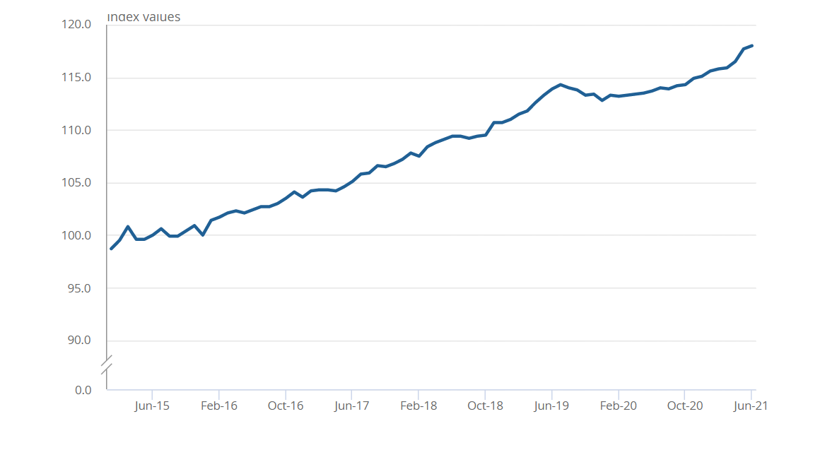
Office for national statistic 2021

Figure 2 – Construction output
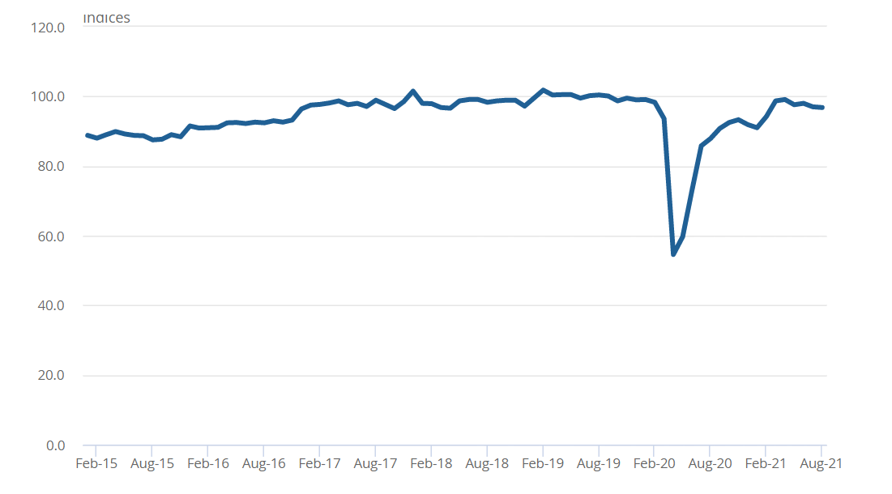Office for national statistic 2021

2.3 Construction delays and material shortages due to Covid-19
Simon Dunkling (June 2021) illustrated the connection between resource shortage and Covid-19 highlighting one of the most notable factors is the surge of construction projects since the easing of lockdown resulting in a high demand for materials. He also discusses that the Construction Leadership Council have recently issued a warning that key construction materials such as cement, timber, electrical components and paints are all in short supply. He quotes:
“With demand increasing across the globe and the UK importing many of its raw materials, not only is demand out striping supply but prices of materials are also rising.”
Simon Dunkling discusses the need for provisions within contracts that allow for price increases on materials, plant, and labour in order to mitigate potential losses due to the volatile market.

2.4 How value engineering is used in construction projects
In order to provide clear and detailed analysis on the best methods to meet a construction projects goals, value engineering is used. Value engineering is not all about cutting costs however gives all parties confidence that the maximum performance and highest values are utilised whilst assuring the most cost-effective manner, Lee Thomas (March 2019)
Value engineering is defined as
“…a conscious and explicit set of discipline procedures designed to seek out optimal value for both initial and long-term investment.” National institute for building sciences (2016)

2.5 Conclusion
Upon completion of the literature review it was concluded by the author that there is a continuous similarity and theme between the price increases of materials and the shortage due to the affects of Covid-19. Due to the continuous strict regulations imposed by governments around the world that have had an affect on manufacturing materials subsequently reducing the availability of said materials in the UK and driving up prices. The author has also discovered that there are ways of improving the project through value engineering.

3.0 Chapter 3 Research Methodology
The author has decided to use quantitative research in order to gain a greater understanding of construction professionals in the industry by handing out surveys and carrying out structured interviews. She has decided on this method due to the time scale and the fact that it is easier to control.

4.0 Chapter 4 Project background information

4.1 Introduction
Within this chapter the author will discuss the background information for the project 90 Alexander Road. This will include an overall description highlighting specific activities the author is involved in. The author will highlight any health and safety implications, identify the management structure involved in the project. The author will also discuss means of communicating with the local community in order to maintain a positive presents. Finally the author will discuss the software, hardware, materials and working processes that will be required for the given project.

4.2 Project Overview
The project is a semi-detached, three-bedroom property located in the Neath area. The property was originally constructed in the 1970’s using a traditional build method of block and brick with a concrete tiled roof. After years of neglect and little maintenance the property fell into a non-habitable state. After completion of a feasibility study the property was purchased by AMY construction Ltd with the proposal to fully renovate the current structure as well as adding a large single storey extension to the rear and a second storey extension to the side of the house to house a master suite. The proposed works would turn a derelict three-bedroom property into a large spacious four-bedroom family home.

4.3 Health and safety
To ensure the general welfare of employees, health and safety is vital in the workplace and there are legal regulations that enforce procedures to protect the health and safety of everyone in the workplace. The main regulation is the health and safety at work act 1974, which details the duties that employers have of their employees and the general public, the employees duties that they have towards themselves and others and finally self employed individuals duties towards others as well as themselves, HSE (January 2022). There are several other health and safety regulations that come in to play on this project such as:
- Working at heights regulations 2005 - This is put in place to prevent injury and or death caused by falling from height, HSE (January 2022a)
- Control of substances hazardous to health 2002 – This is the law that employers must adhere to by controlling substances that are hazardous to health of the workers, general public and environment, HSE (January 2022b)
- Lifting operations and lifting equipment regulations 1998 – these regulations identify the duties of companies/ people who own, operate or control lifting equipment HSE (January 2022c)

4.4 Project management structure
A general project of this size will consist of a project manager who will oversee the complete construction works, however will normally have more than one project running at the same time. A working foreman will be in place on site to ensure everything runs smoothly, their duties include but are not limited to organising daily tasks, creating work schedules and overseeing quality. In order to reduce unneeded preliminary costs the engineer shall be subcontracted to undertake the engineering works and provide a full report. In order to successfully control costs on a project the quantity surveyor will be put in place, they will have a great input at the early stages of the project to ensure maximised profit margins.

4.5 Communication
Communication with residents and business owners is vitally important before and during a project. Listening to the concerns of residents will allow an alternative approach to be found that suits both parties. Before work commences it is proactive to communicate with local residents to explain the nature of the construction work, identify any sensitive residents that will require separate arrangements for communication, provide residents with a timetable showing what works will be happening and when and identify the impact that may be caused by the works detailing the steps that are being taken to minimise said impact. During the construction phase having emergency contact information along with contact information for the site manager available to residents is helpful. Where possible it is considerate to give residents seven days notice of any disturbing or noisy works that will be taking place. Finally maintaining a complaints log along with the methods of rectifying said complaints is proactive, The royal borough of Kensington and Chelsea (January 2022)

4.6 Software
Now more than ever the construction industry relies and utilises many different types of software in order to make construction professionals jobs more efficient. Construction management software can create and handle vast amounts of paperwork and documentation and store it securely. The best software’s are user friendly and easy to understand and allow staff to run a project in accordance with the plan. Construction of software allows important information to be accessed and shared easily. Construction software can also be utilised in accounting and controlling costs in order to maximise profit efficiently. For anyone looking to grow their business and carry out successful projects construction software is invaluable. Applications range from fleet and production tracking, expenses and account tracking to construction program management. The benefits of utilising construction software can be limitless.

4.7 Materials and processes
Many different materials are used in the construction industry for different aspects of a build. Structural engineers advise architects on the load bearing capabilities of specific materials such as concrete, steel and wood. In order for reliable structural integrity there are national standards and testing methods in place. For this project the author has chosen a traditional brick and block constructions to the rear and side extension with a concrete tiled roof. In accordance with the site investigation (SI) reports the foundations will be stripped, trench filled foundations with a reinforced RC35 concrete. The new slab will be a block and beam method, 150mm insulation and 75mm screed. When choosing construction materials U-Values play a significant role. Building regulations currently state that for new construction the maximum U-Values for walls is 0.3 W/m2k, roof must be 0.15 W/m2k and windows must be 1.6 W/m2k. There are many different processes that form the construction process these include demolition, welfare setup, setting out, excavation, foundation installation, frame construction (timber frame, steel frame etc) installation of cladding (brickwork, render etc) internal fitout and landscaping. The project will include all of the above processes.

4.8 Conclusion
In conclusion the author has described the project as a small renovation project with two extensions. The author has also discussed the importance of health and safety in the workplace and has identified the key legislations that impact the project. The company structure has been highlighted along with the means of communication with the local community. Software is extremely useful in construction and the author has outlined the benefits of using construction management software. Finally the author has discussed the key materials and processes that will be required to carry out this project successfully.

5.0 Chapter 5 – Primary Research

5.1 Introduction
Within the following chapter the author will analyse the acquired data that has been collected during the interviews and questionnaires. In order for all the data to be gathered the questionnaires and interview questions have been designed in line with the aims and objectives of this research.

5.2 Data Analysis

5.2.1 Questionnaires.
Figure 3 – Participants Genders

The Construction industry is dominated by males, as clearly shown using the statistics from the participants of the questionnaire. The percentages are shown below;
- Male 57%
- Female 36%
- Trans 5%
- Non-Binary 2%
- Other 0%
Figure 4 – Age of Participants

Making up 66%, the majority of the participants were under the age of 40 years old, with the remaining 34% being made up of over 40-year-olds.
Figure 5 – Seen the effects of price increases

100% of the participants have seen the effects of the price increases across the industry.
There was a section for the participants to fill out in the questionnaire where they were required to use a Lickert scale, the participants could choose whether or not they agree with the statement using 5 as strongly agree to 1 as strongly disagree. The statements are below.

- Certain areas of construction have seen a greater impact regarding price increases than others.

- The price increases have been dependent on where materials are supplied from.

- The price increases are a direct effect of the Brexit deal.

- Covid has had a direct impact on price increases.

Below shows results of the questions in table form.
Q-1 Certain areas of construction have seen a greater impact regarding price increases than others.
Figure 6

As you can see from the table no one disagreed with the first statement and only one participate answered neutral.

Q-2 The price increases have been dependent on where materials are supplied from.
Figure 7

As can be seen from the above statement, the view of the participates is much more spread than question one however the majority agree with said statement.
Q-3 The price increases are a direct effect of the Brexit deal
Figure 8

The majority of the participants agree with this statement, with only one choosing not to “agree” or “strongly agree” however only remaining neutral to the statement.

Q.4 Covid has had a direct impact on price increases.
Figure 9

As shown above all participants agree with the above statement.
Upon reviewing the questionnaires, it is clear that the whole industry has been affected by the price increases and the majority believe that Covid-19 and Brexit are to blame.

5.2.2 Interviews
The Author has decided to limit the interviews to two professionals in the industry.
Interview 1 – Senior Quantity Surveyor – Mr D
Interview 2 – Managing Director – Miss L
Question 1
How many years of experience do you have working in the industry?
Answer
Both interviewees have gained a lot of experience working in the industry with Mr D first working as a bricklayer straight from school and has now been working as a quantity surveyor for over a decade.
Miss L has been working in the industry for over 25 years, she has a background in site management and has worked her way up to a managing director.
Question 2
What has been the greatest impact surrounding cost increases?
Answer
Both interviewees were of the same mind even though they were interviewed individually, they both believe that the biggest impact has been renegotiating long term contracts that are already in place. Mr D has claimed to have spent many hours going back and forth with clients in order to mitigate the losses that his company have received. Miss L works predominantly in private development and sales and has stated that her company have already sold fifty percent of the properties being built in 2023 meaning there is no room to increase revenue on these properties to cover price increases as contracts have already been signed by the purchasers.
Question 3
Do you believe Covid-19 has impacted on price increases?
Answer
Both Mr D and Miss L agree Covid-19 has had a direct impact in prices however both individuals agreed the impact is a lot less than may be believed.
Question 4
Do you believe Brexit has had an impact on prices in the construction industry?
Answer
Both interviewees are of strong mind and agree that Brexit is the key factor for the price increases that have been seen across the industry due to added red tape at border control and increased tariffs on materials and services due to being out of the EU, along with a shortage of foreign labour that generally work for a lower rate.

5.3 Conclusion
In conclusion the author has analysed the data collected from the questionnaires and interviews and has found that most, if not all of the construction industry has been affected by price increases and the majority believe it is due to the Brexit deal as well as the effects of Covid-19. As seen in chapter two the literature that was reviewed supported the view that price increases have been predominantly affected by Covid-19, however as seen in the questionnaires and interviews Brexit has caused the same if not more price increases in the industry.

Appendices:
Appendix (A) – BOQ 90 Alexander Road
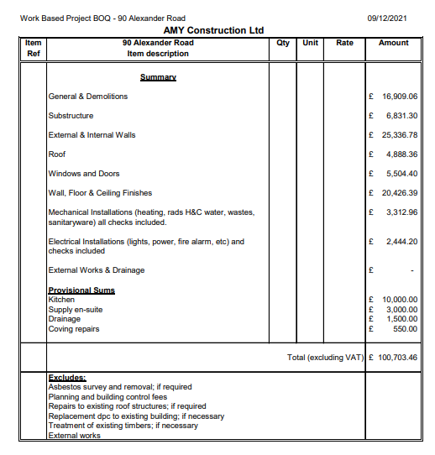
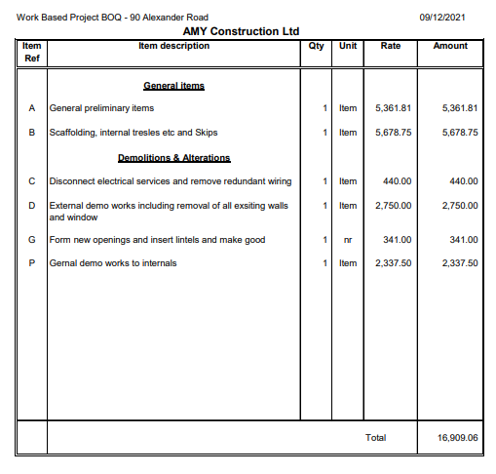
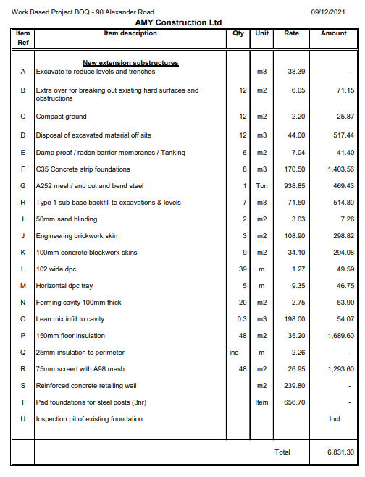
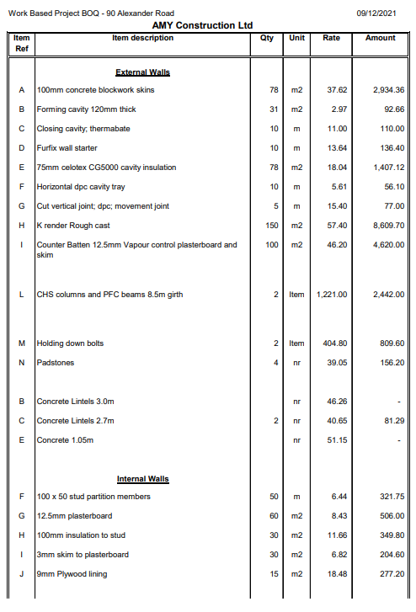
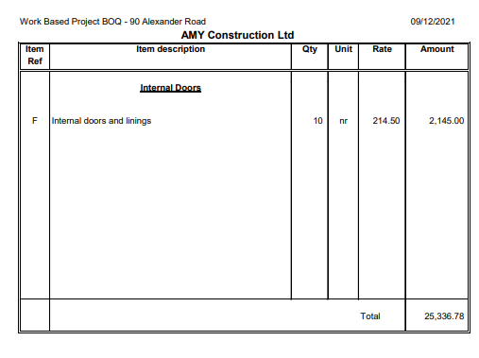
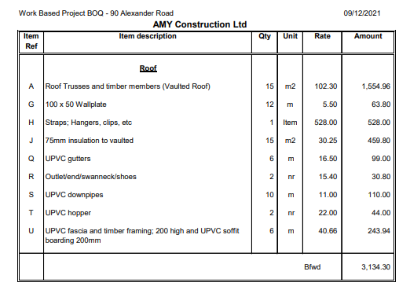
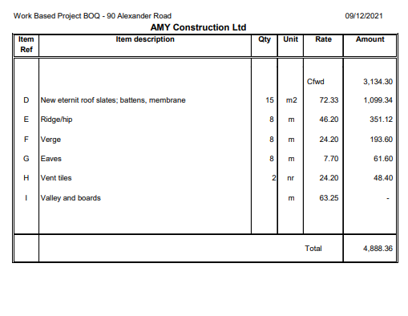
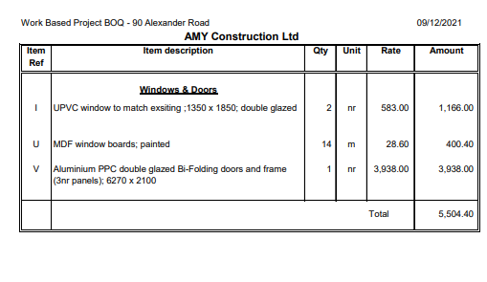
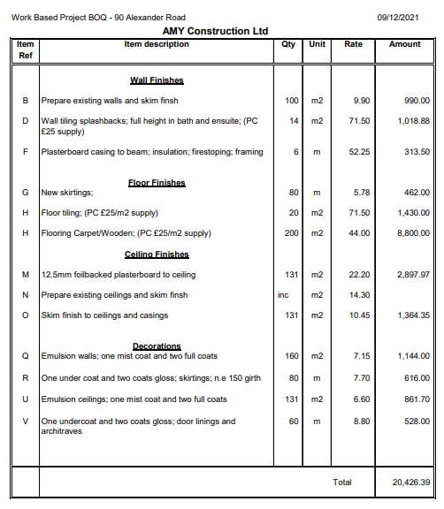
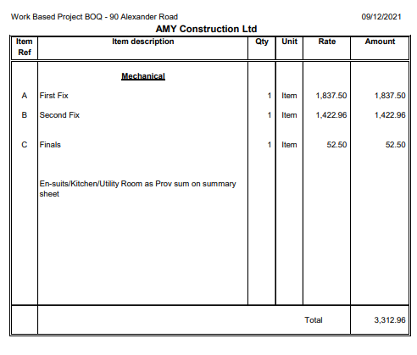
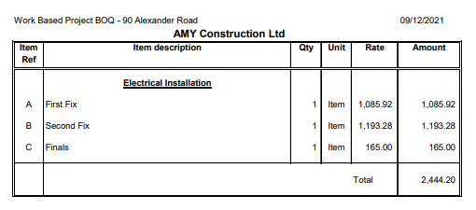
Reference List:
Emilia D’Silva-Parker (October 2021) “Price movements in construction materials and plant hire, UK: 2019-2021” [Online] Available: Price movements in construction materials and plant hire, UK - Office for National Statistics Accessed on: 21/11/2021
Lee Thomas (March 2019) “How value engineering is used in construction projects” [Online] Available: How Value Engineering is Used in Construction Projects | Project Cost Solutions Accessed on: 22/11/2021
National Institute of building science (August 2016) “Value engineering” [Online] Available: Value Engineering | WBDG - Whole Building Design Guide Accessed on: 22/11/2021
Simon Dunkling (June 2021) “Construction delays and material shortages due to Covid-19” [Online] Available: Construction delays and material shortages due to Covid-19 (pbctoday.co.uk) Accessed: 22/11/2021
HSE (January 2022) “Health and Safety at work ect act 1974” [Online] Available: Health and Safety at Work etc Act 1974 – legislation explained (hse.gov.uk) Accessed: 10/01/2022
HSE (January 2022a) “The law” [Online] Available: The law relating to working at height - HSE Accessed: 10/01/2022
HSE (January 2022b) “Control of Substances Hazardous to Health 2002 (COSHH)” [Online] Available: Control of Substances Hazardous to Health 2002 (COSHH) (hse.gov.uk) Accessed: 10/01/2022
HSE (January 2022c) “Lifting operations and lifting equipment regulations 1998 (LOLER)” [Online] Available: Lifting Operations and Lifting Equipment Regulations (LOLER) (hse.gov.uk) Accessed: 10/01/2022
The royal borough of Kensington and Chelsea (January 2022) “Communication during building projects” [Online] Available: Communication during building projects | Royal Borough of Kensington and Chelsea (rbkc.gov.uk) Accessed: 14/01/2022

