
Object Oriented Programming Assignment
1801285 Gemma Dunlop

February 17, 2020
Advanced Software Development – DR mike Dacey
University of Wales Trinity Saint David

Contents
1.1. Introduction 2
Part 1 2
Part 2 2
Part 3 2
2. Part 1 3
2.1. Classes and Objects 3
2.2. Data Encapsulation 5
2.2.1. Accessors and Mutators 5
2.2.2. Properties 6
2.3. Interfaces 7
3. Part 2 9
3.1. Testing Table 9
3.2. String check 17
3.3. Integer Check 19
3.4. Number of Doors Check 21
3.5. Age Check 22
4. Part 3 24
4.1. Design of part 3 24
5. Conclusion 26
Bibliography 27

Introduction

Part 1
This contains a brief description of fundamental concepts in C# object-oriented programming. The concepts discussed include the differences between classes and objects and an explanation of data encapsulation and interfaces.

Part 2
The aim of task 2 was to create a staff management project. This was developed using object-oriented programming concepts in the programming language C#. The project is required to be user friendly and easily understood.
The user is presented with a menu screen from which they can select from five options:
- Option one allows the user to create a new employee.
- Option two allows the user to search for an employee by either the id number or the last name and view the details.
- Option three allows the user to store the staff’s vehicle details that are parked on company premises.
- Option four allows the user to view all the staff vehicle details stored in the program, including the type of vehicle – car, van or motorcycle, the licence plate, the type, the vehicle manufacturer, the number of doors (must be either three, five or seven doors) and the colour of the vehicle.
- Option 5 allows the user to exit the program.
Suitable testing was carried out to ensure the program works properly with near zero errors. This serves to test the system’s functionality.

Part 3
This includes a problem-solving approach in a company which fills containers and empties each one into a mixer. Code was required to make sure each software agent is operating within the required boundaries. The boundaries include ensuring that only one valve is open at a time in each container, that the person manually inserting the elements knows not to insert any when the valve in container three is open. If the required boundaries are not met, code is needed to trigger an alarm.

Part 1

Classes and Objects
In C#, everything is associated with objects and classes. Objects which exist in the real world, for example, cars, trees and people can be easily identified. Whilst the objects naturally can’t exist inside computers, the computer is able to process information. The information a computer processes is an abstract entity as opposed to an object that exists in the real world. However, a program can store information and manipulate it accurately at high speed.
Cars
Class
Objects
Jaguar
Mercedes-Benz
Audi

A computer may hold details such as a car’s registration number, the owner and how many passengers it can carry. This information would be contained in the program as properties and the collection of all the information for a specific car would be the object. The car object contained in the program represents an object from the real world, but it contains only a tiny fraction of the details belonging to the real car.
An object contained in a computer program is not necessarily an object that exists in a physical sense in the real world. Some objects may be intangible for example, a job or an electronic order.
Objects which are similar can be grouped together in a class, for example cars are similar in that they all have four wheels, an engine, a steering wheel so a car can be generically grouped into a class of cars which have characteristics in common.
A class is defined by the properties of the objects and behaviours. For example, cars have the characteristics colour, model and make. All cars have certain behaviours such as stop, start and speed.
A class is like a blueprint for creating objects [1]. The advantage of classes is that they “encapsulate the characteristics and capabilities of an entity in a single, self-sustaining unit of code” [2].
A class can be created by using the keyword ‘class’ followed by the name of the class. Inside the class contains attributes and constructors. Attributes need to be created in a class in order to create objects.

Class Name
Class keyword
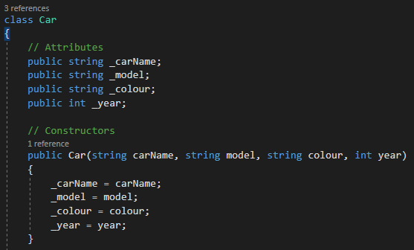
A constructor is a special method which is called when an object is created. A constructor must have the same name as the class name. A class can have as many constructors as needed. Constructors save time as they reduce the amount of code needed to be written when creating an object. As an example:
Main program before constructor is formed:
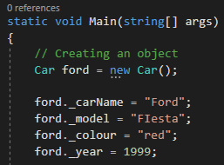
Main program after constructor is made.
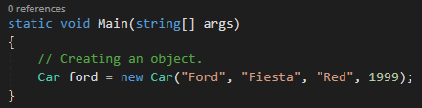

Data Encapsulation
Using data encapsulation allows certain variables to be declared as private.
Encapsulation makes the fields within the class private and provides access to the fields by creating public properties.
Data Encapsulation is an advanced mechanism in C# that wraps up data into a single unit (the class). This prevents the data and code being accessed outside the class, thus acting as a protective barrier. The importance of encapsulation is it hides the complex code within the class. This protects the code, so it prevents the data from being corrupted accidentally by human error or malicious corruption. This increases the security of the data.
Encapsulation keeps the class tidy by ensuring there are minimal visible fields which makes it easy to understand and use.
The fields can be made read-only (get), write-only (set) or both.
Encapsulation protects data from accidental or deliberate corruption. The data in the fields can be declared as private rather than public.
Encapsulation can be demonstrated in two ways:
- Accessors and mutators
- Properties

Accessors and Mutators
To manipulate the data in the Car class, the ‘get’ method – which is the accessor, and the ‘set’ method – the mutator, are used [3]. Setting to private protects the data and means access is only available within the same class, whereas public enables modifiers to access all the code within the program.
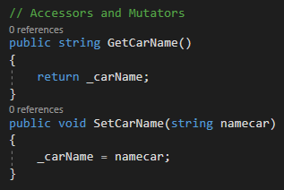
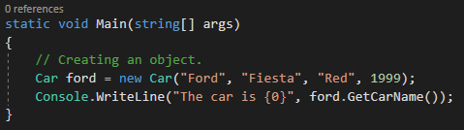

Properties
A new language feature with C# is properties. Properties help to protect a field in a class by applying read-only or write-only to it. Using accessors and mutators is good but encapsulation is smoother using properties.
The advantage of properties is the internal data point can be manipulated using a single named item [4].
Attributes set to private:
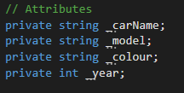
This does not allow attributes to be called in the main.
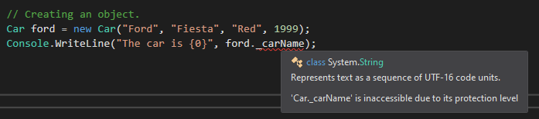
So instead a public property is formed in order for the attribute to be accessed through the property.
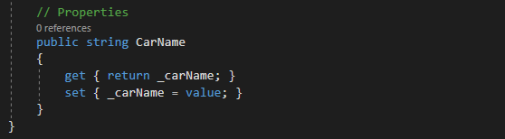
It is called in the main using the property name.
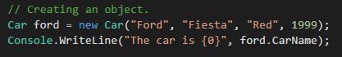
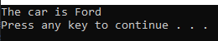

Interfaces
C# does not allow multiple inheritance. However, sometimes multiple inheritance is needed in certain real-life scenarios. In this instance, interfaces can be used to implement multiple interfaces.
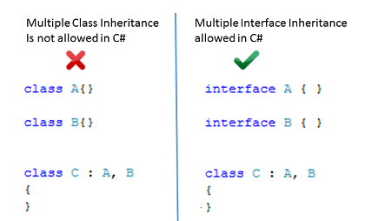 [5]
An interface is an entirely abstract class exclusively consisting of public abstract methods and properties [2]. This means no methods in an interface can contain bodies. An interface can be declared by using the keyword ‘interface’.
All methods in an interface are defaulted as abstract so there is no need to declare each method as abstract. Constant fields, constructors and destructors cannot be used in interfaces and methods cannot be declared as static.
A class can implement one or many interfaces like followed:

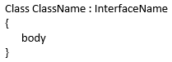

The same interface can be implemented by multiple different classes.
A class can also implement a base class and multiple interfaces. For example:

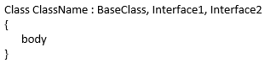

Interfaces can also be sub interfaced. For example:
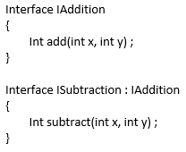
Both methods ‘add’ and ‘subtract’ will be placed in the interface named ISubtraction. This means a class only needs to implement the interface ISubtraction and use both methods.

Part 2

Testing Table
Test No | Aim of Test | Input(s) | Expected Output | Actual Output | Does it work as expected?
1 | Is a menu choice outputted? |  | 5 menu choices that the user can choose from. | 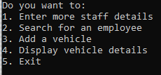 | Yes
2 | When the user chooses option one, is the user told to input staff details? | 1 | User prompted to type the id number of the employee they want to create. | 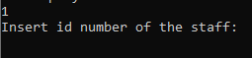 | Yes
3 | Is the user prompted to enter all fields of the object? | 1801285, Gemma, Dunlop, 20, f, 8 Heol Gam | All fields in the object are asked to be input by the user. | 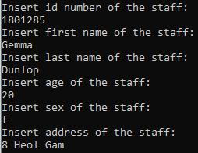 | Yes
18 | Will the program accept blank data to be entered for inputting integer values? | “ “ | Program rejects input and asks user to input a different value. | 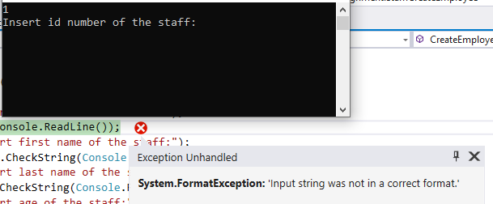 | No
19 | Will the program accept blank data to be entered for inputting string values? | “ “ | Program rejects input and asks user to input a different value. | 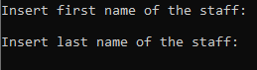 | No
20 | Will the program accept characters to be entered? | Blue | Program rejects input and asks user to input a different value. | 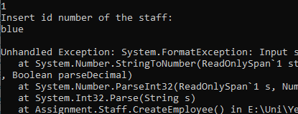 | No
4 | Can the user enter an age that is not between 18-70? | 2 | Does not accept input. | 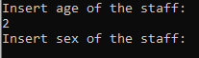 | No
5 | Is the user asked to enter whether the staff’s photo has been taken? |  | Asks if photo has been taken. |  | Yes
5 | Will the program accept the input “True” for staff photo being taken? | True | Sets Boolean value to true and confirms that the photo has been taken. | 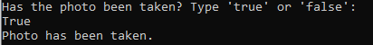 | Yes
6 | Will the program accept the input “true” for staff photo being taken? | true | Sets Boolean value to true and confirms that the photo has been taken. | 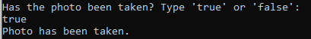 | Yes
7 | Will the program accept the input “False” for staff photo being taken? | False | Sets Boolean value to false, confirms that photo has not been taken and asks the user if they want to take photo now. | 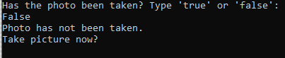 | Yes
8 | Will the program accept the input “false” for staff photo being taken? | false | Sets Boolean value to false, confirms that photo has not been taken and asks the user if they want to take photo now. | 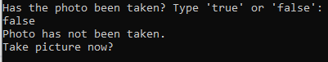 | Yes
9 | Will the program set the status to true if user says yes to taking picture now? | Yes | Status is set to true. | 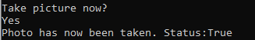 | Yes
10 | If the user says no to taking picture now, will the program ask the user to take photo now until user says yes? | No, no, no, yes | Program tells user that the photo must be taken in order to proceed. | 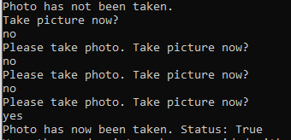 | Yes
11 | Will the program accept the input “True” for staff details being sent to card printers? | True | Boolean value set to true, message outputted saying card details have been printed and user is asked to enter the date the card was issued. | 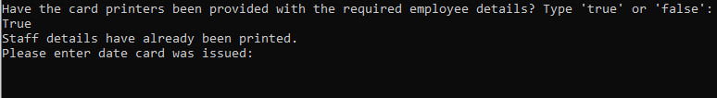 | Yes
12 | Will the program accept the input “true” for staff details being sent to card printers? | true | Boolean value set to true, message outputted saying card details have been printed and user is asked to enter the date the card was issued. |  | Yes
13 | Will the program accept the input “False” for staff details being sent to card printers? | False | Boolean value set to false, message outputted saying card details have been printed and user is asked to enter the date the card was issued. | 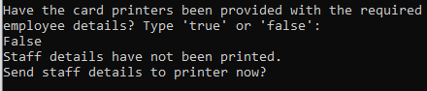 | Yes
14 | Will the program accept the input “false” for staff details being sent to card printers? | false | Boolean value set to false, message outputted saying card details have been printed and user is asked to enter the date the card was issued. | 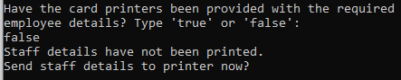 | Yes
15 | If the user says no to taking sending details to card printer, will the program ask the user to take photo now until user says yes? | no, no, no, yes | Program tells user that the staff details must be sent in order to proceed. | 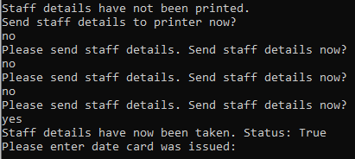 | Yes
16 | Does the program allow the user to enter the date the card is issued? | 17/02/2020 | Tells the user that the card has now been issued. | 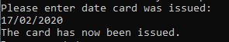 | Yes
17 | Is the user sent to the main menu after entering staff details? |  | Menu choices appear again. |  | Yes
21 | Will the program accept input which is not ‘true’ or ‘false’ for Boolean? | No |  | 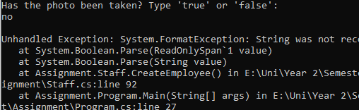 | No
22 | Does the program allow the user to search for a staff member? | 2 | Asks the user if they want to search by last name or id number. | 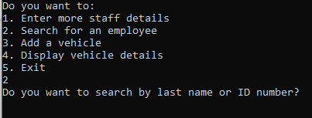 | Yes
23 | If the user chooses to search by last name, will it ask user for last name when chosen? | Last Name | Asks the user for the last name of the staff they want to find. | 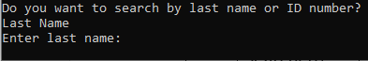 | Yes
24 | If the user choses to search by if number, will it ask user for id number when chosen? | Id Number | Asks the user for the Id Number of the staff they want to find. | 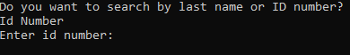 | Yes
25 | Will the program accept an input other than “Last Name” or “Id Number”? | No | Takes user back to main menu | 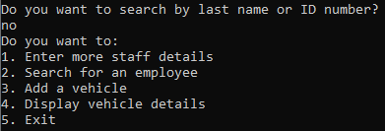 | Yes
26 | Can the staff details be searched by last name? | Dunlop | Details of the staff member which matches the surname entered. | 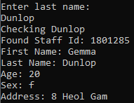 | Yes
27 | Can the staff details be searched by id number? | 1801285 | Details of the staff member which matches the id number entered. | 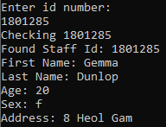 | Yes
28 | Does the program tell the user if a staff they searched in the program is not found? | Jones | Program tells user that there is no staff member with that name. | 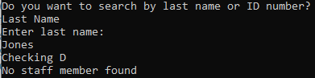 | Yes
29 | Does the program tell the user if a staff they searched in the program is not found? | 4 | Program tells user that there is no staff member with that name. | 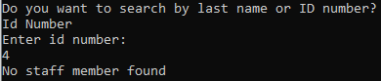 | Yes
30 | Is user asked what vehicle they would like to add when they choose option 3? | 3 | Asks the user to choose between three options: car, van or motorcycle. | 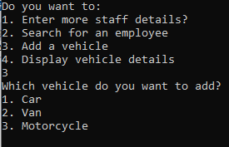 | Yes
31 | If the user inputs “Car”, is the user told to input car details? | Car | Program asks for the licence plate. | 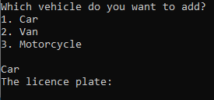 | Yes
32 | If the user inputs “1”, is the user told to input car details? | 1 | Program asks for the licence plate. | 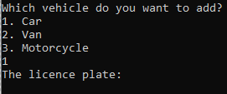 | Yes
33 | If the user inputs “car”, is the user told to input car details? | car | Program asks for the licence plate. | 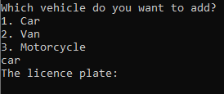 | Yes
34 | Is the user prompted to enter all fields of the car object? | MX53 VMP, X, Jaguar, 5, Silver | All fields are asked to be input by the user. | 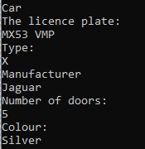 | Yes
35 | Does the program accept the number of doors to be a number other than 3, 5 or 7? | 6 | Program only accepts 3, 5 or 7 | 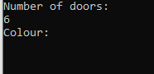 | No
35 | If the user inputs “Van”, is the user told to input van details? | Van | Program asks for the licence plate. | 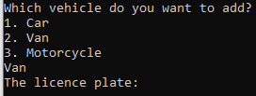 | Yes
36 | If the user inputs “2”, is the user told to input van details? | 2 | Program asks for the licence plate. | 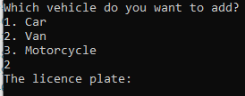 | Yes
37 | If the user inputs “van”, is the user told to input van details? | van | Program asks for the licence plate. | 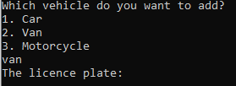 | Yes
38 | Is the user prompted to enter all fields of the object? | JN67 NDK, Elgrand, Nissan, Red, 2.5 | All fields are asked to be input by the user. | 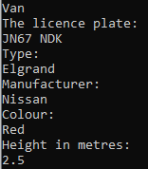 | Yes
39 | When the user inputs “Motorcycle”, is the user told to input motorcycle details? | Motorcycle | Program asks for the licence plate. | 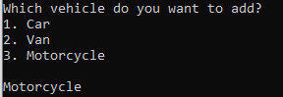 | Yes
40 | When the user inputs “3”, is the user told to input motorcycle details? | 3 | Program asks for the licence plate. |  | Yes
41 | When the user inputs “motorcycle”, is the user told to input motorcycle details? | motorcycle | Program asks for the licence plate. | 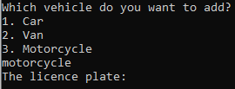 | Yes
42 | Is the user prompted to enter all fields of the object? | JN67 NDK, Elgrand, Nissan, Red, 2.5 | All fields are asked to be input by the user. | 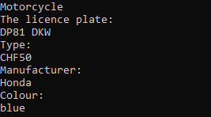 | Yes
43 | Can the program display vehicle details on request? | 4 | All vehicle details are displayed. | 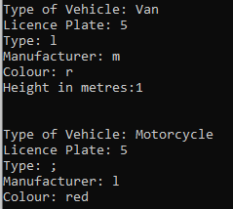 | Yes
44 | Does the program exit on request? | 5 | Closes Program | 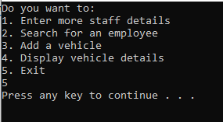 | Yes
45 | Does the program accept a number not in the switch statement? | 7 | Asks user to enter again. | 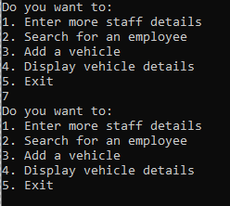 | Yes
46 | Does the program accept an alphanumeric value? | F | Asks user to enter again. | 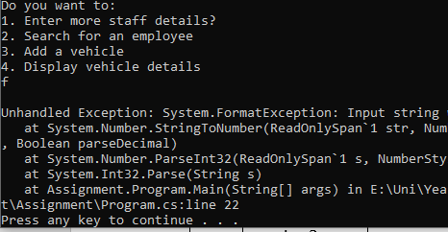 | No
47 | Does the program accept a non-alphanumeric value? | # | Asks user to enter again. | 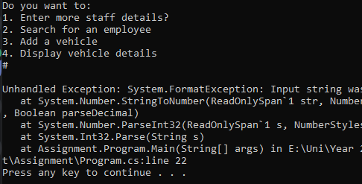 | No

String check
Initially, the program accepted a blank value.
Validation checks were created within a Validation class to prevent the user entering invalid data.
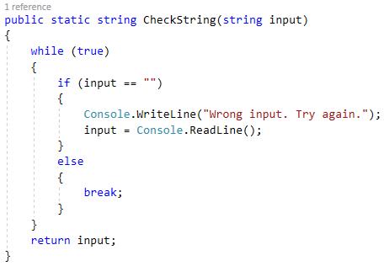
The string check method was used on all string fields in the staff object and the vehicle objects.
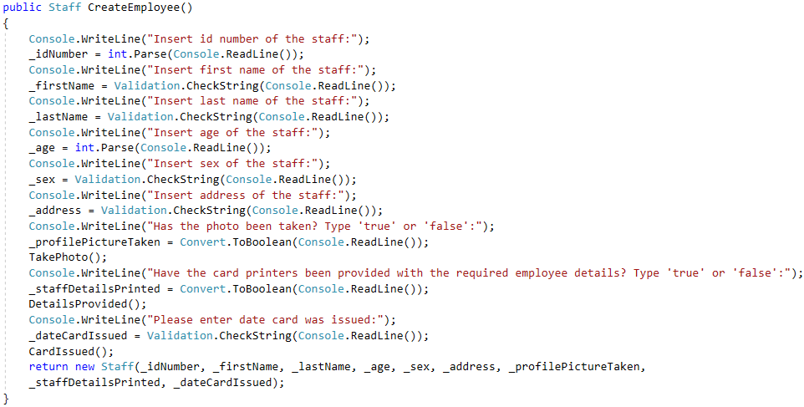
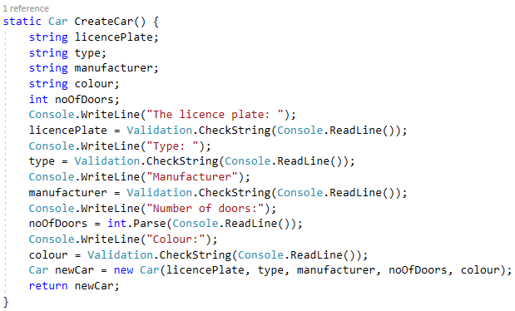
This meant the program returns an error message if blank data was returned and asks the user to enter it again correctly.
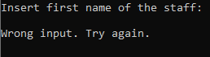
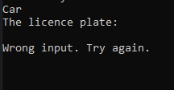

Integer Check
A validation check was created to give an error message if any data other than an integer is entered and asks the user to enter again.
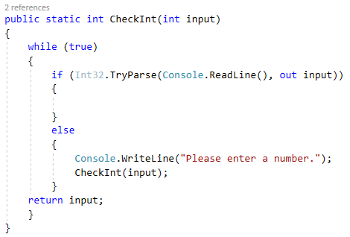
It was used for entering the id number of a staff member.
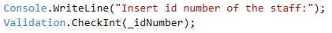
Outputs:

Entering letters
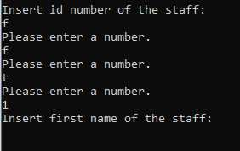

Entering non-alphanumeric values
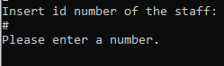

Entering blank data
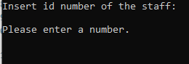

However, this validation was still not effective as it set all user input for integers as 0.

Number of Doors Check
Cars only have 3, 5 or 7 doors. In order to make the program’s input accurate, a validation check was created to prevent invalid input.
To achieve this, a validation function was created to force the user to only input the number 3, 5 or 7.
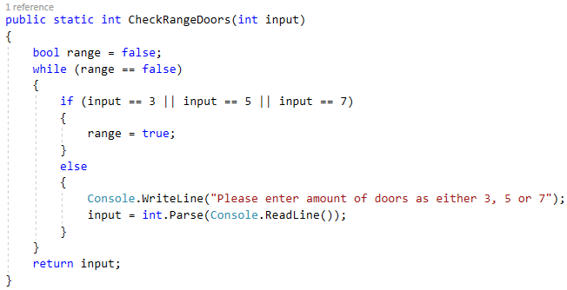
Output:
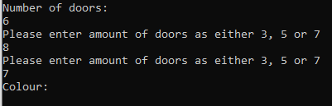
The program continuously asks the user to enter again until the input entered is valid.

Age Check
Currently, the program accepts any number entered for the age. This means values such as 5 or 200 can be entered. As the company cannot hire someone who is 5 years old, or 200 years old, a validation function was made to show an error message if a number out of the range 18-70 was entered.
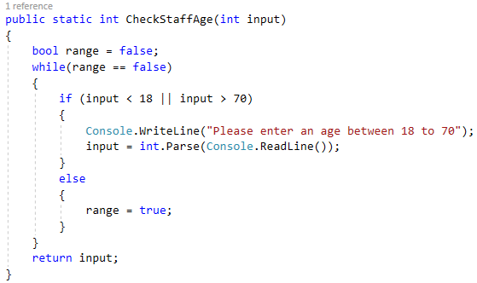
Output:
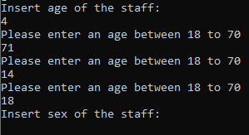
The program continuously asks the user to enter again until the input entered is valid.

Output:
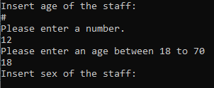
Both the validation functions check for invalid data.

Part 3

Design of part 3
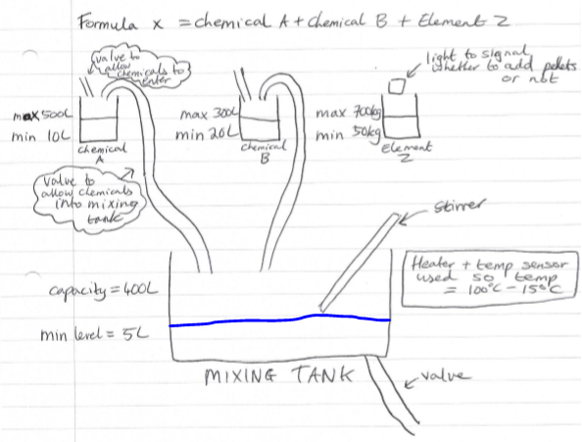

The provided code includes an interface which contains all the abstract methods needed for each step in the system.

Valves
chemicalALoadingValue
chemicalAClosingValve
chemicalBLoadingValve
chemicalBClosingValve

If (chemicalALoadingValue = open)
chemicalAClosingValve = closed
If (chemicalALoadingValue = closed)
chemicalAClosingValve = open
Container Doors
elementZDoor
If (elementZDoor = open)
Light = off

If (light = on)
elementZ = closed

Conclusion
In the assignment, a staff management systems development was designed. It enables the company to add, view and manage details of staff and their vehicles parked. The staff management software application enables the company to reduce paperwork and become more efficient in maintaining staff records, thus saving the company time and money. The functionality was tested. With more time, more testing could have been done, along with more validation methods to ensure data inserted is more valid. To improve the system, the user could have also had the ability to edit staff details after they were created. Thorough testing is important to ensure the reliability of the staff management system and ensures it can perform all the operations that is required of it.

Bibliography

[1] | D. Clark, Beginning C# Object-Oriented Programming, California: Apress, 2013.
[2] | J. Liberty, Programming C#: Building .NET Applications with C#, California: O'Reilly Media Inc., 2005.
[3] | B. Doyle, C# Programming: From Problem Analysis to Program Design, Boston: Cengage Learning Inc, 2015.
[4] | G. G. A. Ganesh, “Encapsulation In C#,” C# Corner, india, 2019.
[5] | R. Singh, “1 Scenario where C# interface is indispensable?,” 1 August 2016. [Online]. Available: https://www.interviewsansar.com/1-scenario-where-csharp-interface-is-indispensable/. [Accessed 21 June 2019].

