
Williams, Matthew
BEng, Yr. 1 - 2024
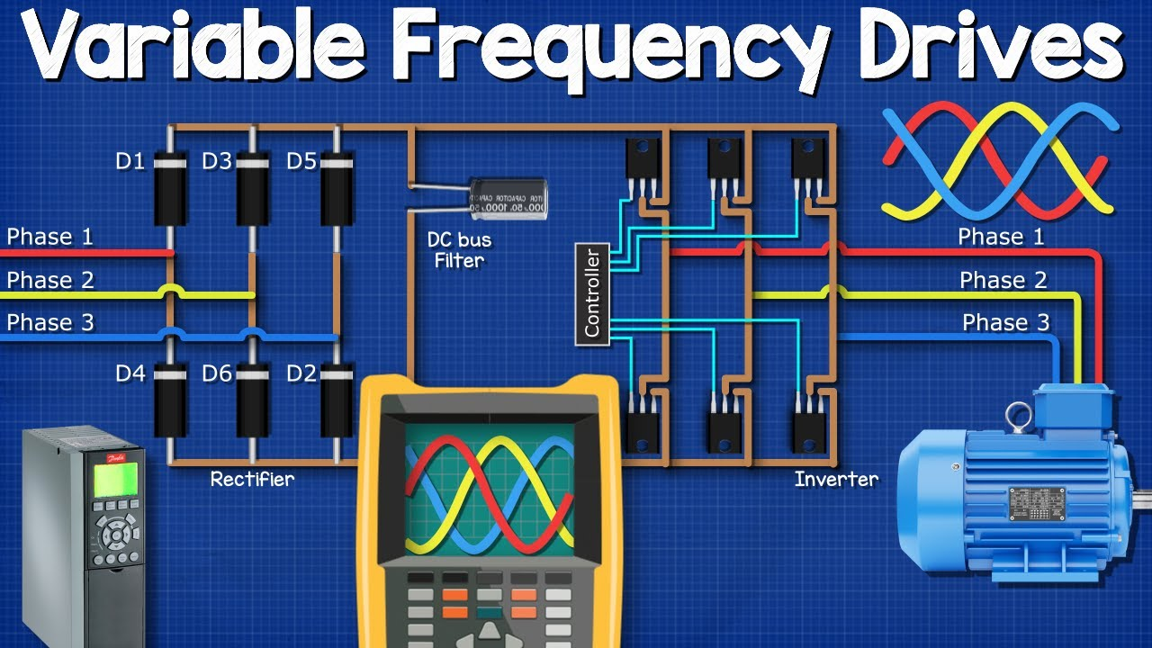
Power Electronics & Drives
BEng Electrical & Electronic Engineering
Electronic Power Drive Systems Design

Table of Contents
Task 1 Introduction 2
Background Information 2
Common DC Bus 2
Protection 2
Cost 2
Flexibility and Information Gathering 2
Vector Control 2
Types of Motor Starters: Manual Starters 3
Magnetic Starters 3
Soft Starters 3
Direct Online (DOL) Starters 3
Star-Delta Starters 3
Motor A (500 kW, 3 Phase, 400V, Reversible, Variable Speed) 4
Motor B (80 kW, 3 Phase, 400V, Reversible, Variable Speed) 7
Motor C (10 kW, 3 Phase, 400V, Non-Reversible, Variable Speed) 10
Motor D (5 kW, 3 Phase, 400V, Reversible, Fixed Speed) 13
Motor E (1 kW, Single Phase, 230V, Non-Reversible, Fixed Speed) 15
Task 1 Conclusion 17
Task 2 Background Information 18
Diodes 18
Thyristors (SCRs) 18
Insulated Gate Bipolar Transistors (IGBTs) 18
Harmonic Noise 19
Minimising Harmonic Noise 20
Effect of Harmonics on Power and Power Factor 21
Simulations 22
Diode Rectifier Simulation 22
Thyristors (SCRs) Rectifier Simulation 25
IGBT Rectifier Simulation 28
12 Pulse Diode Rectifier Simulation 31
Task 2 Conclusions 34
References 35

Task 1 Introduction
We have been tasked with specifying replacement motor drive systems for a factory refit scheme. There are five types of induction motor in the factory as shown in Table 1 below:

 | Motor A | Motor B | Motor C | Motor D | Motor E
Power | 500 kW | 80 kW | 10 kW | 5 kW | 1 kW
Phases | 3 | 3 | 3 | 3 | 1
Voltage | 400 | 400 | 400 | 400 | 230
Required to be Reversible? | Yes | Yes | No | Yes | No
Variable speed required? | Yes | Yes | Yes | No | No
Quantity Installed | 5 | 10 | 23 | 17 | 127
Example Application | Rolling Mill | Gantry Crane | Conveyor | Cutting machine | Pumps / Fans
Table 1: Factory Motors

Background Information
The following must be taken into account when choosing a suitable drive control:

Common DC Bus
For energy efficiency and cost savings, particularly in setups where multiple motors are used a common DC bus system can be advantageous. It allows for energy generated from one part of the system (e.g. generated braking energy) to be used elsewhere, improving overall energy efficiency. Common DC bus also lead to lower hardware costs and simplified system architecture. [1]

Protection
Across all motor types, appropriate protection for overcurrent, overload and thermal protection must be integrated to ensure safe operation.

Cost
The correct control drive selection will be imperative to prevent costs getting out of control. Where Motors A & B will require expensive investments, the use of cheaper technology might be possible for Motors C, D & E.

Flexibility and Information Gathering
Where variable speed and reversible operation are required, VFDs offer advanced control capabilities and the ability to integrate with factory automation systems like BMS, providing valuable operational data for predictive maintenance and efficiency optimization.

Vector Control
Vector Control technology offers significantly increased torque at lower speeds as well as keeping control of speed under sudden load changes. Motors with Vector Control drive run cooler and therefore more efficiently. [2]

Types of Motor Starters: Manual Starters
These are the simplest form of starters, requiring an operator to manually switch the motor on or off.

Magnetic Starters
These are electromagnetically operated starters that automatically start or stop the motor. They consist of a contactor and an overload relay to provide protection.

Soft Starters
Soft starters gradually increase the motor's voltage, providing a smooth ramp-up to full speed. This helps reduce mechanical stress on the motor and electrical stress on the power system.

Direct Online (DOL) Starters
These starters connect the motor directly to the power supply, suitable for small to medium motors. DOL starters are straightforward but can cause high start-up currents.

Star-Delta Starters
Used for larger motors, these starters initially connect the motor windings in a star configuration for low voltage during start-up, then switch to a delta configuration for normal operation, reducing the start-up current.

Motor A (500 kW, 3 Phase, 400V, Reversible, Variable Speed)

 | Power | Phases | Voltage | Required to be Reversible? | Variable speed required? | Quantity Installed | Example Application
Motor A | 500 kW | 3 | 400 | Yes | Yes | 5 | Rolling Mill
Table 2: Motor A Information

The high power requirements of Motor A, and the need for both reversibility and variable speed control would suggest a Variable Frequency Drive would be the ideal technology to be used here for Motor A. Vector Control would offer precise speed and torque control, essential for a high power applications like a rolling mill. The drive must support quick and efficient reversibility without the need for mechanical switches. This capability is crucial for rolling mill operations where the direction of the motor may need to be changed rapidly and frequently. Implementing a common DC bus system could offer energy savings, especially if there are opportunities for regenerative braking to feed energy back into the system. Given the nature of the operation, the drive must include overcurrent, thermal, and overload protection. This is essential for handling sudden changes in load without tripping. Integration with the factory’s existing monitoring and control systems using standard communication protocols (like Ethernet, Modbus, or PROFIBUS) is beneficial for precise control, performance monitoring of the drive system as well as predictive maintenance of heavy industrial plant machines. [3]

Motor A - Rolling Mill
Model: | PowerFlex 755 TL/TR/TM | Altivar Process ATV900 | VTS Series Universal Variable Speed AC Drive
Company: | Rockwell Automation | Schneider Electric | V&T Technologies
Photo: | 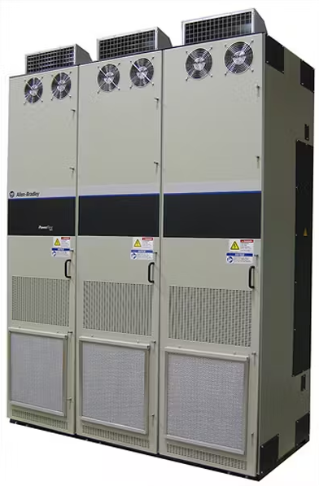 | 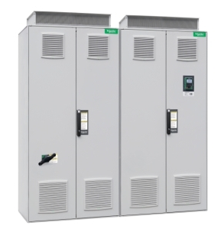 | 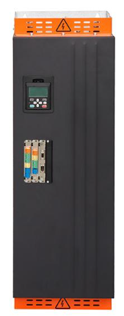
Supply Voltage: | 400 VAC | 380…415 VAC | 380…480 VAC
Phases: | 3 | 3 | 3
Supply Frequency: | 47…63 Hz | 50…60 Hz | 50…60 Hz
Power Rating (Normal Duty): | 560 kW | 630 kW | N/A
Power Rating  (Heavy Duty): | 500 kW | 500 kW | 500 kW
Output Current  (Normal Duty): | 1040 A | 1140 A | 1548 A
Output Current  (Heavy Duty): | 920 A | 900 A | 860 A
Destination: | Asynchronous & Synchronous Motors | Asynchronous & Synchronous Motors | Asynchronous & Synchronous Motors
Speed Drive Output Frequency: | 0…500 Hz | 0.1…599 Hz | 0…600 Hz
Vector Control: | Yes | Yes | Yes
Energy Efficiency: | 97.5% | 96.5% | 98%
Motor Slip Compensation: | N/A | Adjustable,  Automatic whatever the load,  Can be suppressed | N/A
Acceleration And Deceleration Ramps: | N/A | Linear adjustable separately from 0.01 to 9000 s (Customised) | N/A
Refresh Time: | N/A | 0.5 ms | N/A
Communication: | Modbus, Ethernet IP | Modbus TCP,  Modbus Serial, Ethernet IP, | Modbus 485,  EitherCAT,  Profibus-DP,  Profinet
Protection: | Overcurrent, Overload,  Short Circuit, Overvoltage,  Under voltage | Thermal, Safe Torque, Motor Phase Break, Overheating, Overcurrent, Overload,  Short Circuit, Overvoltage,  Under voltage,  Phase Loss,  Over speed | Under-voltage,  Over-current,  Over-voltage,  Over-temperature,  Overload protection,  Short-circuit
IP Rating: | N/A | IP23 | IP20
Ambient Air Temp  for Operation: | -10 to 50 °C | -10 to 40 °C | -10 to 40 °C
Volume of Cooling Air: | 6880 m³/h | 4640 m³/h | N/A
Weight: | N/A | 1450 kg
W x D x H | 597mm x 676mm x 2130mm | 664mm x 1000mm x 2150mm | 407mm x 699mm x 1432mm
Price: | On Request | On Request | On Request
Pros: | Good Energy Efficiency | Offers excellent protection parameters. Excellent Speed variant capability | Cheap and affordable
Cons: | No thermal protection, No Acceleration & Deceleration Ramp, Low speed frequency | Energy Efficiency slightly lower than the competition | Chinese manufacturer and sales, would be unlikely to get Maintenance Support
Website: | https://literature.rockwellautomation.com/idc/groups/literature/documents/td/750-td001_-en-p.pdf | https://www.se.com/uk/en/product/ATV980C63Q4X1/variable-speed-drive-altivar-process-atv900-regenerative-system-atv980-630-500-kw-400-v-with-ce-ip23/ | https://www.vectorque.com/250kw-500kw-vts-series-universal-variable-speed-ac-drive_p45.html
Chosen Drive:
Referencing: | [4] | [5] | [6]
Table 3: Motor A Comparison

Figure 1: Chosen Drive for Motor A

Datasheet - https://www.se.com/uk/en/product/download-pdf/ATV980C63Q4X1?filename=Schneider+Electric_Altivar-Process-ATV900_ATV980C63Q4X1.pdf

Motor B (80 kW, 3 Phase, 400V, Reversible, Variable Speed)

 | Power | Phases | Voltage | Required to be Reversible? | Variable speed required? | Quantity Installed | Example Application
Motor B | 80 kW | 3 | 400 | Yes | Yes | 10 | Gantry Crane
Table 4: Motor B Information

Given Motor B’s use in gantry cranes, precise control over speed and position is crucial. Similar to Motor A reversibility and variable speed loans itself well to a Variable Frequency Drive, and even though Motor B has a lower power requirement than Motor A, energy efficiency measures like a common DC bus could also work very well due to multiple motors breaking at regular intervals as the cranes move around the factory. Selecting a motor drive for a gantry crane application, requires careful consideration of several factors to ensure optimal performance, safety, and longevity of the system. When looking at safety features, drives that offer overcurrent protection, thermal overload protection, and emergency stop functionalities are essential. For precision in movement and operation, especially in crane applications where loads must be handled delicately, a drive that offers smooth and wide-ranging variable speed control is essential. Like Motor A, integration with the factory’s existing systems using standard communication protocols is beneficial for precise control, performance monitoring of the drive system as well as predictive maintenance of the heavy industrial plant machines. [7]

Motor B - Gantry Crane
Model: | Altivar Process ATV600 | ACS880-01-245A-3+N7502 | PowerFlex 750 Series
Company: | Schneider Electric | ABB | Rockwell Automation
Photo: | 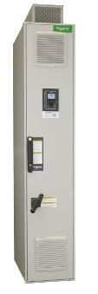 | 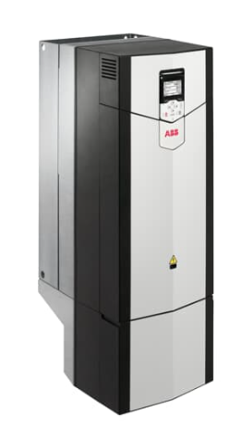 | 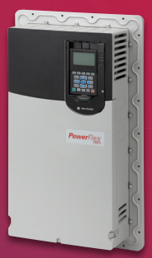
Supply Voltage: | 380…415 VAC | 380…415 VAC | 400 VAC
Phases: | 3 | 3 | 3
Supply Frequency: | 50…60 Hz | 47.5…63 Hz | 50…60 Hz
Power Rating (Normal Duty): | 110 kW | 110 kW | 132 kW
Power Rating  (Heavy Duty): | 90 kW | 90 kW | 110 kW
Output Current  (Normal Duty): | 195 A | 245 A | 260 A
Output Current  (Heavy Duty): | 164 A | 202 A | -
Destination: | Asynchronous & Synchronous Motors | Asynchronous & Synchronous Motors | Asynchronous & Synchronous Motors
Speed Drive Output Frequency: | 0.1…500 Hz | 0…598 Hz | 0…590 Hz
Vector Control: | No | No | Yes
Energy Efficiency: | 98% | 97% | 96.5%
Motor Slip Compensation: | Adjustable,  Automatic whatever the load,  Can be suppressed | 10% of nominal slip | N/A
Acceleration And Deceleration Ramps: | Linear adjustable separately from 0.01 to 9000 s | Yes | N/A
Refresh Time: | 0.5 ms |  | N/A
Communication: | Modbus TCP,  Modbus Serial, Ethernet IP, | CAN,  DeviceNet,  EtherNet/IP,  MODBUS,  PROFIsafe,  PROFIBUS,  PROFINET IO | Modbus, Ethernet IP
Protection: | Thermal, Safe Torque, Motor Phase Break, Overheating, Overcurrent, Overload,  Short Circuit, Overvoltage,  Under voltage,  Phase Loss,  Over speed | Earth Fault,  Over-voltage,  Overload protection, | Overcurrent, Overload,  Short Circuit, Overvoltage,  Under voltage
IP Rating: | IP23 | IP21 | N/A
Ambient Air Temp  for Operation: | -10 to 40 °C | -15 to 40 °C | -20 to 40 °C
Volume of Cooling Air: | 580 m³/h | N/A | N/A
Weight: | 300 kg | 68 kg | N/A
W x D x H | 664mm x 400mm x 2150mm | 300mm x 386mm x 965mm | N/A
Price: | On Request | On Request | £7,189.92
Pros: | Offers excellent protection parameters that’s important for application. Also excellent energy efficiency | Compact, energy efficient unit | Offers Vector Control
Cons: | Speed frequency is lower, but less important for application | Lower IP rating than competition | No thermal protection, No Acceleration & Deceleration Ramp
Website: | https://www.se.com/uk/en/product/ATV660C11Q4X1/variable-speed-drive-altivar-process-atv600-compact-system-atv660-110-90-kw-400-v-ip23/ | https://new.abb.com/products/3AXD50000035936/acs880-01-245a-3n7502 | https://configurator.rockwellautomation.com/configurator/F5C2020B0FDC4BC590385979E14493ED/summary
Chosen Drive:
Referencing: | [8] | [9] | [10]
Table 5: Motor B Comparison

Figure 2: Chosen Drive for Motor B

Datasheet - https://www.se.com/uk/en/product/download-pdf/ATV660C11Q4X1?filename=Schneider+Electric_Altivar-Process-ATV600_ATV660C11Q4X1.pdf

Motor C (10 kW, 3 Phase, 400V, Non-Reversible, Variable Speed)

 | Power | Phases | Voltage | Required to be Reversible? | Variable speed required? | Quantity Installed | Example Application
Motor C | 10 kW | 3 | 400 | No | Yes | 23 | Conveyor
Table 6: Motor C Information

For an application like a conveyor that requires variable speeds but no reversibility, a simpler Variable Frequency Drive setup can be considered for Motor C. For a conveyor, the motor drive should provide smooth speed control, efficient operation, and durability. The focus here should be on cost-effectiveness and ease of integration. Energy efficiency remains important, but the control system can be less complicated than those required for reversible operations like in Motor A & B. While a common DC bus might not be as vital for lesser power hungry applications like Motor C, efficiency and integration into control systems is useful. The drive should offer options for integration with industrial control systems, such as PLCs, via standard communication connections like Modbus, Ethernet/IP or Profinet. A drive that offers Vector Control would also be useful, as they provide higher torque at low speeds, which is beneficial for start-stop applications like conveyors.

Motor C - Conveyor
Model: | PowerFlex 525 | Altivar Process ATV600 | VLT FC51
Company: | Allen Bradley | Schneider Electric | Danfoss
Photo: | 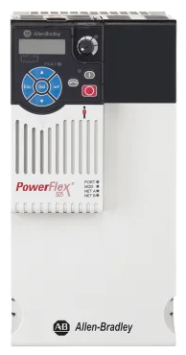 | 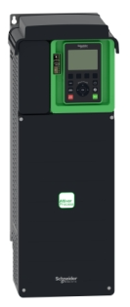 | 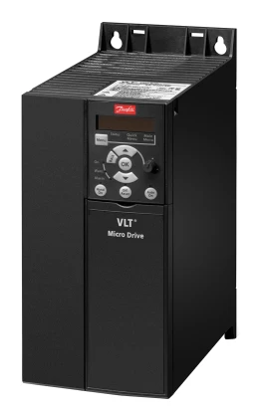
Supply Voltage: | 400 VAC | 380…480 VAC | 400 VAC
Phases: | 3 | 3 | 3
Supply Frequency: | 47…63 Hz | 50…60 Hz | 50…60 Hz
Power Factor: | 0.98 | 0.98 | 0.98
Power Rating: | 11 kW | 11 kW | 11 kW
Output Current : | 24 A | 20.6 A | 23 A
Destination: | AC Motors | Asynchronous & Synchronous Motors | AC Motors
Speed Drive Output Frequency: | 0…500 Hz | 0.1…500 Hz | 0…400 Hz
Vector Control: | Yes | Yes | No
Energy Efficiency: | 97.5% | 97% | 98%
Motor Slip Compensation: | N/A | Can be suppressed,  Adjustable,  Automatic whatever the load | N/A
Acceleration And Deceleration Ramps: | Four independently programmable accel and decel times. Each time may be programmed from 0...600 s in 0.01 s increments | Linear adjustable separately from 0.01...9999 s | 0.05…3600 s
Communication: | Profibus,  Ethernet IP | Ethernet,  Modbus serial,  Modbus TCP | Modbus
Protection: | Overvoltage,  Under voltage,  Overload,  Overcurrent,  Short Circuit | Thermal, Safe Torque, Motor Phase Break, Overheating, Overcurrent, Overload,  Short Circuit, Overvoltage,  Under voltage,  Phase Loss,  Over speed | Thermal,  Earth Fault,  Short Circuit
IP Rating: | IP20 | IP21 | IP21
Ambient Air Temp  for Operation: | -20 to 50 °C | -15 to 50 °C | N/A
Volume of Cooling Air: | 0.575m³/min | 215m³/hour | N/A
Weight: | 12.9 kg | 13.6 kg | N/A
W x D x H | 130mm x 212mm x 260mm | 211mm x 232mm x 546mm | 125mm x 241mm x 292mm
Price: | £1,996.79 | £2,500.93 | £1,439.65
Pros: | Good Energy Efficiency and Power Factor | Excellent protection parameters and Speed Frequencies | Cheaper than others
Cons: | IP rating slightly lower than the competition | Slightly more expensive than competition here | Datasheet not so detailed
Website: | https://uk.rs-online.com/web/p/inverter-drives/8904339 | https://www.se.com/uk/en/product/ATV630D15N4/variable-speed-drive-atv630-15kw-20hp-380-480v-ip21-ul-type-1/ | https://uk.rs-online.com/web/p/inverter-drives/8918845
Chosen Drive:
Referencing: | [11] | [12] | [13]
Table 7: Motor C comparison

Figure 3: Chosen Drive for Motor C

Datasheet - https://www.se.com/uk/en/product/download-pdf/ATV630D15N4?filename=Schneider+Electric_Altivar-Process-ATV600_ATV630D15N4.pdf

Motor D (5 kW, 3 Phase, 400V, Reversible, Fixed Speed)

 | Power | Phases | Voltage | Required to be Reversible? | Variable speed required? | Quantity Installed | Example Application
Motor D | 5 kW | 3 | 400 | Yes | No | 17 | Cutting machine
Table 8: Motor D Information
Given the nature of the application for Motor D is a Cutting Machine, the drive system must be capable of handling more than the 5kW our motor requires. This is to ensure there is a buffer for peak and potential start-up loads. Motor D is not required to be variable speed, this eliminates the need for expensive Variable Frequency Drives. Fixed speed is sufficient for a Cutting Machine, but start-up stress needs to be minimized, a soft starter is ideal, as it will reduce mechanical and electrical stress on the system. Given that Motor D needs to have reversing functionality, the soft starter must include reversible contacts to prevent the need to manually swap wiring. A drive with the ability to adjust parameters like acceleration and deceleration times would also be preferable, along with options for integration with industrial control systems for operational status monitoring.
Motor D - Cutting Machine
Model: | VLT SOFT START  MCD 100-007 | Softstart PSTX | ATS 22 Soft Starter
Company: | DANFOSS | ABB | Schneider Electric
Photo: | 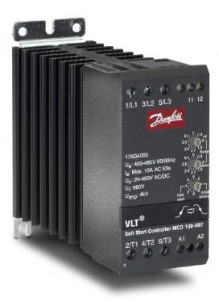 | 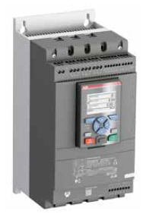 | 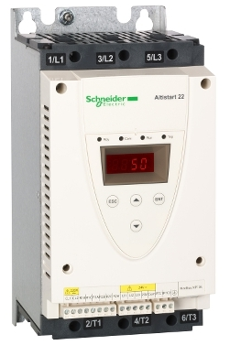
Supply Voltage: | 400…480 V | 400 V | 230…600 V
Phases: | 3 | 3 | 3
Supply Frequency: | 50…60 Hz | 50…60 Hz | 50…60 Hz
Power Factor: | N/A | N/A | N/A
Power Rating: | 7.5 kW | 7.5 kW | 7.5 kW
Output Current : | 15 A | 14.5 A | 15.4 A
Destination: | AC Motors | AC Motors | AC Motors
Speed Drive Output Frequency: | N/A | N/A | N/A
Reversible: | No | Yes | Yes  (via Optional Module)
Motor Slip Compensation: | N/A | N/A | N/A
Acceleration And Deceleration Ramps: | Adjustable | N/A | N/A
Communication: | N/A | EthernetIP,  Profibus | Modbus
Protection: | Short Circuit,  Thermal | N/A | Thermal,  Motor Phase Break
IP Rating: | IP20 | IP20 | IP20
Ambient Air Temp  for Operation: | -5 to 40 °C | N/A | -10 to 40 °C
Volume of Cooling Air: | N/A | N/A | N/A
Weight: | N/A | 4.6 kg | 7 kg
W x D x H | 94mm x 123mm x 102mm | 179.8mm x 185mm x 300mm | 130mm x 169mm x 265mm
Price: | £244.00 | £791.36 | £735.56
Pros: | Cheap
Cons: | Not much detail in Datasheet
Website: | https://store.danfoss.com/gb/en_GB/Drives/Soft-Starters/VLT%C2%AE-Soft-Start-Controller-MCD-100/mcd100-007%2C480v-softstart-380-480v%2C7%2C5kw/p/175G4005 | https://new.abb.com/drives/softstarters/pstx | https://www.se.com/uk/en/product/ATS22D32S6/soft-starterats22control-220vpower-230v7-5kw-400-440v15kw-500v18-5kw/
Chosen Drive:
Referencing: | [14] | [15] | [16]
Table 9: Motor D Comparison

Figure 4: Chosen Drive for Motor D
Datasheet - https://www.se.com/uk/en/product/download-pdf/ATS22D32S6?filename=Schneider+Electric_Altistart-22_ATS22D32S6.pdf

Motor E (1 kW, Single Phase, 230V, Non-Reversible, Fixed Speed)

 | Power | Phases | Voltage | Required to be Reversible? | Variable speed required? | Quantity Installed | Example Application
Motor E | 1 kW | 1 | 230 | No | No | 127 | Pumps / Fans
Table 10: Motor E Information

The simplest and most cost-effective solution for low-power, fixed-speed applications like pumps and fans that do not require speed variation or reversibility, is a Direct On Line (DOL) starter. This technology provides the necessary protection with minimal complexity. It's suited for applications where the start/stop operation is the primary control function. Selection must ensure that the DOL Starter’s Thermal Overload is rated slightly higher than the full load rating of the motor, as to accommodate potential surges or brief periods of higher demand, which can cause overheating of the motor and the switchgear. [17]

Motor E - Pumps / Fans
Model: | DOL Starter | VLT FC51 Series | DOL Starter
Company: | RS PRO | Danfoss | Crompton
Photo: | 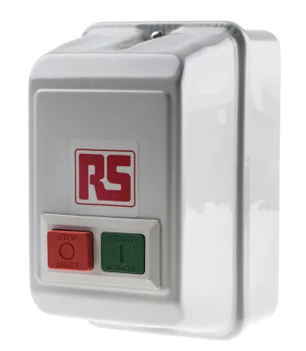 | 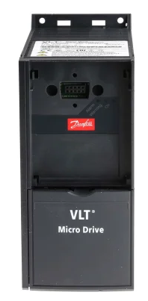 | 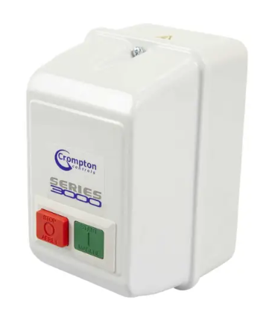
Supply Voltage: | 240 VAC | 230 VAC | 230 VAC
Phases: | 1 | 1 | 1
Supply Frequency: | 50…60 Hz | 50…60 Hz | 50…60 Hz
Power Factor: | N/A | 0.98 | N/A
Power Rating: | 1.1 kW | 1.5 kW | 1.1 kW
Current Rating : | 7..10 A | 6.8 A | 9 A
Destination: | N/A | AC Motors | N/A
Speed Drive Output Frequency: | N/A | 0…200 Hz | N/A
Acceleration And Deceleration Ramps: | N/A | 0.05–3600 sec | N/A
Communication: | N/A | Modbus | N/A
Protection: | Overload | Overload | Overload
IP Rating: | IP55 | IP20 | IP55
Ambient Air Temp  for Operation: | -5 to 40 °C | N/A | IP55
Weight: | N/A | N/A | 81 g
W x D x H | 104mm x 134mm x 174mm | 75mm x 168mm x 176mm | 104mm x 134mm x 174mm
Price: | £80.15 | £336.12 | £112.95
Pros:
Cons:
Website: | https://uk.rs-online.com/web/p/motor-starters/9094089 | https://uk.rs-online.com/web/p/inverter-drives/8918883 | https://www.cef.co.uk/catalogue/products/1778197-1-1kw-230v-direct-on-line-starter-with-overload-fitted
Chosen Drive:
Referencing: | [18] | [19] | [20]
Table 11: Motor E Comparison

Figure 5: Chosen Drive for Motor E

Datasheet - https://docs.rs-online.com/098a/0900766b81586117.pdf

Task 1 Conclusion

Motor | Description | Price/each | Qty Required | Total
A | Schneider Electric Altivar Process ATV900 | On Request  Est…..£50,000.00 | 5 | Unavailable  Est…..£250,000
B | Schneider Electric Altivar Process ATV600 Series | On Request  Est…..£12,500.00 | 10 | Unavailable  Est….£125,000
C | Schneider Electric Altivar Process ATV600 Series | £2,500.93 | 23 | £57,521.39
D | Schneider Electric ATS 22 Soft Starter | £735.56 | 17 | £12,504.52
E | RS PRO DOL Starter | £80.15 | 127 | £10,179.05
 |  | Total Estimated Cost: |  | £455,204.96
Table 12: Estimated Cost for Factory Upgrade of Motor Drives

Table 12 above shows the estimated cost of upgrading the motor drive systems in the factory. Please note this is not exact as a price was not able to be achieved for Motors A & B. I have chosen to utilise Schneider Electric products for Motors A, B, C, and D as I believe it will be easier to overcome compatibility issues when integrating into the factories control system, and achieve a better deal on technical and warranty support with a single manufacturer.

Task 2 Background Information
In the context of Variable Frequency Drives, the rectification of the incoming mains (AC) to DC is a critical first step in the process of converting AC power to a variable frequency AC output. The selection of components for rectification of the incoming mains is crucial for efficiency and optimizing motor control. This rectification can be achieved using various semiconductor devices, including Diodes, Thyristors (Silicon Controlled Rectifiers, SCRs), and Insulated Gate Bipolar Transistors (IGBTs). Each of these components has its unique characteristics, affecting the Variable Frequency Drive's performance and the quality of power. Additionally, the design of the rectifier plays a significant role in minimizing harmonic distortion, which can adversely affect power quality and power factor.

Diodes
Diodes offer the simplest form of rectification. They are used in basic diode bridge rectifiers to convert AC to DC. Diodes are simple, however they do not have any form of control. They allow current to pass when forward-biased and block it when reverse-biased. Power flows from the supply to the motor, but when the motor decelerates the regenerated energy cannot be fed back to the Common DC Bus, and therefore must be directed to a capacitor(s). While being cost-effective and reliable due to fewer moving parts, diode-based rectifiers generate significant harmonic distortion due to their uncontrolled nature. They are most suitable for applications where power quality is not a critical concern.

Thyristors (SCRs)
SCRs provide a limited amount of controlled rectification. Unlike diodes, SCRs can be turned on with a pulse to the Gate at a specific point in the AC cycle, allowing for some control over the phase angle of the current, which can be used to manage the power flow. However, once turned on, SCRs cannot be turned off by the gate control, they require the current to drop to zero naturally. By arranging the SCR bridges in pairs, this allow power to flow in both directions. When the motor decelerates the regenerated energy can then be fed back to the Common DC Bus, making them more efficient than Diodes. SCRs are more complex and expensive than diodes but are beneficial in applications requiring variable output voltage and current control. [21]

Insulated Gate Bipolar Transistors (IGBTs)
The Insulated Gate Bipolar Transistor (IGBT) combines the insulated gate technology of the MOSFET with the output performance characteristics of a conventional bipolar transistor. The result of this hybrid combination is that an IGBT has the output switching and conduction characteristics of a bipolar transistor but is voltage-controlled like a MOSFET. In rectifiers, they allow for precise control over the conversion process by having the ability to control the switching both on and off by introducing a small voltage to the Gate. This significantly reduces the lower order harmonics generation, however they do introduce higher order harmonics. IGBT control is far more complex than SCRs and Diodes and therefore more expensive. Although more expensive, they offer superior performance, making them suitable for high-performance applications where power quality is crucial. The use of IGBTs in rectifiers allows for precise control over the output voltage and current, enabling better performance in applications requiring variable output control. [22]

Harmonic Noise
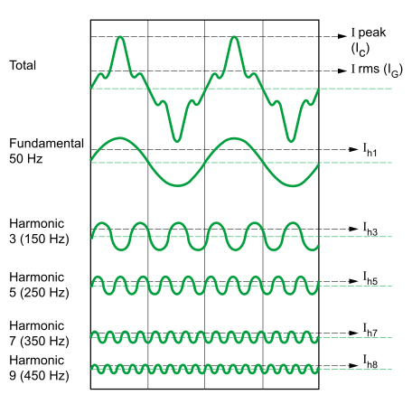
Harmonics are currents or voltages at frequencies that are at multiples of the fundamental frequency of the power system, caused by loads which draw current in a Non-Sinusoidal pattern, for example Variable Frequency Drives. As power is produced at source at 50 Hz, the Harmonics will be multiples of 50 as shown in Figure 6 & 7 below.

Figure 6: Harmonics
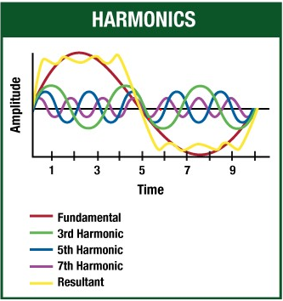

Figure 7: Combined Harmonics

As far as Variable Frequency Drives are concerned, the even numbered Harmonics cancel each other out. The higher order Harmonics are being produced beyond the 50Hz drive, and they are reactive in nature. These higher order harmonics, do not deliver power to the motor, but the system still needs to handle them. Therefore, any sharp edge change in your waveform will produce harmonics. The switching action of the Variable Frequency Drive creates a Pulse-Width Modulated (PWM) waveform, which contains high-frequency harmonics. [23]

Minimising Harmonic Noise
Harmonic noise can be minimized through a variety of careful rectifier design techniques, including the choice of rectifier component and the implementation of filtering and control. Typically there are 3 options to removing VFD Harmonics:
- 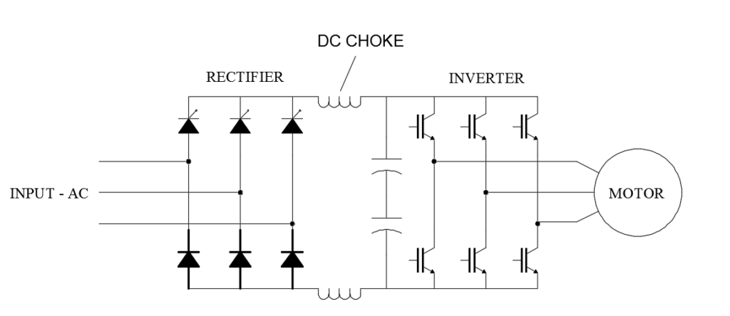By adding impedance to the outward side of the rectifier in the form of a DC Choke as seen in Figure 8 or Line Reactor before the DC Bus can create a low pass filter. This will allow the low 50Hz frequencies through and block the higher frequency harmonics. Additionally, the use of a Line Reactor or Choke on the AC supply line will minimise harmonic leakage back into the supply line.

Figure 8: DC Choke
- The use of 12 or 18 pulse rectifiers and a phase shifting transformer instead of the traditional 6 pulse rectifier can reduces the harmonic distortion. This is achieved by the phase‐shifting transformer, through which some of the lower‐order harmonic currents generated by the six‐pulse rectifier are cancelled in the transformer primary winding.
- Modern Variable Frequency Drives are designed with Active Front End (AFE) to filter out harmonics in the system. These use IGBTs instead of Diodes and Thyristors for rectification. The use of IGBTs with PWM techniques is particularly effective, as it allows for the shaping of the input current waveform to closely align with the AC mains waveform, significantly reducing the lower order Harmonics. However, the higher order harmonics are not eliminated, due to the typically high switching frequency of the IGBTs.

All the above techniques have the same goal in common. The aim is to produce as “flatter” and smooth waveform as possible in order to reduce the Harmonics present. [24]

Effect of Harmonics on Power and Power Factor
Harmonics in the electrical system can have detrimental effects on both power quality and power factor. Harmonics lead to additional current in the system, which does not contribute to useful power (real power) but increases the total apparent power. This results in a lower power factor, indicating less efficient power usage. Furthermore, harmonics produced in Non-linear loads, such as rectifier circuits, don’t typically shift the current waveform, instead they distort it. [25]
Harmonics have several detrimental effects on Power Systems, including:
- Overheating - High currents cause high heat, reducing lifespan of machines, transformers etc. as well as electronic components like capacitors and transistors
- Excessive neutral current leading to voltage drops, transformer overheating, and nuisance tripping of circuit breakers
- Voltage distortion - Harmonic currents can distort the voltage waveform, leading to malfunctions in sensitive equipment, such as computers and control systems.
- Resonance: Harmonics can cause resonance in the power system, leading to voltage surges and equipment failures.
- Electromagnetic Interference - A by-product of Higher Frequency Harmonics is electromagnetic interference. Due to the higher frequency you go, the more likely they are to transmit themselves as radio waves.

The effect of harmonics on power factor is an important consideration in the analysis and design of all electrical systems, especially those involving nonlinear loads such as Variable Frequency Drives. The Harmonics that are produced at multiples of the fundamental frequency of the system are going to be developing and drawing power at much higher frequencies as well. If you have a Harmonic being produced at 300 Hz then your load is going to be using power and phase shifting will also happen at 300 Hz. The designed capacitor bank to smooth out our sinusoidal signal is going to be designed to work at 50 Hz, which means your power factor correction is unable to correct the distortion at the higher frequency.
With all the above in mind, the importance of minimising the production of Harmonics in the design of rectifiers is clear. In order to ensure efficiency and without producing electromagnetic interference which could impact on the safe running of the Variable Frequency Drive. [23]

Simulations
Below are the simulation modelling results created using Proteus to support the arguments given in the previous section.

Diode Rectifier Simulation
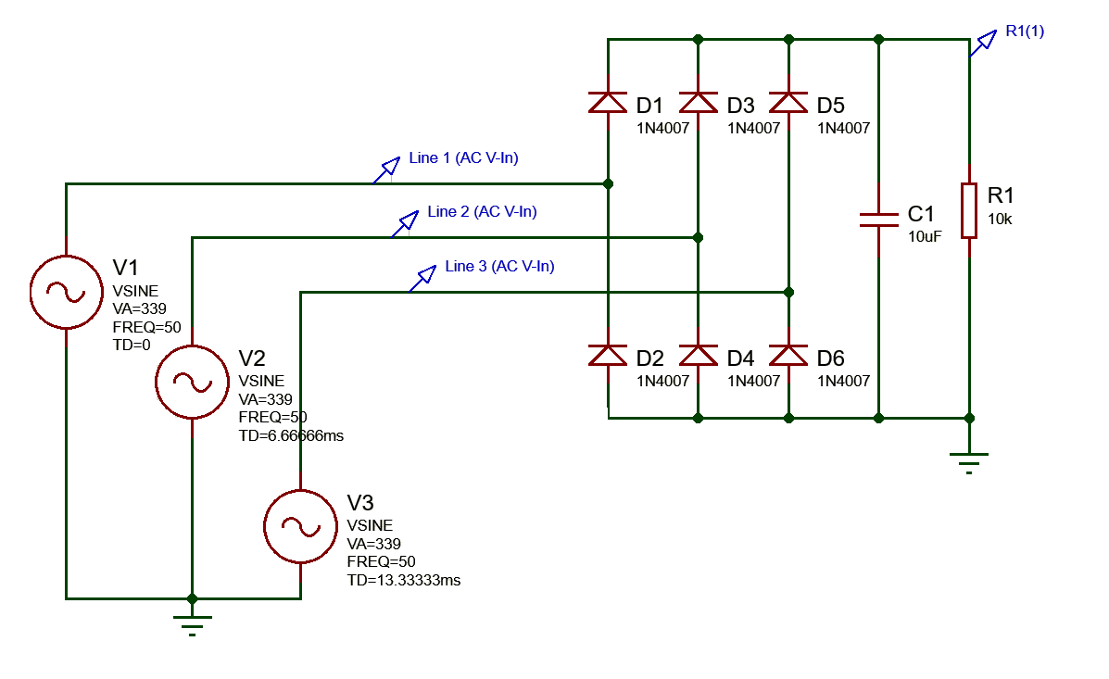
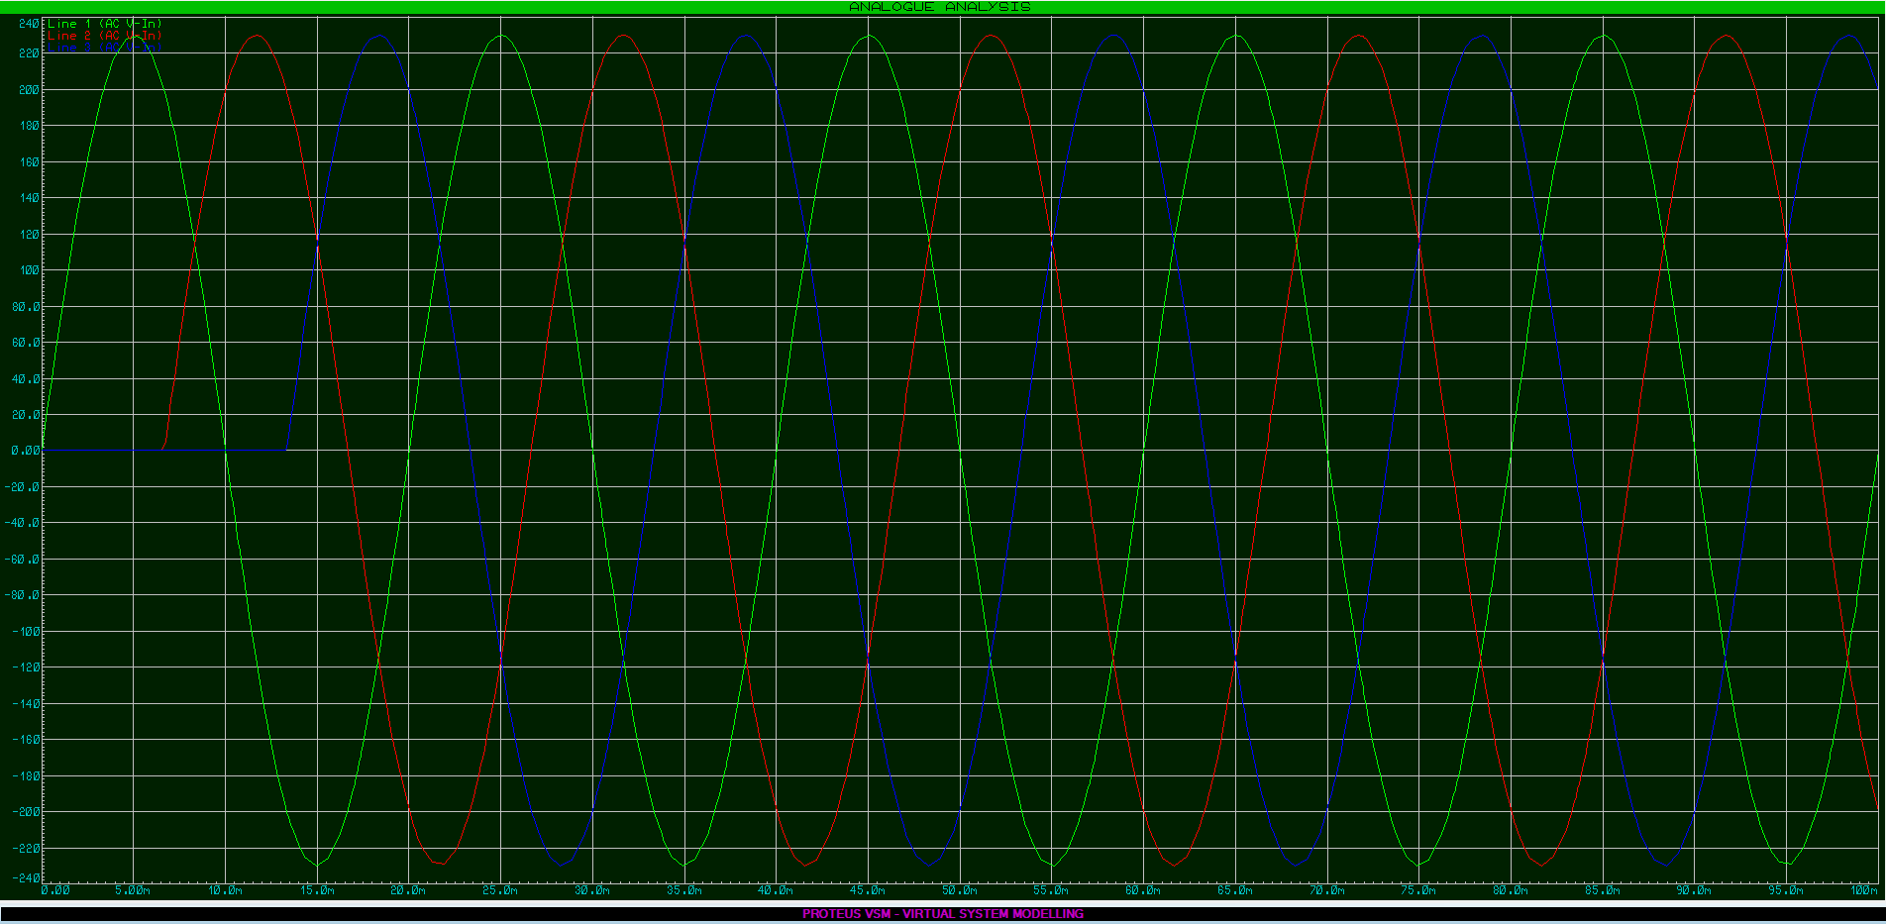
Figure 9: DIODE Rectifier Proteus Schematic

Figure 10: DIODE Rectifier Input Signal Representation

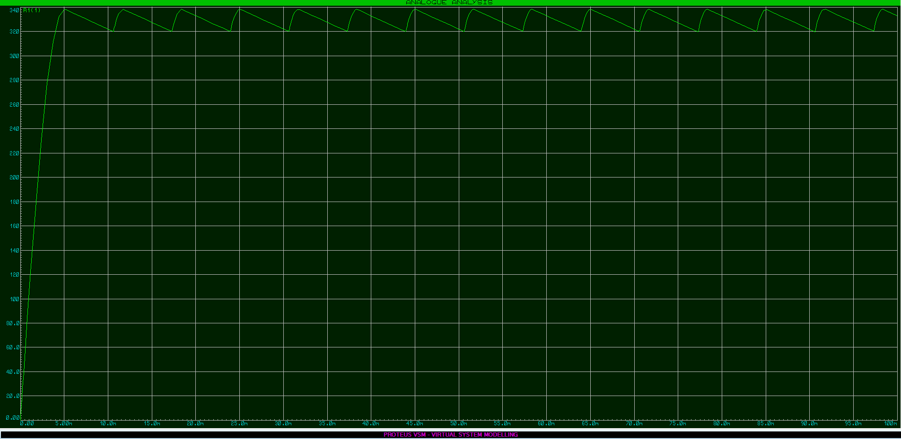
Figure 11: DIODE Rectifier Output Signal Representation
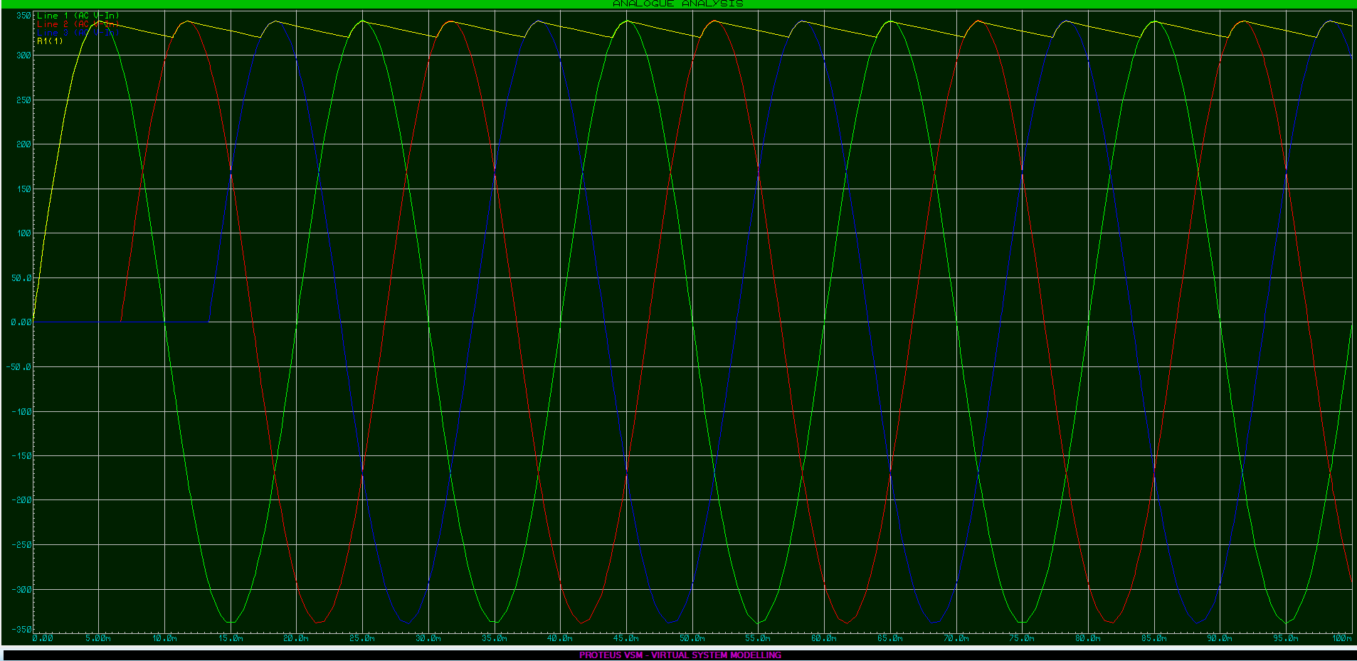
Figure 12: DIODE Rectifier Overlay of Input & Output Signal

In recreating a 6 Pulse Diode rectifier as in Figure 9, a three phase signal was firstly created as per Figure 10. Once the simulation was run within the Proteus Suite a DC signal was created as an output as shown in Figure 11. To easily show the difference, both the Input and the Output signals have been overlaid in Figure 12.

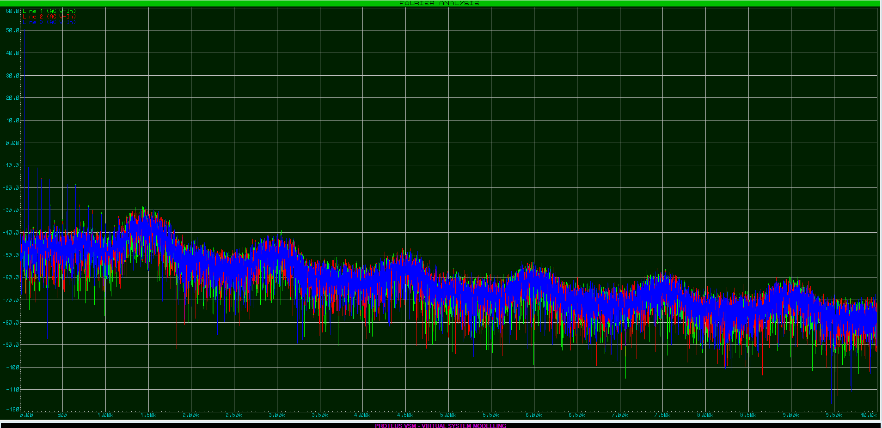
Figure 13: Fourier analysis of DIODE Rectifier Input Signal
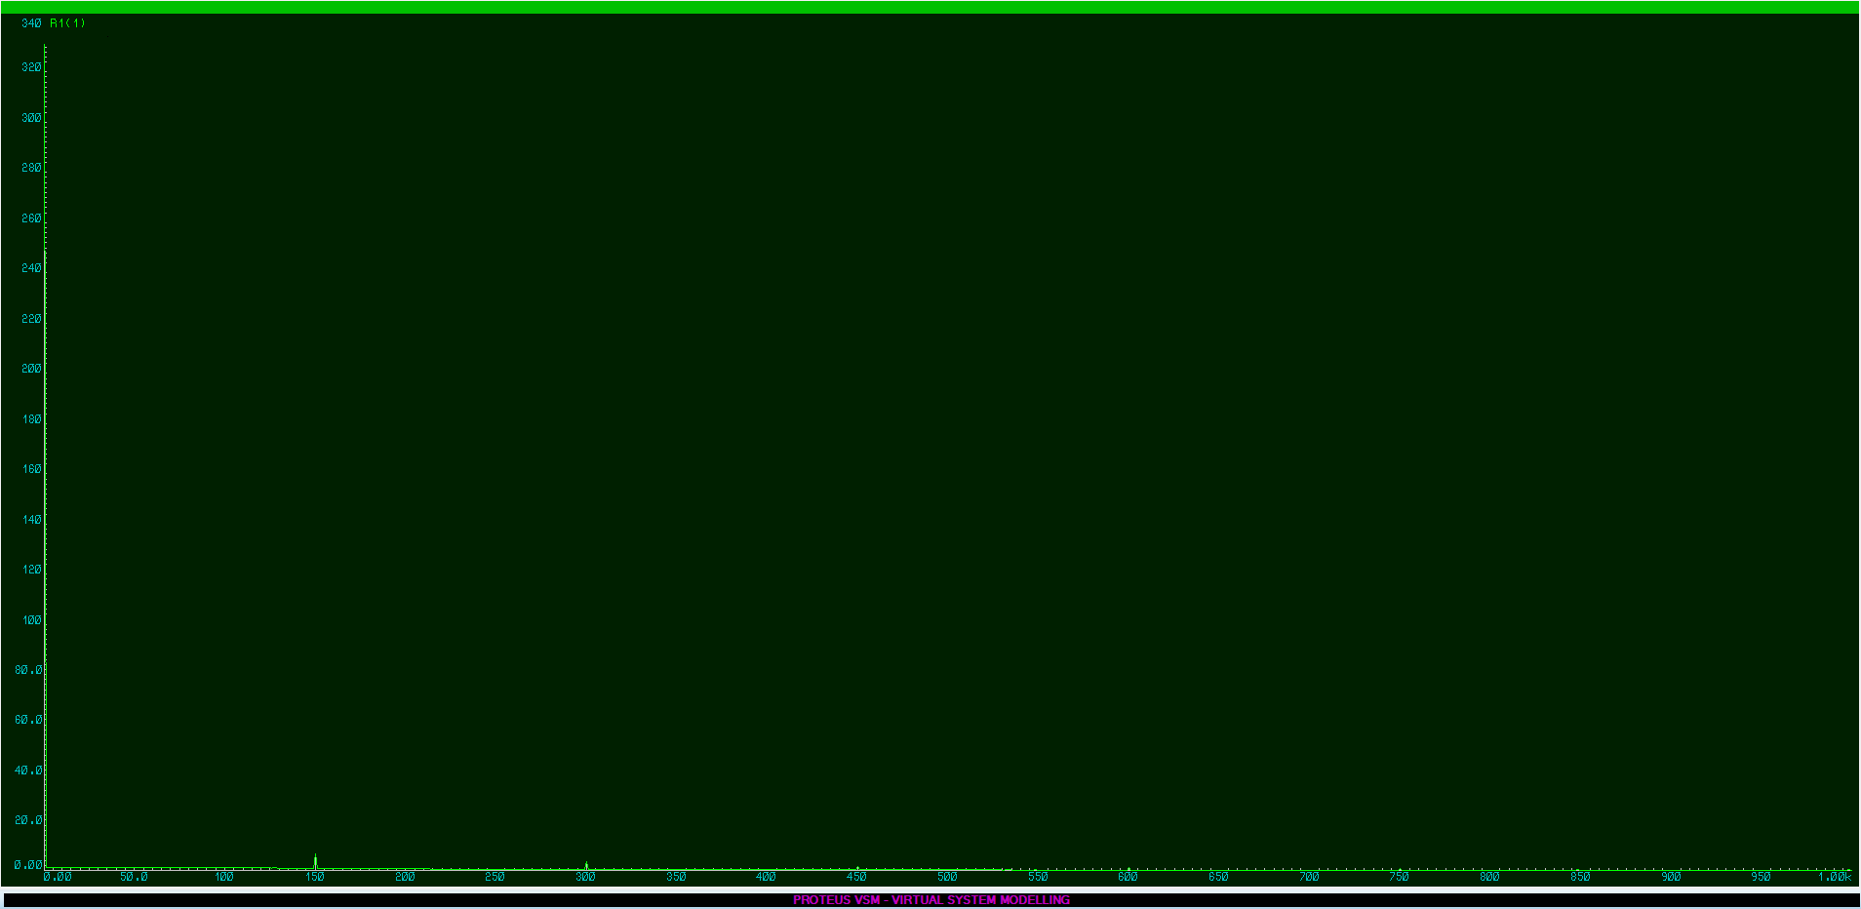
Figure 14: Fourier analysis of DIODE Rectifier Output Signal

A Fourier analysis of the system was also ran and the results of the recreated Harmonics are shown, firstly of the input signal as per Figure 13, and also the created Harmonics from the Diode based AC to DC rectifier in Figure 14.

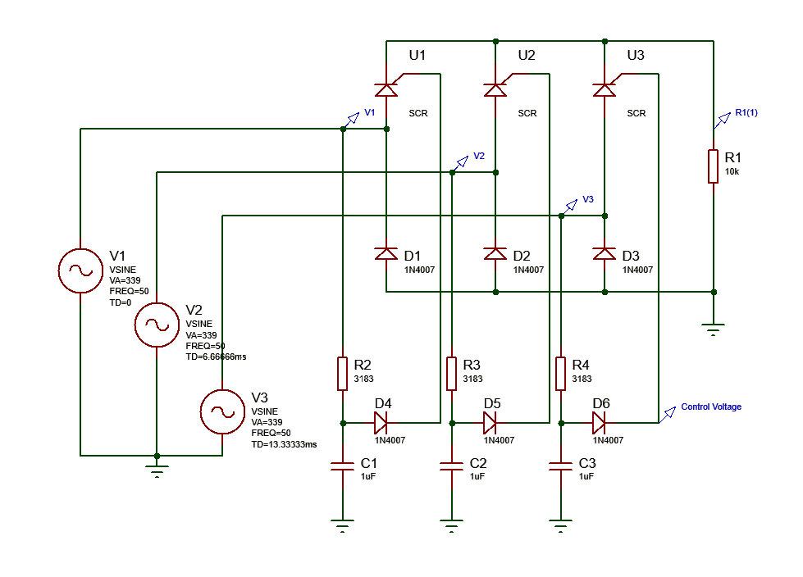Thyristors (SCRs) Rectifier Simulation
Figure 15: SCR Rectifier Proteus Schematic
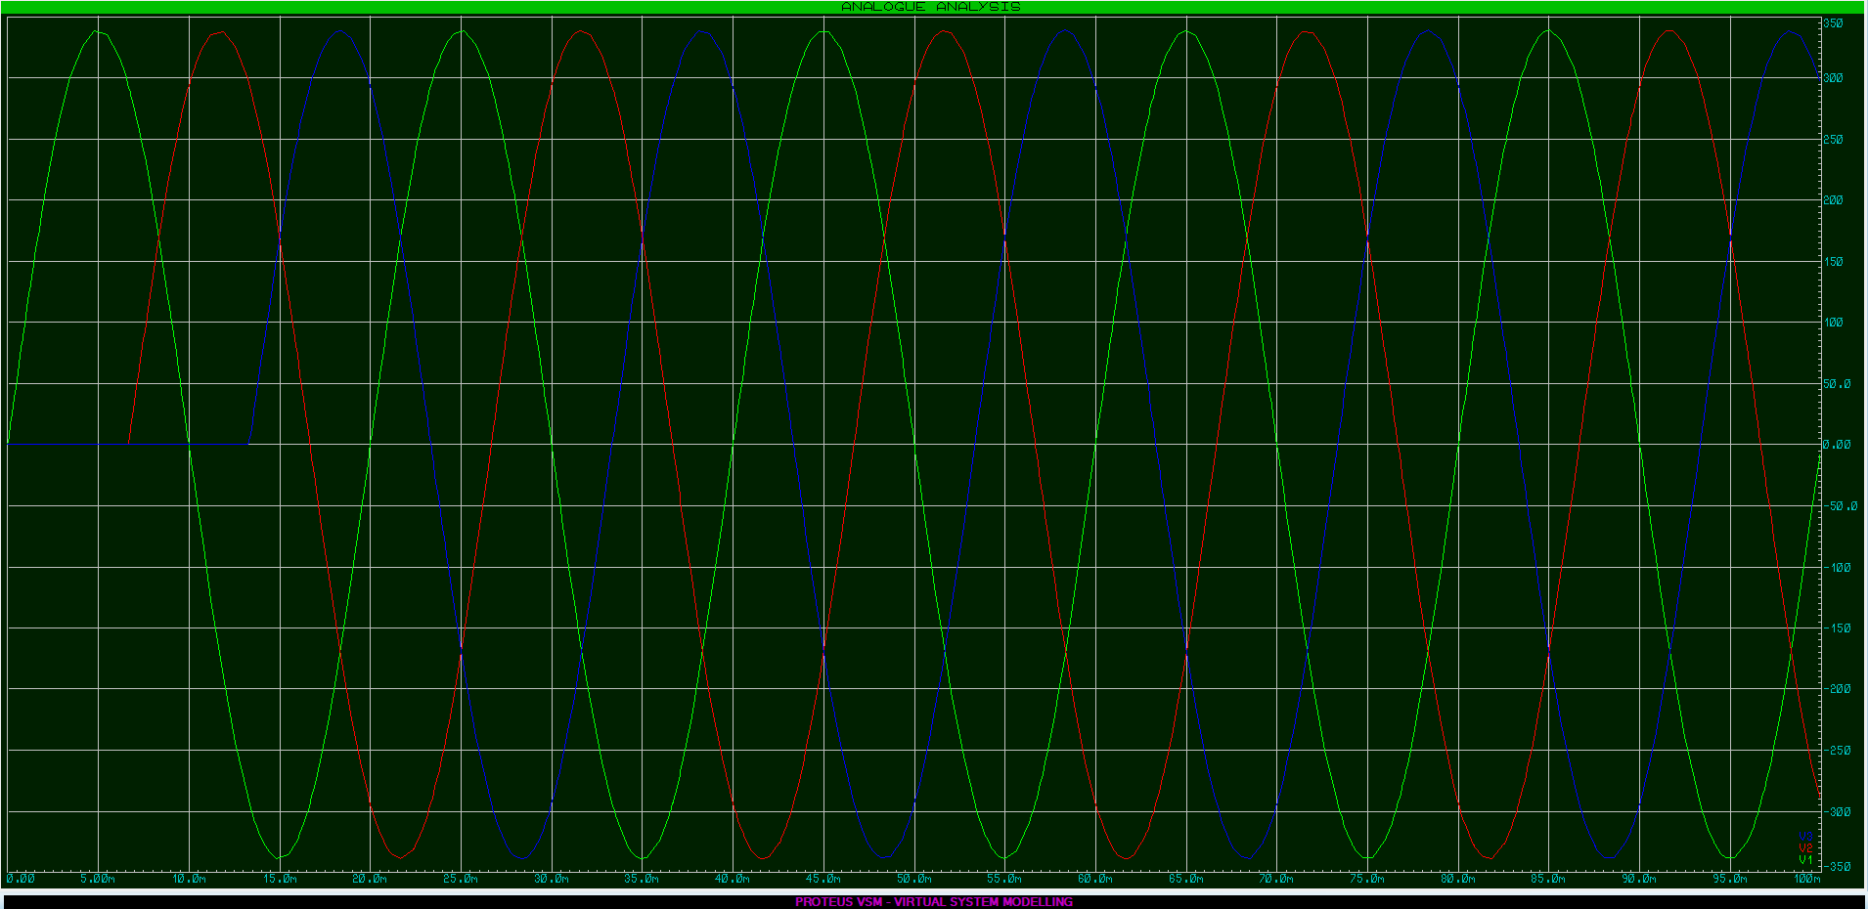
Figure 16: SCR Rectifier Input Signal Representation

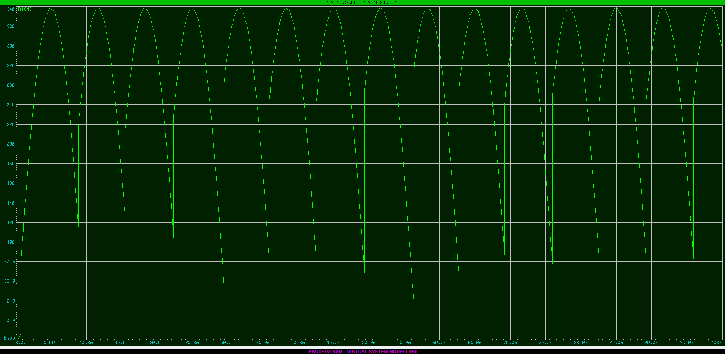
Figure 17: SCR Rectifier Output Signal Representation

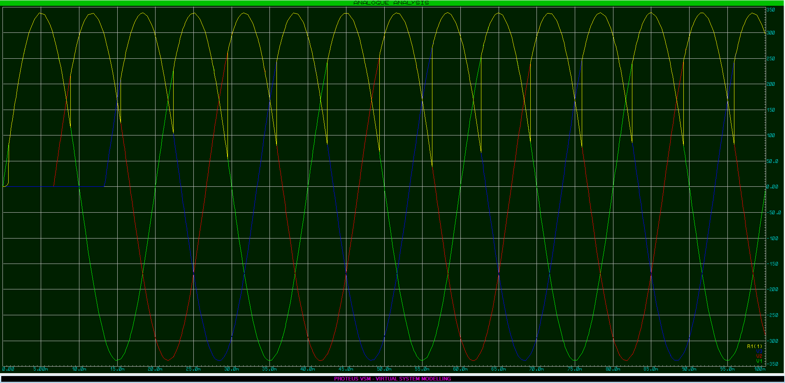
Figure 18: SCR Rectifier Overlay of Input & Output Signal

In recreating a Thyristor rectifier as in Figure 15, a three phase signal was firstly created as per Figure 16. Once the simulation was run within the Proteus Suite a DC signal was created as an output as shown in Figure 17. To easily show the difference, both the Input and the Output signals have been overlaid in Figure 18. Note that for this particular simulation, SCRs were used in conjunction with Diodes for ease of replication, as additional control signals would have been required to switch the remaining SCRs. However the clear “straight edges” are shown where the SCRs are switched, and subsequently a fair representation of the output signal will be created.

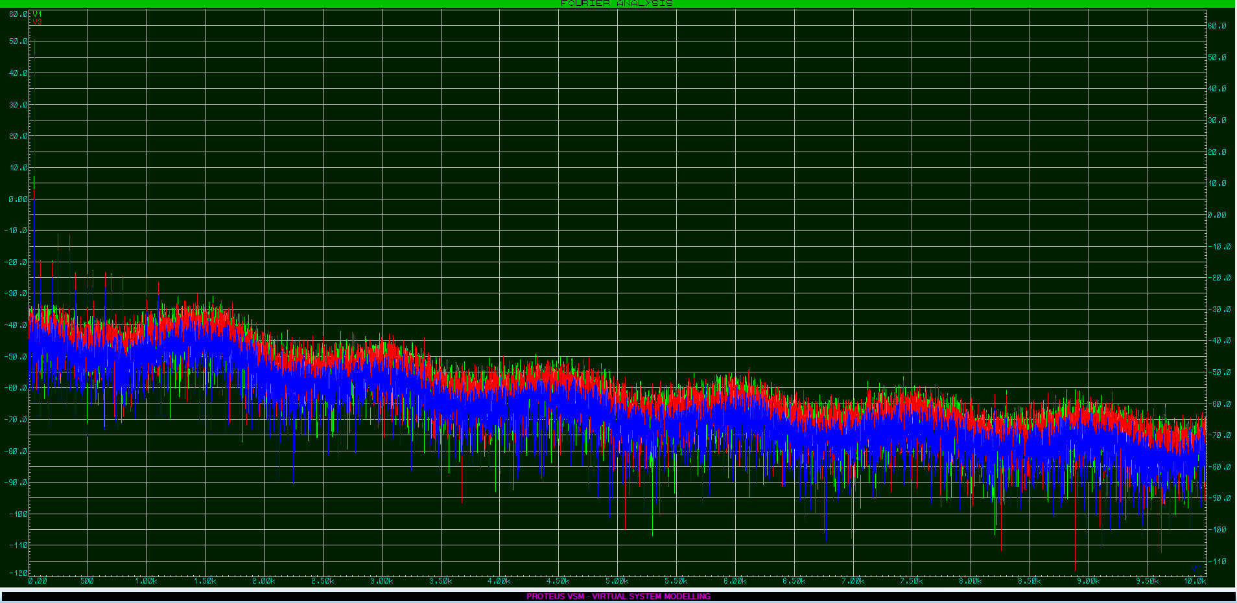
Figure 19: Fourier analysis of SCR Rectifier Input Signal
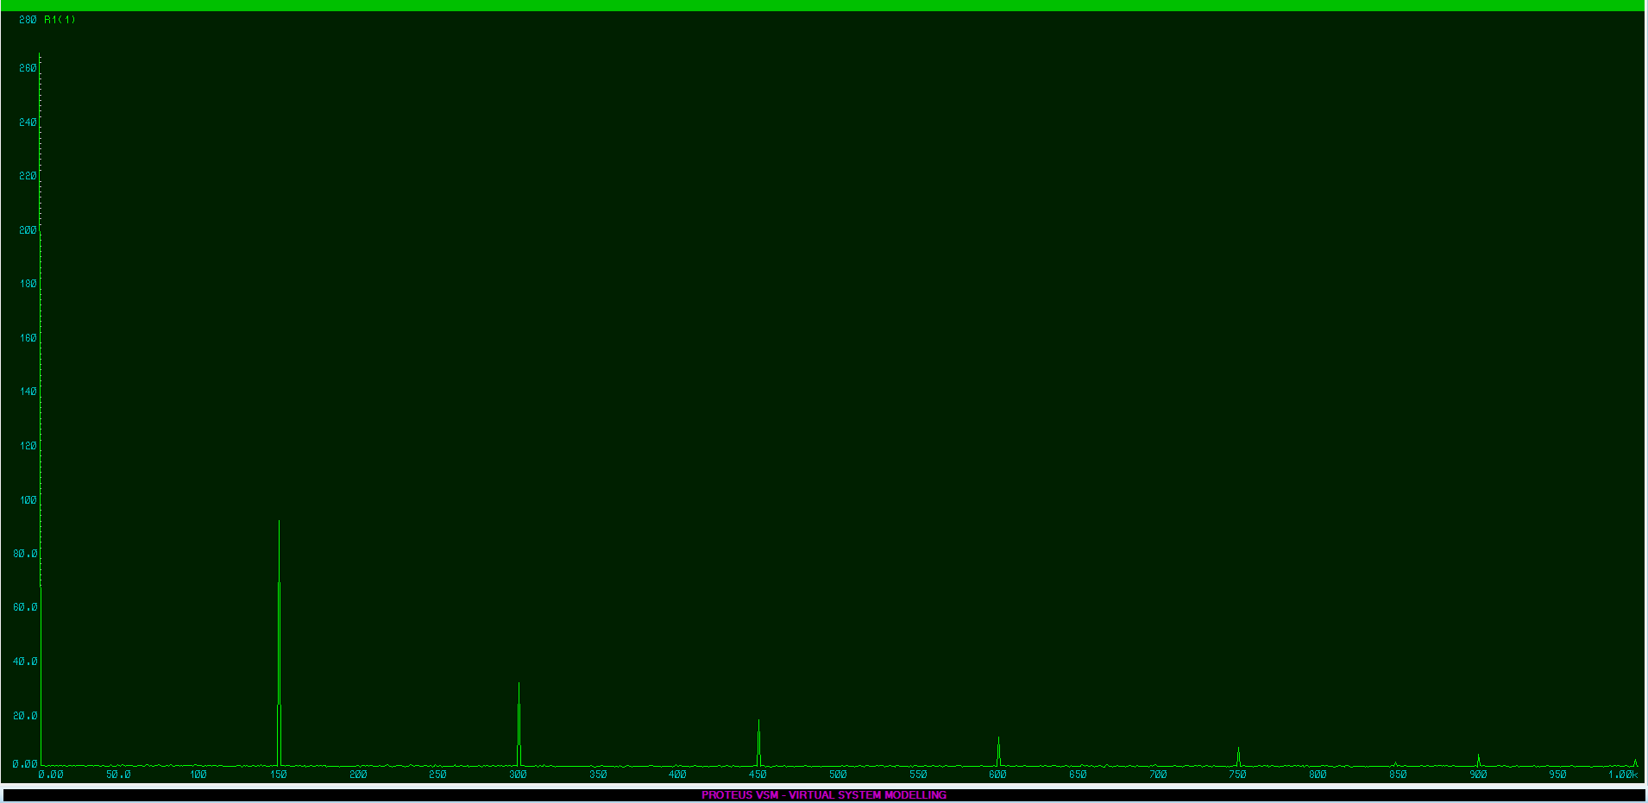
Figure 20: Fourier analysis of SCR Rectifier Output Signal

A Fourier analysis of the system was also ran and the results of the recreated Harmonics are shown, firstly of the input signal as per Figure 19, and also the produced Harmonics from the SCR based AC to DC rectifier in Figure 20.

IGBT Rectifier Simulation

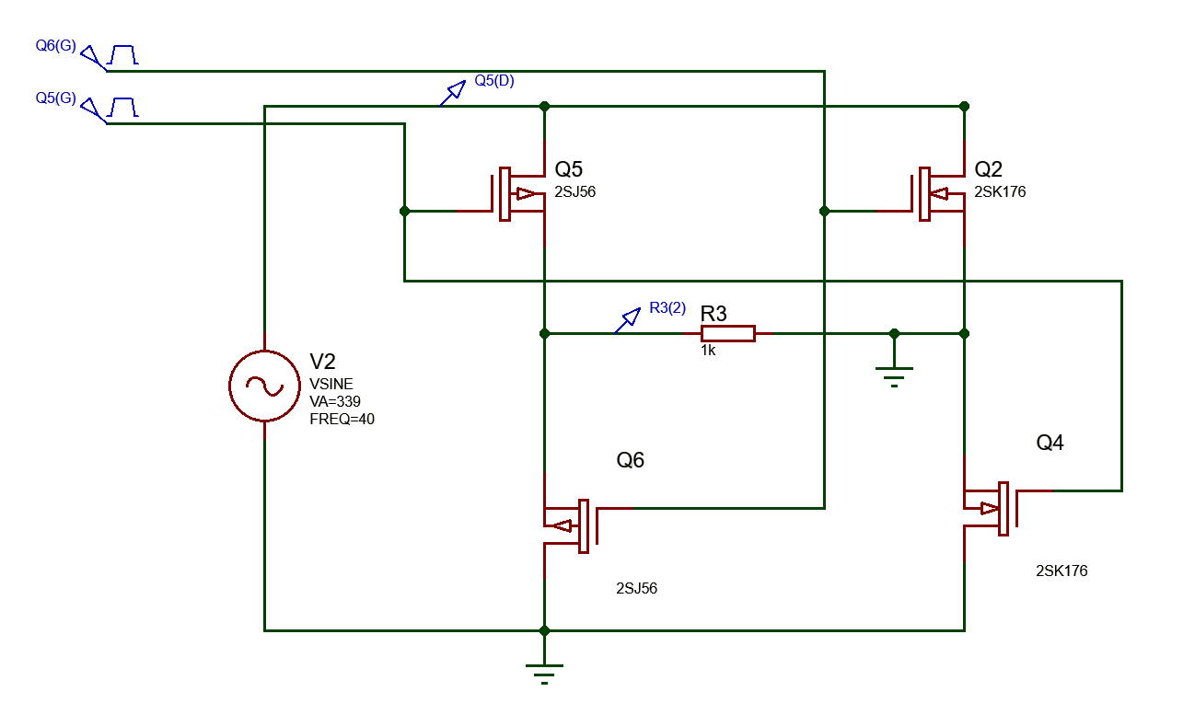
Figure 21: IGBT Rectifier Proteus Schematic
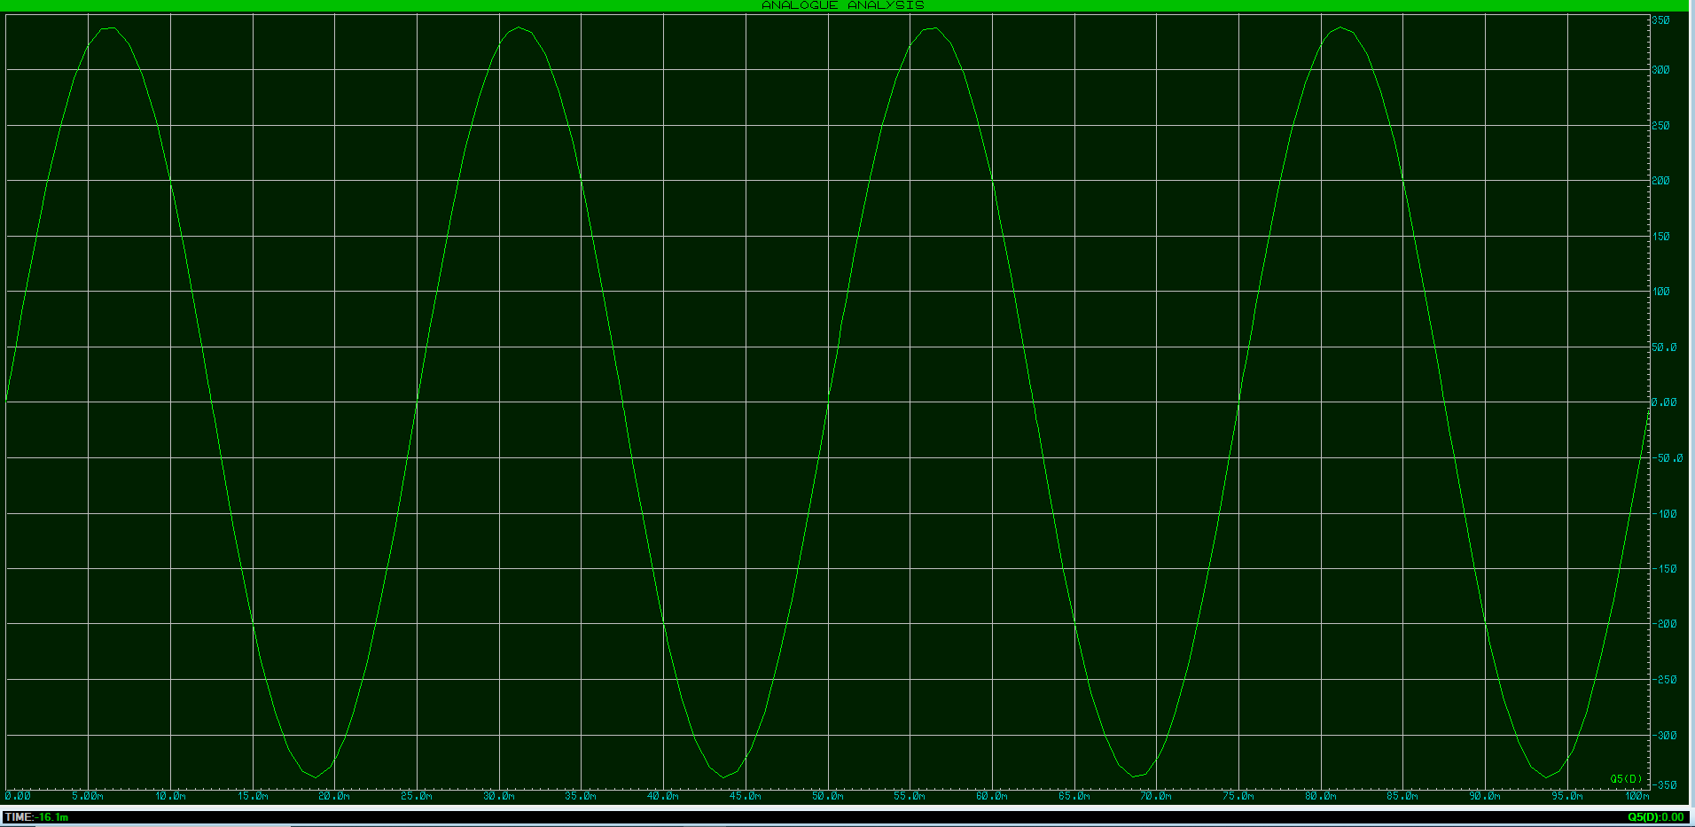
Figure 22: IGBT Rectifier Input Signal Representation
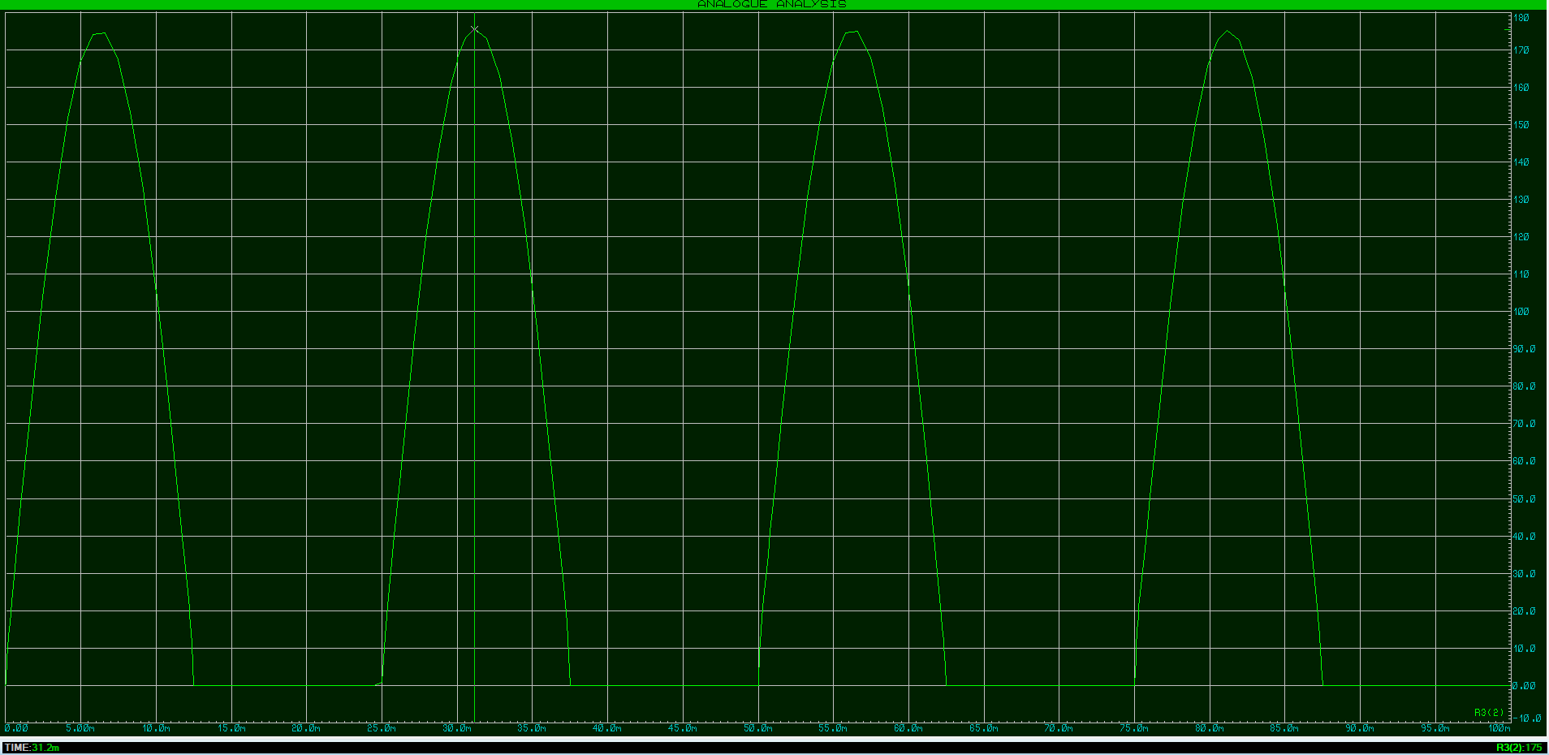
Figure 23: IGBT Rectifier Output Signal Representation

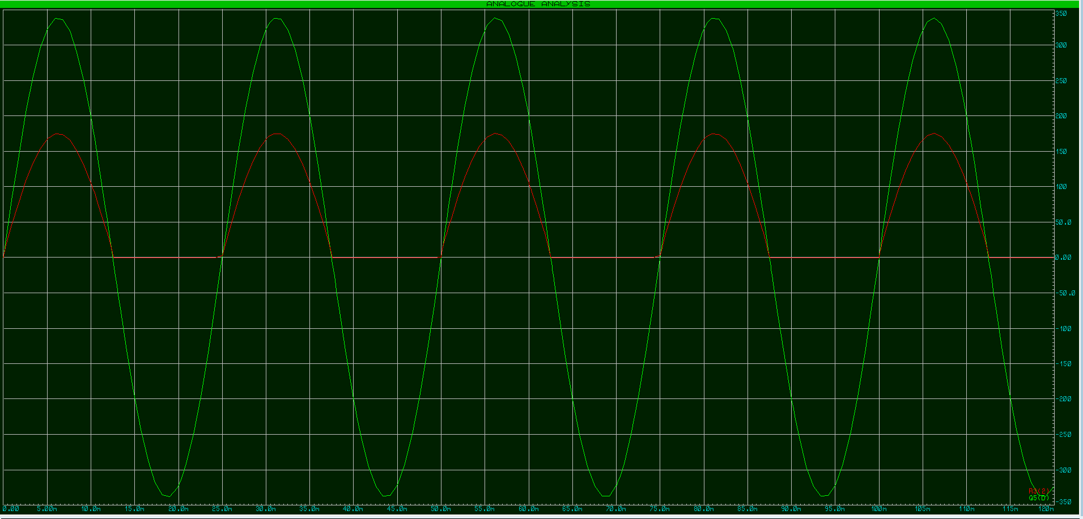
Figure 24: IGBT Rectifier Overlay of Input & Output Signal

In recreating an IGBT rectifier as in Figure 21, a single phase signal was firstly created as per Figure 22. Note that a single phase simulation was recreated for this application to simplify the mock-up. To simulate an active front end rectifier the switching on and off had to be controlled. This was done using MOSFET transistor device in order to mitigate the use of an IGBT Gate Driver. The results will be very similar. Once the simulation was run within the Proteus Suite a DC signal was created as an output as shown in Figure 23. To easily show the difference, both the Input and the Output signals have been overlaid in Figure 24.

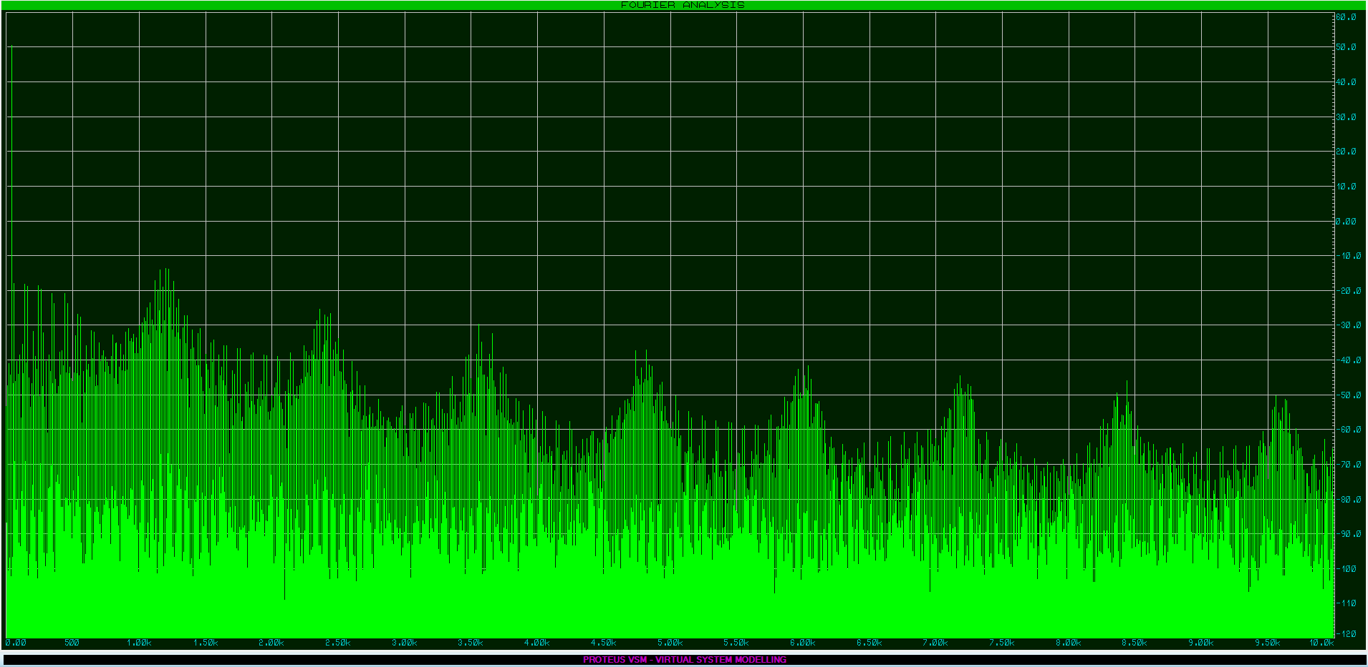
Figure 25: Fourier analysis of IGBT Rectifier Input Signal

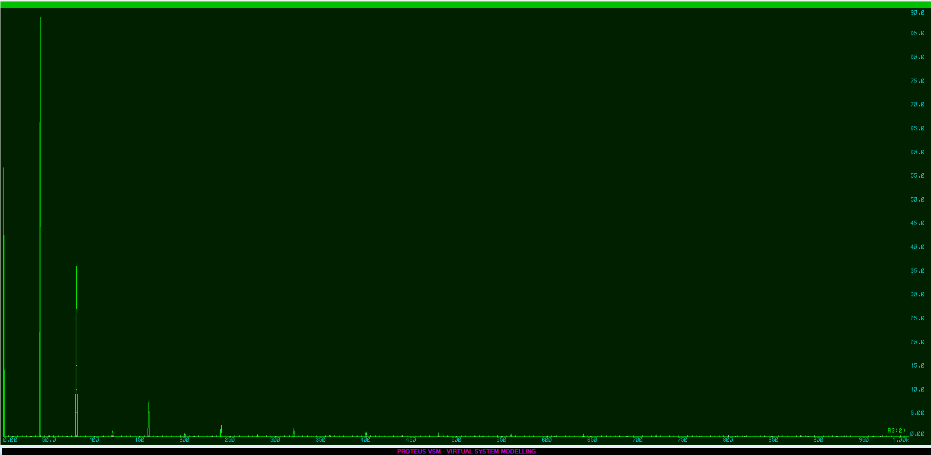
Figure 26: Fourier analysis of IGBT Rectifier Output Signal

A Fourier analysis of the system was also ran and the results of the recreated Harmonics are shown, firstly of the input signal as per Figure 25, and also the produced Harmonics from the IGBT based AC to DC rectifier in Figure 26.

12 Pulse Diode Rectifier Simulation
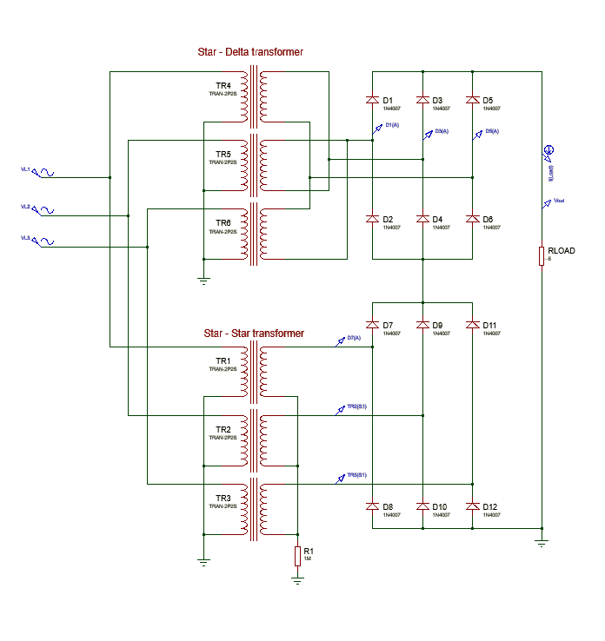
Figure 27: 12 Pulse DIODE Rectifier Proteus Schematic

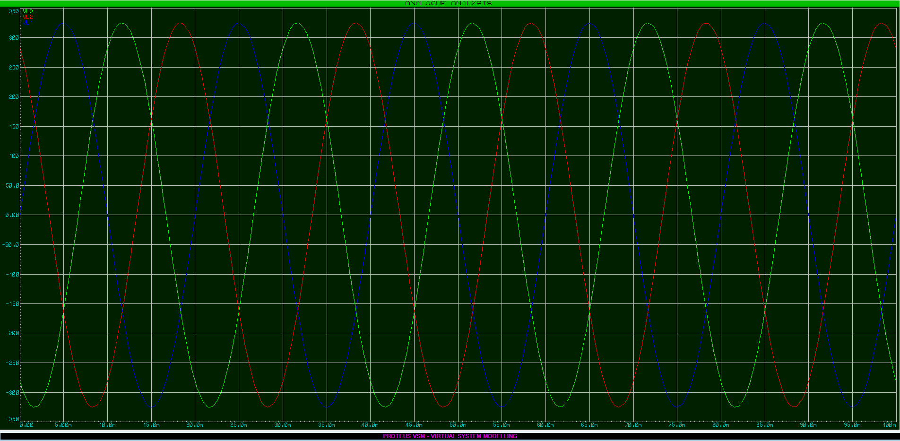
Figure 28: 12 Pulse DIODE Rectifier Input Signal Representation

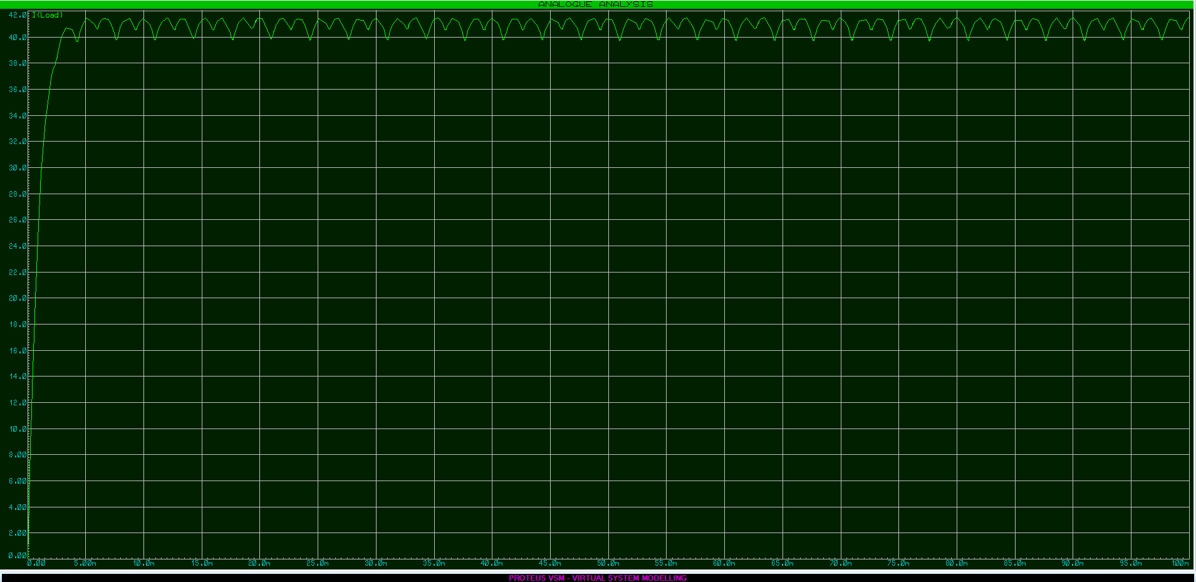
Figure 29: 12 Pulse DIODE Rectifier Output Signal Representation

In recreating a 12 Pulse Diode rectifier as in Figure 27, a three phase signal was firstly created as per Figure 28. Once the simulation was run within the Proteus Suite a DC signal was created as an output as shown in Figure 29. To easily show the difference, both the Input and the Output signals have been overlaid in Figure 30.

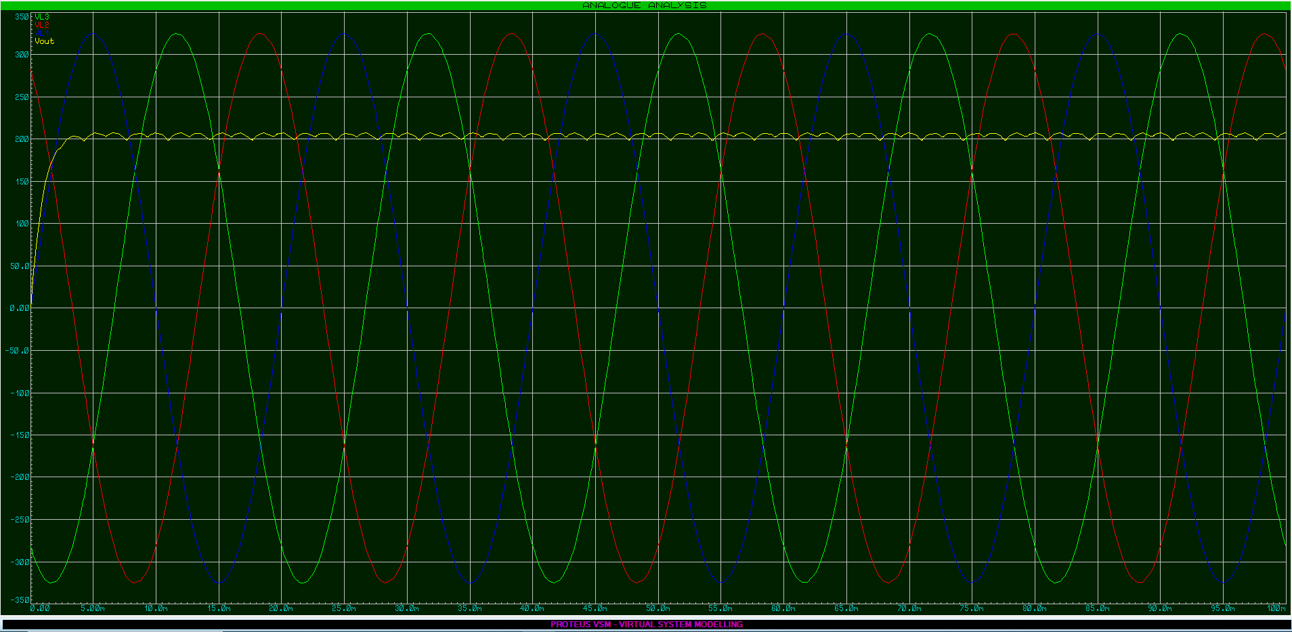
Figure 30: 12 Pulse DIODE Rectifier Overlay of Input & Output Signal

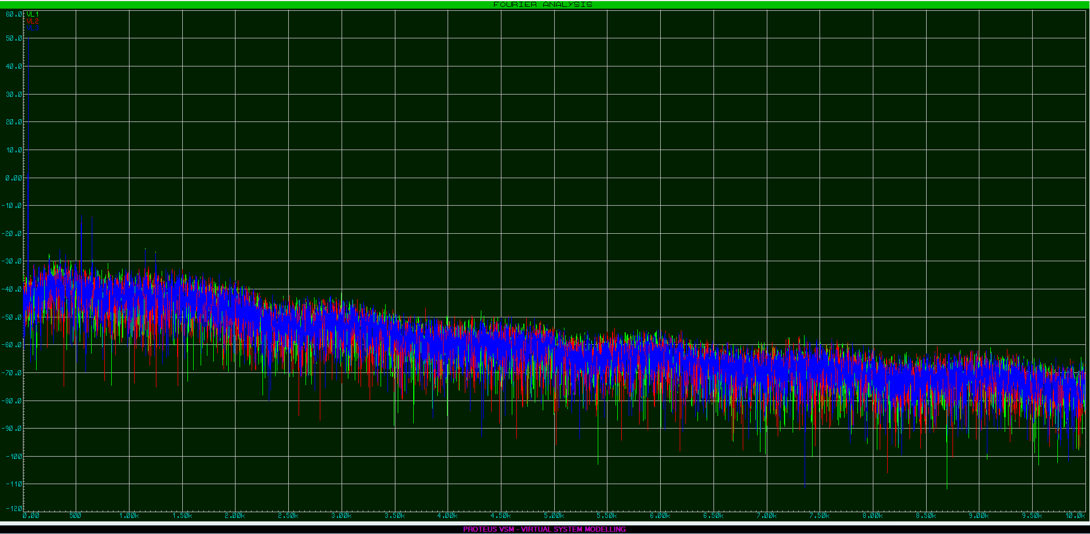
Figure 31: Fourier analysis of 12 Pulse DIODE Rectifier Input Signal

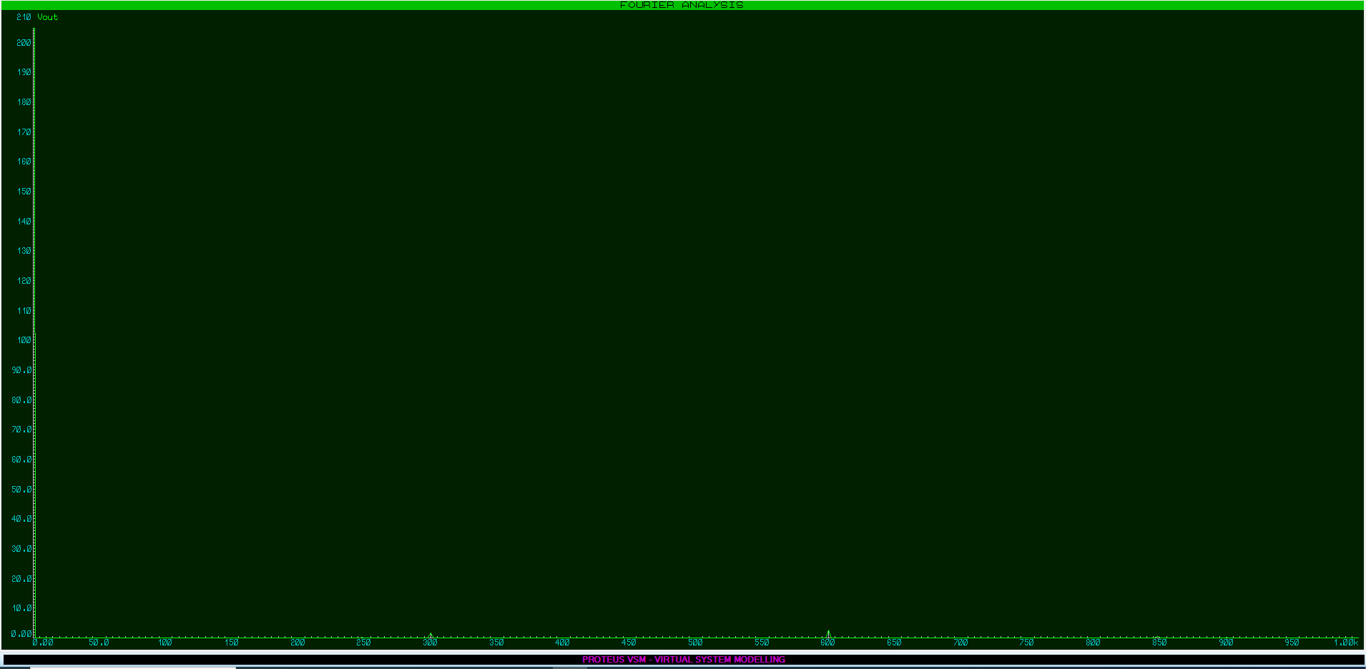
Figure 32: Fourier analysis of 12 Pulse DIODE Rectifier Output Signal

A Fourier analysis of the system was also ran and the results of the recreated Harmonics are shown, firstly of the input signal as per Figure 31, and also the created Harmonics from the 12 Pulse Diode based AC to DC rectifier in Figure 32.

Task 2 Conclusions

In conclusion, the simulations show that Diodes and Thyristors have harmonic noise at similar frequencies. However due to the sharp edge when the Thyristor’s gate receives a pulse, the amplitude of the SCRs harmonic is greater. In comparison to the IGBT however, the Harmonic noise frequency here is proportional to the switching frequency of the device. The simulation of the 12 pulse diode rectifier incorporating a phase-shifting transformer supports the notion that using additional pulses reduces the harmonic distortion compared to the 6 pulse rectifier.

References

[1] | Schneider Electric, “Common DC Bus,” Schneider Electric, 2019. [Online]. Available: https://product-help.schneider-electric.com/Machine%20Expert/V1.1/en/Lx32sDr/Lx32sDr/Engineering/Engineering-13.htm. [Accessed 29 March 2024].
[2] | Invertek Drives Ltd., “Vector Control,” Invertek Drives Ltd., 2024. [Online]. Available: https://www.invertekdrives.com/support/iknow/vfd-fundamentals/vector-control-13#:~:text=Vector%20Control%20offers%20the%20advantages,is%20easy%20to%20set%20up.. [Accessed 30 March 2024].
[3] | E. Thorstenson, “Drive selection for rolling mills,” RUSSULA, 20 May 2010. [Online]. Available: https://www.russula.com/press-releases/drive-selection-for-rolling-mills.html. [Accessed 30 March 2024].
[4] | Rockwell Automation, “PowerFlex 755TL/TR/TM,” Rockwell Automation, 30 March 2024. [Online]. Available: https://configurator.rockwellautomation.com/configurator/C202EA2449D3423B9EAF4A8929E74EA9/summary. [Accessed 30 March 2024].
[5] | Schneider Electric, “Variable speed drive, Altivar Process ATV900, Regenerative System ATV980 -630/500 kW, 400 V with CE, IP23,” Schneider Electric, 2024. [Online]. Available: https://www.se.com/uk/en/product/ATV980C63Q4X1/variable-speed-drive-altivar-process-atv900-regenerative-system-atv980-630-500-kw-400-v-with-ce-ip23/. [Accessed 30 March 2024].
[6] | V&T Technologies, “250kW-500kW VTS Series Universal Variable Speed AC Drive,” V&T Technologies, 2024. [Online]. Available: https://www.vectorque.com/250kw-500kw-vts-series-universal-variable-speed-ac-drive_p45.html. [Accessed 30 March 2024].
[7] | Hi-Speed Industrial Service, “HOW TO SELECT THE RIGHT DRIVE FOR YOUR OVERHEAD CRANE,” Hi-Speed Industrial Service, 2024. [Online]. Available: https://www.gohispeed.com/how-to-select-the-right-drive-for-your-overhead-crane/. [Accessed 30 March 2024].
[8] | Schneider Electric, “Variable speed drive, Altivar Process ATV600, Compact System ATV660, 110/90 kW, 400 V, IP23,” Schneider Electric, 2024. [Online]. Available: https://www.se.com/uk/en/product/ATV660C11Q4X1/variable-speed-drive-altivar-process-atv600-compact-system-atv660-110-90-kw-400-v-ip23/. [Accessed 30 March 2024].
[9] | ABB, “ACS880-01-245A-3+N7502,” ABB, 2024. [Online]. Available: https://new.abb.com/products/3AXD50000035936/acs880-01-245a-3n7502. [Accessed 30 March 2024].
[10] | Rockwell Automation, “PowerFlex 755TS,” Rockwell Automation, 2024. [Online]. Available: https://configurator.rockwellautomation.com/configurator/F5C2020B0FDC4BC590385979E14493ED/summary. [Accessed 30 March 2024].
[11] | RS Components Ltd, “Allen Bradley Inverter Drive, 11 kW, 3 Phase, 400 V ac, 24 A, PowerFlex 525 Series,” RS Components Ltd, 2024. [Online]. Available: https://uk.rs-online.com/web/p/inverter-drives/8904339. [Accessed 30 March 2024].
[12] | Schneider Electric, “variable speed drive ATV630 - 15kW/20HP - 380...480V - IP21/UL type 1,” Schneider Electric, 2024. [Online]. Available: https://www.se.com/uk/en/product/ATV630D15N4/variable-speed-drive-atv630-15kw-20hp-380-480v-ip21-ul-type-1/. [Accessed 30 March 2024].
[13] | RS Components Ltd, “Danfoss Inverter Drive, 11 kW, 3 Phase, 400 V ac, 23 A, VLT FC51 Series,” RS Components Ltd, 2024. [Online]. Available: https://uk.rs-online.com/web/p/inverter-drives/8918845. [Accessed 30 March 2024].
[14] | Danfoss, “175G4005,” Danfoss, 2024. [Online]. Available: https://store.danfoss.com/gb/en_GB/Drives/Soft-Starters/VLT%C2%AE-Soft-Start-Controller-MCD-100/mcd100-007%2C480v-softstart-380-480v%2C7%2C5kw/p/175G4005. [Accessed 30 March 2024].
[15] | ABB, “PSTX softstarter - The advanced range,” ABB, 2024. [Online]. Available: https://new.abb.com/drives/softstarters/pstx . [Accessed 31 March 2024].
[16] | https://www.se.com/uk/en/product/ATS22D32S6/soft-starterats22control-220vpower-230v7-5kw-400-440v15kw-500v18-5kw/, “soft starter-ATS22-control 220V-power 230V(7.5kW)/400...440V(15kW)/500V(18.5kW),” https://www.se.com/uk/en/product/ATS22D32S6/soft-starterats22control-220vpower-230v7-5kw-400-440v15kw-500v18-5kw/, 2024. [Online]. Available: https://www.se.com/uk/en/product/ATS22D32S6/soft-starterats22control-220vpower-230v7-5kw-400-440v15kw-500v18-5kw/. [Accessed 31 March 2024].
[17] | ABC Hansen Africa, “DOL Starter – Standalone with overload protection,” ABC Hansen Africa, 2024. [Online]. Available: https://abchansenafrica.co.za/wp/product/dol-starter/#:~:text=For%20most%20motors%2C%20the%20maximum,on%20the%20motors%20specification%20plate.. [Accessed 31 March 2024].
[18] | RS Components Ltd., “RS PRO DOL Starter, DOL, 1.1 kW, 240 V ac, 1 Phase, IP55,” RS Components Ltd., 2024. [Online]. Available: https://uk.rs-online.com/web/p/motor-starters/9094089. [Accessed 30 March 2024].
[19] | RS Components Ltd, “Danfoss Inverter Drive, 1.5 kW, 1 Phase, 230 V ac, 6.8 A, VLT FC51 Series,” RS Components Ltd, 2024. [Online]. Available: https://uk.rs-online.com/web/p/inverter-drives/8918883. [Accessed 30 March 2024].
[20] | City Electrical Factors Ltd, “Crompton 1.1kW 230V DOL Starter with 7-10A Overload,” City Electrical Factors Ltd, 2024. [Online]. Available: https://www.cef.co.uk/catalogue/products/1778197-1-1kw-230v-direct-on-line-starter-with-overload-fitted. [Accessed 30 Marcg 2024].
[21] | D. Collins, “What is a rectifier?,” Motion Control Tips, 2024. [Online]. Available: https://www.motioncontroltips.com/faq-what-is-ac-drive-rectifier/. [Accessed 1 April 2024].
[22] | Electronics Tutorials, “Insulated Gate Bipolar Transistor,” AspenCore, Inc, 2024. [Online]. Available: https://www.electronics-tutorials.ws/power/insulated-gate-bipolar-transistor.html. [Accessed 1 April 2024].
[23] | R. Sinwer, “Variable Frequency Drives & Harmonics: Cause, Problems, and Solutions,” Linkedin, 20 March 2023. [Online]. Available: https://www.linkedin.com/pulse/variable-frequency-drives-harmonics-cause-problems-solutions-sinwer#:~:text=Harmonics%20are%20currents%20or%20voltages,linear%20loads%20in%20industrial%20applications.. [Accessed 31 March 2024].
[24] | Jordan Engel, “VFDs & Harmonics,” Efficiency Vermont, 6 October 2021. [Online]. Available: https://www.youtube.com/watch?v=-OlRGvDEa5k&t=1107s. [Accessed 1 April 2024].
[25] | P. E. Anthony (Tony) Hoevenaars, “HOW HARMONICS HAVE CONTRIBUTED TO MANY POWER FACTOR MISCONCEPTIONS,” 15 January 2014. [Online]. Available: https://www.mirusinternational.com/downloads/MIRUS-TP003-A-How%20Harmonics%20have%20Contributed%20to%20Many%20Power%20Factor%20Misconceptions.pdf. [Accessed 1 April 2024].

