

Student name: KISSY KAYE PIMENTEL
Student ID: 2530434

Module name: INTRODUCTION TO HEALTH AND SOCIAL CARE
Module code: LCHS4003
Lecturer name: CHRISTIANA MELAM
Content page

Element 1 ……………………………………………………… page 3
Element 2 ……………………………………………………… page 5
Reference ……………………………………………………… page 7
Community Pharmacy Services
KISSY KAYE PIMENTEL, Course Name, Email Details Go Here

History of Pharmacy Services
Developmental timeline: the National Health Service (NHS) was founded in 1948, bringing with it free prescriptions. The Medicines Act followed in 1968, establishing licensing and regulatory oversight of medicines; A revised Community Pharmacy Contract arrived in 2005, broadening saw the introduction of pharmacist dependent prescribing. Most recently, the Pharmacy First service launched in 2024, allowing patients to receive treatment for common ailments directly from pharmacies.
Principal Milestones:
1948 – establishment of the NHS substantially expanded demand for pharmaceutical services through the provision of free prescription Parenthetical: (Connelly, 2018).
1968 – the Medicine Act Instituted a thorough regulatory structure for medicines and introduced the category of Pharmacy (P) medicines Parenthetical: (Connelly, 2018).
2005-2006 – reforms to pharmacy contracts modernised service delivery, while independent prescribing rights broadened the clinical scope of pharmacist’ work Parenthetical: (Connelly, 2018).
2024 – the Pharmacy First Initiative empowered pharmacists to treat a defined set of common conditions, reducing reliance on GP appointments Parenthetical: (NHS England, 2024)
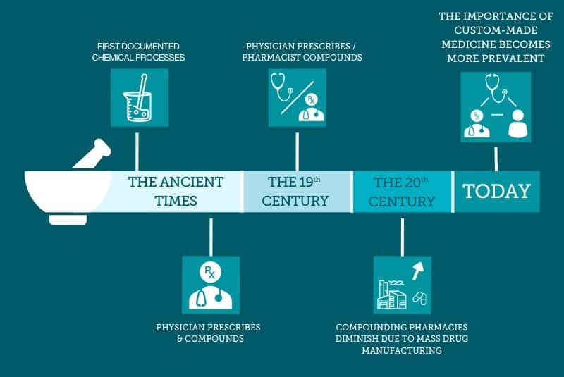
(Google, n.d.)

Pharmacy Services
Pharmacy services occupy a central position within the National Health Services (NHS), supplying medicines, offering clinical guidance, delivering public health interventions, and increasingly undertaking more advanced forms of patient care. Community pharmacies enhance the accessibility of healthcare, ease the burden placed on general practitioners (GPs) and hospitals, and help ensure the population uses medicines safely. Recent policy reforms has broadened the clinical scopes of pharmacists’ work, most notably through schemes such as Pharmacy First, contraceptive provision, and hypertension case-finding (Community Pharmacy England, 2025).
Current Functions of Pharmacy Services
Present – day community pharmacy provision operates across three tiers. Essential services – mandatory for all pharmacies – include dispensing, repeat dispensing, self – care support, public health promotion, and clinical governance. Advance services, commissioned more selectively, encompass Pharmacy First, the New Medicine Service (NMS), hypertension case – finding, pharmacy – based contraception, and smoking cessation support. Local services are commissioned separately by Integrated Care Boards (ICBs) according to the specific needs of their populations ( Community Pharmacy England, 2025).
In practice, a patient interaction with a pharmacy typically proceeds from initial assessment or advice through to either medicine supply or a clinical service, with referral to a GP or hospital where the presenting need exceeds the pharmacy’s scope. As of 2025, all community pharmacies are required to deliver essential services, while a substantial number also provide NHS England – commissioned advanced services. Pharmacy First being the most prominent example, enabling pharmacists to treat selected minor conditions without a GP referral.
Founding for these services is negotiated jointly by NHS England, the Department of Health and Social Care, and community Pharmacy England through the CPCF. For 2025/26, community Pharmacy Funding rose to approximately £3.073 billion, ssupplemented by a further £215 million earmarked for Pharmacy First and associated services – an increase that signals growing govermental recognitionof Pharmacy’s expanding contribution to pharmacy care (Department of Health and Social Care, NHS England and Community Pharmacy England, 2025). The breadth of services now delivered – spanning presciption dispensing, NMS, Pharmacy First consultations, hypertention screening, smoking cessation, contraception, public health promotion, and emergency medicine supply – has strengthened accessibility, aided by pharmacies typically longer opening hours and walk – in availability relative to general practice.
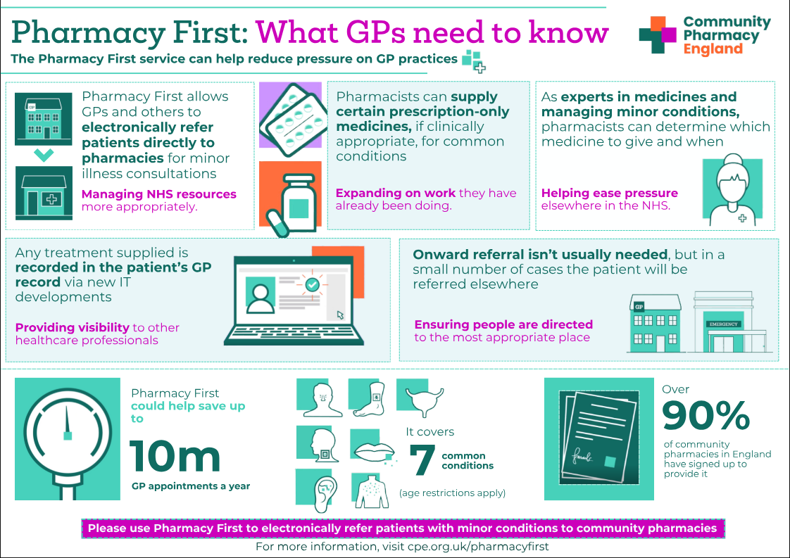 (Google, n.d.)

Conclusion
Community pharmacies have shifted markedly form their historical role are suppliers of medicine toward becoming integral clinical healthcare providers. Since the NHS’s founding in 1948, pharmacy services have expanded substantially, culminating in contemporary initiatives such as Pharmacy First and structured support for chronic disease management. Notwithstanding this process, the sector continues to face considerable challenges around funding sustainability and workforce capacity. Sustained investment and supportive policy will be essential to ensuring pharmacies remain accessible, effective, and equipped to meet future healthcare demand.

Two Challenges Facing Pharmacy Services
Challenge 1: Funding and Financial Sustainability
Financial sustainability represents the most pressing challenge confronting community pharmacy. Care funding remained largely statistic between 20017/18 and 2023/24, even as inflation, prescription volumes, staffing costs, and regulatory obligations continued to rise. Community Pharmacy England (2025) contends that this prolonged underfunding has rendered the existing operating model increasingly untenable.
Independent economic analysis conducted by Frontier Economics and IQVIA, commissioned by Community Pharmacy England (2025), estimated the true cost of delivering NHS pharmaceutical services in England at approximately £5.063 billion against available funding of only around £ 2.755 billion leaving a gap of roughly £ 2.31 billion. This analysis further indicated that the overwhelming majority of pharmacies receive funding below their actual operating costs. Although the 2025 funding settlement raised investment by close to 20% relative prior years, sector bodies continue to caution that many pharmacies remain financially precarious, and that continued closures – particularly in deprived areas – risk undermining patient access (House of Common Library, 2026).
Challenge 2: Workforce Pressures
As a pharmacists assume a wider range of clinical duties, workforce capacity has emerged as a further area of concern. Services such as Pharmacy First, hypertension case – finding, and contraceptive consultations demand additional time, training and staffing investment. NHS England (2025) monitors staffing levels, vacancies, and broader workforce needs across the sector through annual workforce surveys.
Rising demand for pharmacists across hospital, general practice, and community settlings has intensified competition for qualified staff. Where shortages occur, the consequences include disrupted service delivery, heightened workloads pressures will require sustained investment in education, training, recruitment, and retention strategies if pharmacies are to continue meeting NHS priorities and growing patient demand (NHS England, 2025).

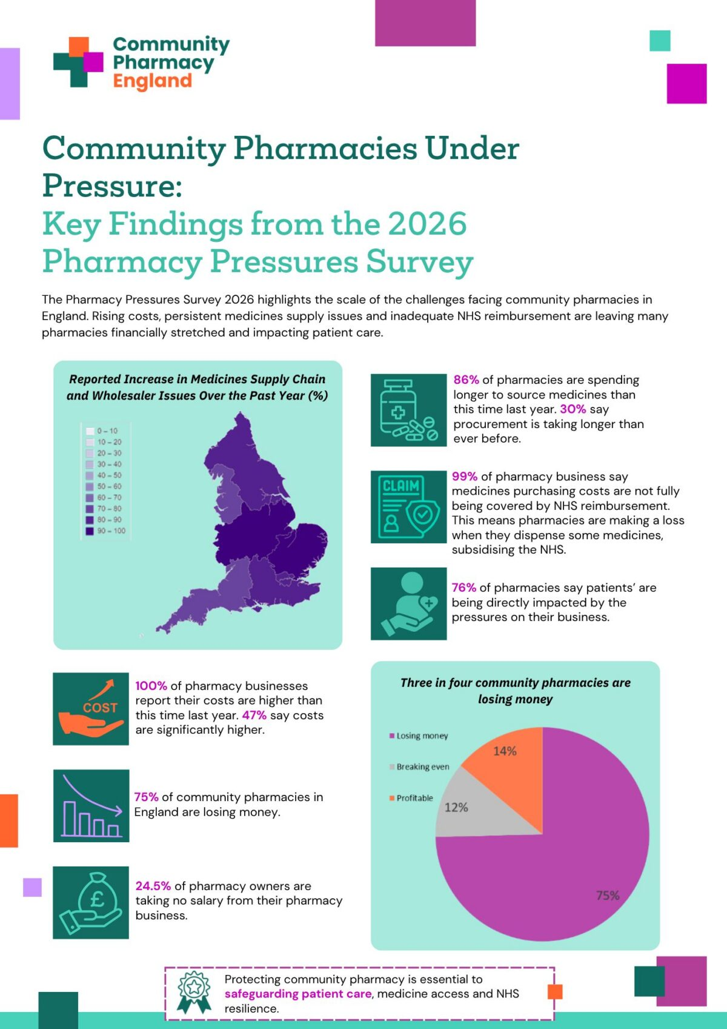
(Google, n.d.)

Element 2

Residential Care Home Services
Residential care homes constitute an essential strand of health and social provision, delivering accommodation, personal support, supervision, and assistance to individuals unable to live independently owing to age, disability, chronic illness, or cognitive impairment. The sector’s development has been shaped by centuries of social, economic, political, and demographic change, and tracing this evolution helps illuminate both its present role and the challenges it continues to encounter.

Historical Origins
The origins of residential care be located in medieval Europe, where religious institutions and charitable organisations undertook responsibility for older people, the poor and those unable to support themselves. In England, almshouses established as early as the tenth century exemplify some of the earliest such provision, typically founded by religious bodies or wealthy benefactors to shelter older disadvantaged individuals (Carehome.co.uk, 2025). Monasteries and early hospitals similarly offered long-term accommodation to the sick and elderly.
A significant turning point came with the Elizabethan Poor Law of 1601, which placed responsibility for supporting those unable to work – due to age, illness, or disability – onto local perishes, driving the expansion of almshouses and the eventual emergence of workhouses as a means of relief (British Geriatrics Society, 2016). This trajectory intensified with the Poor Law Amendment Act 1834, under which workhouses became the principal form of support for impoverished populations, including older adults. This institutions were frequently overcrowded, under-resourced, and deliberately harsh, designed to discourage reliance on public assistance; historians contend that such conditions reflected Victorian attitudes toward poverty rather than any genuine commitment to person-centred support (Peace, 2003).
Reform accelerated through the twentieth century. The Old Age Pension Act 1908 reduced dependence on workhouses through direct financial support for older adults, while the founding of the welfare state and the NHS in 1948 shifted responsibility for long-term care toward local authorities and dedicated residential facilities. Private and voluntary sector provision grew rapidly in subsequent decades, particularly during the 1980’s, as government policy favoured market-based approaches to social care (Gloveman, 2023). The care standardised regulation, consolidating residential and nursing provision under the unified category of “care homes,” with renewed emphasis on quality assurance and residents’ rights.

Critical Evaluation of Contemporary Provision
Present-day residential care homes provide accommodation, personal-care, support with daily living, social engagement, and specialised care for individuals with complex needs such as dementia current models increasingly emphasise person-centred principles, dignity, autonomy, and multidisciplinary collaboration, reflected in the NHS’s Enhanced Health in Care Homes Framework, which promotes integrated, personalised support delivery jointly by care homes and healthcare providers (NHS England, 2026).
A key strength lies in the sector’s capacity for continuous care and monitoring, granting residents access to trained staff, medication management, nutritional support, and mobility assistance – of particular value for those with advanced frailty or multiple chronic conditions. However, substantial challenges persist; research from the National Institute for Health and Care Research points to understaffing, recruitment difficulties, and low wages as factors undermining both resident outcomes and staff being (NIHR Evidence, 2021). Concerns also remain regarding institutionalisation, whereby residents may experience diminished autonomy or social isolation despite efforts to promote independence, with some scholars noting that traces of the sector’s historically custodial character persist in certain settings. Quality varies considerably between providers, and the World Health Organization stresses that effective long-term care depends on robust standards, monitoring, safeguarding, and active resident involvement in decision-making (WHO, n. d.).

Contribution to Quality of Life
Residential homes can meaningfully enhance quality of life across physical, psychological, and social domains. Ongoing assistance with daily activities, medication, nutrition, and chronic disease management can reduce avoidable hospital admissions, while structured routines and professional support offer emotional security, particularly benefiting residents with dementia through tailored intervention. Socially, communal living and organised activity help counter loneliness and isolation common among older adults. The WHO identifies quality of life, dignity, and user satisfaction as central makers of successful long-term care, underscoring that residential provision contributes to healthy ageing beyond mere physical survival.

Conclusion
Residential care homes have evolve from religious charity and Victorian workhouses into a regulated, increasingly person-centred component of contemporary care. While challenges around quality, staffing, funding, and autonomy, such as homes continue to play vital role in promoting health, dignity, and wellbeing among vulnerable populations.

References
Anderson, S. (n.d.) History of Pharmacy in Great Britain 1841–Present. British Society for the History of Pharmacy. Available at: https://www.bshp.org/history-of-pharmacy (Accessed: 5 July 2026)
Balogun, B. and Harker, R. (2026) Community pharmacy in England. House of Commons Library, Research Briefing CBP-9854, 2 March. Available at: https://commonslibrary.parliament.uk/research-briefings/cbp-9854/ (Accessed: 16 July 2026)
Baird, B. (2025) Community pharmacy explained. The King’s Fund. Available at: https://www.kingsfund.org.uk/insight-and-analysis/long-reads/community-pharmacy-explained (Accessed: 9 July 2026)
British Geriatrics Society (2016) A brief history of the care of the elderly. Available at: https://www.bgs.org.uk (Accessed: 9 July 2026)
Carehome.co.uk (2025) A history of care homes. Available at: https://www.carehome.co.uk/advice/a-history-of-care-homes (Accessed: 9 July 2026).
Care Quality Commission (2025) Regulations for service providers and managers. Available at: https://www.cqc.org.uk/guidance-regulation/providers/regulations-service-providers-and-managers (Accessed: 9 July 2026)
Community Pharmacy England (2025) Community Pharmacy England’s brief guide to the Community Pharmacy Contractual Framework and Funding. May 2025. Available at: https://cpe.org.uk/wp-content/uploads/2025/05/Brief-guide-to-the-CPCF-and-funding-May-2025.pdf (Accessed: 9 July 2026)
Community Pharmacy England (2025) Pharmacy Pressures Survey: Funding and Profitability Report. Available at: https://cpe.org.uk/ (Accessed: 16 July 2026)
Community Pharmacy England (2025) Pharmacy Pressures Survey: Staffing and Morale Report. Available at: https://cpe.org.uk/ (Accessed: 16 July 2026)
Connelly, D. (2018) NHS70: major moments in pharmacy 1948–2018. The Pharmaceutical Journal, 22 June. Available at: https://pharmaceutical-journal.com/article/infographics/nhs70-major-moments-in-pharmacy-1948-2018 (Accessed: 16 July 2026)
Department of Health and Social Care (2025) Community Pharmacy Contractual Framework 2024/25–2025/26. London: Department of Health and Social Care. Available at: https://www.gov.uk/ (Accessed: 16 July 2026)
Department of Health and Social Care, NHS England and Community Pharmacy England (2025) Community Pharmacy Contractual Framework: 2024 to 2025 and 2025 to 2026. GOV.UK. Published 31 March 2025. Available at: https://www.gov.uk/government/publications/community-pharmacy-contractual-framework-2024-to-2025-and-2025-to-2026/community-pharmacy-contractual-framework-2024-to-2025-and-2025-to-2026 (Accessed: 9 July 2026)
Gloveman (2023) The history of care homes in Britain. Available at: https://www.gloveman.co.uk/news/the-history-of-care-homes-in-britain (Accessed: 9 July 2026)
Google (n.d.) Current Functions of Pharmacy Services in the UK. Google Images. Available at: https://www.google.com/search?q=Current+Functions+of+Pharmacy+Services+in+the+UK (Accessed: 15 July 2026)
Google (n.d.) History of pharmacy timeline. Google Images. Available at: https://www.google.com/search?q=history+of+pharmacy+timeline (Accessed: 15 July 2026)
Google (n.d.) What are the challenges of pharmacist in the UK. Google Search. Available at: https://www.google.com/search?q=what+are+the+challenges+of+pharmacist+in+the+UK (Accessed: 18 July 2026)
Great Britain (2014) Care Act 2014 (c. 23). London: The Stationery Office. Available at: https://www.legislation.gov.uk/ukpga/2014/23/contents (Accessed: 15 July 2026)
House of Commons Library (2026) Community Pharmacy in England. Available at: https://commonslibrary.parliament.uk/research-briefings/cbp-9854/ (Accessed: 9 July 2026)
Johnson, J., Rolph, S. and Smith, R. (2010) ‘Uncovering history: Private sector care homes for older people in England’, Journal of Social Policy, 39(2), pp. 235–253
Legislation.gov.uk (2014) Care Act 2014. Available at: https://www.legislation.gov.uk/ukpga/2014/23 (Accessed: 9 July 2026)
Munson, S. (2025) A history of care homes. Carehome.co.uk. Available at: https://www.carehome.co.uk/advice/a-history-of-care-homes (Accessed: 15 July 2026)
NHS England (2024) Pharmacy First. Available at: https://www.england.nhs.uk/primary-care/pharmacy/pharmacy-services/pharmacy-first/ (Accessed: 16 July 2026)
NHS England (2025) Pharmacy services. Available at: https://www.england.nhs.uk/primary-care/pharmacy/pharmacy-services/ (Accessed: 16 July 2026)
NHS England (2025) Community Pharmacy Workforce Survey. Available at: https://www.hee.nhs.uk/our-work/pharmacy/community-pharmacy-workforce-survey (Accessed: 9 July 2026)
NIHR Evidence (2021) Improving the quality of care in care homes. Available at: https://evidence.nihr.ac.uk (Accessed: 9 July 2026)
Peace, S. (2003) The Development of Residential and Nursing Home Care in the United Kingdom. Buckingham: Open University Press.
Royal Pharmaceutical Society (2018) Timeline of pharmacy development in the UK. Available at: https://www.rpharms.com (Accessed: 4 July 2026)
The King's Fund (2025) Community pharmacy explained. Available at: https://www.kingsfund.org.uk/ (Accessed: 16 July 2026)
UK Government (2026) Care Quality Commission. Available at: https://www.gov.uk/government/organisations/care-quality-commission (Accessed: 9 July 2026)
World Health Organization (n.d.) Quality management in long-term care. Available at: https://www.who.int (Accessed: 9 July 2026)
Your Health Your Pharmacy (n.d.) Community pharmacy – past, present and future. Available at: https://www.yourhealthyourpharmacy.co.uk/community-pharmacy-past-present-and-future-3/ (Accessed: 9 July 2026)

