Report on the Value and Purpose of Code-switching

Time: March 25th, 2022
Attendee: Chinese-English Bilingual Parents
Reportor: Wang Yanyan
Subject: The Values and Purposes of Code-switching

Abstract
The purpose of this report is to introduce the specific linguistic and social communicating phenomenon--codes-witching, and further discuss its value and purposes. In the following report, the following questions will be illustrated :
- What are the language choice patterns of the subjects and their parents at home?
- What should be the parents attitude towards children’s cod-switching?
3. What are the reasons of the children’s code-switching?
4. What are the values and purposes of the children’s code-switching?
5. What should be the parental strategies towards code-switching?

Introduction
Code-switching refers to going from one language to the other in mid-speech when both speakers know the same two languages. (Cook, 2008) Adults have been observed to code-switch in conversations to create metaphorical effects in the discourse (Blom & Gumperz, 1972; Gumperz, 1982; Ritchie & Bhatia, 2012). Parents may also code-switch to produce metaphorical effects unique to a childs language development. This could include code-switching in order to get their childs attention, emphasize a point, or discipline their child (Bail et al., 2015; Byers-Heinlein, 2013; Goodz, 1989).
Lanza (2001) listed five major parental strategies in analyzing parental response towards are exemplified in the following chart:
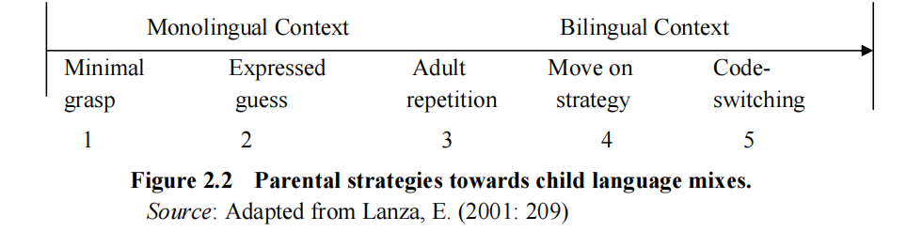
According to Lanza(2001), code-switching is the most bilingual strategy among the five, comprising both inter-sentential and intra-sentential code-switching. By code-switching, it means that parents switch from their ethnic language to the other language under discussion. The parents in the examples above, when responding to a child’s utterance mixed with the other language, instead of sticking to their own language, either readily incorporated the child’s misuse of the wrong code in their response or alternate to the other code completely. If the child’s code-switching behavior is an initiation for code negotiation, the parental response could be a signal that the parents are quite open to engage in the negotiation initiated.
In the book，which I have reviewed recently，“A Parents and Teachers Guide to Bilingualism”（Baker 2014）, an quite meaningful and debatable question has been raised by the parents. “Does Switching between languages have any value or purpose?” To answer the question, we should stand on the side of the parents. They are afraid of the occurrence of mixing-up of languages, which is called Language mixing (be used to refer use either language indiscriminately). According to the author, although one language may sometimes influence the infants less dominant language, children soon become aware of those social situations and those people with whom they can and cannot code-switch. Thus, it is not sensible or real for the distinction between mixing and codes-witching. More researchers would like to stand on the points that code-switching is a valuable and purposeful communication strategy.

Why and When Code-switching happens?
There are numerous reasons why adults code-switch in speech to other bilingual adults, as well as additional reasons why adults might code-switch when speaking to their children. The reason(s) motivating a parents code-switching could potentially bolster a child’s language development.
In the environments where multiple languages are used, bilingual and multilingual speakers can combine more than one language in their conversations, a phenomenon known as code-switching. Code-switching was originally believed to be the result of a language deficiency (Weinreich, 2010), a strategy used by bilinguals to compensate for a lack of proficiency in either one or both languages (Heredia & Altarriba, 2001). Scholars today, however, overwhelmingly reject these views and recognize that code-switching is a systematic and complex linguistic phenomenon that is typical of bilingual communities (Hoff & Core, 2015; Ritchie & Bhatia, 2012; Yow, Tan & Flynn, 2018). For the past several decades, researchers have investigated how often, where syntactically, and why code-switching occurs.

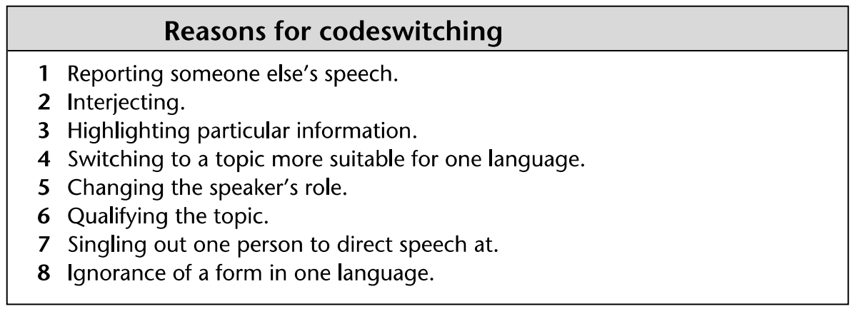
Chart 1.1 Reasons for Codes-witching (Cook, 2004)

As listed in chart 1.1, different reasons involve in code-switching depending on the purpose of interaction. First, code-switching behaviors vary significantly between different communities of bilinguals (Heller, 2010). For many, code-switching serves to reinforce a community’s identity by following the accepted local norms and functions of code-switching (Nilep, 2006). Indeed, research on childrens early productions of code-switching have found that children code-switch at a similar rate to their parents, suggesting that parental code-switching may serve as a model for developing bilinguals (Comeau, Genesee & Lapaquette, 2003; Yip & Matthews, 2016). There are also reports that parents sometimes code-switch in order to teach their child a new word, again using code-switching strategically to enhance their children’s comprehension and learning (Byers-Heinlein, 2013). They have been observed code-switching in these circumstances may help to support children’s language learning.
Additionally, adults have been observed to code-switch in conversations to create metaphorical effects in the discourse (Blom & Gumperz, 1972; Gumperz, 1982; Ritchie & Bhatia, 2012). Parents may also code-switch to produce metaphorical effects unique to a childs language development. This could include code-switching in order to get their childs attention, emphasize a point, or discipline their child (Bail et al., 2015; Byers-Heinlein, 2013; Goodz, 1989). In order to adapt to their child’s knowledge bilingual parents may use code-switching, for example, it is common for Chinese parents to use "Hello" instead of "Ni hao" to greet the children, and "Goodbye" is used in various situations. Moreover, bilingual parents give English nicknames to their kids and use as much English as possible in their daily communication.
Finally, when the children goes to school, code-switching is often used in language classroom,and plays important role in organizing classroom, controlling classroom atmosphere and order, explaining sentence grammar, promoting students' understanding and so on. To be better involved in the future English class, its a good attempt to get familiar with code-switching at an early age.

What are the Values of Code-switching?

Colin Baker listed out 11 major uses of code-switching in "A Parents and Teachers Guide to Bilingualism", that indicates the significant value of shifting from one language to another in mid-speech. Major Uses of Code-switching : (1) Emphasize a particular point in a conversation. (2) If a people do not know a word or a phrase in a language, they may substitute a word in another language. (3) Express more adequately an idea. (4) Repeat a phrase or a command. (5) Communicate friendship. (6) In relating a conversation held previously, the person may report the conversation in the language or languages used. (7) A way of interjecting into a conversation. (8) Ease tension and inject humor into a conversation. (9) Indicate social distance. (10) Exclude people from a conversation. (11) To indicate a change of relationship and a change of attitude.
These values are worth of further illustration from my own experience :
As for point (1), it reminds me the division of code-switching: inter-sentential and intra-sentential. As for Chinese bilingualism, the emphasizing of point often occur in intra-sentential cod-switching, for example “DJ he yue dui dou lai le, yin yue yue lai yue ‘high’ le.” which means “As the DJ and band had come, the music became more and more exciting.” At present, bilingualism is extremely common in China, the using frequency of "Hello" “Thank you” “Sorry” “cool”. are as high as the Chinese equivalents. Parents, who intend to cultivate the children’s bilingual ability at an early age, will expose them with more code-switching patterns as appeared in songs, rhymes, stories, picture books and so on.
(2) & (3) can be best illustrated in ESL classroom, because the great value of code-switching lies in ESL, especially for children and teenagers, Code switching is a very effective teaching method, which can help teachers analyze and explain sentences and facilitate students' learning and understanding. According to some domestic survey reports, the use of mother tongue in English classes in many middle schools in China is very common, and most teachers and students believe that the appropriate use of code switching can help students remember and understand vocabulary and grammar to a certain extent. Foremost, Code-switching proper can also be exploited as part of actual teaching methodology.(Morizumi, 2002). Here are examples belongs to information code switching, which I perceived from secondary English teaching classroom. 
1. Terminology translation or difficult to express English and Chinese vocabulary
T: What is the special food for Dragon Boat Festival (Duan Wu Jie)? 
S: Zong zi.
- Grammar teaching needs
T: This is bin yu cong ju. (This is objective clause.) Ta de yong fa shi .(The usage of it is.)
Through the above code switching methods, students can improve their understanding and memory of English vocabulary and grammar, and it is also a better way for teachers to explain rare English words. Expressing in their familiar language can save a lot of time and avoid many possible mistakes.
- Repeating a phrase or a command is a common phenomenon in second language teaching. In order to achieve better understanding, parents or teachers would like to explain a concept in one language and then will illustrate it in another language believing that repetition adds reinforcement for depth of understanding.
- (11) Moreover, the above mentioned points, I have deep impression of the fifth & eleventh ones: communicate friendship and changing of attitude . When I was working in Dhaka University Bangladesh, Bangladeshi intermingled with English was my Bangladeshi friends favorite way of communication style. Because they take the foreigners efforts of speaking their mother tongue as indicating deference and friendship.
- (7) are the points that occur in the situation that one of the speakers do not know about the language of the other speakers. When I was working in Bangladesh, the students are very considerate to make English and Chinese bilinguals to explain what they are talking about in other languages. Most of the students in Dhaka university are multilingual speakers, they can easily shift from one language to another. Consequently, codes-witching occurs both inter-sentential and intra-sentential.
(8)The humor of using another language reminds me the use of "Sorry" in Chinese has a special effect of humour. The heroin of the story is a national famous TV hostess, she mistook the names of two superstars in one large scale ceremony. Because it is a lively show, millions of audiences witnessed the embarrassment of the hostess.To redeem the mistake, the hostess used English “Sorry!” instead of Chinese expression “Dui bu qi!”. So then, to admit mistakes and ask for forgiveness, “sorry” could be a better choice to ease the tension.
(10) The exclusion of other people from the conversation seems impolite and offensive as it is shown by the example given by Colin Baker. However, if the conversation goes to certain privacy or secrets, the application of another language is one of the best choices.
Actually, Code-switching is not only a linguistic phenomenon, but also indicates important social and power relationship.

What are the Purposes of Code-switching?

Nowadays , code-switching, for the child, this would mean that his code-switching behavior was quite appropriate and he would take his parents response as a positive sign encouraging his code-switching. As has been noted by Nicoladis and Genesee (1998), however, the category is ‘nonspecific’. It could be used for many different purposes like move-on, clarification request, expressing a guess, or repetition so that it should be further explained, based on the specific context. As more people become multilingual, code-switching becomes more common phenomenon, which occurs in daily communication. For example, in mandarin we may say, “Ta shi yi ge hen ‘nice’ de ren。”（The English translation is “She is very nice. ”）. Bilingual or multiple lingual speakers can alternate between different languages in a conversation.
Code switching is a communicative strategy for speakers to achieve the ultimate goal of their intentions by means of the adaptability principle. Code switching aims at its adaptation to linguistic reality，social conventions and mental motivations(Verschueren，1999). The implementation of the adaptability principle is to realize some concrete teaching objectives which are helpful in developing students English skills and enhancing the teaching effect.
The use of code switching in Chinese family can promote the communication between parents and students, and further help children more interested in new language learning and improve children’s learning motivation. It is a parental teaching method worthy of promotion. Additionally, it lays a foundation for the students to participate in their future English class. At present, English teachers in primary and middle schools often use second language in the classroom. They create the classroom atmosphere and control classroom discipline through code-switching, which has a strong purpose. If students with weak language foundation that they can't understand teaching content, it will have a great impact on the continuation of follow-up courses. This problem is common. In response to this problem, parents had better generally use code switching to analyze and explain the expressed content. Thus, the earlier adaption to bilingualism circumstance will be the cornerstone of bilingual learning in the classroom.

Recommendations

Generally speaking, it is widely acknowledged that bilingualism brings lots of benefits to children, consequently more and more parents tend to train their children at an early age. It should be noted that sometimes the parents who are less capable in English may still choose to speak more English with their children as a means to facilitate their children’s learning of English.
The use of code switching in the family can promote the communication between the two sides, and the parents who teach in the family also have great attainments in both languages. Therefore, in the process of communicating, parents should take a consideration of the quality of children,the frequency of code-switching,and the content in which they will make some necessary code switching.
Firstly, parents' attitudes towards bilingual children's code switching are related to their bilingual language view and children's language development goals. The bilingual code-switching of children should be guided and encouraged.
Secondly, the number of children's code switching reflects the activity of language acquisition to a certain extent. So the frequency had better be removed. Careful observation and recording will help to understand its development trend. If the frequency and results significantly affect children's normal communication with the outside world, especially when children feel seriously frustrated, they should seek advice or help from language experts.
Thirdly, the occurrence of children's code switching is often closely related to specific objects, occasions, topic content and other factors. Therefore, parents can try to make use of these factors to better guide cross language development.

Conclusion
To conclude, code-switching is a challenge both to the children and to the parents. As a generally observed as language phenomenon and strategy, the appropriate use of code-switching in bilingual families is beneficial to improving children’s ability of English use promoting students efficiency in studying English and reinforcing the language intelligence.So to conclude overall, we have shown that both language choice and code-switching are dependent on a developing bilingual's linguistic resources. Language choice cannot occur until the child has equivalent lexical items in the vocabulary between which he or she can choose, and code-switching cannot occur until the child has two alternative grammatical systems.
However, in the light of the situation that English is taught as a foreign language in Chinese context，the introduction and implementation of code switching in families is indispensable. English is rather rapidly entering the Chinese families, code-switching seems to be one of the parents favourite language choice.

References

［1］Colin Baker, Parent’s and Teacher’s Guide to Bilingualism, Clevedon:Nultilingual Matters，2007. PP. 148-156
［2］Vivian Cook, Second Language Learning and Language Teaching 4th Edition, Hodder Education, 2008. PP170-192
［3］Lena V. KREMIN, Code-switching in Parents’ Everyday Speech to Bilingual Infants, Journal of Child Language (2021),PP. 1–27
［4］Comminms J.The influence of bilingualisn on cognitive growth:a synthesis of research findings and explanatory hypotheses［J］.Working Papers on Bilingualisn, 1976（9）:1-43.
［5］Dau-Cheng Lyu, Tien-Ping Tan, Eng-Siong Chng and Haizhou Li, Mandarin–English Code-switching Speech Corpus, Lang Resources & Evaluation (2015), PP. 581–600
［6］Heredia, R. R., & Altarriba, J. (2001). Bilingual Language Mixing: Why Do Bilinguals Code-Switch? Current Directions in Psychological Science, 10(5), 164–168.
［7］Lyon J.Becoming bilingual:language acquisition in a bilingual community . Clevedon:Multilingual Matters. 1996.
［8］Soderstrom, M., Blossom, M., Foygel, R., & Morgan, J. L. (2008). Journal of Child Language, PP. 869–902.
［9］Yip, V., & Matthews, S. Code-mixing and mixed verbs in Cantonese-English bilingual children: Input and innovation. 2016
［10］Yow V Q, Tan J S . Code-switching as a Marker of Linguistic Competence in Bilingual Children. 2018，PP:1075-1090
［11］祝畹瑾． 新编社会语言学概论[M]． 北京：北京大学出版社， 2013：255．
［12］ 高 军，戴炜华. 语言教学中的语码转换研究和实验分析 [J]. 外语教学，2007, 51-55.
［13］ 刘永厚. 英语教师课堂教学语码转换功能的个案研究[J]. 北京第二外国语学院学报，2008, PP77-81.
［14］曲 晶，孙芙蓉. 英语教学中的语码转换[J]. 现代教育科学， 2007（5）PP. 148-150.
［15］金 虹. 关于大学公共英语课堂中语码转换的分析：以沈阳大学部分师生为调研对象[J]. 沈阳大学学报（社会科学版），2015 PP 362-365.
［16］唐丽萍. 语言课堂语码转换述评[J]. 国外外语教学，2003 （1）PP5-10.
［17］ 程晓丽. 国内英语课堂语码转换研究的现状与展望 [J]. 外国语文，2015（5）PP150-157.

