Data Handling and Business Intelligence
(LCBB5000)
Assessment 2

Lecturer: Anupam Mazumdar
Student: Ana Maria Cirstea (2011016)

Table of Content

Introduction 1
Part 1 2
Changes in the Average Price Over the Years 2
Use of Microsoft Excel for Pre-Processing, Analysing, and Visualising Data 8
Steps of Performing Two Excel Functions 8
Production of Charts 12
Part 2 15
1. Frequency of Male and Female Students 15
2. Frequency of Students Who Qualify for Reduced/Free Lunch 16
3. Mean and Median of Students who Qualify and Does not Qualify for Reduced or Free Lunch 17
4. The Mean and Median Differences of Students 18
5. Clustering Using SPSS 19
6. Five Most Common Data Mining and Text Mining Methods 23
7. Advantages and Disadvantages of SPSS and Excel 24
Conclusion 26
Reference 27

Introduction
Data handling and analysis are crucial tasks conducted by data analysts that allow managers to make informed decisions (Santos-Pereira, Gruenwald and Bernardino, 2022). With the advancement of the technologies, several software had been invented to process, analyse, and present data findings for easier understanding and interpretation of data. This report involves two tasks that examines the usefulness of MS Excel and SPSS, as well as discusses the advantages and disadvantages of the respective software for data mining and analysis.

Part 1

Changes in the Average Price Over the Years
In order to determine the increase or decrease in the average price of the hotel rooms, data sorting is required. Thus, firstly, the two columns, arrival time and the average price, must be selected as shown below. These two columns have been selected as the arrival time would help us to track the average prices of the hotel rooms every year.
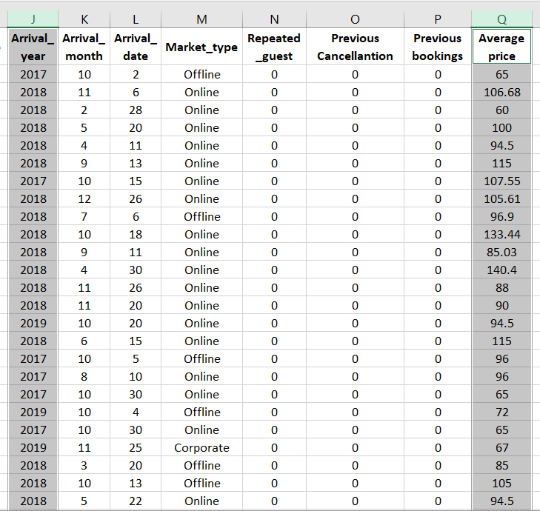
Afterwards, these columns must be copied and pasted to another Excel sheet, as shown below. This would make sorting much easier.
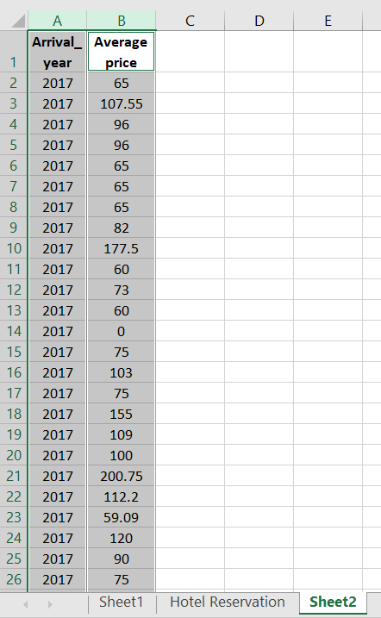
As there are a large amount of data with irregular input of arrival time, it is important to sort the year and the respective prices in an ascending order, that is 2017 to 2022. For this, both the columns must be selected and the tab ‘Sort & Filter’ within the Editing section of the Task bar must be clicked. A dropdown shall appear and the first option of ‘Sort Smallest to Largest’ must be selected.
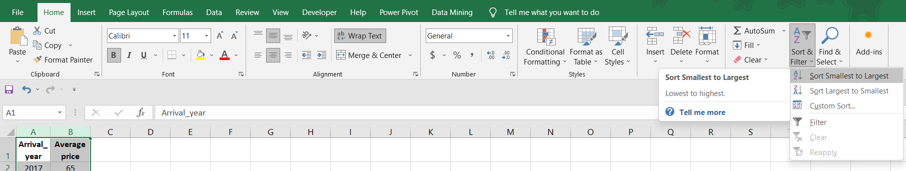
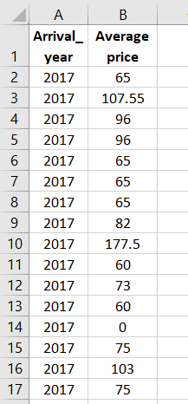 After pressing OK, the columns shall be arranged in an ascending order of the year as shown in the image. Next, the line chart must be produced to help determine the changes in the prices over the years. In order to so, the two columns must be selected and the ‘Insert’ tab must be clicked and the ‘Insert Line or Area Chart’ option from the Chart section must be selected, as shown below.
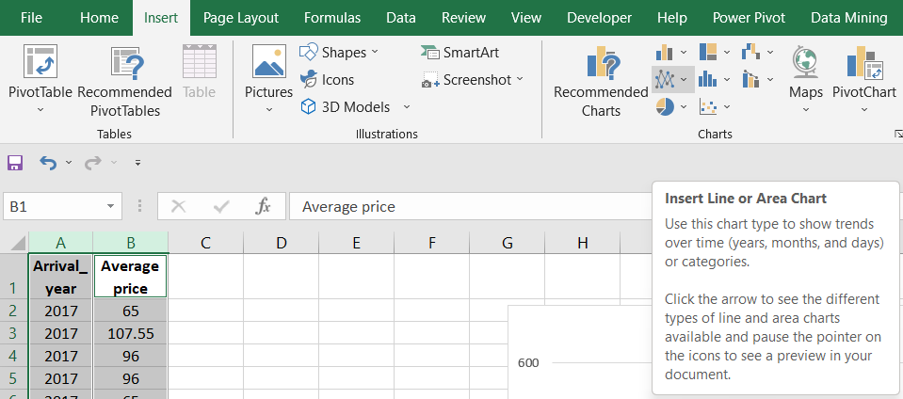
A drop-down button of the Line Chart must be clicked and the first option of ‘Line’ must be selected after which a chart shall appear.
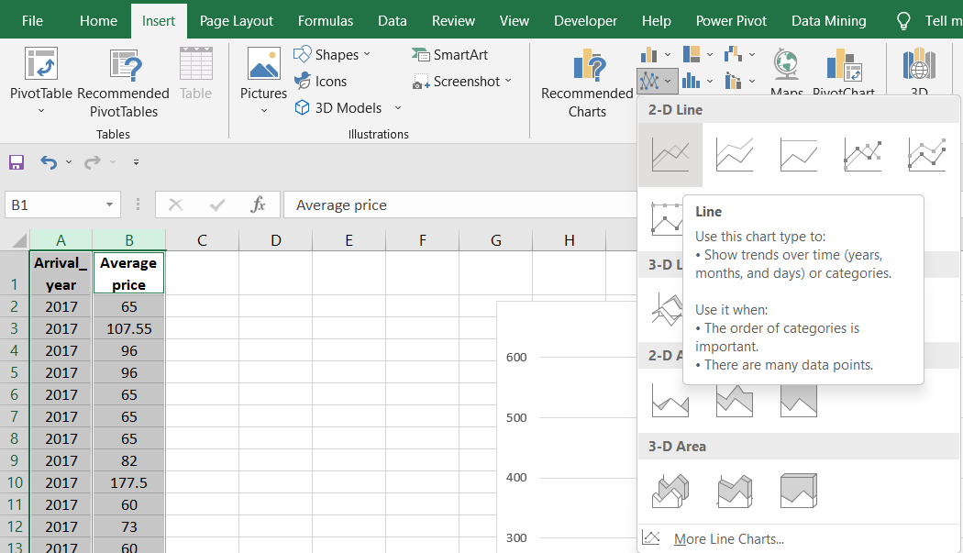
The line chart that shall appear may have inaccurate allocation of data within its access. This is the one limitation of Excel of being unable to detect variables appropriate for the axis correctly when using large amounts of data. Thus, to correct the line chart, the option ‘Select Data’ must be clicked after right clicking within the line graph as shown below.
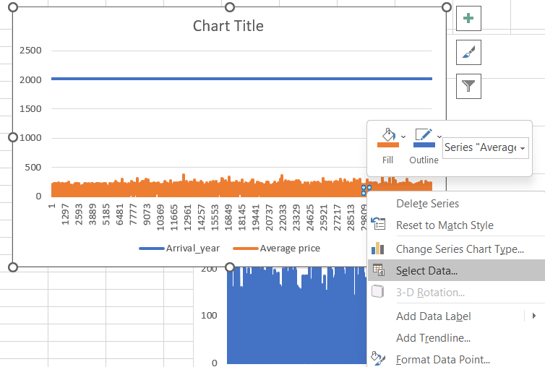
A command box shall appear as shown below. And the button ‘Add’ must be clicked. This shall help to select the data range for the y-axis.
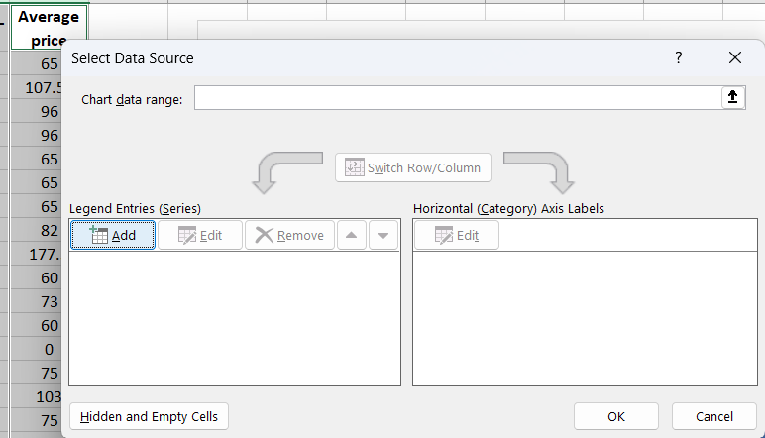
Within the series name, the cell with the column name must be selected which had been the Average price. In the Series value, the data from the entire column must be selected. And then OK must be clicked as shown below.
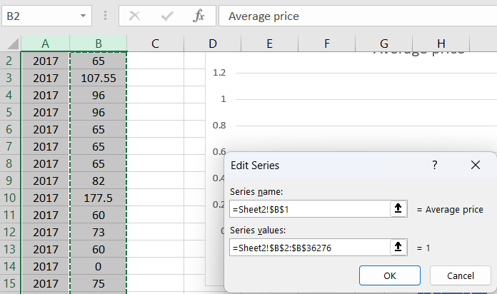
Then, the x-axis must be edited, thus, the option of ‘Edit’ must be clicked, after which a command box shall appear.
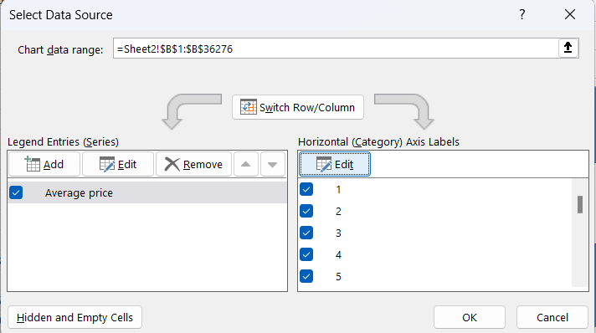
Within the command box, the data range of the arrival year must be selected and ‘OK’ must be clicked as shown below.
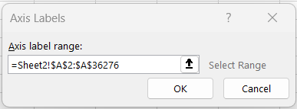
Afterwards, the chart shall be presented in a correct manner, which shall be helpful to determine the changes of the average price. As it can be seen, the average prices can be observed to be drastically fluctuating over the years with a few outliers of high price ranges within year 2018. Nonetheless, the average prices are said to be fluctuating and more or less remaining within the range of mid 100s.
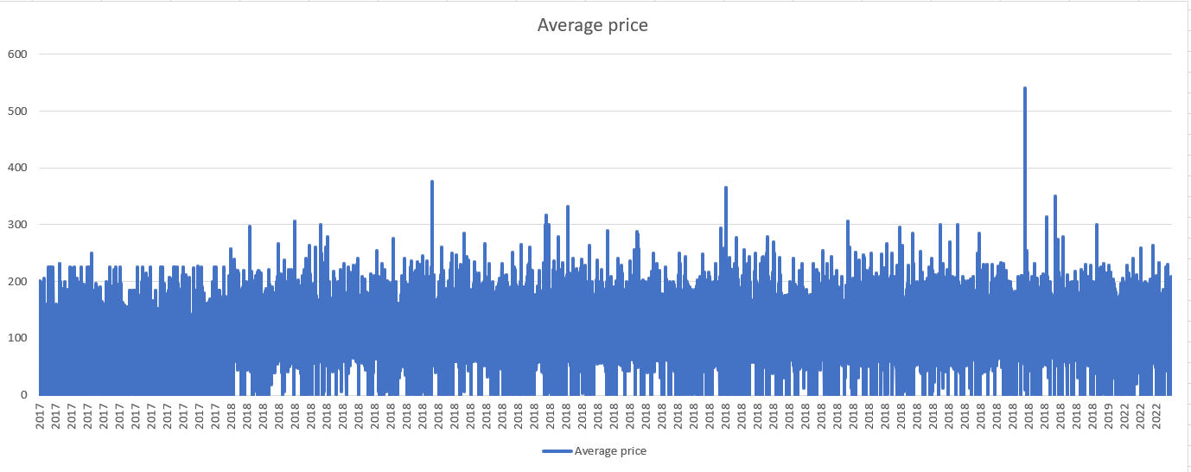

Use of Microsoft Excel for Pre-Processing, Analysing, and Visualising Data
Excel is a very user-friendly software which allows data pre-processing, analysing, and visualisation. As much as the process pre-processing of data can be easily done, a large amount of data often times slows the software down (Chen et al., 2020). This may result in lag in processing time of the software. However, pre-processing of data can be easily done without much effort. As for the analysing part, it is important to know how analyse the data using appropriate tools in Excel (Ferreira‐Mello et al., 2019). This is mainly because the software had numerous data analytical tools, but are located and processed in different manners, as some data analysis can be done by simply implementing formulae within the designated cells; other advanced data analytical tools are located under the data analysis tab within the ‘Data’ task bar option. Thus, implementing the correct data analytical tools can be tricky but easy if the analyst knows which functions to use. Moreover, the visualisation of data is rather easy to perform and the necessary corrections can be easily made (Antons et al., 2020). The software provides an array of numerous charts and illustration tools for the data set which can be easily implemented as described above. Thus, visualisation is rather easy to implement and edit according to the analysts’ will.

Steps of Performing Two Excel Functions
There are numerous Excel functions that can be implemented within the dataset. However, relating to the average prices of the hotel rooms, IF function had been implemented to test of the average prices had been relatively high if the prices had been higher than 90. The function used had been =IF(Q2>90,"HIGH", ), where the condition of the average price cell (column Q) being greater than 90 would result in “HIGH”, otherwise would be “NORMAL”. This function had allowed to identify the average price of each of the reservation to be identified as either high if the price was over 90 or normal if it was below 90.
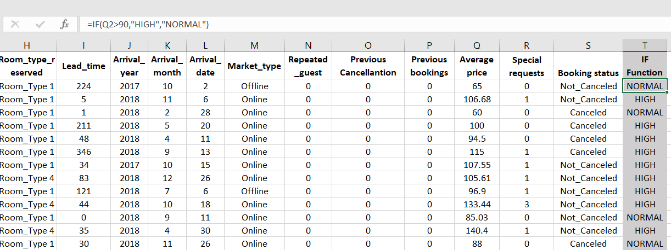
Next, another function of ‘Pivot Table’ had been implemented to sort the dataset within a table that is easier to understand based on the criteria the data analyst wants to detect. Firstly, the option of pivot table must be selected from the ‘Insert’ tab from the task bar and the option of ‘From Table/Range’ must be clicked as shown below.
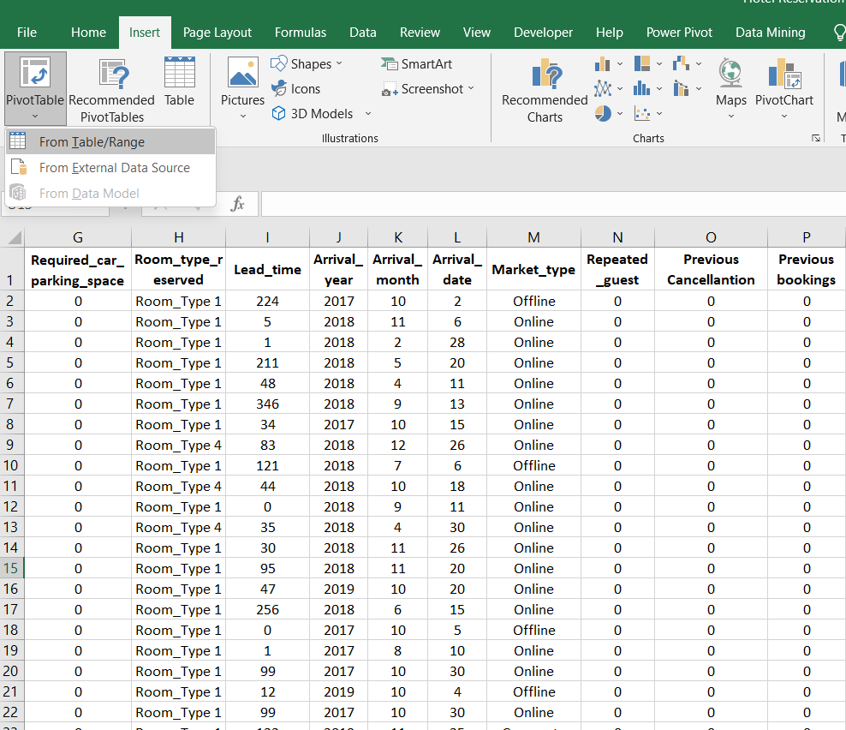
Then, a command box shall appear as shown below. The table range shall be automatically selected but the range can be manually selected if the table range had not been correctly selected automatically. As this datasheet already has large amount of data, to make the data analysis easier and faster, the output location of the Pivot Table is selected to be in a ‘New Worksheet’ rather than the existing worksheet.
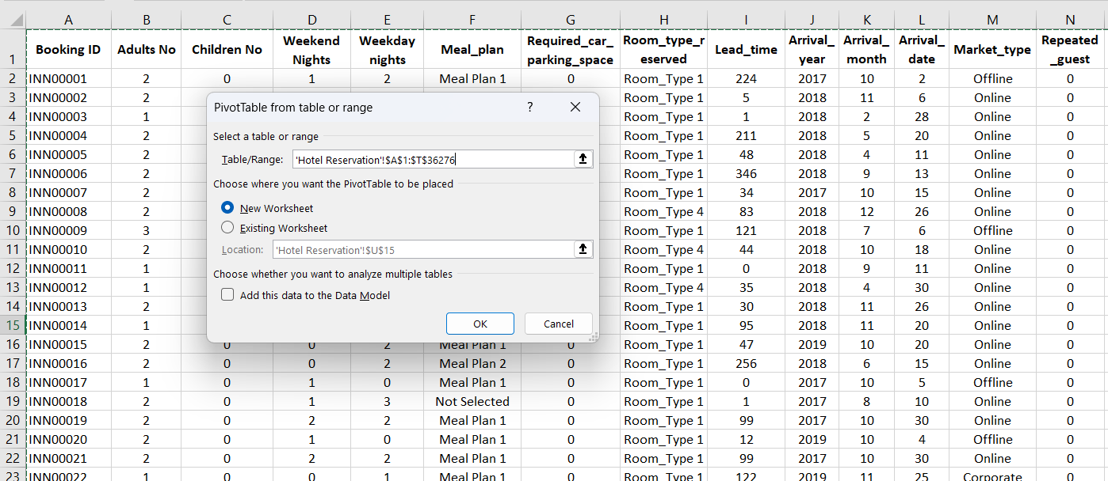
Afterwards, the OK button must be clicked, and a new spreadsheet shall appear with the pivot table option. The following image illustrates how the spreadsheet would look like after the command box disappears. From ‘PivotTable Fields’ the necessary filters, columns, rows, and values can be selected.
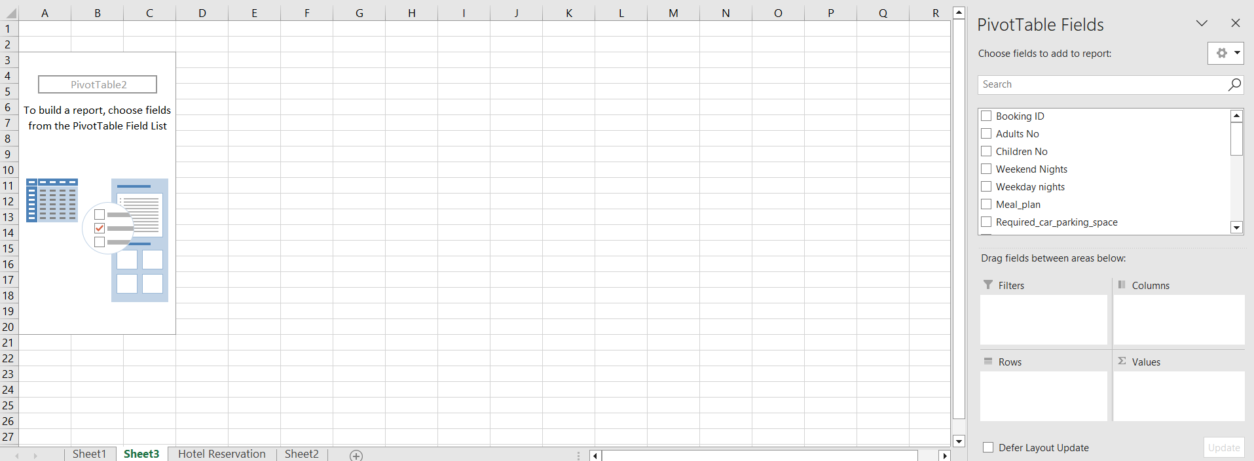
For this dataset, the following items had been selected for the Pivot Table – average price, number of adults, number of Children, weekday nights, weekend nights, market type, and complementary. This helps to identify the rationale behind the changes in prices of the hotel reservations.
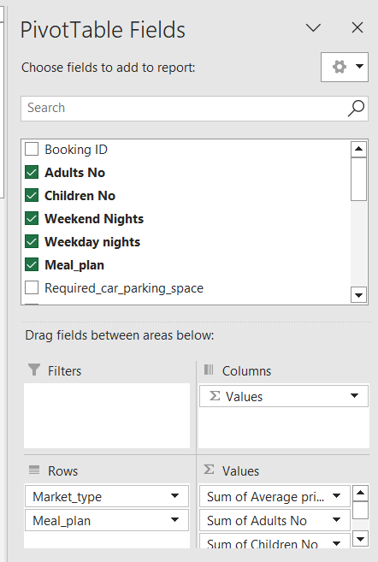
The following is the outcome of the pivotable that had been produced after selection of respective data columns. It shows the sum of average prices of the different market places along with the sum of adults, children, weekend, and weekday nights. It can be observed that reservations through aviation had lowest prices, probably due to its lowest adults, lowest children, and lowest weekend and lowest weekday nights. On the other hand, online reservations had the highest prices with highest frequencies of the other variables as well.
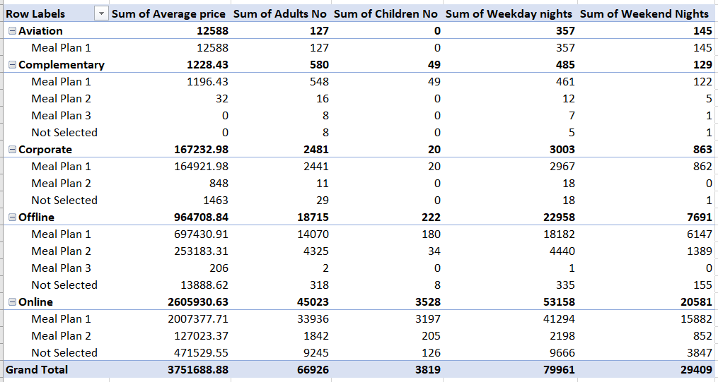

Production of Charts
To produce a chart of the if function used, it is important to quantify the qualitative data (normal and high) deduced from the IF function. So, in order to do so, firstly, the countif function is used to count the frequency of the ‘normal’ and ‘high’ average prices, respectively. So, the formula to identify the total number of ‘NORMAL’ within the IF function output has been used - =COUNTIF(T2:T36276,"NORMAL"), whilst the formula to identify the total number of ‘HIGH’ within the IF function output has been used - =COUNTIF(T2:T36276,"HIGH"). The results have been illustrated below.
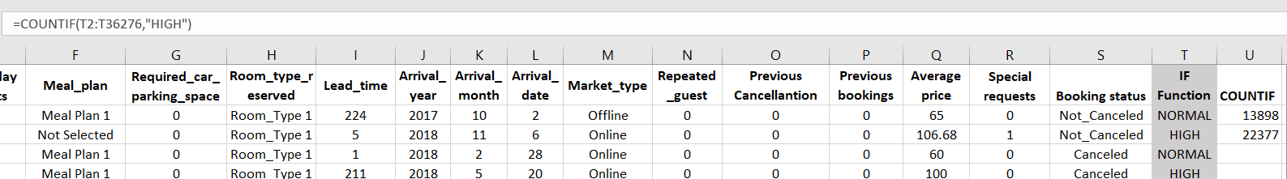
Afterwards, a pie chart had been deduced to illustrate the ratio of normal and high average prices of the hotel reservations. So, the respective cells had been chosen to represent the normal countif results and the high countif results. Then, the pie-chart option had been selected to yield in a pie chart representing the ratio of high and normal average prices of the hotel reservations.
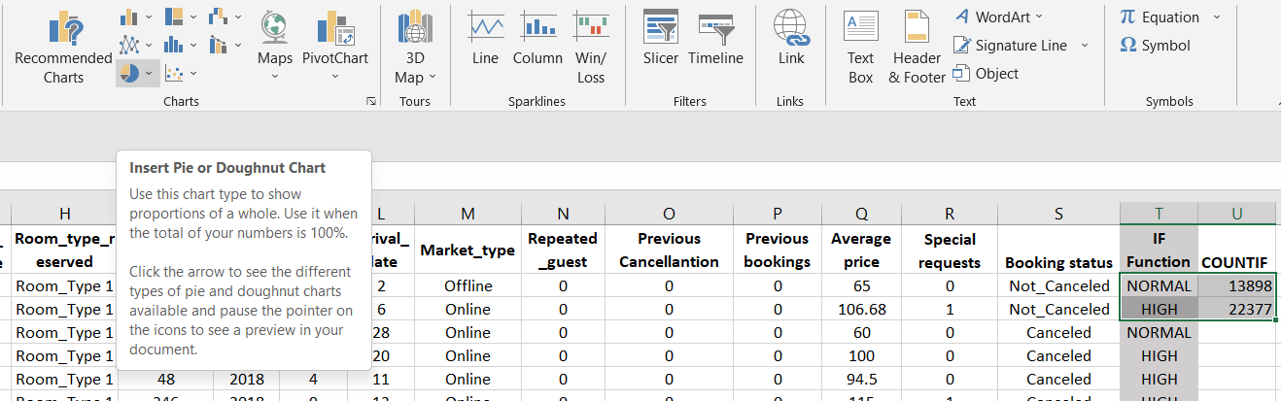
It can be observed from the image below that a pie chart had appeared but without any labelling of the percentages of the variables. Thus, the chart design had been changed to another type with the clear indication of the percentages of the variables.
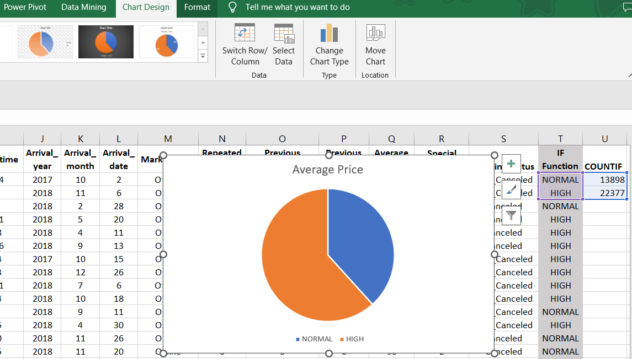
After the changes to the charts from the chart design had been made, the following chart had been produced, indicating that over 62% hotel reservation had been over 90 in average prices yielding in high and the remaining 38% had been below 90 yielding in normal average hotel room prices.
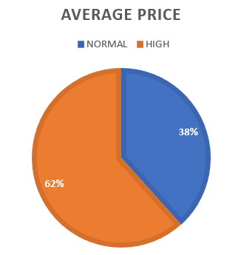
From the pivot table, charts can be easily formed, by simply clicking the cell with ‘Row Labels’ and selecting the bar chart from the chart option within the ‘Insert’ task bar. For the simplicity of the task, clustered chart had been chosen. This is mainly because, it would allow to illustrate the differences between the average prices and other variables of the reservations placed through different market places.
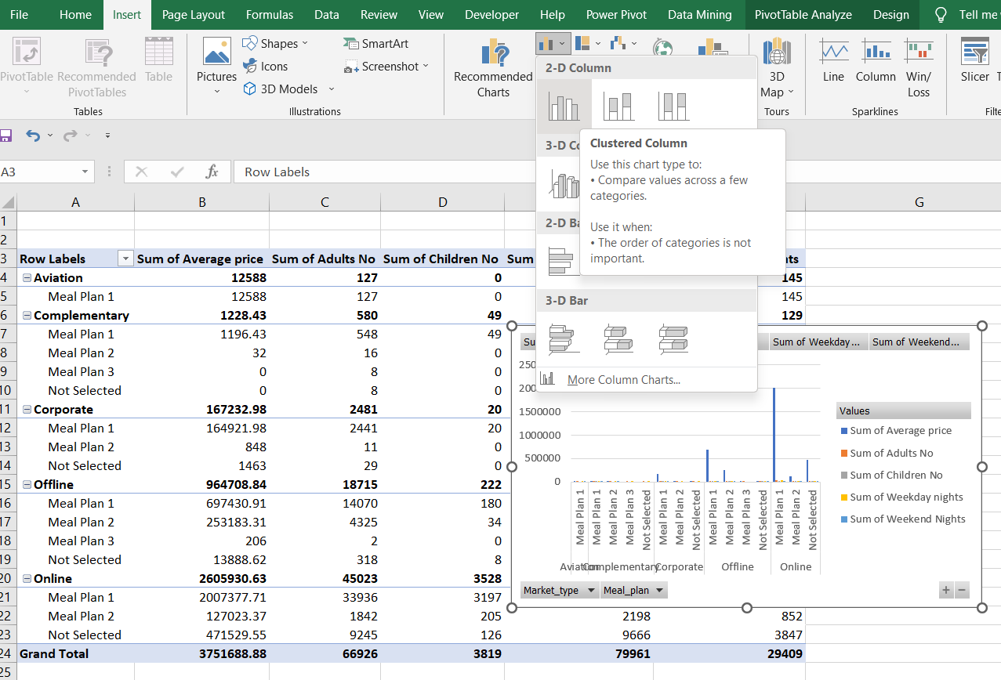
As the following chart can be observed, the bar chart helps to identify the highest average price incurring market place which had been online, whilst aviation has the lowest average price. Similarly, the other variables have similar trends.
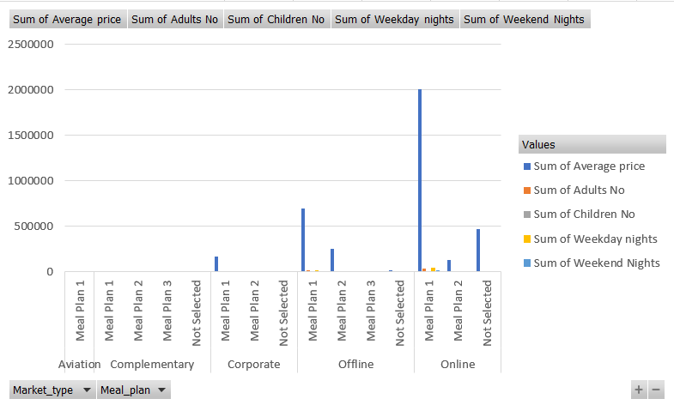

Part 2

Frequency of Male and Female Students
In order to calculate and identify the number of male students and female students, COUNTIF function had been used within the Excel file. For the calculation of the male students, the function - =COUNTIF(H2:H2134,"Male"), had been used. The data range for the formula had been the Gender column and the condition had been set to ‘Male’, the term used for the boys in the column.
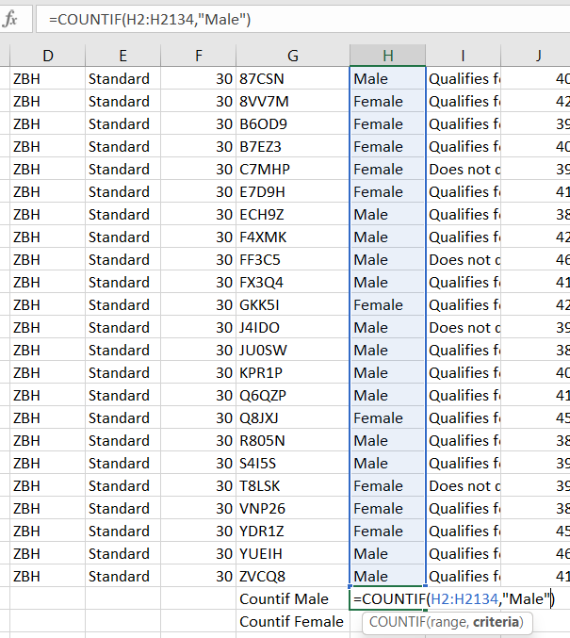
The output indicates that there are 1,077 male students within the dataset.

For the calculation of the female students, the function - =COUNTIF(H2:H2134,"Female"), had been used. The data range for the formula had been the Gender column and the condition had been set to ‘Female’, the term used for the girls in the column. The output indicates that there are 1,056 female students within the dataset.
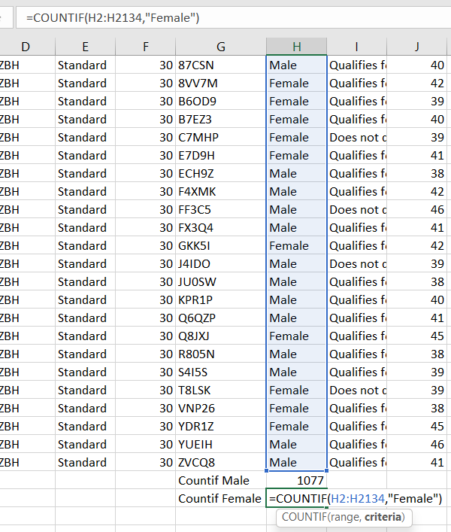

Frequency of Students Who Qualify for Reduced/Free Lunch
In order to calculate and identify the number of students who qualify for reduced or free lunch, COUNTIF function had been used within the Excel file. For the calculation of the reduce or free lunch qualified students, the function - =COUNTIF(I2:I2134,"Qualifies for reduced/free lunch"), had been used. The data range for the formula had been the Lunch column and the condition had been set to ‘Qualifies for reduced/free lunch’, the term used for the boys in the column.
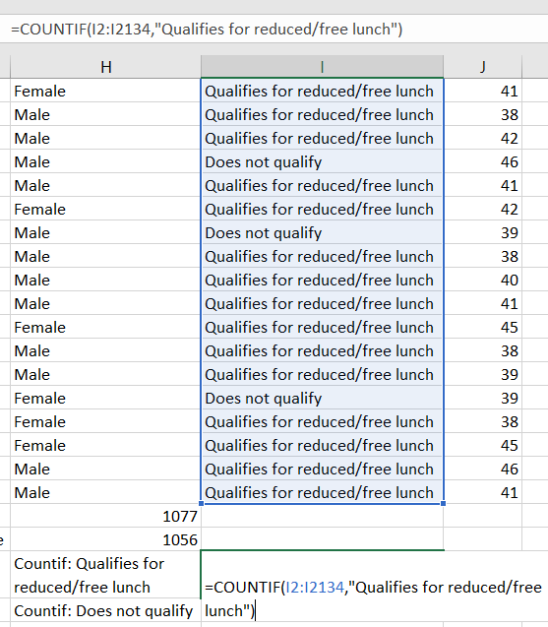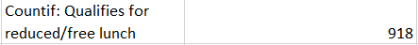
It had been deduced that 918 students had been qualified for reduced or free lunch.

Mean and Median of Students who Qualify and Does not Qualify for Reduced or Free Lunch
The mean of the students who qualify for reduced or free lunch had been calculated by dividing the number of students who qualify for reduced or free lunch by the total number of students as shown below. The total number of students account for both who qualify and does not qualify for reduced or free lunch. The mean of the students who qualify and does not qualify for reduced or free lunch is 0.4303. Which means that the average student does not qualify for reduced or free lunch.
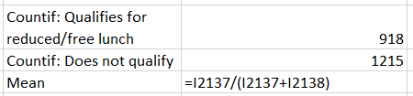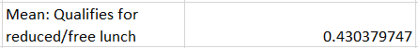
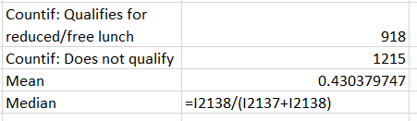
The median of the students who qualify for reduced or free lunch had been calculated by dividing the number of students who do not qualify for reduced or free lunch by the total number of students as shown below. The total number of students account for both who qualify and does not qualify for reduced or free lunch. The median of the students who do not qualify and does not qualify for reduced or free lunch is 0.5696. Which means that the median student does not qualify for reduced or free lunch.

The Mean and Median Differences of Students
In order to identify the mean and median of the differences between the scores of the pretests and post-tests of the students, the differences between the respective scores must be calculated as shown below using the formula - =K2-J2.
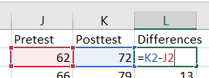
Afterwards, the mean is calculated using the function =AVERAGE(L2:L2134), as the average is the mean of the dataset.
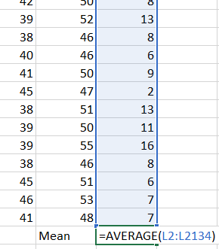
The mean of the difference between the scores of the students is 12.14627286. As for the median, the formula had been used =MEDIAN(L2:L2134) as shown below. The median for the difference between the scores of the students is 12.
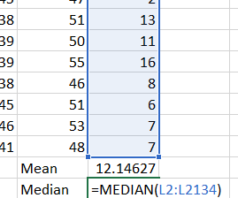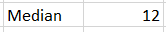

Clustering Using SPSS
Using the SPSS software, the cluster graph had been produced. The file is firstly opened and the decimals had been reduced to 0 for the variables. Next, the analyse option must be clicked from the task bar, and descriptive statistics must be clicked, and then descriptive must be chosen.
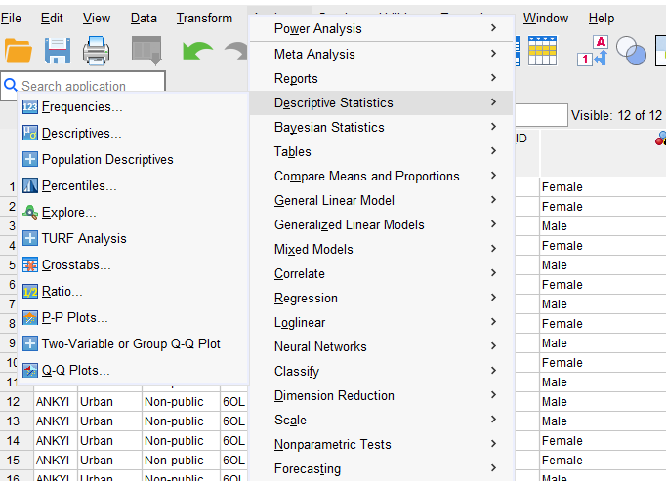
Then a command box shall appear, and the variables must be selected using the curved arrow button as shown below. Also, the option to save standardised values as variables must be selected.
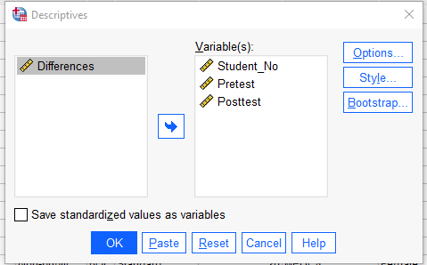 The following descriptive results shall be produced.
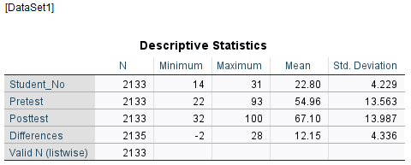
Afterwards, analyse option from the task bar shall be chosen again and then k-clustering from ‘classify’ must be selected as shown below.
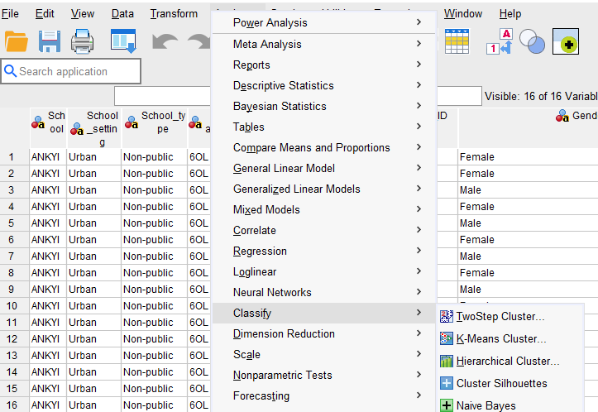
Then, a command box shall appear, where the z-score variables must be chosen and the option Iterate must be clicked, as shown below. Also, in the save button must be clicked from which cluster membership must be clicked.
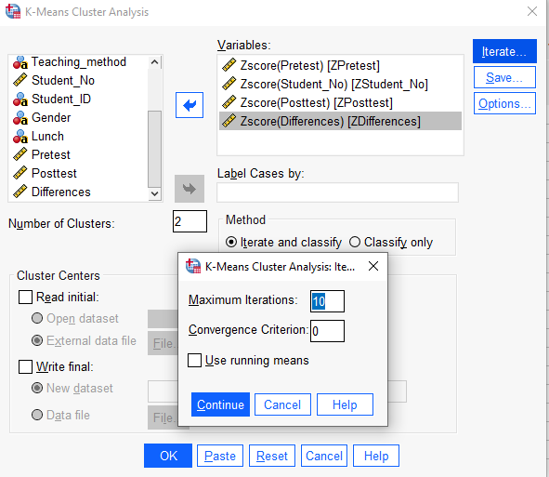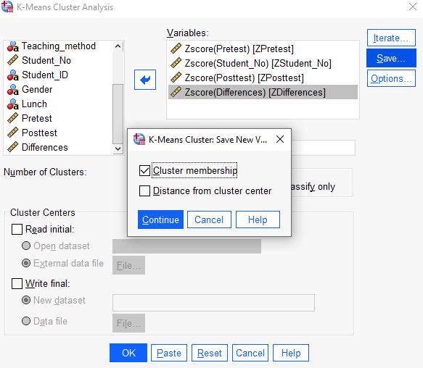
Then, from the options, all the statistics must be chosen and continue button must be pressed.
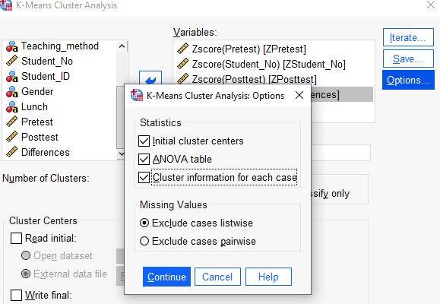
After pressing OK, the following output would emerge.
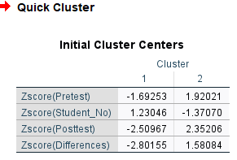
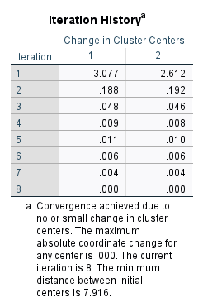
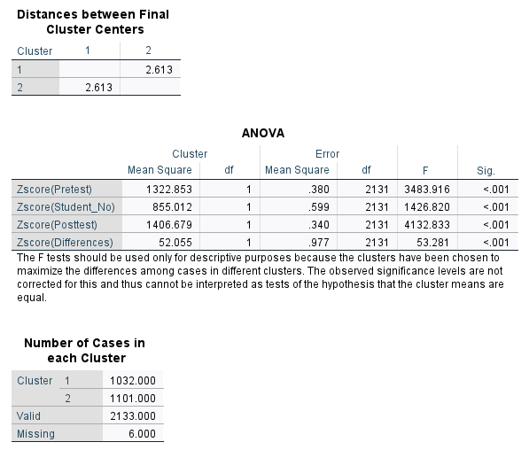
From the findings it can be said that both the scores have same cluster values. The testing has no statistical significance.

Five Most Common Data Mining and Text Mining Methods
There are several data and text mining methods that are implemented to retrieve both quantitative and qualitative data. Some of the most common data and text mining methods involve the following.
- Topic Modelling – it helps to perform the initial exploration of a dataset by providing the overview of the topics appeared within the respective text body. It helps to identify themes and concepts within large dataset which may be difficult if done manually (Hassani et al., 2020). It also assists to identify research gaps and trends within the literature reviews. However, such a tool is not suitable for small text bodies and cannot be solely relied upon when making decisions. This is often used in researches for subject syllabus assessment.
- Term Frequency – this is a method when the frequency of a specific term or phrase repeated within a text body is identified. This is done by the counting the number of times the term had been used to provide an insight of the topic(s) discussed within the text body. Inverse document frequency helps to offset any terms that may not be unique or used in other documents. This helps to detect useful terms and phrases which are unique to the respective text body or document (Ying and Mursitama, 2021). However, this method does not account for synonym words or homographs. This is often done in data analysis for interviews and surveys.
- Collocation Analysis – collocation is referred to the collection of words which may not be normally used together but is present within a specific text body. This method uses statistical test to identify re-occurring such words and the determine the strength of relations between the words. It helps to understand the context of the words used within the text body and subtle differences in the meaning of the similar words. However, different statistical tests can yield in different results, so, it is important to use the most appropriate one for the respective text to yield in the most useful outcomes (Härkänen et al., 2019). Such analysis can be used within researches.
- Sentimental Analysis – it is done to identify the emotion within the text narrative to be positive, negative, or neutral. It is mainly conducted by rating the sentences as positive, negative, or neutral based upon the phases used. An algorithm helps to analyse the text and score the sentences. The score of the sentences is then averaged to provide an overall sentiment score for the text body. However, such tests cannot be useful when sarcastic remarks are used, as the overall score can yield in unreliable output (Hassani et al., 2020). This is often used in psychological testing and sessions, during interrogation.
- Tracking themes and patterns along with classification – data mining can be done using theme trackers which allows to identify any recurring patterns or trends within the dataset. This helps to identify changes within the dataset. Also, classification is another form of data mining method which helps to sort the data into more understandable data forms (Byshevets et al., 2019). However, it is important that appropriate classification of data is used to yield in the most useful insights of the overall dataset such as pivotable.

Advantages and Disadvantages of SPSS and Excel
SPSS is a data storage and analysis, spreadsheet software, often used by professionals. The software has its own set of advantages and disadvantages, which have been identified below.
Advantages | Disadvantages
- Has versatile functions and data analytical tools (Nelson, Christopher and Milton, 2022).  - Provides separate output sheet which makes its easier and neater to view.  - Provides detailed outputs (Roni and Djajadikerta, 2021). | - It is expensive to purchase which may not be feasible for individuals.  - Free version has limited functions and usability (Roni and Djajadikerta, 2021).  - Cannot be used for large datasets.
MS Excel is a spreadsheet software, often used by individual, companies, and professionals. The software has its own set of advantages and disadvantages, which have been identified below.
Advantages | Disadvantages
- It is relatively cheap and comes within the package of Microsoft Office.  - It is user-friendly and very straight-forward (Guerrero, Guerrero and Rauscher, 2019).  - Data can be easily retrieved and identified. | - Has complicated functions which can be difficult to remember.  - The outputs can be numerically wrong when using for large amounts of data.  - Large datasets can slow the software, hindering the progress of data mining and analysis (Kronthaler, 2022).

Conclusion
Software like MS Excel and SPSS are greatly useful for data analysts in terms of data mining, processing, analysis, and representations. The report had discussed the various uses of MS Excel and also discusses the limitations of the software. Moreover, the software SPSS had been used to extract data findings after respective data analysis tools had been implemented. Also, the five most common software for data and text mining had been discussed.

Reference
Antons, D. et al. (2020) ‘The application of text mining methods in innovation research: current state, evolution patterns, and development priorities’, R&D Management, 50(3), pp. 329–351.
Byshevets, N. et al. (2019) ‘Development skills implementation of analysis of variance at sport-pedagogical and biomedical researches.
Chen, X. et al. (2020) ‘Unlabeled text mining methods based on two extension models of concept lattices’, International Journal of Machine Learning and Cybernetics, 11, pp. 475–490.
Ferreira‐Mello, R. et al. (2019) ‘Text mining in education’, Wiley Interdisciplinary Reviews: Data Mining and Knowledge Discovery, 9(6), p. e1332.
Guerrero, H., Guerrero, R. and Rauscher (2019) Excel data analysis. Springer.
Härkänen, M. et al. (2019) ‘Text mining method for studying medication administration incidents and nurse-staffing contributing factors: a pilot study’, CIN: Computers, Informatics, Nursing, 37(7), pp. 357–365.
Hassani, H. et al. (2020) ‘Text mining in big data analytics’, Big Data and Cognitive Computing, 4(1), p. 1.
Kronthaler, F. (2022) Statistics Applied with Excel: Data Analysis Is (Not) an Art. Springer.
Nelson, K., Christopher, F. and Milton, N. (2022) ‘Teach yourself SPSS and STATA’, International Journal of Academic Pedagogical Research, 7(6), pp. 84–122.
Roni, S.M. and Djajadikerta, H.G. (2021) Data analysis with SPSS for survey-based research. Springer.

