
Responsabilties & liabilities while transporting third party goods
M4X01276

November 14, 2018

Abstract
This report has been compiled with a view to research, understand and explain responsibilities and liabilities of carriers while transporting third party goods. Research materials have included specialist text books, internet searches and Acts of Parliament.
The research has shown that there are a lot of significant factors that the carriers are responsible and liable for. Most of which are outlined in legislation.
The PESTEL report outlines come factors to look into which have been expanded on.

Contents
Abstract 1
Introduction 3
Methodology 4
pestel 4
Findings 4
Political 4
Technological 5
Legal 6
Conclusion 6
References 7

Introduction
This report has been written with a view to understand and explain certain aspects of the carrier’s responsibilities and liabilities while transporting third party good. This will mostly cover courier and transport companies. It will look at a PESTEL report of certain factors then expand on these.

Methodology
The research for this report is comprised from several areas. Due to the fact that there is a lot of legislation there is a lot of research material on the legal aspects of the liabilities and responsibilities of the carrier of third party goods. Another huge resource that covers all aspects of transport operations is the forty seventh edition of Lowe’s Transport Manager’s and Operator’s Handbook from 2017.

Pestel

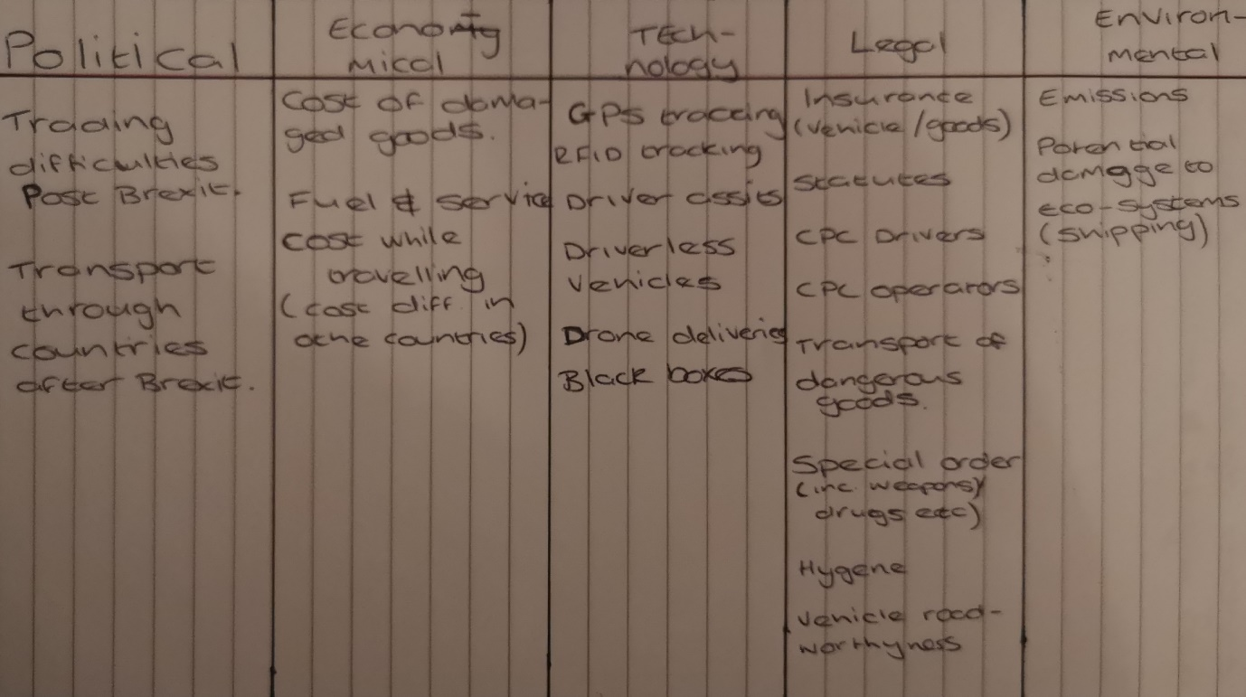

As you can see from the table, there are many significant areas that a carrier of third party goods has to consider when transporting those goods. There are elements in the PESTEL that can affect the carrier, but are not their responsibility or liability, but they can take actions to limit or change the impact from these areas. This report will touch on each section but will focus in more detail on some of the more important responsibilities they have to take into account and in some cases adhere to.

Findings

Political
The political aspects of a carrier’s responsibilities look to be made much more difficult by the impending Brexit situation that is going to affect the whole nation. As it stands at the moment the UK is subject to the EU Treaties, which provide the basis for any actions EU institutions take. This means that a lot of the transport law and regulations that exist in the UK are actually in place as a direct result of EU legislations. Butcher, L (2018)
Economic & Social
The economic and social aspects are covered pretty well by the Consumer Rights Act 2015. This clearly states that the retailer is responsible for delivery and making sure that the delivery is made within a reasonable time, usually anything up to thirty days unless otherwise agreed. If the parcel carrier is a third party courier contracted by the sender to deliver an item then they actually have little responsibility to meet the consumer’s delivery expectations, since any issue will have to be dealt with by the retailer, not the courier company. If the carrier is a third party courier type company they will have responsibilities to the sender. These will be agreed upon through a contract or consignment note. Carriage of Good Act (1965)
In the evet that the consignment becomes damaged or lost while in the care of the carrier, the carrier shall be liable for the losses. The carrier is absolved of this liability is the damage or loss is caused by the neglect or wrongful act of the sender, for example, if it is not packaged correctly.

As seen in the Carriage of Goods by Road Act, 1965:
Subject to article 18, paragraphs 2 to 5, the carrier shall be relieved of liability when the loss or damage arises from the special risks inherent in one or more of the following circumstances:
(a)Use of open unsheeted vehicles, when their use has been expressly agreed and specified in the consignment note;
(b)the lack of, or defective condition of packing in the case of goods which, by their nature, are liable to wastage or to be damaged when not packed or when not properly packed;
(c)handling, loading, stowage or unloading of the goods by the sender, the consignee or persons acting on behalf of the sender or the consignee;
(d)the nature of certain kinds of goods which particularly exposes them to total or partial loss or to damage, especially through breakage, rust, decay, desiccation, leakage, normal wastage, or the action of moth or vermin;
(e)insufficiency or inadequacy of marks or numbers on the packages;
(f)the carriage of livestock.
5Where under this article the carrier is not under any liability in respect of some of the factors causing the loss, damage or delay, he shall only be liable to the extent that those factors for which he is liable under this article have contributed to the loss, damage or delay.
Carriage of Goods by Road Act, 1965
(Accessed 18th November 2018)

Technological
One of the most important things for a carrier to ensure is operating correctly is the Tachograph system. Any goods vehicles registered on, or after 1 May 2006 must be fitted with a Tachograph system. If the vehicle is registered before 1 May 2006 it still has to be fitted with a Tachograph (except for certain exemptions) however an analogue Tachograph is acceptable. This system is designed to monitor several aspects of a driver’s day, such as distance travelled, average speed and one of the most important, drivers hours. Tachographs: Rules for Drivers & Operators, (Accessed 2018)
The reason behind the tachograph’s important boils down to public safety, specifically the road going public. There are very stringent rules around how long a good vehicle can drive for during the day in total and what the maximum time is between breaks. A driver is allowed to drive for a maximum of nine hours per day (except two extended days at ten hours) the maximum time between breaks is four and half hours, which must be forty five minutes. Lowe, D & Pidgeon, C (2017)
This ties in with one of the goods vehicle drivers main responsibilities, in that they have to drive their vehicle in a safe and responsible way to ensure other road users safety.

Legal
The legal responsibilities and liabilities will be the most comprehensive since there is a lot of legislation that covers a wide range of items and processes that the carrier is responsible for. These are set out in several UK government and EU legislations. Some of these, like the Road Traffic Act of 1988 covers all road users and some, like the Carriage of Goods Act of 1965 will only apply to certain road users.
Section 143 of the Road Traffic Act (1988) stipulates that every person using or permits another to use a motor vehicle on the UK road network are required to have a valid insurance policy that covers at least the third party in respect of damage or injury. For organisations employing drivers and supplying them with vehicles, the responsibility to insure and ensure the certificate of insurance is valid usually falls to the operator. However, the driver has a responsibility to check that it is in place before he uses the vehicle as he could be held liable.
Carriers also have to take into account Goods In Transit insurance. While not a legal requirement, the carrier has a responsibility to the sender and if there is any damage to the item could be held liable for costs incurred. Most Goods in Transit policies have a standard value up to £1300 per tonne. If the item or items will equate to a higher value than this then they should consider amending their policy to cover the expected cost of the items being transported. It is advisable for owner-drivers (drivers who own their vehicle and are therefore responsible for all licencing and legalities relating to the vehicle and good being transported) to scrutinise their Goods In Transit insurance to be sure it covers the value of items being transported. Lowe, D & Pidgeon, C (2017)
Another aspect that the both the carrier operator and drivers are liable for is licences. There are several types of licences that are needed. The operator licence will be granted with conditions that the operator has to adhere to maintain that licence. Failure to meet these conditions, or any other relevant legislation could lead the operator having their licence revoked and fines. Similarly, Drivers are subject to licencing. They need to have a licence that permits them to drive the vehicle type and weight required for their job. They also have to prove competency by taking Certificate of Professional Competence training. there is a version of this that applies to operators, the Operators Certificate of Competence, this is usually included in the operator’s licence conditions. Lowe, D & Pidgeon, C (2017)
Something that a lot of logistics companies will is extra training that is more detailed than the Certificate of Professional Competence to ensure their staff present with a professional manor at all times.

Conclusion
While it is clear that there are lots of responsibilities carriers have to take into to account, there are two aspects to their responsibilities. There is a legal requirement for most of what the carrier is responsible for. However there are certain aspects that more of a moral responsibility meaning it is not covered by law, but will be put into practice to maintain a high professional standard.

References
GOV.UK. (n.d.). Tachographs: rules for drivers and operators. [online] Available at: https://www.gov.uk/tachographs [Accessed 18 Nov. 2018].
House of Commons Library (2018). Brexit and transport. London: House of Commons Library.
Legislation.gov.uk. (1965). Carriage of Goods by Road Act 1965. [online] Available at: http://www.legislation.gov.uk/ukpga/1965/37 [Accessed 18 Nov. 2018].
Legislation.gov.uk. (1988). Road Traffic Act 1988. [online] Available at: https://www.legislation.gov.uk/ukpga/1988/52/contents [Accessed 18 Nov. 2018].
Lowe, D. and Pidgeon, C. (n.d.). Lowe's Transport Manager's and Operator's Handbook 2017. 47th ed. London: Kogan Page.

