

Matt Claridge

Taguchi Exercise

UWTSD
Ordnance, Munitions & Explosives

BEng Degree Apprenticeship
Academic Year: 2023 - 2028

Lecturer: Dave Holley
July 2026

Abstract
This report presents the application of Taguchi’s experimental design method to identify the key control factors influencing the performance of a mechanical catapult. The study used an L8 orthogonal array to evaluate seven variables at two levels, significantly reducing the number of experimental runs required while still capturing the influence of each factor and their interactions.
Data demonstrated considerable variation in range across the eight test conditions, highlighting the sensitivity of the system to changes in pull back angle and stop position. Response graphs were used to quantify the effect of each factor, revealing that pull back and stop position were the dominant contributors to performance, while other factors such as the BC interaction had minimal impact.
A confirmation trial was conducted using repeated firings of selected factor combinations, allowing the midpoint performance to be predicted for an intermediate pull back setting. The predicted range of 142.9 cm closely matched the achieved range of 142 cm, validating the accuracy of the Taguchi method for performance prediction.

Table of Contents
Abstract ii
1 Objective 4
2 Method and Apparatus 5
3 Experimental Data 6
4 Interpretation of Results 7
5 Conclusion 9
6 Reflection 10

Objective
The aim of this experiment was to apply Taguchi’s experiment method to identify the key control factors to predict the performance of a mechanical catapult at different settings.
Taguchi’s method is an optimisation technique created by Genichi Taguchi to improve the quality of manufacturing. [1] Using Taguchi’s method tests multiple variables at once using a matrix table called orthogonal array. [2] The objective of the systematic approach can be to solve the design optimization problem by a multi-disciplinary experimentation. This allows engineers identify key control factors and the interactions between them quickly by reducing the number of experiments required. [3] The Taguchi method has many advantages such as time- and cost- effective, robustness, and ease of explanation of results. Taguchi’s method can quantify the influence of each factor and predict system performance at new settings, making it is effective for optimising tasks such as the catapult experiment.
Using the L8 orthogonal array the experiment assessed how seven factors at two levels contributed to the performance of the Catapult. The aim was evaluating the factors to predict the Catapults range at a chosen setting.

Method and Apparatus
The experiment used a mechanical catapult with adjustable band and stop positions and a varied pull back scale to measure the distance a ball would be launched at different settings. There were seven independent variables, which were front band position, Anchor band position, the interaction between factors 1 and 2, stop position, pull back, the interaction between factors 2 and 4 and operator. Each factor had two settings. Front band positions 1 and 3, anchor band positions 2 and 4, stop positions 1 and 3 and pull back angles of 140°&170°.
An L8 orthogonal array was used, meaning that eight experiments were used to test the seven variables at two settings. This reduced the need from one hundred and twenty-eight runs testing every combination down to just eight.
Several noise variables were identified but not controlled during the experiment. These were friction caused by bolt tightness, twisting of the band causing altered tension, wear of the band, how the ball is sat in the cup and freely it was released, rate of fire affecting the settling of the band, operator fatigue, background distractions and errors in measurement.

Experimental Data
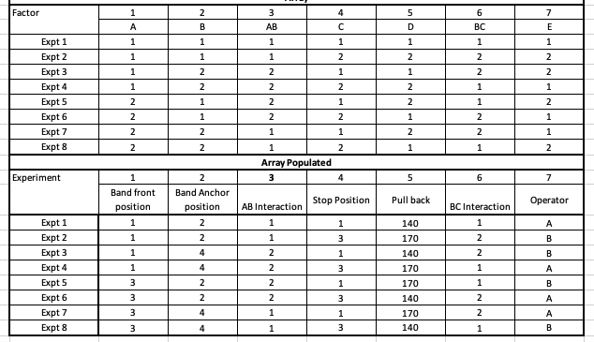
Figure 3-1 - Orthogonal Array
Figure 3-1 shows the design matrix used for Taguchi analysis. The table in the top half is the orthogonal array, which is a standard L8 Taguchi table. It lists the eight experiments and seven factors, each set at level 1 or level 2, and interactions labelled with letters. The table in the bottom half has been populated with the settings used for each of the eight experiments.

Interpretation of Results
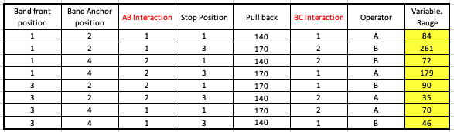
Figure 4-1 Results
Figure 4-1 shows the result of the eight experiments. The variable range column shows the distance the ball travelled when launched from the catapult under each of the eight set ups.
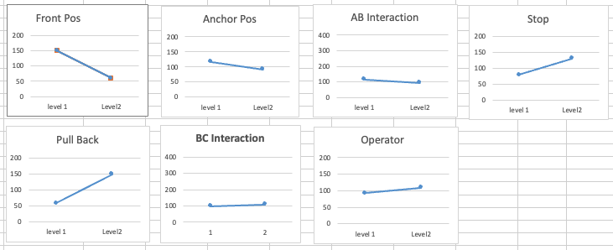
Figure 4-2 Variable Graphs
The graphs in Figure 4-2 show the average range change between the level 1 and level 2 for each factor of the experiment. They were calculated by grouping the range results according to factor level, calculating an average range for each level, and then plotting the averages. The steeper the line the more the results are affected by the factor. The graphs indicate that pull back and stop position had the largest effect, while the BC interaction (the interaction between band anchor and stop position) had almost no impact.
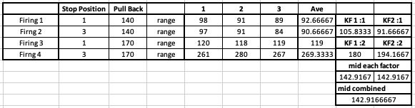
Figure 4-3 - Refined Test Results
A confirmation trial was conducted to validate the Taguchi method. The results in Figure 4-3 demonstrate how the method could be used to predict the results of a third pull back setting in the middle of the ranges. The confirmation trial for the two key factors identified in the previous experiment, which were the stop position and the pull back. Four more firings were conducted three times in the different combinations of these two factors, then the average range was calculated. The midpoint of each factor was then determined and combined resulting in a range of 142.9cm. The catapult was set up, this time with a firing angle set to 155°. The ball was then launched achieving a very closely matched achieved range of 142cm.

Conclusion
The Taguchi exercise successfully demonstrated how optimisation techniques can be used to increase efficiency in system design, identifying key control factors and even predicting the performance of different set ups.
Using the L8 orthogonal array significantly reduced the time and associated costs of having to replicate experiments reducing the need of potentially one hundred and twenty-eight down to just eight. The Taguchi method captured the influence of each factor; the influence the factors had on each other and determined the key factors whilst quantifying these behaviours.
The results identified that although several factors contributed to the range of the catapult, the pull back and stop position were the dominant control factors, this was highlighted by the gradient of the response graphs being steepest between the two levels. The BC interaction was almost flat indicating it had almost no effect.
The refined trial reinforced these findings by isolating the two key factors and conducting multiple firings validating predicted performance. The midpoint calculation correctly predicted the launch range of 142cm for a pullback angle of 155°. This demonstrates the accuracy and reliability of the Taguchi method in predicting system performance under new settings.
This exercise shows how Taguchi’s approach can be applied to systems engineering to optimise performance, reduce experimental workload and provide reliable predictions for intermediate settings.

Works Cited
[1] | I. Turkmen, R. Gul and C. Celik, “A Taguchi approach for investigation of some physical properties of concrete produced from mineral admixtures,” Building and Environment, vol. 43, pp. 1127-1137, 2008.
[2] | C. Celik and N. Burnak, “A systematic approach to the solution of the design optimization problem,” TOTAL QUALITY MANAGEMENT, vol. 9, no. 1, pp. 101-108, 1998.
[3] | N. Li, C. Shi, Z. Zhang, H. Wang and Y. Liu, “A review on mixture design methods for geopolymer concrete,” Composites Part B, vol. 178, pp. 1-14, 2019.

