Martin Dunn (1705105)

Programming in c++
Martin Dunn 1705105

Contents
Introduction Page 3
Higher/lower Page 3
Logical flowchart Page 3
Problem Solving List (Easiest to Hardest) Page 6
Hidden Treasure Page 6
Problem Solving List (Easiest to Hardest) Page 6
Conclusion Page 7
Appendix Page 7
Higher/Lower Code Page 7
Hidden Treasure Code Page 9
Running Screenshots Page 13

Introduction
This report will document the different aspects and steps taken to create mini games using the language C++. Out of the three games that were tasked only the first two were attempted and believed to be fully completed efficiently.

Higher/Lower
The first game that was tasked to create was a simpler higher/lower mini game for two people to play. Player 1 is prompted to input 7 different values between 1-10, then player 2 is given the first value to guess if the following value is higher or lower. If they guess incorrectly, they loose meaning player 1 wins. If they guess all correctly, they win.
This was created by storing the player 1 numbers in an array and using a counting loop, also known as a for loop, to fill each element of the array with player 1 input. Player 2 is prompted to simply enter a single letter, h = higher, l = lower, this was then stored in a single ‘char’ variable. Once these values are gathered a simple ‘if’ statement plays out the entire game. The player 2 input is also in a loop with the ‘if’ statement as if they are correct the next value must be displayed, and the same question posed to the player.
There was a total of 3 functions used to create this game, not including the main function. The first function is to prompt player 1 to enter his values, a string is passed into this array, there is a while loop to prevent the user inputting a variable not in the required range. The number is then returned.
This function is called via another function that has the array passed into it, this function uses only a single counting loop to assign the number returned from the first function for each value in the array, in short, this function calls the first function 7 times and each returned value is stored in the next free element in the array.
Finally, the last function includes the main game, this is where all functions are called, the only function that is called from the main function is this function. The game function calls the player 1 prompt, and that calls the function to fill the array, this is nesting functions. See code in the appendix.

Logical Flowchart
See figures below to see logic flowchart that was created for the higher/lower program before the coding took place.
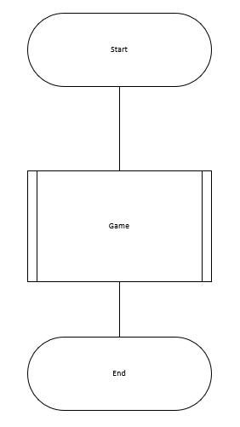

Fig 1 (Main Function)

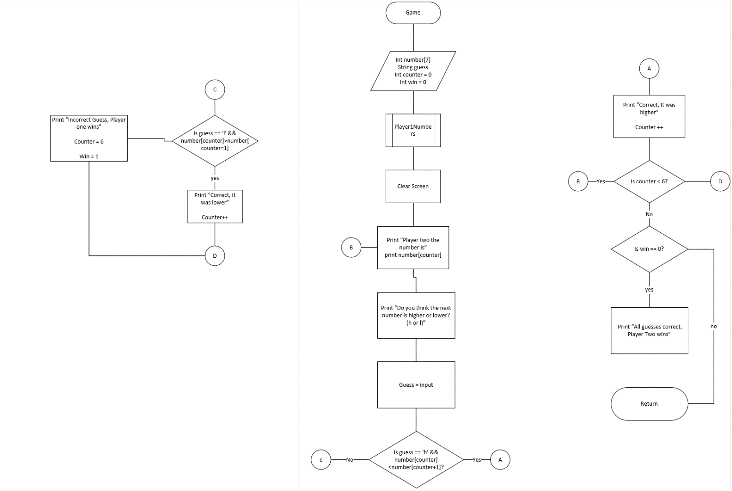
Fig 2 (Game Function)

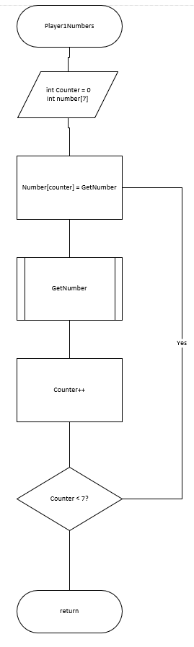

Fig 3 (Player1Number Function)

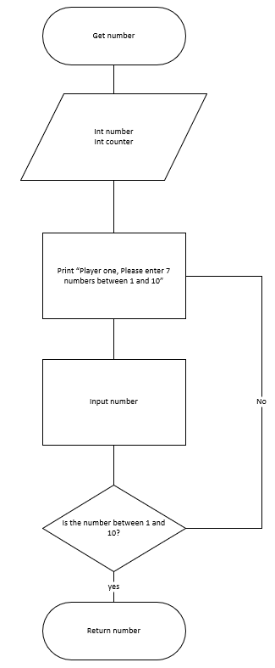

Fig 4 (GetNumber Function)

Problem solving list (Easiest to hardest)
Below is a simple problem-solving list that was created in the time that was spent before programming to ensure that the solution was already figured out before the programming took place. This step is very useful when it comes to writing the code as what is needed to be written should always be known once this step is complete, therefore a lot of time is saved.

- Set variables
- Output text
- Write main function
- Input number pattern
- For loop the game
- Correct/incorrect guess decision (if statement)
- Limiting the range of values that can be input
- Making functions
- Passing array into function
- Displaying correct winners at end game

Hidden Treasure
This hidden treasure mini game is the second and final game that has been created. The rules are simple, there is an 8x8 game grid, in which player 1 must choose the row and column co-ordinates to hide 3 pieces of treasure. Once all 3 treasures are hidden player 2 is prompted to guess the location of all 3 treasures using only 3 lives. Correct guesses to not remover a life. If the treasure is not found after 3 total incorrect guesses plater 1 wins, if the treasure is found, player 2 wins.

This game was programmed as 4 separate functions, and a multi-dimensional array. The first function simply sets every value in the array to ‘-‘ this defines a blank space on the grid, this operation was set to its own function as the grid is reset to all blank to hide player one chosen location for the treasure. The second function simply displays the grid to the screen, as the grid is displayed after all treasures are hidden, also after each guess from the second player, and at the end of the game showing hidden treasure, wrong guesses and found treasure locations. This means the grid can be displayed up to 7 times in a single game. The third function simply prompts the player 1 to input their 3 desired locations for the treasure and sets them accordingly. Finally, the fourth function is where the main game takes place, there is a second temporary array that will hold the hidden locations on the grid, whilst a blank grid is being used for the game, the two grids are then merged at the end. The game was achieved by using a counting loop with the counter set to 3, within this loop are while loops to prevent people guessing incorrect values also and if statement to prevent the same location being chosen, this also applies to the hiding treasure function. If a guess is correct there is 1 subtracted from the counter to add and extra time around the loop, there is also 1 added to a win variable to break out of the loop if it becomes equal to 3. In the game function a ‘Sleep()’ command was used, this is used to clear the output screen whilst still executing the code. This was used to hide the grid that shows the first player where the treasures had been placed, this was achieved by using the windows.h library at the top as the OS being used is windows. See code in the appendix.

Problem Solving List (Easiest to Hardest)
- Declaring variable
- Output text
- Write main function
- Input number pattern
- Loops
- Creating multi-dimensional array
- Assigning treasure locations
- Assigning wrong guess locations
- Assigning correct guess locations
- Assigning blank grid
- Preventing same locations entered for hiding treasures
- Preventing a number not in the range being entered
- Passing multi-dimensional array to multiple functions
- Creating functions
- Printing game grid
- Getting the correct winner
- Combining 2 arrays
- Preventing guessing the same location more than once

Conclusion
In conclusion, the programs that have been developed are believed to be the most efficient to the capabilities of the author. There are places that could be executed in a better/more efficient way if more knowledge in the language had been acquired. For example, ‘the sleep()’ function that is used in hidden treasure is not the most efficient way to pause the code as the library used to execute such a function is OS dependant. This means that depending on the operating system of the user a different library must be included for each one. Alternatively, player one could have been prompted to press a key when they would like the screen to be cleared for player two to begin their turn. This way was not chosen as the author was unsure how to set any key to execute the function. This could have also been bypassed by printing to the screen what key specifically to hit to clear the screen.
It is believed to the author that the higher/lower mini game is completed efficiently and clean and to the best of their abilities.

Appendix
Higher/lower code
#include<iostream>
#include<sstream>
#include<string>
#include<stdlib.h>

using namespace std;
int GetNumber(string message);
void Player1numbers(int myarray[]);
void Game();

int main(int argc, char* argv[])
{

Game();

cin.get();
return 0;
}

int GetNumber(string message)
{
string input;
stringstream stream;
int number;
int i;

cout << "Player one, Please enter 7 numbers between 1 and 10: " << endl;
getline(cin, input);

stream.str(input);
stream >> number;
stream.clear();

while (number <= 0 || number >= 11)
{
cout << "Number out of Range, Please enter a number between 1 and 10: " << endl;
getline(cin, input);

stream.str(input);
stream >> number;
stream.clear();
}

return number;
}

void Player1numbers(int myarray[])
{
for (int i = 0; i < 7; i++)
{
myarray[i] = GetNumber("Please enter a number");
}
}

void Game()
{
int number[7];

Player1numbers(number);

string guess;
int i;
int win = 0;

system("CLS");
for(i = 0;i < 6 ;i++)
{
cout << "Player Two, The number is: " << number[i] << endl;
cout << "Do you think the next number is higher or lower? (Please enter h or l)" << endl;
getline(cin, guess);

if (guess == "h" && number[i] < number[i + 1])
{
cout << endl << "Correct, It was higher!" << endl << endl;
}
else if (guess == "l" && number[i] > number[i + 1])
{
cout << endl << "Correct, It was lower!" << endl << endl;
}
else
{
cout << endl << "Incorrect Guess, Player one wins!" << endl << endl;
i = 6;
win = 1;
}

}

if (win == 0)
{
cout << "All guesses were correct! Player Two wins!!!" << endl;
}
}

Hidden Treasure Code
#include<iostream>
#include<sstream>
#include<string>
#include<stdlib.h>
#include<Windows.h>

using namespace std;

void blankMap(char gameGrid[8][8]);
void map(char gameGrid[8][8]);
void treasure(char gameGrid[8][8]);
void game(char gameGrid[8][8]);

int main(int argc, char *argv[])
{
char gameGrid[8][8];//8x8 game grid for hiding and guessing treasure locations

blankMap(gameGrid);

map(gameGrid);

treasure(gameGrid);

game(gameGrid);

cin.get();
return 0;
}

void blankMap(char gameGrid[8][8])
{
int i, j;//counting variables

for (i = 0; i < 8; i++)
{
for (j = 0; j < 8; j++)
{
gameGrid[i][j] = '-';
}
}
}

void map(char gameGrid[8][8])
{
int i, j;//counting variables

cout << " ";

for (i = 0; i < 8; i++)
{
cout << i << " ";
}
cout << endl;

for (i = 0; i < 8; i++)
{
cout << i << " ";

for (j = 0; j < 8; j++)
{
cout << gameGrid[i][j] << " ";
}

cout << endl;
}
}

void treasure(char gameGrid[8][8])
{
string input;
stringstream stream;

int row[3];
int col[3];
int tempRow = 10;
int tempCol = 10;
int i = 0;
int treasure = 3;

for (i = 0; i < treasure; i++)
{
cout << endl << "Where would you like to hide treasure number " << i + 1 << endl << "Please select which row: " << endl;
getline(cin, input);
stream.str(input);
stream >> row[i];
stream.clear();

while (row[i] < 0 || row[i] > 7)
{
cout << "Invalid number. Try Again." << endl << endl;
cout << "Please select which row: " << endl;
getline(cin, input);
stream.str(input);
stream >> row[i];
stream.clear();
}

cout << "Please select which column: " << endl;
getline(cin, input);
stream.str(input);
stream >> col[i];
stream.clear();

while (col[i] < 0 || col[i] > 7)
{
cout << "Invalid number. Try Again." << endl << endl;
cout << "Please select which col: " << endl;
getline(cin, input);
stream.str(input);
stream >> col[i];
stream.clear();
}

if (gameGrid[row[i]][col[i]] == gameGrid[tempRow][tempCol])
{
cout << endl << endl << "Invalid choice, Location is already occupied!" << endl << "Please choose again" << endl;
i--;
}

tempRow = row[i];
tempCol = col[i];

gameGrid[row[i]][col[i]] = 'X';
}

map(gameGrid);
Sleep(3000);
}

void game(char gameGrid[8][8])
{
string input;
stringstream stream;

int i, j;
int lives = 0;
int rowGuess;
int colGuess;
int guesses = 0;
int win = 0;
char tempGrid[8][8];

system("CLS");

for (i = 0; i < 8; i++)
{
for (j = 0; j < 8; j++)
{
tempGrid[i][j] = gameGrid[i][j];
}
}

blankMap(gameGrid);

cout << "Welcom Treasure hunter! You have 3 lives to find the location of 3 hidden treasures on an 8x8 grid!" << endl;
cout << "If a peice of treasure is found you do not loose a life" << endl;
cout << "Please enter guesses between 0-7" << endl << endl;

for(i = 0;i < 3;i++)
{

cout << "Please enter the row: " << endl;
getline(cin, input);
stream.str(input);
stream >> rowGuess;
stream.clear();

while (rowGuess < 0 || rowGuess > 7)
{
cout << "Invalid number." << endl << endl;
cout << "Where would you like to hide treasure number " << i + 1 << endl << "Please select which Row: " << endl;
getline(cin, input);
stream.str(input);
stream >> rowGuess;
stream.clear();
}

cout << "Please enter the column: " << endl;
getline(cin, input);
stream.str(input);
stream >> colGuess;
stream.clear();

while (colGuess < 0 || colGuess > 7)
{
cout << "Invalid number." << endl << endl;
cout << "Where would you like to hide treasure number " << i + 1 << endl << "Please select which column: " << endl;
getline(cin, input);
stream.str(input);
stream >> colGuess;
stream.clear();
}//while range end

if (gameGrid[rowGuess][colGuess] == 'H' || gameGrid[rowGuess][colGuess] == 'N')
{
cout << endl << endl << "Invalid choice, Location has already been chosen!" << endl << "Please choose again" << endl << endl;
i--;
}
else
{
if (tempGrid[rowGuess][colGuess] == 'X')
{
cout << "Congrats!! You found a peice of treasure!!" << endl;
win++;
i--;
gameGrid[rowGuess][colGuess] = 'H';
map(gameGrid);

if (win == 3)
{
break;
}
}
else
{
cout << "You have found nothing!! Try again!" << endl;
gameGrid[rowGuess][colGuess] = 'N';
map(gameGrid);
}
}
}//for end

for (i = 0; i < 8; i++)
{
for (j = 0; j < 8; j++)
{
if (gameGrid[i][j] != 'F' && gameGrid[i][j] != 'N')
{
gameGrid[i][j] = tempGrid[i][j];
}
}
}

if (win == 3)
{
cout << endl << "WOOOHHOOO!! You have found all the treasure!" << endl;
map(gameGrid);
}
else
{
cout << endl << "You are out of lives!! Better luck next time!" << endl;
map(gameGrid);
}

cout << "N = incorrect guesses" << endl << "X = Treasure" << endl;
}

Running screenshots

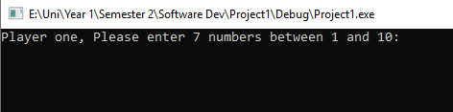

Fig 5 (Test print out)

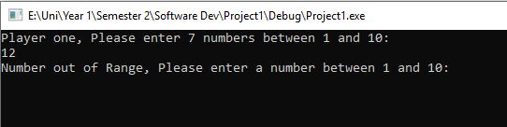

Fig 6 (Preventing wrong values)

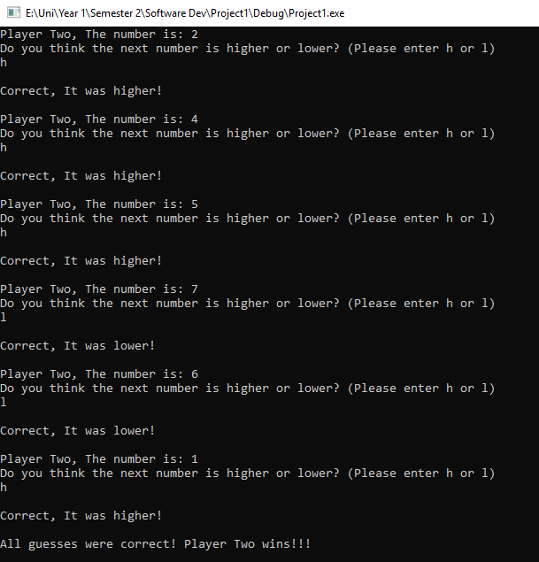

Fig 7 (Testing Player 2 Win)

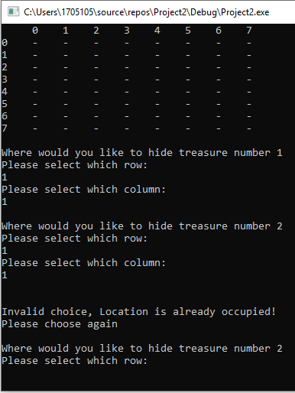

Fig 8 (Testing duplicate location prevention)

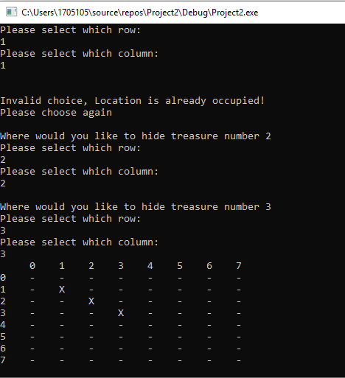

Fig 9 (Testing display hidden treasure)
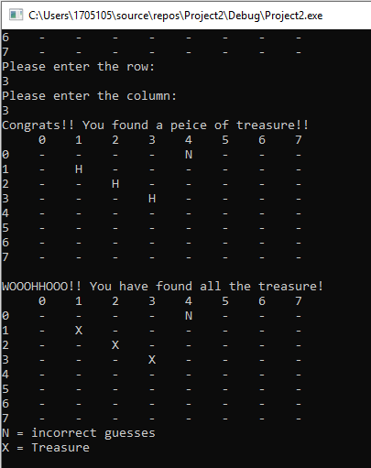
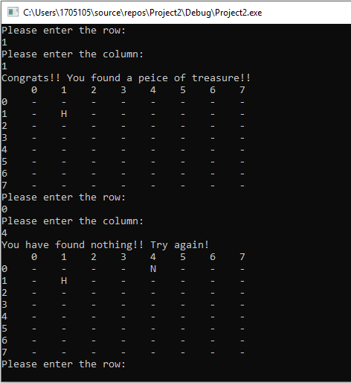
Fig 11 (Test end game display grid)
Fig 10 (Testing Hit and Miss Guesses)

