A Critical Evaluation of Personal and Professional Development at Maples Hair and Beauty Salon
Workplace Personal Development Assignment
Belinda Jones
Organisation: Maples Hair & Beauty Salon
Proposed PDP: 1 October to 23 December 2026

Table of Contents
1. Introduction 3
2. Organisational Context and Development-Needs Analysis 4
3. Critical Assessment of Benefits to the Organisation and Individual 6
3.1 Potential Benefits to the Individual 6
3.2 Potential Benefits to Maples Hair & Beauty 7
3.3 Limitations and Conditions for Benefit 8
4. Managing the Individual’s Expectations 9
5. Critical Evaluation of Development Vehicles 10
5.1 Formal Courses and Digital Learning 10
5.2 Coaching and Mentoring 11
5.3 Experiential, Social and Reflective Learning 12
5.4 Recommended Blended Approach 12
6. Detailed Personal Development Plan 13
6.1 Implementation, Responsibility and Risk Control 15
7. Monitoring, Evaluation and Review 16
8. Conclusion 18
References 19

1. Introduction
Personal and professional development extends the knowledge, skills, behaviours and self-awareness needed for effective performance and future responsibilities. At Maples Hair & Beauty, customers experience technical judgement and interpersonal skills together, making staff capability central to service quality.
Human-capital theory treats education and skills as a productive investment (Becker, 1993), while resource-based theory suggests that valuable, hard-to-replicate employee capabilities can drive competitive advantage (Barney, 1991). However, development does not automatically improve organisational performance. Its value depends on identifying the correct need, selecting appropriate development methods, providing opportunities to apply learning and evaluating whether workplace behaviour changes (Baldwin & Ford, 1988; Salas et al., 2012).
This assignment focuses on Belinda Jones, owner-manager of Maples, whose learning influences employees. Personal development involves diagnosing needs, setting goals, practising behaviour and reviewing effects; professional development includes occupational knowledge and standards. Her practical expertise and customer understanding are strengths, but appointment overruns, inconsistent records, underused Booksy functions and owner dependence indicate development needs.
These issues should not simply be interpreted as individual weaknesses because performance reflects an interaction between leadership, systems, workload and team practice. Consequently, development priorities include delegation, coaching and performance management, digital leadership, time management, knowledge sharing and reflective practice.
The assignment assesses benefits and limitations, manages expectations, compares development vehicles and proposes a three-month personal development plan (PDP). It recommends blended workplace learning to support behavioural and operational improvement.

2. Organisational Context and Development-Needs Analysis
Maples is an independent UK salon with loyal customers expecting personal attention and continuity. Tacit knowledge includes styling judgement, colour formulation and communication; explicit knowledge includes hygiene guidance, allergy records, appointment durations and client histories.
Because substantial salon expertise is experiential, the business becomes vulnerable when knowledge remains with individual employees. Wenger (1998) argues that learning occurs through social participation within communities of practice, while Brown and Duguid (1991) demonstrate that workplace knowledge frequently develops through informal practice. Observation, peer learning and discussion are therefore appropriate for Maples, although these activities require sufficient structure to prevent inconsistent or unsafe practices from being reproduced.
Development-needs analysis must also distinguish genuine skill gaps from wider organisational causes. Noe (2020) identifies organisational, task and person analysis, while Garavan (1991) emphasises the importance of connecting development with organisational strategy.
Organisational priorities are reliable appointments, consistent consultations, secure records and reduced owner dependence. Belinda’s tasks include capacity management, delegation, coaching and performance monitoring. Individual needs include structured delegation, digital reporting and reflection, building on her technical expertise.
A concise development-needs mind map links the assignment's diagnosis to the proposed learning vehicles:

Figure 1
Maples development needs mind map
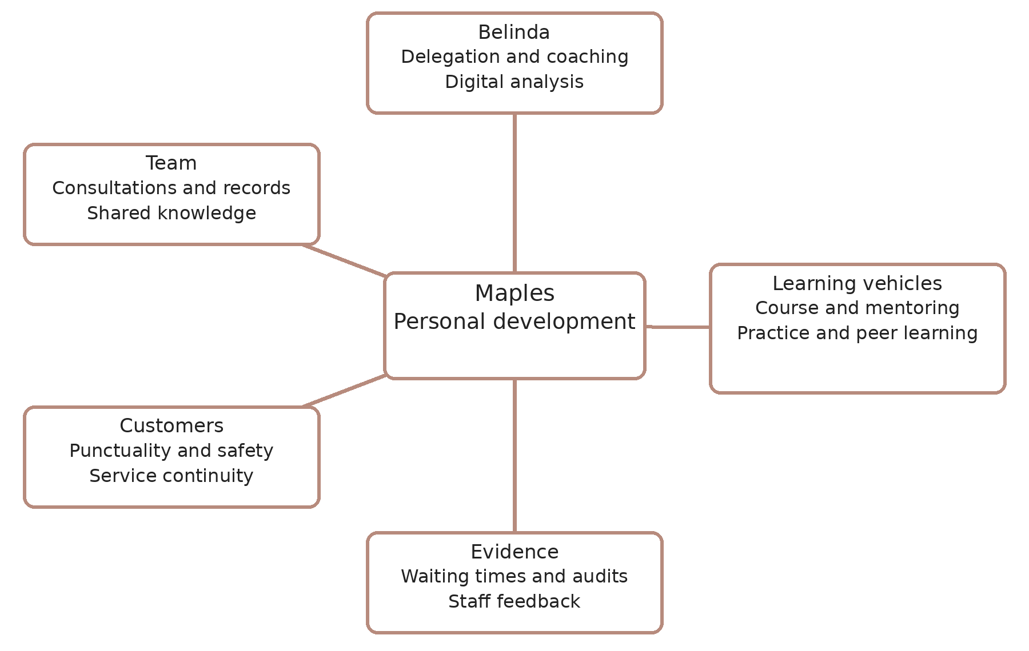
Note. Author’s own synthesis of the needs analysis; branches connect needs, learning methods and evaluation.
This diagnosis prevents the common mistake of treating every performance problem as a training problem. Repeated appointment delays, for example, may result from unrealistic service durations, insufficient buffers, complex treatments, customer lateness or an overloaded diary rather than poor employee time-management skills. Training employees to work faster could consequently damage consultation quality or wellbeing rather than solve the underlying problem.
Kolb’s (1984) cycle connects experience, reflection, conceptualisation and experimentation, enabling Belinda to test and refine delegation techniques. Schön’s (1983) reflection-in-action explains adaptation during unpredictable situations. Both require evidence to challenge existing assumptions.

3. Critical Assessment of Benefits to the Organisation and Individual
3.1 Potential Benefits to the Individual
For Belinda, structured development could strengthen managerial competence, confidence and control. Improved delegation would enable responsibilities to be allocated according to employee competence rather than retained by the owner because completing tasks personally appears quicker. Effective delegation may therefore reduce overload and create additional capacity for strategic management.
Development in coaching and performance conversations could also strengthen Belinda’s ability to address rushed work, poor customer greeting behaviours or inconsistent records constructively. Locke and Latham (2002) demonstrate the value of specific goals and feedback. Objectives such as completing structured employee development conversations or reducing avoidable appointment delays consequently provide clearer direction than a general intention to become a better manager.
Motivation is another potential benefit. Self-determination theory proposes that autonomy, competence and relatedness contribute to higher-quality motivation (Deci & Ryan, 2000). Development that provides choice, evidence of progress and stronger workplace relationships may therefore support Belinda’s engagement. However, autonomy should not mean avoiding challenge. Constructive feedback may reveal established leadership behaviours that require modification.
Delegation, coaching and digital analysis can support recruitment, complaints and growth. Emotional intelligence may help leaders adapt interpersonal behaviour (Goleman, 2000), but empathy requires clear standards and accountability to improve performance.

3.2 Potential Benefits to Maples Hair & Beauty
Development may improve organisational service consistency, productivity and customer retention. Aguinis and Kraiger (2009) identify benefits of training and development at the individual, team, and organisational levels, although these depend on programme design and context.
At Maples, stronger management of appointment durations and staff capability could reduce late starts and accumulated delays. More consistent digital consultations could improve personalisation and safety by ensuring authorised employees can access information on customer preferences, allergies, colour formulations, and treatment histories. Coaching may also strengthen greeting, listening and complaint-handling behaviours.
Distributing knowledge and responsibility reduces dependence on Belinda. Senge’s (2006) learning-organisation perspective supports proportionate shared learning through monthly skill sessions, procedures and brief reviews.
Knowledge sharing may also assist employee development and innovation. From a resource-based perspective, shared technical knowledge, customer relationships and routines may be harder to imitate than purchased software (Barney, 1991). Becker’s (1993) human-capital argument predicts returns from skill investment, but employee mobility means Maples cannot assume it captures all returns. Wenger’s (1998) social-learning view suggests that sharing skills can turn individual gains into team capability; together, the two theories support investment alongside knowledge-sharing routines.
Development may further influence engagement and retention where opportunities are relevant and equitable. However, the psychological contract concerns employees’ perceptions of reciprocal obligations (Rousseau, 1995). Development could raise expectations about promotion, pay, or preferred responsibilities that a small salon may not be able to meet. Transparent communication about what development can and cannot provide is therefore essential.

3.3 Limitations and Conditions for Benefit
Development involves both direct and indirect costs. Formal programmes require fees, while learning time may remove employees from revenue-generating appointments. Small businesses may also lack dedicated HR resources or replacement cover.
More significantly, training does not guarantee behavioural change. Baldwin and Ford (1988) show that transfer depends on learner characteristics, programme design, and the work environment. Knowledge gained through a course may therefore have little impact where employees lack opportunities to practise or established systems reinforce previous behaviour. Salas et al. (2012) similarly emphasise preparation and post-training support.
Development should therefore be combined with appropriate organisational changes. Appointment problems may require revised booking rules and service durations, while inconsistent records may require better templates and employee learning. Success must also be evaluated through balanced indicators. Reducing waiting times would not constitute genuine improvement if complaints, corrective work or employee pressure simultaneously increased.
Evidence for the predicted benefits should include before-and-after waiting times, audited consultation records and staff feedback, with complaints and rework checked for unintended harm. These comparisons indicate contribution rather than proving that training alone caused any change. Development therefore offers significant potential but should not be treated as a universal solution. It is most valuable when aligned with organisational priorities, supported by workplace conditions and evaluated through behavioural and operational evidence.

4. Managing the Individual’s Expectations
Expectation management should begin with a two-way development conversation. Belinda should clarify the purpose of the PDP, identify strengths and development priorities and agree realistic boundaries relating to time, cost, support and evidence.
An external mentor can challenge Belinda where employees might hesitate. Staff-feedback themes should be considered alongside operational evidence and used for development.
Expectations should separate learning opportunities from outcomes: protected time and feedback cannot guarantee profitability or punctuality. Belinda remains responsible for preparation, practice and follow-through. Clarifying responsibilities supports the psychological contract (Rousseau, 1995).
SMART objectives can provide useful structure. Doran (1981) proposed specific, measurable, assignable, realistic, and time-related objectives; contemporary PDPs often frame these as achievable and time-bound. The three-month goals below specify a deadline, an owner, a measurable threshold and evidence. Test their attainability against the first two weeks of baseline data and staff capacity. For example, Belinda could delegate three recurring responsibilities to competent employees by 30 October 2026, supported by defined standards and fortnightly review.
However, measurable activity does not necessarily demonstrate quality. Recording completion of employee one-to-ones does not prove that the conversations were constructive. Quantitative indicators should therefore be combined with feedback, observation and reflection.
Monthly mentor reviews can identify progress, barriers and necessary changes. The GROW sequence of goal, reality, options and will or way forward can provide a simple structure for coaching conversations (Whitmore, 2017). However, it should not be used mechanically because workplace relationships can involve emotional and power dynamics that a simple framework does not fully capture.
Fairness must also be considered. If development appears exclusively focused on the owner, employees may perceive it as management-centred. Belinda’s development should therefore create opportunities for wider peer learning. Expectations concerning pay, promotion and increased responsibility should be discussed explicitly rather than implied.
Development is also unlikely to progress linearly. Confidence may initially decline when weaknesses become more visible or challenging feedback is received. Bandura (1997) suggests that self-efficacy develops particularly through mastery experiences. Early achievable actions, followed by progressively more demanding objectives, can therefore provide evidence of capability.
Development addresses capability gaps; repeated failure to meet understood standards may require accountability. For Belinda, system and capacity problems must also be distinguished from individual weaknesses.

5. Critical Evaluation of Development Vehicles
5.1 Formal Courses and Digital Learning
A short leadership or management programme could provide theoretical frameworks, external perspectives and structured learning. Targeted digital modules may also support coaching, employment responsibilities, Booksy functionality, UK GDPR and cybersecurity awareness.
Knowles et al. (2015) argue that adults engage more effectively when learning is relevant, problem-centred and connected with experience. Maples should therefore select learning that applies to genuine workplace challenges.
Formal programmes nevertheless have limitations. Generic management training may not reflect the operational realities of salon demand, colour-processing times or clients who prefer specific stylists. Online completion data demonstrate participation rather than workplace application. A lengthy qualification may provide academic depth but require substantial cost and time away from appointments, while very short digital modules may encourage passive completion.
Formal learning is therefore useful for concepts and specialist knowledge but should form only one part of the development strategy.

5.2 Coaching and Mentoring
Coaching is particularly appropriate for delegation, self-awareness and performance management because it can be individualised and action-focused. Ellinger et al. (2003) associate managerial coaching with employee satisfaction and performance. However, their warehouse study does not establish equivalent outcomes in salons; Maples must evaluate transfer within its own service context.
An external coach could challenge Belinda without creating the role conflict that an employee might experience. However, coaching has financial costs and can depend on rapport or self-reported progress. Clear objectives and supporting workplace evidence are therefore necessary.
Mentoring provides a slightly different benefit. An experienced salon or small-business mentor could offer broader perspectives on leadership, capacity and commercial decision-making. Clutterbuck (2014) argues that developmental relationships should focus on purposeful learning rather than advice alone.
Mentors’ experiences can nevertheless be context-specific, and excessive imitation could reduce independent judgement. Coaching is consequently particularly suitable for defined behavioural objectives, whereas mentoring can provide broader perspective and confidence.

5.3 Experiential, Social and Reflective Learning
Workplace action learning closely matches Maples’ requirements. Belinda could lead an appointment-punctuality improvement project by analysing booking information, consulting employees, testing revised service durations or buffers and reviewing outcomes.
Experiential learning supports transfer because development occurs close to the environment in which performance is required (Kolb, 1984). However, additional projects can increase workload for an already busy owner. Activities therefore require realistic scope and protected time.
Peer learning can also distribute tacit knowledge. Eraut (2004) observes that substantial workplace learning occurs informally through everyday activity and relationships. Communities of practice may similarly support collective learning (Wenger, 1998). However, informal learning can reproduce poor practice, meaning seniority should not automatically be treated as evidence of teaching competence. Agreed professional and safety standards should support peer learning.
Reflective practice provides another low-cost development vehicle. Gibbs’ (1988) reflective cycle offers a structured process of description, feelings, evaluation, analysis, conclusion and action planning, while Schön (1983) recognises reflection during professional action. For Maples, concise critical learning logs could combine practical reflection with evidence and alternative explanations.

5.4 Recommended Blended Approach
No single development method adequately addresses all identified needs. A blended approach is therefore most appropriate, combining targeted formal learning, Booksy-related digital development, coaching or mentoring, workplace action learning, structured delegation, peer knowledge sharing and reflection.
Formal learning supplies concepts; coaching provides feedback; mentoring offers perspective; workplace trials apply knowledge; peer learning shares expertise; reflection examines results.
This comparison favours coached workplace trials for the appointment problem because Belinda can test booking changes immediately; it favours a short digital module and supervised practice for Booksy competence because inaccurate records present a different learning need. A mentoring relationship provides wider challenge, while monthly peer sessions spread technical knowledge. The mind map in Figure 1 connects these vehicles with the corresponding outcomes. The approach should nevertheless remain proportionate. Excessive development activity could compete with customer appointments and increase owner workload. Priority should therefore be given to activities that can be incorporated into normal management practice and demonstrate strong potential for workplace transfer.
For Maples, workplace action learning, supported by periodic external coaching or mentoring, should form the core of the programme, while formal and digital learning provide targeted knowledge. This is more appropriate than using course attendance as evidence of success because development should ultimately be demonstrated through changed behaviour and improved organisational capability.

6. Detailed Personal Development Plan
The proposed PDP runs from 1 October to 23 December 2026, approximately 12 weeks. It prioritises manageable leadership changes rather than a lengthy qualification. Baseline data will be collected from 1–14 October. Belinda will protect two hours weekly for learning, practice and review, with three separate 30-minute team sessions.
Belinda owns the plan; an external mentor provides challenge, and consenting colleagues support trials—a proposed £300 ceiling covers short-course and mentoring fees, subject to supplier availability. Protected time also has an opportunity cost. If suitable support exceeds the ceiling, Belinda should adjust scope before committing funds.
Table 1
Three-month personal development plan for Belinda Jones
Need and owner | SMART objective and deadline | Resources and success evidence
Delegation: Belinda | By 30 October, delegate three recurring tasks to trained colleagues, with written standards and authority limits. Review fortnightly through 23 December. | Supervised practice and staff capacity check; at least 80% of sampled tasks meet agreed standards without owner rework.
Coaching: Belinda | Complete one short coaching course by 30 October; hold a development conversation with every team member by 27 November. Review agreed actions by 23 December. | Protected time, mentor feedback and a conversation template; staff feedback and follow-up demonstrate quality.
Digital practice: Belinda and two volunteers | By 27 November, demonstrate available Booksy record and reporting functions and prepare two competent champions. Achieve 95% completeness in a 20-record audit by 23 December. | Booksy guidance, anonymised practice examples and checklist; both champions demonstrate tasks independently; at least 19 records meet relevant completeness standards.
Appointment flow: Belinda and team | By 23 December, reduce mean client waiting time by 10% against the 1–14 October baseline, without worsening complaints or rework rates. | Trial service durations and buffers from 19 October; compare similar services and weekdays, appointment volume and staff feedback.
Knowledge sharing: Belinda and team | Hold three 30-minute sessions by 30 October, 27 November and 18 December; record and test one agreed improvement from each. | Protected team time and practice notes; three documented actions and follow-up evidence.
Reflection and evaluation: Belinda and mentor | Complete two evidence-based reflections monthly, six by 23 December; review the PDP on 12 November and 23 December. | Brief learning log and mentor review; identify changed behaviour, barriers and next-stage objectives.
Note. Author’s own plan informed by Doran (1981), Kolb (1984), Baldwin and Ford (1988), and Kirkpatrick and Kirkpatrick (2006). All deadlines are in 2026.
Figure 2
Three-month personal development timeline
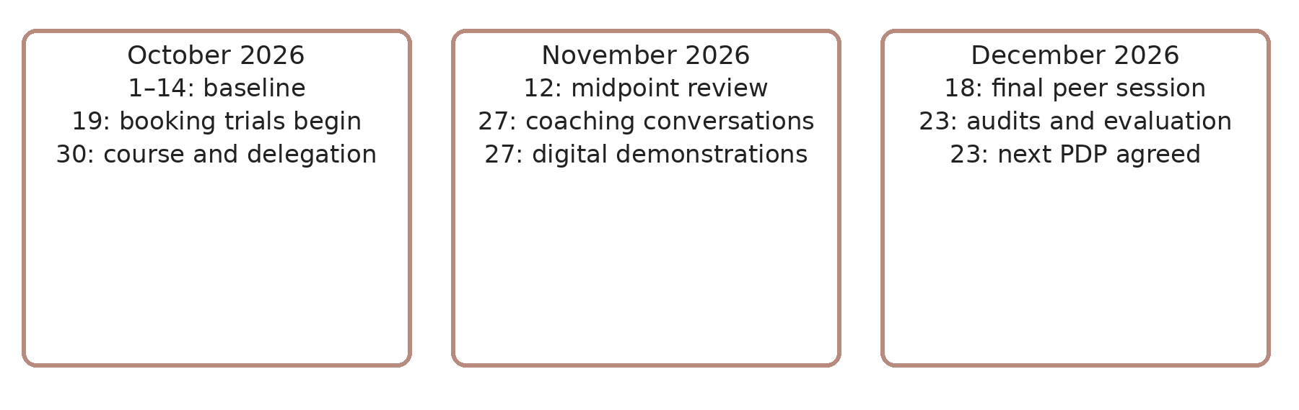
Note. Author’s own visual summary of Table 1.
Figure 2 summarises the staged deadlines. The waiting-time target is a proposed improvement, not an established result. A 10% target is proportionate to the shorter period, but baseline causes and staffing capacity must confirm it is attainable. Any revision requires a recorded rationale at the midpoint review; it should not conceal underperformance. December demand may affect comparisons, so interpret results cautiously.

6.1 Implementation, Responsibility and Risk Control
Belinda should confirm course and mentor availability by 7 October. Two weekly learning hours must fit the diary; reschedule programme activities if customer demand prevents protected time. Employees accepting tasks need instruction, authority, capacity and escalation arrangements.
Verify Booksy functions before agreeing objectives. Champions must demonstrate competence before supporting colleagues. Record checks should assess necessary information and authorised access, avoiding unnecessary client-data collection. Anonymise employee-feedback themes where feasible; a small team cannot guarantee complete anonymity.
Waiting time is the minutes between the booked start and the actual service start for clients who arrive on time. Compare baseline and final-period averages and record client lateness separately. Measure complaints and rework per 100 completed appointments, so volume changes do not distort quality comparisons.
Delegation must not become workload dumping. Fortnightly checks should assess task quality, staff capacity and whether Belinda has reverted to doing colleagues’ tasks. Protected time and conservative scope are particularly important during the salon’s busy December period.

7. Monitoring, Evaluation and Review
Evaluate development using multiple forms of evidence. Figure 3 applies Kirkpatrick and Kirkpatrick’s (2006) framework to reaction, learning, behaviour and results.
Figure 3
Kirkpatrick’s four-level training evaluation model applied to Maples Hair & Beauty.
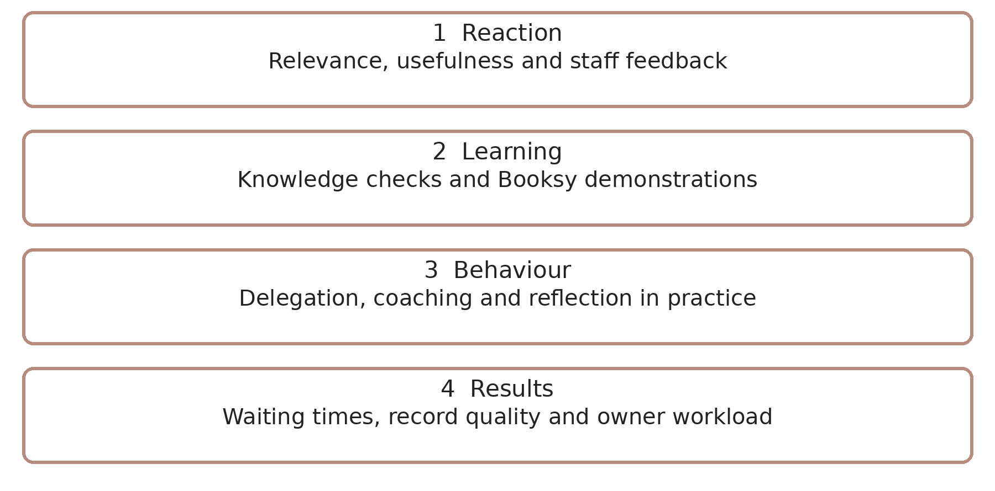

Note. Author’s adaptation of Kirkpatrick and Kirkpatrick (2006).
Figure 3 links relevance feedback, demonstrated learning, observable behaviour and operational results. Repeat bookings and employee feedback can supplement its indicators.
However, Kirkpatrick’s framework has limitations. Holton (1996) argues that the four levels function more effectively as a taxonomy than as a complete causal evaluation model. This is significant for Maples because improved organisational results cannot automatically be attributed to personal development.
For example, reduced waiting times might partly result from seasonal demand or changes to booking arrangements. Prices, treatment outcomes and appointment availability could also influence customer satisfaction. Baseline and fortnightly observations should therefore be compared, with demand and other operational changes recorded.
Evaluation should examine development’s plausible contribution and the conditions supporting improvement, rather than attribute every positive change to the PDP.
Monthly reviews should remain proportionate and sustainable. A concise dashboard could monitor appointment punctuality, average waiting time, consultation completion, complaints and agreed development actions.
At the 12 November midpoint review, Belinda and the mentor should assess progress and transfer barriers. On 23 December, they should compare outcomes with baseline evidence, consider staff feedback and agree the next PDP. Retention and profitability require longer follow-up because three months cannot establish sustained effects.
Where learning has not transferred into workplace behaviour, the response should identify whether the barrier concerns capability, motivation, opportunity, role clarity or resources rather than automatically prescribing further training.

8. Conclusion
Personal development can strengthen Belinda’s delegation, coaching, digital capability and judgement, supporting service consistency and organisational resilience. However, gains depend on learning transfer, staff capacity and appropriate systems; training alone cannot resolve unrealistic bookings or workload pressures.
Expectations require clear objectives, resources and reciprocal responsibilities. Comparing development vehicles supports workplace trials alongside targeted formal learning, mentoring, peer learning, and reflection. Each contributes differently, and no vehicle guarantees improved performance.
The three-month PDP links learning to Maples’ priorities through staged milestones and balanced evidence. Kirkpatrick’s framework organises evaluation, while Holton’s critique cautions against assuming causation. Baseline comparisons, staff feedback and regular reviews should guide adjustments and the next development cycle.

References
Aguinis, H., & Kraiger, K. (2009). Benefits of training and development for individuals and teams, organisations, and society. Annual Review of Psychology, 60, 451–474. https://doi.org/10.1146/annurev.psych.60.110707.163505
Baldwin, T. T., & Ford, J. K. (1988). Transfer of training: A review and directions for future research. Personnel Psychology, 41(1), 63–105. https://doi.org/10.1111/j.1744-6570.1988.tb00632.x
Bandura, A. (1997). Self-efficacy: The exercise of control. W. H. Freeman.
Barney, J. (1991). Firm resources and sustained competitive advantage. Journal of Management, 17(1), 99–120. https://doi.org/10.1177/014920639101700108
Becker, G. S. (1993). Human capital: A theoretical and empirical analysis, with special reference to education (3rd ed.). University of Chicago Press.
Brown, J. S., & Duguid, P. (1991). Organisational learning and communities-of-practice: Toward a unified view of working, learning, and innovation. Organisation Science, 2(1), 40–57. https://doi.org/10.1287/orsc.2.1.40
Clutterbuck, D. (2014). Everyone needs a mentor (5th ed.)—Chartered Institute of Personnel and Development.
Deci, E. L., & Ryan, R. M. (2000). The “what” and “why” of goal pursuits: Human needs and the self-determination of behaviour. Psychological Inquiry, 11(4), 227–268. https://doi.org/10.1207/S15327965PLI1104_01
Doran, G. T. (1981). There is a S.M.A.R.T. way to write management’s goals and objectives. Management Review, 70(11), 35–36.
Ellinger, A. D., Ellinger, A. E., & Keller, S. B. (2003). Supervisory coaching behaviour, employee satisfaction, and warehouse employee performance: A dyadic perspective in the distribution industry. Human Resource Development Quarterly, 14(4), 435–458. https://doi.org/10.1002/hrdq.1078
Eraut, M. (2004). Informal learning in the workplace. Studies in Continuing Education, 26(2), 247–273. https://doi.org/10.1080/158037042000225245
Garavan, T. N. (1991). Strategic human resource development. Journal of European Industrial Training, 15(1), 17–30. https://doi.org/10.1108/EUM0000000000219
Gibbs, G. (1988). Learning by doing: A guide to teaching and learning methods. Oxford Polytechnic Further Education Unit.
Goleman, D. (2000). Leadership that gets results. Harvard Business Review, 78(2), 78–90.
Holton, E. F., III. (1996). The flawed four-level evaluation model. Human Resource Development Quarterly, 7(1), 5–21. https://doi.org/10.1002/hrdq.3920070103
Kirkpatrick, D. L., & Kirkpatrick, J. D. (2006). Evaluating training programs: The four levels (3rd ed.). Berrett-Koehler.
Knowles, M. S., Holton, E. F., III, & Swanson, R. A. (2015). The adult learner: The definitive classic in adult education and human resource development (8th ed.). Routledge.
Kolb, D. A. (1984). Experiential learning: Experience as the source of learning and development. Prentice Hall.
Locke, E. A., & Latham, G. P. (2002). Building a practically useful theory of goal setting and task motivation: A 35-year odyssey. American Psychologist, 57(9), 705–717. https://doi.org/10.1037/0003-066X.57.9.705
Noe, R. A. (2020). Employee training and development (8th ed.). McGraw-Hill Education.
Rousseau, D. M. (1995). Psychological contracts in organisations: Understanding written and unwritten agreements. Sage.
Salas, E., Tannenbaum, S. I., Kraiger, K., & Smith-Jentsch, K. A. (2012). The science of training and development in organisations: What matters in practice. Psychological Science in the Public Interest, 13(2), 74–101. https://doi.org/10.1177/1529100612436661
Schön, D. A. (1983). The reflective practitioner: How professionals think in action. Basic Books.
Senge, P. M. (2006). The fifth discipline: The art and practice of the learning organisation (Rev. ed.). Currency Doubleday.
Wenger, E. (1998). Communities of practice: Learning, meaning, and identity. Cambridge University Press.
Whitmore, J. (2017). Coaching for performance: The principles and practice of coaching and leadership (5th ed.). Nicholas Brealey Publishing.

