


Network Security (NS)

Lab 9

Faculty of Architecture, Computing & Engineering
I.Q. Building room 205
Swansea
SA1 6ED

Introduction

The labs given within this module is geared to assist you in carrying out penetration testing on systems. In a penetration test an Ethical Hacker attempts to break into a company’s network to find vulnerability or the weakest link in the network or the network system. They are also required to analyzes the company security policy and procedures and report any vulnerability to management.

An Ethical Hacker is a person who performs most of the same activities as a hacker but with the owner of the company’s permission. The distinction is important and can mean the difference between being charged with a crime or not being charged. Ethical Hackers are usually contracted to perform penetration tests or security tests. After pre-engagement activities, penetration testers begin gathering information about their targets. Often all the information learned from a client is the list of IP addresses and/or web domains that are in scope. Penetration testers then learn as much about the client and their systems as possible, from searching for employees on social networking sites to scanning die perimeter for live systems and open ports. Taking all the information gathered into account, penetration testers study the systems to find the best routes of attack. Tins is similar to what an attacker would door what an invading army would do when trying to breach the perimeter. Then penetration testers move into vulnerability analysis, the first phase where they are actively engaging the target.

Task 1:
Detecting Intrusions Using Snort.
Snort is an open-source network IDS/IPS

The goal of the Intrusion Detection Analyst is to find possible attacks against a network. However, the overwhelming flow of events generated by IDS sensors makes it hard for security administrators to uncover hidden attack plans.

Lab Objectives
The objective of this lab is to have students learn about and understand IPSs and IDSs.

Getting started, you need:
To carry this out, you need:

- Install Snort
- Configure and validate snort.conf file
- WinPcap drivers installed on host machine
- Notepad++ installed on host machine

Lab Tasks

- Have Windows 7 or Windows server 2008 running in a virtual machine
- To install Snort go the shared one drive or you may download the latest version from https://www.snort,org/downloads. Not if you decide to download the latest version, screenshots might differ.
- Install the Snort_2_9_5_6 installer.exe file; follow the installation wizard.
- If an Open file – Security warning pop-up window appears; click run

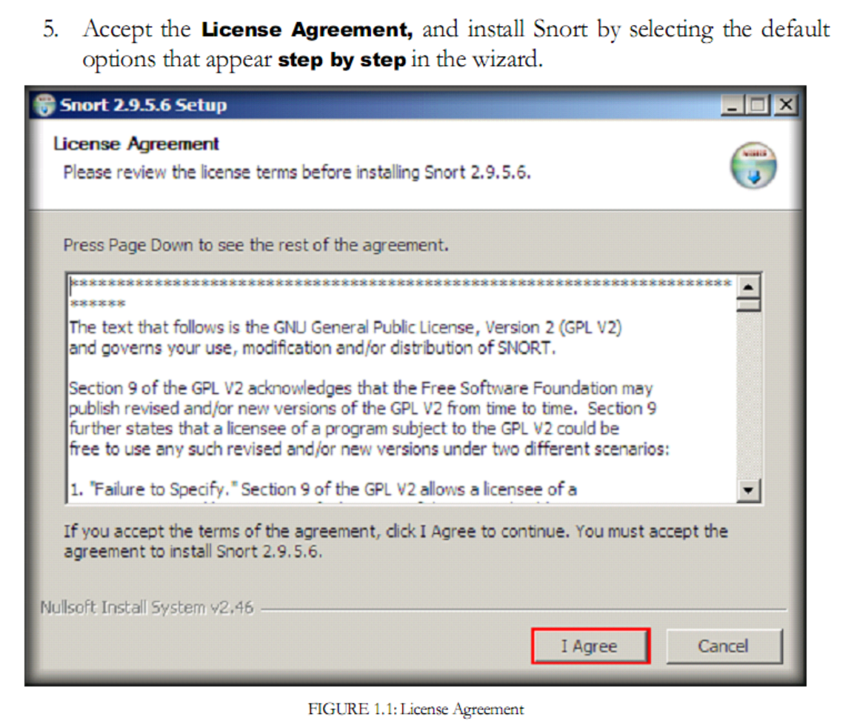

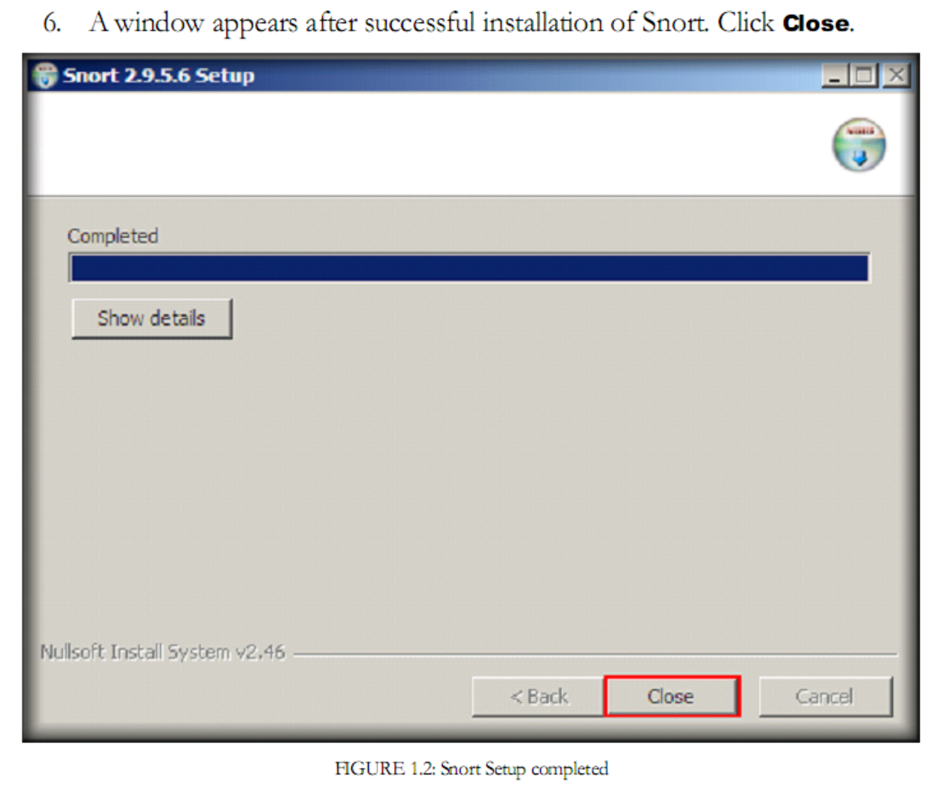
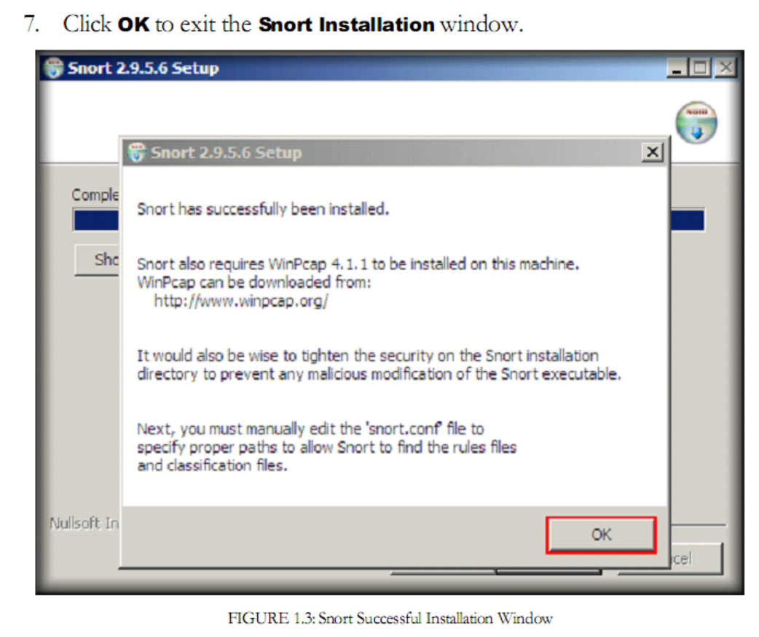
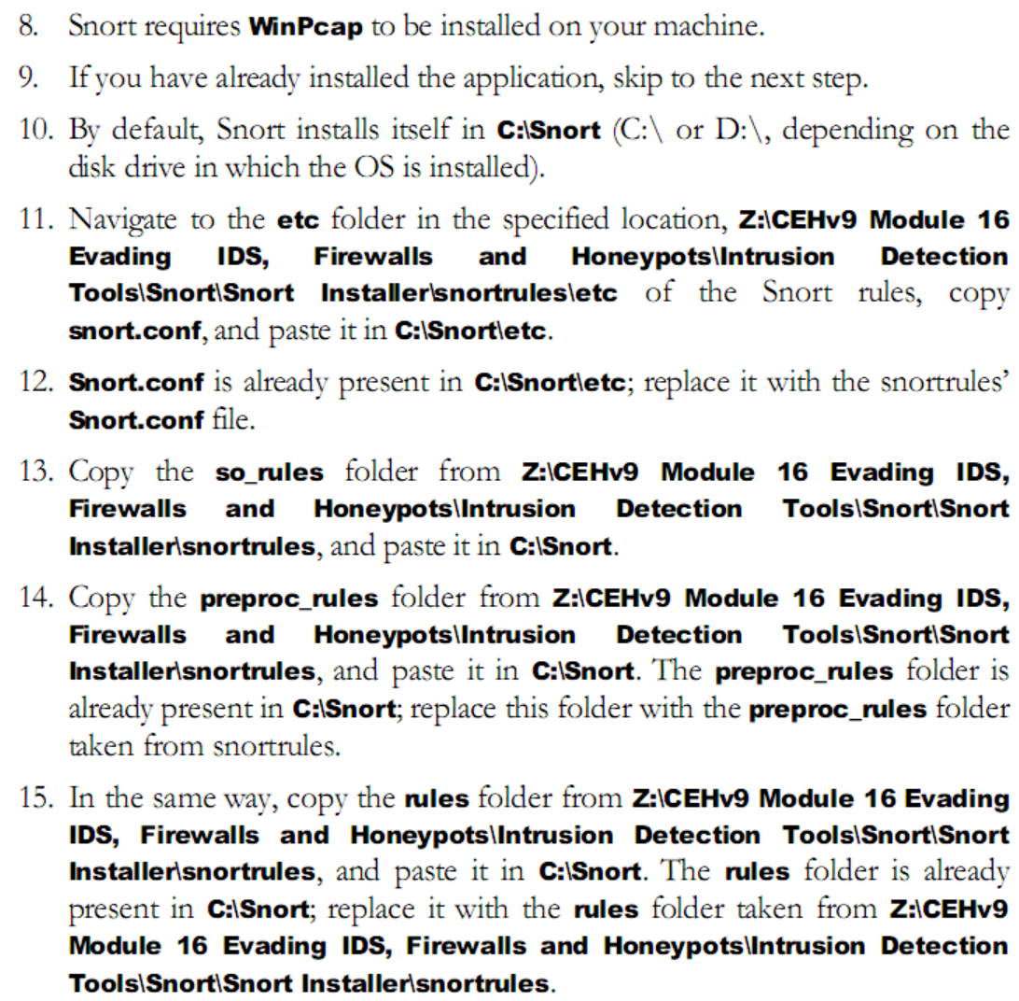
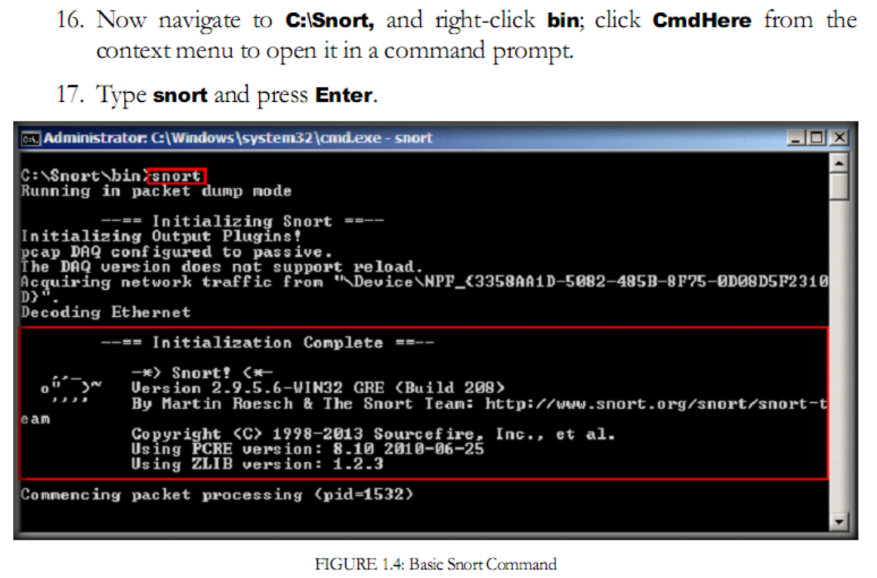
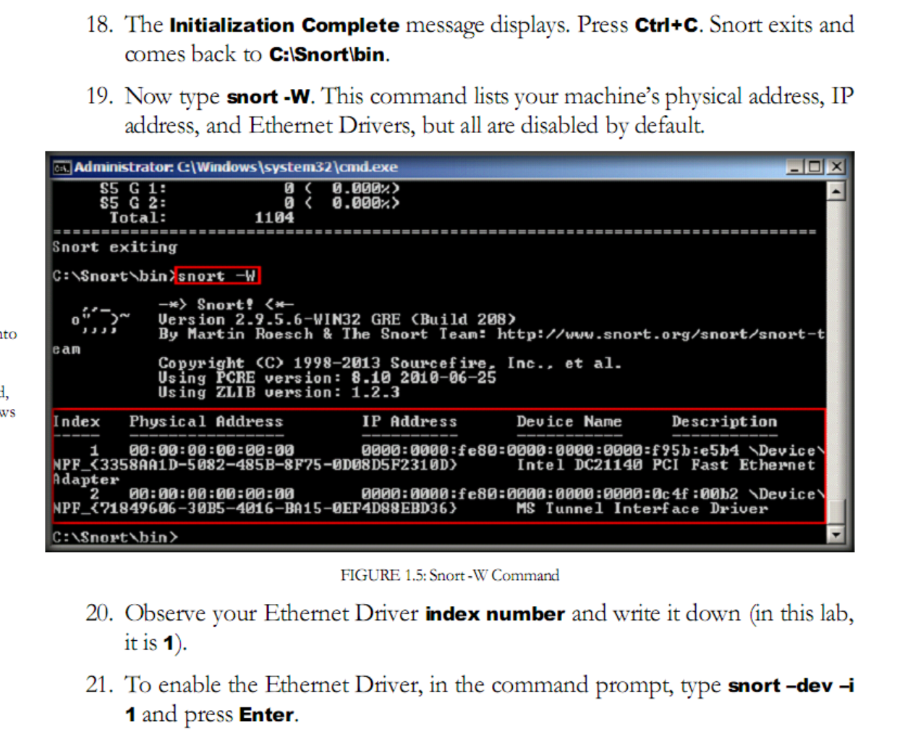

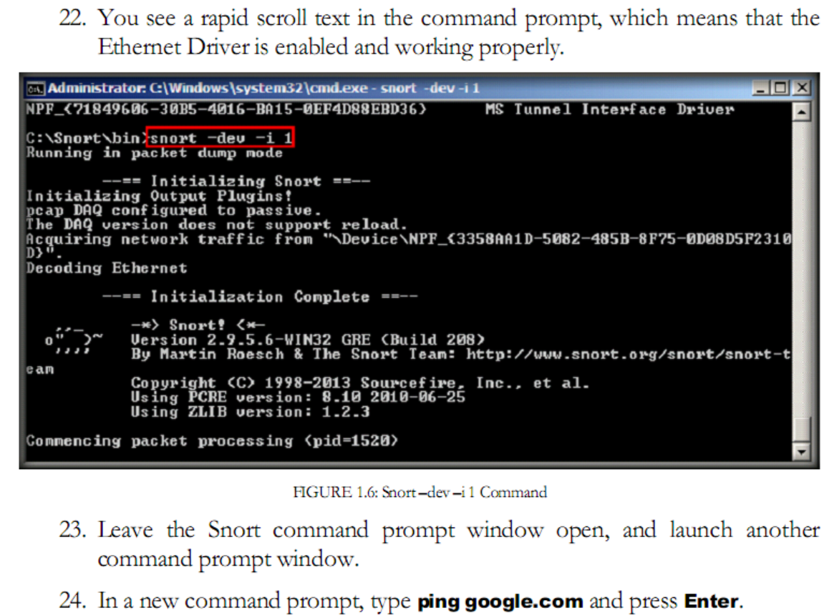
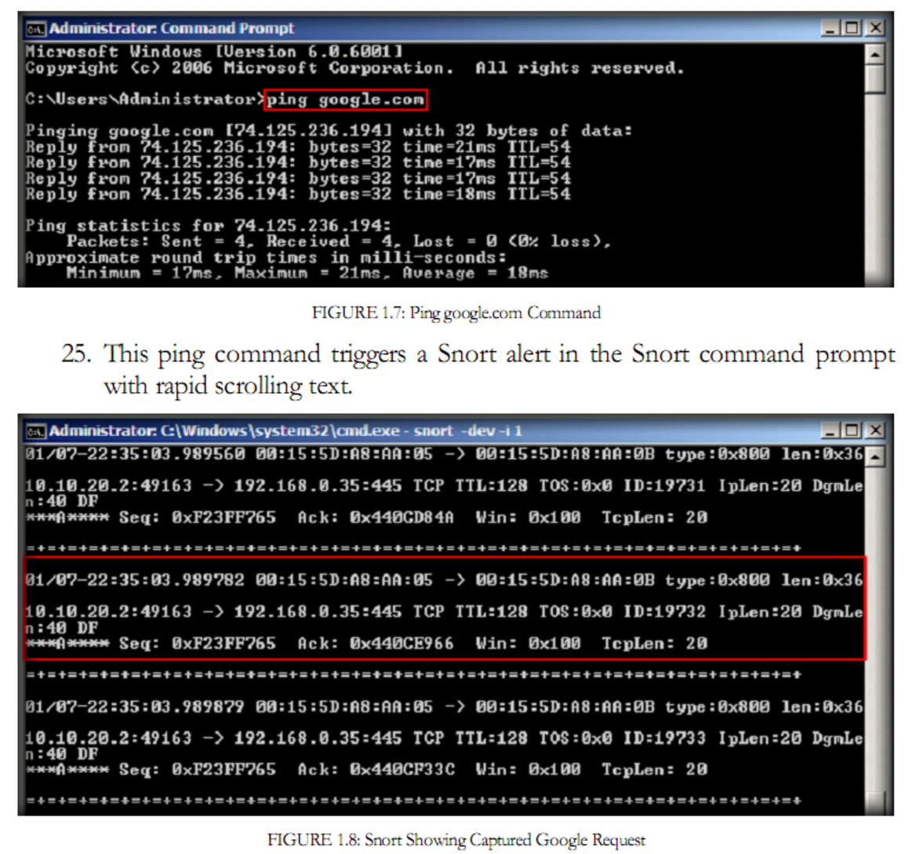
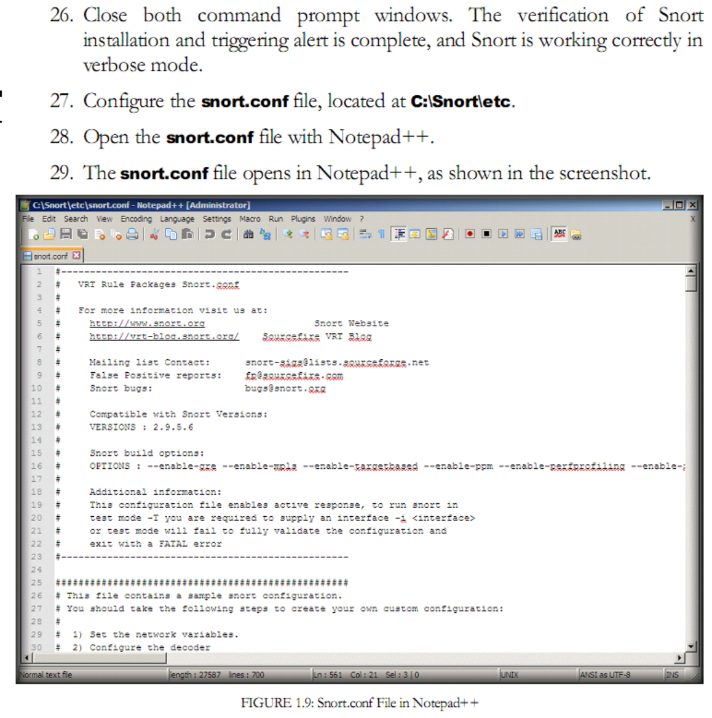
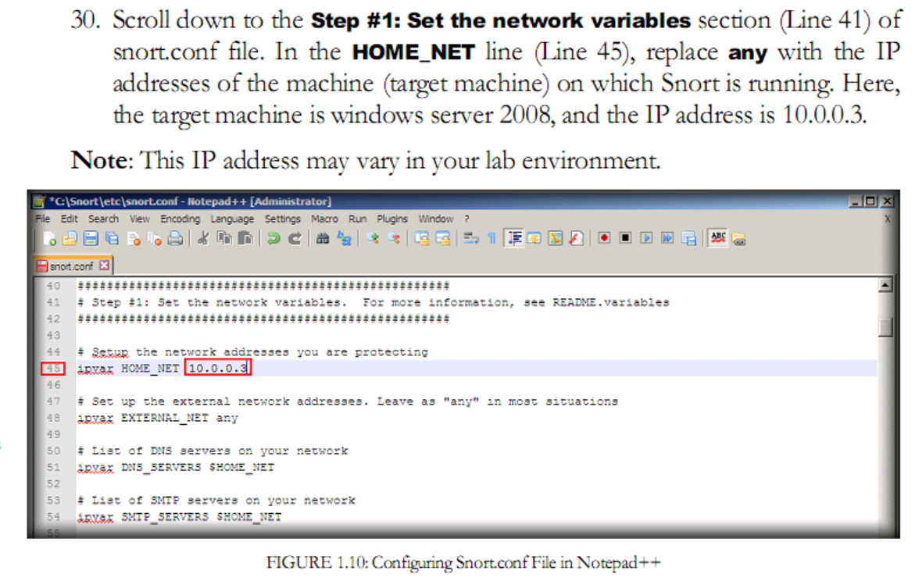
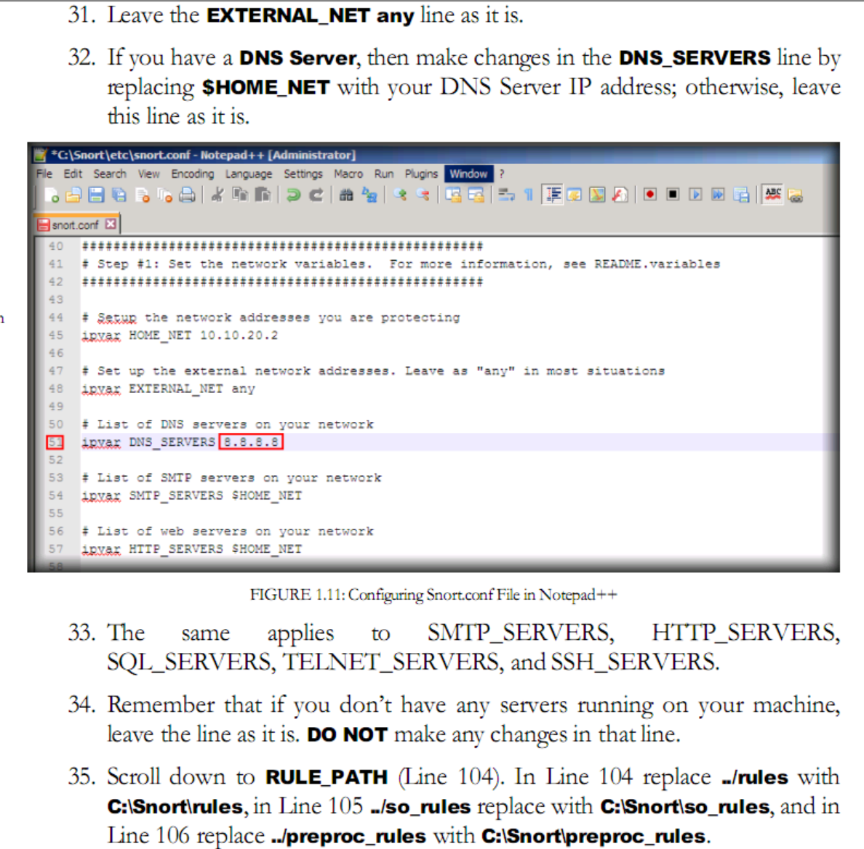
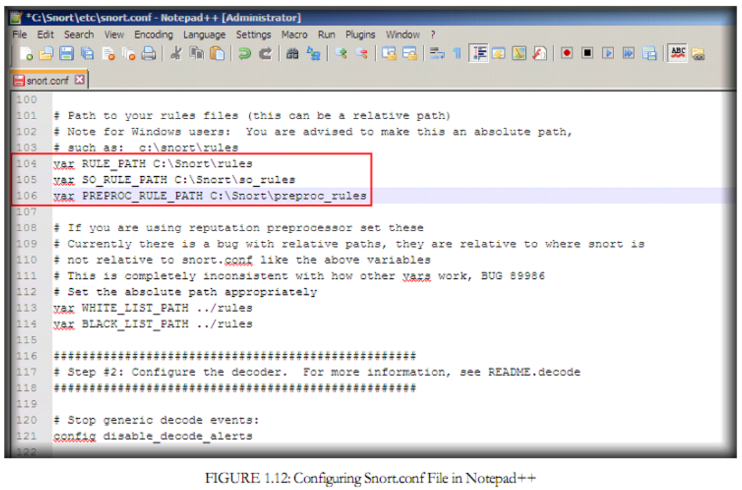
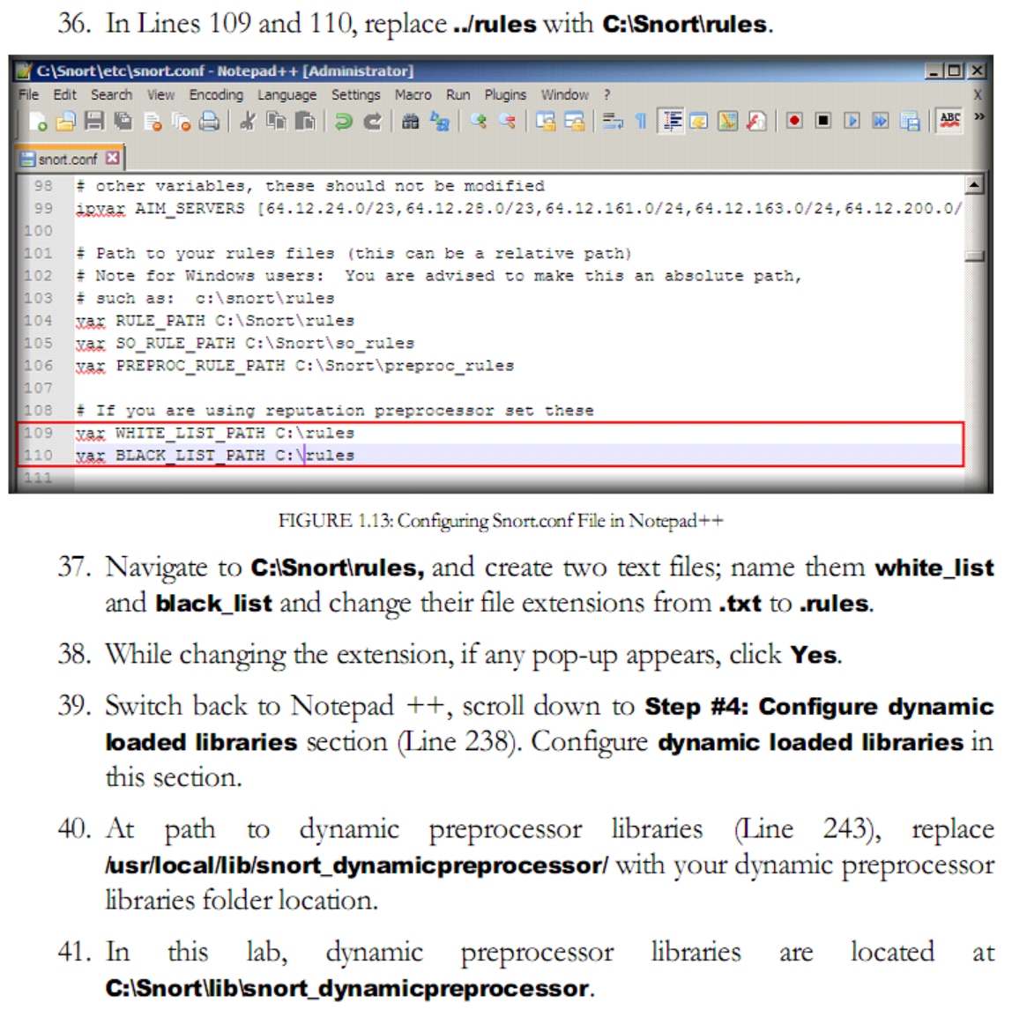
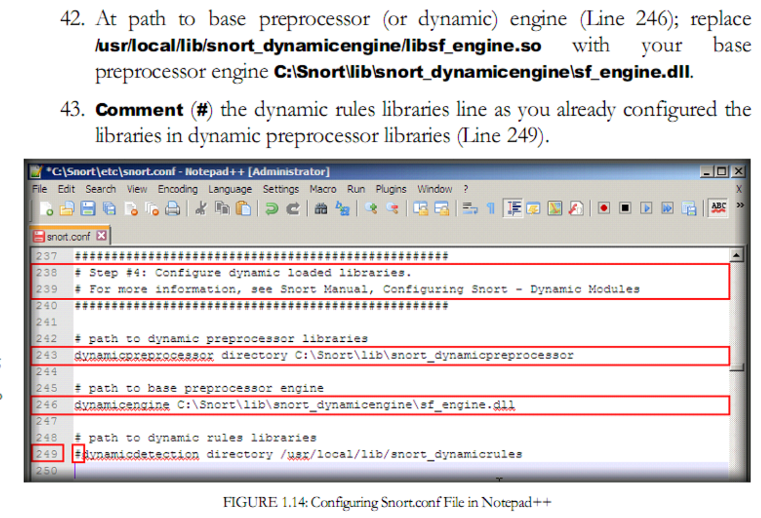
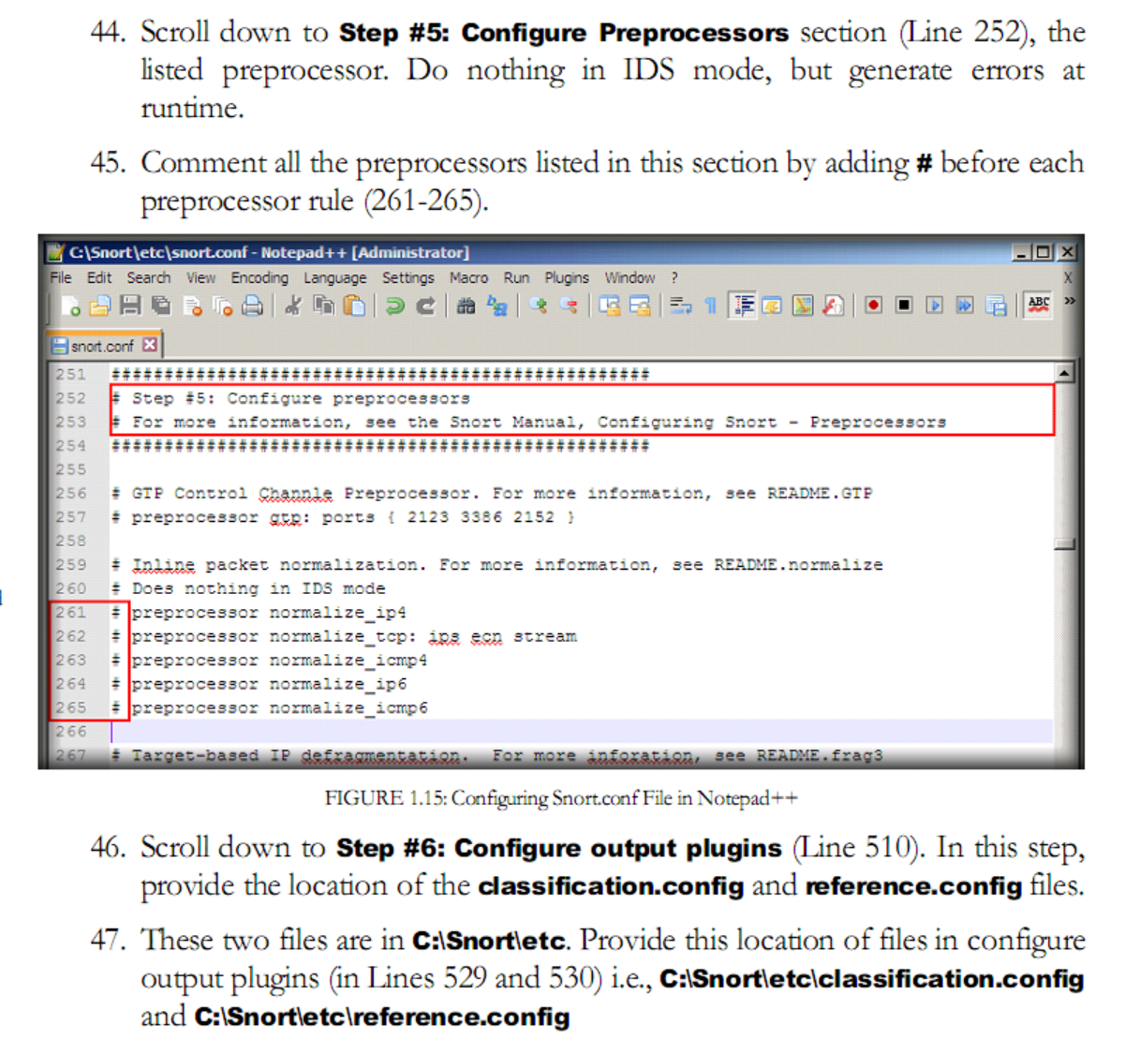
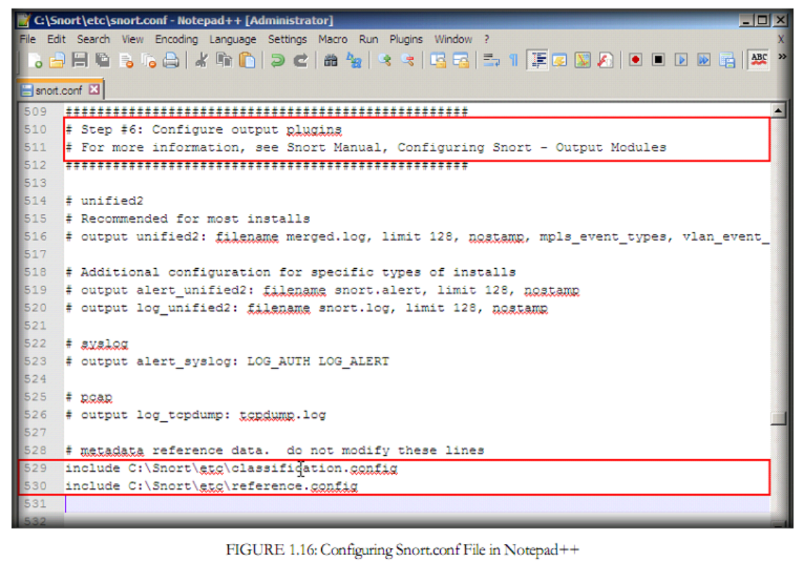
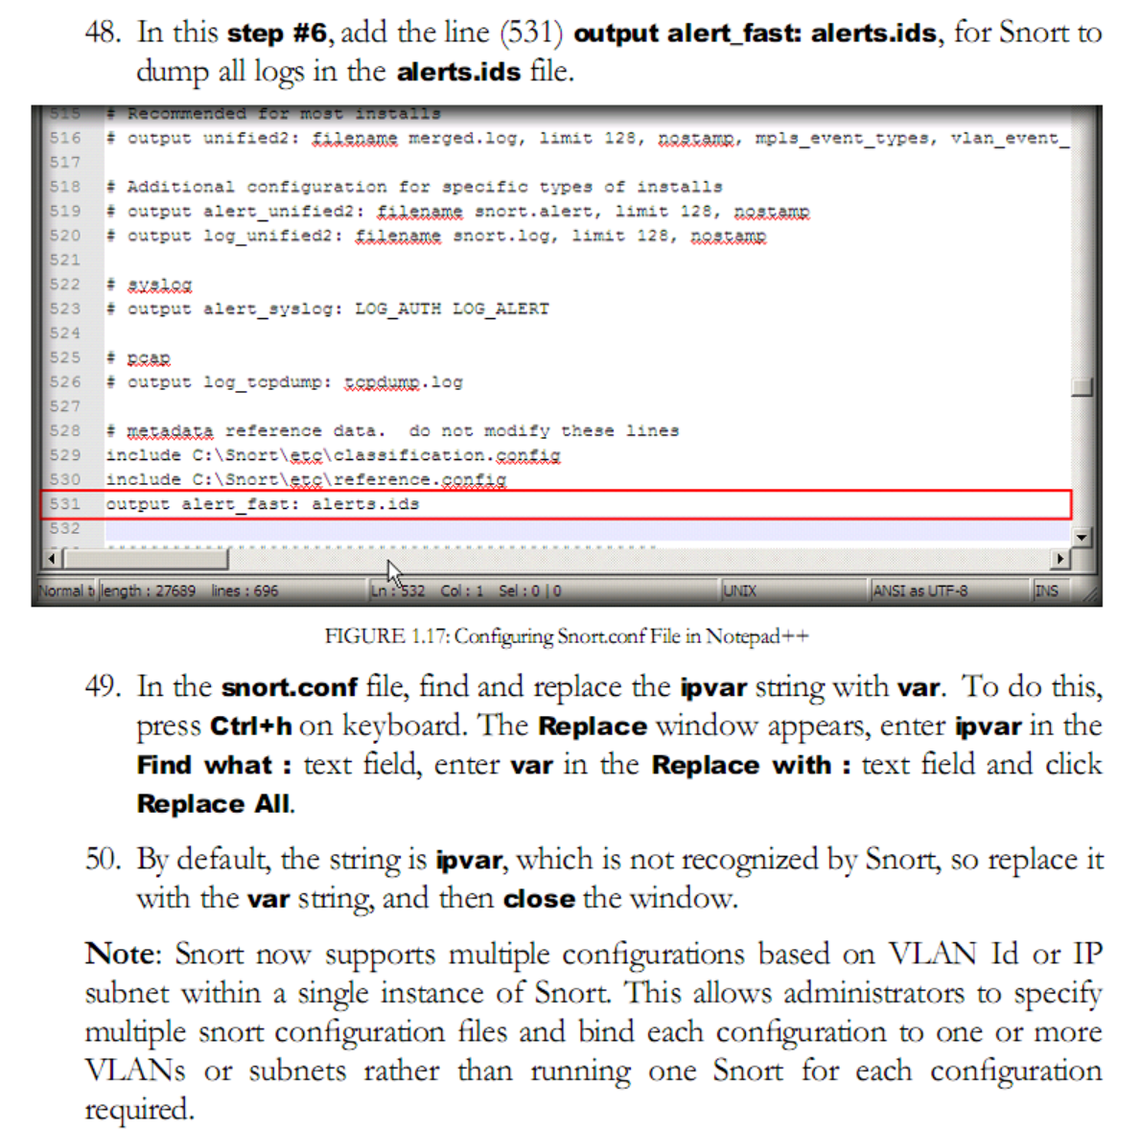
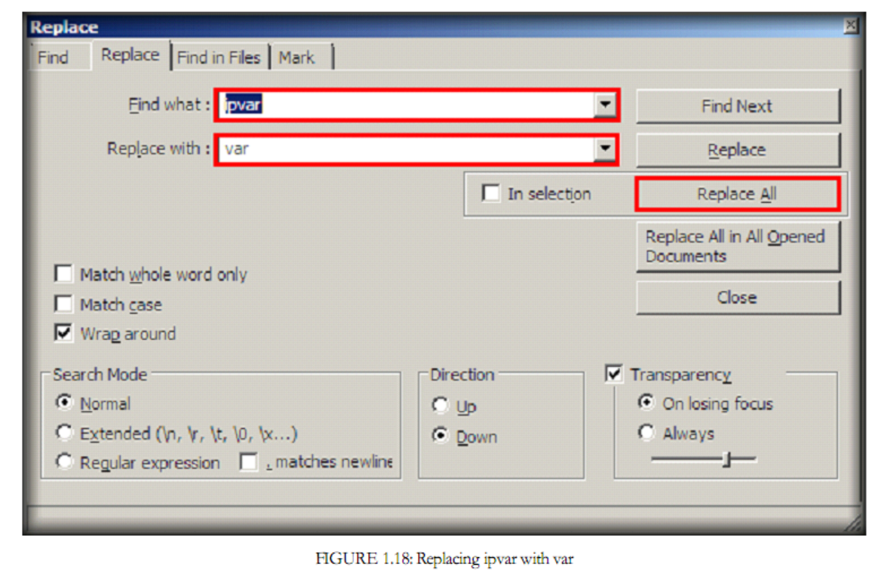
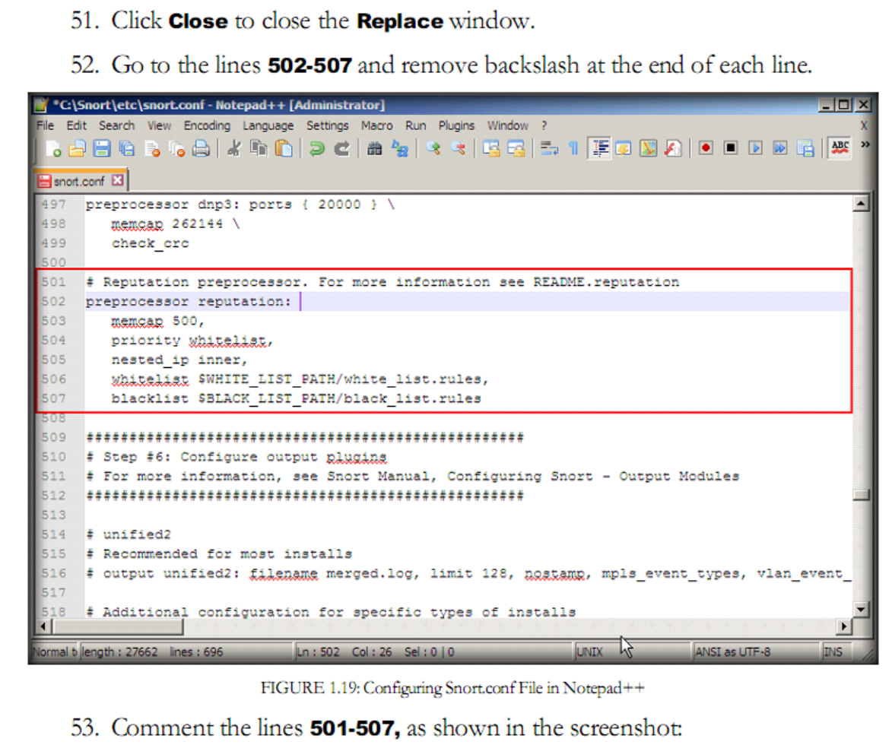
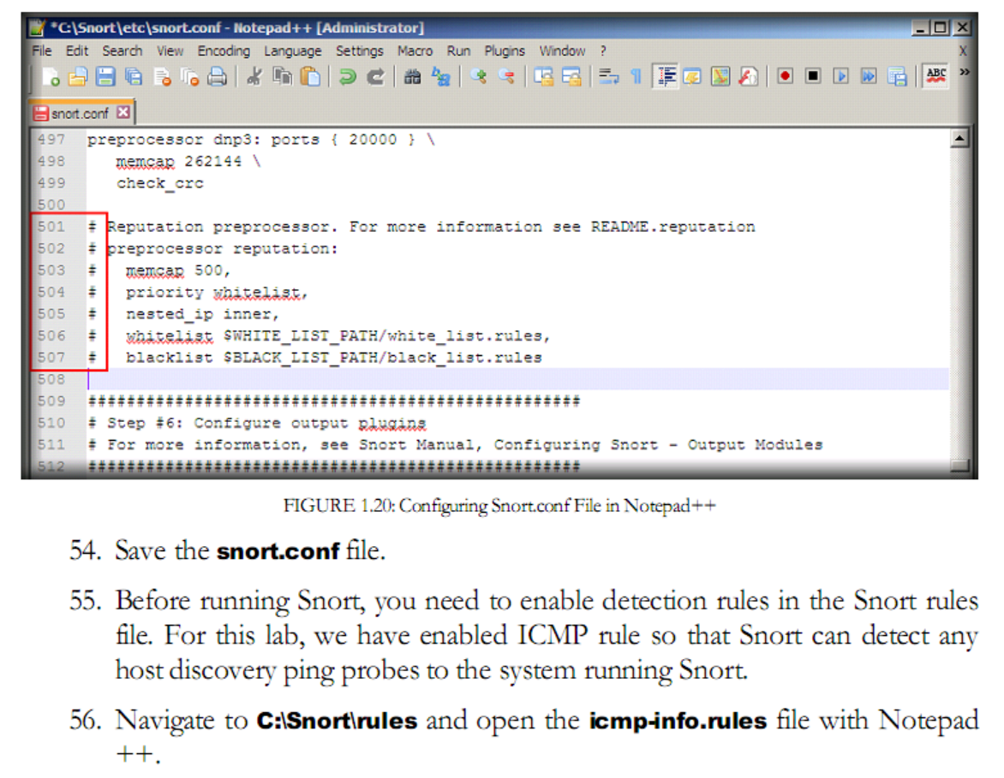
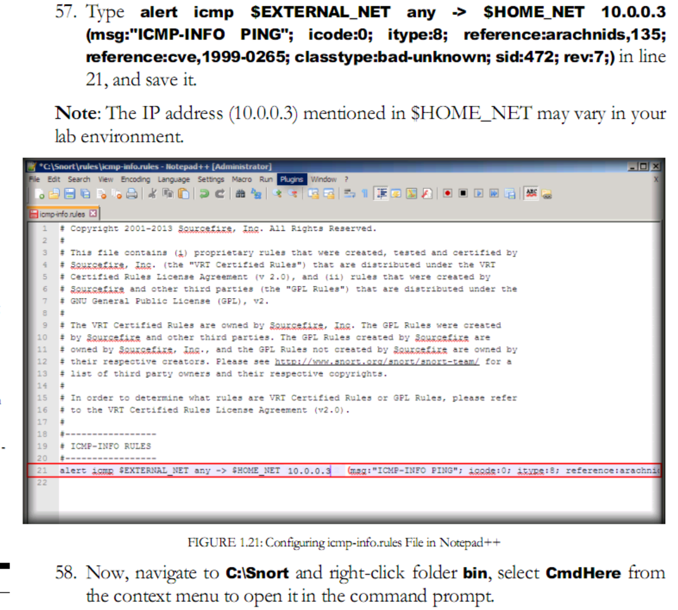
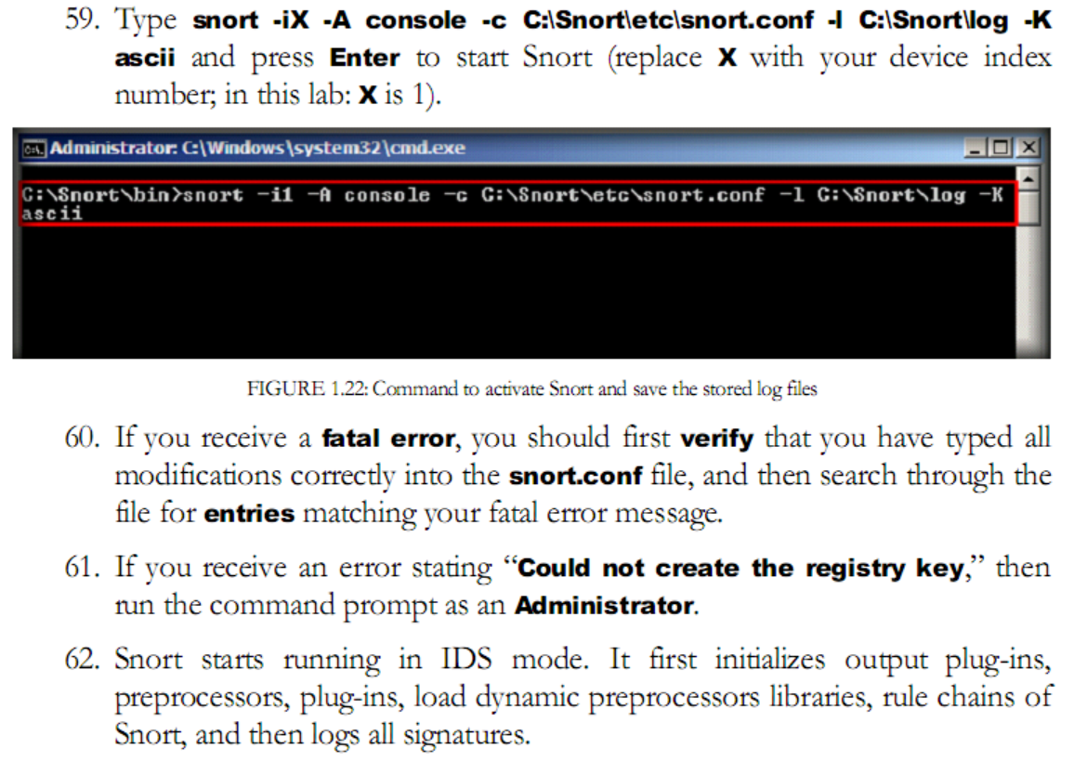
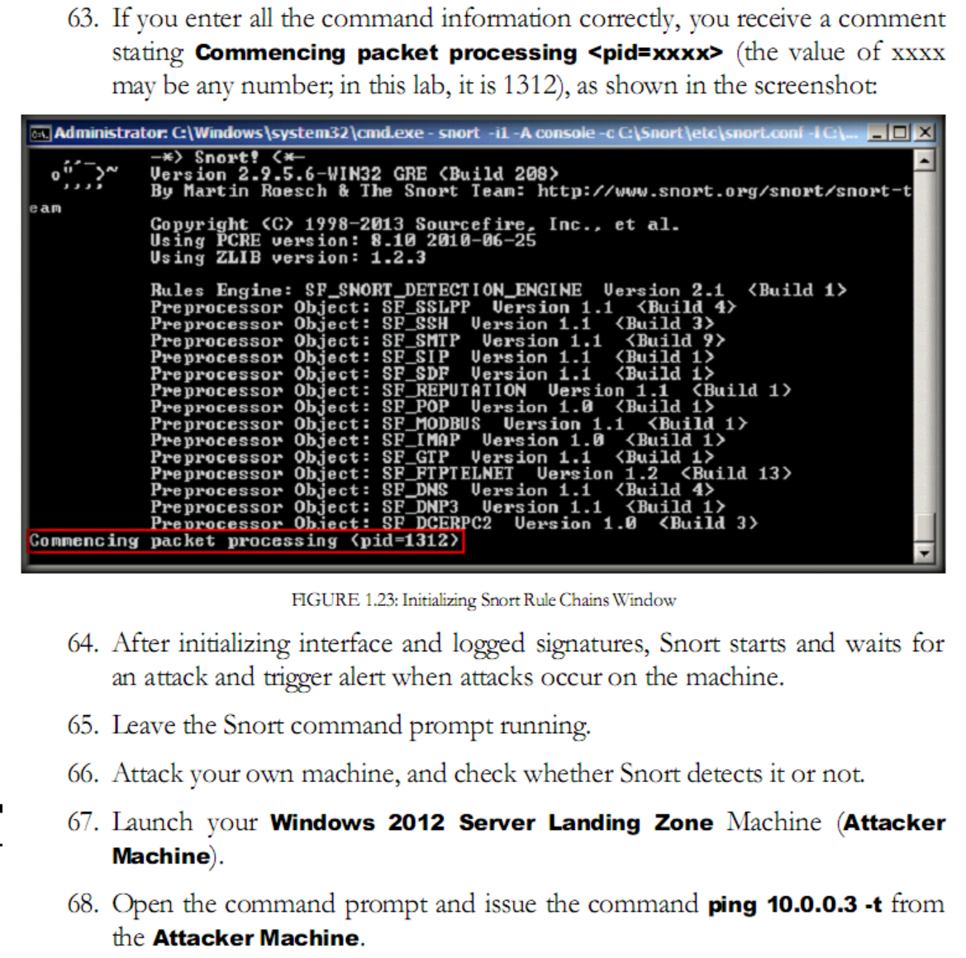
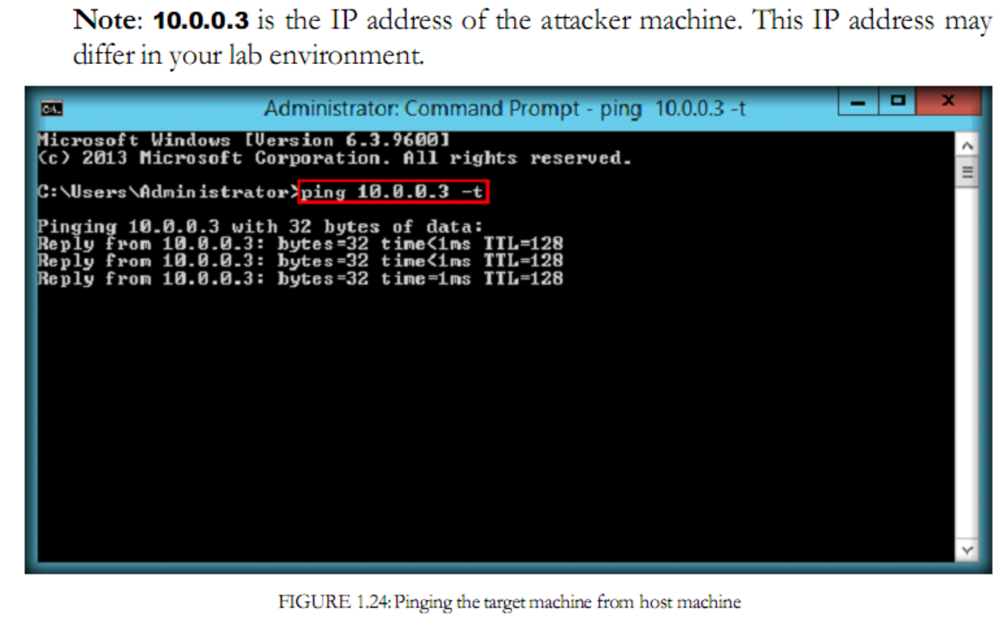
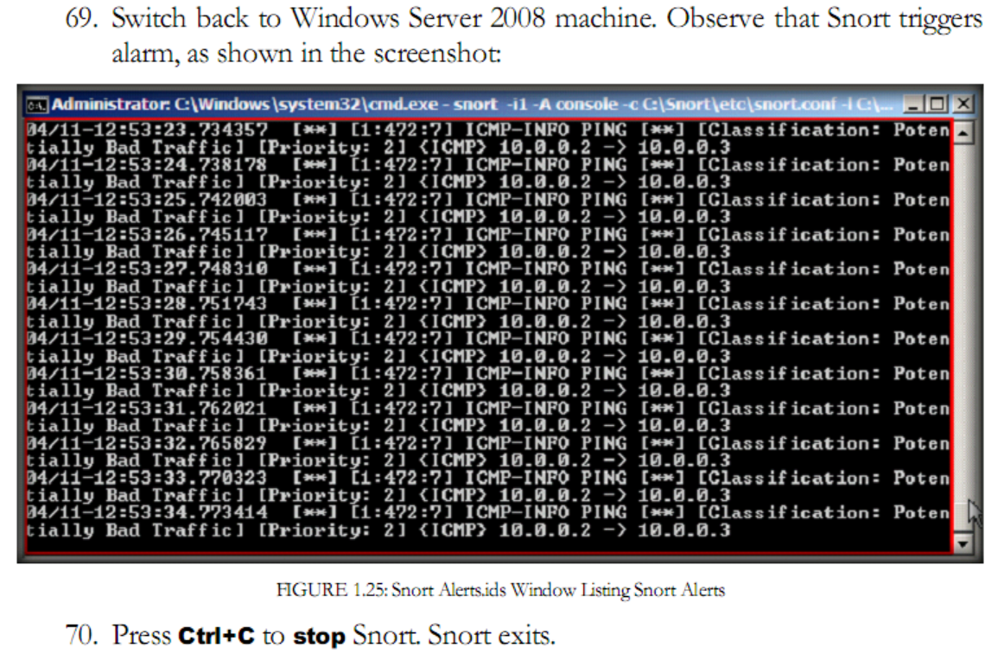
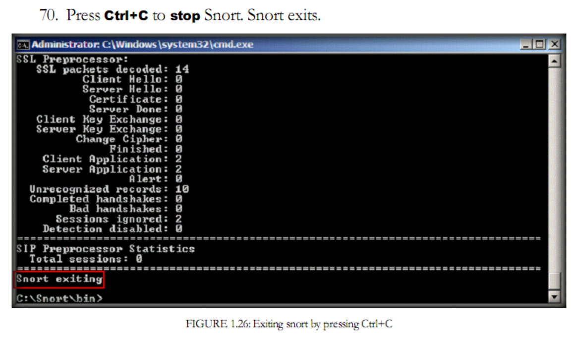
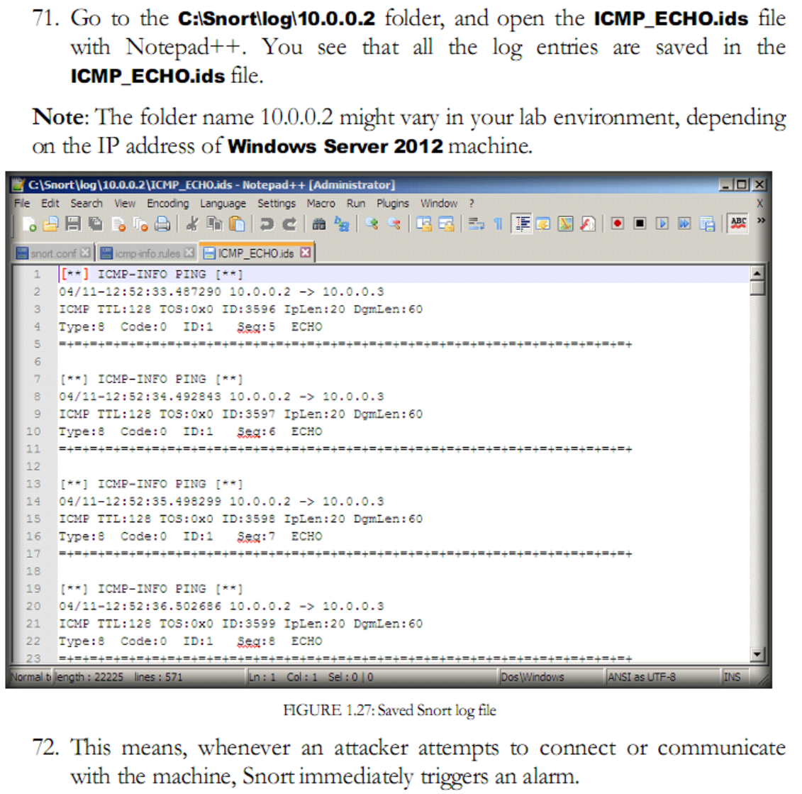
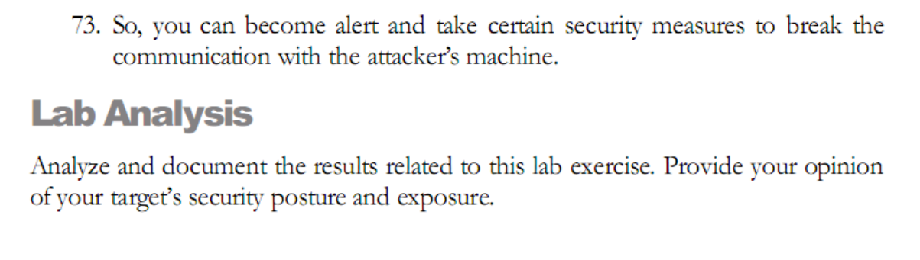

Task 2:
Detecting Malicious Network Traffic using HoneyBot

HoneyBot is a medium interaction honeypot for windows. A honeypot creates safe environment to capture and interact with unsolicited traffic on a network. HoneyBOT is an easy to use solution that is ideal for network security research or as part of an early-warning IDS,

Lab Objectives
The objective of this lab is to help students learn to detect malicious traffic on a network by using HoneyBot.

Getting started, you need:
To carry this out, you need:

- Kali Linux running in a virtual machine
- HoneyBot; located on the shared one drive or you can download the latest version from http://www.atomonicsoftwaresolution.com. If you decide to use the latest version, screenshots might differ.

Lab Tasks

- Launch the Kali Linux virtual machine before running this lab.
- Install the HoneyBot


